Supplementary Data
For Age and Ageing paper A foodservice approach to enhance energy intake of elderly subacute patients: A pilot study to assess impact on patient outcomes and cost.

Supplementary data Table 1 - Example of a standard and higher energy intervention hospital menu
Meal | Standard menu (control) | Energy (kJ) | Protein (g) | Higher energy menu (intervention) | Energy (kJ) | Protein (g)
Breakfast | Cereal  Low fat milk  1 x toast  + margarine + jam  Tea or coffee | 480  290  350  450  - | 3  6  3  -  - | Cereal  Full cream milk  2 x pikelets  + margarine + jam  2 x juice | 480  410  460  450  420 | 3  5  3  -  -
Morning tea | 2 sweet biscuits  Tea or coffee | 390  - | 1  - | Muffin/s  Hot chocolate | 800  440 | 2  2
Lunch | Soup of the day  Sandwich of the day  Daily dessert  Tea or coffee | 300  1200  700  - | 3  20  4  - | Soup of the day  Chef’s selection hot meal  Daily dessert  Tea or coffee | 300  1500  700  - | 3  34  4  -
Afternoon tea | Cheese and biscuits  Tea or coffee | 440  - | 5  - | Cake  Hot chocolate | 900  440 | 3  2
Dinner | Chef’s selection hot meal  Daily dessert  Tea or coffee | 1500  700  - | 34  4  - | Chef’s selection hot meal  Daily dessert  Tea or coffee | 1500  700  - | 34  4  -
Supper | Fruit cake  Tea or coffee | 650  - | 2  - | 2 chocolate biscuits  Flavoured milk | 810  820 | -  10
Daily total |  | 7450 | 85 |  | 11130 | 109
The default menu options provided when patients have not made their own selection are displayed for breakfast, lunch and dinner. An anticipated selection of food and drink items are discplayed for morning tea, afternoon tea and supper.
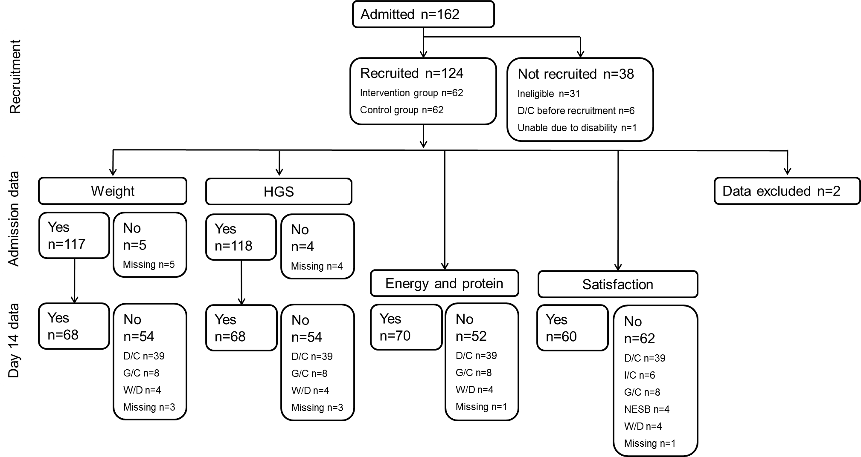
Supplementary data Figure 1 - Recruitment and retention of study participants
HGS, hand grip strength; D/C, discharged; G/C, group change; W/D, withdrawn; I/C, significantly impaired cognition; NESB, Non-English speaking background
n=2 participants who were recruited went on to receive a combination of enteral and oral nutrition and were excluded
In total n=12 failed to complete the study by day 14 due to group change (n=4 intervention, n=4 control) or withdrawal (n=3 intervention, n=1 control).
A further 12 participants failed to complete the study before discharge after day 14 due to group change (n=3 intervention, n=3 control) or withdrawal (n=3 intervention, n=3 control).
On average (median), admission data for weight and HGS were collected on day 2 of admission and day 14 data for weight, HGS, plate waste and satisfaction were collected on the designated day.
Supplementary data Table 2 - Comparison of demographic characteristics and outcome data at admission between intervention and control participants remaining in the pilot at day 14 of admission.
Characteristic |  |  | Control  n=39 | Intervention  n=32 | p value
Age (years), median (IQR) |  |  | 82 (78 – 87) | 86 (82 – 91) | 0.036
Male, n (%) |  |  | 21 (53.8) | 15 (46.9) | 0.559
Cognitive impairment, n (%) |  |  | 19 (48.7) | 16 (50.0) | 0.914
Birthplace, n (%) |  | Australia  Other | 21 (53.8)  18 (46.2) | 20 (62.5)  12 (37.5) | 0.463
Language, n (%) |  | English  Other | 33 (84.6)  6 (15.4) | 32 (100.0)
Primary diagnosis, n (%) | Stroke/neurology  Orthopaedic  Functional/cognitive decline  Oncology  Amputation  Respiratory  Cardiology  GI/Hepatic  Other |  | 1 (2.6)  14 (35.9)  9 (23.1)  1 (2.6)  4 (10.3)  2 (5.1)  3 (7.7)  5 (12.8) | 1 (4.3)  11 (47.8)  8 (34.8)  2 (8.7)  3 (13.0)  2 (8.7)  3 (13.0)  2 (8.7)
Diet code, n (%) | Full ward diet  Soft  Diabetic |  | 21 (53.8)  2 (5.1)  16 (41.0) | 25 (78.1)  2 (6.3)  5 (15.6)
Nutritional status at admission, n (%) | Well nourished  Mild/moderate malnutrition  Severe malnutrition |  | 23 (59.0)  12 (30.8)  4 (10.3) | 20 (62.5)  10 (31.3)  2 (6.3)
FIM score at admission, mean (SD) |  |  | 72 (19) | 69 (14) | 0.507
HGS (kg) at admission, mean (SD) ª |  |  | 37.1 (17.4) | 34.9 (14.9) | 0.583
Weight (kg) at admission, median (IQR) ^{b} |  |  | 71.15 (56.40-79.30 | 57.50 (57.50-68.85) | 0.005
  - Well nourished, SGA=A,MST<2; mild/moderate malnutrition, SGA=B; severe malnutrition, SGA=C; FIM, Functional Independence Measure.
ª sample size n=38 control group, n=31 intervention group
^{b} sample size n=37 control group, n=31 intervention group
Supplementary data - Participants’ selection of intervention menu items
At breakfast, 20 participants received pikelets (7 males, 12 females) and five received an omelette (2 males, 3 females). At morning tea muffins were the most popular (4 males, 5 females), followed by hot chocolate (2 males, 4 females), full cream yoghurt (2 males, 3 females) and cheese and biscuits x 2 (3 males, 1 female). At afternoon tea the items received were: cake (2 males, 5 females), hot chocolate (3 males, 2 females), cheese and biscuits x 2 (3 males, 2 females) and full cream yoghurt (1 male, 1 female). At supper 21/31 participants chose nothing from the menu while the remaining participants selected chocolate biscuits (1 male, 3 females), hot chocolate (3 females), mousse (1 male, 1 female) and yoghurt (1 male). Juice (n=3) and flavoured milk (n=3) were selected infrequently during the day. At breakfast seven participants requested toast and across all mid meals 21 participants received tea, coffee or milo despite these items not being included in the intervention menu.

Supplementary data Table 3 - Linear regression model of factors predicting length of stay and change in Functional Independence Measure (FIM) during subacute care (n=95)
 | B | SE | p value
Model 1 – Length of stay (days)
Group | 1.682 | 2.873 | 0.560
Age (years) | 0.298 | 0.140 | 0.036
FIM score at admission | -0.090 | 0.081 | 0.267
Change in FIM score between admission and discharge | 0.221 | 0.107 | 0.042
Impaired cognition | 1.144 | 2.896 | 0.694
Model 2 – Change in FIM score between admission and discharge
Group | 1.596 | 2.779 | 0.567
Age (years) | -0.006 | 0.139 | 0.963
Length of stay (days) | 0.207 | 0.100 | 0.042
FIM score at admission | -0.124 | 0.078 | 0.114
Impaired cognition | 0.626 | 2.803 | 0.824
  - Model 1:R²=0.134, adjusted R²=0.086, SEE=13.844
  - Model 2: R²=0.098, adjusted R²=0.047, SEE=13.391
  - Group, intervention (code 1) or control (code 0); FIM, functional independence measure; Impaired cognition, yes (code 1) or no (code 0); B, regression coefficient; SE, standard error of B; SEE, standard error of the estimate

