Appendix
Missing Data Pattern
 | Week 4 | Week 8 | Week 12 | Total Count for Pattern
Pattern of assessment attendance | × |  |  | 1036
 | × |  | × | 920
 | × | × |  | 488
 | × | × | × | 396
 |  | × |  | 66
 |  | × | × | 44
 |  |  | × | 37
Total count for assessment visit | 2840 | 994 | 1397
× = Underwent assessment

Appendix Table 1: Clinical characteristics of patients who underwent and did not undergo Week-4 assessment.
Variables | Underwent Assessment  (N=2840) | No Assessment  (N=147) | P-value
Age (years) | 62.0 67.2 72.8  67.4 ± 7.4 | 63.0 67.3 73.1  67.7 ± 8.0 | 0.64¹
Body weight (kg) | 59 66 74  67 ± 13 | 59 66 75  68 ± 14 | 0.76¹
BMI (kg/m²) | 24.3 26.9 30.0  27.5 ± 4.5 | 24.7 27.5 30.4  27.8 ± 4.6 | 0.33¹
Preop knee flexion (°) | 109 121 131  118 ± 18 | 106 122 130  118 ± 17 | 0.73¹
Preop SF-36 bodily pain | 22 32 42  36 ± 19 | 22 32 44  36 ± 18 | 0.54¹
Preop SF-36 physical function | 20 35 55  39 ± 23 | 20 35 55  37 ± 24 | 0.32¹
Contralateral knee pain | 57% (1618) | 60% ( 88) | 0.49²
Preop walking aids |  |  | 0.22³
None | 2% ( 43) | 1% ( 2)
Stick | 2% ( 63) | 1% ( 2)
Quadstick | 74% (2113) | 71% ( 105)
Frame | 22% ( 621) | 26% ( 38)
Hypertension | 65% (1833) | 71% ( 105) | 0.088²
Diabetes | 21% ( 591) | 20% ( 30) | 0.91²
Heart disease | 11% ( 313) | 16% ( 23) | 0.084²
Length of stay (days) | 3.0 4.0 5.0  4.4 ± 2.4 | 3.0 4.0 5.5  5.1 ± 3.9 | 0.56¹
Walk on day 1 post TKA | 78% (2217) | 73% ( 107) | 0.13²
Able to perform SLR on day of hospital discharge | 88% (2503) | 86% ( 126) | 0.38²
Continuous variables are summarized as 25th 50th 75th percentiles and mean ± SD.
Categorical variables are summarized as percentages and frequencies (n).
Tests used: ¹Wilcoxon test; ²Pearson test; ³Proportional odds likelihood ratio test.
SLR = Straight Leg Raise

Appendix Table 2: Clinical characteristics of patients who underwent and did not undergo Week-8 assessment.
Variables | Underwent Assessment  (N=994) | No Assessment  (N=1993) | P-value
Age (years) | 62.2 66.8 72.4  67.2 ± 7.4 | 62.0 67.4 73.0  67.5 ± 7.4 | 0.16¹
Body weight (kg) | 59 66 75  68 ± 13 | 59 66 74  67 ± 13 | 0.42¹
BMI (kg/m²) | 24.3 26.8 29.9  27.5 ± 4.6 | 24.4 27.0 30.0  27.5 ± 4.5 | 0.55¹
Preop knee flexion (°) | 109 122 131  119 ± 17 | 108 121 131  118 ± 18 | 0.78¹
Preop SF-36 bodily pain | 22 32 42  36 ± 19 | 22 32 42  36 ± 19 | 1¹
Preop SF-36 physical function | 20 35 55  39 ± 23 | 20 35 55  39 ± 22 | 0.8¹
Contralateral knee pain | 58% ( 572) | 57% (1134) | 0.74²
Preop walking aids |  |  | 0.4³
None | 1% ( 14) | 2% ( 31)
Stick | 2% ( 16) | 2% ( 49)
Quadstick | 74% ( 740) | 74% (1478)
Frame | 23% ( 224) | 22% ( 435)
Hypertension | 66% ( 653) | 64% (1285) | 0.51²
Diabetes | 21% ( 205) | 21% ( 416) | 0.87²
Heart disease | 12% ( 116) | 11% ( 220) | 0.61²
Length of stay (days) | 3.0 4.0 5.0  4.6 ± 2.9 | 3.0 4.0 5.0  4.4 ± 2.3 | 0.39¹
Walk on day 1 post TKA | 77% ( 765) | 78% (1559) | 0.43²
Able to perform SLR on day of hospital discharge | 87% ( 869) | 88% (1760) | 0.48²
Continuous variables are summarized as 25th 50th 75th percentiles and mean ± SD.
Categorical variables are summarized as percentages and frequencies (n).
Tests used: ¹Wilcoxon test; ²Pearson test; ³Proportional odds likelihood ratio test.
SLR = Straight Leg Raise

Appendix Table 3: Clinical characteristics of patients who underwent and did not undergo Week-12 assessment.
Variables | Underwent Assessment  (N=1397) | No Assessment  (N=1590) | P-value
Age (years) | 61.9 66.9 71.9  67.1 ± 7.3 | 62.2 67.5 73.2  67.7 ± 7.6 | 0.023¹
Body weight (kg) | 59 66 74  67 ± 12 | 59 66 74  68 ± 13 | 0.44¹
BMI (kg/m²) | 24.3 26.7 29.6  27.3 ± 4.4 | 24.4 27.1 30.3  27.7 ± 4.7 | 0.022¹
Preop knee flexion (°) | 110 122 131  119 ± 17 | 106 120 131  118 ± 18 | 0.04¹
Preop SF-36 bodily pain | 22 32 51  36 ± 18 | 22 32 42  35 ± 20 | 0.5¹
Preop SF-36 physical function | 20 40 55  40 ± 23 | 20 35 55  38 ± 23 | 0.006¹
Contralateral knee pain | 59% (826) | 55% (880) | 0.037²
Preop walking aids |  |  | 0.86³
None | 2% ( 21) | 2% ( 24)
Stick | 1% ( 16) | 3% ( 49)
Quadstick | 76% (1061) | 73% (1157)
Frame | 21% ( 299) | 23% ( 360)
Hypertension | 63% ( 879) | 67% (1059) | 0.035²
Diabetes | 21% ( 300) | 20% ( 321) | 0.39²
Heart disease | 11% ( 156) | 11% ( 180) | 0.89²
Length of stay (days) | 3.0 4.0 5.0  4.4 ± 2.6 | 3.0 4.0 5.0  4.5 ± 2.5 | 0.19¹
Walk on day 1 post TKA | 80% (1115) | 76% (1209) | 0.013²
Able to perform SLR on day of hospital discharge | 89% (1249) | 87% (1380) | 0.028²
Continuous variables are summarized as 25th 50th 75th percentiles and mean ± SD.
Categorical variables are summarized as percentages and frequencies (n).
Tests used: ¹Wilcoxon test; ²Pearson test; ³Proportional odds likelihood ratio test.
SLR = Straight Leg Raise

Inverse Probability Weighting
In sensitivity analyses, we used inverse probability weighting to adjust for missing data(1). We computed inverse probability weights for each patient at each time point from pooled logistic regression models that were fitted to predict the probability of having a missing knee flexion range-of-motion, quadriceps strength, and gait speed value. Models were run separately for women and men. Covariates included age, body weight, diabetes, hypertension, coronary heart disease, the availability of caregiver support post TKA (yes vs. no), the type of gait aids used preoperatively (coded into 4 categories: (i) none, (ii) walking stick, (iii) quadstick, and (iv) walking frame), knee flexion range-of-motion measured at hospital discharge, and the ability to perform an active straight-leg-raise on the day of hospital discharge (able vs. unable). Inversed probability weights were truncated at the 99th percentile level and incorporated into the weights argument of the rq R function(2). Appendix Figures 1 and 2 show that the inverse probability weighting estimates were similar to the unadjusted estimates.

References
1. Cole SR, Hernan MA. Constructing inverse probability weights for marginal structural models. Am J Epidemiol 2008;168(6):656-64.
2. Koenker R. quantreg: Quantile Regression. R package version 5.26. https://CRAN.R-project.org/package=quantreg. 2016.

A | B | C
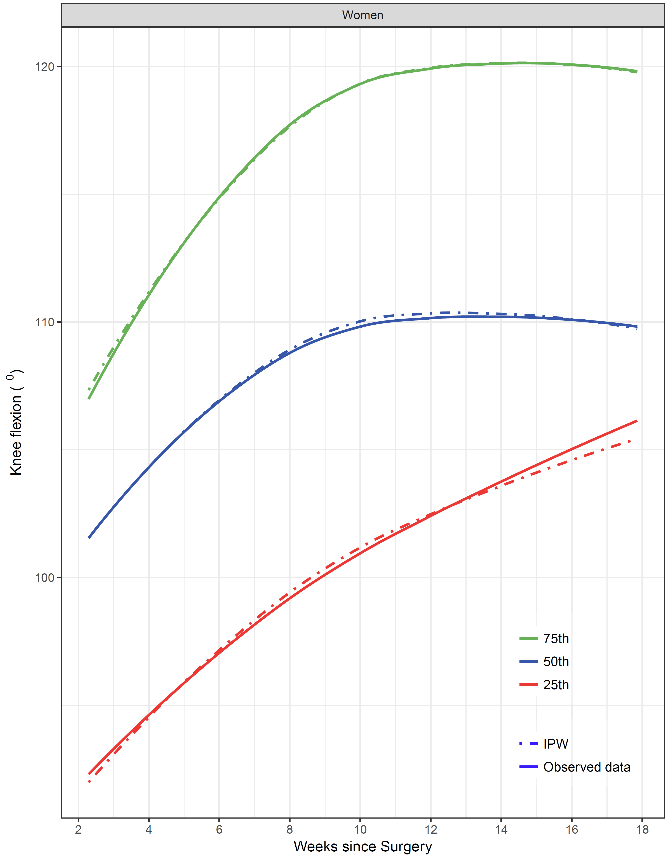 | 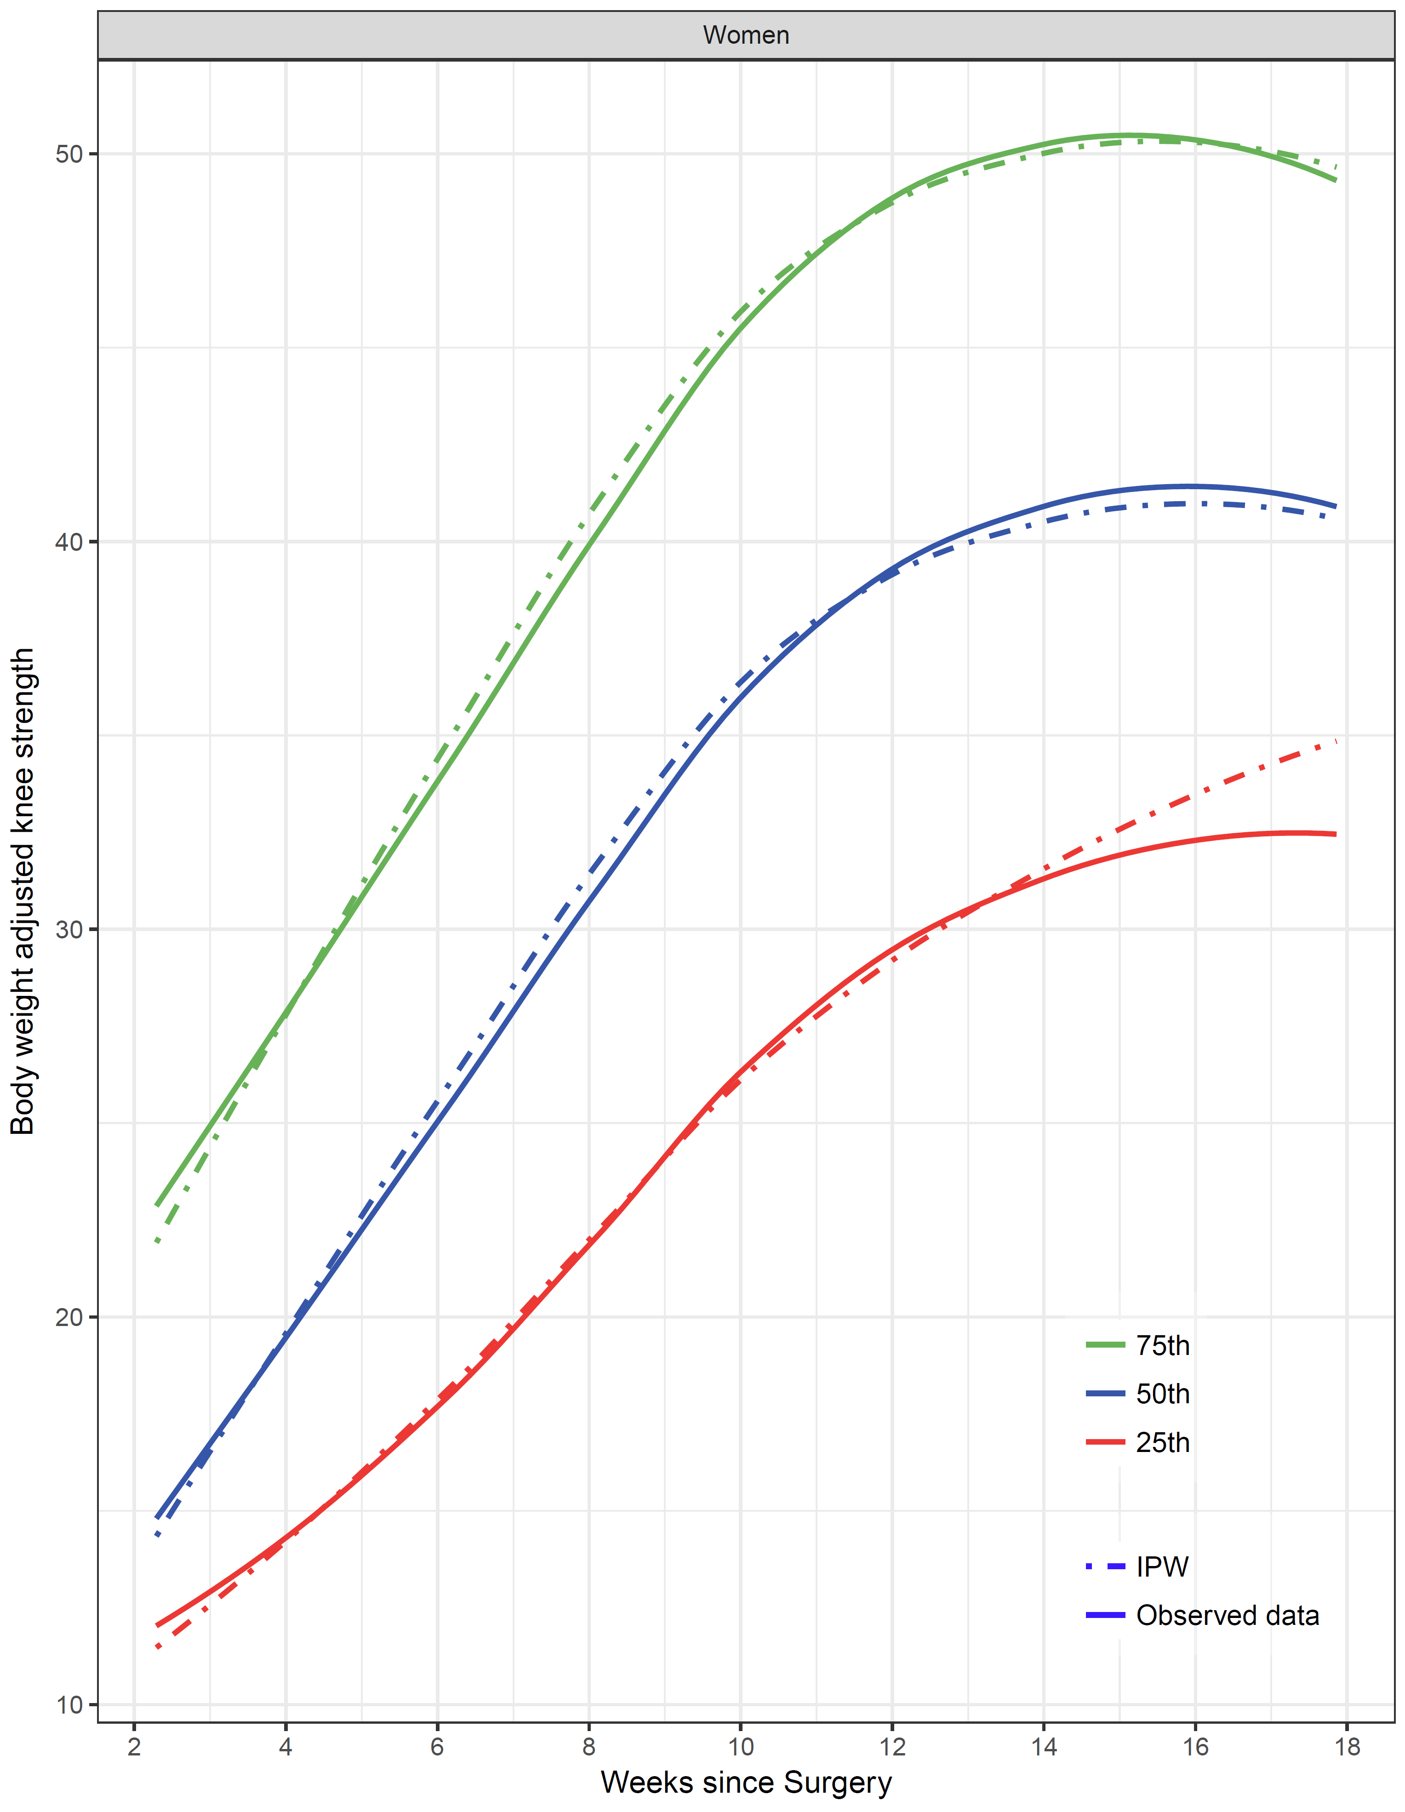 | 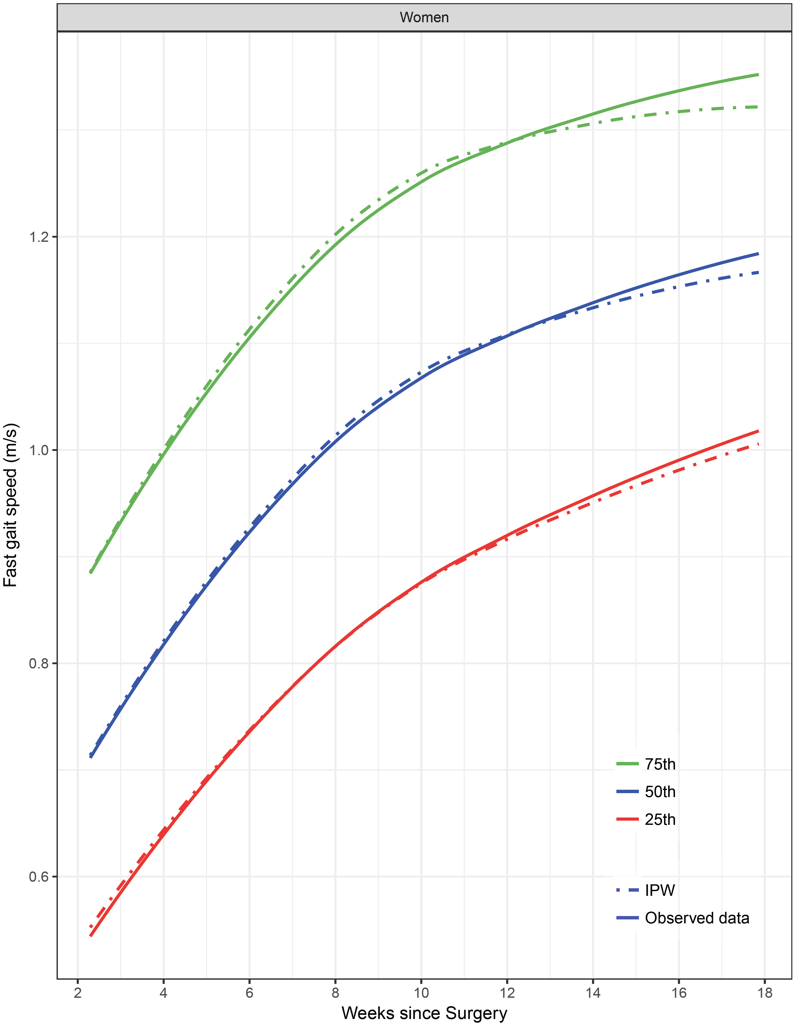
Appendix Figure 1: Median and interquartile range knee flexion range-of-motion (A), body-weight adjusted quadriceps strength (B), and fast gait speed (C) in women estimated using inverse probability weighting (IPW) to adjust for missing data (dot dashed lines) versus using observed data only (solid lines). Blue lines show the estimated medians; red and green lines show the estimated 25th and 75th percentiles, respectively. Age was set to 65 years.

A | B | C
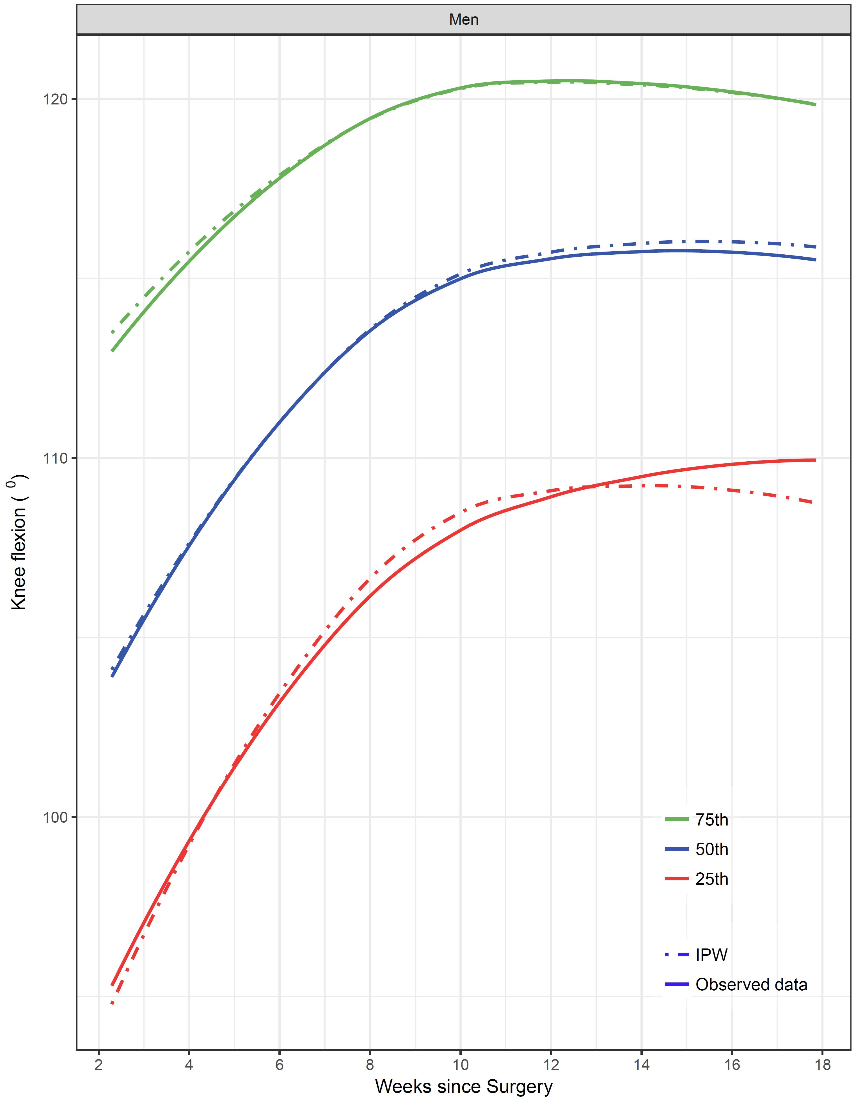 | 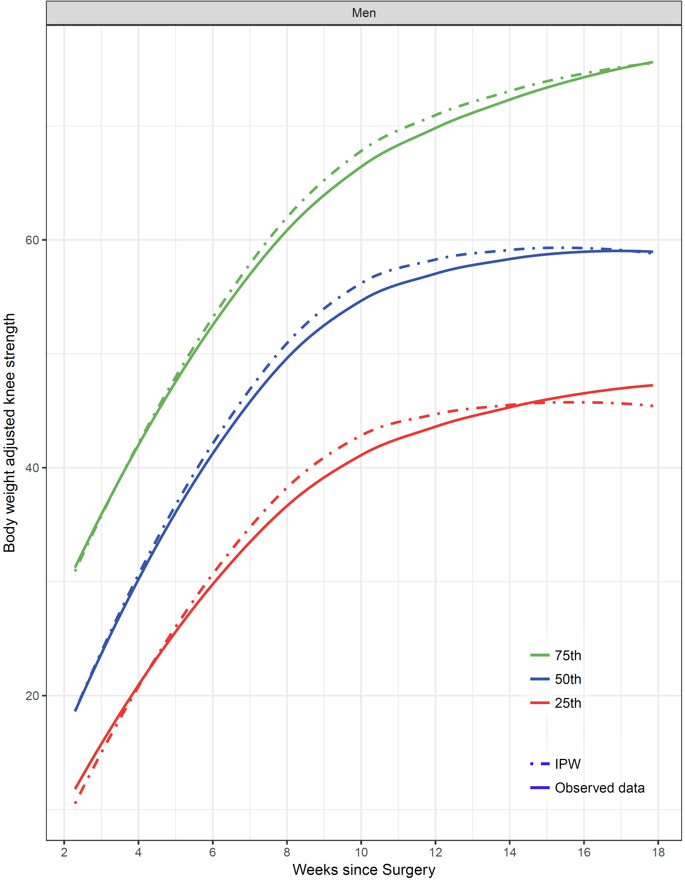 | 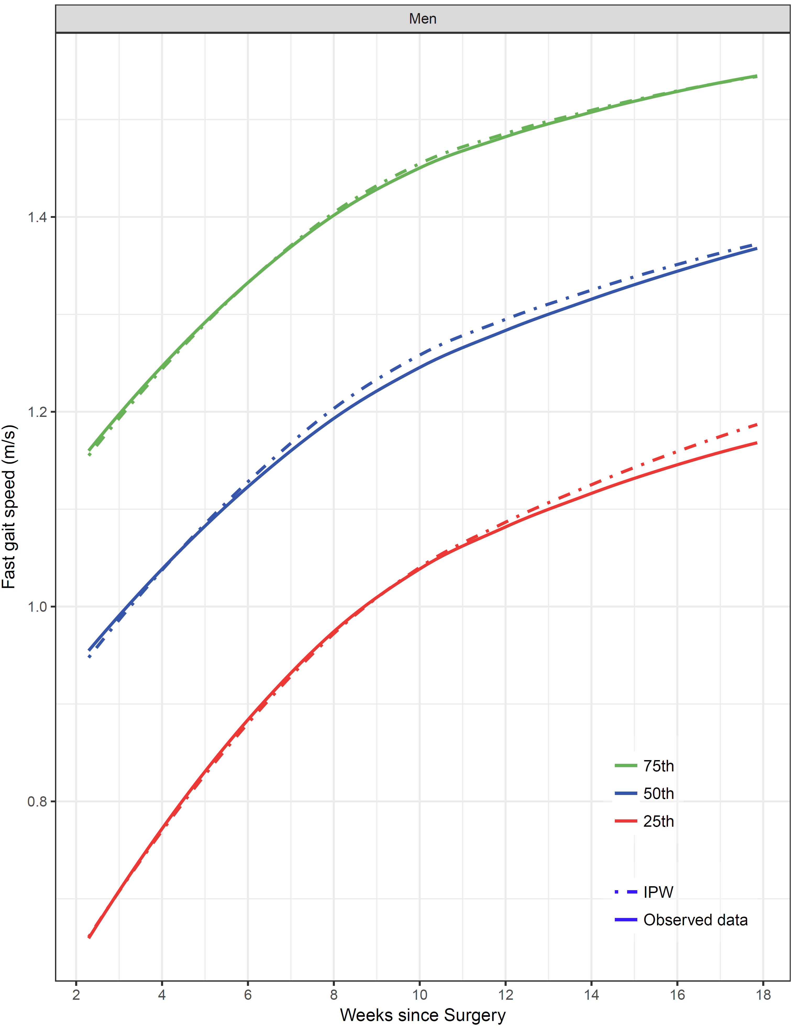
Appendix Figure 2: Median and interquartile range knee flexion range-of-motion (A), body-weight adjusted quadriceps strength (B), and fast gait speed (C) in men estimated using inverse probability weighting (IPW) to adjust for missing data (dot dashed lines) versus using observed data only (solid lines). Blue lines show the estimated medians; red and green lines show the estimated 25th and 75th percentiles, respectively. Age was set to 65 years.

