Positive Scores on the 4AT Delirium Assessment Tool at Hospital Admission are Linked to Mortality, Length of Stay, and Home Time: Two-Centre Study of 82,770 Emergency Admissions

SUPPLEMENTARY DATA

- Supplementary Table 1. 4AT scores and completion rates by age
- Supplementary Table 2. Readmission and mortality outcomes by 4AT score in index hospital admissions in Lothian
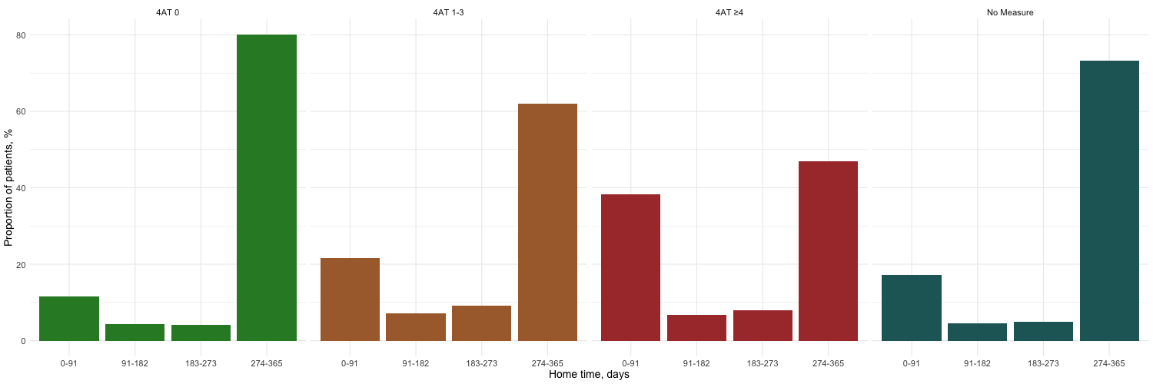
- Supplementary Table 3. Readmission and mortality outcomes by 4AT score in index hospital admissions in Salford
- Supplementary Figure 1. Completion rates of 4AT by month since introduction within electronic health records in Lothian (A) and Salford (B)
- Supplementary Figure 2. Inpatient mortality at 30 days by 4AT score
- Supplementary Figure 3. Density plot showing length of hospital stay distribution by 4AT score in Lothian (A) and Salford (B).
- Supplementary Figure 4. Home time in the year following discharge for survivors of index admission in Lothian (A) and Salford (B)

Supplementary Table 1. 4AT scores and completion rates by age
 | All |  | Lothian |  |  | Salford
Age band (years) | Number of episodes | Completed 4AT (%) | Number of episodes | Mean 4AT  score (SD) | Completed  4AT (%) | Number of episodes | Mean 4AT  score (SD) | Completed  4AT (%)
65-70 | 15,388 | 58 | 7,718 | 0.9 (2.3) | 75 | 7,670 | 1.2 (2.8) | 42
70-75 | 15,200 | 62 | 7,791 | 1.1 (2.4) | 77 | 7,409 | 1.6 (3.2) | 46
75-80 | 16,436 | 65 | 8,830 | 1.4 (2.7) | 78 | 7,606 | 2.0 (3.4) | 49
80-85 | 16,380 | 66 | 9,022 | 1.8 (3.0) | 78 | 7,358 | 2.4 (3.7) | 51
85-90 | 12,301 | 67 | 6,898 | 2.2 (3.2) | 78 | 5,403 | 3.1 (3.9) | 54
>90 | 7,065 | 68 | 3,687 | 2.8 (3.4) | 79 | 3,378 | 3.5 (3.9) | 56
All | 82,770 | 64 | 43,946 | 1.6 (2.9) | 77 | 38,824 | 2.2 (3.5) | 46

Supplementary Table 2. Readmission and mortality outcomes by 4AT score in index hospital admissions in Lothian
 | All | 4AT 0 | 4AT 1-3 | 4AT ≥4 | Not measured
Number of patients | 22,934 | 11,216 (49) | 3,359 (15) | 3,093 (13) | 5,266 (23)
Age, years (SD) | 79 (8) | 78 (8) | 83 (8) | 82 (8) | 79 (8)
Females | 12,807 (56) | 6,131 (55) | 1,934 (58) | 1,798 (58) | 2,944 (56)
Length of stay, median (Q1–Q3) days | 4 (2–13) | 4 (1–9) | 10 (3–27) | 10 (4–29) | 3 (1–8)
Readmission within 30 days | 3,276 (14) | 1,721 (15) | 530 (16) | 297 (10) | 728 (14)
Inpatient mortality at 30 days | 1,523 (7) | 373 (3) | 223 (7) | 561 (18) | 366 (7)
Any inpatient mortality | 2,039 (9) | 465 (4) | 346 (10) | 788 (25) | 440 (8)
All-cause mortality at 1 year | 6,417 (28) | 2,238 (20) | 1,191 (35) | 1,565 (51) | 1,423 (27)
Home time at 1 year, median (Q1–Q3) days | 352  (222–361) | 357  (322–362) | 324  (131–356) | 245  (0–351) | 356  (246–362)
Post-discharge home time at 1 year in index admission survivors, median (Q1–Q3) days* | 365  (334–365) | 365  (354–365) | 363  (251–365) | 361  (177–365) | 365  (340–365)
Values are n (%) unless stated otherwise. *Calculated in 20,895 patients who survived to discharge from index hospital episode

Supplementary Table 3. Readmission and mortality outcomes by 4AT score in index hospital admissions in Salford
 | All | 4AT 0 | 4AT 1-3 | 4AT ≥4 | Not measured
Number of patients | 8,332 | 2,533 | 599 | 845 | 4,355
Age, years (SD) | 78 (8) | 78 (8) | 83 (8) | 82 (8) | 78 (8)
Females | 4,548 (55) | 1,349 (53) | 368(61) | 480 (57) | 2,351 (54)
Length of stay, median (Q1–Q3) days | 3 (1–9) | 4 (1– 9) | 6 (2–15) | 6 (2–17) | 2 (0–7)
Readmission within 30 days | 1,306 (16) | 374 (15) | 133 (22) | 144 (17) | 655 (15)
Inpatient mortality at 30 days | 413 (5) | 79 (3.1) | 44 (7) | 116 (14) | 174 (4)
Any inpatient mortality | 485 (6) | 90 (4) | 56 (9) | 133 (16) | 206 (4.7)
All-cause mortality at 1 year | 2,005 (24) | 447 (18) | 213 (36) | 377 (45) | 968 (22)
Home time at 1 year, median (Q1–Q3) days | 354  (270–363) | 356  (319–362) | 321  (98–355) | 295  (30–354) | 357  (291–364)
Post-discharge home time at 1 year in index admission survivors, median (Q1–Q3) days* | 363  (324–365) | 364  (344–365) | 350  (240–365) | 351  (144–365) | 364  (332–365)
Values are n (%) unless stated otherwise. *Calculated in 7,847 patients who survived to discharge from index hospital episode

Supplementary Figure 1. Completion rates of 4AT by month since introduction within electronic health records in Lothian (A) and Salford (B)

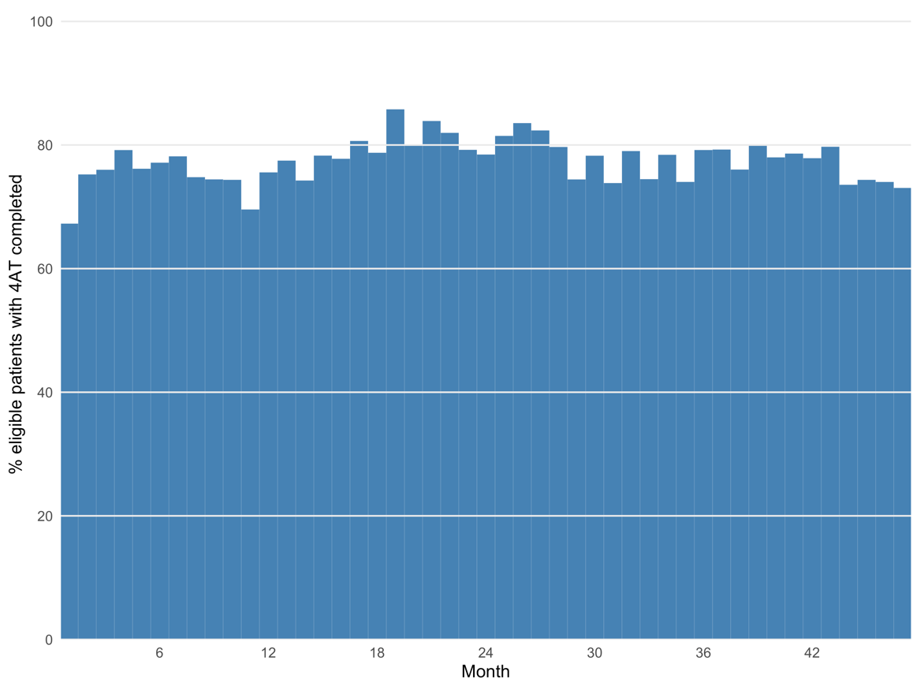
A B
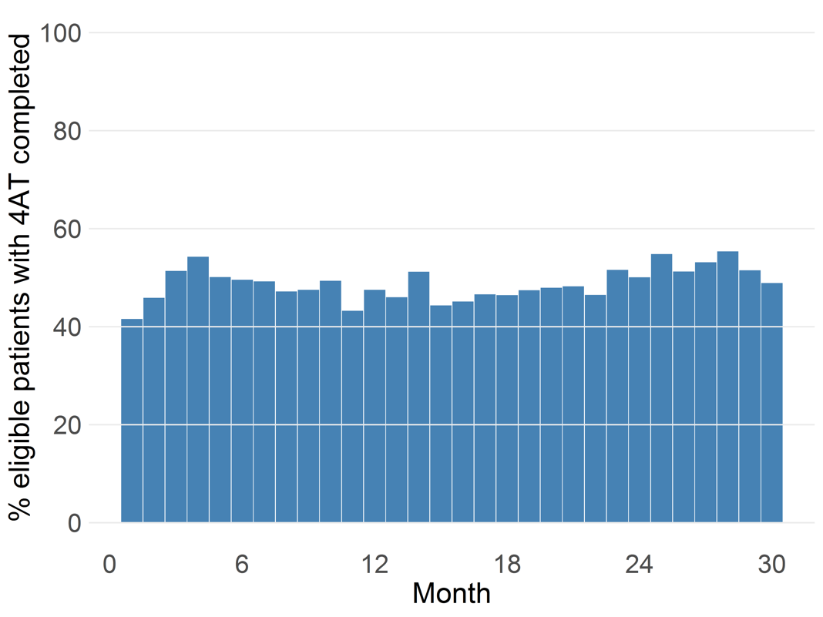

Supplementary Figure 2. Inpatient mortality at 30 days by 4AT score

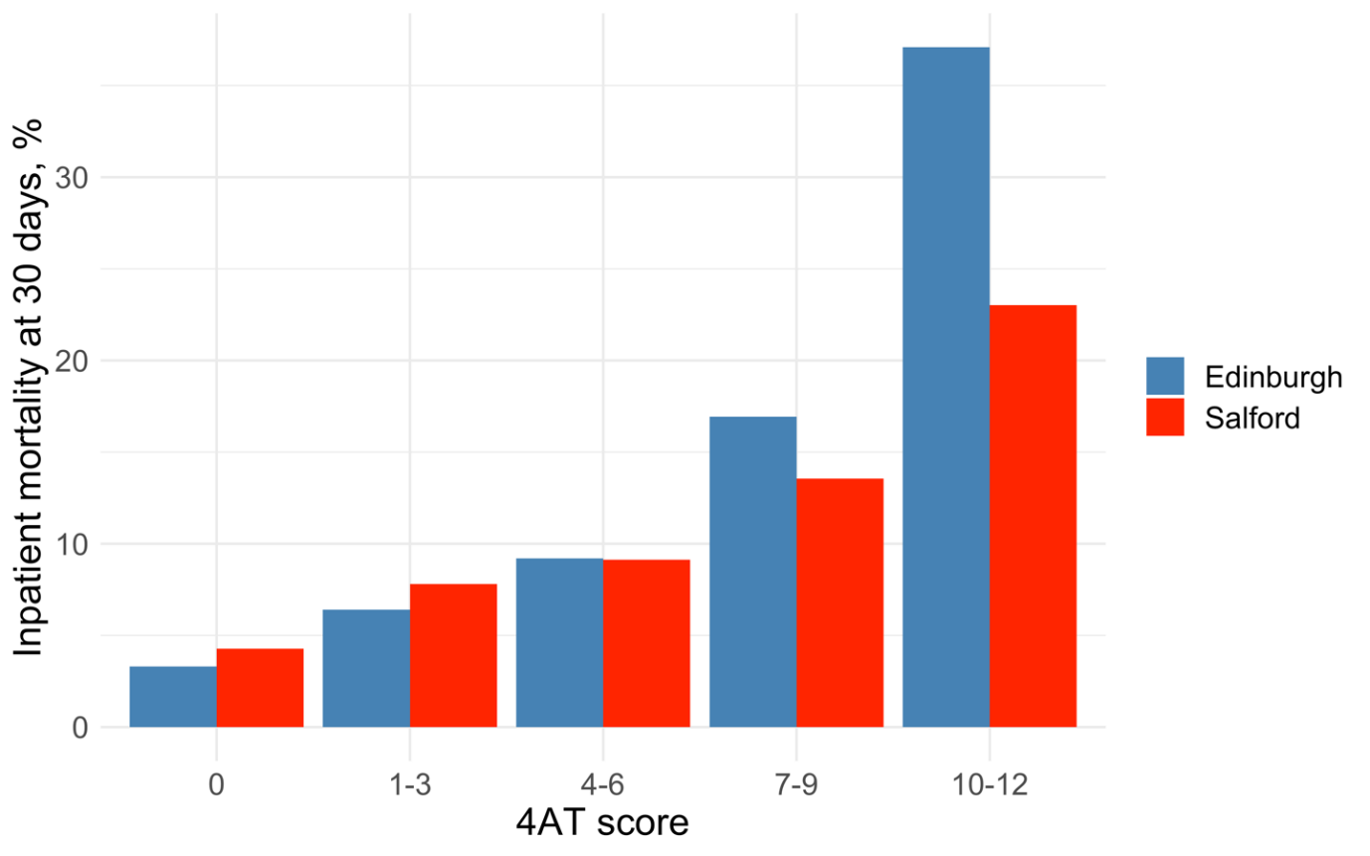
Supplementary Figure 3. Density plot showing length of hospital stay distribution by 4AT score in Lothian (A) and Salford (B).
A
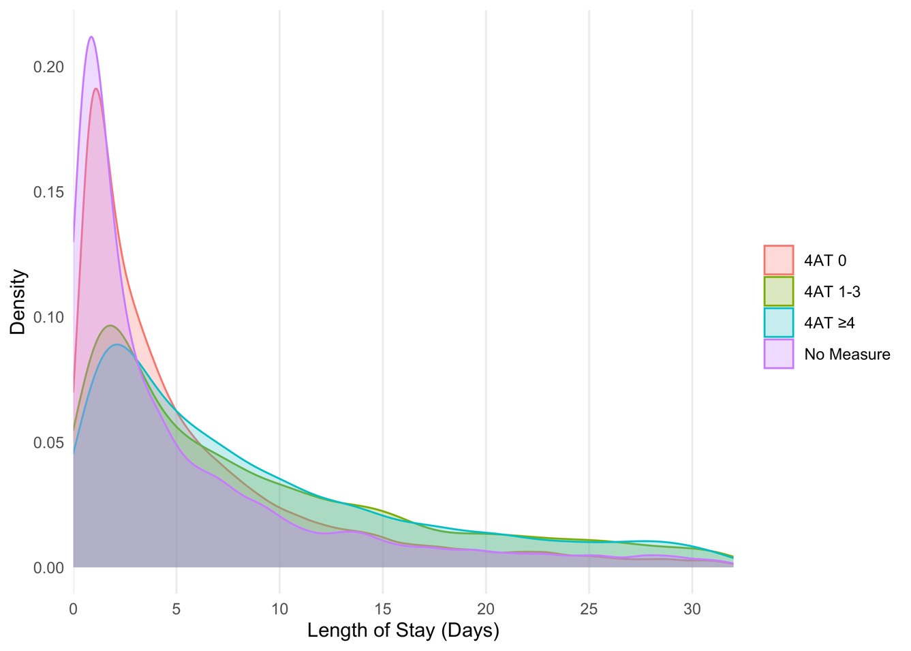
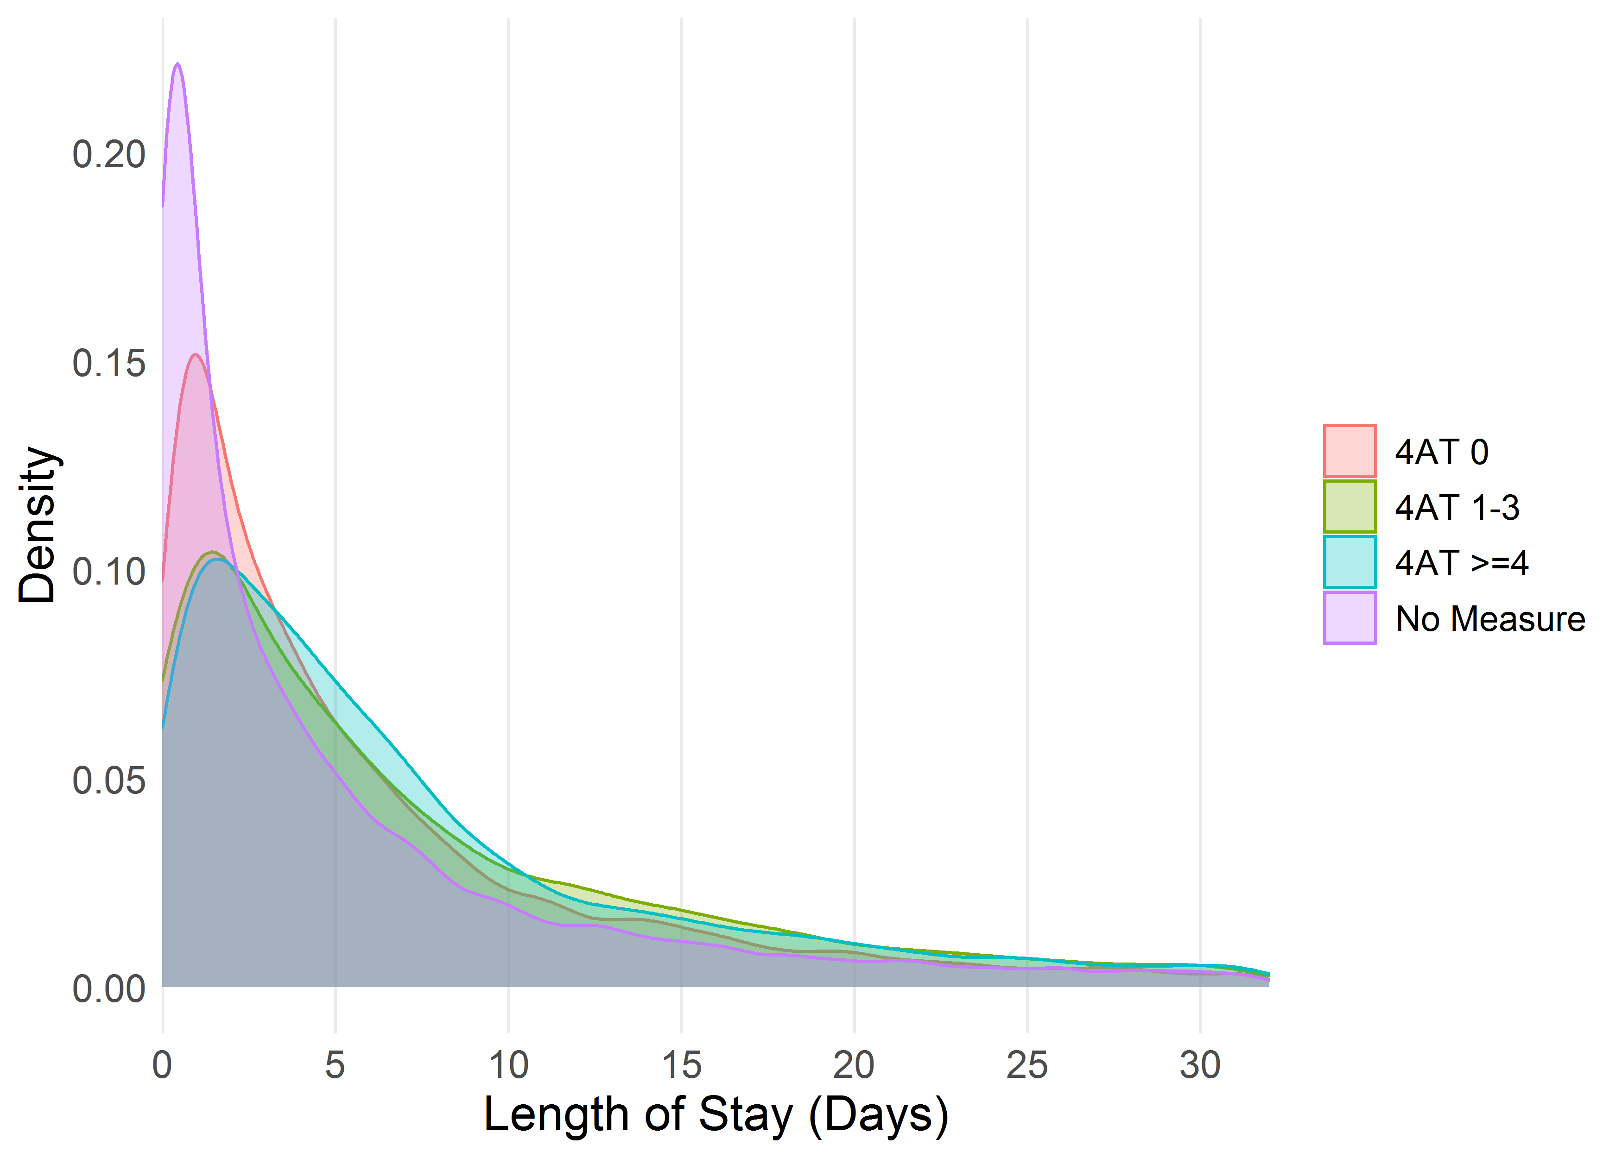
B

Supplementary Figure 4. Home time in the year following discharge for survivors of index admission in Lothian (A) and Salford (B)
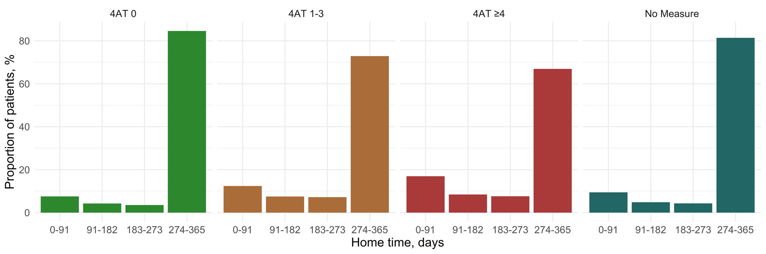
A

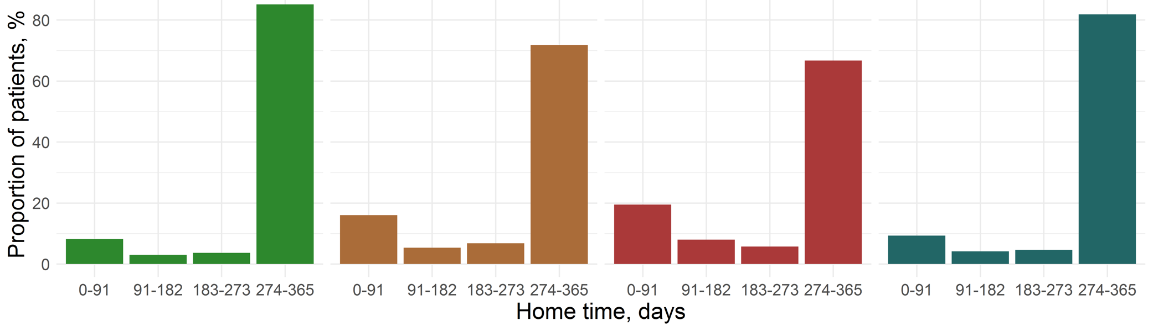
B

