Supplementary Material Table S1. List of vocal parameters measured and their descriptions, many of which were first described in Price et al. (2007).

Character | Description
Average note length | Summed note duration divided by the number of notes in a song
Average pause length | Summed pause duration divided by the number of pauses in a song
Minimum frequency | Minimum fundamental frequency occurring in a song
Maximum frequency | Maximum fundamental frequency occurring in a song
Peak frequency | Fundamental frequency with the highest amplitude in the entire song
Average note bandwidth | The average frequency range of notes within a song
Song bandwidth | Difference between the maximum and minimum fundamental frequencies in a song
Frequency shift rate | Number of frequency sweeps that span >1 kHz and ≤20 ms divided by the song duration
Maximum frequency shift | Greatest change in frequency within a 20 msec time window
Note rate | Number of notes in a song divided by the song duration
Trill rate | Number of notes per second in a trill. A minimum of five repeated notes within a second duration defined a trill

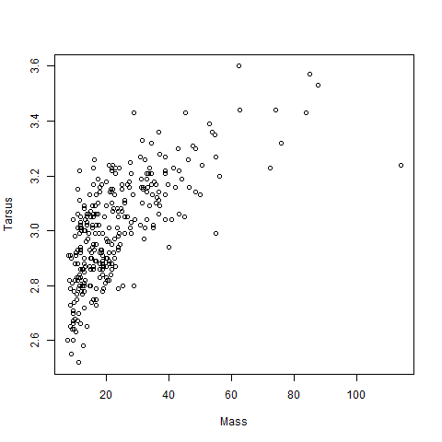
Figure S1. Plot demonstrating the collinearity between body mass and tarsus length (Spearman’s Rank Correlation, r² = 0.60, p = 2.2^{e–16}). The positive association between these two characters illustrates the positive scaling relationship between the two different proxies for body size, hence our confidence in using tarsus length in our study.

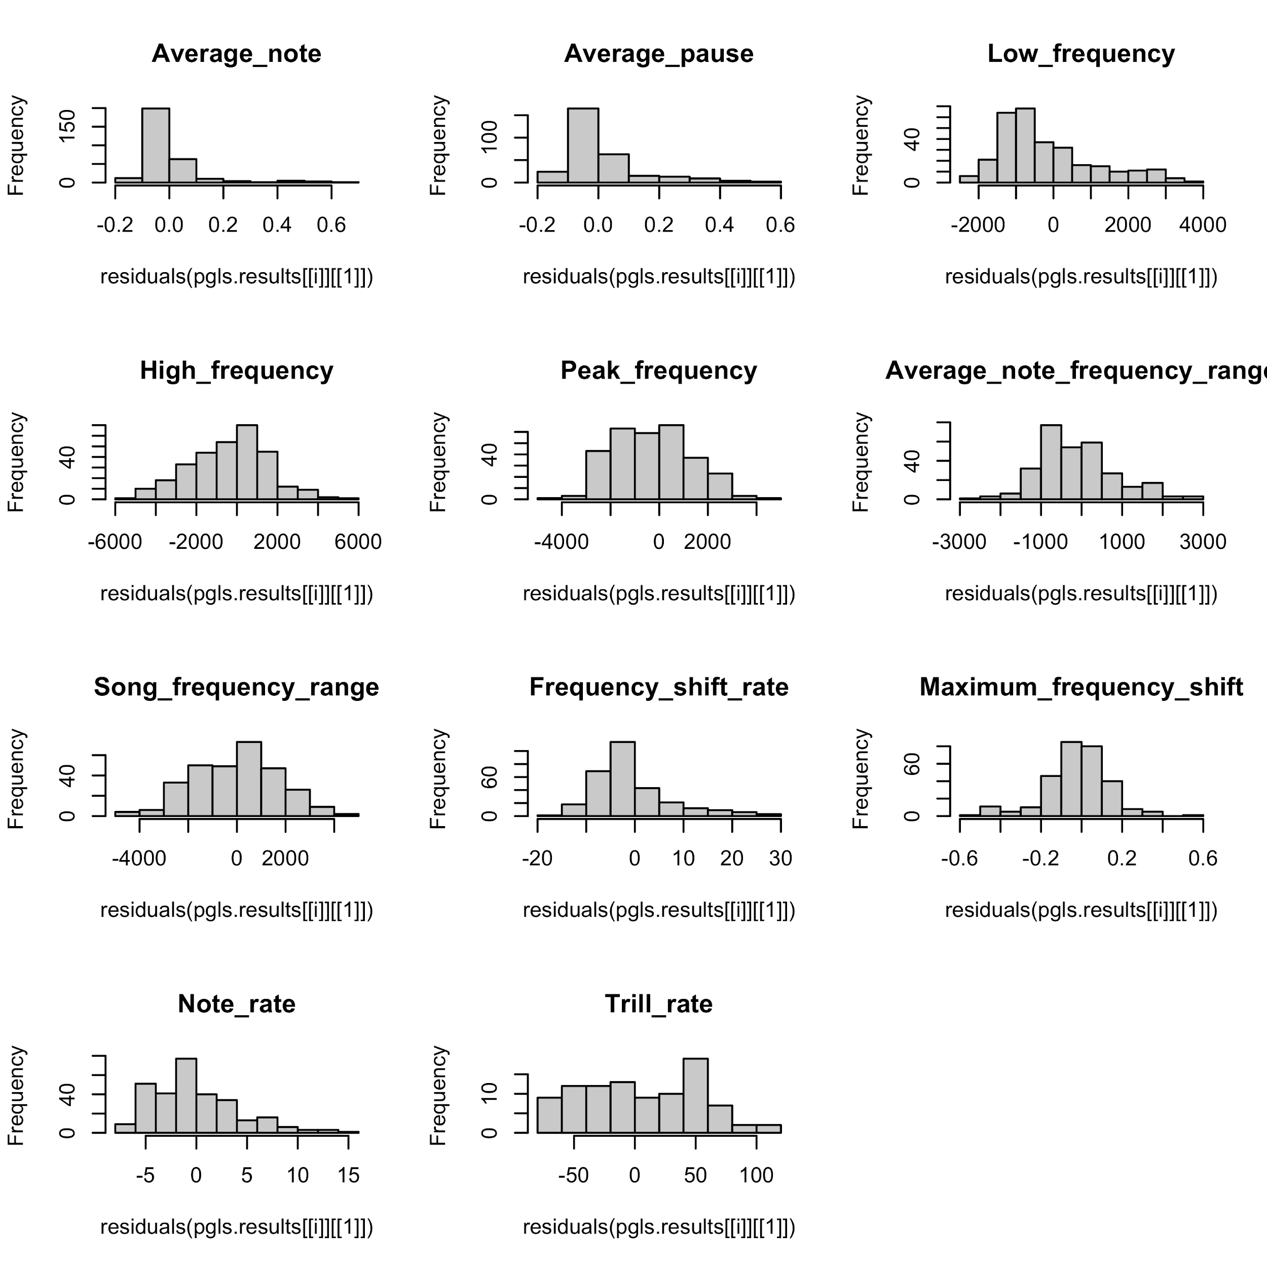
Figure S2. Plot of the residual distribution of the song variables before log-transformation.

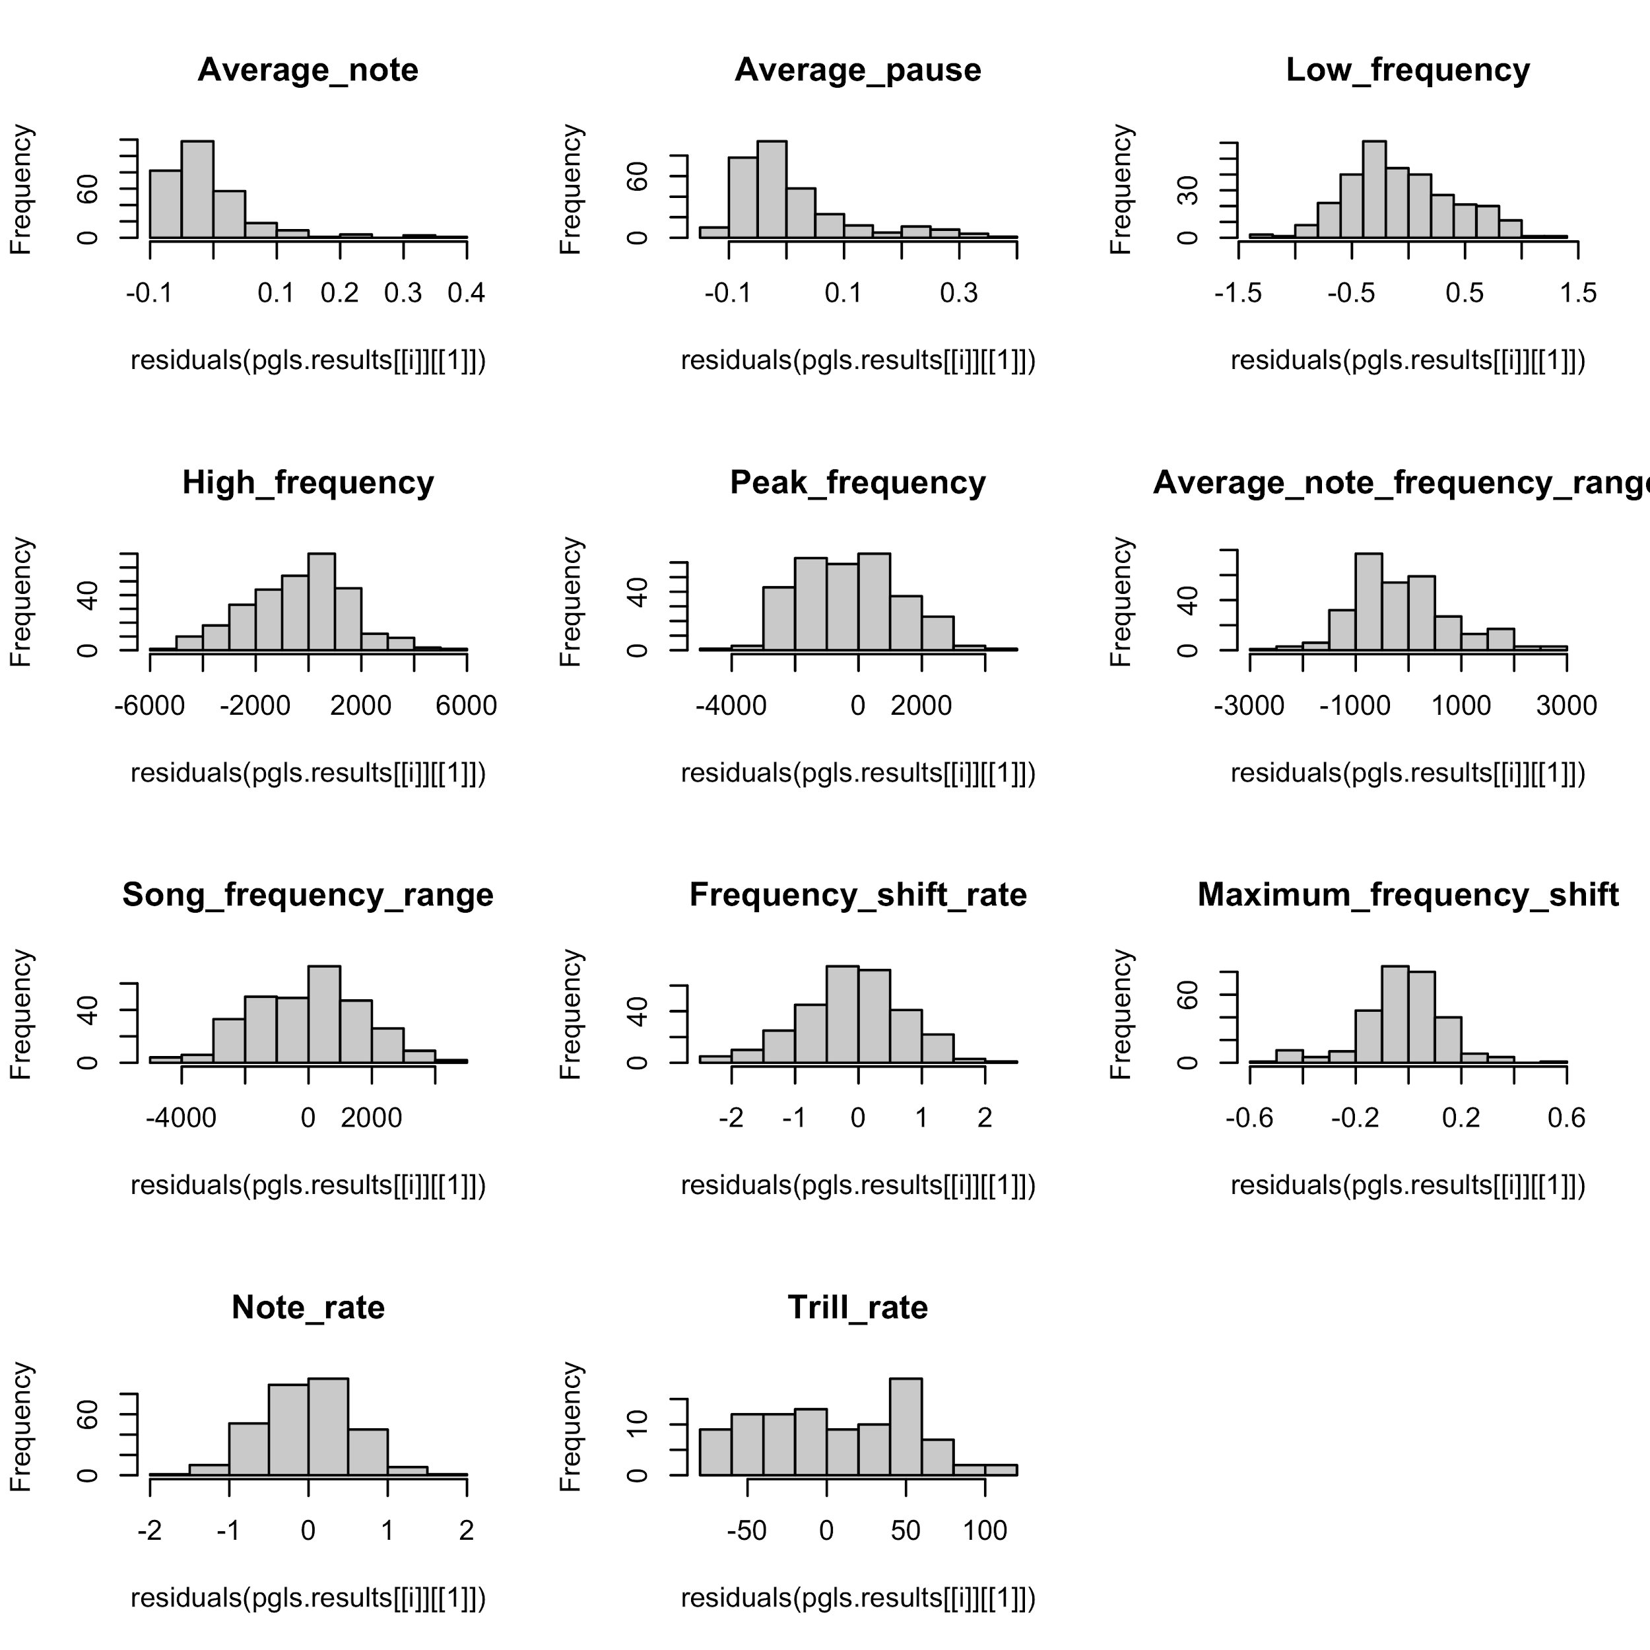
Figure S3. Plot of the residual distribution of the song variables after log-transformation.

