Supplementary Material S1. Maximum likelihood approach for identifying photographic bouts. The timestamps of subsequent different individuals photographed by the same camera/photographer were used to estimate photographic bouts. Our dataset could be divided into bouts of photographs taken within and between groupings: the first process corresponded to taking pictures of different individuals in a very short time period (in the same grouping, surfacing in close proximity); the second process corresponded to taking pictures of different groupings of whales in close spatial proximity. A 3 process model explained the data better than a 2 process model (2 processes AIC = 107891.6, 3 processes AIC = 106741.9, Likelihood ratio = 1149.725, p-value = 0). The third process corresponded to a longer time without taking pictures, such as when stopping for acoustic recordings. The analysis was performed in R 3.2.3 (R Core Team 2015) using the package DiveMove (Luque 2007) adapting its functions to model a mixture of 2 Poisson processes to identify bouts of behavior to functions to model a mixture of 3 Poisson processes.

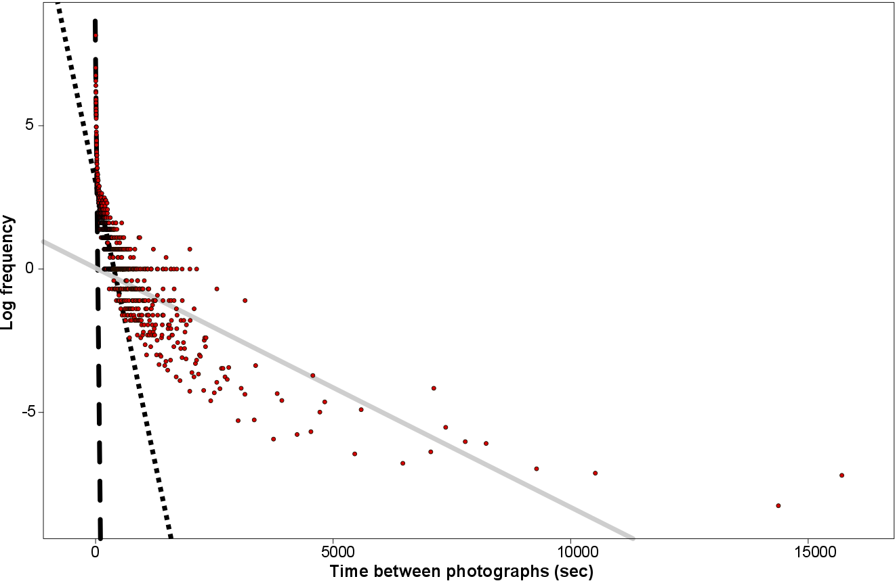
Figure S1. 3 processes broken stick model fitted to the log frequency of the time interval between subsequent different individuals photographed by the same camera/photographer. Lines show the values of bout ending criterion: the dashed line represents the end of the first process, the dotted line represents the end of the second process and the smooth grey line the end of the third process.

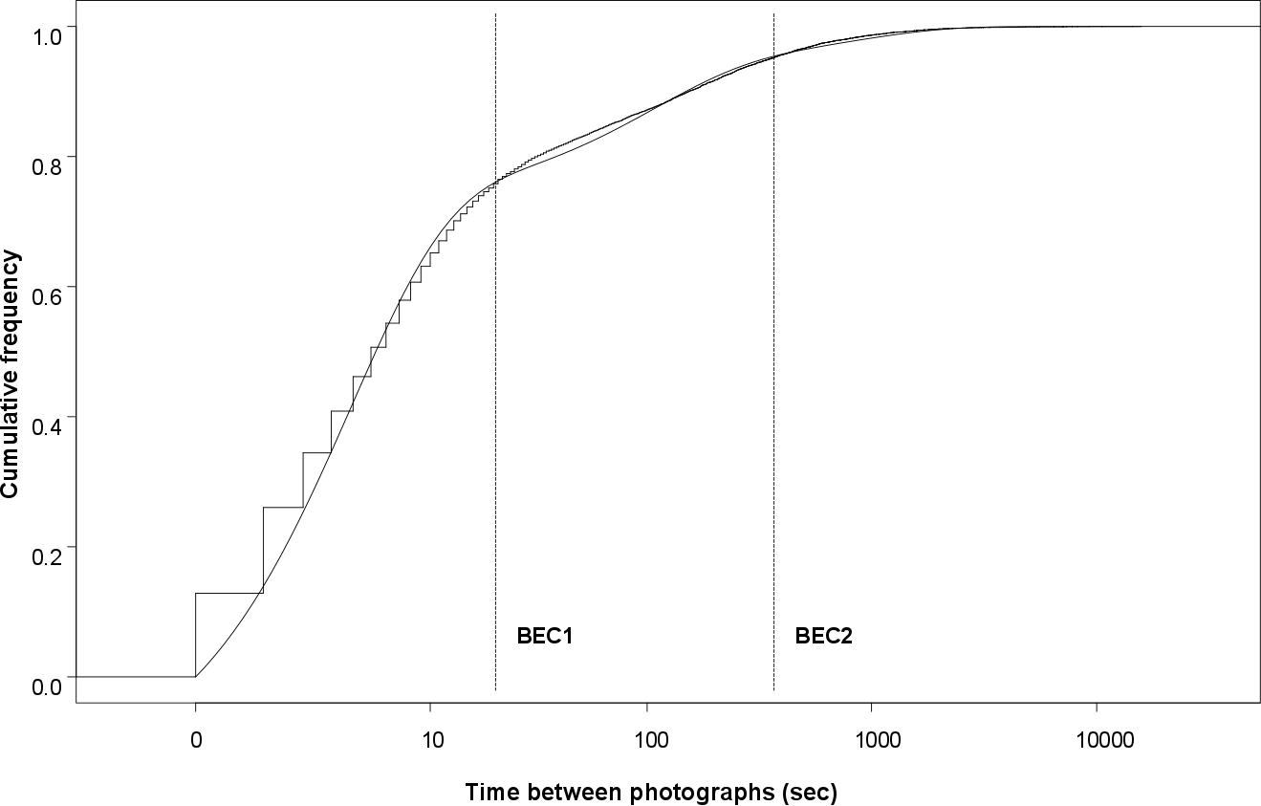
Figure S2. Relative observed cumulative frequencies (stepped function) and estimated cumulative frequencies (smooth line) through the maximum likelihood method. Vertical lines mark the values of bout ending criterion. The first process (BEC1) ends at 20 seconds and the second process (BEC2) ends at 368 seconds.

References
Luque SP. 2007. Diving behaviour analysis in R. R News 7:8–14.
R Core Team. 2015. R: A language and environment for statistical computing.

