Supplementary Material S2. Patterns of association using a relatively more restrictive and a more permissive temporal association criteria, associated for the day if photographed within 5 seconds or 1 hour, respectively. Using both association criteria, the half-weight index (HWI) was calculated for individuals seen in more than 4 different days. There was no variation in general association patterns when fluctuating the association criterion, with associations not being clearly stratified into hierarchical tiers (no change to clear stratification of the rate of cumulative bifurcation with changing association criteria). The HWI value to which hierarchical clusters could be classified was lower for the 5 seconds association criteria (0.015) and slightly higher to the 1 hour criteria (0.121) compared to the 20 seconds criteria (0.024). The smaller value potentially omits some associations and the larger value probably includes non-associated dyads of individuals. We calculated the social differentiation for both criteria using the likelihood method with non-parametric bootstrap for calculating its standard error (SE) and sampling periods chosen randomly for each of 1000 bootstrap samples (Whitehead 2008). The social differentiation for the 5 seconds criterion was S ± SE = 0.851 ± 0.024 and for the 1 hour criterion was S ± SE = 0.900 ± 0.029, both lower than the obtained value with the criterion used in this study (S ± SE = 0.978 ± 0.025). This indicated that the chosen temporal criterion provided the higher variability of association indices within the population and the more likely meaningful temporal association value for the animals’ social structure.

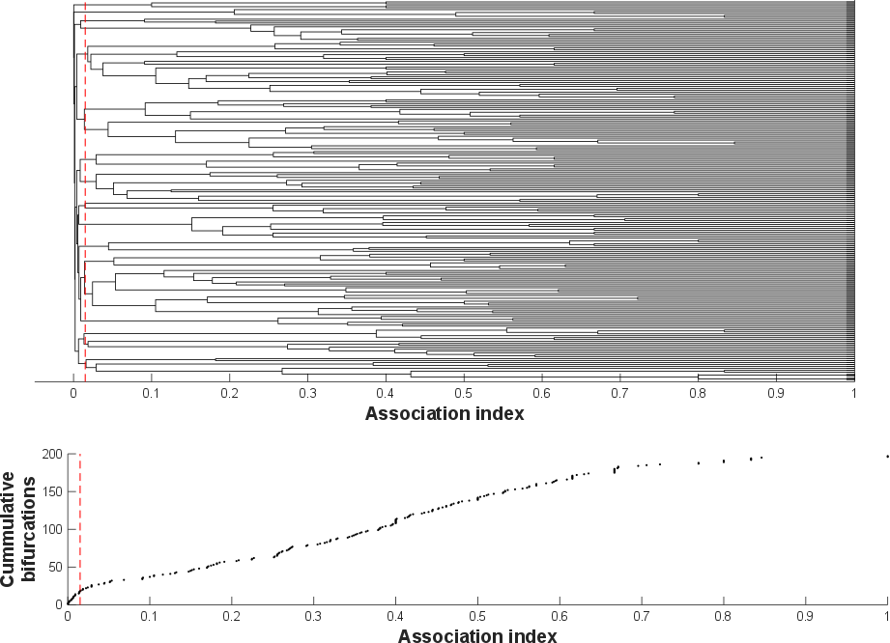
Figure S3. Average-linkage cluster dendogram (cophenetic correlation coefficient [CCC] = 0.93) and knot diagram of cumulative bifurcations for the 198 individuals encountered in more than 4 days and associated if photographed whithin 5 seconds. A maximum modularity-G, within hierarchical clustering, of 0.73 suggests a division into distinct clusters at an HWI of 0.015 (dashed line).

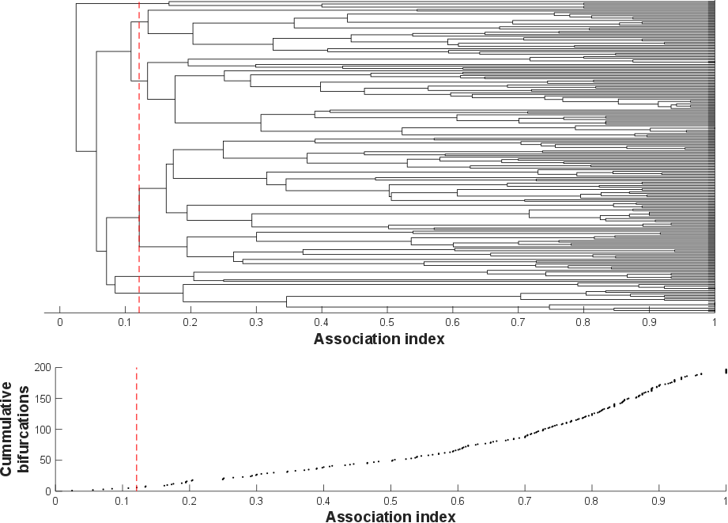
Figure S4. Average-linkage cluster dendogram (cophenetic correlation coefficient [CCC] = 0.81) and knot diagram of cumulative bifurcations for the 198 individuals encountered in more than 4 days and associated if photographed whithin 1 hour. A maximum modularity-G, within hierarchical clustering, of 0.28 suggests a division into distinct clusters at an HWI of 0.121 (dashed line).

References
Whitehead H. 2008. Precision and power in the analysis of social structure using associations. Anim. Behav. 75:1093–1099.

