Supplementary Material S3. Effect of observation threshold on observed population structure.
To evaluate the consistency of the results due to the removal of infrequently observed individuals we used sequentially larger observational thresholds. Whitehead (2008) recommended a minimum of 5 identifications and testing further thresholds of 10 and 20 sampling periods to see whether results change substantially.
With increasing observational threshold the number of individuals included in the study gradually decreases (Figure S5). Restricting the data to individuals seen in ≥ 5 days includes 198 individuals, while ≥ 10 days includes 117 and ≥ 20 days only 30 individuals (see Table S1 for details). The mean half-weight index (HWI) and mean non-zero HWI of the population obtained were very similar across observational thresholds (see Table S1). The distribution of non-zero HWI values observed (Figure S6 and Table S1) was also very similar across thresholds, with a high proportion of low level associations and relatively fewer strong ties at high HWI values. The proportion of high values of HWI was very similar and the proportion of HWI = 1 was extremelly small even for the less restrictive threshold.
Despite the very low number of individuals, a restriction of ≥ 20 sightings also presents a network more interconnected at low HWI thresholds that fragments quickly at low HWI values and presents small sets of individuals connected at stronger ties (i.e. HWI = 0.5; Figure S7). However, ≥ 20 sightings restricts the analysis to the more resighted individuals in the study and includes only one of the individuals seen only in the winter. Thus this restriction would barely include the different movement patterns observed in the population and impairs a comprehensive analysis of the modular population structure linked to the population turnover. Results were consistent when including more individuals, with different movement patterns, at a threshold of ≥ 5 and ≥ 10. Regardless of the threshold, associations did not appear to be clearly stratified into hierarchical tiers. On both hierarchical dendogram display (≥ 5 - Figure 2 on main text; ≥ 10 – Figure S8) the divergence of social clusters occurred at similar extremely low HWI values (see Table S1) and the rate of cumulative bifurcations on the knot diagram was highly constant. Also, the network diagrams for both thresholds were highly interconnected at low HWI thresholds and fragmented quickly with the removal of links at low HWI values (≥ 5 - Figure 3 on main text; ≥ 10 – Figure S9).
Using Newman’s (2006) clustering technique, both thresholds presented a similarly high modularity, significantly dividing the population into social clusters with similar mean sizes (see Table S1). The lower number of clusters for the ≥ 10 restriction is due to the considerably lower number of individuals, with clusters being similar in membership to the ones obtained using ≥ 5 threshold or resulting from the combination of clusters from the ≥ 5 analysis into new ones. Restricting from ≥ 5 to ≥ 10 resulted in the removal of 5 clusters due to the higher restriction on individual sightings, but interestingly these were intermediate complexity clusters (M and R) and stale clusters (N and O), except for cluster F discarded from the clustering classification when using the ≥ 5 treshold (see main text for more details). Using the ≥ 10 restriction, the obtained social clusters remained similarly variable in complexity and also not completely discriminated by movement pattern (Figure S10). In fact, despite the higher restriction, 3 clusters were still composed of a mix of individuals sighted in both seasons and individuals sighted in a single season. One of these was composed by the individuals sighted in Scotland in the summer and individuals seen in Iceland year-round, both still significantly associated to be clustered together.
Since the results were similar between ≥ 5 and ≥ 10 sightings restrictions, we chose to include individuals seen in at least 5 sampling periods in the main paper, substantially increasing the sample size from 117 to 198 individuals and therefore allowing a better exploration of the full population structure than the ≥ 10 threshold.
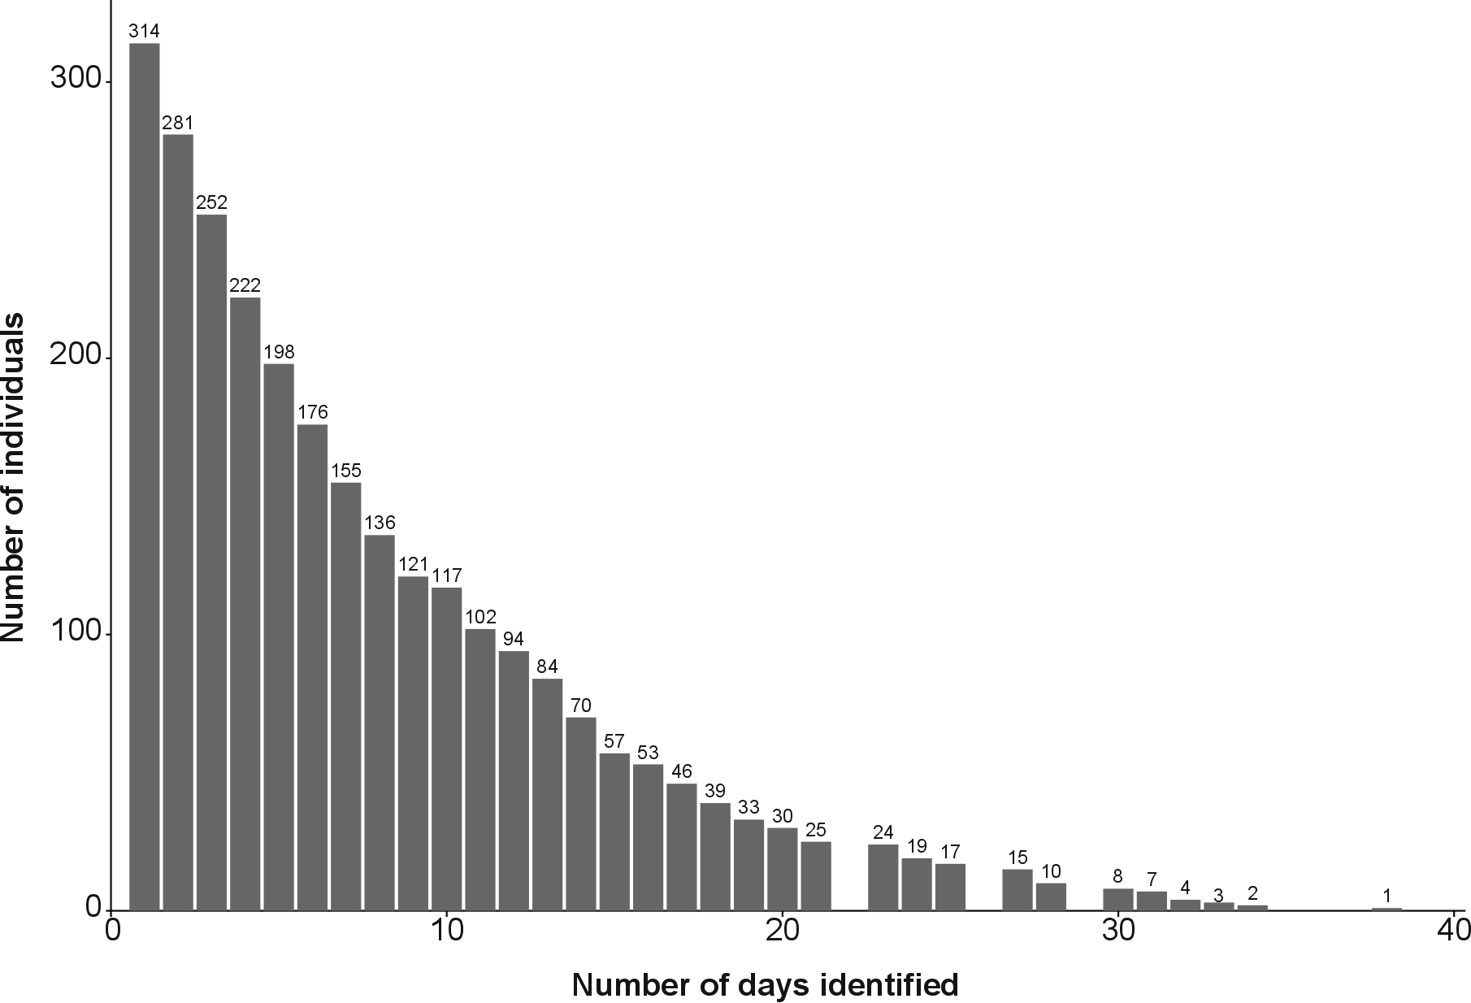
Figure S5. Histogram of the number of individuals included in the study for diferent observational tresholds (number of days identified).

Table S1. Summary of the main results using 3 different observational thresholds.
Observational threshold (days) | ≥ 5 | ≥ 10 | ≥ 20
n | 198 | 117 | 30
Included movement patterns ¹ | 51 W  32 S  115 B | 29 W  13 S  75 B | 1 W  6 S  23 B
Mean ± SD sightings | 12.57 ± 7.13 days | 16.78 ± 6.45 days | 26.17 ± 4.76 days
Mean ± SD HWI | 0.02 ± 0.01 | 0.03 ± 0.01 | 0.08 ± 0.03
Non-zero mean ± SD HWI | 0.18 ± 0.19 | 0.22 ± 0.28 | 0.16 ± 0.19
Proportion of HWI values | Figure S6
< 0.1 | 51.4% (1161 associations) | 63.8 % (889 associations) | 59.9% (124 associations)
≥ 0.5 | 9.9% (224 associations) | 8.6% (120 associations) | 9.7% (20 associations)
≥ 0.8 | 0.9% (21 associations) | 0.7% (10 associations) | 0.97% (2 associations)
Dendogram
Divergence of clusters at HWI | 0.02 | 0.04 | 0.18
Modularity | 0.679 | 0.635 | 0.497
Network diagrams | Figure 3 – main text | Figure S9 | Figure S7
Fragmentation | Rapid at HWI > 0.1 | Rapid at HWI > 0.1 | Rapid at HWI > 0.1
Newman’s (2006) clustering | 18 clusters | 11 clusters | 7 clusters
Modularity | 0.656 | 0.631 | 0.502
Sizes | 3-33 individuals, mean ± SD of 11 ± 7.77 individuals per cluster | 3-22 individuals, mean ± SD of 11 ± 5.46 individuals per cluster | 2-9 individuals, mean ± SD of 4 ± 2.29 individuals per cluster
n, number of individuals in the analysis; HWI, half-weight index of association; SD, standard deviation.
¹ Movement patterns: W – only seen in the winter, S – only seen in the summer, B – seen in both seasons.

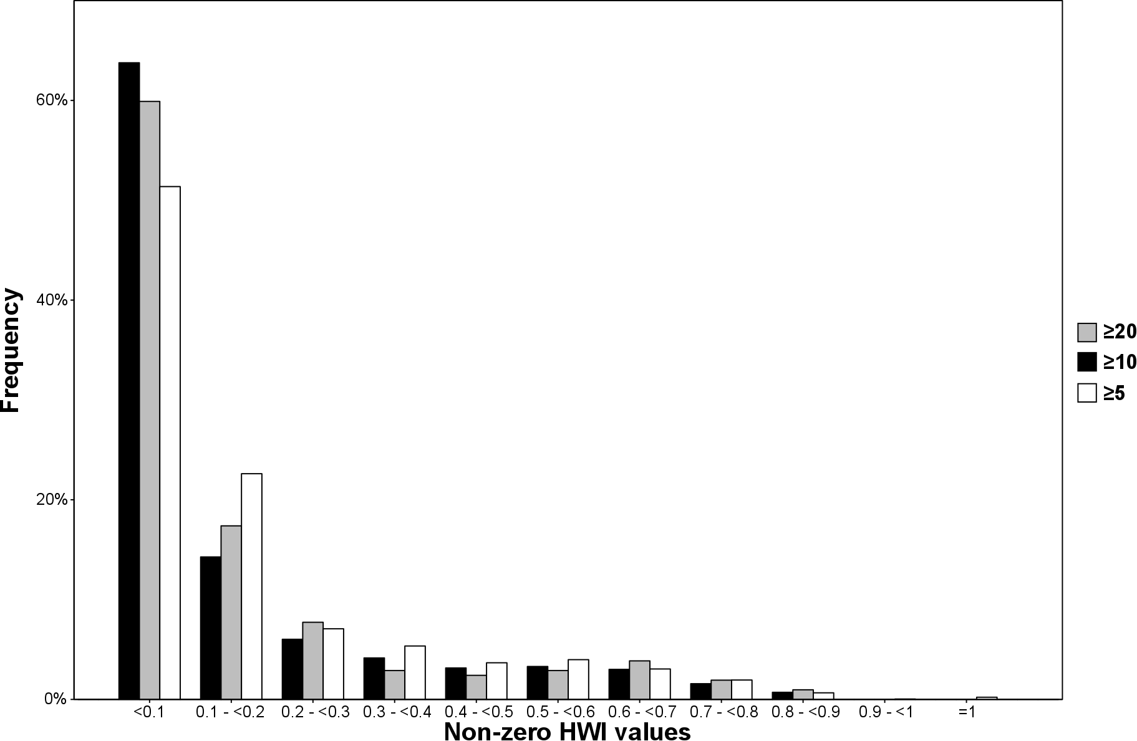
Figure S6. Distribution of non-zero HWI values in the population using 3 observational thresholds (≥ 5, ≥ 10 and ≥ 20 sightings).

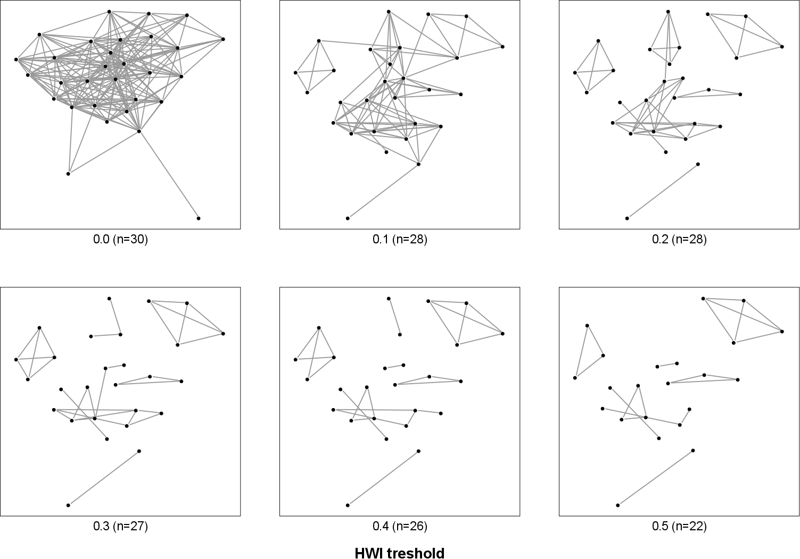
Figure S7. Network fragmentation with increasing HWI threshold using ≥ 20 observational restriction. Isolated individuals are removed from the network (n indicates the number of individuals present). Plotted using Fruchterman-Reingold force-directed layout (Fruchterman and Reingold 1991).

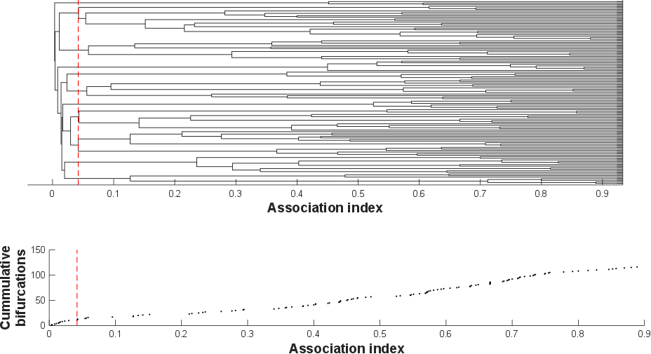
Figure S8. Average-linkage cluster dendogram (cophonetic correlation coefficient [CCC] = 0.94) and knot diagram of cumulative bifurcations for the ≥ 10 treshold. A maximum modularity-G, within hierarchical clustering, of 0.64 suggests a division into distinct clusters at an HWI of 0.042 (dashed line).

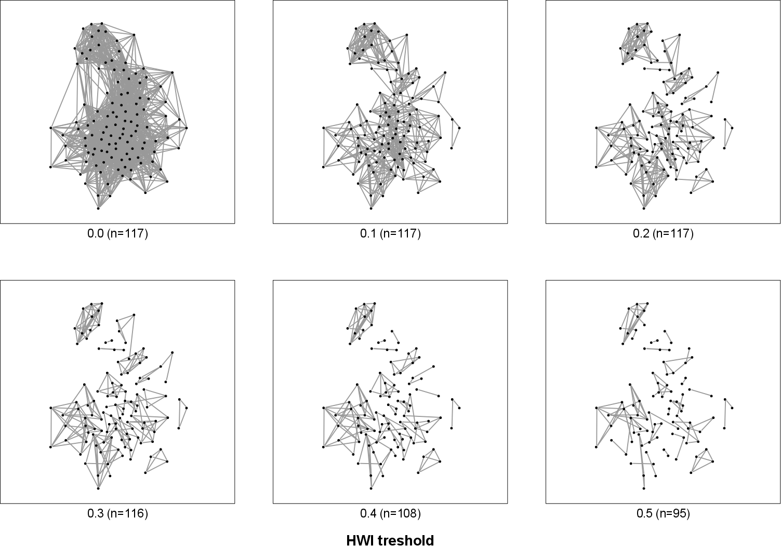
Figure S9. Network fragmentation with increasing HWI threshold using ≥ 10 observational restriction. Isolated individuals are removed from the network (n indicates the number of individuals present). Plotted using Fruchterman-Reingold force-directed layout (Fruchterman and Reingold 1991).
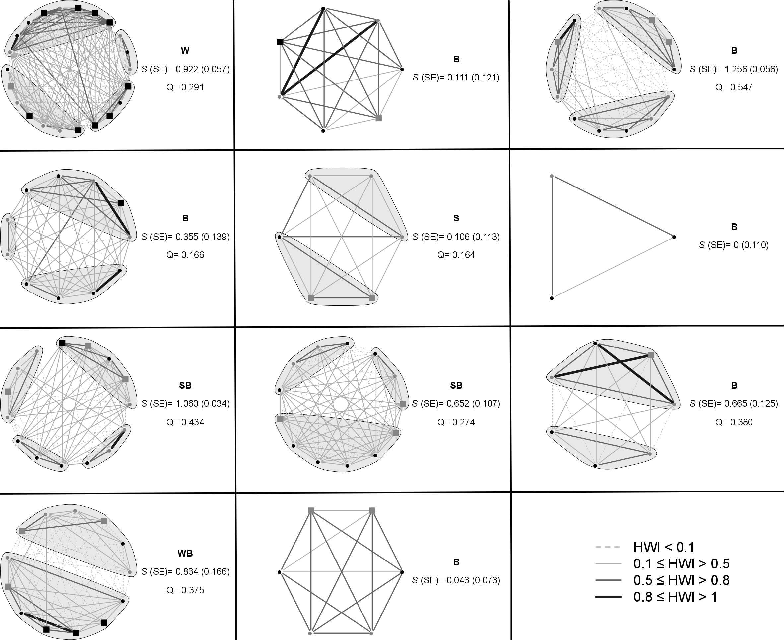
Figure S10. Sociograms of the 11 clusters obtained using the ≥ 10 treshold. The thickness of the edges is related to the HWI value of association as shown in the lower-right panel. Nodes represent individuals and are shaped/colored based on age-sex class (black circle: Female; grey circle: Male; black square: Other; grey square: Juvenile). For each cluster, the movement pattern of non-juvenile members is indicated by different characters: W – only seen in the winter, S – only seen in the summer, B – seen in both seasons, WB – seen only in the winter or in both seasons, SB – seen only in the summer or in both seasons. S (SE) indicates the social differentiation (standard error). Q indicates the modularity of potential subcluster division.

References
Fruchterman TMJ, Reingold EM. 1991. Graph drawing by force-directed placement. Softw. Pract. Exp. 21:1129–1164.
Newman MEJ. 2006. Modularity and community structure in networks. Proc. Natl. Acad. Sci. U. S. A. 103:8577–8582.
Whitehead H. 2008. Analyzing animal societies: quantitative methods for vertebrate social analysis. Chicago, USA: University Of Chicago Press.

