Supplementary Material S5. Patterns of association for the most encountered adult females.

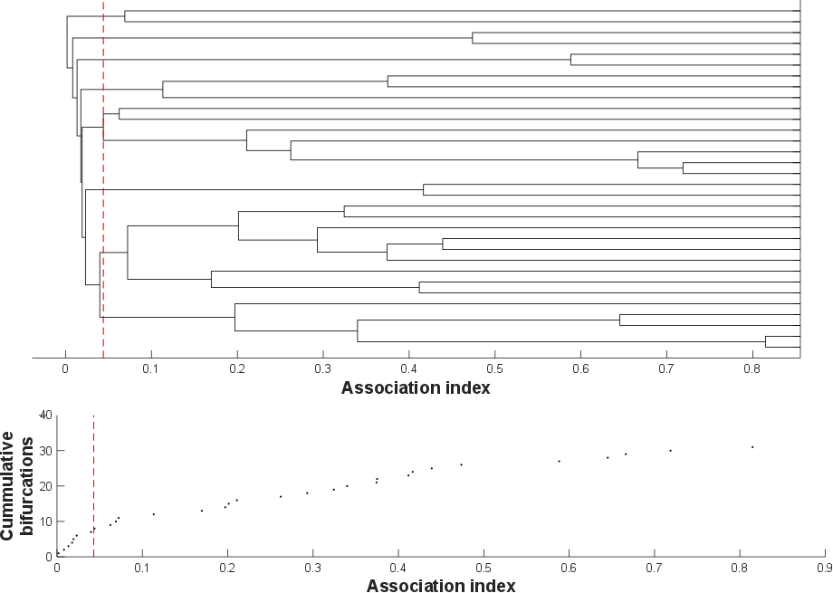
Figure S11. Average-linkage cluster dendogram (cophenetic correlation coefficient [CCC] = 0.93) and knot diagram of cumulative bifurcations for the 32 most encountered adult females (on more than 10 days over at least 3 years). A maximum modularity-G, within hierarchical clustering, of 0.48 suggests a division into distinct clusters at an HWI of 0.043 (dashed line).

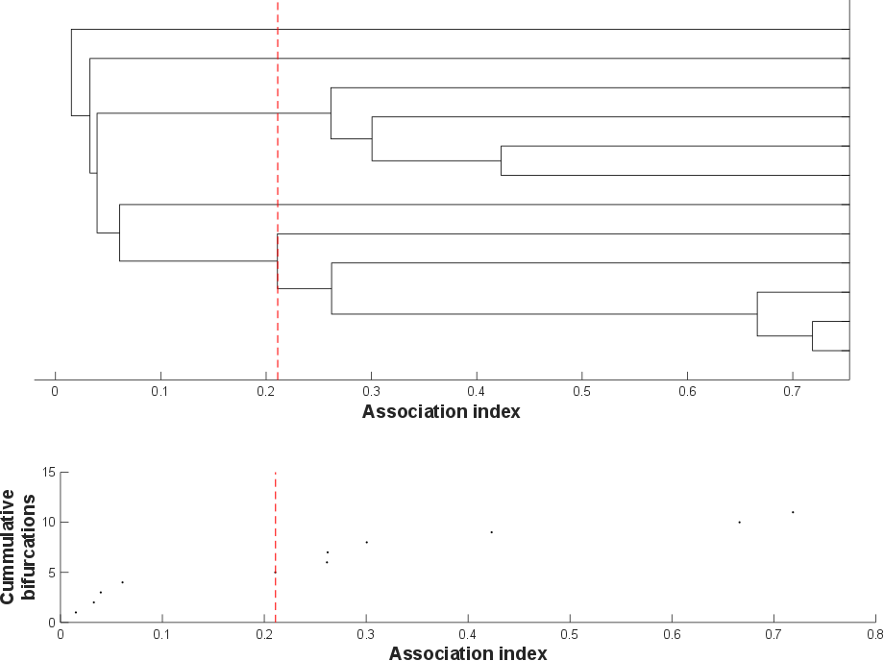
Figure S12. Average-linkage cluster dendogram (cophenetic correlation coefficient [CCC] = 0.96) and knot diagram of cumulative bifurcations for the 12 most encountered adult females (on at least 20 days over at least 3 different years). A maximum modularity-G, within hierarchical clustering, of 0.39 suggests a division into distinct clusters at an HWI of 0.211 (dashed line).

