DelPhiForce web server: electrostatic forces and energy calculations and visualization
Lin Li¹, Zhe Jia¹, Yunhui Peng¹, Arghya Chakravorty¹, Lexuan Sun¹ and Emil Alexov^{1,*}

¹Department of Physics, Clemson University, Clemson SC. 29631
*To whom correspondence should be addressed.

DelPhiForce algorithm:
- Electrostatic potential: DelPhi program.
The core part of the DelPhiForce software, which calculates the electrostatic forces, is performed by the DelPhi program (Li, et al., 2012). DelPhi solves Poisson-Boltzmann equation (PBE) to deliver the electrostatic potentials of biomolecules (Li, et al., 2012). The corresponding PBE is:
$∇∙\left[ϵ\left(r\right)∇ϕ\left(r\right)\right]=-4πρ\left(r\right)+κ^{2}\left(r\right)sinh⁡({ϕ(r)}/{k_{B}T})$ (1)
where$ϕ(r)$ is the electrostatic potential, $ϵ\left(r\right)$ is the dielectric permittivity, $ρ\left(r\right)$ is the permanent charge density (distribution) of biomolecules, $κ$ is the Debye- Huckel parameter, $k_{B}$ is the Boltzmann constant and $T$ is temperature.
Note that the dielectric distribution ϵ(r) can be determined by either the traditional two dielectric constants method (Rocchia, et al., 2002) or a Gaussian-based smooth method (Li, et al., 2014; Li, et al., 2013). In the traditional two dielectric constants method, the molecular surface (MS) surface is constructed to distinguish two dielectric constant regions; in the Gaussian smooth method, the ϵ(r) is a smooth function.
- From electrostatic potential to electric field, electrostatic force and electrostatic energy.
DelPhi uses finite difference (FD) method to solve the PBE (equation (1)) and delivers the electrostatic potential on a three-dimensional Cartesian grid. Once the electrostatic potential is obtained, the electric field $E(r)$ is calculated as negative of the derivative of electrostatic potential $ϕ(r)$. In the FD method, the electrostatic potential $ϕ(r)$ is obtained on each grid-point $(i, j,k)$, which is denoted by $ϕ(i,j,k)$. Thus the $E(i,j,k)$ components are calculated as:
$\left\{\begin{aligned}E_{x}\left(i,j,k\right)=-\left[ϕ\left(i,j,k\right)-ϕ\left(i-1,j,k\right)\right]/h \\ E_{y}\left(i,j,k\right)=-\left[ϕ\left(i,j,k\right)-ϕ\left(i,j-1,k\right)\right]/h \\ E_{z}\left(i,j,k\right)=-\left[ϕ\left(i,j,k\right)-ϕ\left(i,j,k-1\right)\right]/h\end{aligned}\right.$ (2)
Equation (2) delivers the electric field $E(r)$ on each grid-point. In order to deliver the electric field $E(r)$ on arbitrary position, a three-dimensional interpolation method is used. We have implemented and tested three interpolation methods: tri-linear, tri-quadratic and tri-cubic interpolations. Our tests demonstrated that tri-cubic interpolation is the most accurate method to deliver the forces at desired positons. All of the three interpolation methods are available in DelPhi distribution. The tri-cubic method is the default interpolation method.
- Assigning charges.
In order to calculate the electric field and electrostatic forces, one has to assign appropriate charges of titratable groups. The charges are assigned by DelPhiPKa webserver (Wang, et al., 2015; Wang, et al., 2015). For molecule-molecule interactions, the DelPhiForce takes two molecules as input, one is a reference molecule and the other is a probe molecule. To calculate the forces on residues of the probe molecule which are generated by the reference molecule: 1) DelPhiForce keeps the charge of the reference molecule while the atoms of the probe molecule do not carry any charge. This avoids unwanted contribution of charges from probe molecule on itself while accounting for its presence in the system (both reference and probe molecules are put together in the water to create low dielectric cavities, as shown in figure S1(a); 2) The electrostatic potential and electric field at the positions of the atoms of the probe molecule are calculated by DelPhi; 3) The charges of the probe molecule are assigned (shown in figure S1(b)) and the forces on the probe molecule are calculated.

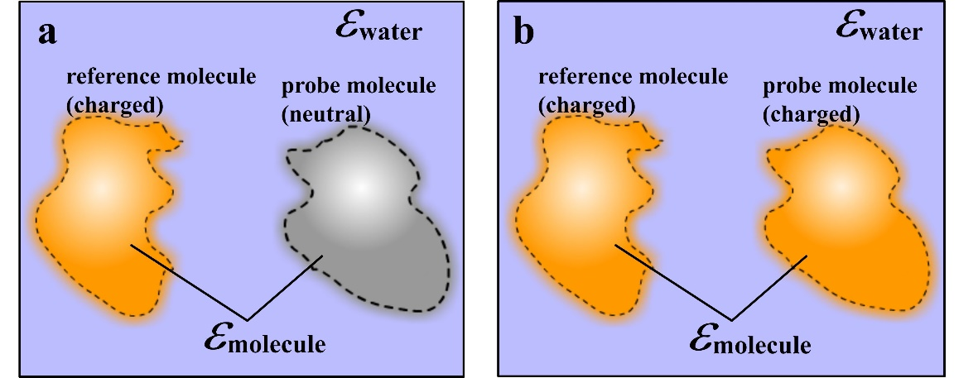
Figure S1. The charge assignment during DelPhiForce calculations for molecule-molecule interactions. a. The reference molecule (shown in orange) is charged while the probe molecule is neutral (shown in gray). b. Both of the reference and probe molecules (shown in orange) are charged.

To calculate the forces between groups of atoms/residues in a molecule(s): 1) DelPhiForce keeps the charges of reference group while all the other atoms of the molecules are neutral, including those of probe group, so that the whole molecule creates a low dielectric cavity in the water, as shown in figure S2(a); 2) The electrostatic potential and electric field at the positions of the atoms of the probe group are calculated by DelPhi; 3) The charges of the probe group are assigned (shown in figure S2(b)) and the forces on probe group are calculated.
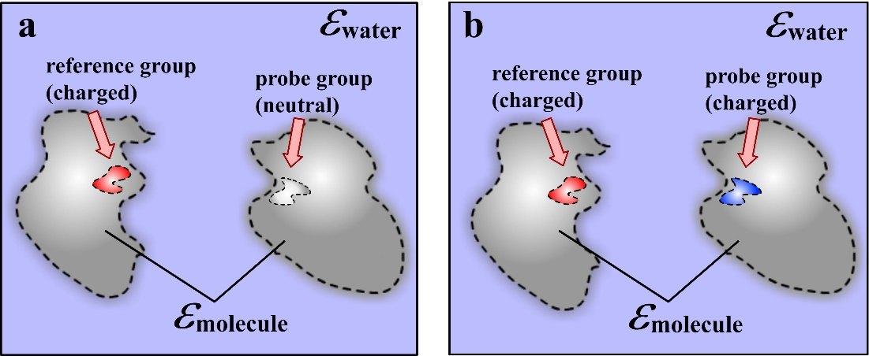
Figure S2. The charge assignment during the DelPhiForce calculation for group-group interactions. a. The reference group (shown in red) is charged while the probe group is neutral (shown in gray). b. Both the reference and probe groups (shown in red and blue) are charged.

Pairwise Electrostatic Interaction Energy in Hen egg white lysozyme.
In the main body of the manuscript we demonstrated the usage of DelPhiForce webserver in modeling biomolecules interactions, including protein-protein binding, inter-domain interaction, protein-DNA binding, protein-RNA binding and protein-ligand binding. Here we show another feature of DelPhiForce webserver allowing for calculations of residue-residue electrostatic energy.
Lysozyme (Hen Egg White; HEW) is a protein that has been studied extensively. Here we model the pairwise electrostatic energy of residues ASP119 and ARG125 of HEW lysozyme. These residues form a salt-bridge and their interaction has been investigated in the past (Alexov, 2003) .
The crystal structure of HEW lysozyme from the Protein Data Bank (PDB ID: 1AKI (Artymiuk, et al., 1982)) was used. The structure was first protonated at pH 7 and the charge and radii parameters were assigned using AMBER99SB force field (Showalter and Brüschweiler, 2007) in GROMACS-5.0.5 (Abraham, et al., 2015). The protonated lysozyme had a net charge of +8.0e with all the ASP and ARG charged (net charges -1e and +1e respectively). Figure S3(a) shows a ribbon representation of the protein backbone and both the residues are shown in CPK representation. Subsequently, the structure was minimized in vacuum for 5000 steepest descent (SD) steps before calculating the pairwise interaction energy. After minimization, the structure (as a PQR FILE) was imported to DelPhiForce and calculations were done using a scale of 2.0 grids/Å with a protein dielectric value of 2.0. Two different dielectric methods were tried and the resulting pairwise electrostatic interaction energy of the ASP119-ARG125 pair is shown in the Table S1. Note that the energies are quite different due to the difference of the corresponding dielectric function.

Table S1: The pairwise interaction energy values of ASP119-ARG125 in HEW Lysozyme obtained using two different dielectric distribution method.
Dielectric Distribution | Pairwise Interaction Energy (kT)
Traditional 2-dielectric | -24.1705
Gaussian-smoothed  (SRFCUT=20; SIGMA = 0.93) | -4.7074

Furthermore, Figure S3(b) shows electrostatic forces calculated for the same pair of residues. One can see the arrow from the positively charged ARG125 (red) pointing towards the teal colored ASP119 residue which is negatively charged. If the order of the residues in the input to DelPhiForce is reversed, the arrow also flips its direction (Figure S3c). It now reveals that ASP119 atoms are being attracted towards the ARG125 atoms.
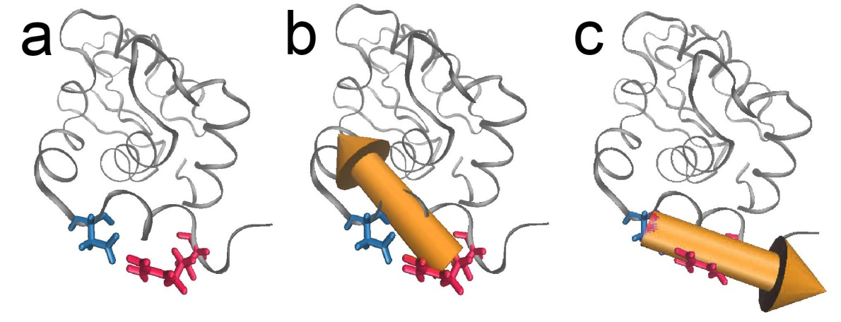
Figure S3: 1AKI backbone is shown in the Ribbon representation (steel) and the residues ASP119-ARG125 are shown in CPK representation and colored in teal and red respectively. Left panel: The minimized structure. Middle panel: arrow indicating the electrostatic force on ARG125 atoms due to ASP119 in the energy minimized configuration. Right panel: arrow indicating the electrostatic force on ASP119 atoms due to ARG125.
DelPhiForce web server applications:
The DelPhiForce webserver is designed to calculate the electrostatic forces and energies between molecules such as proteins, DNAs/RNAs, domains in a single molecule, residue-residue pairs within inner and inter molecules, group-group pairs inner and inter molecules. The forces are visualized via 3Dmol. DelPhiForce webserver provides TCL script file, which can be downloaded and visualized by VMD (Humphrey, et al., 1996).
Reference:
Abraham, M.J., et al. (2015) GROMACS: High performance molecular simulations through multi-level parallelism from laptops to supercomputers, SoftwareX, 1, 19-25.
Alexov, E. (2003) Role of the protein side‐chain fluctuations on the strength of pair‐wise electrostatic interactions: Comparing experimental with computed pKas, Proteins: Structure, Function, and Bioinformatics, 50, 94-103.
Artymiuk, P., et al. (1982) The structures of the monoclinic and orthorhombic forms of hen egg-white lysozyme at 6 Å resolution, Acta Crystallographica Section B: Structural Crystallography and Crystal Chemistry, 38, 778-783.
Humphrey, W., Dalke, A. and Schulten, K. (1996) VMD: visual molecular dynamics, Journal of molecular graphics, 14, 33-38.
Li, L., Li, C. and Alexov, E. (2014) On the modeling of polar component of solvation energy using smooth Gaussian-based dielectric function, Journal of Theoretical and Computational Chemistry, 13, 1440002.
Li, L., et al. (2012) DelPhi: a comprehensive suite for DelPhi software and associated resources, BMC biophysics, 5, 9.
Li, L., et al. (2013) On the dielectric “constant” of proteins: smooth dielectric function for macromolecular modeling and its implementation in Delphi, Journal of chemical theory and computation, 9, 2126.
Rocchia, W., et al. (2002) Rapid grid‐based construction of the molecular surface and the use of induced surface charge to calculate reaction field energies: Applications to the molecular systems and geometric objects, Journal of computational chemistry, 23, 128-137.
Showalter, S.A. and Brüschweiler, R. (2007) Validation of molecular dynamics simulations of biomolecules using NMR spin relaxation as benchmarks: application to the AMBER99SB force field, Journal of chemical theory and computation, 3, 961-975.
Wang, L., Li, L. and Alexov, E. (2015) pKa predictions for proteins, RNAs, and DNAs with the Gaussian dielectric function using DelPhi pKa, Proteins: Structure, Function, and Bioinformatics, 83, 2186-2197.
Wang, L., Zhang, M. and Alexov, E. (2015) DelPhiPKa web server: predicting pKa of proteins, RNAs and DNAs, Bioinformatics, btv607.

