Supplementary information
Plot | input data |  |  |  |  | Options
 | Fastq | Fastq  rich | Fastq  minimal | Bam | Albacore Summary
Histogram of read length | x | x | x | x | x | N50
Histogram of log transformed read length | x | x | x | x | x | N50
Bivariate plot of length against base call quality | x | x |  | x | x | log transformation
Heatmap of reads per channel |  | x |  |  | x
Cumulative yield plot |  | x | x |  | x
Violin plot of read length over time |  | x | x |  | x
Violin plot of base call quality over time |  | x |  |  | x
Bivariate plot of aligned read length against sequenced read length |  |  |  | x
Bivariate plot of percent reference identity against read length |  |  |  | x |  | log transformation
Bivariate plot of percent reference identity against base call quality |  |  |  | x
Bivariate plot of mapping quality against read length |  |  |  | x |  | log transformation
Bivariate plot of mapping quality against basecall quality |  |  |  | x

Supplementary table 1: NanoPlot plots

Supplementary table 2: NanoStat example output

General statistics
Number of reads: | 150,735
Total bases: | 4,769,579,795
Median read length: | 18,796.00
Mean read length: | 31,642.15
Readlength N50: | 61,411
Top 5 read lengths and their average base call quality score
Length: 763,488bp | Q: 11.64
Length: 760,365bp | Q: 11.46
Length: 744,361bp | Q: 10.38
Length: 656,649bp | Q: 12.13
Length: 628,176bp | Q: 11.96
Top 5 average base call quality scores and their read lengths
Length: 323bp | Q: 16.57
Length: 29,090bp | Q: 14.1
Length: 8,297bp | Q: 14.05
Length: 1,233bp | Q: 13.94
Length: 112,093bp | Q: 13.92
Number of reads and fraction above quality cutoffs:
Q5: | 143,721 (95.35%)
Q10: | 114,990 (76.29%)
Q15: | 1 (0.00%)
Q20: | 0 (0.00%)
Data produced using 506 active channels.

Supplementary Figure S1: Histogram of read lengths
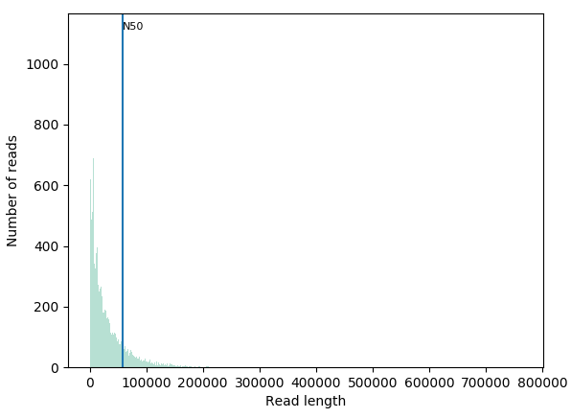
NanoPlot histogram of read lengths in bins of 100bp, showing the read length N50 value.

Supplementary Figure S2: Histogram of log transformed read lengths
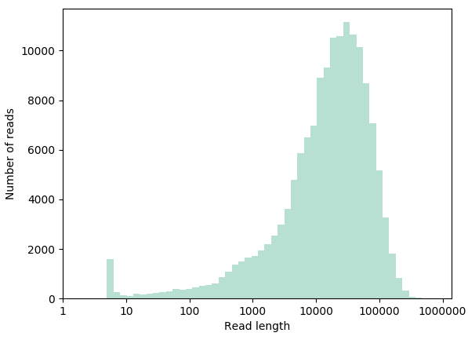
NanoPlot histogram of log transformed read lengths

Supplementary Figure S3: Quality versus length plot in ‘pauvre’ style

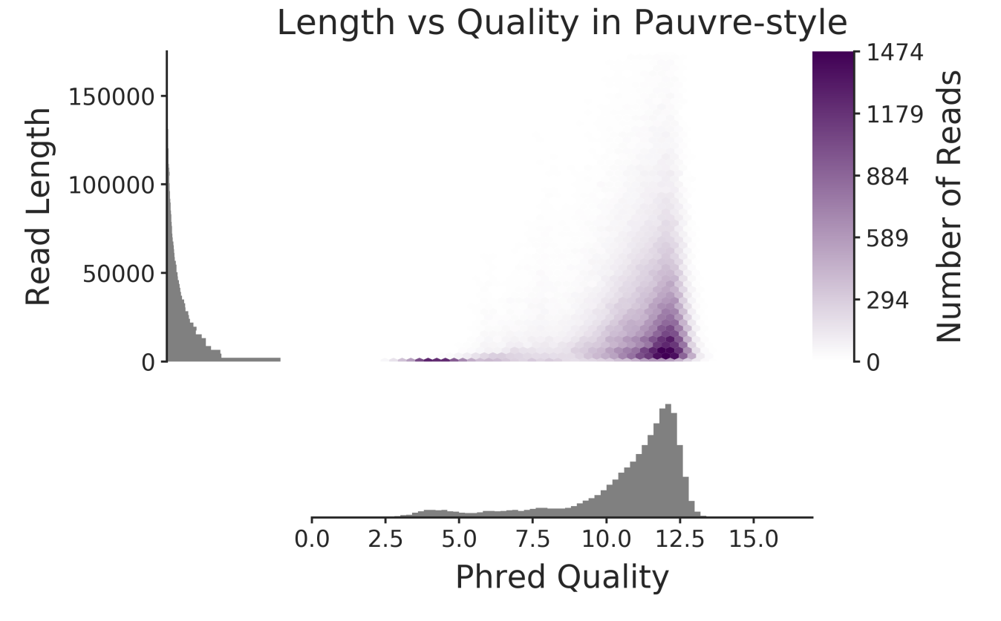

NanoPlot bivariate plot of per read reads lengths against mean basecall quality score in pauvre style.

Supplementary Figure S4: Bivariate plot of sequenced read lengths against aligned read length

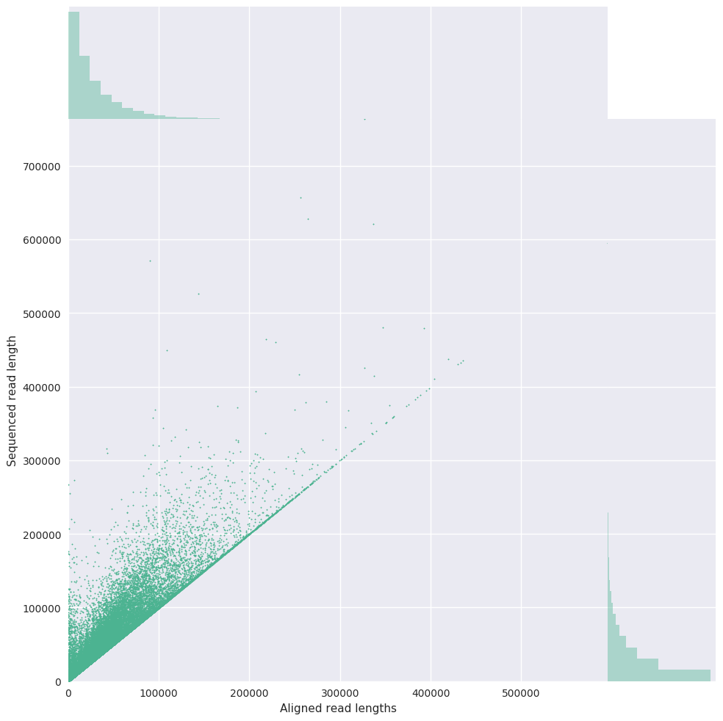
NanoPlot bivariate plot of sequenced reads lengths against aligned read lengths, showing reads not aligning end to end to the reference genome.

Supplementary Figure S5: NanoComp comparison of throughput in megabases

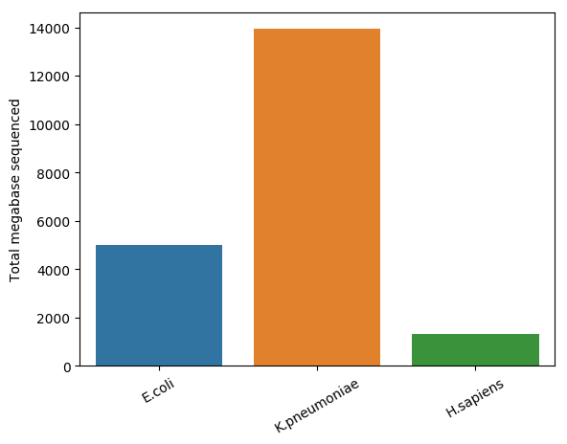
NanoComp bar chart of throughput in megabases per dataset.

Supplementary Figure S6: NanoComp comparison of quality distribution using violin plots

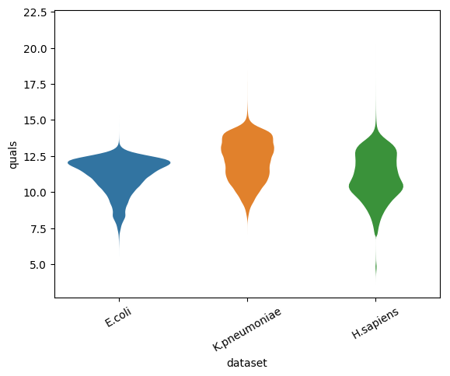
NanoComp violin plot of per read average read quality per dataset.

Supplementary Figure S7: NanoComp comparison of percent reference identities

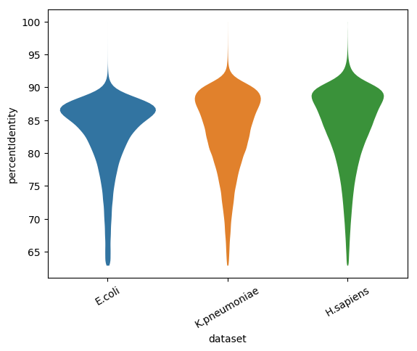
NanoComp violin plot of per read percent reference identity (edit distance scaled to aligned read length) compared to the reference genome.

