Predicting serious rare adverse reactions of novel chemicals
Aleksandar Poleksic and Lei Xie
Supplementary Material

CS algorithm for drug-ADR association prediction
Goal: Predict missing drug-ADR associations.
Input: An incomplete binary matrix of known (observed) associations $R$, a matrix $W$ containing frequencies of drug-ADR associations, an impute matrix $Q$, a matrix $M$ of pairwise ADR similarity scores, a matrix $N$ of pairwise drug similarity scores.
Output: The matrix $P$ of probabilities of individual drug-ADR associations.
Implementation details:
Denote by $m$ and $n$ the number of ADRs and drugs respectively and let $R=(r_{i,j})$ be a $m×n$ matrix of drug-ADR associations ($r_{i,j}=1$ if drug $j$ is known to cause ADR $i$ and $r_{i,j}=0$ otherwise). The binary matrix $R$ is derived from the SIDER database and is incomplete in the sense that a zero entry $r_{i,j}=0$ does not necessarily mean that $i$ is not the adverse reaction of $j$, but it simply indicates the lack of evidence of any such association.
Our algorithm attempts to complete $R$ by reclassifying some of its entries. The key assumption is that the true matrix of drug-ADR associations is of low rank and, therefore, it can be written as the product $FG^{'}$ of two matrices $F$ and $G$ of dimensions $m×r$ and $n×r$, respectively, where $r≪min(m,n)$.
Following Steck (2010) and Lim et al. (2016), we compute the matrices $F$ and $G$ by minimizing the loss function:
$$\sum_{i,j}{w_{i,j}\left\{\ln\left(1+e^{f_{i}g_{j}^{'} }\right)-\left(r_{i,j}+q_{i,j}\right)f_{i}g_{j}^{'}\right\}}+{λ_{F}\left\|F\right\|}_{2}^{2}+{λ_{G}\left\|G\right\|}_{2}^{2}+$$
+ $λ_{M}tr\left(F^{'}\left(D_{M}-M\right)F\right)+λ_{N}tr\left(G^{'}\left(D_{N}-N\right)G\right)$ (1)
The meaning of each term of (1) is provided in the Methods section of the main text. We note that the partial derivatives of (1) are given by:
$∂/∂F=\left\{W⨀\left[P-\left(R+Q\right)\right]\right\}G+{2λ}_{r}F+{2λ_{M}(D}_{M}-M)F$
$∂/∂G=\{W^{'}⨀\left[P^{'}-\left(R^{'}+Q^{'}\right)\right]\}F{+ 2λ}_{r}G+{2λ}_{N}(D_{N}-N)G$
where $⨀$ represents the Hadamard product. The matrices $F$ and $G$ satisfying $∂ /∂F=0$ and $∂ /∂G=0$ are found in an iterative fashion using the gradient descent method Ada-Grad (Duchi et al., 2011).
To address the so-called “cold-start” problem i.e., to predict drug-ADR associations for new drugs (those without any observed ADRs) we use the so-called “weighted-profile” method (Yamanishi et al., 2008; Yao et al. 2014). More precisely, the $i^{th}$ row of $G$, containing the latent preferences of the drug $i$, is computed as the weighted sum of latent preferences for the drug $i$ (calculated during the iterative minimization procedure, described above) and the latent preferences of drugs most similar to the drug $i$. More specifically, the $i^{th}$ row of the matrix $G$ is set to $({vg}_{i}+ \sum_{j=1}^{J}{n_{i,j}g_{j})/S}$, where $g_{j}$ is the $j^{th}$ row of $G$ (representing the latent preferences of the drug $j$), $v$ is the weight parameter and $n_{i,j}$ represents the Tanimoto similarity of drugs $i$ and $j$. The normalization factor $S$ is set to $v+ \sum_{j=1}^{J}{n_{i,j}}$.
In case of completely new drugs, the above scores are further multiplied by the prior and posterior ADR probabilities computed from the training set in a manner similar to that used in the ML algorithm (see the definitions of $P(H_{s}^{l})$ and $P(E_{C_{t}\left(l\right)}^{l}|H_{s}^{l})$ given in the main text). We use the same “weighted-profile” method to predict drugs for “knew” ADRs.
The parameters $λ$ of the loss function (1) are trained on a selected matrix of drug-ADR associations derived from the post-marketing data. This data is available as part of the SIDER database. The number of AdaGrad iterations and the matrix rank $r$ are each set to 100. The parameter $J$ is set to 5. In our experience, the choice of the algorithm’s parameters do not significantly affect the algorithm’s performance, as long as the parameters were selected within a reasonable range (e.g. $λ's$ between 0.01 and 1, number of iterations above 50 and $J$ between 3 and 10). In fact, due to the complexity of the training procedure, some methods for similar or unrelated problems pick these parameters somewhat arbitrary (Yao et al., 2014).

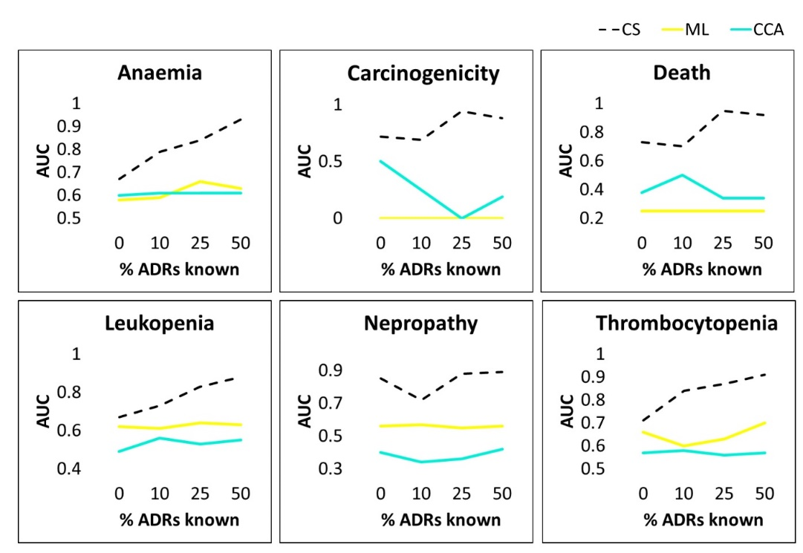
Figure S1. Predicting ADRs responsible for drug market withdrawals. The x-axis represents the percentage (0%, 10%, 25%, 50%) of already known ADRs for the drug. The y-axis represents the AUC values. The mean AUC values shown in the figures are obtained over multiple runs on “control” drugs to achieve robust statistics (STDERR too small to show).

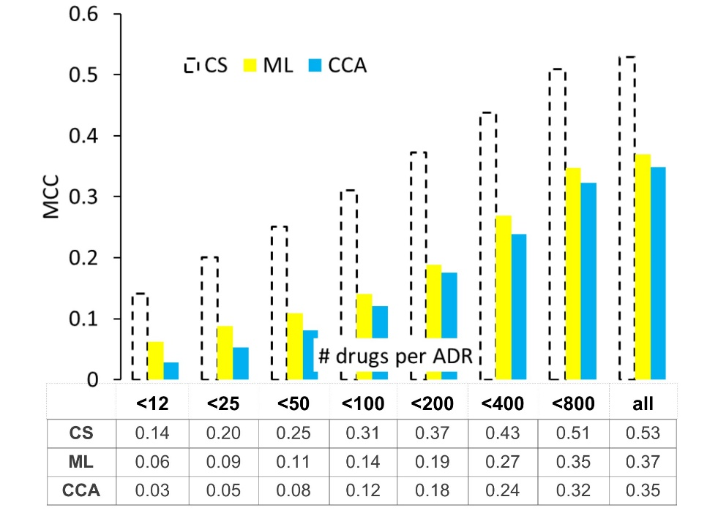
Figure S2. Value added by compressed sensing (CS) in MCC benchmark. The data table beneath the graph shows the mean MCC scores obtained in 5 rounds of 10-fold CV benchmark. All STDERR values are smaller than $8{.0e}^{-4}$.
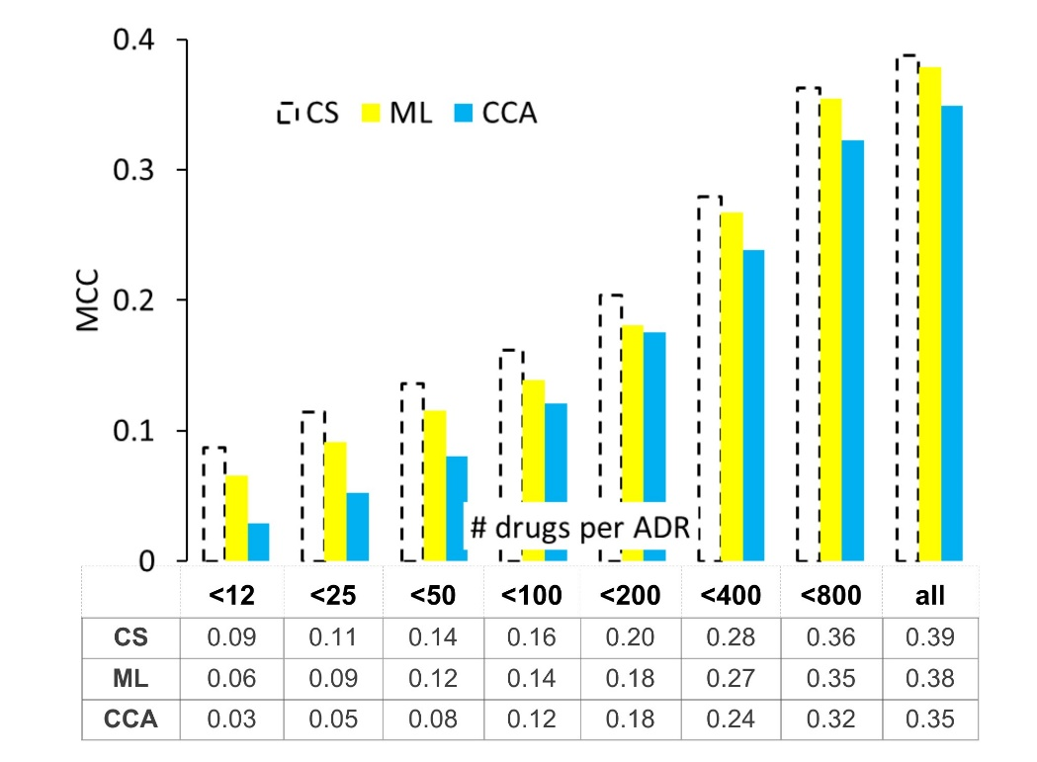
Figure S3. Value added by compressed sensing (CS) in the “cold-start” setting. The mean MCC scores obtained in 5 rounds of the 10-fold cross-validation on the set of “new” drugs, those with all ADRs hidden (masked out). All STDERR values are smaller than $1.0e^{-3}$.

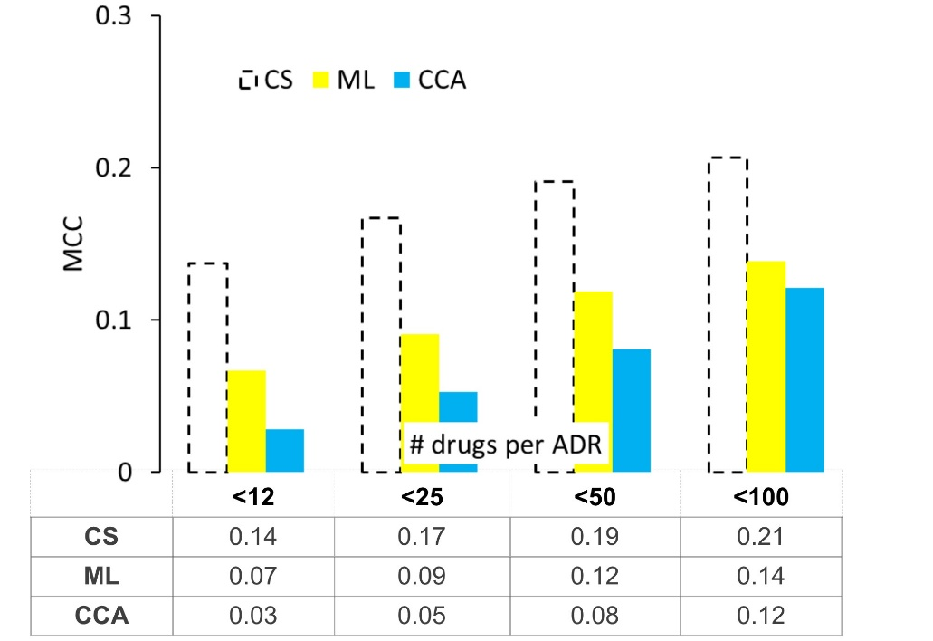
Figure S4. MCC test for rare ADRs. The mean MCC values obtained in 5 rounds of 10-fold CV test on the set of drugs with no known rare ADRs. All STDERR values are smaller than $1.0e^{-3}$.

 | CS |  |  |  | ML |  |  |  | CCA
CutOff | AUC | STDERR | ENRCH |  | AUC | STDERR | ENRCH |  | AUC | STDERR | ENRCH
<12 drugs per ADR
0.1 | 0.769 | 0.002 | 1.5 |  | 0.505 | 0.005 | 1.0 |  | 0.525 | 0.005 | 1.1
0.2 | 0.790 | 0.004 | 1.6 |  | 0.556 | 0.007 | 1.1 |  | 0.563 | 0.006 | 1.1
0.3 | 0.805 | 0.003 | 1.6 |  | 0.576 | 0.004 | 1.2 |  | 0.574 | 0.006 | 1.1
0.4 | 0.823 | 0.002 | 1.6 |  | 0.590 | 0.004 | 1.2 |  | 0.587 | 0.004 | 1.2
0.5 | 0.833 | 0.003 | 1.7 |  | 0.608 | 0.005 | 1.2 |  | 0.605 | 0.006 | 1.2
0.6 | 0.831 | 0.002 | 1.7 |  | 0.613 | 0.003 | 1.2 |  | 0.615 | 0.003 | 1.2
0.7 | 0.841 | 0.004 | 1.7 |  | 0.626 | 0.006 | 1.3 |  | 0.625 | 0.006 | 1.3
0.8 | 0.846 | 0.003 | 1.7 |  | 0.644 | 0.004 | 1.3 |  | 0.634 | 0.005 | 1.3
0.9 | 0.853 | 0.002 | 1.7 |  | 0.660 | 0.009 | 1.3 |  | 0.641 | 0.010 | 1.3
1 | 0.856 | 0.006 | 1.7 |  | 0.666 | 0.005 | 1.3 |  | 0.639 | 0.004 | 1.3
<25 drugs per ADR
0.1 | 0.768 | 0.001 | 1.5 |  | 0.608 | 0.002 | 1.2 |  | 0.621 | 0.002 | 1.2
0.2 | 0.803 | 0.005 | 1.6 |  | 0.645 | 0.006 | 1.3 |  | 0.654 | 0.006 | 1.3
0.3 | 0.820 | 0.003 | 1.6 |  | 0.671 | 0.004 | 1.3 |  | 0.673 | 0.005 | 1.3
0.4 | 0.834 | 0.003 | 1.7 |  | 0.678 | 0.006 | 1.4 |  | 0.682 | 0.006 | 1.4
0.5 | 0.844 | 0.002 | 1.7 |  | 0.701 | 0.004 | 1.4 |  | 0.700 | 0.005 | 1.4
0.6 | 0.849 | 0.006 | 1.7 |  | 0.695 | 0.005 | 1.4 |  | 0.696 | 0.005 | 1.4
0.7 | 0.861 | 0.002 | 1.7 |  | 0.712 | 0.002 | 1.4 |  | 0.709 | 0.004 | 1.4
0.8 | 0.859 | 0.001 | 1.7 |  | 0.720 | 0.003 | 1.4 |  | 0.711 | 0.004 | 1.4
0.9 | 0.871 | 0.002 | 1.7 |  | 0.751 | 0.004 | 1.5 |  | 0.731 | 0.005 | 1.5
1 | 0.873 | 0.003 | 1.7 |  | 0.757 | 0.002 | 1.5 |  | 0.732 | 0.002 | 1.5
<50 drugs per ADR
0.1 | 0.738 | 0.002 | 1.5 |  | 0.656 | 0.002 | 1.3 |  | 0.667 | 0.001 | 1.3
0.2 | 0.811 | 0.003 | 1.6 |  | 0.728 | 0.004 | 1.5 |  | 0.736 | 0.004 | 1.5
0.3 | 0.835 | 0.003 | 1.7 |  | 0.745 | 0.005 | 1.5 |  | 0.749 | 0.005 | 1.5
0.4 | 0.840 | 0.002 | 1.7 |  | 0.745 | 0.004 | 1.5 |  | 0.748 | 0.004 | 1.5
0.5 | 0.856 | 0.003 | 1.7 |  | 0.752 | 0.004 | 1.5 |  | 0.755 | 0.003 | 1.5
0.6 | 0.864 | 0.001 | 1.7 |  | 0.756 | 0.004 | 1.5 |  | 0.756 | 0.006 | 1.5
0.7 | 0.867 | 0.003 | 1.7 |  | 0.766 | 0.004 | 1.5 |  | 0.763 | 0.004 | 1.5
0.8 | 0.877 | 0.003 | 1.8 |  | 0.780 | 0.003 | 1.6 |  | 0.771 | 0.003 | 1.5
0.9 | 0.881 | 0.004 | 1.8 |  | 0.795 | 0.005 | 1.6 |  | 0.779 | 0.004 | 1.6
1 | 0.883 | 0.003 | 1.8 |  | 0.812 | 0.003 | 1.6 |  | 0.787 | 0.003 | 1.6
<100 drugs per ADR
0.1 | 0.779 | 0.001 | 1.6 |  | 0.669 | 0.003 | 1.3 |  | 0.678 | 0.002 | 1.4
0.2 | 0.782 | 0.003 | 1.6 |  | 0.785 | 0.003 | 1.6 |  | 0.789 | 0.004 | 1.6
0.3 | 0.835 | 0.002 | 1.7 |  | 0.807 | 0.002 | 1.6 |  | 0.810 | 0.002 | 1.6
0.4 | 0.860 | 0.003 | 1.7 |  | 0.803 | 0.003 | 1.6 |  | 0.806 | 0.003 | 1.6
0.5 | 0.868 | 0.002 | 1.7 |  | 0.808 | 0.003 | 1.6 |  | 0.806 | 0.004 | 1.6
0.6 | 0.876 | 0.005 | 1.8 |  | 0.811 | 0.003 | 1.6 |  | 0.813 | 0.004 | 1.6
0.7 | 0.885 | 0.001 | 1.8 |  | 0.820 | 0.001 | 1.6 |  | 0.814 | 0.002 | 1.6
0.8 | 0.897 | 0.003 | 1.8 |  | 0.843 | 0.002 | 1.7 |  | 0.832 | 0.003 | 1.7
0.9 | 0.893 | 0.002 | 1.8 |  | 0.841 | 0.003 | 1.7 |  | 0.826 | 0.003 | 1.7
1 | 0.901 | 0.002 | 1.8 |  | 0.854 | 0.004 | 1.7 |  | 0.833 | 0.004 | 1.7

Table S1. The results of LOOCV for chemicals of novel 3D structure using AUC as the accuracy measure. The AUC scores shown are the mean values obtained from 5 rounds of the leave-one-out-cross-validation test on the sets of 100 randomly chosen drugs. For each drug tested, we removed from the training set all drugs form the same structural class i.e., those that have the above cutoff Tanimoto similarity to the test drug. ENRCH columns gives the fold enrichment over the random classifier.

 | CS |  |  |  | ML |  |  |  | CCA
CutOff | AUPR | STDERR | ENRCH |  | AUPR | STDERR | ENRCH |  | AUPR | STDERR | ENRCH
<12 drugs per ADR
0.1 | 0.228 | 0.011 | 2.9 |  | 0.101 | 0.008 | 1.3 |  | 0.116 | 0.010 | 1.5
0.2 | 0.120 | 0.005 | 5.1 |  | 0.037 | 0.003 | 1.6 |  | 0.043 | 0.002 | 1.8
0.3 | 0.097 | 0.006 | 8.2 |  | 0.020 | 0.001 | 1.7 |  | 0.019 | 0.001 | 1.6
0.4 | 0.082 | 0.004 | 11.9 |  | 0.015 | 0.003 | 2.2 |  | 0.011 | 0.001 | 1.5
0.5 | 0.082 | 0.005 | 14.4 |  | 0.014 | 0.002 | 2.4 |  | 0.009 | 0.000 | 1.6
0.6 | 0.088 | 0.004 | 15.9 |  | 0.016 | 0.002 | 2.9 |  | 0.009 | 0.000 | 1.7
0.7 | 0.091 | 0.007 | 16.6 |  | 0.016 | 0.002 | 3.0 |  | 0.010 | 0.000 | 1.8
0.8 | 0.106 | 0.006 | 19.8 |  | 0.030 | 0.001 | 5.6 |  | 0.011 | 0.000 | 2.0
0.9 | 0.134 | 0.007 | 26.8 |  | 0.052 | 0.006 | 10.5 |  | 0.012 | 0.001 | 2.3
1 | 0.120 | 0.008 | 24.4 |  | 0.055 | 0.004 | 11.1 |  | 0.011 | 0.001 | 2.3
<25 drugs per ADR
0.1 | 0.231 | 0.007 | 2.8 |  | 0.166 | 0.006 | 2.0 |  | 0.189 | 0.006 | 2.3
0.2 | 0.139 | 0.004 | 4.6 |  | 0.069 | 0.004 | 2.3 |  | 0.086 | 0.005 | 2.8
0.3 | 0.104 | 0.004 | 7.1 |  | 0.035 | 0.002 | 2.4 |  | 0.041 | 0.001 | 2.8
0.4 | 0.099 | 0.003 | 10.0 |  | 0.024 | 0.001 | 2.4 |  | 0.027 | 0.001 | 2.7
0.5 | 0.082 | 0.003 | 13.2 |  | 0.018 | 0.002 | 3.0 |  | 0.017 | 0.001 | 2.8
0.6 | 0.086 | 0.001 | 14.1 |  | 0.019 | 0.003 | 3.2 |  | 0.015 | 0.001 | 2.5
0.7 | 0.104 | 0.004 | 18.6 |  | 0.025 | 0.004 | 4.5 |  | 0.016 | 0.001 | 2.8
0.8 | 0.108 | 0.002 | 19.4 |  | 0.042 | 0.001 | 7.5 |  | 0.017 | 0.001 | 3.0
0.9 | 0.134 | 0.005 | 25.1 |  | 0.061 | 0.005 | 11.5 |  | 0.019 | 0.002 | 3.6
1 | 0.149 | 0.003 | 26.0 |  | 0.080 | 0.001 | 13.8 |  | 0.021 | 0.001 | 3.7
<50 drugs per ADR
0.1 | 0.237 | 0.007 | 2.7 |  | 0.230 | 0.007 | 2.6 |  | 0.230 | 0.007 | 2.6
0.2 | 0.175 | 0.007 | 4.9 |  | 0.127 | 0.005 | 3.5 |  | 0.158 | 0.007 | 4.4
0.3 | 0.129 | 0.006 | 6.7 |  | 0.068 | 0.003 | 3.5 |  | 0.081 | 0.004 | 4.2
0.4 | 0.101 | 0.006 | 8.8 |  | 0.039 | 0.002 | 3.4 |  | 0.046 | 0.002 | 4.0
0.5 | 0.095 | 0.002 | 12.2 |  | 0.029 | 0.001 | 3.7 |  | 0.032 | 0.002 | 4.1
0.6 | 0.103 | 0.004 | 15.0 |  | 0.030 | 0.002 | 4.3 |  | 0.028 | 0.001 | 4.0
0.7 | 0.096 | 0.005 | 14.2 |  | 0.030 | 0.002 | 4.5 |  | 0.026 | 0.002 | 3.9
0.8 | 0.122 | 0.005 | 18.0 |  | 0.057 | 0.003 | 8.4 |  | 0.029 | 0.001 | 4.3
0.9 | 0.139 | 0.004 | 19.8 |  | 0.090 | 0.005 | 12.9 |  | 0.038 | 0.002 | 5.5
1 | 0.144 | 0.007 | 22.3 |  | 0.092 | 0.004 | 14.1 |  | 0.038 | 0.002 | 5.8
<100 drugs per ADR
0.1 | 0.313 | 0.008 | 3.3 |  | 0.270 | 0.007 | 2.9 |  | 0.312 | 0.007 | 3.3
0.2 | 0.204 | 0.006 | 4.9 |  | 0.190 | 0.003 | 4.5 |  | 0.190 | 0.003 | 4.5
0.3 | 0.166 | 0.003 | 7.0 |  | 0.126 | 0.004 | 5.3 |  | 0.153 | 0.003 | 6.5
0.4 | 0.129 | 0.001 | 9.3 |  | 0.070 | 0.003 | 5.1 |  | 0.085 | 0.003 | 6.2
0.5 | 0.114 | 0.004 | 11.2 |  | 0.051 | 0.003 | 5.1 |  | 0.059 | 0.003 | 5.8
0.6 | 0.111 | 0.004 | 12.5 |  | 0.047 | 0.003 | 5.3 |  | 0.052 | 0.003 | 5.8
0.7 | 0.123 | 0.003 | 14.5 |  | 0.053 | 0.002 | 6.3 |  | 0.051 | 0.003 | 5.9
0.8 | 0.135 | 0.002 | 16.6 |  | 0.090 | 0.002 | 11.1 |  | 0.050 | 0.001 | 6.2
0.9 | 0.145 | 0.004 | 17.2 |  | 0.115 | 0.003 | 13.6 |  | 0.052 | 0.002 | 6.2
1 | 0.154 | 0.007 | 17.7 |  | 0.126 | 0.006 | 14.5 |  | 0.055 | 0.003 | 6.3

Table S2. The results of LOOCV for chemicals of novel 3D structure using the AUPR as the accuracy measure.

 | CS |  |  | ML |  |  | CCA
CutOff | MCC | STDERR |  | MCC | STDERR |  | MCC | STDERR
<12 drugs per ADR
0.1 | 0.197 | 0.009 |  | 0.030 | 0.008 |  | 0.076 | 0.004
0.2 | 0.149 | 0.007 |  | 0.057 | 0.003 |  | 0.038 | 0.004
0.3 | 0.131 | 0.006 |  | 0.014 | 0.002 |  | 0.050 | 0.002
0.4 | 0.131 | 0.006 |  | 0.014 | 0.002 |  | 0.050 | 0.002
0.5 | 0.140 | 0.010 |  | 0.014 | 0.007 |  | 0.057 | 0.005
0.6 | 0.138 | 0.010 |  | 0.007 | 0.002 |  | 0.036 | 0.003
0.7 | 0.145 | 0.004 |  | 0.023 | 0.006 |  | 0.039 | 0.005
0.8 | 0.172 | 0.011 |  | 0.050 | 0.011 |  | 0.035 | 0.004
0.9 | 0.204 | 0.011 |  | 0.087 | 0.013 |  | 0.037 | 0.005
1 | 0.204 | 0.012 |  | 0.107 | 0.005 |  | 0.041 | 0.006
<25 drugs per ADR
0.1 | 0.219 | 0.007 |  | 0.074 | 0.005 |  | 0.187 | 0.008
0.2 | 0.198 | 0.005 |  | 0.100 | 0.005 |  | 0.168 | 0.022
0.3 | 0.161 | 0.006 |  | 0.080 | 0.005 |  | 0.114 | 0.007
0.4 | 0.132 | 0.006 |  | 0.038 | 0.002 |  | 0.094 | 0.004
0.5 | 0.150 | 0.007 |  | 0.020 | 0.001 |  | 0.085 | 0.009
0.6 | 0.155 | 0.004 |  | 0.020 | 0.002 |  | 0.063 | 0.001
0.7 | 0.167 | 0.009 |  | 0.024 | 0.003 |  | 0.058 | 0.003
0.8 | 0.157 | 0.007 |  | 0.055 | 0.006 |  | 0.074 | 0.007
0.9 | 0.207 | 0.006 |  | 0.098 | 0.003 |  | 0.069 | 0.004
1 | 0.200 | 0.014 |  | 0.102 | 0.016 |  | 0.082 | 0.007
<50 drugs per ADR
0.1 | 0.245 | 0.006 |  | 0.196 | 0.005 |  | 0.185 | 0.007
0.2 | 0.224 | 0.006 |  | 0.173 | 0.005 |  | 0.224 | 0.017
0.3 | 0.184 | 0.008 |  | 0.127 | 0.006 |  | 0.163 | 0.007
0.4 | 0.149 | 0.002 |  | 0.088 | 0.002 |  | 0.129 | 0.008
0.5 | 0.174 | 0.004 |  | 0.079 | 0.001 |  | 0.099 | 0.008
0.6 | 0.161 | 0.005 |  | 0.062 | 0.002 |  | 0.086 | 0.004
0.7 | 0.171 | 0.006 |  | 0.054 | 0.002 |  | 0.085 | 0.004
0.8 | 0.163 | 0.002 |  | 0.080 | 0.001 |  | 0.082 | 0.006
0.9 | 0.200 | 0.009 |  | 0.101 | 0.005 |  | 0.095 | 0.007
1 | 0.188 | 0.006 |  | 0.114 | 0.009 |  | 0.115 | 0.006
<100 drugs per ADR
0.1 | 0.239 | 0.007 |  | 0.210 | 0.004 |  | 0.235 | 0.010
0.2 | 0.339 | 0.002 |  | 0.193 | 0.004 |  | 0.208 | 0.032
0.3 | 0.222 | 0.004 |  | 0.172 | 0.006 |  | 0.237 | 0.007
0.4 | 0.196 | 0.004 |  | 0.145 | 0.004 |  | 0.186 | 0.010
0.5 | 0.174 | 0.003 |  | 0.117 | 0.003 |  | 0.138 | 0.012
0.6 | 0.182 | 0.007 |  | 0.109 | 0.004 |  | 0.114 | 0.002
0.7 | 0.206 | 0.007 |  | 0.121 | 0.005 |  | 0.126 | 0.003
0.8 | 0.195 | 0.003 |  | 0.132 | 0.001 |  | 0.126 | 0.009
0.9 | 0.187 | 0.008 |  | 0.139 | 0.007 |  | 0.125 | 0.005
1 | 0.208 | 0.010 |  | 0.151 | 0.004 |  | 0.117 | 0.003

Table S3. The results of LOOCV for chemicals of novel 3D structure using the MCC as the accuracy measure.

REFERENCES
Duchi, J. et al. (2011) Adaptive subgradient methods for online learning and stochastic optimization. J. Mach. Learn. Res., 12, 2121–2159.
Lim, H. et al. (2016) Improved genome-scale multi-target virtual screening via a novel collaborative filtering approach to cold-start problem. Sci. Rep., 6.
Steck, H. (2010) Training and testing of recommender systems on data missing not at random. In Proceedings of the 16th ACM SIGKDD International Conference on Knowledge discovery and data mining, pages 713–722.
Yamanishi, Y. et al. (2008) Prediction of drug-target interaction networks from the integration of chemical and genomic spaces. Bioinformatics, 24, i232–i240.
Yao, Y. et al. (2014) Dual-regularized one-class collaborative filtering. In Proceedings of the 23rd ACM International Conference on Conference on Information and Knowledge Management, pages 759-768.

