GGRaSP: A R-package for selecting representative genomes using Gaussian mixture models

Supplemental Figure
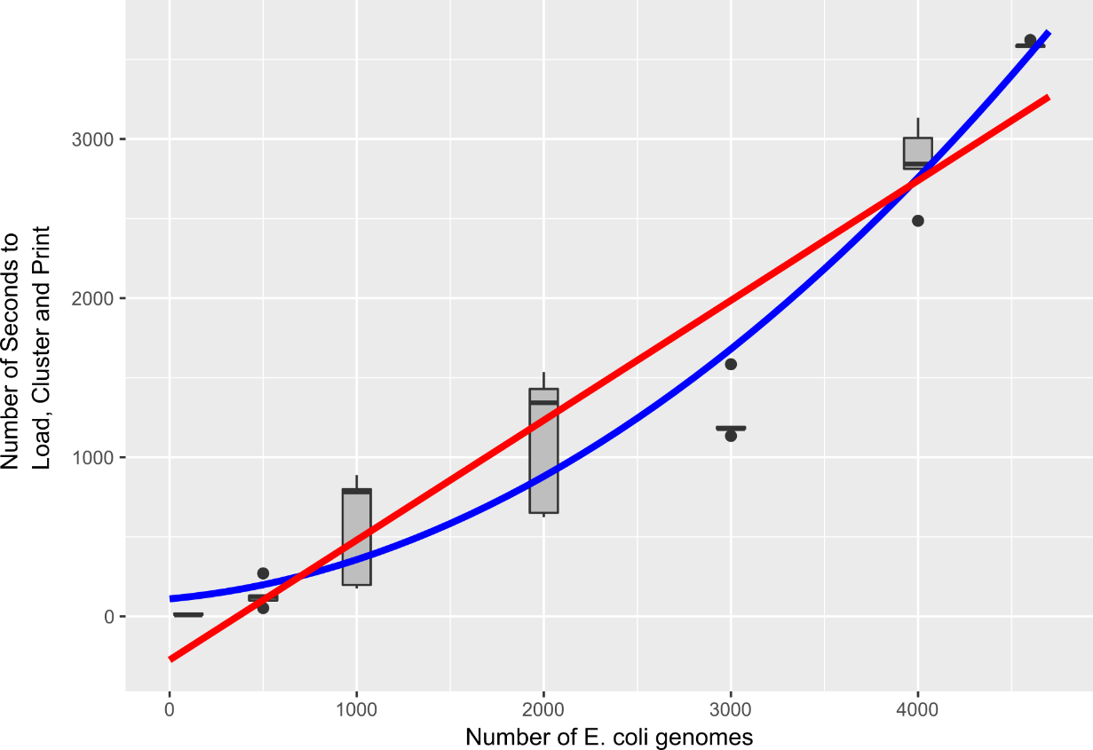

Figure S1. Time usage for GGRaSP. GGRaSP runs of 100, 500, 1,000, 2,000, 3,000, or 4,000 randomly sampled genomes from the E. coli set was used to estimate time usage. Best-fit linear (red; r² = 0.90) and polynomial (blue; r² = 0.94) models were calculated and are shown.

