Supplementary Materials for ‘GlycoStore: A Database of Retention Properties for Glycan Analysis’
Sophie Zhao¹, Ian Walsh¹, Jodie L Abrahams², Louise Royle³, Terry Nguyen-Khuong¹, Daniel Spencer³, Daryl L Fernandes³, Nicolle H Packer^{2,4}, Pauline M Rudd¹ and Matthew P Campbell^{2,*}
¹Bioprocessing Technology Institute, Agency for Science, Technology and Research (A*STAR), Singapore, ²Institute for Glycomics, Griffith University, Gold Coast, Australia, ³Ludger Ltd., Culham Science Centre, Oxfordshire, United Kingdom, ⁴Department of Chemistry and Biomolecular Sciences, Macquarie University, Sydney, Australia.

Table S1: A summary of the data collections available in GlycoStore including a description of the analytical technique and sample sets (http://www.glycostore.org/collections). New data collections released for GlycoStore 1.0 include: i) MQ Porous Graphitic Carbon (PGC), ii) BTI N-glycans, iii) BTI-GSL Standards, and iv) Ludger.

Collection Name | Description | Samples in Collection | Technique | Reference
BTI GSL Standards | 60 glycosphingolipids standards labelled with 2-AB and procainamide | Ganglio-, Lacto-, Neolacto-, Globo- and Iso-globo | HILIC-UPLC
CE Database | N-glycans analysed by capillary electrophoresis | Haptoglobin, IgG, Purified Standards, RNase B, Transferrin | CE-LIF | (Mittermayr, et al., 2011)
Human Serum N-glycans  NIBRT | Glycans characterised in house | Human Serum | HILIC-UPLC | (Saldova, et al., 2014)
Milk Oligosaccharides | A comprehensive overview of milk oligosaccharides from a variety of domestic animal species including cow, goat, sheep, pig, horse, and dromedary camel. | Cow, Dromedary Camel, Goat, Horse, Pig, Sheep | HILIC-UPLC | (Albrecht, et al., 2014)
MQ Porous Graphitic Carbon (PGC) | 90 N-glycan structures released from a number of standard glycoproteins. | Commercially available glycoprotein standards | PGC-LC-ESI-MS/MS | (Abrahams, et al., 2017)
NIBRT GSL | 28 glycosphingolipids from human serum and mammalian cell surfaces | Mammalian cell surfaces,  blood serum | UPLC-HILIC-FLD | (Albrecht, et al., 2016)
O-Glycans | 68 O-glycans | Various O-Glycans | HILIC-HPLC | (Royle, et al., 2003)
Original Release of GlycoBase | Original collection of N-glycans analysed at the Oxford Glycobiology Institute. | Human Serum, Human Immunoglobulins, Monoclonal Antibodies, Follicle Stimulating Hormone, and cell surface glycoproteins including  human CD’s | HILIC-HPLC | (Campbell, et al., 2008)
Royle (2008) Paper | HPLC-based analysis of serum N-glycans on a 96-well plate  platform with dedicated database software. | Human Serum | HILIC-HPLC | (Royle, et al., 2008)
RP IgG glycans | N-glycans characterised by reversed-phase UPLC | Human IgG | RP-UPLC
UPLC BTI | N-glycan structures analysed from a variety of samples | Human IgG  Alpha-1 antitrypsin (AAT),  Human Serum,  Mouse Serum | HILIC-UPLC
UPLC Ludger | A collection of N- and O-glycan structures characterised from Ludger standards and a variety of biological samples | Ludger commercial glycoprotein and glycan standards, Saliva, and Ocular mucin | HILIC-HPLC, HILIC-UPLC

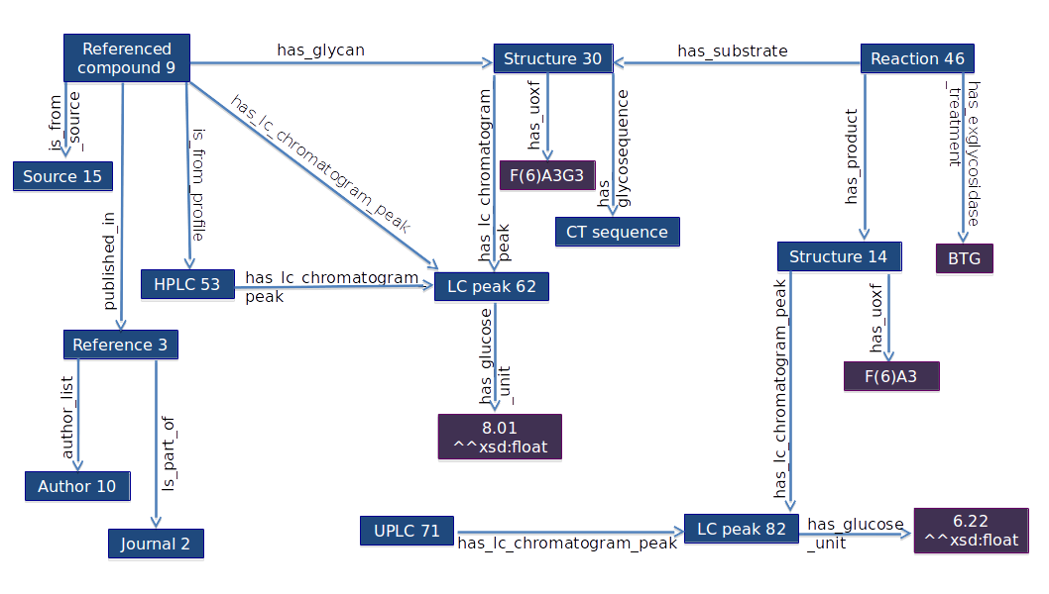

Figure S1: An overview of the GlycoStore data model. The RDF schema is based on the GlycoRDF syntax, which has been extended to support chromatography and electrophoretic data collections. Important inclusions are the experimental classes glycan:evidence_hplc, glycan:evidence_uplc and glycan:evidence_rpuplc, which differentiate modes of chromatography with glycan:has_glucose_unit and glycan:has_arabinose_unit describing the evidence type. The ontology supports annotation of exoglycosidase array digestions with predicates describing commonly used enzymes, which can be applied to the Reaction class. The ReferencedCompound class connects information such as source, reference and evidence from one experiment profile to a single glycan structure. Finally, the Source class describes the origin of a glycan structure e.g. specification of the species, tissue, fluid, cell type, cell line, strains, life stage and related diseases. For simplicity, the figure focuses on the experimental data and omits the Saccharide and Reference classes that are described by the GlycoRDF ontology. GlycoRDF release 1.2.1 is available at https://github.com/ReneRanzinger/GlycoRDF (Ranzinger, et al., 2015).

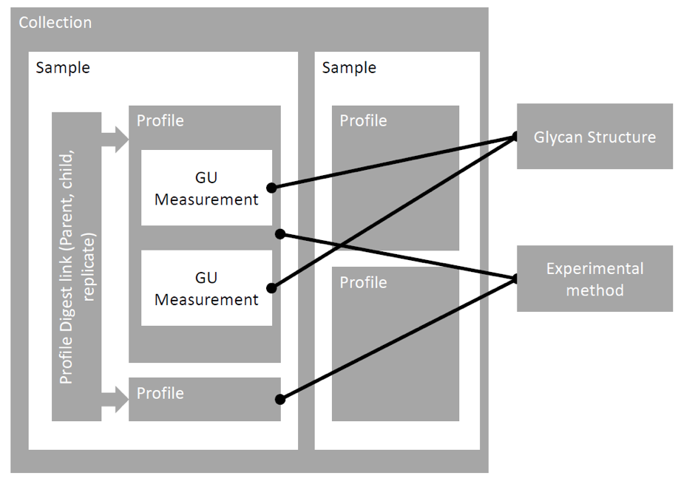
Figure S2: Data organisation and relationships. Glycan structures and experimental methods are stored outside the context of ‘Collections’ and ‘Samples’, but attached to GU/AU/Time measurements and ‘Profiles’ respectively. Individual glycan structures can be linked to multiple elution positions, across several reports and collections.

Figure S3: Glycan summary page for the tri-antennary fully galactosylated structure A3G(4)3. (a) For each glycan structure, all retention values and supporting literature records are summarised, and a complete description of the data source is shown in (b), which links to (c) a list of experimental profiles and (d) all recorded exoglycosidase evidence.

Figure S4: Example of a GlycoStore quick search. The glycan name search retrieves entries corresponding to the specified structure based on the Oxford shorthand nomenclature (Harvey, et al., 2009). The retention value search will return glycan entries that match the queried value with a tolerance of ± 0.5.

References

Abrahams, J.L., Campbell, M.P. and Packer, N.H. Building a PGC-LC-MS N-glycan retention library and elution mapping resource. Glycoconj J 2017.
Albrecht, S., et al. A comparative study of free oligosaccharides in the milk of domestic animals. Br J Nutr 2014;111(7):1313-1328.
Albrecht, S., et al. Comprehensive Profiling of Glycosphingolipid Glycans Using a Novel Broad Specificity Endoglycoceramidase in a High-Throughput Workflow. Anal Chem 2016;88(9):4795-4802.
Campbell, M.P., et al. GlycoBase and autoGU: tools for HPLC-based glycan analysis. Bioinformatics 2008;24(9):1214-1216.
Harvey, D.J., et al. Proposal for a standard system for drawing structural diagrams of N- and O-linked carbohydrates and related compounds. Proteomics 2009;9(15):3796-3801.
Mittermayr, S., et al. Multiplexed analytical glycomics: rapid and confident IgG N-glycan structural elucidation. J Proteome Res 2011;10(8):3820-3829.
Ranzinger, R., et al. GlycoRDF: an ontology to standardize glycomics data in RDF. Bioinformatics 2015;31(6):919-925.
Royle, L., et al. HPLC-based analysis of serum N-glycans on a 96-well plate platform with dedicated database software. Anal Biochem 2008;376(1):1-12.
Royle, L., et al. Secretory IgA N- and O-glycans provide a link between the innate and adaptive immune systems. J Biol Chem 2003;278(22):20140-20153.
Saldova, R., et al. Association of N-glycosylation with breast carcinoma and systemic features using high-resolution quantitative UPLC. J Proteome Res 2014;13(5):2314-2327.

