Table S1. The details of the training data of RBP-24 dataset. For the intendent testing set, all RBPs have 500 positives and 500 negatives, which are directly downloaded from original study GraphProt.
RBP | Abbreviations | # of training positives | # of training  negatives
ALKBH5 PAR-CLIP | ALKBH5 | 1197 | 1213
C17ORF85 PAR-CLIP | C17ORF85 | 1860 | 1849
C22ORF28 PAR-CLIP | C22ORF28 | 9369 | 9136
CAPRIN1 PAR-CLIP | CAPRIN1 | 8140 | 7901
Ago2 HITS-CLIP | Ago2 | 48095 | 44251
ELAVL1 HITS-CLIP | ELAVL1H | 8595 | 8436
SFRS1 HITS-CLIP | SFRS1 | 19438 | 17195
HNRNPC iCLIP | HNRNPC | 21472 | 19794
TDP43 iCLIP | TDP43 | 92031 | 75079
TIA1 iCLIP | TIA1 | 18049 | 16135
TIAL1 iCLIP | TIAL1 | 42332 | 36652
Ago1-4 PAR-CLIP | Ago1-4 | 36902 | 31310
ELAVL1 PAR-CLIP (B) | ELAVL1B | 9464 | 9283
ELAVL1 PAR-CLIP (A) | ELAVL1A | 27275 | 23974
EWSR1 PAR-CLIP | EWSR1 | 16292 | 14720
FUS PAR-CLIP | FUS | 34581 | 31480
ELAVL1 PAR-CLIP (C) | ELAVL1C | 125202 | 113686
IGF2BP1-3 PAR-CLIP | IGF2BP1-3 | 8539 | 6838
MOV10 PAR-CLIP | MOV10 | 13793 | 12987
PUM2 PAR-CLIP | PUM2 | 9116 | 8227
QKI PAR-CLIP | QKI | 10276 | 9142
TAF15 PAR-CLIP | TAF15 | 7298 | 6606
PTB HITS-CLIP | PTB | 44574 | 43700
ZC3H7B PAR-CLIP | ZC3H7B | 20962 | 20018

Table S2. The details of the training data of RBP-47 dataset. In each dataset, the number of positives equals to the number of negatives, and only RBPs with at least 4000 training samples are kept. The 80% of data size of individual RBPs are used as training set, and the remaining 20% are used as testing set. The results of RNAcommender are taken from the original paper, ‘1’ means no prediction results for this RBP in the paper.
RBPs | Data size | RNAcommender | Pse-SVM | iDeepE-L | iDeepE-G | iDeepE
MOV10 | 11168 | - | 0.86 | 0.85 | 0.86 | 0.88
SRRM4 | 40610 | - | 0.67 | 0.71 | 0.78 | 0.79
ZFP36 | 6918 | - | 0.86 | 0.85 | 0.86 | 0.88
CAPRIN1 | 11220 | - | 0.75 | 0.74 | 0.75 | 0.78
HNRNPU | 7578 | - | 0.74 | 0.72 | 0.75 | 0.77
C22ORF28 | 9502 | - | 0.69 | 0.65 | 0.70 | 0.72
RC3H1 | 4720 | - | 0.66 | 0.66 | 0.69 | 0.70
LARP4B | 30132 | - | 0.76 | 0.75 | 0.80 | 0.81
PABPC1 | 3716 | - | 0.60 | 0.66 | 0.65 | 0.68
ATXN2 | 16680 | - | 0.79 | 0.76 | 0.81 | 0.83
U2AF2 | 3524 | - | 0.66 | 0.62 | 0.63 | 0.65
ADAR1 | 3536 | 0.70 | 0.73 | 0.79 | 0.80 | 0.82
STAU1 | 5632 | 0.48 | 0.61 | 0.67 | 0.71 | 0.73
HNRNPF | 7206 | 0.79 | 0.76 | 0.76 | 0.75 | 0.80
TAF15 | 7140 | 0.90 | 0.81 | 0.78 | 0.79 | 0.81
FXR2 | 16736 | 0.87 | 0.78 | 0.78 | 0.80 | 0.82
LIN28B | 24102 | 0.86 | 0.75 | 0.74 | 0.79 | 0.81
HNRNPD | 25258 | 0.61 | 0.66 | 0.68 | 0.72 | 0.74
FMR1_iso1 | 27078 | 0.86 | 0.77 | 0.77 | 0.82 | 0.83
FMR1_iso7 | 29166 | 0.77 | 0.68 | 0.70 | 0.75 | 0.77
TIA1 | 31126 | 0.89 | 0.83 | 0.82 | 0.86 | 0.87
TIAL1 | 40986 | 0.88 | 0.82 | 0.82 | 0.86 | 0.87
AGO1 | 51144 | 0.82 | 0.87 | 0.86 | 0.90 | 0.91
EWSR1 | 9944 | 0.91 | 0.82 | 0.83 | 0.81 | 0.85
MSI1 | 17282 | 0.80 | 0.76 | 0.75 | 0.79 | 0.81
LIN28A | 20514 | 0.88 | 0.77 | 0.75 | 0.80 | 0.83
EIF4A3 | 34816 | 0.65 | 0.70 | 0.75 | 0.80 | 0.81
RBM47 | 29846 | 0.79 | 0.85 | 0.83 | 0.87 | 0.88
FUS | 12124 | 0.87 | 0.79 | 0.79 | 0.81 | 0.83
AGO2 | 33218 | 0.85 | 0.77 | 0.76 | 0.81 | 0.82
ELAVL1 | 41144 | 0.72 | 0.75 | 0.77 | 0.81 | 0.82
DDX21 | 15080 | 0.67 | 0.65 | 0.66 | 0.70 | 0.71
ZC3H7B | 19904 | 0.82 | 0.83 | 0.83 | 0.85 | 0.87
PCBP2 | 6000 | 0.78 | 0.85 | 0.76 | 0.83 | 0.84
FXR1 | 5374 | 0.93 | 0.86 | 0.83 | 0.86 | 0.88
YTHDF1 | 10638 | 0.81 | 0.77 | 0.75 | 0.79 | 0.82
HNRNPC | 7680 | 0.85 | 0.83 | 0.81 | 0.82 | 0.85
RBM10 | 15950 | 0.72 | 0.67 | 0.68 | 0.73 | 0.74
HNRNPH1 | 7774 | 0.72 | 0.82 | 0.80 | 0.83 | 0.86
RBPMS | 7530 | 0.86 | 0.81 | 0.82 | 0.84 | 0.87
IGF2BP2 | 14824 | 0.81 | 0.75 | 0.67 | 0.68 | 0.70
IGF2BP3 | 18288 | 0.75 | 0.72 | 0.65 | 0.67 | 0.67
IGF2BP1 | 15024 | 0.79 | 0.71 | 0.63 | 0.67 | 0.67
HNRNPA2B1 | 3522 | 0.82 | 0.76 | 0.77 | 0.78 | 0.80
PUM2 | 5730 | 0.76 | 0.84 | 0.81 | 0.79 | 0.81
YTHDF2 | 3374 | 0.85 | 0.81 | 0.82 | 0.78 | 0.82
PUM1 | 6062 | 0.53 | 0.64 | 0.65 | 0.70 | 0.70

Table S3. Parameter selection for iDeepE on RBP-24 datasets
learning rate | weight_decay | dropout | window size | shift size | AUC
0.001 | 0.01 | 0.5 | 81 | 50 | 0.91592992
0.001 | 0.01 | 0.5 | 101 | 20 | 0.91742379
0.0001 | 0.0001 | 0.25 | 81 | 50 | 0.917788104
0.001 | 0.01 | 0.5 | 101 | 30 | 0.917798801
0.0001 | 0.01 | 0.5 | 81 | 50 | 0.918257797
0.001 | 0.01 | 0.5 | 151 | 50 | 0.918260741
0.0001 | 0.01 | 0.5 | 81 | 20 | 0.918301934
0.001 | 0.01 | 0.5 | 81 | 30 | 0.918343363
0.001 | 0.01 | 0.5 | 151 | 30 | 0.918362605
0.0001 | 0.001 | 0.5 | 81 | 30 | 0.918453411
0.001 | 0.01 | 0.5 | 81 | 20 | 0.918794747
0.0001 | 0.0001 | 0.5 | 81 | 50 | 0.919371399
0.0001 | 0.001 | 0.25 | 81 | 50 | 0.919461984
0.001 | 0.001 | 0.5 | 101 | 20 | 0.920100627
0.001 | 0.001 | 0.5 | 81 | 50 | 0.920146301
0.001 | 0.01 | 0.25 | 81 | 50 | 0.920167661
0.001 | 0.01 | 0.5 | 151 | 20 | 0.920356212
0.001 | 0.01 | 0.5 | 101 | 50 | 0.92043817
0.0001 | 0.0001 | 0.5 | 101 | 20 | 0.920507976
0.001 | 0.01 | 0.25 | 101 | 30 | 0.92053586
0.0001 | 0.01 | 0.5 | 101 | 20 | 0.92060177
0.0001 | 0.01 | 0.25 | 81 | 50 | 0.920624225
0.0001 | 0.001 | 0.25 | 81 | 20 | 0.920662676
0.0001 | 0.01 | 0.5 | 101 | 30 | 0.920794807
0.0001 | 0.0001 | 0.5 | 101 | 30 | 0.920810359
0.0001 | 0.001 | 0.25 | 101 | 30 | 0.920917155
0.0001 | 0.001 | 0.5 | 81 | 50 | 0.921054178
0.0001 | 0.01 | 0.25 | 81 | 30 | 0.921168072
0.001 | 0.01 | 0.25 | 81 | 30 | 0.921423714
0.0001 | 0.0001 | 0.25 | 101 | 30 | 0.921468826
0.001 | 0.01 | 0.25 | 81 | 20 | 0.921604201
0.0001 | 0.0001 | 0.5 | 81 | 20 | 0.921635037
0.0001 | 0.01 | 0.5 | 81 | 30 | 0.921646669
0.0001 | 0.0001 | 0.25 | 101 | 20 | 0.92174411
0.0001 | 0.0001 | 0.5 | 81 | 30 | 0.921754502
0.0001 | 0.0001 | 0.25 | 81 | 20 | 0.921871274
0.001 | 0.01 | 0.25 | 101 | 20 | 0.921953088
0.0001 | 0.001 | 0.5 | 101 | 20 | 0.92210856
0.001 | 0.0001 | 0.25 | 81 | 50 | 0.922293548
0.0001 | 0.001 | 0.5 | 81 | 20 | 0.922329077
0.001 | 0.0001 | 0.5 | 81 | 50 | 0.922353255
0.0001 | 0.001 | 0.5 | 101 | 30 | 0.922359981
0.0001 | 0.01 | 0.25 | 81 | 20 | 0.922368137
0.001 | 0.001 | 0.5 | 101 | 50 | 0.922440475
0.0001 | 0.001 | 0.25 | 81 | 30 | 0.922559852
0.0001 | 0.0001 | 0.25 | 81 | 30 | 0.922571535
0.001 | 0.001 | 0.5 | 81 | 30 | 0.922615792
0.0001 | 0.001 | 0.25 | 101 | 20 | 0.922657423
0.001 | 0.01 | 0.25 | 151 | 50 | 0.922876543
0.0001 | 0.01 | 0.25 | 101 | 30 | 0.923081873
0.0001 | 0.01 | 0.25 | 101 | 20 | 0.923222209
0.0001 | 0.0001 | 0.5 | 151 | 50 | 0.923367046
0.001 | 0.0001 | 0.25 | 101 | 20 | 0.923449456
0.0001 | 0.001 | 0.5 | 151 | 20 | 0.923501198
0.001 | 0.001 | 0.5 | 101 | 30 | 0.92353602
0.0001 | 0.0001 | 0.5 | 151 | 20 | 0.923549028
0.001 | 0.001 | 0.5 | 81 | 20 | 0.923597983
0.0001 | 0.001 | 0.5 | 151 | 50 | 0.923639938
0.001 | 0.001 | 0.25 | 101 | 30 | 0.92384987
0.001 | 0.001 | 0.25 | 81 | 30 | 0.923866715
0.001 | 0.0001 | 0.25 | 101 | 30 | 0.924121694
0.001 | 0.001 | 0.25 | 81 | 50 | 0.924372076
0.001 | 0.0001 | 0.5 | 101 | 20 | 0.924411164
0.001 | 0.01 | 0.25 | 101 | 50 | 0.924533676
0.0001 | 0.01 | 0.5 | 151 | 30 | 0.924553316
0.0001 | 0.0001 | 0.5 | 101 | 50 | 0.924670855
0.001 | 0.001 | 0.5 | 151 | 50 | 0.924725111
0.0001 | 0.01 | 0.5 | 151 | 50 | 0.924732016
0.0001 | 0.01 | 0.5 | 101 | 50 | 0.924805297
0.001 | 0.001 | 0.25 | 101 | 20 | 0.92503193
0.0001 | 0.0001 | 0.25 | 101 | 50 | 0.925175611
0.001 | 0.0001 | 0.5 | 81 | 30 | 0.925235101
0.001 | 0.001 | 0.5 | 151 | 30 | 0.925276632
0.0001 | 0.001 | 0.25 | 101 | 50 | 0.925684529
0.001 | 0.0001 | 0.5 | 101 | 50 | 0.925769295
0.0001 | 0.001 | 0.5 | 101 | 50 | 0.925883198
0.001 | 0.0001 | 0.5 | 101 | 30 | 0.925888765
0.001 | 0.001 | 0.25 | 81 | 20 | 0.926076107
0.001 | 0.001 | 0.25 | 151 | 50 | 0.926219882
0.001 | 0.0001 | 0.5 | 81 | 20 | 0.926340309
0.001 | 0.0001 | 0.5 | 151 | 50 | 0.926480347
0.0001 | 0.0001 | 0.5 | 151 | 30 | 0.92663563
0.0001 | 0.001 | 0.25 | 151 | 50 | 0.926663003
0.0001 | 0.01 | 0.25 | 101 | 50 | 0.926908516
0.001 | 0.0001 | 0.25 | 81 | 30 | 0.926952054
0.0001 | 0.01 | 0.25 | 151 | 50 | 0.927153123
0.001 | 0.0001 | 0.25 | 101 | 50 | 0.927323808
0.0001 | 0.001 | 0.5 | 151 | 30 | 0.927410826
0.0001 | 0.0001 | 0.25 | 151 | 30 | 0.927430691
0.0001 | 0.0001 | 0.25 | 151 | 50 | 0.927520312
0.0001 | 0.001 | 0.25 | 151 | 20 | 0.92775604
0.001 | 0.0001 | 0.25 | 81 | 20 | 0.927757847
0.0001 | 0.01 | 0.5 | 151 | 20 | 0.927878595
0.0001 | 0.01 | 0.25 | 151 | 30 | 0.927995002
0.001 | 0.001 | 0.5 | 151 | 20 | 0.928175655
0.0001 | 0.001 | 0.25 | 151 | 30 | 0.928391935
0.001 | 0.0001 | 0.25 | 151 | 50 | 0.928544134
0.001 | 0.0001 | 0.5 | 151 | 30 | 0.928565375
0.0001 | 0.0001 | 0.25 | 151 | 20 | 0.928863056
0.001 | 0.01 | 0.25 | 151 | 20 | 0.929564805
0.0001 | 0.01 | 0.25 | 151 | 20 | 0.929954593
0.001 | 0.01 | 0.25 | 151 | 30 | 0.930326625
0.001 | 0.001 | 0.25 | 151 | 20 | 0.930441024
0.001 | 0.001 | 0.25 | 151 | 30 | 0.93122751
0.001 | 0.001 | 0.25 | 101 | 50 | 0.931302047
0.001 | 0.0001 | 0.5 | 151 | 20 | 0.932314743
0.001 | 0.0001 | 0.25 | 151 | 20 | 0.933717728
0.001 | 0.0001 | 0.25 | 151 | 30 | 0.934292645

Table S4. The impact of different sequence similarity cutoff 80%, 70%, 60% and 50% on the performance of iDeepE.
 | 80% |  |  |  | 70.00% |  | 60.00% |  |  | 50.00%
RBP | iDeepE | iDeepE-G | iDeepE-L | iDeepE | iDeepE-G | iDeepE-L | iDeepE | iDeepE-G | iDeepE-L | iDeepE | iDeepE-G | iDeepE-L
CAPRIN1 | 0.685 | 0.657 | 0.661 | 0.688 | 0.641 | 0.671 | 0.620 | 0.607 | 0.596 | 0.568 | 0.603 | 0.546
RBPMS | 0.784 | 0.760 | 0.745 | 0.761 | 0.739 | 0.724 | 0.709 | 0.674 | 0.704 | 0.572 | 0.586 | 0.538
YTHDF1 | 0.717 | 0.706 | 0.684 | 0.713 | 0.703 | 0.678 | 0.668 | 0.661 | 0.639 | 0.641 | 0.597 | 0.619
ZC3H7B | 0.787 | 0.791 | 0.731 | 0.797 | 0.784 | 0.771 | 0.759 | 0.750 | 0.723 | 0.604 | 0.617 | 0.574
FXR2 | 0.744 | 0.744 | 0.681 | 0.735 | 0.723 | 0.673 | 0.713 | 0.675 | 0.700 | 0.522 | 0.586 | 0.489
HNRNPC | 0.762 | 0.734 | 0.729 | 0.756 | 0.740 | 0.719 | 0.719 | 0.722 | 0.669 | 0.617 | 0.607 | 0.581
PABPC1 | 0.601 | 0.602 | 0.554 | 0.607 | 0.562 | 0.611 | 0.524 | 0.524 | 0.523 | 0.239 | 0.380 | 0.325
RC3H1 | 0.582 | 0.537 | 0.595 | 0.573 | 0.607 | 0.533 | 0.515 | 0.501 | 0.543 | 0.436 | 0.381 | 0.568
DDX21 | 0.629 | 0.619 | 0.601 | 0.619 | 0.609 | 0.588 | 0.615 | 0.603 | 0.589 | 0.570 | 0.552 | 0.528
YTHDF2 | 0.738 | 0.734 | 0.706 | 0.726 | 0.721 | 0.693 | 0.727 | 0.682 | 0.719 | 0.615 | 0.623 | 0.560
HNRNPU | 0.691 | 0.674 | 0.650 | 0.688 | 0.677 | 0.627 | 0.654 | 0.632 | 0.624 | 0.527 | 0.549 | 0.504
TAF15 | 0.728 | 0.739 | 0.672 | 0.710 | 0.702 | 0.658 | 0.698 | 0.678 | 0.669 | 0.670 | 0.686 | 0.596
IGF2BP1 | 0.704 | 0.691 | 0.682 | 0.699 | 0.680 | 0.672 | 0.627 | 0.606 | 0.620 | 0.439 | 0.456 | 0.496
TIA1 | 0.805 | 0.793 | 0.763 | 0.786 | 0.779 | 0.725 | 0.748 | 0.726 | 0.727 | 0.590 | 0.608 | 0.575
TIAL1 | 0.765 | 0.757 | 0.727 | 0.763 | 0.752 | 0.722 | 0.755 | 0.744 | 0.722 | 0.718 | 0.683 | 0.665
SRRM4 | 0.614 | 0.614 | 0.568 | 0.615 | 0.610 | 0.572 | 0.581 | 0.572 | 0.555 | 0.572 | 0.473 | 0.599
ELAVL1 | 0.747 | 0.740 | 0.704 | 0.752 | 0.741 | 0.713 | 0.764 | 0.747 | 0.721 | 0.595 | 0.560 | 0.597
LARP4B | 0.690 | 0.673 | 0.640 | 0.680 | 0.651 | 0.658 | 0.639 | 0.608 | 0.609 | 0.552 | 0.490 | 0.576
FMR1_iso7 | 0.642 | 0.622 | 0.613 | 0.635 | 0.610 | 0.607 | 0.633 | 0.610 | 0.618 | 0.604 | 0.578 | 0.584
MSI1 | 0.728 | 0.711 | 0.687 | 0.702 | 0.697 | 0.664 | 0.675 | 0.657 | 0.643 | 0.530 | 0.531 | 0.531
RBM47 | 0.846 | 0.840 | 0.831 | 0.835 | 0.826 | 0.807 | 0.807 | 0.798 | 0.784 | 0.670 | 0.635 | 0.629
LIN28B | 0.704 | 0.685 | 0.661 | 0.687 | 0.677 | 0.656 | 0.654 | 0.641 | 0.630 | 0.512 | 0.477 | 0.564
ATXN2 | 0.731 | 0.714 | 0.695 | 0.715 | 0.695 | 0.672 | 0.690 | 0.651 | 0.681 | 0.576 | 0.552 | 0.566
EIF4A3 | 0.672 | 0.642 | 0.657 | 0.668 | 0.654 | 0.635 | 0.641 | 0.627 | 0.619 | 0.640 | 0.593 | 0.639
LIN28A | 0.730 | 0.710 | 0.696 | 0.723 | 0.708 | 0.686 | 0.672 | 0.678 | 0.631 | 0.596 | 0.592 | 0.584
FUS | 0.771 | 0.731 | 0.762 | 0.756 | 0.732 | 0.725 | 0.744 | 0.722 | 0.720 | 0.664 | 0.647 | 0.616
PUM1 | 0.554 | 0.536 | 0.559 | 0.541 | 0.525 | 0.546 | 0.578 | 0.560 | 0.557 | 0.565 | 0.514 | 0.620
AGO2 | 0.721 | 0.705 | 0.686 | 0.713 | 0.690 | 0.693 | 0.654 | 0.635 | 0.632 | 0.546 | 0.530 | 0.531
PUM2 | 0.854 | 0.833 | 0.830 | 0.827 | 0.822 | 0.788 | 0.785 | 0.780 | 0.760 | 0.582 | 0.575 | 0.604
FMR1_iso1 | 0.718 | 0.702 | 0.681 | 0.703 | 0.694 | 0.669 | 0.678 | 0.673 | 0.634 | 0.595 | 0.578 | 0.566
ADAR1 | 0.749 | 0.735 | 0.733 | 0.742 | 0.729 | 0.716 | 0.739 | 0.698 | 0.710 | 0.740 | 0.711 | 0.692
ZFP36 | 0.786 | 0.786 | 0.737 | 0.801 | 0.789 | 0.782 | 0.775 | 0.762 | 0.741 | 0.591 | 0.600 | 0.570
HNRNPA2B1 | 0.744 | 0.707 | 0.722 | 0.723 | 0.695 | 0.690 | 0.671 | 0.636 | 0.639 | 0.537 | 0.497 | 0.563
PCBP2 | 0.738 | 0.717 | 0.696 | 0.698 | 0.687 | 0.640 | 0.717 | 0.703 | 0.652 | 0.790 | 0.745 | 0.753
U2AF2 | 0.491 | 0.495 | 0.491 | 0.517 | 0.527 | 0.494 | 0.538 | 0.492 | 0.558 | 0.358 | 0.361 | 0.400
AGO1 | 0.788 | 0.817 | 0.726 | 0.798 | 0.814 | 0.746 | 0.789 | 0.778 | 0.758 | 0.561 | 0.637 | 0.535
RBM10 | 0.657 | 0.643 | 0.616 | 0.629 | 0.605 | 0.612 | 0.580 | 0.567 | 0.555 | 0.467 | 0.529 | 0.470
C22ORF28 | 0.564 | 0.555 | 0.531 | 0.567 | 0.572 | 0.537 | 0.546 | 0.545 | 0.539 | 0.580 | 0.508 | 0.600
HNRNPH1 | 0.801 | 0.790 | 0.744 | 0.801 | 0.790 | 0.743 | 0.740 | 0.718 | 0.701 | 0.598 | 0.547 | 0.591
HNRNPF | 0.777 | 0.761 | 0.733 | 0.732 | 0.730 | 0.690 | 0.707 | 0.690 | 0.658 | 0.460 | 0.505 | 0.456
STAU1 | 0.581 | 0.550 | 0.585 | 0.568 | 0.539 | 0.573 | 0.590 | 0.551 | 0.573 | 0.502 | 0.554 | 0.459
FXR1 | 0.857 | 0.831 | 0.849 | 0.850 | 0.829 | 0.829 | 0.822 | 0.806 | 0.804 | 0.568 | 0.510 | 0.607
HNRNPD | 0.604 | 0.592 | 0.588 | 0.598 | 0.586 | 0.583 | 0.626 | 0.621 | 0.600 | 0.673 | 0.626 | 0.662
IGF2BP3 | 0.745 | 0.734 | 0.718 | 0.730 | 0.719 | 0.699 | 0.692 | 0.664 | 0.666 | 0.579 | 0.577 | 0.567
MOV10 | 0.851 | 0.834 | 0.825 | 0.837 | 0.812 | 0.811 | 0.783 | 0.766 | 0.758 | 0.601 | 0.611 | 0.583
IGF2BP2 | 0.747 | 0.751 | 0.706 | 0.754 | 0.732 | 0.731 | 0.693 | 0.676 | 0.674 | 0.605 | 0.602 | 0.564
EWSR1 | 0.786 | 0.775 | 0.757 | 0.782 | 0.764 | 0.761 | 0.772 | 0.755 | 0.737 | 0.597 | 0.605 | 0.522
Mean | 0.717 | 0.704 | 0.685 | 0.708 | 0.695 | 0.676 | 0.681 | 0.663 | 0.657 | 0.573 | 0.565 | 0.565

Table S5. The number of training samples for 12 shared RBPs between RBP-24 and RBP-47. For RBP-47, only 80% of the data is used for training.
RBP | # of training in RBP-24 | # of training  in RBP-47
C22ORF28 | 18505 | 9502
Ago2 | 92346 | 33218
HNRNPC | 41266 | 7680
TIA1 | 34184 | 31126
TIAL1 | 78984 | 40986
EWSR1 | 31102 | 9944
FUS | 66061 | 12124
ELAVL1C | 238888 | 41144
MOV10 | 26780 | 11168
PUM2 | 17343 | 5730
TAF15 | 13904 | 7140
ZC3H7B | 40980 | 19904

Table S6. The overlap of 12 shared RBPs between RBP-24 and RBP-47, here we calculate the percent of training sequences in RBP-47 overlapping with the training sequences in RBP-24. We decide whether they are overlapped or not based on the coordinate on genome
RBP | % of overlapped positives | % of overlapped negatives
C22ORF28 | 92.2 | 4.1
Ago2 | 97.1 | 15.3
HNRNPC | 52.1 | 8.6
TIA1 | 61.9 | 8.3
TIAL1 | 64.9 | 14.4
EWSR1 | 94.5 | 6.3
FUS | 94.2 | 11.2
ELAVL1C | 36.5 | 3.8
MOV10 | 94.5 | 4.7
PUM2 | 85.7 | 4.0
TAF15 | 91.6 | 3.3
ZC3H7B | 87.7 | 8.4

Table S7. The overlap of 5 RBPs between negative samples in RBP-47 and binding sites derived from eCLIP, we decide whether they are overlapped or not based on the coordinate on genome .
RBP | % of overlap between negative samples in RBP-47 and binding sites in eCLIP
HNRNPC | 47.5
TIA1 | 61.3
EWSR1 | 28.7
PUM2 | 44.0
TAF15 | 55.6

Algorithm 1. Pseudo code of iDeepE for predicting RBP binding sites on RNAs.
Inputs: training RNA sequences, test RNA sequences.
Outputs: binding probabilities P for test RNA sequences.
Do
- Pad RNA sequences into the same length, and convert them into one-hot encoded matrix
- Train a global CNN on the one-hot encoded matrix and saved the trained model M1.
- Do the same as step 1 for test RNA sequences, and use the trained model M1 to predict binding probabilities P1 for those test RNA sequences
- Break the RNA sequences into overlapped subsequences with window size 101 and overlapped shift S = 50, and convert the subsequences into one-hot matrix
- Train a local CNN on those one-hot matrix and save the trained model M2.
- Do the same as step 4 for test RNA sequences, and use the trained model M2 to predict binding probabilities P2 for those test RNA sequences.
- Calculate final binding probabilities: P = (P1 + P2)/2.
End

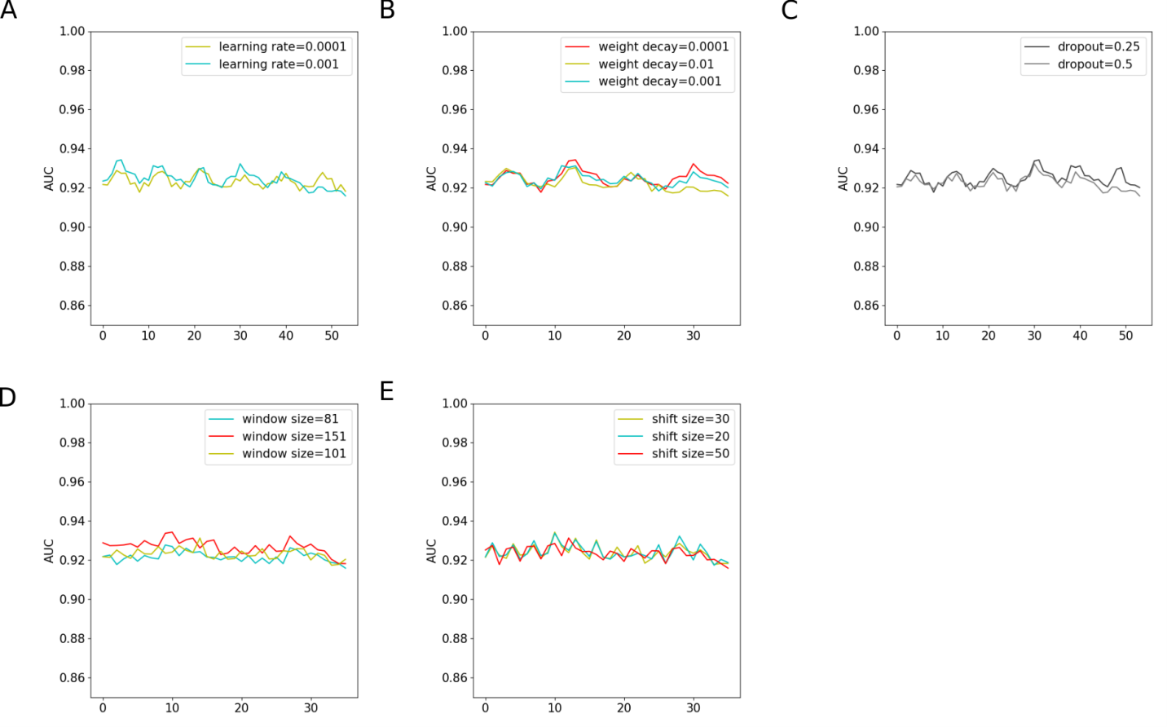
Figure S1. The impact of different parameters on iDeepE for RBP-24 dataset. In total, there are 108 trials for the 5 parameters. In each sub figures, x-axis is a trial corresponding to the same combination of other 4 parameters.

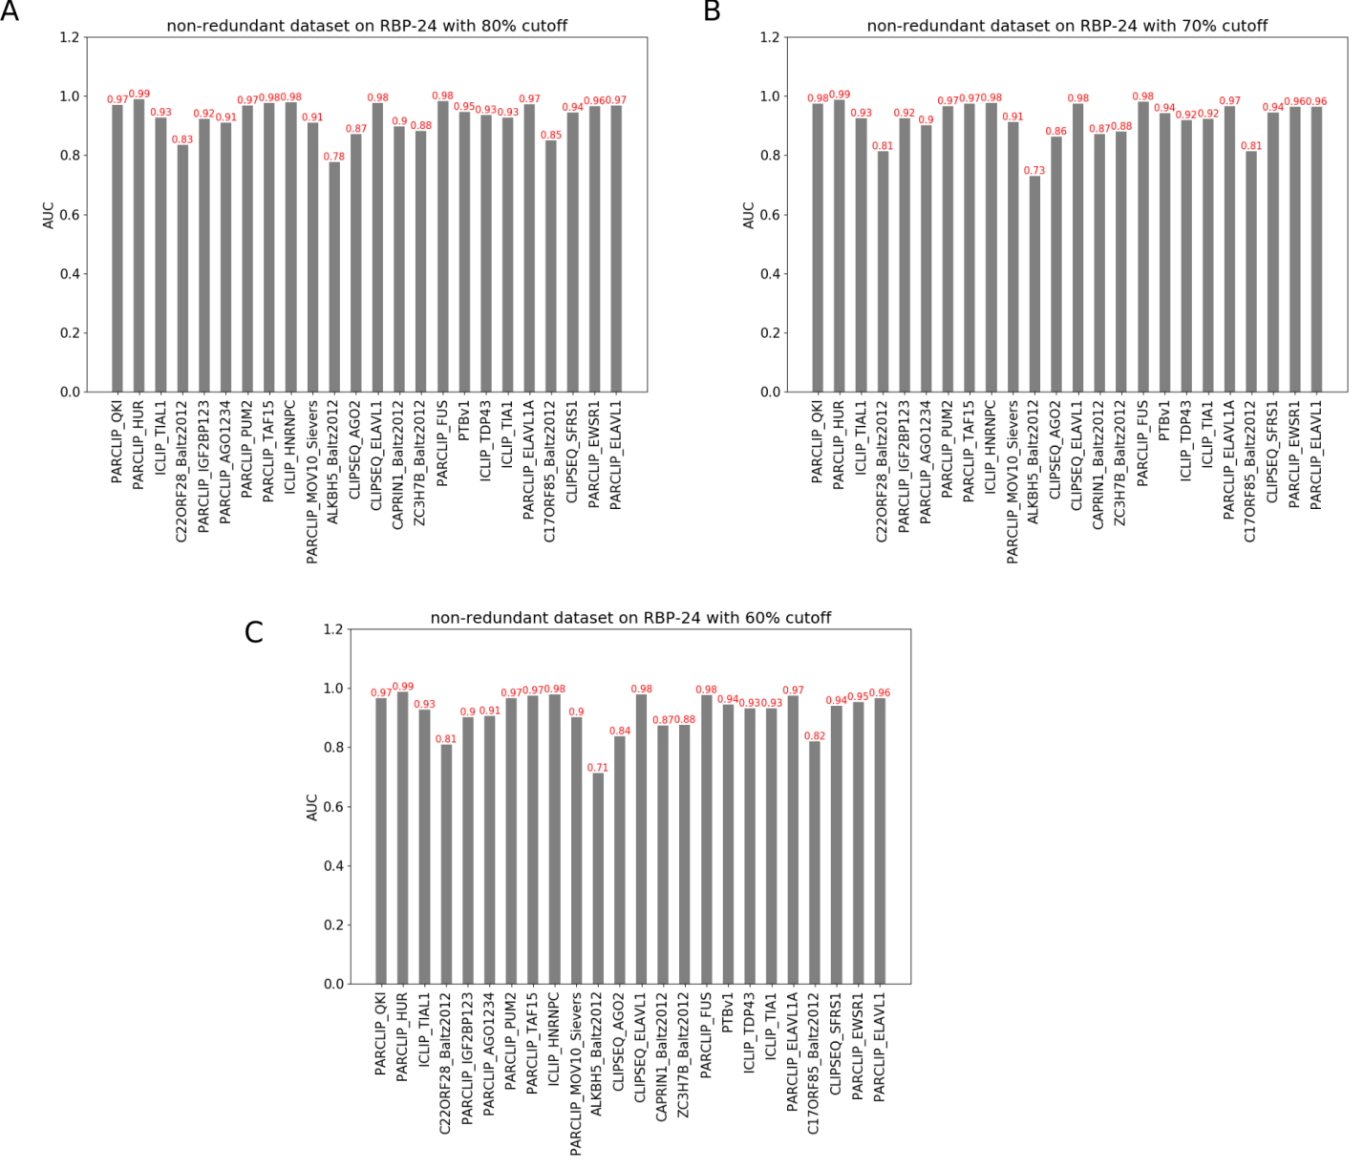
Figure S2. The AUCs of iDeepE across 24 RBPs on non-redundant RBP-24, in which the sequences in testing set have no sequence similarity over 80%, 70% and 60% to any sequences in training set, respectively.

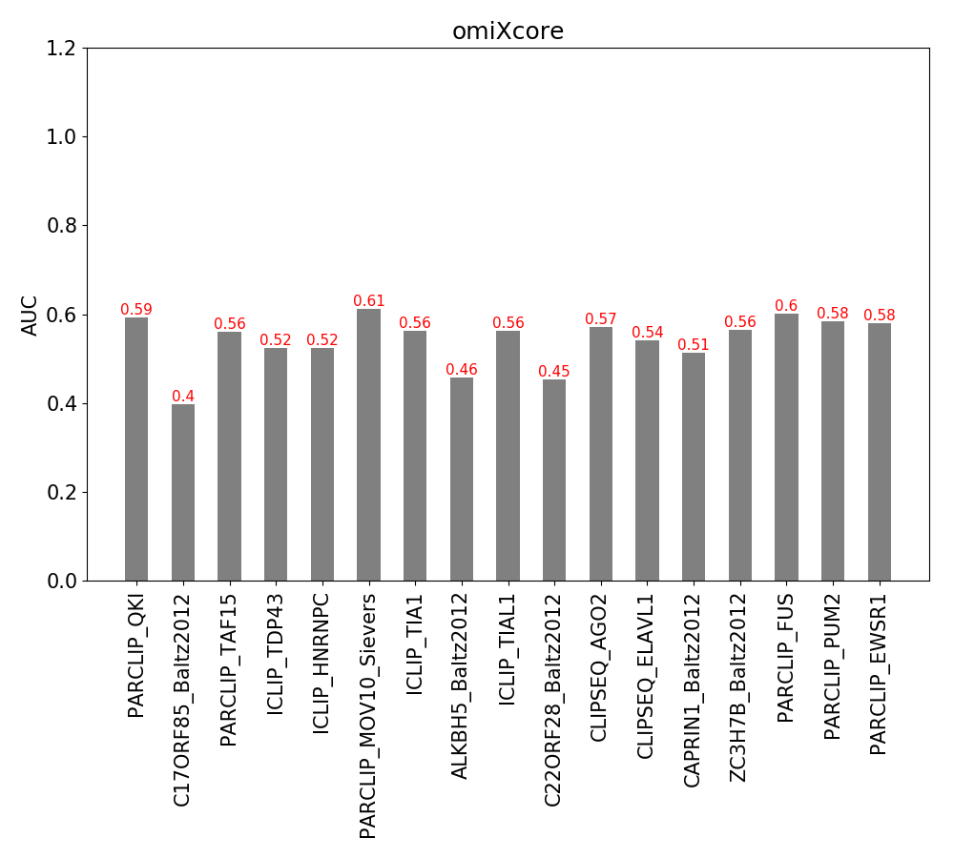
Figure S3. AUCs of omiXcore on testing set in RBP-24. The predicted binding scores are calculated by omiXcore.
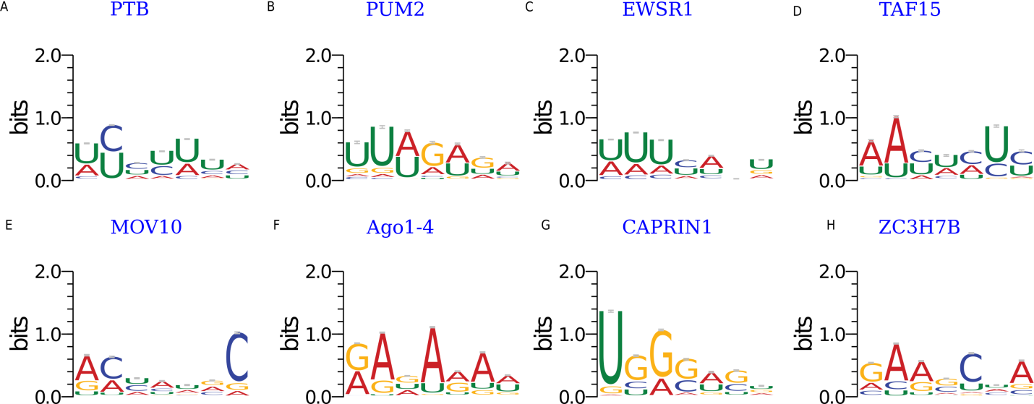
Figure S4. The enriched binding motifs detected by iDeepE using AME for individual RBPs.

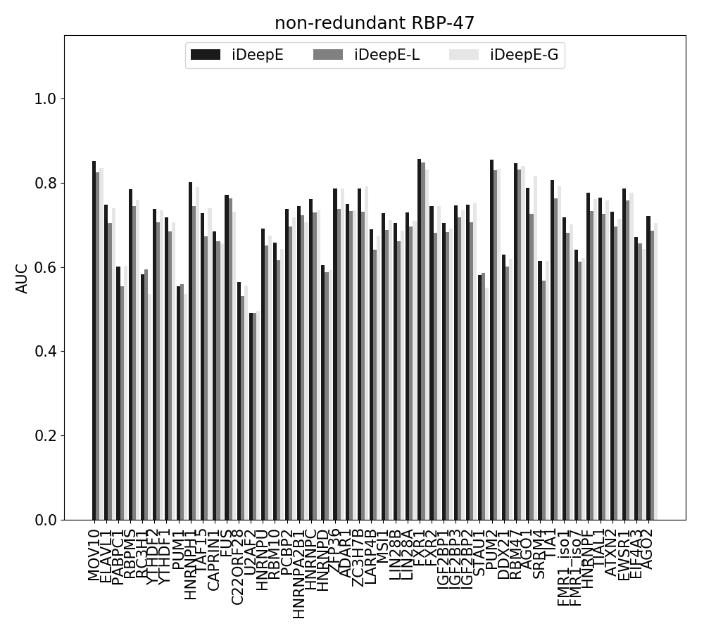
Figure S5. The AUCs of iDeepE across 47 RBPs on non-redundant RBP-47, in which the sequences in testing set have no sequence similarity over 80% to any sequences in training set.
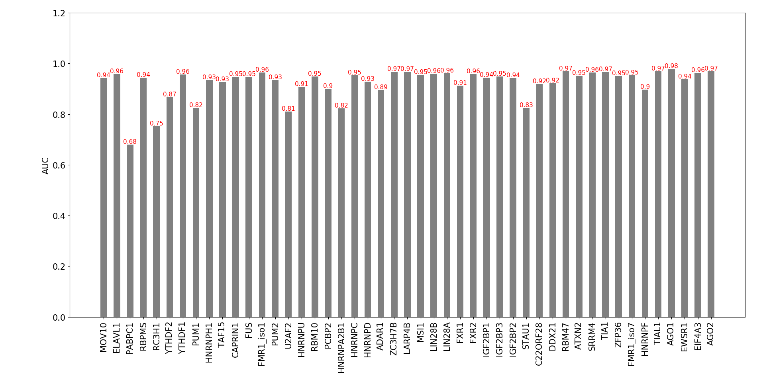
Figure S6. The AUCs of iDeepE across 47 RBPs using shuffled positive sequences as negative samples, where positive sequences are the same as RBP-47, but the negative sequences are those shuffled sequences of positive sequences in training set.

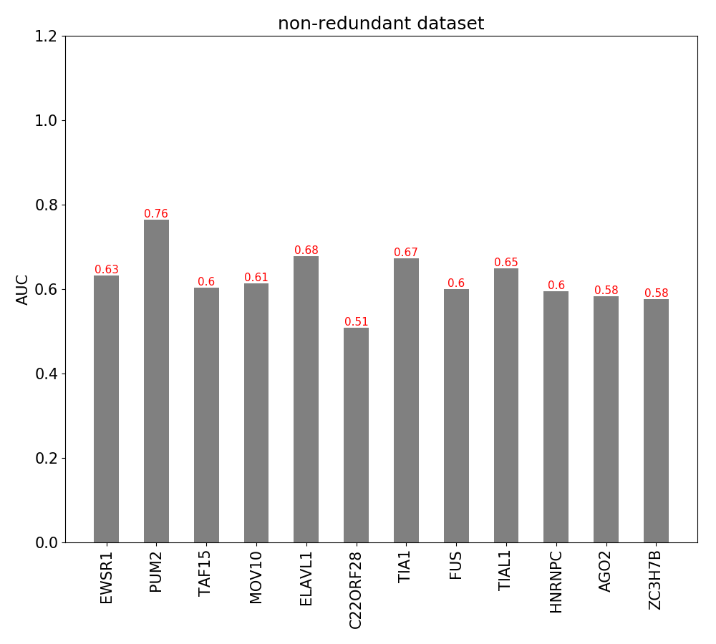
Figure S7. The cross-dataset validation performance of iDeepE-1 on non-redundant RBP-47, in which the sequences in testing set have no sequence similarity over 80% to any sequences in training set.

Network architectures
The layers of the three models CNNs, CNN-LSTM.
CNN (
(layer1): Sequential (
(0): Conv2d(6, 16, kernel_size=(4, 10), stride=(1, 1))
(1): BatchNorm2d(16, eps=1e-05, momentum=0.1, affine=True)
(2): ReLU ()
(3): MaxPool2d (size=(1, 3), stride=(1, 1), dilation=(1, 1))
)
(layer2): Sequential (
(0): Conv2d(16, 16, kernel_size=(1, 10), stride=(1, 1))
(1): BatchNorm2d(16, eps=1e-05, momentum=0.1, affine=True)
(2): ReLU ()
(3): MaxPool2d (size=(1, 3), stride=(1, 1), dilation=(1, 1))
)
(drop1): Dropout (p = 0.25)
(fc1): Linear (1360 -> 200)
(drop2): Dropout (p = 0.25)
(relu1): ReLU ()
(fc2): Linear (200 -> 2)
)

CNN_LSTM (
(layer1): Sequential (
(0): Conv2d(6, 16, kernel_size=(4, 10), stride=(1, 1))
(1): BatchNorm2d(16, eps=1e-05, momentum=0.1, affine=True)
(2): ReLU ()
(3): MaxPool2d (size=(1, 3), stride=(1, 1), dilation=(1, 1))
)
(downsample): Conv2d(16, 1, kernel_size=(1, 10), stride=(1, 1))
(layer2): LSTM(87, 200, num_layers=2, batch_first=True, bidirectional=True)
(drop1): Dropout (p = 0.5)
(fc1): Linear (400 -> 200)
(drop2): Dropout (p = 0.25)
(relu1): ReLU ()
(fc2): Linear (200 -> 2)
)

