Supplementary Materials
for
Recombinational DSBs-intersected genes converge on specific disease- and adaptability-related pathways

Zhi-Kai Yang, Hao Luo, Yanming Zhang, Baijing Wang and Feng Gao*

Supplementary Methods

Gene functional annotation: In this study, we selected the standard strain s288c as reference, and reannotated all the protein-coding genes based on the latest functional data. In the entire annotating process, we adopted the InterProScan tool to annotate the Gene Ontology (GO) terms (Quevillon et al., 2005), adopted the online KEGG Automatic Annotation Server (KAAS) to carry out the assignment of biological pathways based on the current Kyoto Encyclopedia of Genes and Genomes (KEGG) database (http://www.genome.jp/kegg) (Moriya et al., 2007), and adopted the BLASTx (Altschul, et al., 1990) to conduct the KOG (eukaryotic orthologous groups) annotation with an E-value cut-off of 1.0E-03 against KOG/COG database (http://www.ncbi.nlm.nih.gov/COG/) (Tatusov et al., 2003).

Supplementary Results

KOG analysis of RDIGs
KOG database is a secondary database classifying eukaryotic genes into functional categories and groups. By BLASTX search of RDIGs against this database, we found that 2292 out of 3013 protein-coding RDIGs (76%) were significantly aligned to 1683 clusters, which were classified into 24 KOG functional groups (Supplementary Fig. S6). By statistics, we found that top three groups were the general function prediction only [R], posttranslational modification, protein turnover, chaperones [O], and signal transduction mechanisms [T] respectively. Protein turnover was found to occur in brain cells in the same way as any other eukaryotic cells and decreased with aging in senescent organisms (Dhondt et al., 2017). Chaperones were closely associated with many human diseases, such as the Alzheimer’s disease (AD) (Sadigh-Eteghad et al., 2015). Generally, signal transduction mechanisms would be altered as brain aged, but the aging process would greatly challenge such neurorestorative and neuroprotective signal transduction mechanisms, causing devastating consequences, such as neurodegenerative diseases (NDs) and stroke (Sweeney et al., 2016). These findings suggested that the abnormal or error-prone repair of DSBs in RDIGs was most likely to cause diseases.

Results of GO Enrichment Analysis in HRDIGs
We found that HRDIGs were significantly enriched in these GO terms related to intron homing (Supplementary Fig. S7; Supplementary Table S2). Intron homing refers to lateral transfer of intron to homologous allele without introns, which is mediated by a site-specific homing endonuclease (Wu et al., 2015). Generally, intron homing is a strictly DNA-based process of gene conversion, initiated by double-strand cleavage of intronless allele, and involving the recombination of homologous exons (Stoddard et al., 2014). As reported previously, homing endonucleases may play an editing role in gene transcription, as well as an integrating role for intron and gene transposition (Salavirta et al., 2014). More notably, previous study has shown that homing endonuclease is the product of ORF within mobile intron (Stoddard et al., 2014) and can promote homologous recombination in various types of eukaryotic cells, including mammalian cells (Marcaida et al., 2010). So the enrichment of intron homing, endonuclease activity and nuclease activity, together with previous studies, strongly indicated that intron homing involved in the generation of recombinational DSBs. In addition, some monogenic diseases may be amenable to treatment by homing endonuclease-induced homologous recombination (Marcaida et al., 2010), suggesting that recombination contributed to the repair of disease-related DNA lesions.

Meanwhile, we found that HRDIGs were also significantly enriched in these GO terms related to oxidation-reduction process and cellular respiration (Supplementary Fig. S7; Supplementary Table S2). It has been known that many human diseases were related to the oxidation-reduction process. Most commonly, this process may be correlated with the development of most NDs, such as Parkinson’s disease (PD) and Huntington’s disease (HD) (Ni et al., 2015). As to the cellular respiration, it was the link between stress-response systems and metabolic function and regulation (Metallo et al., 2013; Hill, 2014). Impaired activity of enzymes related to cellular respiration would greatly contribute to the HD (Lodi, 2017), because neurons generally had high mitochondrial respiration and hence produced a large amount of ROS which enlarged the damage of mitochondrial and nuclear DNA. Therefore, accurate repair of DSBs related to both oxidation-reduction and cellular respiration was critical to keep the ROS at a relatively low level so as to decrease the production of DSBs. In addition, previous study also showed that differentially expressed genes between parental and cancer cells were significantly enriched in the oxidation-reduction process (Wang et al., 2017). These findings indicated that certain human diseases were tightly linked with HRDIGs.

References:

Altschul,S.F. et al. (1990). Basic local alignment search tool. J. Mol. Biol., 215, 403-410.
Dhondt,I. et al. (2017). Changes of Protein Turnover in Aging Caenorhabditis elegans. Mol. Cell Proteomics, 16, 1621-1633.
Hill,G.E. (2014). Cellular respiration: the nexus of stress, condition, and ornamentation. Integr. Comp. Biol., 54, 645-657.
Lodi,R. (2017). Is mitochondrial oxidative metabolism the right therapy target in early Huntington disease? Neurology, 88, 116-117.
Marcaida,M.J. et al. (2010). Homing endonucleases: from basics to therapeutic applications. Cell Mol. Life Sci., 67, 727-748.
Metallo,C.M. et al. (2013). Understanding metabolic regulation and its influence on cell physiology. Mol. Cell, 49, 388-398.
Moriya,Y. et al. (2007). KAAS: an automatic genome annotation and pathway reconstruction server. Nucleic Acids Res., 35, W182-W185.
Ni,Q. et al. (2015). Prediction of Metabolic Gene Biomarkers for Neurodegenerative Disease by an Integrated Network-Based Approach. Biomed. Res. Int., 2015, 432012.
Quevillon,E. et al. (2005). InterProScan: protein domains identifier. Nucleic Acids Res., 33, W116-W120.
Sadigh-Eteghad,S. et al. (2015). Regulation of nicotinic acetylcholine receptors in Alzheimer’s disease: a possible role of chaperones. Eur. J. Pharmacol., 755, 34-41.
Salavirta,H. et al. (2014). Mitochondrial genome of Phlebia radiata is the second largest (156 kbp) among fungi and features signs of genome flexibility and recent recombination events. PLoS One, 9, e97141.
Stoddard,B.L. (2014). Homing endonucleases from mobile group I introns: discovery to genome engineering. Mob. DNA, 5, 7.
Sweeney,M.D. et al. (2016). Pericytes of the neurovascular unit: key functions and signaling pathways. Nat Neurosci., 19, 771-783.
Tatusov,R.L. et al. (2003). The COG database: an updated version includes eukaryotes. BMC Bioinformatics, 4, 41.
Wang,D. et al. (2017). Identification of new biomarkers for cisplatin-resistance in A549 human lung adenocarcinoma cells by an integrated bioinformatical analysis. Transl Cancer Res., 6, 474-482.
Wu,B. et al. (2015). Extensive Horizontal Transfer and Homologous Recombination Generate Highly Chimeric Mitochondrial Genomes in Yeast. Mol Biol Evol., 32, 2559-2570.

Supplemental Tables

Table S1. Geographic and environmental origins of 42 S. cerevisiae strains

Strain | Geographic origin | Environmental origin | Strain | Geographic origin | Environmental origin
YJM1439† | W. Africa | Ginger beer | YJM1549# | Netherlands | Fermenting fruit juice
YJM1341† | South Africa | Wine | YJM1383# | Philippines | Coconut
YJM1460† | Africa | Palm Wine | YJM1400# | Philippines | Guava
YJM1342# | South Africa | Soil | YJM1078* | Portugal | Clinical
YJM1443# | Bahamas | Fruit | YJM244* | Romania | Clinical
YJM1527# | Winters, CA | Prune | YJM270† | Slovenia | Wine
YJM1463# | Ethiopia | White Tecc | YJM1252# | Spain | Alpechin
YJM1415† | France | Wine | YJM1592# | Thailand | Sewage
YJM1433† | France | Wine | YJM1381# | Trinidad | Rum fermentation
YJM1573# | India | Fermented food | YJM456* | CA, USA | Clinical
YJM1244# | Indonesia | Fruit | YJM682* | TX, USA | Clinical
YJM987* | Italy | Clinical | YJM693* | YX, USA | Clinical
YJM1332† | Italy | Wine | YJM1307* | DC, USA | Clinical
YJM1336† | Italy | Wine | YJM1311* | MI, USA | Clinical
YJM1387† | Japan | Wine | YJM1615* | CA, USA | Clinical
YJM1418# | Japan | Oak tree | S288c# | USA | Laboratory
YJM1386# | Jamaica | Sugar cane | YJM1477† | MO, USA | Blatz beer
YJM1388# | Malaya | Fermented tapioca | YJM1385# | MD, USA | Sugar refinery
YJM1447# | Malaysia | Bertam Palm | YJM1338# | MD, USA | Sour fig
YJM1450* | Newcastle, UK | Clinical | YJM1434# | PA, USA | Oak
In this study, * belong to the clinic group, † belong to the wine group, # belong to the other group.

Table S2. All the recombination events detected by RDP4 program



Table S3. Significantly enriched KEGG pathways in HRDIGs

Map ID | KEGG Pathway | No. Genes | Adjusted P-values
map04612 | Antigen processing and presentation | 4 | 2.74E-04
map04915 | Estrogen signaling pathway | 4 | 3.05E-03
map00980 | Metabolism of xenobiotics by cytochrome P450 | 3 | 3.35E-03
map00982 | Drug metabolism - cytochrome P450 | 3 | 3.35E-03
map04260 | Cardiac muscle contraction | 4 | 3.35E-03
map00350 | Tyrosine metabolism | 3 | 8.12E-03
map05012 | Parkinson's disease | 5 | 8.12E-03
map05010 | Alzheimer's disease | 5 | 8.12E-03
map05204 | Chemical carcinogenesis | 2 | 1.31E-02
map04626 | Plant-pathogen interaction | 2 | 1.31E-02
map02020 | Two-component system | 3 | 1.34E-02
map04932 | Non-alcoholic fatty liver disease (NAFLD) | 4 | 1.34E-02
map00190 | Oxidative phosphorylation | 5 | 1.54E-02
map05016 | Huntington's disease | 5 | 1.54E-02
map04657 | IL-17 signaling pathway | 2 | 2.38E-02
map04659 | Th17 cell differentiation | 2 | 3.52E-02
map00360 | Phenylalanine metabolism | 2 | 4.01E-02
map05215 | Prostate cancer | 2 | 4.51E-02
map05162 | Measles | 2 | 4.75E-02
map00410 | beta-Alanine metabolism | 2 | 4.75E-02
map05418 | Fluid shear stress and atherosclerosis | 2 | 5.00E-02
map00340 | Histidine metabolism | 2 | 5.00E-02
No. Genes indicates the number of genes belonging to corresponding pathway. Adjusted P-values indicates the adjusted significance of enrichment testing. HRDIGs refer to these recombinational DSBs-intersected genes with high frequency (>= 0.9) of recombinational DSBs.

Table S4. Significantly enriched GO terms in HRDIGs

GO ID | GO Term | Class | No. Genes | Level | Adjusted P-values
 | Biological process (BP)
GO:0045333 | cellular respiration | BP | 6 | 5 | 2.87E-03
GO:0006314 | intron homing | BP | 3 | 7 | 3.37E-03
GO:0055114 | oxidation-reduction process | BP | 15 | 4 | 5.79E-03
 | Cellular component (CC)
GO:0016491 | oxidoreductase activity | MF | 15 | 3 | 2.87E-03
GO:0009055 | electron carrier activity | MF | 6 | 2 | 5.79E-03
GO:0004519 | endonuclease activity | MF | 5 | 6 | 8.37E-03
GO:0004518 | nuclease activity | MF | 6 | 5 | 1.06E-02
No. Genes indicates the number of genes belonging to corresponding category. Adjusted P-values indicate the adjusted significance of enrichment testing. Level indicates the level of Gene Ontology (GO) term in the tree-like organized GO vocabulary system (the deeper the level of GO term is, the more specifically the GO term is defined). HRDIGs refer to these recombinational DSBs-intersected genes with high frequency (>= 0.9) of recombinational DSBs.

Supplemental Figures

Figure S1. Phylogenetic network for budding yeast generated by SplitsTree with the default settings. Recombination events between different strains are indicated by the multiple reticulate networks. Scale bar shows that the evolutionary rate is 0.01 substitutions per site.

Figure S2. Statistical analysis of recombination events for every chromosome. (a) Length distribution of recombination sequences in each chromosome and blue dots linked by line (right axis) show the length of corresponding chromosome. (b) Bar plot showing the number and average length of recombination events in each chromosome and red dots linked by line (right axis) showing the average length of recombination sequences in each chromosome. Rec represents the recombination.

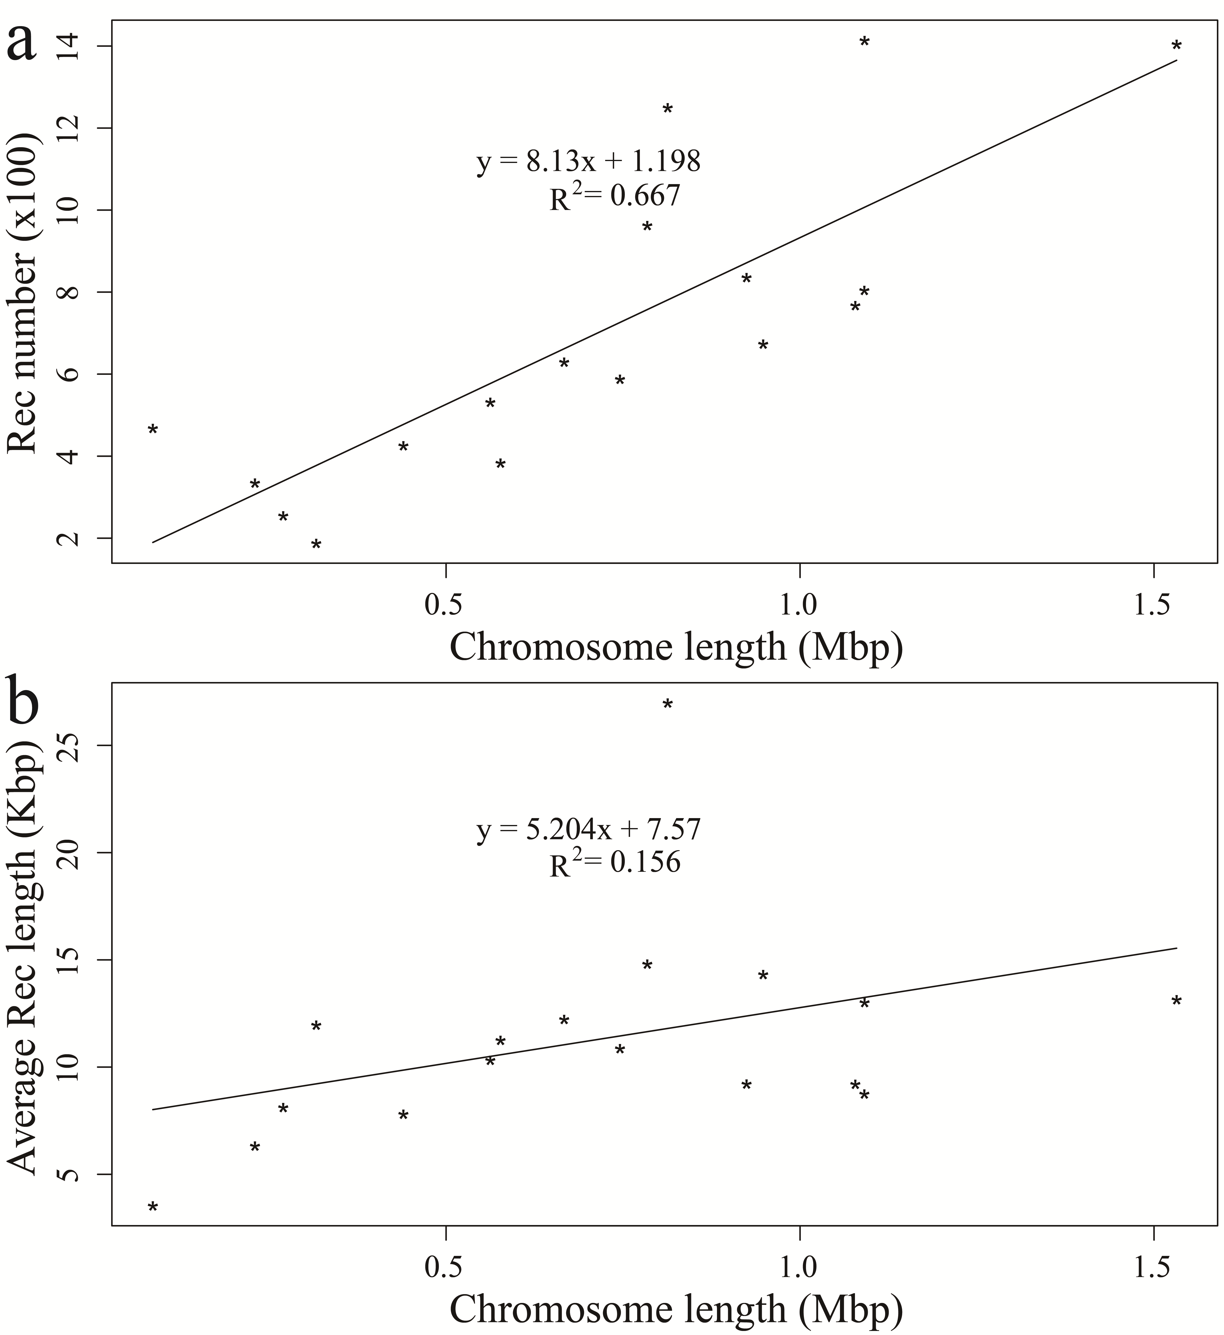
Figure S3. Regression analysis of correlation between recombination and chromosome. (a) Linear regression of chromosome length against the number of recombination events. (b) Linear regression of chromosome length against the average length of recombination events. Rec represents the recombination.

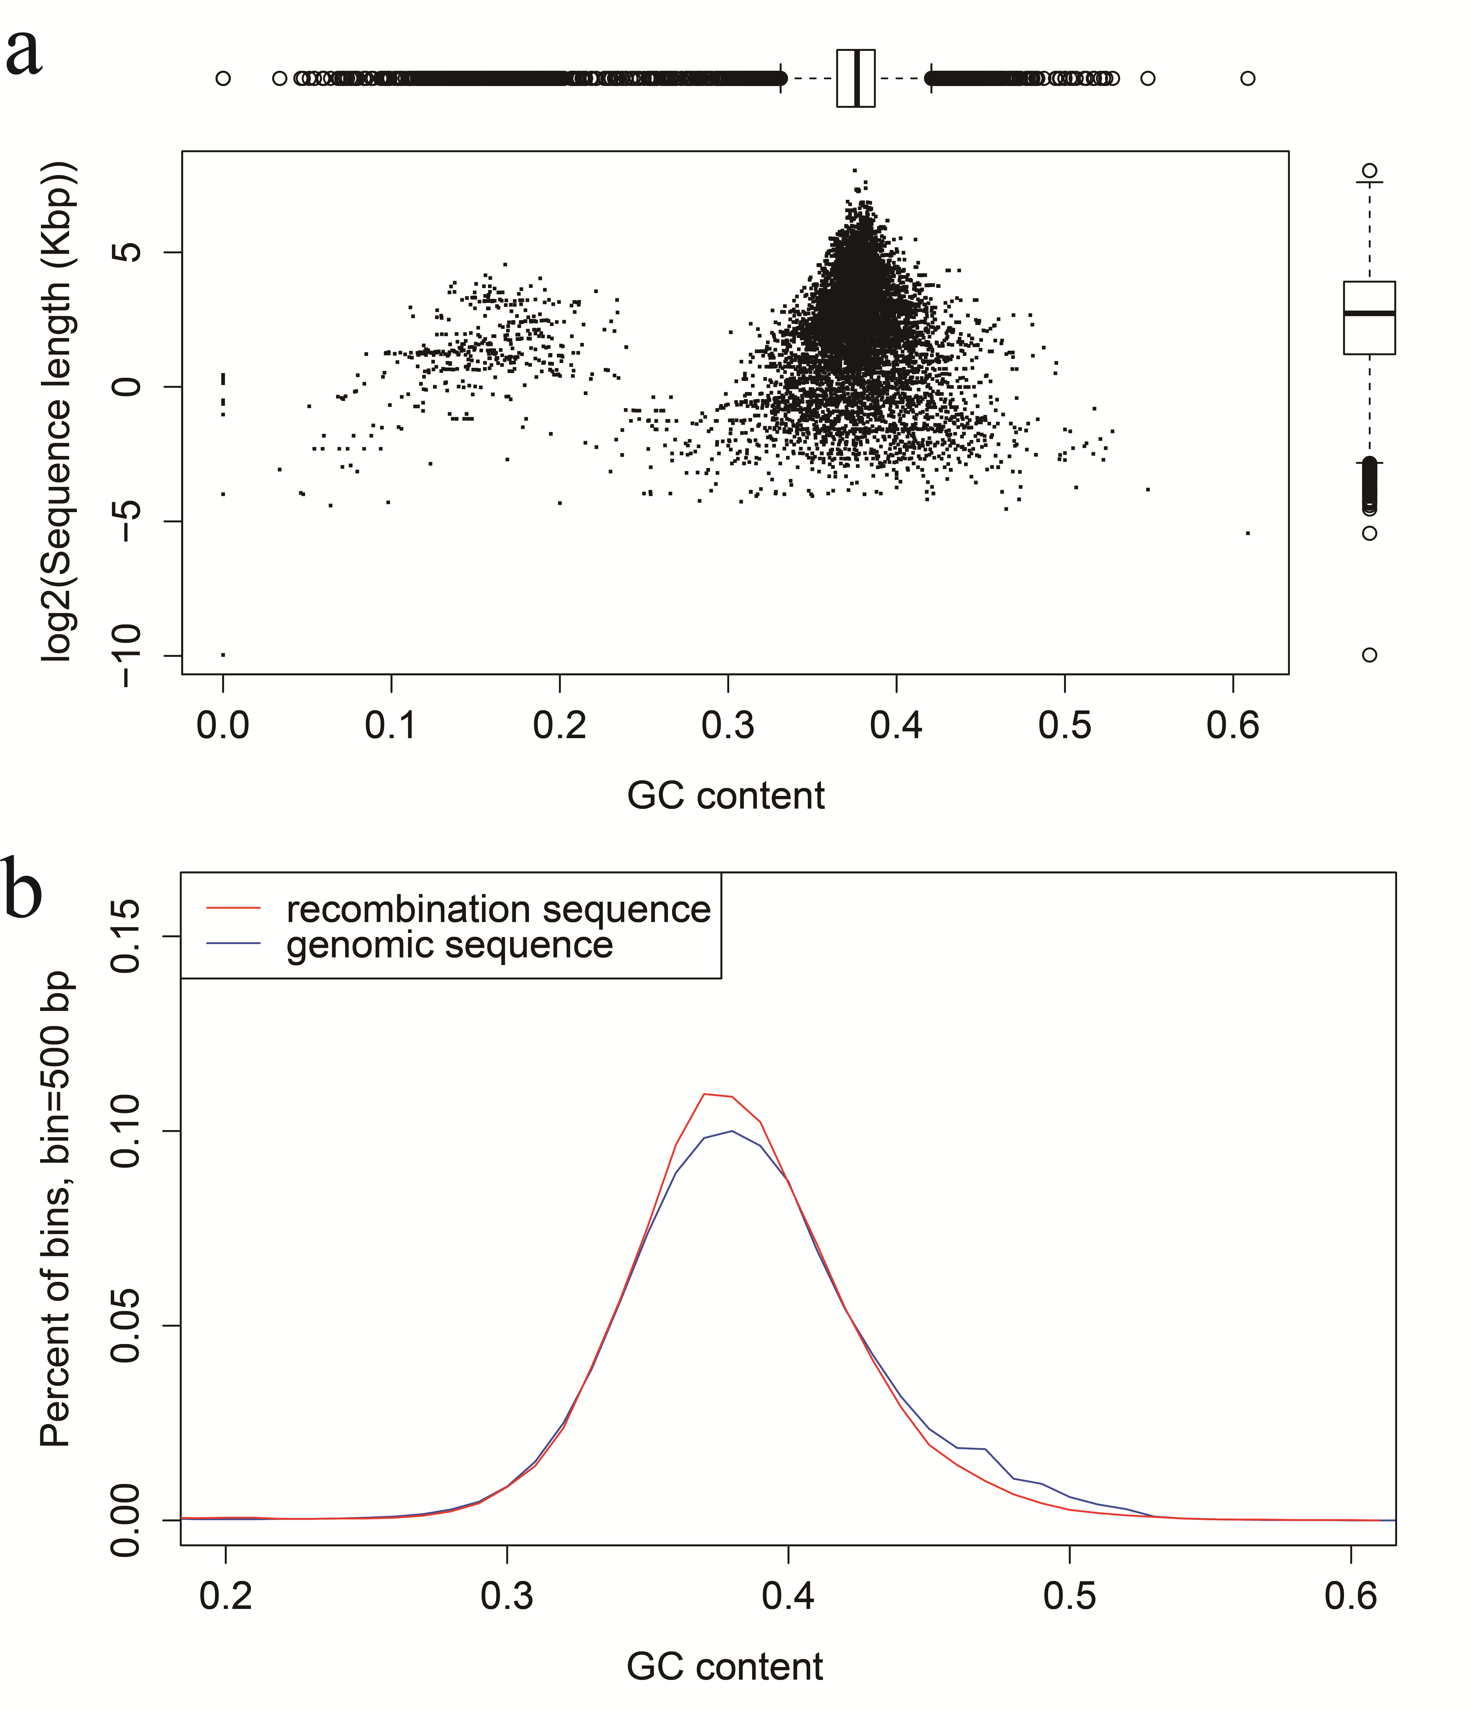
Figure S4. GC content of recombination sequences. (a) Relationship between the length of recombination sequences and their GC contents. Top box plot shows the distribution of GC content in recombination sequences, and right box plot shows their length distribution. (b) Density distribution of GC content in genome (blue line) and in recombination sequences (red line).
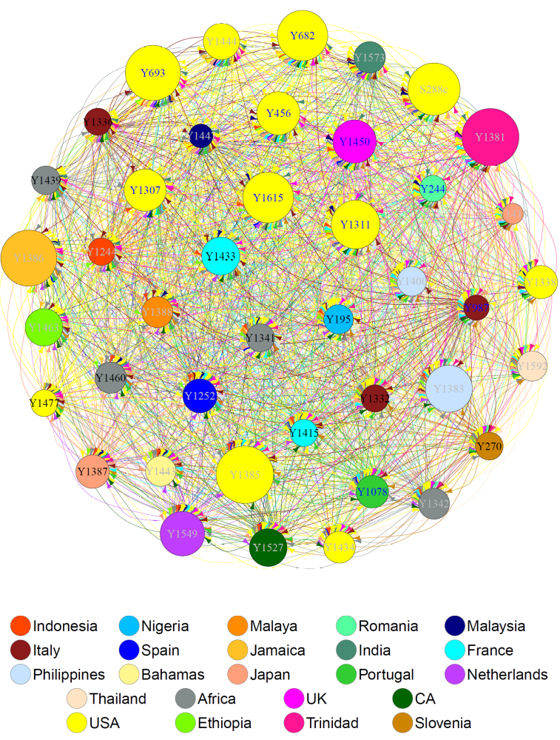

Figure S5. Network relationships of recombination events. Network graph represents the relationships between recombinational donor and receptor, in which the arrow holding the same color as donor points to the receptor, and the wider the link between nodes is, the stronger their relationships is. All strains are represented by nodes, colored according to geographical origin as specified by legend, the size of node represents the number of recombination events. Names of strains (“Y” is the abbreviation of “YJM”) are labeled on nodes, and blue, black and grey letters of names represent sources related to clinic, wine and other, respectively.

Figure S6. KOG function classification of RDIGs. KOG database contains four meta-categories, namely the information storage and processing (including J, A, K, L and B), cellular processes and signaling (including D, Y, V, T, M, N, Z, W, U and O), metabolism (including C, E, F, G, H, I, P, Q), and poorly characterized (including R and S).
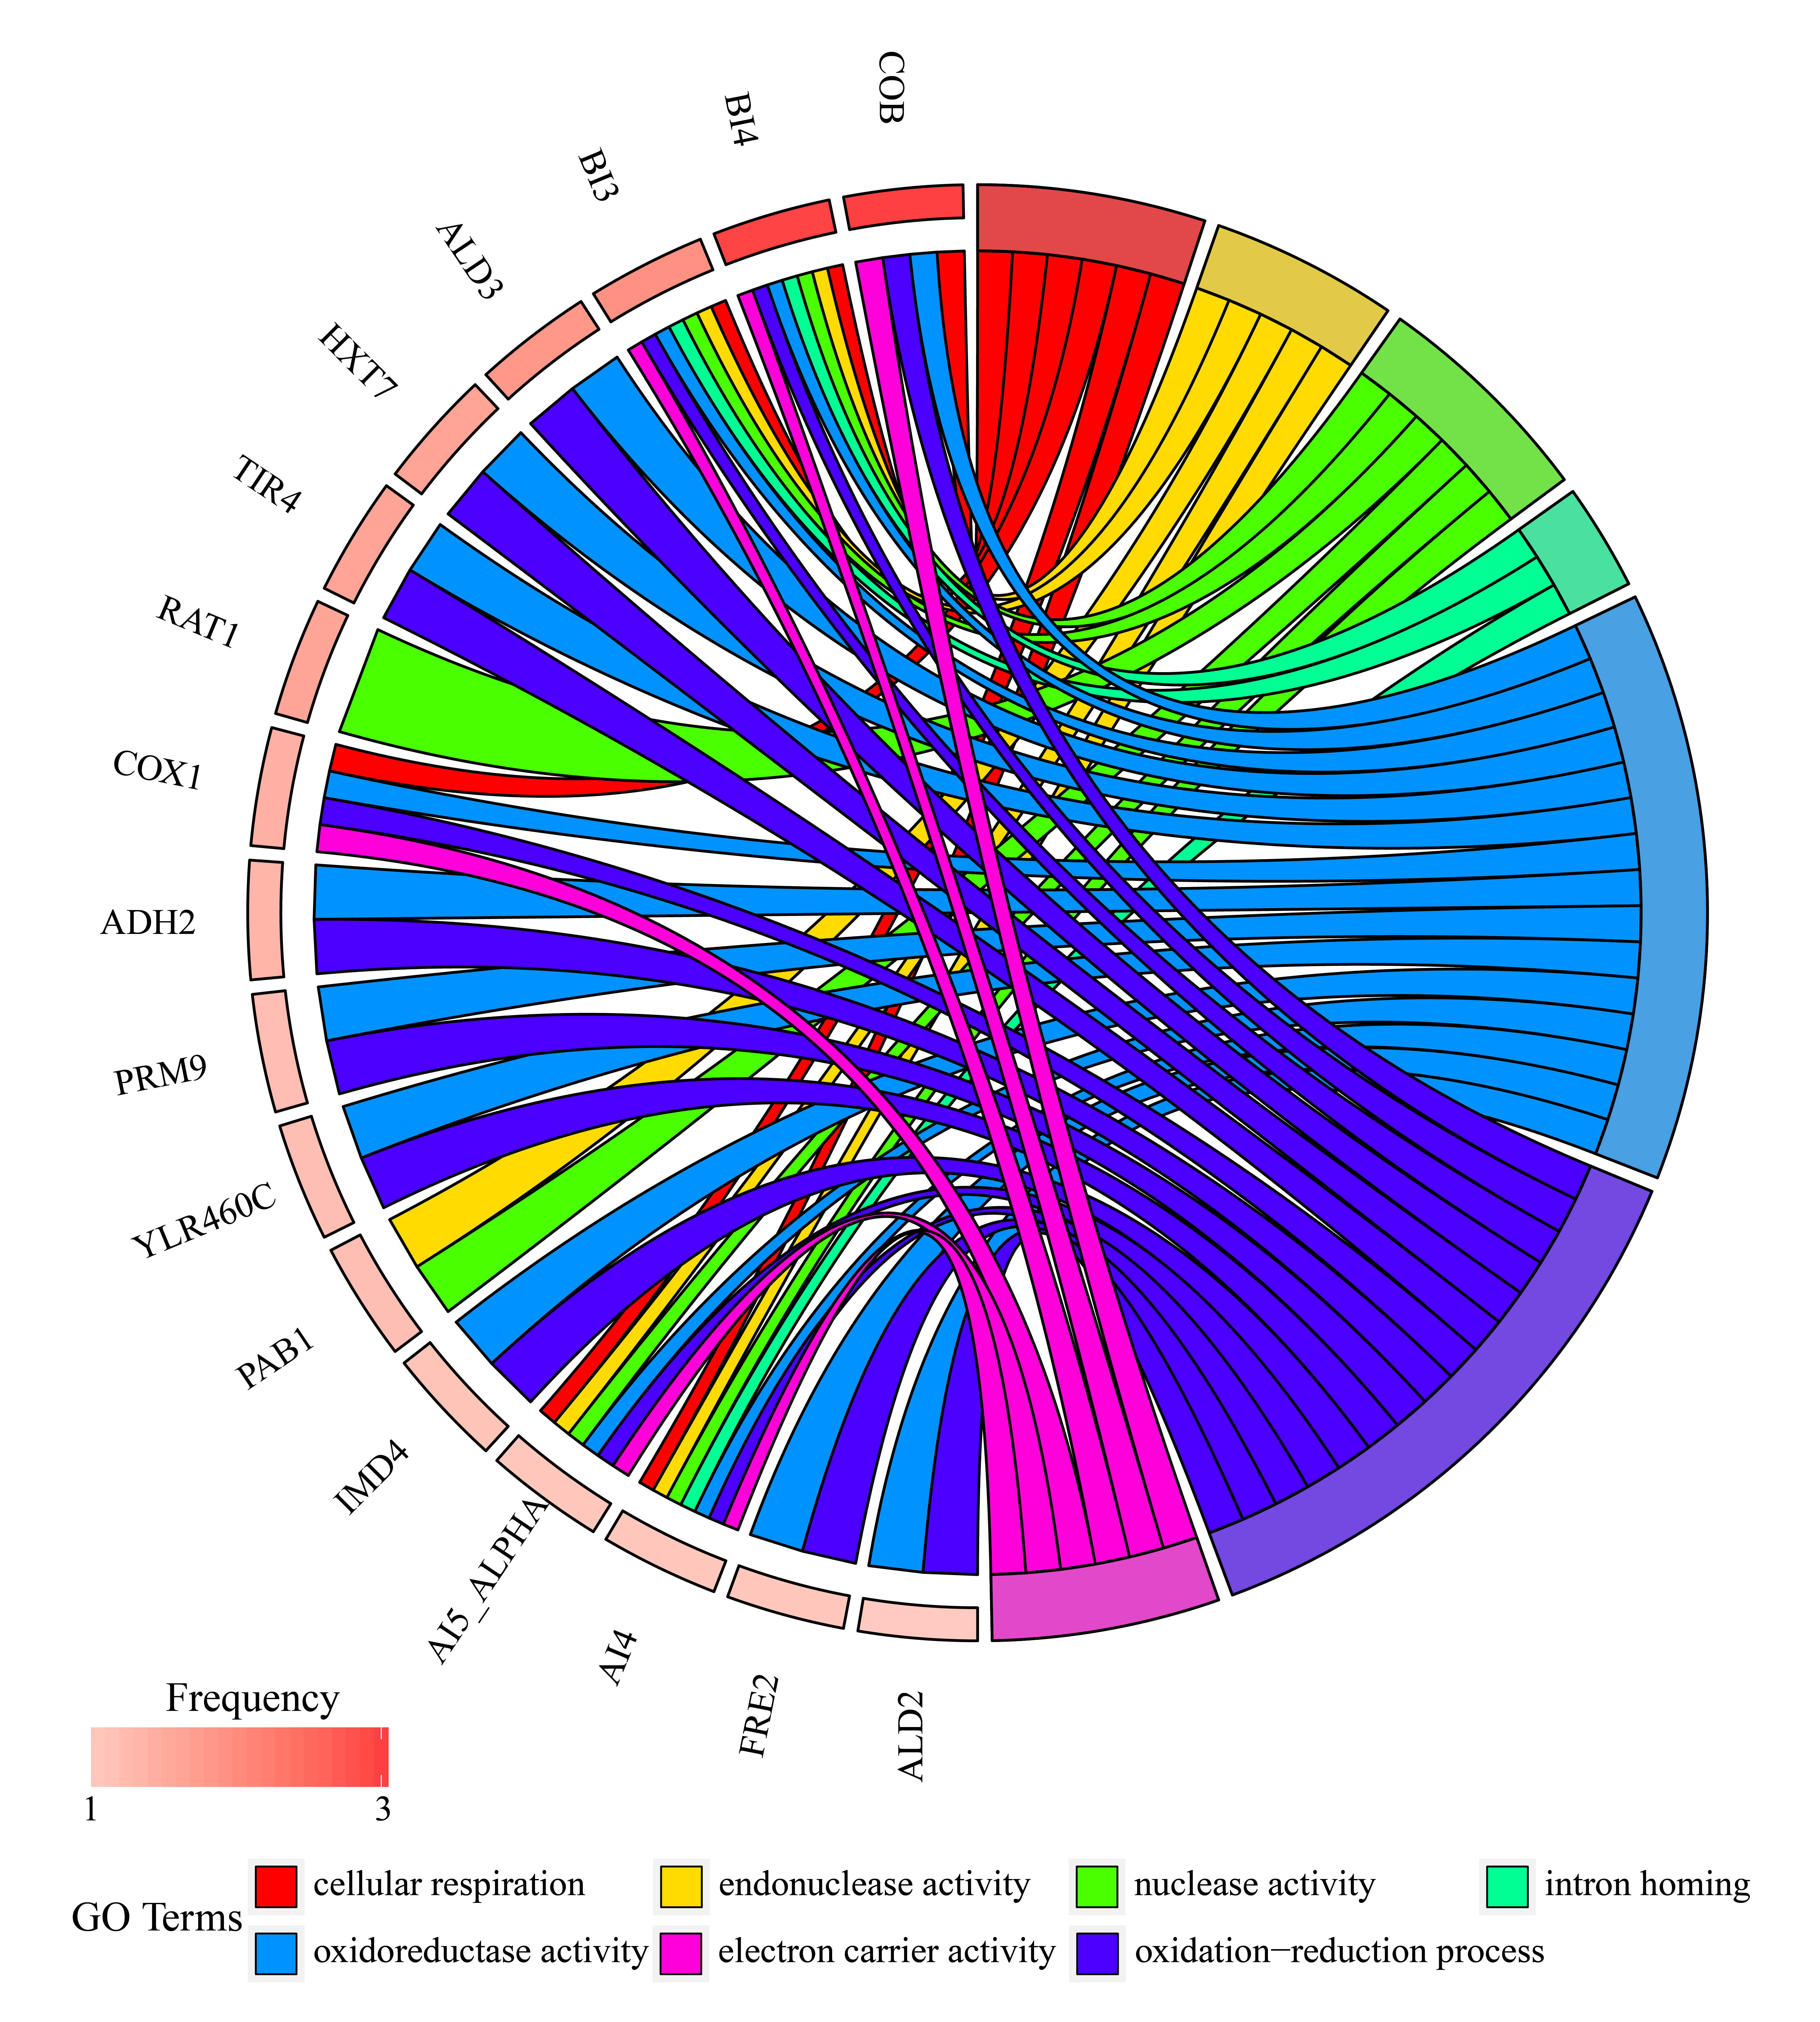

Figure S7. Plot of significantly enriched GO terms in HRDIGs. Right rectangle represents the GO term, and its length represents the number of gene. Left rectangle represents the corresponding gene and its color depth represents the average frequency of recombinational DSBs occurred in gene. The right rectangle is linked with left rectangle by the same color of stripe.

