Supplementary Information

MRMAssayDB: an integrated resource for validated targeted proteomics assays
Pallab Bhowmick^{1†}, Yassene Mohammed^{1, 2†*}, and Christoph H. Borchers^{1, 3-5*}

¹University of Victoria - Genome British Columbia Proteomics Centre, Victoria, BC V8Z 7X8, Canada
²Center for Proteomics and Metabolomics, Leiden University Medical Center, Leiden 2333 ZA, Netherlands
³Dept. of Biochemistry and Microbiology, University of Victoria, Victoria, BC V8P 5C2, Canada
⁴Proteomics Centre, Segal Cancer Centre, Lady Davis Institute, Jewish General Hospital, McGill University, Montreal, Quebec H3T 1E2, Canada
⁵Gerald Bronfman Department of Oncology, Jewish General Hospital, Montreal H4A 3T2, Quebec, Canada

† These authors contributed equally to the manuscript. *corresponding authors

Figure S1: An example of search results in MRMAssayDB. The results page is divided into three parts, A) the results datatable containing all entries with corresponding links to all layered and additional information about each assay, B) tabular statistics on the result entries, and c) graphical statistics on the on the result entries.

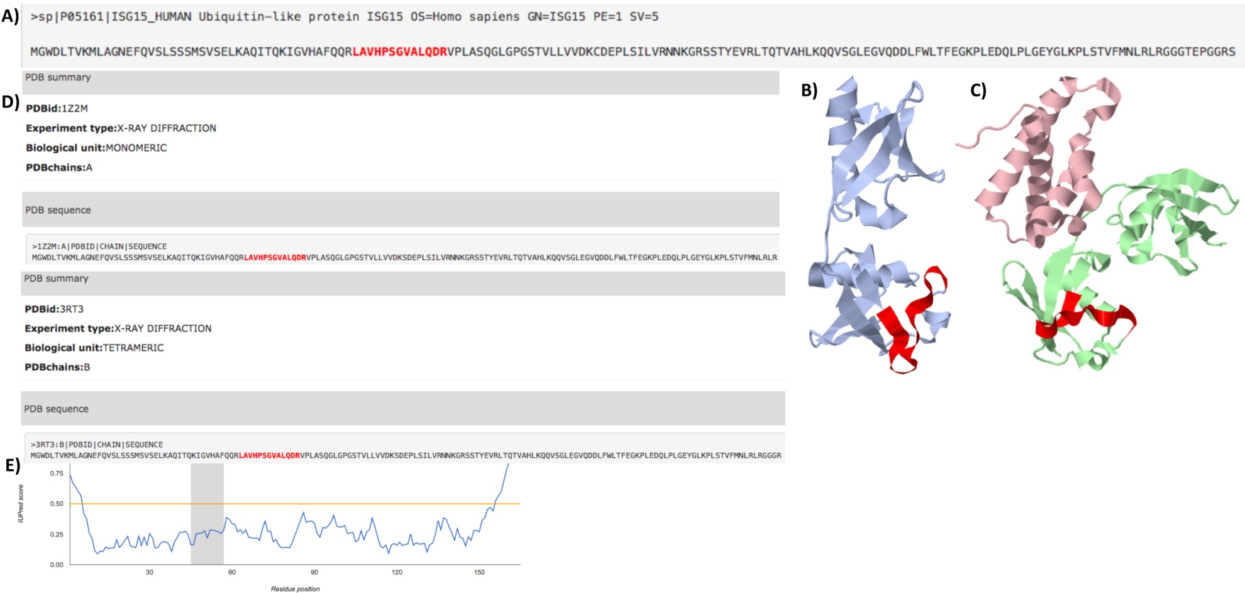

Figure S2: 3D Protein Structure with the target peptide of the MRM assay highlighted in red, as viewed in MRMAssayDB. A) The peptide highlighted in the protein sequence. (B) A display of an ISG15 protein 3D unbound structure with the proteotypic peptide region highlighted in red (PDB ID: 1Z2M). (C) A display of an ISG15 protein 3D bound structure with peptide region highlighted in red (PDB ID: 3RT3). (D) A summary of the PDB information on ISG15 as shown by MRMAssayDB. (E) Predicted structural disorder using IUPred (peptide regions shown in gray).

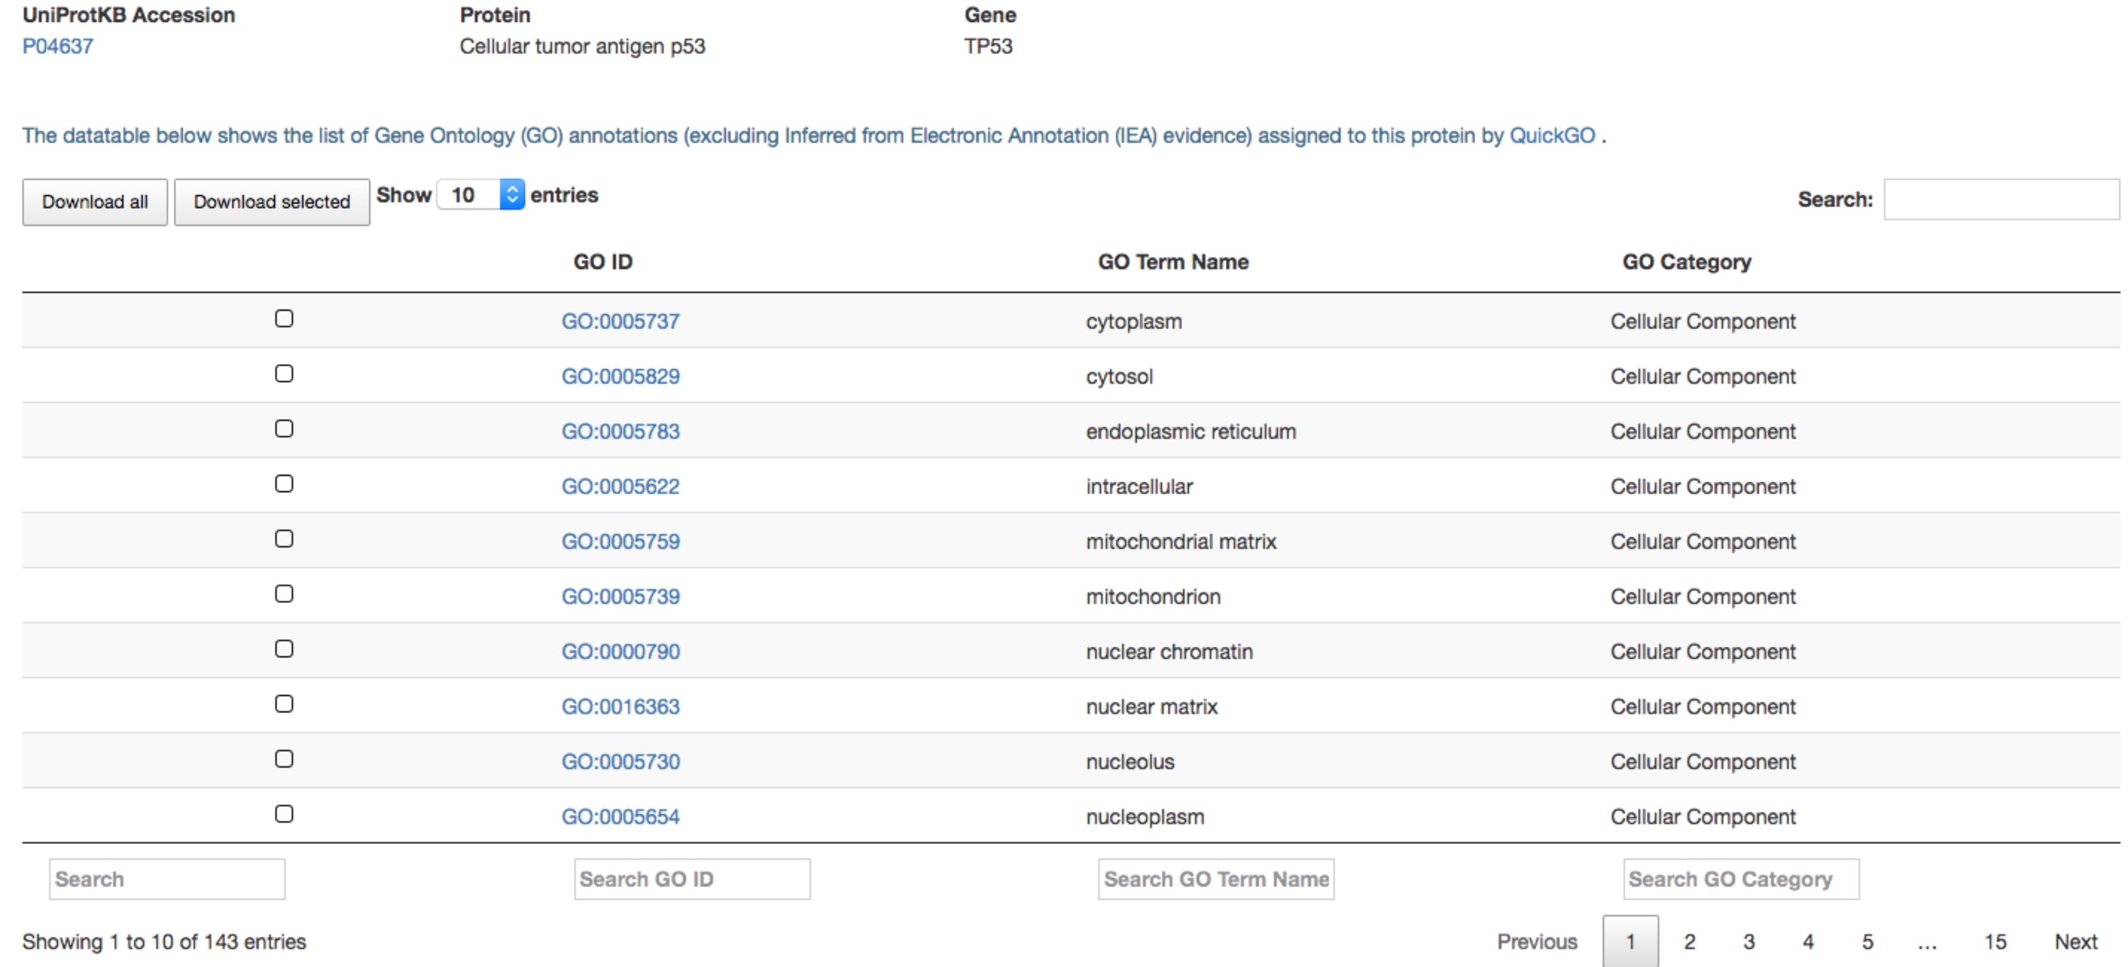

Figure S3: The table shows an example of the Gene Ontology (GO) annotations assigned to a protein.

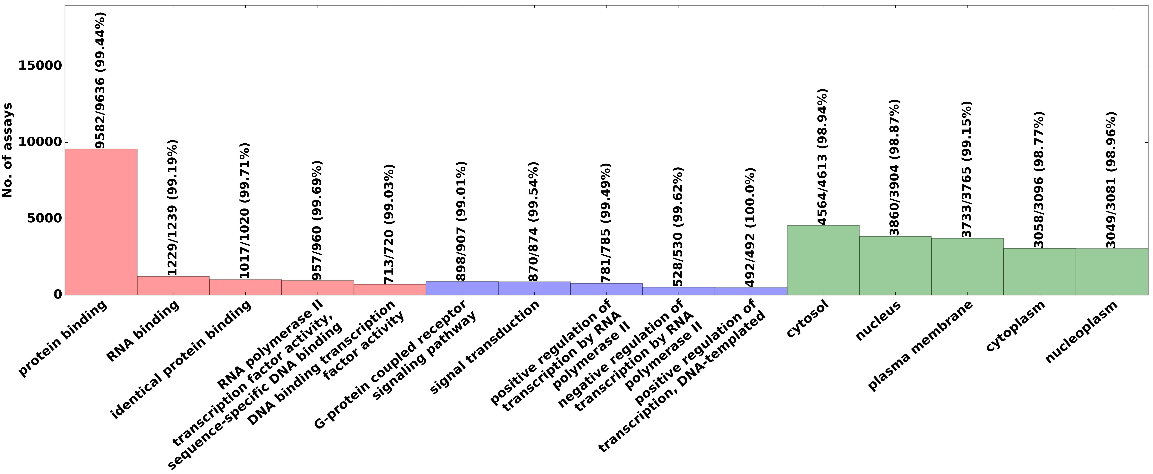

Figure S4: Top 5 gene ontology annotations for molecular function (red), biological process (blue), and cellular component (green), which are assigned to the assays in MRMAssayDB for Homo sapiens. Above each bar is the number of proteins with assays in MRMAssayDB, the total number of proteins corresponding to that pathway, and -- in parentheses -- the corresponding percent coverage of MRMAssayDB entries in comparison to all proteins annotated in GO with that specific term.

