SUPPLEMENTAL INFORMATION

Supplemental Information includes four tables, three figures, one dataset and a method.

Supporting Information Legends

S1: Sequence data source

S2: CG and AG (purine) content percentage of the LAUPs

S3: Statistical tests for 21 typical mammals

S4: OS_Ratio in different k and n of Homo sapiens

S5: Workflows for the LAUP analysis

S6: LAUPs number of 24 specie's whole genomes

S7: The occurrences number of CpG-containing sequences compare between
Observe and Expected for Homo sapiens data.

S8: 586 common LAUPs for the whole genome of 21 typical mammalian species

S9: JBLA code and important process algorithms

Supplementary tables

Table 1: Sequence data source, it is noted that the sequences of 24 representative species are from the NCBI sites with the latest version of the GenBank GBFF (GenBank Flat File) format, which are divided into five lineages, such as Bacteria, Plant, Human, Primates (other than human) and Mammals (excluding Primates).

Classification | Species | Data size  (Gb) | Version
Bacteria | - Bacteria | 5.1 | All in ftp://ftp.ncbi.nih.gov/genomes/  archive/old_refseq/Bacteria/
Plant | - Oryza sativa | 0.38 | GCF_000005425.2_Build_4.0
 | - Arabidopsis  thaliana | 0.12 | GCF_000001735.3_TAIR10
Human | - Homo sapiens | 3.1 | GCF_000001405.36_GRCh38.p10
Primats  (except human) | - Ornithorhynchus anatinus | 2.0 | GCF_000002275.2_Ornithorhynchus_anatinus_5.0.1
 | - Pan troglodytes | 3.23 | GCF_000001515.7_Pan_tro_3.0
 | - Macaca mulatta | 3.24 | GCF_000772875.2_Mmul_8.0.1
 | - Papio anubis | 2.95 | GCF_000264685.2_Panu_2.0
 | - Colobus angolensis | 2.97 | GCF_000951035.1_Cang.pa_1.0
 | - Owl monkey | 2.93 | GCF_000952055.1_Anan_1.0
 | - Callithrix  jacchus | 2.91 | GCF_000004665.1_Callithrix_jacchus-3.2
 | - Microcebus murinus | 2.49 | GCF_000165445.2_Mmur_3.0
 | - Otolemur garnettii | 2.52 | GCF_000181295.1_OtoGar3
Mammals  (except Primates) | - Rattus  norvegicus | 2.87 | GCF_000001895.5_Rnor_6.0
 | - Mus  musculus | 2.81 | GCF_000001635.25_GRCm38.p5
 | - Oryctolagus  cuniculus | 2.74 | GCF_000003625.3_OryCun2.0
 | - Canislupus familiaris | 2.41 | GCF_000002285.3_CanFam3.1
 | - Miniopterus  natalensis | 1.8 | GCF_001595765.1_Mnat.v1
 | - Tupaia  chinensis | 2.85 | GCF_000334495.1_TupChi_1.0
 | - Erinaceus  europaeus | 2.72 | GCF_000296755.1_EriEur2.0
 | - Dasypus novemcinctus | 3.63 | GCF_000208655.1_Dasnov3.0
 | - Loxodonta  africana | 3.2 | GCF_000001905.1_Loxafr3.0
 | - Echinops  telfairi | 2.95 | GCF_000313985.1_EchTel2.0
 | - Monodelphis domestica | 3.6 | GCF_000002295.2_MonDom5

Table 2: CG and AG (purine) content percentage of the LAUPs in the WG. The “*” indicates that there is no LAUP existing for the specie.

Species | K=10 |  | K=11 |  | K=12 |  | K=13 |  | K=14
 | CG | AG | CG | AG | CG | AG | CG | AG | CG | AG
Bacteria | * | * | * | * | * | * | * | * | 50.89% | 49.91%
Homo sapiens | * | * | 61.33% | 50.07% | 59.26% | 50.03% | 58.53% | 50.01% | 56.22% | 50%
Plants | * | * | * | * | 62.72% | 50% | 59.28% | 50% | 55.71% | 50%
Primates | * | * | * | * | * | * | 59.07% | 50% | 57.94% | 50%
Mammals | * | * | * | * | * | * | 58.78% | 50% | 57.99% | 50%

Table 3: Statistical tests for 21 typical mammals. Once the P value is less than 0.05, we use “Yes” to indicate statistically significance, otherwise “No”.

Species | First occurred LAUP number | AT/CG | AG/CT
1. Homo sapiens | 100 | Yes | No
2. Pan troglodytes | 795 | Yes | No
3. Macaca mulatta | 440 | Yes | No
4. Papio anubis | 790 | Yes | No
5. Colobus angolensis | 1143 | Yes | No
6.Owl monkey | 1095 | Yes | No
7. Callithrix jacchus | 664 | Yes | No
8. Microcebus murinus | 70 | Yes | No
9. Otolemur garnettii | 1307 | Yes | No
10. Rattus norvegicus | 253 | Yes | No
11. Mus musculus | 1 | No | No
12. Oryctolagus cuniculus | 253 | Yes | No
13. Canis lupus familiaris | 421 | Yes | No
14. Miniopterus natalensis | 315 | Yes | No
15. Tupaia chinensis | 222 | Yes | No
16. Erinaceus europaeus | 3 | No | No
17. Dasypus novemcinctus | 283 | Yes | No
18. Loxodonta africana | 321 | Yes | No
19. Echinops telfairi | 87 | Yes | Yes
20. Monodelphis domestica | 2 | No | No
21. Ornithorhynchus anatinus | 3 | No | Yes

Table 4 OS_Ratio in different k and n of Homo sapiens. OS_Ratio describe the difference between Observe (k, n) and Expect (k, n).
CG number | 1 | 2 | 3 | 4 | 5 | 6 | 7
k=4 | 0.6431 | 0.2543
k=5 | 0.6673 | 0.2357
k=6 | 0.6937 | 0.2407 | 0.2587
k=7 | 0.6623 | 0.1699 | 0.0963
k=8 | 0.7068 | 0.1833 | 0.1299 | 0.1511
k=9 | 0.7513 | 0.1951 | 0.1418 | 0.1744
k=10 | 0.7953 | 0.2076 | 0.1505 | 0.1828 | 0.7106
k=11 | 0.8636 | 0.2570 | 0.2211 | 0.3905 | 1.8491
k=12 | 0.9034 | 0.2644 | 0.2124 | 0.3622 | 1.0635 | 32.2200
k=13 | 0.9463 | 0.2714 | 0.2047 | 0.3316 | 0.8434 | 10.1374
k=14 | 0.9922 | 0.2773 | 0.2018 | 0.3056 | 0.7851 | 4.0734 | 255.6871

Supplementary figures

Figure 1: (A) Workflow for the LAUPs counting procedure; (B)Workflow for the statistical test; (C)Workflow for the CpG-containing sequences analysis.

Figure 2: Lineage-associated never represented permutations (LAUPs) number of 24 specie's whole genome (WG) (A).The number (B) and proportion (C) of all permutations (4^{k}) of first appeared common LAUPs is generally low for WG, here common LAUPs means those LAUPs which spices in the same classification all have. Horizontal axis represents the length of K-mer. The vertical axis employs the logarithmic function to represent the number (A&B) or the proportion (C) of LAUPs for each length of K-mer.
A.

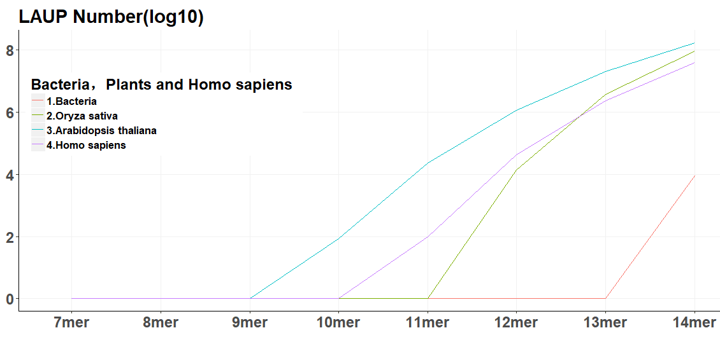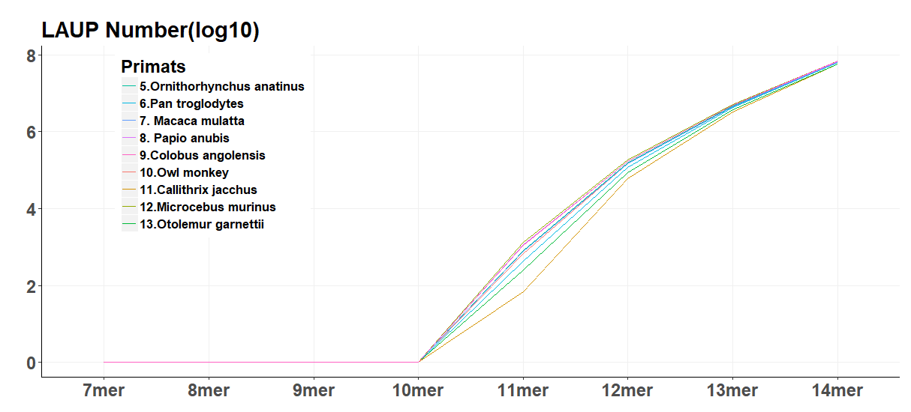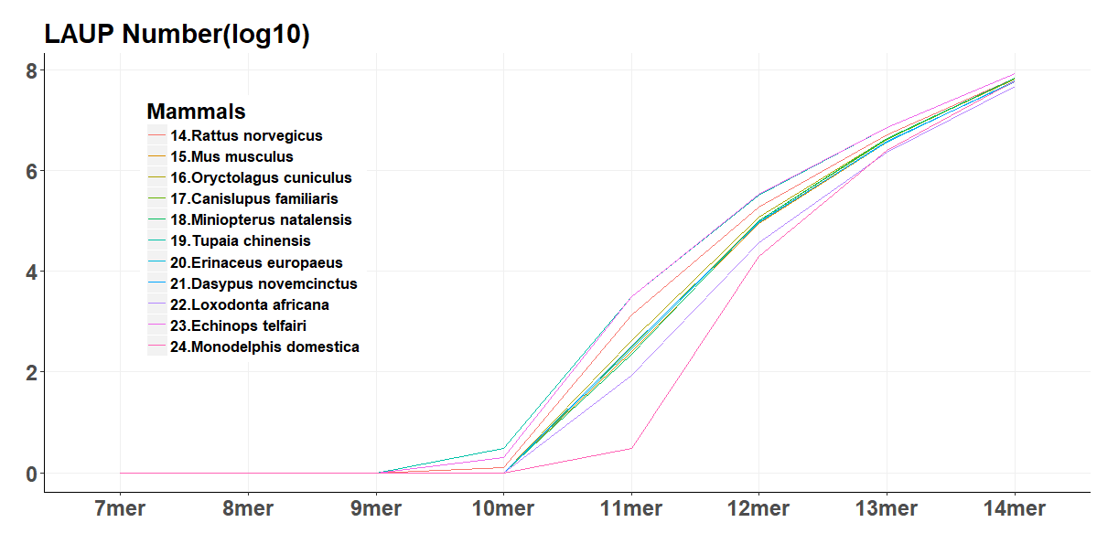

B．
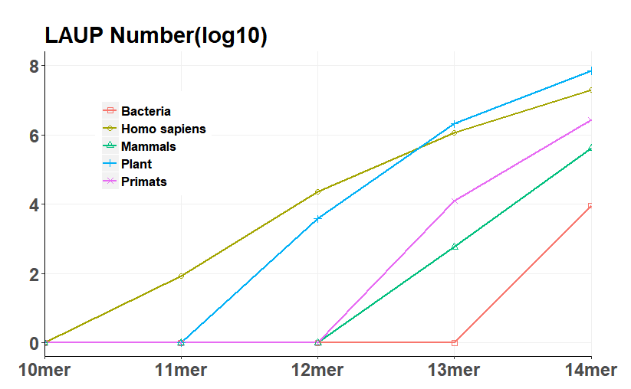
C.
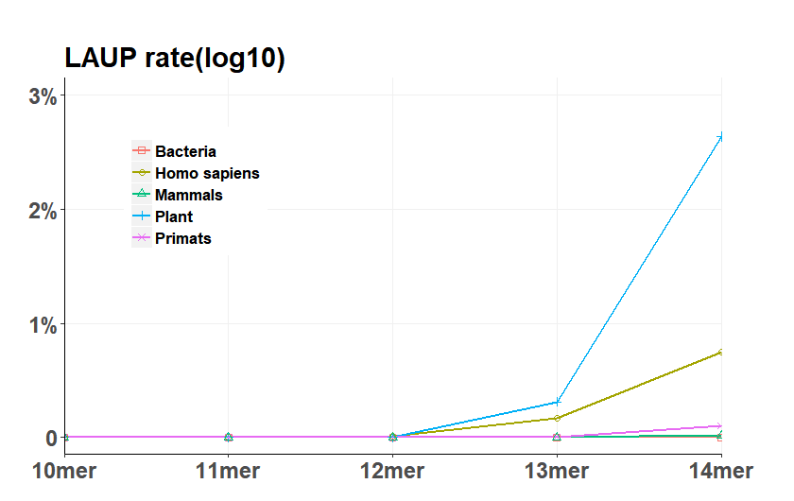

Figure 3: The occurrences number of CpG-containing sequences compare between Observe and Expected for Homo sapiens data. The horizontal and vertical axes represent CG number and the occurrences number of CpG-containing sequences.

A. B.
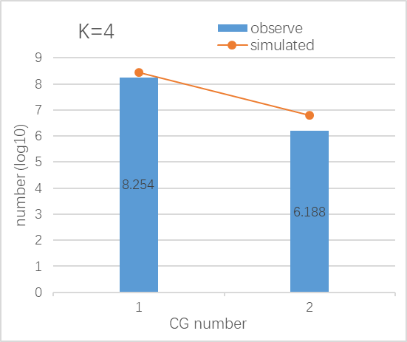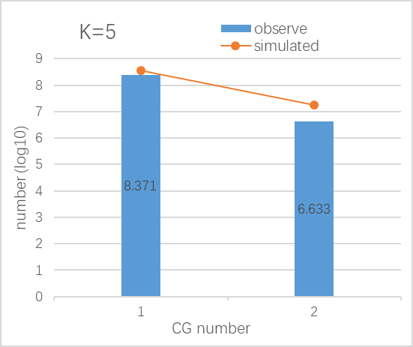
C. D.
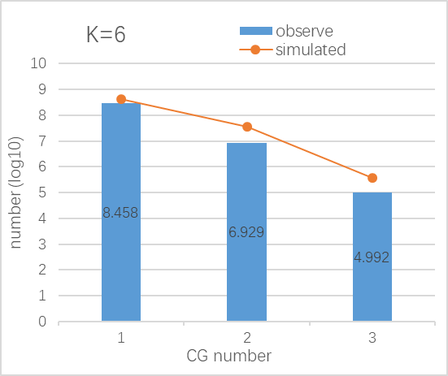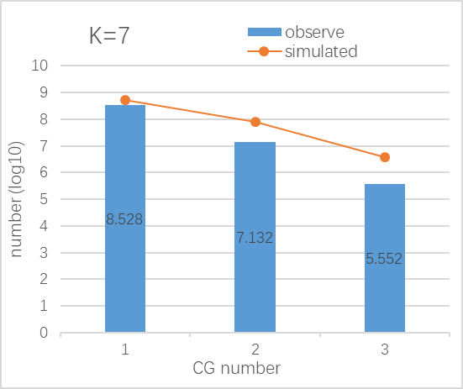
E. F.
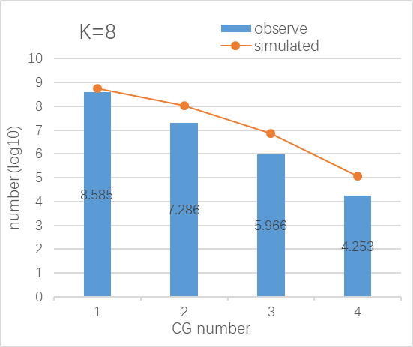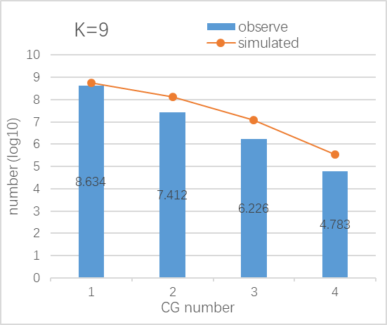

G. H.
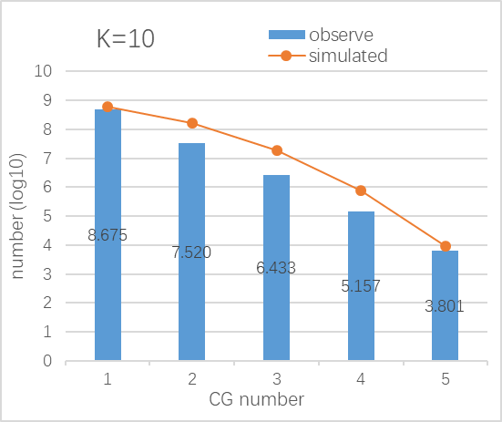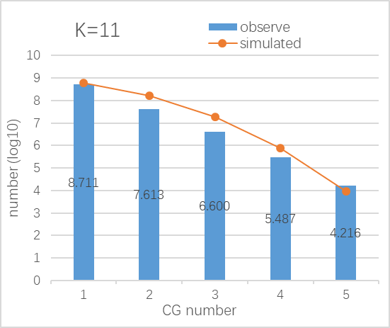
I. J.
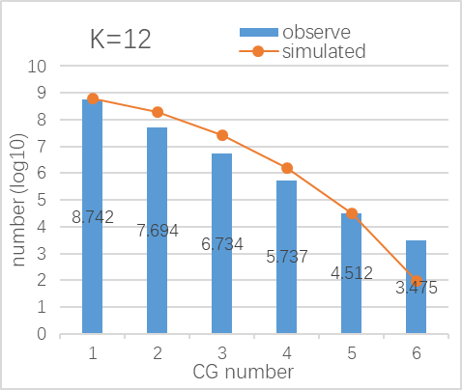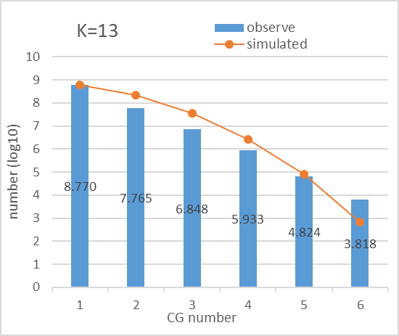
K.
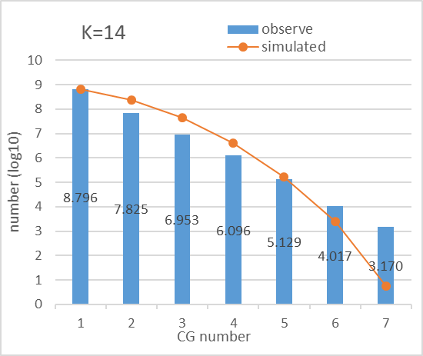

Supplementary data

586 common LAUPs for the whole genome of 21 typical mammalian species

CGATTGCGCGAAA
ACTTCGCGCGAAA
TACTCGCGCGAAA
GCGTTCGCGATAA
GATCGCGCGATAA
ATCGCGCGACTAA
CGTCGATGCGTAA
ACGACGCGCGTAA
TGATCGCGCGTAA
ATCGCGCGCGTAA
TCGTACGCCGCAA
TATTCGCGCGCAA
GTCGCGTAACGAA
CTATCGCGACGAA
ATACGCGCTCGAA
CGTAACGGTCGAA
CGTACCGGTCGAA
GTTACGACGCGAA
TATCGGTCGCGAA
GACGATCCGCGAA
TATACGCGCGGAA
TACGCGCGTAATA
TCGCGCACGAATA
CGAGCGACGAATA
CGTCGCTCGAATA
TCGAGCGCGAATA
CTACGCGCGAATA
TTGCGCGCGAATA
CCGCGACGATATA
ATCGCGCGTTATA
CGCGTCGAGTATA
CGGTCGACGTATA
CGCTCGTCGTATA
CTCGACGCGTATA
CCGCTCGCGTATA
CTACGCGCGTATA
TTCCGCGCGTATA
CCGACGGCGTATA
TCGACGCGACATA
CGATCGCGACATA
TACGCGCGTCATA
TCGTCGCGCCATA
TCGTACGCGCATA
CGGCGCGTTGATA
CTCGCGAACGATA
CGCGACTACGATA
CGAAGCGACGATA
TCTCGCGACGATA
TCGCGCGACGATA
TTCGCGACCGATA
ACGCGGACCGATA
CGGTACGCCGATA
CGATTACGCGATA
CCGGTACGCGATA
CGTCGACGCGATA
TCGAATCGCGATA
CTACGTCGCGATA
GTTCGTCGCGATA
GCGTACCGCGATA
GTCGTCCGCGATA
ACGGTCCGCGATA
GTAACGCGCGATA
CCATCGCGCGATA
TGATCGCGCGATA
CCGTCGCGCGATA
GCGTCGCGCGATA
TGGTCGCGCGATA
CGTACGGGCGATA
CGCGGACGTATTA
TACGCGCGCATTA
CGCGCGACGATTA
CGTATCGCGATTA
GTACGCGCGATTA
TGTCGCGCGATTA
TCGCGCGGATTTA
ACGTTCGCGCTTA
ATACGCGCGGTTA
CGCGTCGCAACTA
CGACGCGATACTA
CGACCGCGTACTA
ATCGCGCGTACTA
GTCGCGCGTACTA
GTCGTCGCGACTA
CGTCGGTACGCTA
TCGCGGTACGCTA
ACGCGTCGAAGTA
CGTCGCGCTAGTA
ATCGTCGCGAGTA
TTTCGCGCGAGTA
ATCCGCGCGAGTA
GCGCGTAAACGTA
ATCGACGAACGTA
GGCGACGAACGTA
GCCGTCGAACGTA
CCGCGACTACGTA
GTCGCACGACGTA
TCGCATCGACGTA
ACTACGCGACGTA
ATTGCGCGACGTA
CGCGCGAATCGTA
GCGCGATATCGTA
GCGCGCGATCGTA
CGAACGATTCGTA
CGCGCGATTCGTA
CGCGAATTTCGTA
TCGCGAAGTCGTA
TCGGTTCGCCGTA
CGCGGATAGCGTA
TCGTACGAGCGTA
CGCGTAATGCGTA
CCGTCGATGCGTA
CGCGTTACGCGTA
TCGTAATCGCGTA
GTACGATCGCGTA
ACGCGATCGCGTA
CGCTAGTCGCGTA
GATACGTCGCGTA
CGATACGCGCGTA
TATTACGCGCGTA
TATGACGCGCGTA
GTTGTCGCGCGTA
CTAACCGCGCGTA
TCGACCGCGCGTA
TAATGCGCGCGTA
AATCGCGGGCGTA
GCGCGAAACGGTA
CGACGCGTCGGTA
CGTCGACCGTACA
CGTATCGCGTACA
CAATTGCGCGACA
TAATCGCGCGACA
TTACGCGCGATCA
TATCGCGCGATCA
TATCGCGCGACCA
AATCGACCGCGCA
TCGGTACGCGAGA
TATCGTCGCGAGA
TCGCGTCGAACGA
CGATCGCGAACGA
GGCGCGTATACGA
TCGCACGATACGA
ACGCGCGATACGA
TACGCGATTACGA
CTCGCGATTACGA
CGCGGATTTACGA
TACGCTCGTACGA
GATACGCGTACGA
GTTTCGCGTACGA
ACGTCGCGTACGA
CTACCGCGTACGA
TATGCGCGTACGA
GTCGCGCGTACGA
TTGCGGCGTACGA
ATCGGGCGTACGA
ATACGCGCGACGA
TATGGCGCGACGA
TCGCGCGAATCGA
CGTGACGCATCGA
TATCGCGATTCGA
TATTCGCGCTCGA
CGCGTAACGTCGA
CGGCGATCGTCGA
CGTAGTCCGTCGA
CTTATCGCGTCGA
TATGTCGCGTCGA
TACGCGCGGTCGA
TACGGCGAACCGA
TCTCGCGTACCGA
AACCGCGTAGCGA
CGCGACGATGCGA
TACGTCGATGCGA
CGTCGAATTGCGA
TCGTATCGTGCGA
CGACGTAACGCGA
AGTTCGAACGCGA
GCGTTATACGCGA
CGACCGTACGCGA
GATCGGTACGCGA
TCGTTCGACGCGA
CGTCGAATCGCGA
CGACAATTCGCGA
CGCGAATTCGCGA
TACGACTTCGCGA
CGATAGTTCGCGA
ATATCGTTCGCGA
ATACGACTCGCGA
AGTATCGTCGCGA
TAGCGTACCGCGA
CGATTATGCGCGA
TATTCGTGCGCGA
CTTATACGCGCGA
ATAGTACGCGCGA
GTCGTACGCGCGA
CACTATCGCGCGA
ACCTATCGCGCGA
TCGATTCGCGCGA
TATCGTCGCGCGA
TAAATCCGCGCGA
CAATTGCGCGCGA
CAATTCGCGCGGA
CGTATACGGCGGA
AATCGCGCGAAAT
CGTCGCGACTAAT
TACGTCGCGCAAT
GTTCGCGCGCAAT
CGCGTACGCGAAT
GGTTCGCGCGAAT
CGACCGCGAATAT
ACGGCGCGAATAT
CGACGCGTTATAT
CGTCGACGCATAT
TCGCGAACGATAT
CGCGACGCGATAT
CGTACCGCGATAT
GGTCGCGCGATAT
CCGCGCGAATTAT
GTCGCGCGATTAT
TCGCGCGTACTAT
CGCGACGAAGTAT
TCGCGAGTCGTAT
CGCGCTAGCGTAT
TTCGAGCGCGTAT
TCGTCGCGCGTAT
TAACCGCGCGTAT
CGTACGGGCGTAT
GTCGACGCGGTAT
CGCGACGAACGAT
CGCGACGCACGAT
TACTCGCGACGAT
CGCGAACGTCGAT
TACGTTCGTCGAT
GTCGCGTACCGAT
CGCGTTATCCGAT
TCGTACGCCCGAT
CGAACTCGCCGAT
CGCATTACGCGAT
TATAACGCGCGAT
GTATACGCGCGAT
TAGTACGCGCGAT
CGATTCGCGCGAT
CATTTCGCGCGAT
TTAGTCGCGCGAT
AACGTCGCGCGAT
TTACGCGCGCGAT
CGTATCCGGCGAT
TACTCGCGCGGAT
CGCGTACCGAATT
CCGTACGCGAATT
CCGCGACGATATT
CGTCGCGCGTATT
CGCGCGAACGATT
GCGATCGTCGATT
TGCGCGGTCGATT
TACGCCCGCGATT
ATTTCGCGCGATT
ATCGCGCGACGTT
GTATTCGCGCGTT
TCGCTACGCGGTT
GTCGCGCGAAACT
CGGTCGACGAACT
TCGCGTTCGAACT
CGCGCCGTATACT
TCGCGACGATACT
CGCGCCGATAAGT
TTTCGCGCGAAGT
ACGTCGCGATAGT
GACGCGCGATAGT
TACGTCGCGTAGT
CGCGACGTATTGT
TAAGCGCGAACGT
TCGTACGCGACGT
ACTATCGCGACGT
CGCGATATATCGT
CGCGAATTATCGT
CGCAACTTATCGT
CGCTATACGTCGT
GCGGATACGTCGT
TTACGCGCGTCGT
TATCGCGGACCGT
GTACGCGATCCGT
ATATTCGCGCCGT
GCGCGTATAGCGT
TACTTCGACGCGT
TACGCGATCGCGT
TATCGGTCCGCGT
GGTAATCGCGCGT
TCGTATCGCGCGT
TCGCGCGATAGGT
CGTACGACGAAAC
TCGTACGCGAAAC
CGTCGCGAATAAC
CGCGACCGATAAC
TTCGCGTCGTAAC
TACGCGCGACAAC
TATCGCGACGAAC
GTATCGCGCGAAC
ATTGCGCGCGAAC
CGAACGCGAATAC
AACGCGCGAATAC
CGTCGCGCTATAC
ATCGCGCGTATAC
CGCGCAACGATAC
GGCGCGACGATAC
CGCGGTCCGATAC
CGCGTTGCGATAC
CGAAACGCGATAC
GTTCGCGCGATAC
CGCGGCGAATTAC
TATCGCGCGTTAC
CGCGGTACGCTAC
CGTCGCGATGTAC
CGAATCGACGTAC
TACGCGATCGTAC
CGTAATCGCGTAC
ACGGATCGCGTAC
TAATCGCGCGTAC
CGATACGCGGTAC
GCGCGTATACGAC
TCGCGCGTACGAC
TAGTCGCGACGAC
TATCGCGGACGAC
CGCGATAATCGAC
CGATATCGTCGAC
ATACCGCGTCGAC
CGCGTATTGCGAC
TACGTCGTGCGAC
CCGTATACGCGAC
CCGATTACGCGAC
TTCGTTACGCGAC
ATCGGTACGCGAC
CGTTATTCGCGAC
GGTACGTCGCGAC
CGTTATGCGCGAC
TAGTACGCGCGAC
TCGTACGCGCGAC
ATAATCGCGCGAC
CTTATCGCGCGAC
AGTTTCGCGCGAC
CGCGACGTATATC
TACGCGACGTATC
TCGTACGCGTATC
CGCGCGAACGATC
TCGCGTACCGATC
CGATTCGCCGATC
TTATCGCGCGATC
TTCGCGGATCGTC
ACTATCGCGCGTC
ATTCGCGCGAACC
ACGCGCGATTACC
GTCGCGACGTACC
CGTACGTTCGACC
ATATCGCGCGACC
TACGTTCGTCGCC
TCGTATACGCGCC
GTATCGTCGCGCC
TCGCGTATAACGC
TTATCGCGAACGC
CGCCGATATACGC
TATCGCGGTACGC
TATCGCGCGACGC
CGAACGATATCGC
CGTCGATTATCGC
AATCGACGATCGC
ACGACGTATCCGC
ACGCTATACGCGC
GTCGTATACGCGC
TACGTTTACGCGC
TACGATATCGCGC
CGTAAGATCGCGC
TACCGTTTCGCGC
CGATAAGTCGCGC
TACGATCGCGCGC
CGCGCGAATTGGC
TACGTTCGACGGC
TCGCGCGTATAAG
TCGACGCGATAAG
GTCGCGCGATAAG
CGTACGACGATAG
TTCGTCGCGATAG
TACGCGCGGTTAG
TATCGCGACGTAG
CGCGCGATCGTAG
TATACGCGCGTAG
TATTCGCGCGTAG
TCGTACGCGGTAG
TATACGCGTCGAG
TCGTAATCGCGAG
TATCGTTCGCGAG
ATCGCGCGAAATG
CGCGCGAAATATG
CGCGAATCGTATG
TGTCGCGCAATTG
TCGCGCGCAATTG
TCCGCGCGAATTG
CCGTCGACGATTG
TCGCGCGATAGTG
CGTATCGCGCGTG
GTCGCGAATAACG
CGGACGTATAACG
GTCGCGCATAACG
CCGGTATCGAACG
CGATACGCGAACG
CGCGCGATATACG
CGACGATTATACG
CGTGCGCTATACG
TCCGCCGTATACG
CGCGCGTGATACG
CCGCAACGATACG
TGTACGCGATACG
TAATCGCGATACG
CACGCGCGATACG
ATCGCCGGATACG
GTACGCGATTACG
GCGCGATCTTACG
TTCGACCGTTACG
TCGACGGACTACG
CGTCGATAGTACG
CGACGCTAGTACG
CGCGAAACGTACG
GGTCGAACGTACG
CTATCGTCGTACG
GTTTCGTCGTACG
ATACGCCCGTACG
TATCGCCCGTACG
TTCGACCGGTACG
ATATCGCGGTACG
TCGATGCGTCACG
CGTATAGCGCACG
CCGTATCGAGACG
CCGATATACGACG
GCGATAATCGACG
CGTACTATCGACG
TTACGCATCGACG
TCGCAATTCGACG
TCGCGATTCGACG
CGATAGTTCGACG
ATATGCGTCGACG
TATCGCGTCGACG
TGTACGGTCGACG
TAGCGTACCGACG
TATTCGAGCGACG
CGAGTATGCGACG
GTACATCGCGACG
GTTATTCGCGACG
ATTAGTCGCGACG
GTATAGCGCGACG
TACTAGCGCGACG
AATACGCGCGACG
TCGCGCATAATCG
TATCGCGTAATCG
TTTCGCGCAATCG
ATCGCGCGAATCG
GATCGGCGAATCG
CGCGCCTATATCG
CGCGCGTATATCG
GTCGACGATATCG
CCGCGAATTATCG
CGACGTATTATCG
CCGCGTATTATCG
GCGCGACTTATCG
CGTCGAACTATCG
TCGCGAACTATCG
CGTTCGCGTATCG
GTACCGCGTATCG
TACGCGCGTATCG
TCGTTCGCGATCG
TATGTCGCGATCG
CGCGGACTATTCG
CCGGTACGATTCG
GTACGTCGATTCG
GTATCGCGTTTCG
TATCGTCGCTTCG
CGCGATTAGTTCG
ATCGGCGAGTTCG
TACGAATCGTTCG
GCGATATCGTTCG
GTATTCGCGTTCG
CGTCGCATACTCG
TATTCGTCGCTCG
CGACGTATAGTCG
TCGCGAATTGTCG
CGATAATACGTCG
CGACTATACGTCG
TCGCGTTACGTCG
CGTATAATCGTCG
CGTACTAGCGTCG
ATATAACGCGTCG
TACCGACGCGTCG
TAGTATCGCGTCG
TCGCGTACGGTCG
TAGTACGCGGTCG
ATATTCGCGGTCG
CGCATACGGGTCG
CGCGATATAACCG
CGCGAGTATACCG
CCGTCGTATACCG
TATCGGCGTACCG
TATACGTCGACCG
AGTTCGTCGACCG
CGTTATACGTCCG
TCGACGATCGCCG
TATCAACGCGCCG
ACGACGTATAGCG
TACGCGACTAGCG
TATACGACGAGCG
ATCGCGTAATGCG
CGACCCGTATGCG
ACGATAAGTTGCG
ATCGGATAACGCG
TACGCGTAACGCG
GTATCGCAACGCG
CCGTTCGAACGCG
GTCGCAATACGCG
TACGCATTACGCG
TCGACGTTACGCG
ATTCGCGTACGCG
AATTCGGTACGCG
TATACTCGACGCG
TAGTTGCGACGCG
CGAACTAATCGCG
ACGATATATCGCG
CGGTTATATCGCG
GTCGATTATCGCG
TACGAAATTCGCG
ACGATAATTCGCG
TCGCGAATTCGCG
CATACGATTCGCG
CGTACGTTTCGCG
ATCGACGTTCGCG
CGGTATACTCGCG
TATCGTAGTCGCG
ACAATACGTCGCG
GATATACGTCGCG
TCGCATCGTCGCG
ATACTTCGTCGCG
ATCGTTCGTCGCG
ATCGTGCGTCGCG
ATATCGCGTCGCG
GTTATCGGTCGCG
GTAGCGTACCGCG
GTATCGGACCGCG
TCGTAAATCCGCG
TACGCTATCCGCG
CGAATAGTCCGCG
TAATACGTCCGCG
GTAATTCGCCGCG
ATACGCTAGCGCG
GTATCGTTGCGCG
CGATATACGCGCG
CGTATCACGCGCG
TACGAATCGCGCG
CGTATATCGCGCG
CTACGATCGCGCG
GCCAATTCGCGCG
TACGATTCGCGCG
CATATTTCGCGCG
AATCGTTCGCGCG
GATCGTTCGCGCG
TAATCGTCGCGCG
CGATATAGGCGCG
AGTATACGGCGCG
ACTTATCGGCGCG
GCGTATATCGGCG
TATCGCGCGATGG
CGCGTTCGAACGG
GTCGCGTATACGG
CGTCTCGATACGG
AATTCGCGTACGG
CGGTATACGACGG
TACGCATCGACGG
CAATCGTCGACGG
TATCGCGCGACGG
GTCGCGTAATCGG
CGTCGTATATCGG
TATACGCCGTCGG
CGTTCGATACCGG
CGAATCGTACCGG
TATCGCGTACCGG
TATACGCGAGCGG
CGTATCGTTGCGG
CGATAATACGCGG
CGATAATTCGCGG
TACGTAGTCGCGG
AATATCGTCGCGG
TATATCGTCGCGG
ATAATTCGCGCGG

Supplementary methods

- We develop a Jellyfish based LAUP analysis software (JBLA) by integrating Jellyfish, MEME and NCBI genome database applications for efficient LAUP sequence analysis. Here we list some important process algorithms in the software and the main code of JBLA is in the file JBLA_code.zip.

  - LAUP counting process algorithm
LAUP counting process algorithm（Input: K and P are index; Output: LR for LAUP）
1: For K = 1,…,N (N is the upper K limit)
2: Initialize two Jellyfish parameter: K value and hash table size for hash()
3: Send each K-mer result into hash(K) .
4: For P = 1,…K⁴,
5: Assign each permutation of A, T, C and G a numerical index P
6: String arr[] = { "A", "T", "C", "G" }
7: String kmer_string;
8: For i = 0,…K-1,
9: kmer_string += arr[((P / pow(4, i))) % 4] ;
10: End For
11: If the permutations kmer_string is in hash(K):
12: Put this permutation kmer_string into LR.
13: End If
14: End For
15: End For

  - Statistical test process algorithm
Statistical test process algorithm（Input: K and N is the index and limit; Output: P-value)
1: For K = 1, … N,
2: If the data follow the normal distribution:
3: Homogeneity test of variance.
4: Use T-test to obtain the P-value for the data.
5: Else
6: Use Wilcoxon rank sum test to obtain the P-value.
7: End If
8: If P-value <= 0.05
9: The data is statistical significance.
10: Else The data is not statistical significance.
11: End If
12: End For

  - CpG-containing sequence Observe counting process algorithm
CpG-containing sequence Observe counting process algorithm
（Input: K and i,n is index; Output: Observe (k, n))

1: map<int, long long> map1;
2: map<String,long long> map2;
3: String arr[] = { "A", "T", "C", "G" }
4: String kmer_string;
5: map<String,long long>::iterator it
6: While(scanf ( kmer_string, frequency) !=EOF)
7: Insert <kmer_string,frequency> to map2;
8: End While
9: For it=map2.begin…map2.end-1
10: If map2->first[i i+1] = “CG”
11: num++;
12: End If
13: map1[num]+=map2->second;
14: End For
15: For m=1…K/2
16: Observe = map1[m]->second
17: End For

  - CpG-containing sequence Expect Rate counting process algorithm
CpG-containing sequence Expect Rate counting process algorithm
（Input: K and i,n is index; Output: Expect _rate(k, n))
1: map<int, long long> map1;
2: String arr[] = { "A", "T", "C", "G" }
3: String kmer_string;
4: For i=0,…4^K-1,
5: kmer_string += arr[((P / pow(4, i))) % 4] ;
6: For j=0…K-1
7: If kmer_string[i j+1] = “CG”
8: num++;
9: End If
10: End For
11: map1[num]++
12: End For
13: For n=1…K/2
14: Expect _rate = map1[n]->second / pow(4,K)
15: End For

