TimeXNet Web – Supplementary Information

1. TimeXNet Web Workflow
The TimeXNet Web input and workflow are described below:
- Setting the gene/protein identifier: TimeXNet Web allows the user to enter the gene/protein identifiers in multiple formats. The user is asked to select the type of identifier from a drop down menu. This identifier type is later used for comparison with the identifier type of the input network.

- Formatting the time-course omics data: TimeXNet Web can be used to analyze any type of time-course data over three or more time points. If TimeXNet is given a matrix of log fold change values over multiple time points, it first classifies the time points into 3 groups – early, intermediate and late. It then assigns each gene/protein to one of the three groups depending on the time at which it shows the highest fold change value. Each gene/protein is also assigned a score equal to the ratio of its highest fold change and the average maximum fold change of all genes/proteins across all time points. Alternatively, the three groups of genes/proteins and their scores can also be directly given to TimeXNet Web in the form of input files. The user has an option of providing a single file with a gene/protein list specifying their scores and groups 1, 2 or 3. The input can also be provided in 3 separate files, one containing the genes/proteins and their scores for each group. Each gene must be present only in one group i.e. the same gene cannot be present in multiple groups.

- Formatting the molecular interaction network: The TimeXNet algorithm requires an interaction network containing at least 50% of the genes/proteins from the above-mentioned high-throughput time-course dataset. The user can provide a customized molecular interaction network along with the gene/protein identifiers. If the identifier format is different from that used in the input gene/protein list, TimeXNet Web converts both the identifier formats to UniProt using the Ensembl BioMart web service. The user can also choose to use an inbuilt protein-protein interaction network provided by HitPredict as input, which is currently available for 12 model organisms. These networks are updated annually, subject to funding. In this case, the user specified identifiers will also be converted to UniProt.

- Setting the additional parameters: Gamma1 and Gamma2 are real positive values that affect the number of early and intermediate genes/proteins that are included in the network. By default, gamma1 is set to 1 and gamma2 is set to 0. The number of selected input genes/proteins in the response network increases with the value of the gamma1 and gamma2.

- Running the TimeXNet algorithm: The TimeXNet algorithm uses the three groups of genes/proteins and the input interaction network to identify the most probable paths that maximally connect the gene/proteins with the highest scores i.e. the highest fold change at consecutive time points (Patil, et al., 2013). TimeXNet uses minimum cost flow optimization to identify these paths. This problem is solved using linear programming. For the detailed problem formulation, please see Patil et al., 2013.
The network flow computation is done for all time points together by solving the optimization problem once across the entire input network. A predicted node can be selected multiple times in the final solution, however, it is shown only once in the network. For example, node N is connected to nodes A and B, which are expressed at time points, 1 and 2 respectively. It is also connected to node C and D, which are expressed at time points 3 and 4 respectively. In this case, it is possible for the algorithm to select edges A-N-B and C-N-D as part of the solution. The output network will show the node N connected to all four nodes A, B, C and D.
On average, TimeXNet Web requires 3-5 minutes to predict one response network from an input network of approximately 130,000 edges and an input list of approximately 1600 genes/proteins. The run time increases with the size of the input network and the number of input genes/proteins. The TimeXNet algorithm has been evaluated against other similar tools such as ResponseNet and SDREM (Patil, et al., 2013; Patil and Nakai, 2014). It has shown a better performance in terms of the number of known regulators identified within the response network, the length of pathways reconstructed in KEGG and speed of execution. The TimeXNet algorithm has been shown to be robust to the presence of noise in the input interaction network (Patil and Nakai, 2014).

- TimeXNet Web Output: After job submission, TimeXNet Web automatically checks if the job is complete and displays the output when it is done. If an email address has been provided, the user is notified of the job completion via email with a link to the results. The output of TimeXNet Web is a cellular response network that maximally connects genes/proteins activated at consecutive time points. The network interactions and genes/proteins are assigned flows, or scores, indicating their connectivity and functional importance. TimeXNet Web provides an interface to view the sub-networks for individual genes/proteins. The Single Gene Network view shows the selected gene/protein and up to 99 of its connections with the highest predicted flows. Multiple selections of genes/proteins to identify connecting network paths is possible in the Multi-gene Network view. The genes/proteins in the network views are colored based on the time of their maximum fold change with those in the early group colored pink, intermediate group in yellow and late group shown in green. Genes/proteins that do not show change in their experimental values but connect the three groups of genes/proteins are shown in blue.
Gene Ontology term enrichment and KEGG pathway enrichment can be performed using the DAVID web service (Huang da, et al., 2009; Jiao, et al., 2012). The enrichment analysis is performed using the hypergeometric distribution with the input network or the whole genome as the background. The top 3000 genes/proteins with the highest predicted flows are used for enrichment analysis due to the limitation set by the DAVID web service on the number of input values. In networks that require conversion from gene names or Ensembl Protein IDs to UniProt IDs, TimeXNet Web may be slow due to the excess time required for format conversion using Ensembl Biomart, since the DAVID web service does not allow these two formats as input. Additionally, our testing shows that the DAIVD web service requires a longer time to return enrichment analysis results when a background gene list is provided.
The response network can be mapped onto KEGG pathways (Kanehisa, et al., 2017) using Pathview (Luo and Brouwer, 2013). The output can also be downloaded and imported into Cytoscape (Shannon, et al., 2003) with node and edge annotations.

2. Case studies
TimeXNet has been tested in multiple species and on diverse types of high-throughput datasets. All the tested case studies and their results are available online. TimeXNet was used to predict the response network from time-course gene expression profiles of mouse bone marrow dendritic cells stimulated with LPS (Patil, et al., 2013). The response of yeast osmotic stress has also been studied (Patil and Nakai, 2014). Here, we describe three additional case studies:

- Innate immune response of mouse BMDCs stimulated with LPS using time-course phospho-proteome profiles (Mertins, et al., 2017)
Mertins et al. studied the innate immune response of mouse bone marrow dendritic cells (BMDCs) to lipopolysaccharide (LPS) through the temporal profiling of phosphorylation levels of cellular peptides. They measured levels of phospho-peptides within BMDCs before LPS stimulation and at 15 minutes to 6 hours after LPS stimulation. We used this data to predict the mouse innate immune response network with TimeXNet Web.

Input: The phospho-peptides and their changes in phosphorylation were taken from Table S2 in Mertins et al. 1603 proteins were classified into three mutually exclusive groups – early, intermediate and late – based on the earliest time at which they showed a change in phosphorylation levels. We assumed that the earliest time of change in phosphorylation at any site of the protein corresponds to the time it first participates in the signaling process. Since a protein is phosphorylated at multiple sites simultaneously and it is difficult to tell which site is responsible for the protein activation or inactivation, the highest fold change across all the phospho-sites on the protein was used to assign a score to each protein. TimeXNet Web was then given these three groups of proteins with scores corresponding to their activity. TimeXNet Web was also given a molecular interaction network of 103,218 scored edges for mouse containing protein-protein interactions from HitPredict, transcription regulatory interactions from Transfac and post-translational modifications from KEGG pathways (Patil, et al., 2013).

Output: TimeXNet Web predicted a response network of 1005 proteins and 1743 interactions that showed enrichment of proteins and pathways activated during the innate immune response. To test the utility of the TimeXNet algorithm in identifying correct pathways and previously unknown regulators, we compared the predicted response network with pathways in KEGG and the experimentally identified targets of the phospho-proteins from Mertins et al. We found that TimeXNet Web identified the longest consecutive paths (3 edges) within the TLR signaling pathway, which is known to be activated during the innate immune response. Additionally, TimeXNet Web identified 66 out of the 263 target proteins affected by knock-down of the phospho-proteins, including several known regulators of the TLR pathway (Mertins, et al., 2017). Of these, 38 proteins do not show any change in their phosphorylation levels. This confirms that TimeXNet Web can identify regulators that are functionally important in a response pathway but whose activity is not measured experimentally. Further, TimeXNet Web also identified 37 out of 95 downstream transcription factors, of which 16 do not show any change in their phosphorylation levels (Mertins, et al., 2017). Thus, TimeXNet Web not only identifies response networks enriched in the stimulated proteins, but also intermediate regulators that are functionally important in the response though not experimentally visible. It also shows the temporal relationships between the proteins by identifying how the early activators are connected to the intermediate regulators and finally to the late effectors.

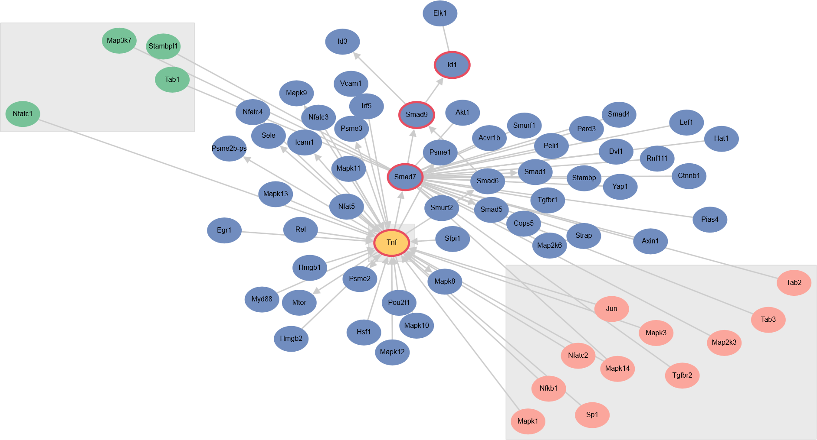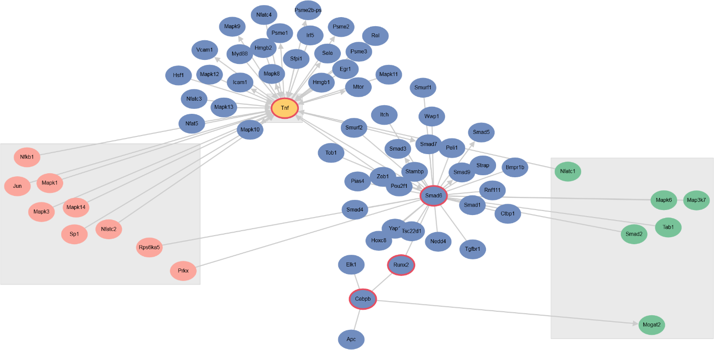
Figure S1. TimeXNet Web Multi-gene Network view, showing genes (with red border) of the Tnf beta signaling pathway and the Toll-like receptor signaling pathway identified within the innate immune response network. Node colors indicate the protein groups – early (pink), intermediate (yellow) and late (green) – based on the time of highest change in phosphorylation levels. The blue nodes are proteins that do not show change in phosphorylation but connect those that do.

- Time-course proteome profiling of HeLa cells with DTT-induced misfolding stress (Cheng, et al., 2016)
Cheng et al. measured protein levels in HeLa cells over 30 hours to study their response to endoplasmic reticulum (ER) stress induced by the reagent, dithiothreitol (DTT). TimeXNet Web was used to predict the response network using the temporal protein profiles.

Input: The 1020 proteins with at least 2-fold changes in protein levels were classified into three mutually exclusive groups – early, late and intermediate – based on the time at which they showed the highest fold change with respect to the control sample. TimeXNet Web was also given a human interaction network of 115,669 scored edges created using the protein-protein interactions from HitPredict, the transcriptional regulatory interactions from Transfac and the post-translational modifications from KEGG pathways.

Output: TimeXNet Web predicted the temporal ER stress response network of 1119 genes/proteins and 2149 interactions. TimeXNet Web identified several paths from relevant KEGG pathways such as the ErbB signaling pathway, the cell cycle and the chemokine signaling pathway. The network predicted by TimeXNet was validated using the transcriptional data from the same experiment. For instance, TimeXNet was also able to identify the known interactions activated during ER stress such as that between DNAJC3, a member of the Hsp40 chaperone family, and EIF2AK3, an inhibitor of the eiF2 alpha kinase, even though the latter shows no change in its protein levels (Cheng, et al., 2016; Roobol, et al., 2015). The induction network of the protein HSPA5 that plays an important role during ER stress (Cheng, et al., 2016) was also identified. Additionally, important chaperones that function during ER stress, HSPA8, HSP90AA1 and HSP90B1 (Cheng, et al., 2016) were also identified by TimeXNet Web despite showing no changes in their protein levels.
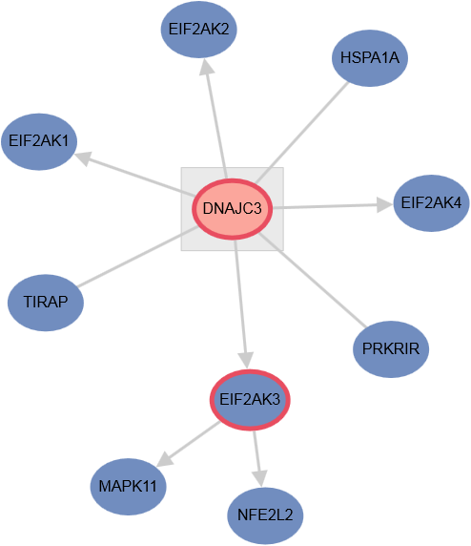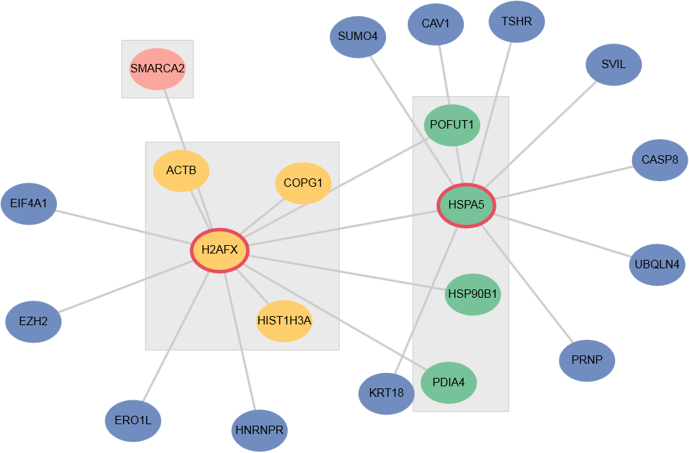
Figure S2. The network of DNAJC3 and HSPA5 identified by TimeXNet Web in the Multi-gene Network view. Node colors are same as in Figure S1.

- Time-course gene expression profiles of human myeloma cells exposed to chemotherapy (Wiita, et al., 2013)
Wiita et al. measured the gene expression pattern over time in human myeloma cells to study apoptosis induced during chemotherapy as a result of exposure to the proteasome inhibitor, bortezomib. mRNA expression levels were measured at 1.5 hours to 12 hours after exposure.

Input: The log2 fold change values of genes at 5 time points were given as input to TimeXNet Web along with the specification of the time points to be grouped. The gene groups were generated automatically by TimeXNet Web. Genes showing the maximum fold change at 1.5 and 3 hours were classified as early genes, those maximally expressed at 6 hours were classified as intermediate genes and, genes highly expressed at 9 and 12 hours were classified as late genes. The genes were identified and scored automatically based on their maximum fold change within TimeXNet Web and used as input. The input human interaction network was the same as that used with the Cheng et al. dataset described above.

Output: TimeXNet Web identified a temporal response network for this dataset with several predicted paths overlapping known KEGG pathways in apoptosis. The longest path predicted by TimeXNet Web was 8 consecutive edges in the Jak-Stat signaling pathway. Several upstream regulators that the authors identified using Ingenuity Pathway Analysis, such as XBP1, NFE2L2, HSF1 (Wiita, et al., 2013) were also identified by TimeXNet Web. Other potential upstream regulators MAPK3, CREM and PARD1, and anti-apoptotic transcription factors, such as RELA, FOXO1, ESR1 were also predicted by TimeXNet Web, though their role remains to be experimentally validated.
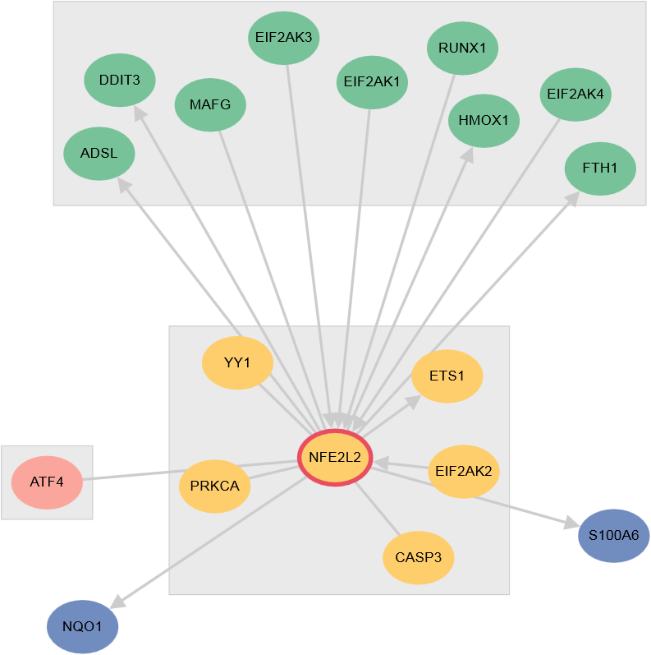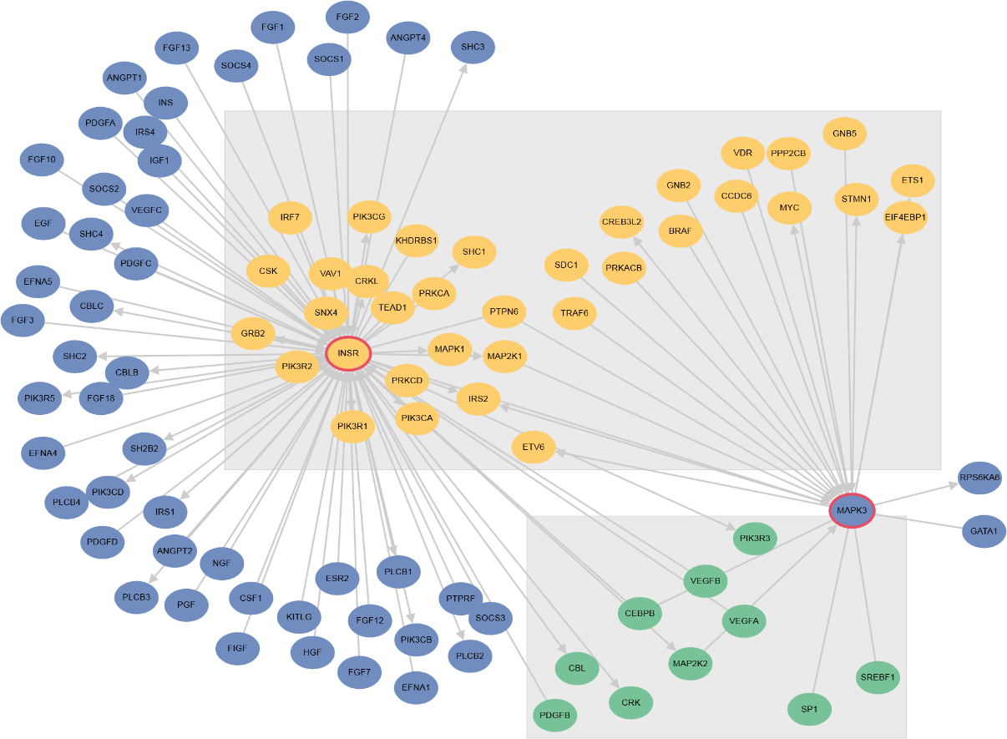
Figure S3. Networks of predicted upstream regulators NFE2L2 and MAPK3 from TimeXNet Web. Node colors are the same as in Figure S1.

References
Cheng, Z., et al. Differential dynamics of the mammalian mRNA and protein expression response to misfolding stress. Mol Syst Biol 2016;12(1):855.
Huang da, W., Sherman, B.T. and Lempicki, R.A. Systematic and integrative analysis of large gene lists using DAVID bioinformatics resources. Nat Protoc 2009;4(1):44-57.
Jiao, X., et al. DAVID-WS: a stateful web service to facilitate gene/protein list analysis. Bioinformatics 2012;28(13):1805-1806.
Kanehisa, M., et al. KEGG: new perspectives on genomes, pathways, diseases and drugs. Nucleic Acids Res 2017;45(D1):D353-D361.
Luo, W. and Brouwer, C. Pathview: an R/Bioconductor package for pathway-based data integration and visualization. Bioinformatics 2013;29(14):1830-1831.
Mertins, P., et al. An Integrative Framework Reveals Signaling-to-Transcription Events in Toll-like Receptor Signaling. Cell Rep 2017;19(13):2853-2866.
Patil, A., et al. Linking transcriptional changes over time in stimulated dendritic cells to identify gene networks activated during the innate immune response. PLoS Comput Biol 2013;9(11):e1003323.
Patil, A. and Nakai, K. TimeXNet: identifying active gene sub-networks using time-course gene expression profiles. BMC Syst Biol 2014;8 Suppl 4:S2.
Roobol, A., et al. p58<sup>IPK</sup> is an inhibitor of the eIF2α kinase GCN2 and its localization and expression underpin protein synthesis and ER processing capacity. Biochemical Journal 2015;465(2):213-225.
Shannon, P., et al. Cytoscape: a software environment for integrated models of biomolecular interaction networks. Genome research 2003;13(11):2498-2504.
Wiita, A.P., et al. Global cellular response to chemotherapy-induced apoptosis. Elife 2013;2:e01236.

