Using meshes for MeSH term enrichment and semantic analyses
Guangchuang Yu
data(GSE12418_eset, package="curatedOvarianData")
eset = Biobase::exprs(GSE12418_eset)
d = data.frame(gene=rownames(eset), expr=apply(eset, 1, median, na.rm=T))
id=clusterProfiler::bitr(d$gene, "SYMBOL", 'ENTREZID', 'org.Hs.eg.db')
## 'select()' returned 1:many mapping between keys and columns
## Warning in clusterProfiler::bitr(d$gene, "SYMBOL", "ENTREZID",
## "org.Hs.eg.db"): 3% of input gene IDs are fail to map...
d <- merge(d, id, by.x='gene', by.y='SYMBOL')
geneList = d$expr
names(geneList) = d$ENTREZID
geneList = sort(geneList, decreasing=T)
de = names(geneList)[abs(geneList) >1]
library(meshes)
data(hsamd)
x <- enrichMeSH(de, MeSHDb = "MeSH.Hsa.eg.db", database='gendoo', category = 'C')
x <- DOSE::setReadable(x, 'org.Hs.eg.db', 'ENTREZID')
y <- gseMeSH(geneList, MeSHDb = "MeSH.Hsa.eg.db", database='gendoo', category = 'C', nPerm=10000)
p1 <- dotplot(x, showCategory=15)
p2 <- cnetplot(x, foldChange=geneList)
p3 <- emapplot(x)
p4 <- ridgeplot(y, fill='pvalue', showCategor=15)
require(cowplot)
plot_grid(p1, p4, ncol=1, labels=c("C", "D")) %>%
plot_grid(p3, ., ncol=2, labels = c("B", "")) %>%
plot_grid(p2, ., ncol=1, labels = c("A", ""), rel_heights=c(.8, 1))
## Picking joint bandwidth of 0.224
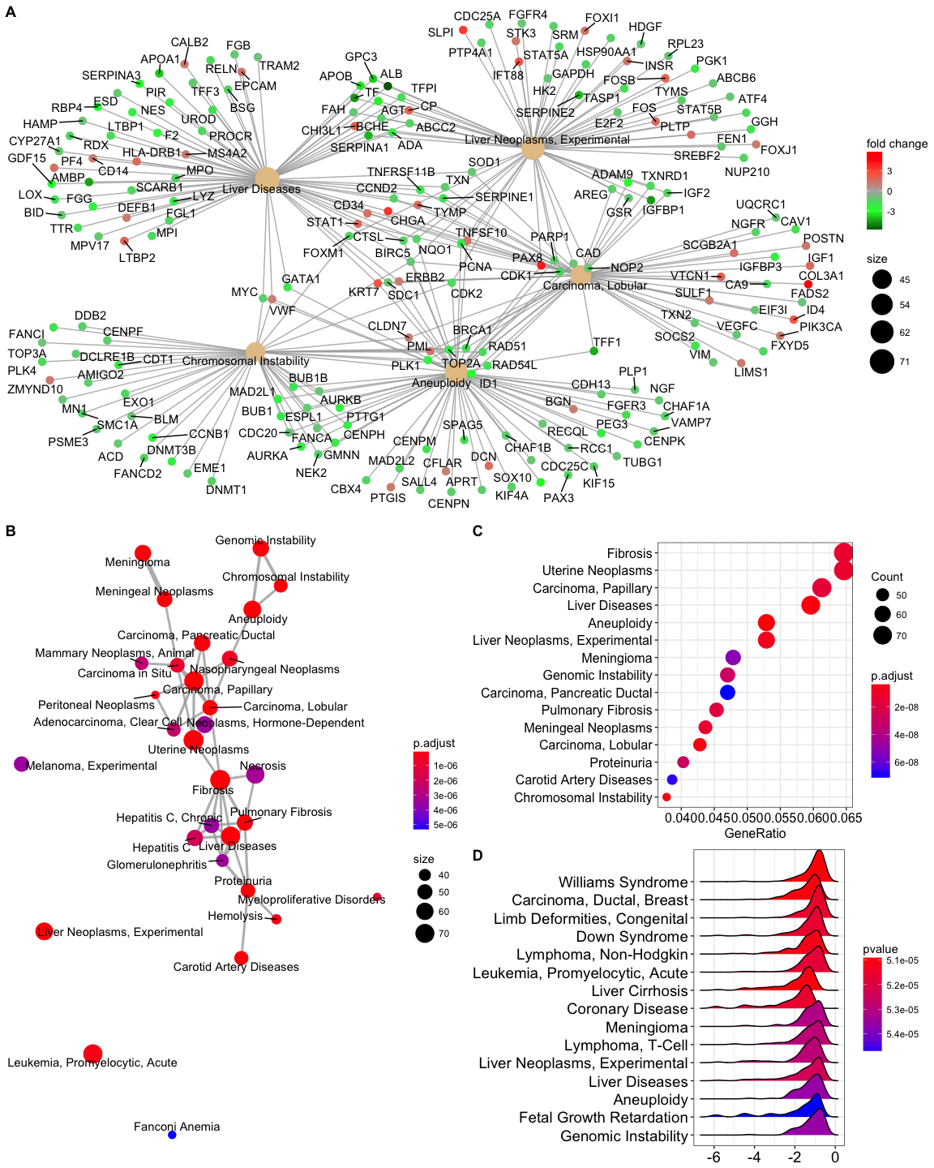

Session Info
sessionInfo()
## R version 3.4.3 (2017-11-30)
## Platform: x86_64-apple-darwin15.6.0 (64-bit)
## Running under: macOS High Sierra 10.13.3
##
## Matrix products: default
## BLAS: /Library/Frameworks/R.framework/Versions/3.4/Resources/lib/libRblas.0.dylib
## LAPACK: /Library/Frameworks/R.framework/Versions/3.4/Resources/lib/libRlapack.dylib
##
## locale:
## [1] en_US.UTF-8/en_US.UTF-8/en_US.UTF-8/C/en_US.UTF-8/en_US.UTF-8
##
## attached base packages:
## [1] parallel stats4 stats graphics grDevices utils datasets
## [8] methods base
##
## other attached packages:
## [1] cowplot_0.9.2 ggplot2_2.2.1 meshes_1.5.2
## [4] org.Hs.eg.db_3.5.0 AnnotationDbi_1.40.0 IRanges_2.12.0
## [7] S4Vectors_0.16.0 Biobase_2.38.0 BiocGenerics_0.24.0
## [10] DOSE_3.5.2 rvcheck_0.0.9 rmarkdown_1.9
## [13] roxygen2_6.0.1 magrittr_1.5 BiocInstaller_1.28.0
##
## loaded via a namespace (and not attached):
## [1] viridis_0.5.1 tidyr_0.8.0 bit64_0.9-7
## [4] viridisLite_0.3.0 splines_3.4.3 ggraph_1.0.1
## [7] assertthat_0.2.0 DO.db_2.9 blob_1.1.1
## [10] ggrepel_0.7.0 pillar_1.2.1 RSQLite_2.1.0
## [13] backports_1.1.2 glue_1.2.0 digest_0.6.15
## [16] qvalue_2.10.0 colorspace_1.3-2 htmltools_0.3.6
## [19] plyr_1.8.4 pkgconfig_2.0.1 clusterProfiler_3.7.1
## [22] purrr_0.2.4 GO.db_3.5.0 scales_0.5.0
## [25] tweenr_0.1.5 enrichplot_0.99.14 BiocParallel_1.12.0
## [28] ggforce_0.1.1 tibble_1.4.2 UpSetR_1.3.3
## [31] lazyeval_0.2.1 memoise_1.1.0 evaluate_0.10.1
## [34] MASS_7.3-49 xml2_1.2.0 tools_3.4.3
## [37] data.table_1.10.4-3 stringr_1.3.0 MeSH.db_1.9.0
## [40] munsell_0.4.3 bindrcpp_0.2.2 compiler_3.4.3
## [43] rlang_0.2.0 units_0.5-1 grid_3.4.3
## [46] ggridges_0.5.0 igraph_1.2.1 labeling_0.3
## [49] gtable_0.2.0 DBI_0.8 reshape2_1.4.3
## [52] R6_2.2.2 gridExtra_2.3 knitr_1.20
## [55] dplyr_0.7.4 MeSHDbi_1.14.0 bit_1.1-12
## [58] udunits2_0.13 bindr_0.1.1 fastmatch_1.1-0
## [61] commonmark_1.4 fgsea_1.4.1 rprojroot_1.3-2
## [64] GOSemSim_2.5.1 stringi_1.1.7 Rcpp_0.12.16

