Supplementary Corrigendum Material

Corrigendum: DDR: Efficient computational method to predict drug–target interactions using graph mining and machine learning approaches
Rawan S. Olayan¹, Haitham Ashoor¹ and Vladimir B. Bajic^{1,*}
¹King Abdullah University of Science and Technology (KAUST), Computational Bioscience Research Center (CBRC), Computer, Electrical and Mathematical Sciences and Engineering (CEMSE) Division, Thuwal, Saudi Arabia
*To whom correspondence should be addressed.

Changes in the main article
Position of changes | p. 1164, line 13 of Abstract
stands | by 34% when the drugs are new,
should be | by 31% when the drugs are new,
Position of changes | p. 1169, Sub-section 4.1, right column, line 1
stands | , (S_{D}: 14%) and
should be | , (S_{D}: 32%) and
Position of changes | p. 1169, Sub-section 4.1, right column, line 19
stands | , (S_{D}: 79%) and
should be | , (S_{D}: 86%) and
Position of changes | p. 1170, Sub-section 4.1, left column, line 11
stands | and 22%, for
should be | and 20%, for
Position of changes | p. 1170, Sub-section 4.1, left column, lines 30-31
stands | by 34% for predicting DTIs as in setting (S_{D})
should be | by 31% for predicting DTIs as in setting (S_{D})
Position of changes | p. 1170, Sub-section 4.1, left column, last line before Sub-section 4.2
stands | 51% in the S_{D} setting
should be | 21% in the S_{D} setting
Position of changes | p. 1172, Section 5, left column, lines 34-40
stands | On the other hand, in predicting DTIs in both settings of S_{D} and S_{T}, we observed that the second best method, based on the weighted average of AUPR results over the five different datasets, is the NRLMF method. This is due to the methodology followed by the NRLMF method in incorporating neighborhood information from most similar drugs and target proteins.
should be | On the other hand, in predicting DTIs, we observed that the second best method, based on the weighted average of AUPR results over the five different datasets in the S_{T} and S_{D} setting, are the NRLMF and COSINE, respectively.

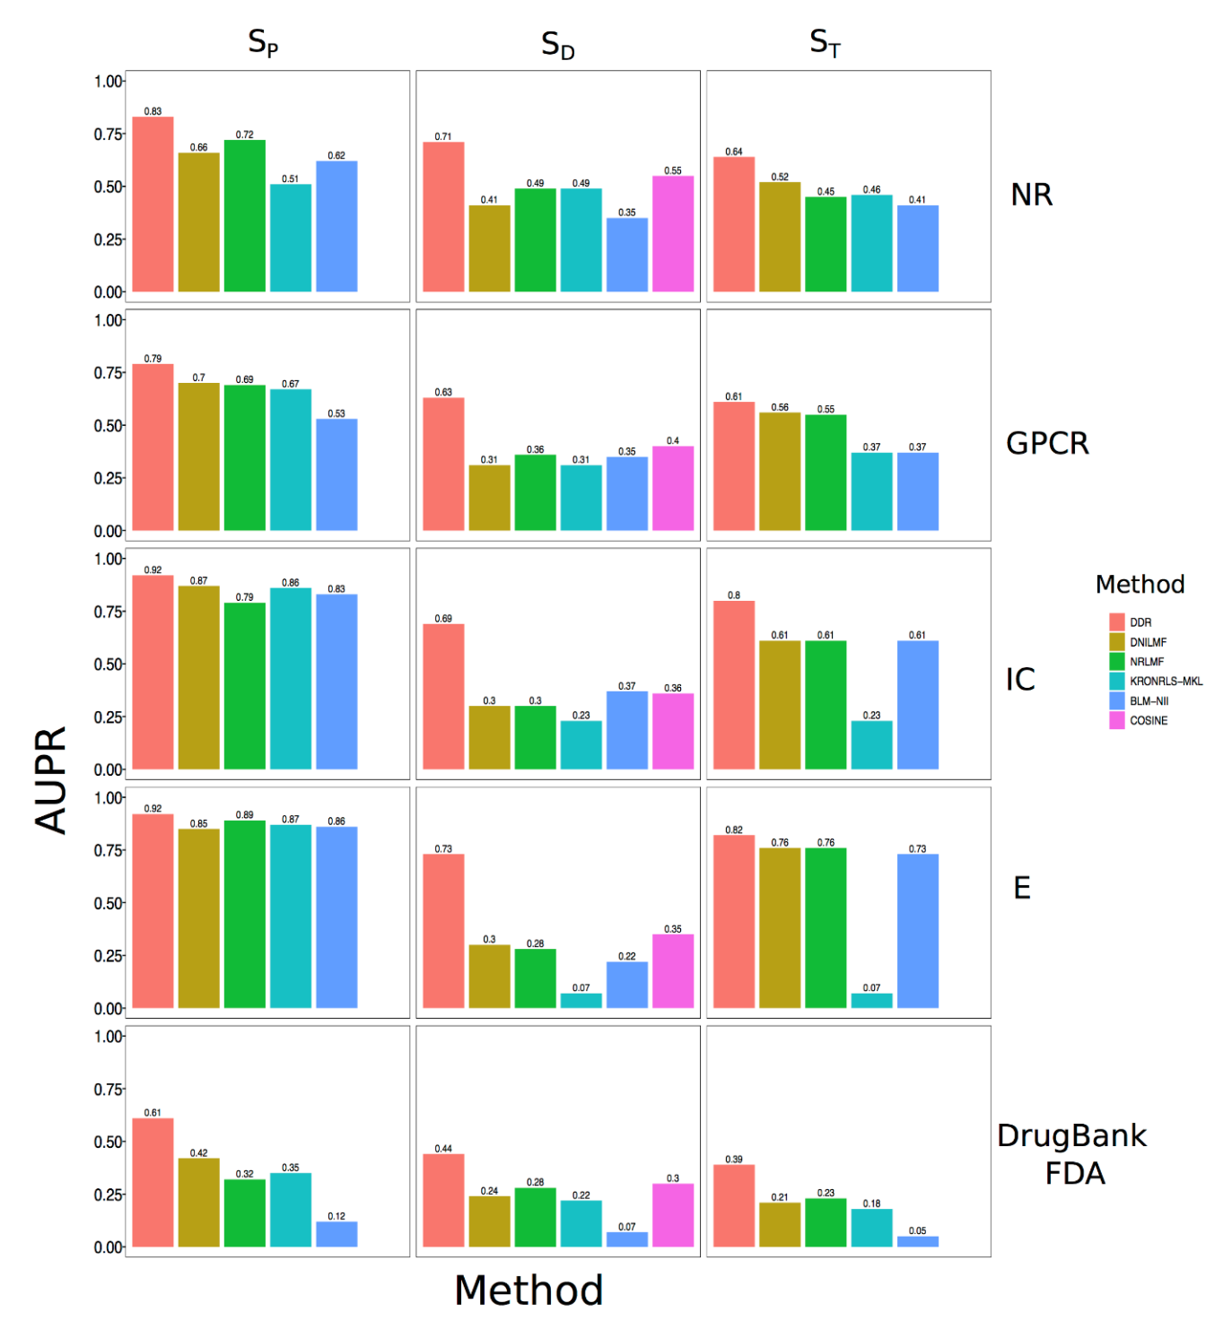
Supplementary Corrigendum Figure S1 (corrected original Fig. 2). Comparison results (in terms of AUPR scores) of DDR with the ﬁve state of the art methods (DNILMF, NRLMF, KRONRLS-MKL, COSINE and BLM-NII) using 5-repeats of 10-fold CV. Results are obtained under three prediction tasks (S_{P}, S_{D} and S_{T}) over all datasets (NR, GPCR, IC, E and DrugBank_FDA) used in this study. The results for DNILMF, NRLMF, KRONRLS-MKL, COSINE and BLM-NII are obtained using the best parameters reported in the respective publications.

Changes in the original Supplementary Material

In the original Supplementary Table S2:
The AUC value for COSINE in the S_{D} setting on the DrugBank_FDA dataset should be 0.88.

Corrected original Supplementary Table S3. Average position ranking, based on AUPR values reported from 5-repeats of 10-fold CV, for all methods (DDR, DNILMF, NRLMF, KRONRLS-MKL, COSINE, BLM-NII) using all datasets (NR, GPCR, IC, E, DrugBank_FDA) used in this study and under the three prediction settings (S_{P}, S_{D}, S_{T}). Green highlight marks the changes.
Dataset | DDR rank | DNILMF rank | NRLMF rank | COSINE rank | KRONRLS-MKL rank | BLM-NII rank
S_{P}
NR | 1 | 3 | 2 | NA | 5 | 4
GPCR | 1 | 2 | 3 | NA | 4 | 5
IC | 1 | 2 | 5 | NA | 3 | 4
E | 1 | 5 | 2 | NA | 3 | 4
DrugBank_FDA | 1 | 2 | 4 | NA | 3 | 5
Average ranking | 1 | 2.8 | 3.2 | NA | 3.6 | 4.4
S_{D}
NR | 1 | 4 | 3 | 2 | 3 | 5
GPCR | 1 | 5 | 3 | 2 | 5 | 4
IC | 1 | 4 | 4 | 3 | 5 | 2
E | 1 | 3 | 4 | 2 | 6 | 5
DrugBank_FDA | 1 | 4 | 3 | 2 | 5 | 6
Average ranking | 1 | 4 | 3.4 | 2.2 | 4.8 | 4.4
S_{T}
NR | 1 | 2 | 4 | NA | 3 | 5
GPCR | 1 | 2 | 3 | NA | 4 | 4
IC | 1 | 2 | 2 | NA | 3 | 2
E | 1 | 2 | 2 | NA | 4 | 3
DrugBank_FDA | 1 | 3 | 2 | NA | 4 | 5
Average ranking | 1 | 2.2 | 2.6 | NA | 3.6 | 3.8
Average ranking over all datasets and under three settings | 1 | 3 | 3.0667 | NA | 4 | 4.2

In the original Supplementary Table S4:
The AUPR and AUC values for COSINE in the S_{D} setting on the DrugBank_FDA dataset, should be 0.25 and 0.84, respectively.

