- SUPPLEMENTARY FIGURES
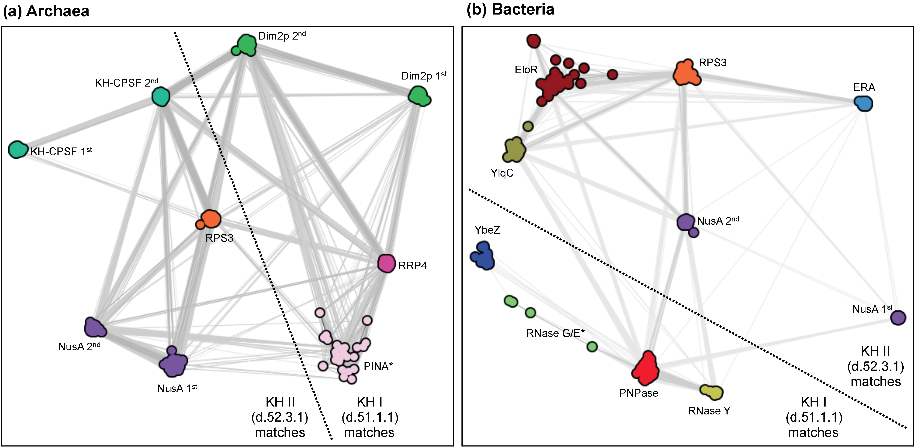
Fig. S1. Clustering of KHI and KHII matches found on prokaryotic proteomes. Cluster maps built with the matches for KHI (d.51.1) and KHII (d.52.3.1) in (a) archaea and (b) bacteria. Clustering was done with CLANS (Frickey and Lupas, 2004) in 2D until equilibrium at a BLASTp p-value cutoff of (a) 10⁻¹⁴ and (b) 10⁻⁶. Dots represent protein sequences and are colored according to the different protein families identified with HHPred (Zimmermann et al., 2018). Connections represent similarities up to a p-value of (a) 10⁻¹⁰ and (b) 10⁻⁴ (darker means more similar). Asterisks (*) mark protein families for which the domain boundaries suggested by the HMMER searches did not agree with the results from HHpred searches over SCOPe95.

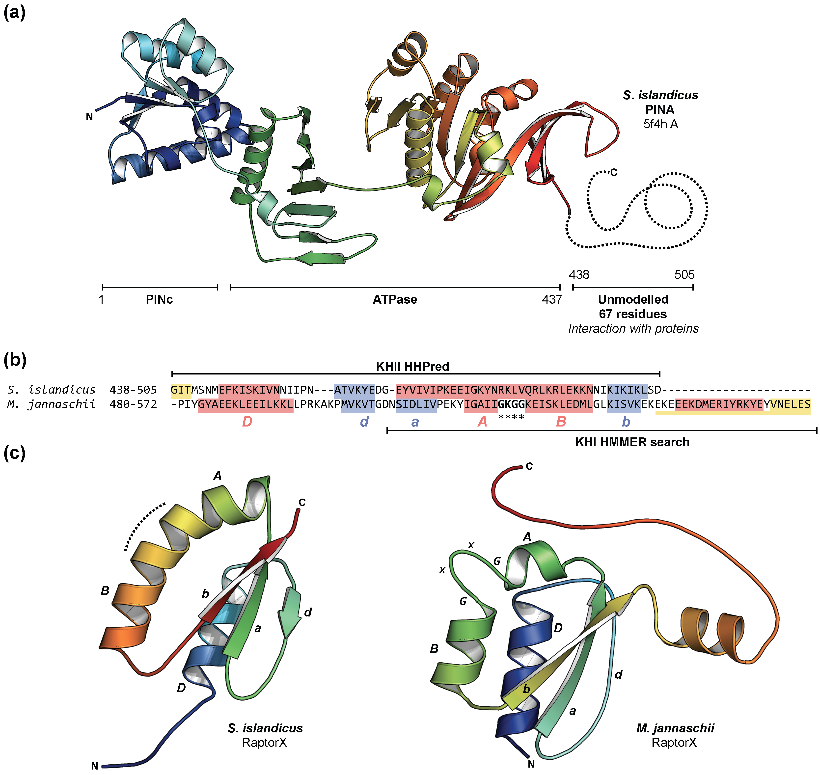
Fig. S2. The KH domain from archaeal PINA. (a) Ribbon representation of the single structure available for PINA; the crystallographic structure (pdbID: 5f4h, chain L) of the PINA monomer from the crenarchareota Sulfolobus islandicus. This conserved ATPase is involved in DNA recombinational repair in archaea (Zhai et al., 2017) and is composed by three domains: an N-terminal PINc domain, an ATPase domain and a C-terminal domain involved in protein-protein interactions. This C-terminal domain is unmodelled in the final structure. (b) Sequence alignment of the C-terminal domain of PINA from S. islandicus (UniProtKB: MJ1533) and the euryarchareota Methanocaldococcus jannaschii (UniProtKB: MJ1533). HHPred predicts this domain to be a KHII but the euryarchareota sequence is longer than its crenarchareota ortholog (Zhai et al., 2017); the HMMER searches suggested a KHI topology for this sequence. The secondary structure, as predicted with Quick2D (Alva et al., 2016), is shown: helices are marked in red, strands in blue and disordered regions in yellow. (c) Ribbon diagram of the structure modelled with RaptorX Contact Prediction (Wang et al., 2017) for the sequences in (b). The secondary structure predicted with Quick2D and the RaptorX models support a KHII fold for the C-terminal domain of PINA from both archaeal lineages.
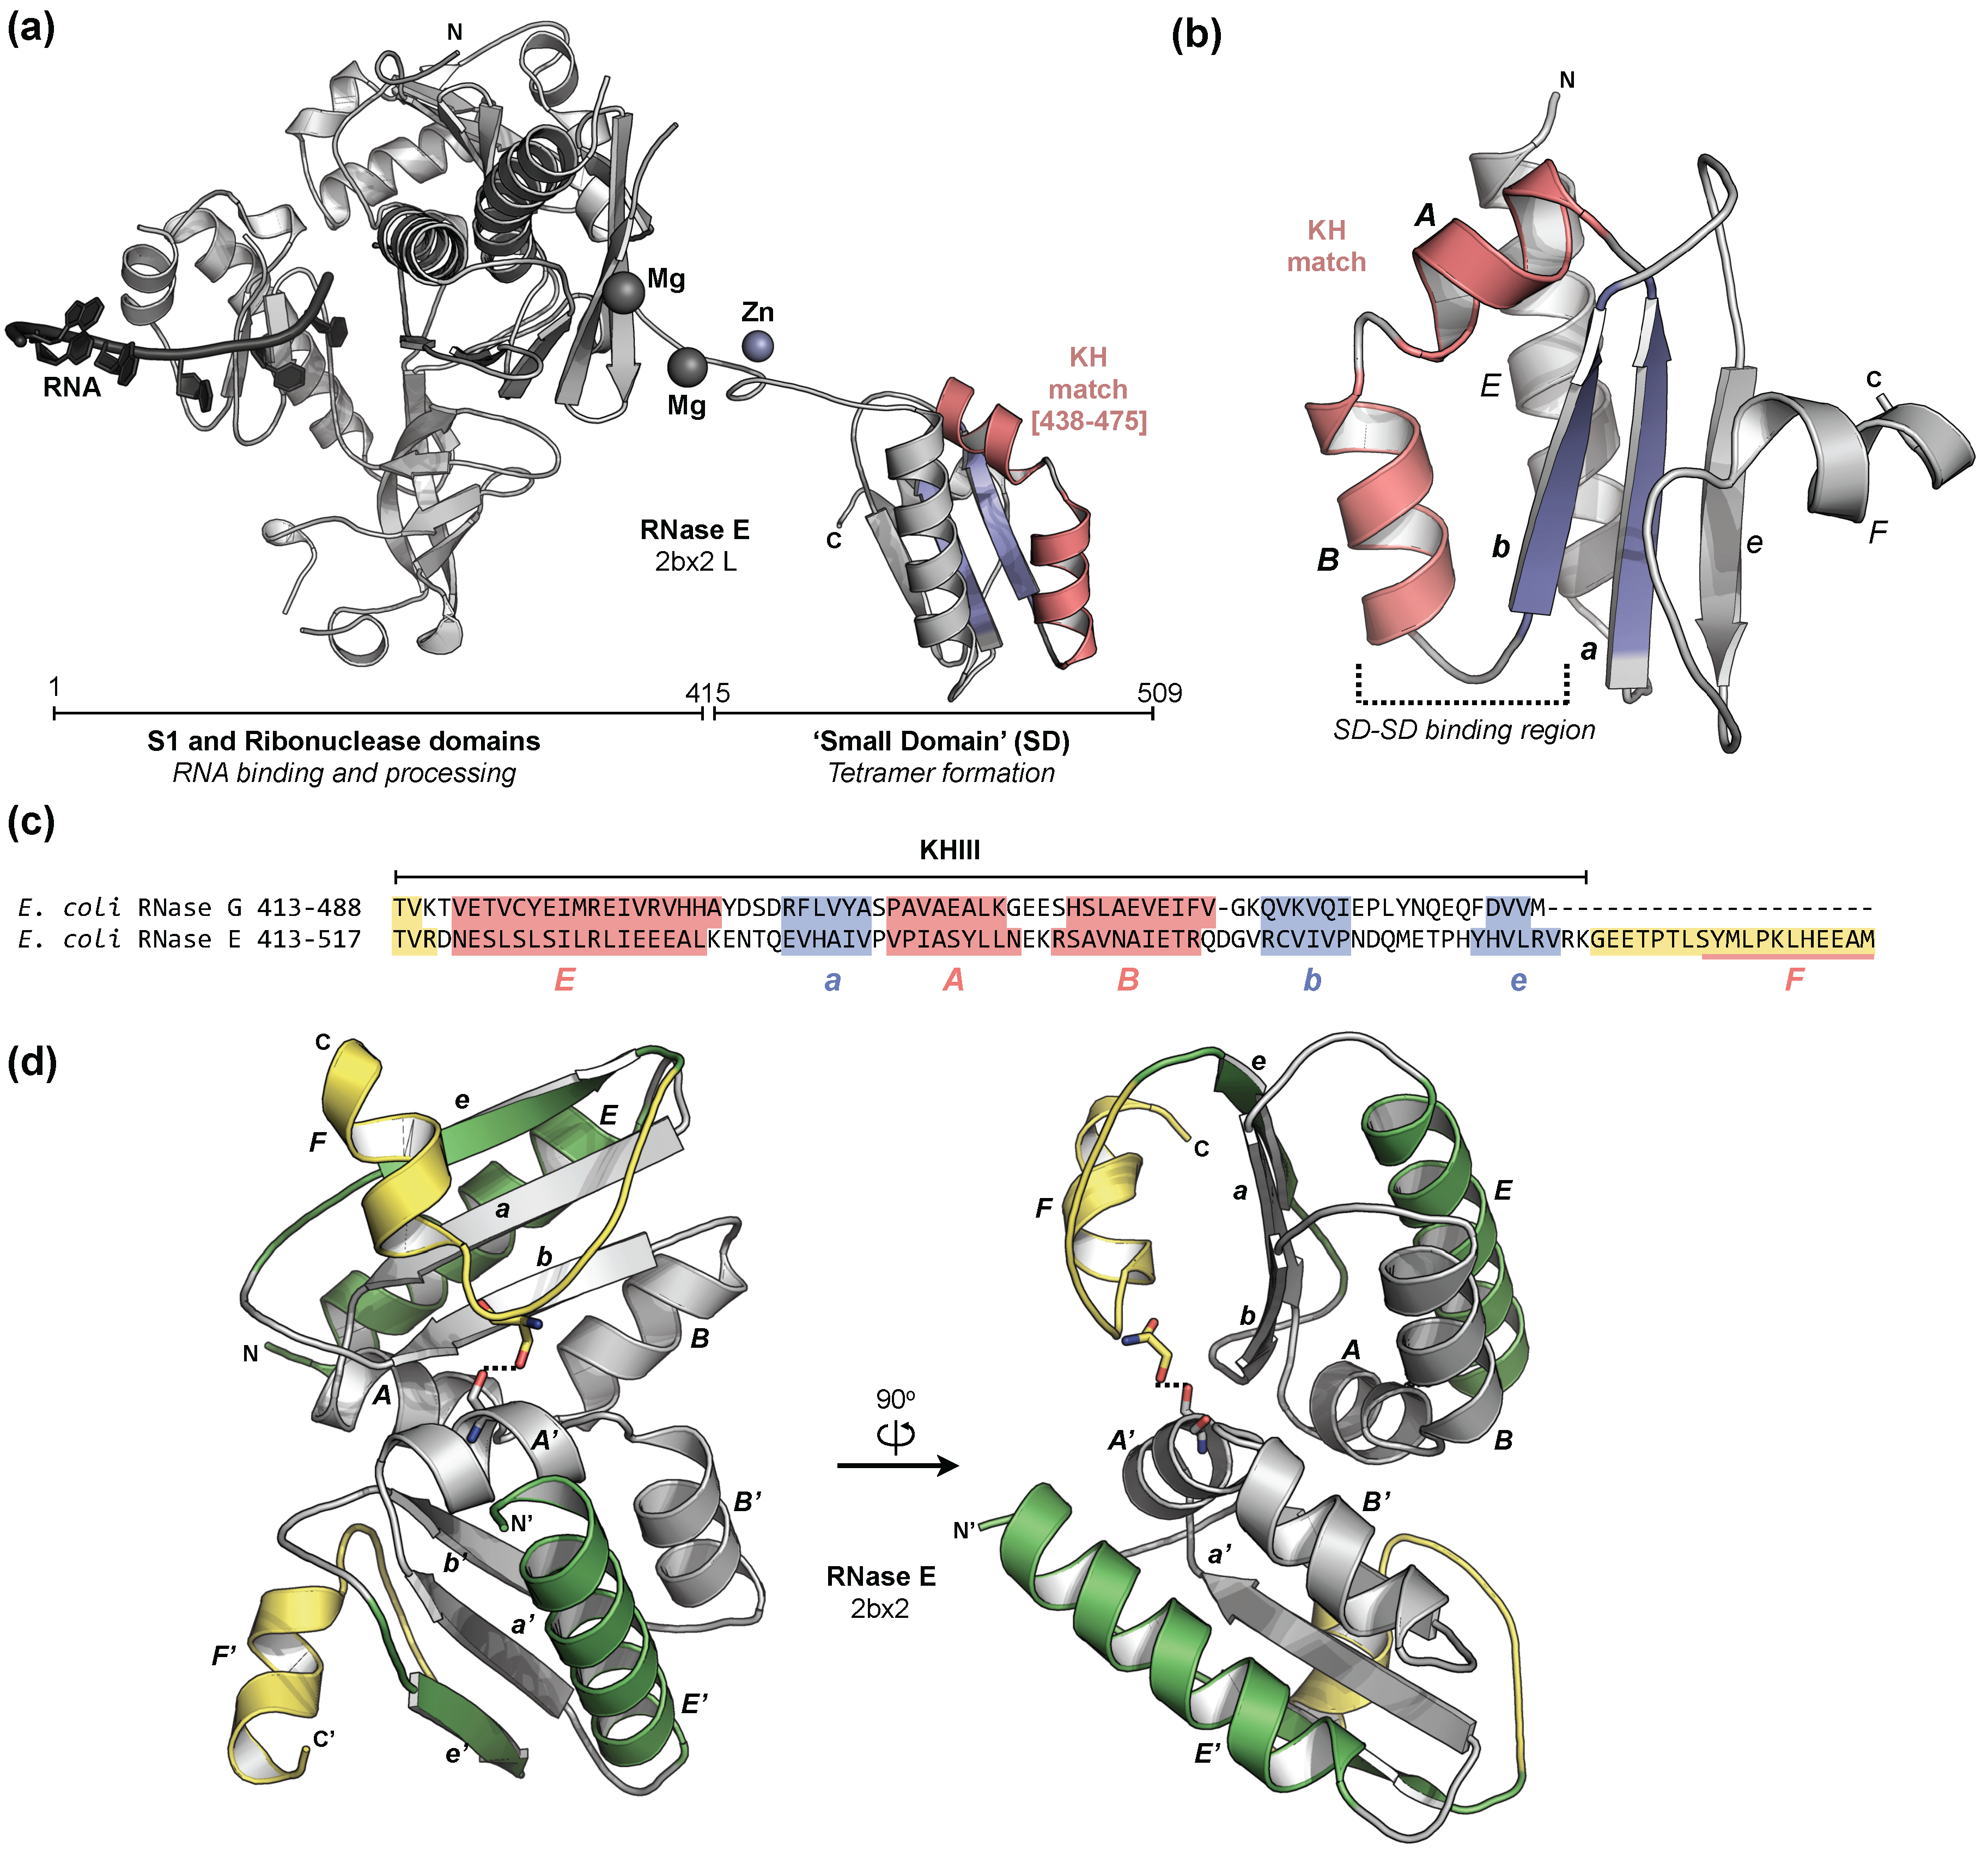
Fig. S3. The Small Domain (SD) from E. coli RNases E and G. (a) Ribbon diagram of the crystallographic structure (pdbID: 2bx2, chain L) of the monomer of the catalytic region from the RNase E of E. coli, depicting its three main domains and their role, as well as the RNA binding region (Callaghan et al., 2005). (b) Zoom into the Small Domain and the initial KH match. (c) Sequence alignment (obtained with Promals3D (Pei and Grishin, 2014)) of the SD sequences from RNases E and G from E. coli, depicting the secondary structural predictions obtained with Quick2D (Alva et al., 2016). Helices are marked in red, strands in blue and disordered regions in yellow. (d) Ribbon diagram of the crystallographic dimer (pdbID: 2bx2) of the SD from E. coli RNase E, where the participation of the region containing helix F in dimerization is illustrated. The KH motif is colored grey, the KHIII decorations green and the predicted disordered region in yellow.

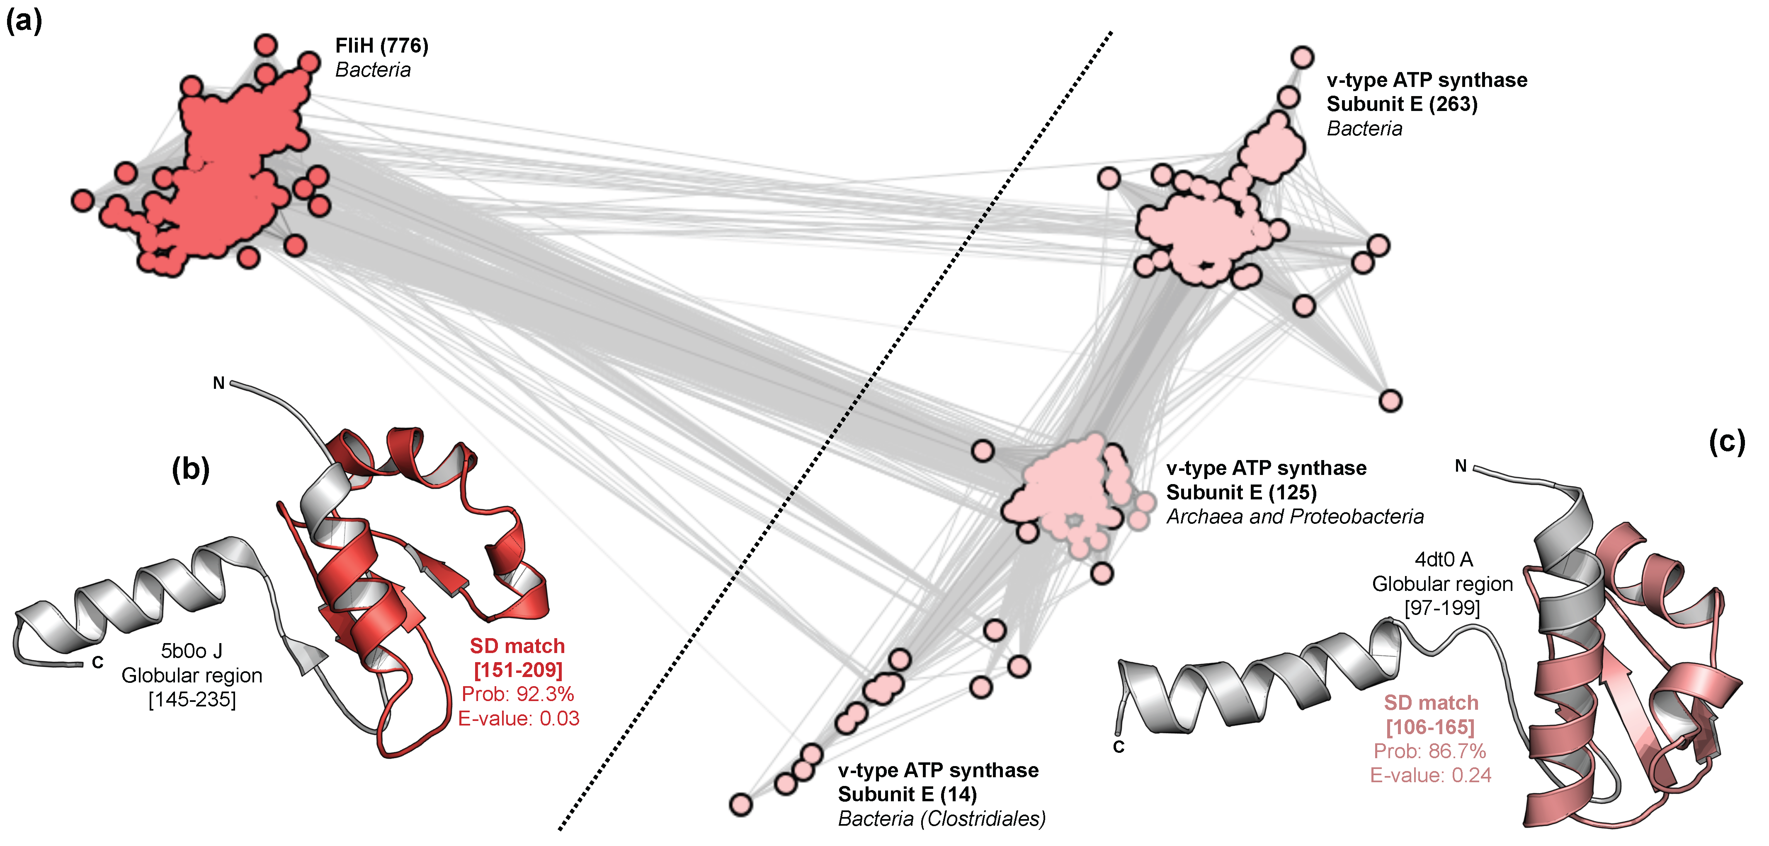
Fig. S4. Classification of non-KH domains homologous to the SD of RNases E and G. (a) Cluster map of the sequences of the globular regions from bacterial FliH and prokaryotic subunit E of v-type ATP synthase, obtained with JackHMMER (Finn et al., 2015) over the reference proteomes of archaea and bacteria. Clustering was done with CLANS (Frickey and Lupas, 2004) in 2D at a BLASTp p-value cutoff of 10⁻¹⁴ until equilibrium. Dots represent protein sequences; they are colored according to the different protein families and lined based on their taxonomy (grey: archaea; black: bacteria). Connections represent similarities up to a p-value of 10⁻¹⁰ (darker means more similar). The number of sequences in each cluster is shown within brackets. (b-c) Re-refined crystallographic structures of the globular domains from (b) Salmonella enterica FliH and (c) Pyrococcus horikoshii v-type ATP synthase subunit E. These matches were identified by using the sequence alignment of the SD from E.coli RNases G and E for HHpred searches over the PDB70, using 8 iterations of PsiBlast over the nre70 database and not scoring for secondary structure (Zimmermann et al., 2018). The probability and E-value for the matches, as well as the sequence intervals used for the following JackHMMER searches, are given.
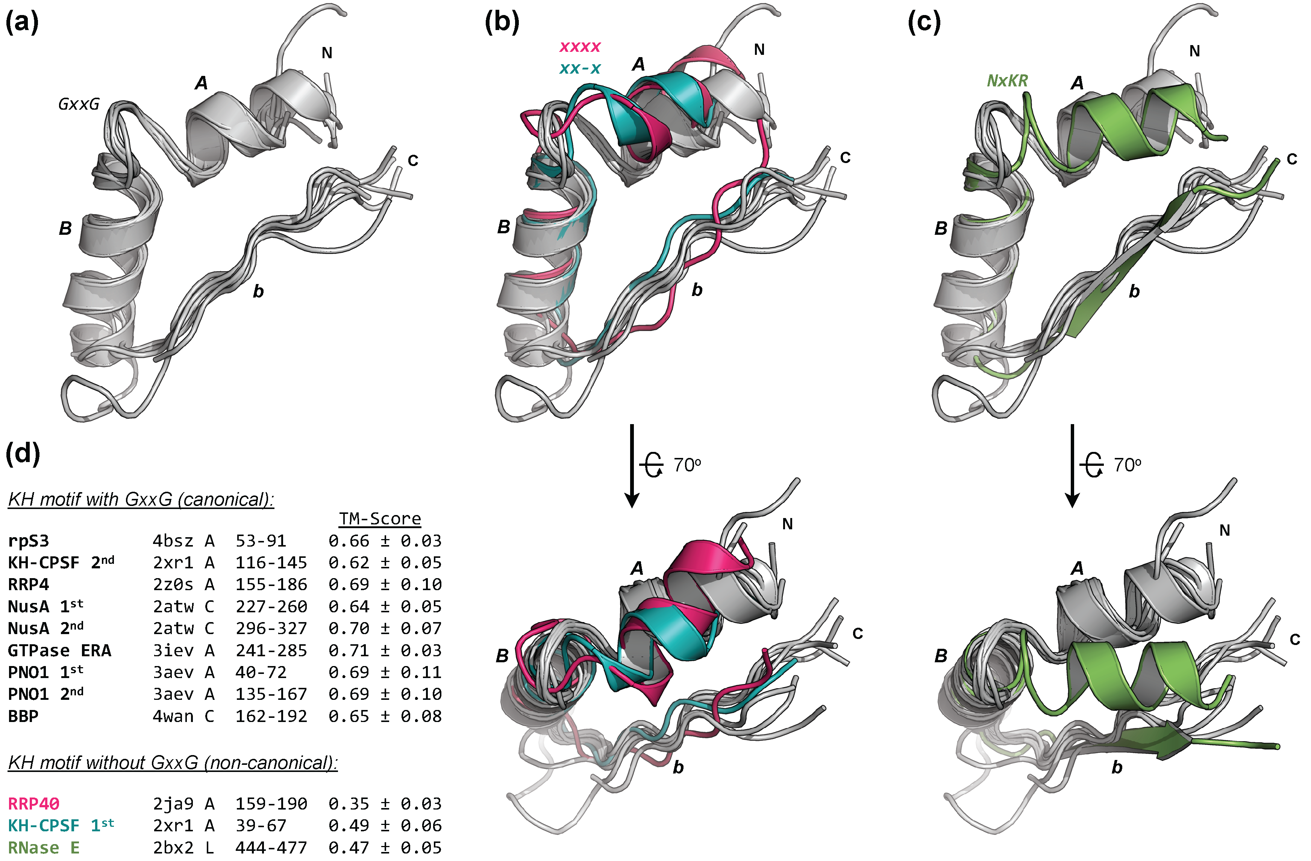
Fig. S5. Structural alignment of ααβ (ABb) motifs. Structural superposition of the motif from yeast rpS3 (PDBid: 4bsz, chain A) to (a) those containing the conserved GxxG loop (canonical), (b) those lacking it (non-canonical) and (c) that from the Small Domain of RNase E from E. coli. (d) List of fragments superimposed with TMalign (Zhang and Skolnick, 2005), colored accordingly. The average TM-score and corresponding standard deviations from the superimposition to all GxxG-containing motifs are shown. Only crystallographic structures at a resolution better than 3.0 Å and re-refined with PDB_REDO (Joosten et al., 2014) were considered.
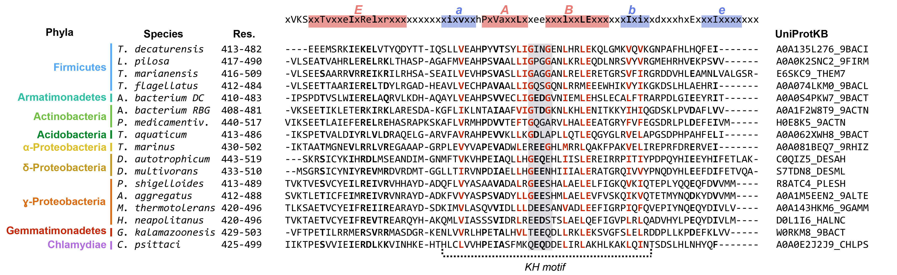
Fig. S6. Sequence alignment of SD sequences from RNase G. A subset of the sequences from the RNase G cluster represented in figure 2 was selected and shown together with the HMM sequence profile computed for it with hhmake (Söding, 2005) (on top). The profile is colored according to the secondary structure of the RNase G consensus sequence and named based on the topology showed in figure 1. Conserved positions depicted by the sequence profile are marked in bold and those conserved in the profiles of KHI and KHII domains in red. The phyla to which each species belongs to are shown on the left and the UniProtKB accession number on the right. The position of the conserved GxxG pattern within the KH motif is highlighted in grey.
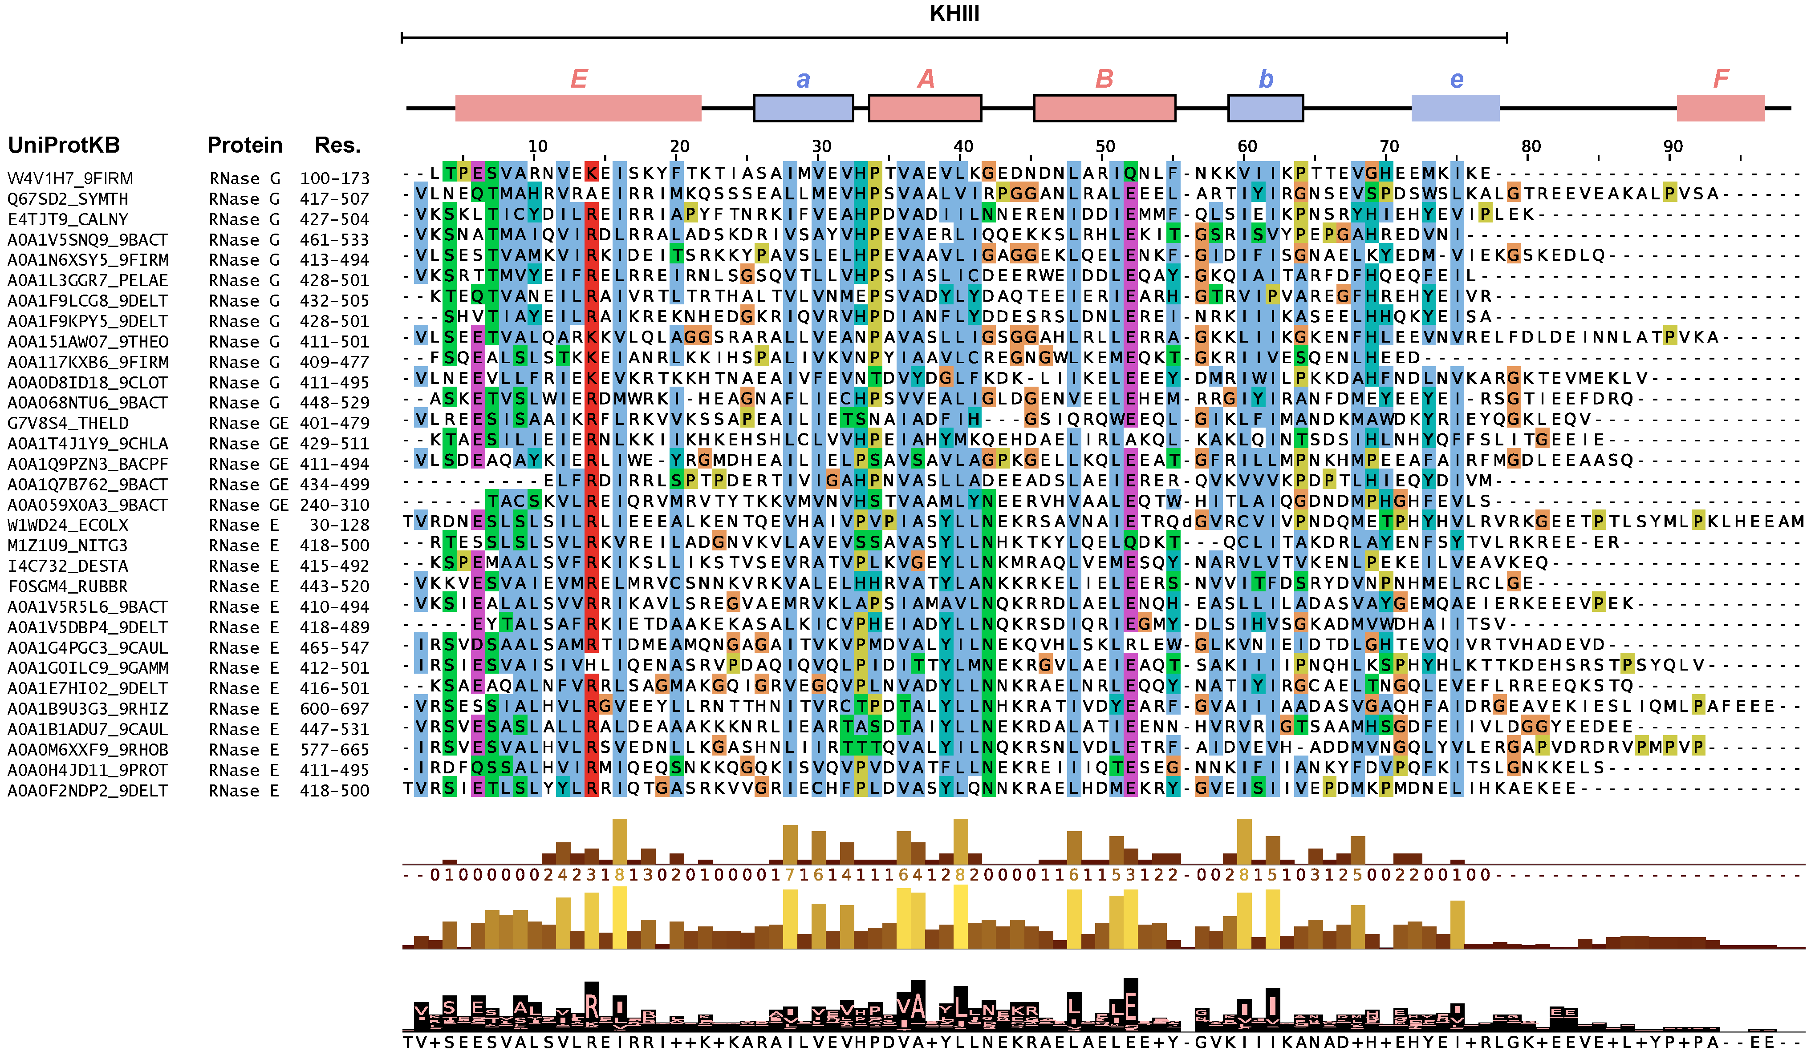
Fig. S7. Sequence alignment of representative sequences of Small Domains from bacterial RNases G and E. Sequences were obtained by searching bacterial sequences in UniproKB with HMMER (Finn et al., 2015). The sequence alignment of the SD from E. coli RNase E (PDBid: 2bx2, chain L, res. 413-517) and its homologous in T. marianensis RNase G (UniprotKB: E6SKC9_THEM7, res. 416-506), which carries the GxxG pattern and is longer than its E. coli ortholog, was used as input with default settings. The aligned matches were processed with trimAL (Capella-Gutierrez et al., 2009) in order to remove columns where more than 85% of the positions represented a gap (gap score of 0.15) and a representative set of sequences extracted with HHfilter (Remmert et al., 2011) to a maximum sequence identity of 35%. The alignment was visualized with Jalview (Waterhouse et al., 2009) and colored based on the ClustalX color scheme. Only protein sequences with a known name were considered; their names, UniProtKB accession codes and residue intervals are shown. The secondary structure of the SD from E. coli RNase E (PDBid: 2bx2, chain L) is represented and mapped on the top of the alignment: red boxes represent helices and blue boxes strands; those surrounded by a black line represent the KH motif. The region considered in this work as the KHIII domain is depicted and corresponds to the conserved block on the alignment.

- SUPPLEMENTARY TABLES
Table S1. List of KHII sequences added to the initial KHII set. Protein sequences not yet annotated to a SCOPe family were identified by HHPred searches over the PDB70 with default parameters.
Protein family | PDBid | Chain | Position
KH-CPSF | 2xr1 | A | 3-67
KH-CPSF | 2xr1 | A | 72-138
KH-CPSF | 2ycb | A | 3-66
KH-CPSF | 2ycb | A | 71-136
EloR | 3gku | A | 57-137
EloR | 2pt7 | G | 115-191

Table S2. List of KH-containing protein families identified by HMMER searches. The taxonomic distribution of the families identified was obtained by BLASTp searches over the reference proteomes of bacteria, archaea and eukaryote; a universal protein is present in all superkingdoms. The consensus KH fold annotated based on our HMMER and HHPred searches (as described in the Methods section) is shown, along with its position on the reference sequence. When more than one KH domain is found on the same protein, the position of all of those is given. The consensus presence of the GxxG pattern on the HMM profiles computed (as described in the Methods section) for the given KH domains is shown. Reference structures were identified by HHPred searches over the PDB70.
Protein family | Taxonomy | Reference sequence | KH fold | Position | Canonical KH | Previously reported | Reference structure
rpS3 | Universal | RS3_ECOLI | II | 17-95 | yes | Grishin, 2001 | 4v9o DC
GTPase ERA | Bacteria | ERA_THET8 | II | 208-285 | yes | Tu et al., 2009 | 3iev A
NusA | Bacteria and archaea | NUSA_ECOLI | II  II | 200-276 278-341 | yes | Beuth et al., 2005 | 2atw C
KH-CPSF | Archaea | Q8PZ03_METMA | II  II | 7-74  77-156 | no  yes | Mir-Montazeri et al., 2011 | 2xr1 A
EloR | Bacteria | JAG_BACSU | II | 63-134 | yes | Hare et al., 2007 | 3gku A
YlqC | Bacteria | YLQC_BACSU | II | 5-79 | yes | n.a. | n.a.
PINA | Archaea | Y1533_METJA | II | 489-572 | yes | Anantharaman, 2002 | n.a.
PNPase | Bacteria and organelles | PNP_ECOLI | I | 553-621 | yes | Symmons et al., 2000 | 4nbq B
RNase Y | Bacteria | RNY_BACSU | I | 208-275 | yes | Condon, 2003 | n.a.
Dim2p | Archaea and eukaryota | O59282_PYRHO | I | 32-102  123-190 | yes  yes | Vanrobays et al., 2004 | 3aev A
RRP4 | Archaea and eukaryota | RRP4_ARCFU | I | 136-217 | yes | Lu et al., 2010 | 2z0s A
YbeZ | Bacteria | PHOL_ECOLI | I | 3-89 | no | n.a. | n.a.
RNase E | Bacteria and chloroplasts | RNE_ECOLI | III | 413-517 | no | n.a. | 2bx2 L
RNase G | Bacteria and chloroplasts | RNG_ECO57 | III | 413-488 | no | n.a. | n.a.

References
Alva,V. et al. (2016) The MPI bioinformatics Toolkit as an integrative platform for advanced protein sequence and structure analysis. Nucleic Acids Res., 44, W410–W415.
Anantharaman,V. (2002) Comparative genomics and evolution of proteins involved in RNA metabolism. Nucleic Acids Res., 30, 1427–1464.
Beuth,B. et al. (2005) Structure of a Mycobacterium tuberculosis NusA–RNA complex. EMBO J., 24, 3576–3587.
Callaghan,A.J. et al. (2005) Structure of Escherichia coli RNase E catalytic domain and implications for RNA turnover. Nature, 437, 1187–1191.
Capella-Gutierrez,S. et al. (2009) trimAl: a tool for automated alignment trimming in large-scale phylogenetic analyses. Bioinformatics, 25, 1972–1973.
Condon,C. (2003) RNA Processing and Degradation in Bacillus subtilis. Microbiol. Mol. Biol. Rev., 67, 157–174.
Finn,R.D. et al. (2015) HMMER web server: 2015 update. Nucleic Acids Res., 43, W30–W38.
Frickey,T. and Lupas,A. (2004) CLANS: A Java application for visualizing protein families based on pairwise similarity. Bioinformatics, 20, 3702–3704.
Grishin,N. V. (2001) KH domain: one motif, two folds. Nucleic Acids Res., 29, 638–43.
Hare,S. et al. (2007) Identification, structure and mode of action of a new regulator of the Helicobacter pylori HP0525 ATPase. EMBO J., 26, 4926–4934.
Joosten,R.P. et al. (2014) The PDB_REDO server for macromolecular structure model optimization. IUCrJ, 1, 213–220.
Lu,C. et al. (2010) Crystal structure of the S. solfataricus archaeal exosome reveals conformational flexibility in the RNA-binding ring. PLoS One, 5, e8739.
Mir-Montazeri,B. et al. (2011) Crystal structure of a dimeric archaeal Cleavage and Polyadenylation Specificity Factor. J. Struct. Biol., 173, 191–195.
Pei,J. and Grishin,N. V. (2014) PROMALS3D: Multiple Protein Sequence Alignment Enhanced with Evolutionary and Three-Dimensional Structural Information. In, Methods in molecular biology (Clifton, N.J.)., pp. 263–271.
Remmert,M. et al. (2011) HHblits: lightning-fast iterative protein sequence searching by HMM-HMM alignment. Nat. Methods, 9, 173–175.
Söding,J. (2005) Protein homology detection by HMM – HMM comparison. Bioinformatics, 21, 951–960.
Symmons,M.F. et al. (2000) A duplicated fold is the structural basis for polynucleotide phosphorylase catalytic activity, processivity, and regulation. Structure, 8, 1215–26.
Tu,C. et al. (2009) Structure of ERA in complex with the 3’ end of 16S rRNA: implications for ribosome biogenesis. Proc. Natl. Acad. Sci. U. S. A., 106, 14843–8.
Vanrobays,E. et al. (2004) Dim2p, a KH-domain protein required for small ribosomal subunit synthesis. RNA, 10, 645–56.
Wang,S. et al. (2017) Accurate De Novo Prediction of Protein Contact Map by Ultra-Deep Learning Model. PLOS Comput. Biol., 13, e1005324.
Waterhouse,A.M. et al. (2009) Jalview Version 2--a multiple sequence alignment editor and analysis workbench. Bioinformatics, 25, 1189–1191.
Zhai,B. et al. (2017) Structure and Function of a Novel ATPase that Interacts with Holliday Junction Resolvase Hjc and Promotes Branch Migration. J. Mol. Biol., 429, 1009–1029.
Zhang,Y. and Skolnick,J. (2005) TM-align: a protein structure alignment algorithm based on the TM-score. Nucleic Acids Res., 33, 2302–2309.
Zimmermann,L. et al. (2018) A completely reimplemented MPI Bioinformatics Toolkit with a new HHpred server at its core. J. Mol. Biol.

