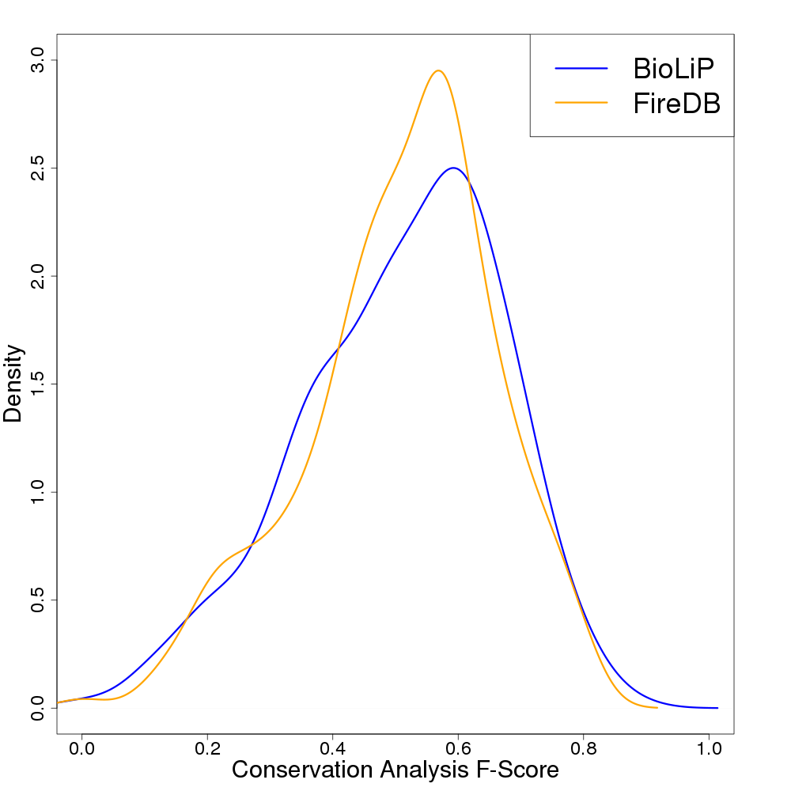

Supplemental Figure 1. Comparison of Max Sampled MSA conservation analysis F-Score distributions for 249 miscellaneous-molecule-binding proteins whose binding sites are annotated by both BioLiP (blue) and FireDB (orange). The distributions display minor differences overall, indicating that the F-Score of the Max Sampled MSA is minimally affected by the choice benchmark data set. The median Max Sampled MSA F-Score when defining binding sites by BioLiP is 0.532, while that when using FireDB is 0.529. These differences are not statistically significant (*p* = 0.758, Wilcoxon rank sum test).

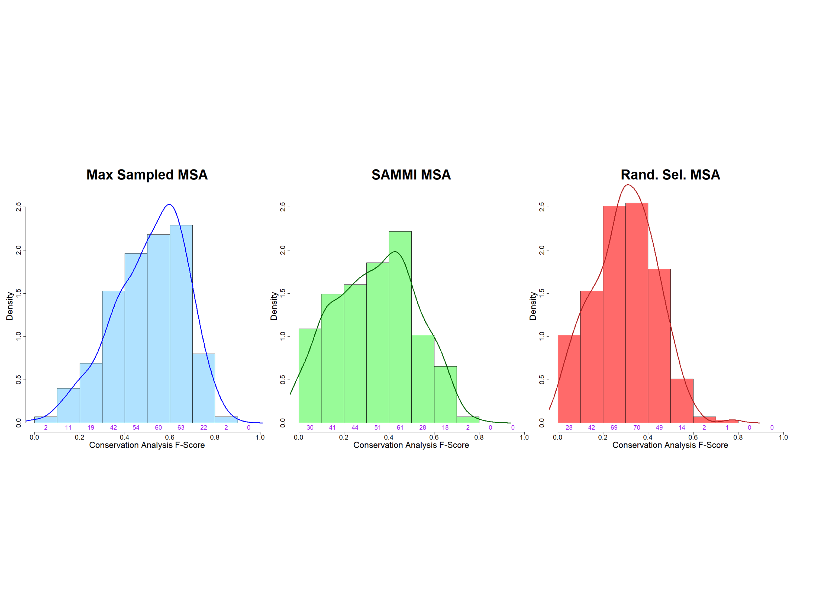

Supplemental Figure 2. Conservation analysis F-Score distributions for Max Sampled (blue), SAMMI (green), and randomly selected (red) MSAs for 275 miscellaneous-molecule-binding proteins. The data in these plots correspond to the density estimators plotted in Figure 2A and show accurate fit to histograms representing the underlying data. The number of cases in each histogram bin is shown in purple text.

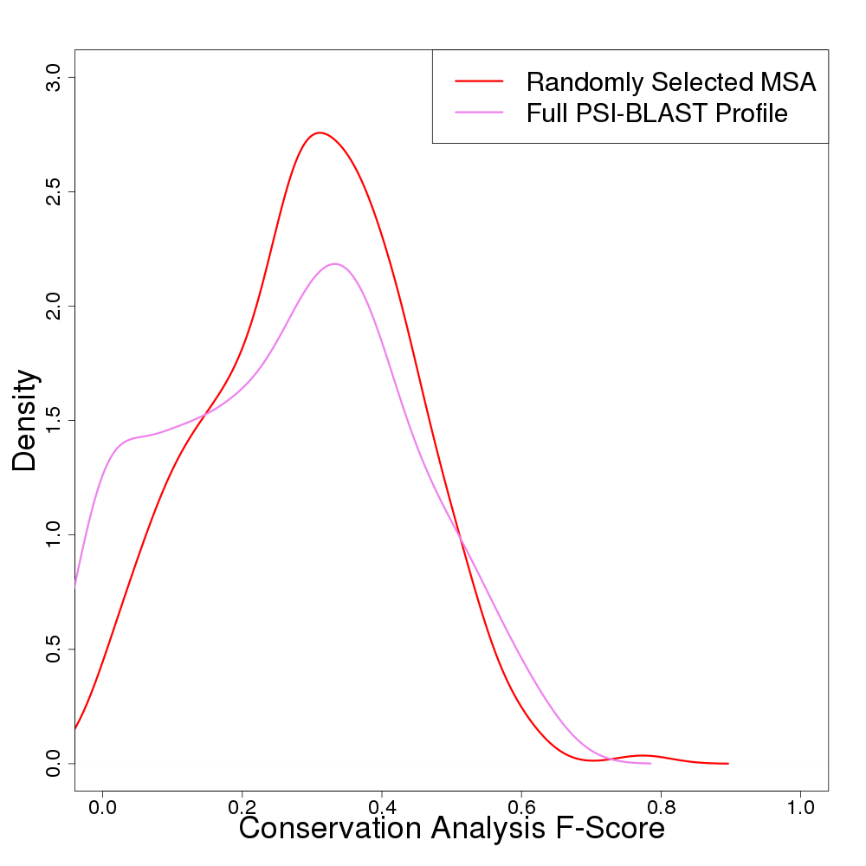

Supplemental Figure 3. Comparison of conservation analysis F-Score distributions obtained when using randomly selected MSAs (red) versus MSAs including the full set of sequences obtained from the original PSI-BLAST search (Full PSI-BLAST Profile; pink) for the set of 275 miscellaneous-molecule-binding proteins. The median F-Score values for the randomly selected and full PSI-BLAST profiles are 0.297 and 0.273, respectively, indicating that using the full set of PSI-BLAST sequences in conservation analysis generally leads to marginally inferior performance (p = 0.043, Wilcoxon rank sum test). A relatively large proportion of cases when using full PSI-BLAST profiles have an F-Score of zero due to the mixing of conservation signals from different protein functional families.

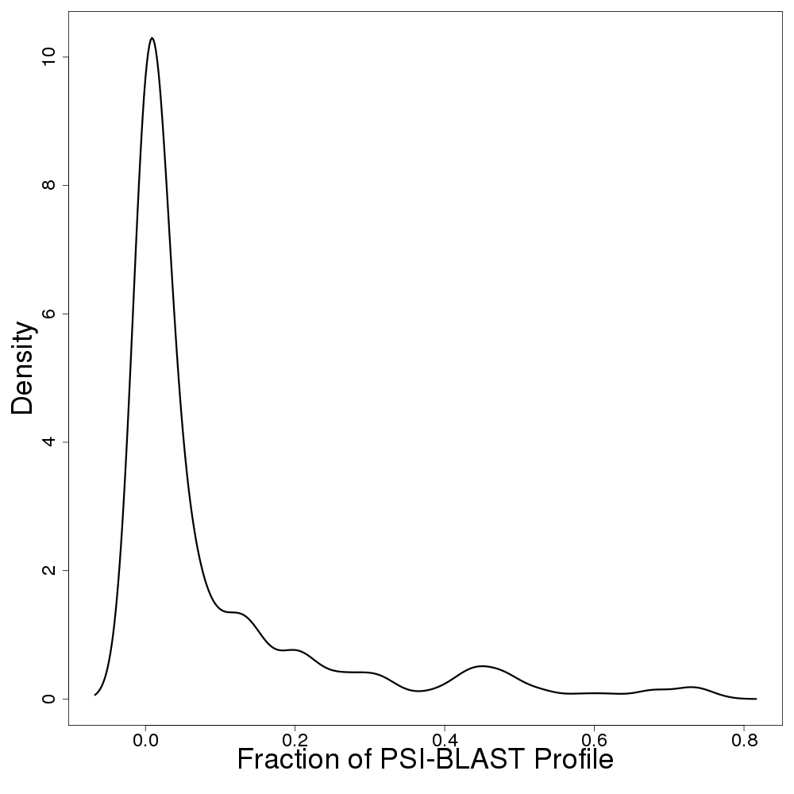

Supplemental Figure 4. Fraction of sequences in PSI-BLAST profile included in Max Sampled MSAs for the set of 275 miscellaneous-molecule-binding proteins. The mean fraction is 0.09, indicating that only a small portion of the sequences in a PSI-BLAST search are needed to construct MSAs optimal for functional site identification by conservation analysis.

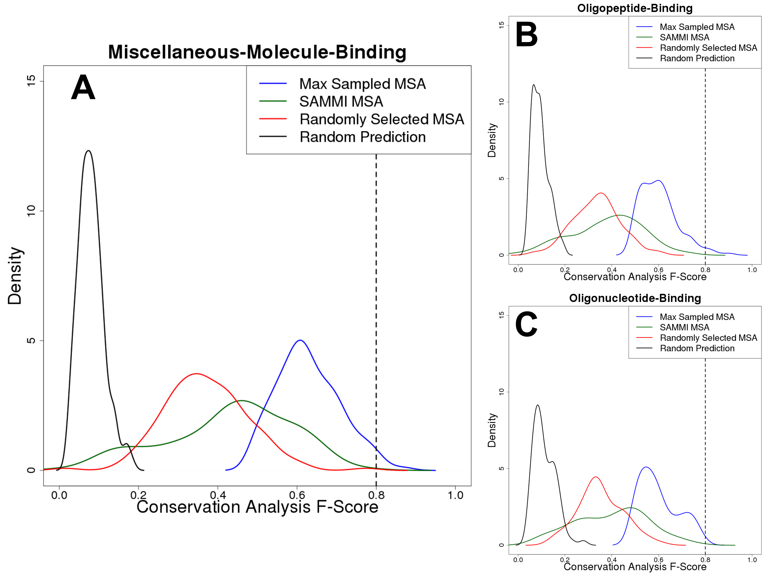

Supplemental Figure 5. Conservation analysis F-Score distributions for the subset of proteins in each of the three data sets (A: miscellaneous-molecule-binding, B: oligopeptide-binding, C: oligonucleotide-binding) with Max Sampled F-Scores greater than 0.5, demonstrating the benefit of SAMMI in all cases. There were 140, 118, and 77 proteins meeting this threshold in the miscellaneous-molecule-binding, oligopeptide-binding, and oligonucleotide-binding data sets, respectively. The benefit of selecting the SAMMI MSA is strong in all data sets, although a non-negligible fraction of cases have F-Scores that appear to be random at a higher rate than those of randomly selected MSAs. We have demonstrated previously that these are likely due to secondary, unannotated ligand binding sites. The dashed lines at F-Scores of ~0.8 indicate the approximate theoretical upper limit that was established by analysis of the agreement between different databases.

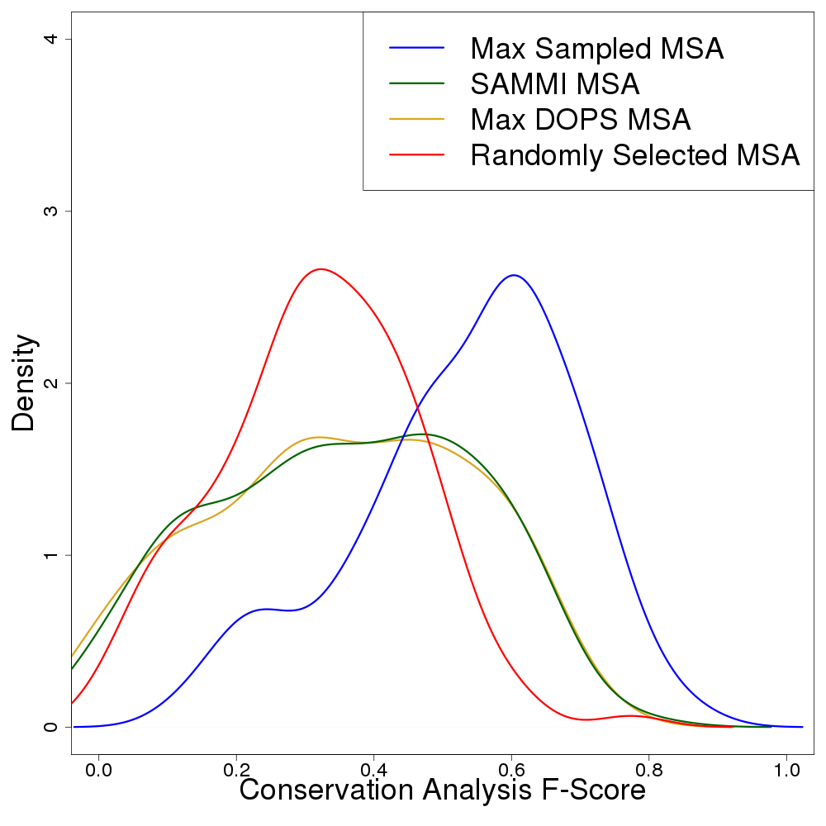

Supplemental Figure 6. Conservation analysis F-Score distributions obtained when selecting MSAs scored most highly by SAMMI (green) or DOPS (yellow), plotted for 126/275 miscellaneous-molecule-binding proteins. Scoring MSAs with SAMMI and DOPS largely appears to result in the selection of equivalent MSAs – for this set, the median F-Score of DOPS-selected MSAs is 0.35 while that of SAMMI-selected MSAs is 0.36 (p = 0.449, Wilcoxon rank sum test). Both DOPS and SAMMI are statistically significant improvements over random MSA selection, which has a median F-Score of 0.31 (p = 0.0419 for DOPS and p = 0.0295 for SAMMI, Wilcoxon rank sum test). However, both DOPS and SAMMI fall short of the theoretically possible Max Sampled MSA (blue), where the median F-Score is 0.56 (p < 0.001 for both DOPS and SAMMI).

Supplemental Table 1. Percentage of area overlap between the distributions of the F-Scores resulting from random residue predictions (black curves in Fig. 2) with the F-Scores from conservation analysis of the Randomly Selected (Rand. Sel.; red curves in Fig. 2), SAMMI (green curves in Fig. 2), and Max Sampled (blue curves in Fig. 2) MSAs for each data set. Overlap values were calculated with the CRAN package “overlapping”*.

|  |  |  |  |
| --- | --- | --- | --- |
| Data Set | Rand. Sel. MSA | SAMMI MSA | Max Sampled MSA |
| Misc.-Molecule-Binding | 13% | 12% | 2.3% |
| Oligopeptide-Binding | 30% | 24% | 12% |
| Oligonucleotide-Binding | 33% | 29% | 10% |

* Massimiliano Pastore (2017). overlapping: Estimation of Overlapping in Empirical Distributions. R package version 1.5.0. https://CRAN.R-project.org/package=overlapping

Supplemental Table 2. SAMMI MSA, Max Sampled MSA, and Rand. Sel. MSA F-Scores and their associated p-values for all the proteins in the data set. Refer to section 3.5 of the main article for an explanation of how p-values were calculated.

|  |  |  |  |  |  |  |
| --- | --- | --- | --- | --- | --- | --- |
| **PDB ID** | **MaxMI MSA F-Score** | **p-value** | **Max Sampled MSA F-Score** | **p-value** | **Rand Sel. MSA F-Score** | **p-value** |
| **Miscellaneous-Molecule-Binding Proteins** | | | | | | |
| 1a0gB | 0.38 | < 0.001 | 0.77 | < 0.001 | 0.50 | < 0.001 |
| 1apzB | 0.55 | < 0.001 | 0.55 | < 0.001 | 0.43 | < 0.001 |
| 1b33A | 0.58 | < 0.001 | 0.58 | < 0.001 | 0.47 | < 0.001 |
| 1b5fA | 0.29 | < 0.001 | 0.29 | < 0.001 | 0.26 | < 0.001 |
| 1bibA | 0.29 | < 0.001 | 0.48 | < 0.001 | 0.30 | < 0.001 |
| 1c52A | 0.44 | < 0.001 | 0.49 | < 0.001 | 0.38 | < 0.001 |
| 1c80A | 0.38 | < 0.001 | 0.46 | < 0.001 | 0.26 | < 0.001 |
| 1cr2A | 0.09 | 0.093 | 0.52 | < 0.001 | 0.27 | < 0.001 |
| 1ds7B | 0.67 | < 0.001 | 0.67 | < 0.001 | 0.52 | < 0.001 |
| 1e8eA | 0.47 | < 0.001 | 0.56 | < 0.001 | 0.46 | < 0.001 |
| 1ecaA | 0.33 | < 0.001 | 0.60 | < 0.001 | 0.44 | < 0.001 |
| 1ew6A | 0.38 | < 0.001 | 0.44 | < 0.001 | 0.39 | < 0.001 |
| 1exfA | 0.12 | < 0.001 | 0.12 | < 0.001 | 0.05 | 0.737 |
| 1f17A | 0.44 | < 0.001 | 0.59 | < 0.001 | 0.37 | < 0.001 |
| 1f7kA | 0.56 | < 0.001 | 0.67 | < 0.001 | 0.35 | < 0.001 |
| 1fujA | 0.11 | 0.001 | 0.33 | < 0.001 | 0.09 | 0.020 |
| 1g2vA | 0.64 | < 0.001 | 0.71 | < 0.001 | 0.37 | < 0.001 |
| 1g3rA | 0.47 | < 0.001 | 0.60 | < 0.001 | 0.30 | < 0.001 |
| 1g9sA | 0.64 | < 0.001 | 0.64 | < 0.001 | 0.53 | < 0.001 |
| 1gu1A | 0.14 | < 0.001 | 0.57 | < 0.001 | 0.31 | < 0.001 |
| 1gwwB | 0.13 | < 0.001 | 0.63 | < 0.001 | 0.21 | < 0.001 |
| 1gz6C | 0.33 | < 0.001 | 0.56 | < 0.001 | 0.40 | < 0.001 |
| 1h4hC | 0.24 | < 0.001 | 0.59 | < 0.001 | 0.33 | < 0.001 |
| 1hmpB | 0.14 | < 0.001 | 0.79 | < 0.001 | 0.49 | < 0.001 |
| 1i7pA | 0.23 | < 0.001 | 0.46 | < 0.001 | 0.19 | < 0.001 |
| 1i7qB | 0.60 | < 0.001 | 0.70 | < 0.001 | 0.49 | < 0.001 |
| 1ionA | 0.14 | < 0.001 | 0.48 | < 0.001 | 0.29 | < 0.001 |
| 1iwpB | 0.46 | < 0.001 | 0.57 | < 0.001 | 0.40 | < 0.001 |
| 1jf8A | 0.59 | < 0.001 | 0.71 | < 0.001 | 0.51 | < 0.001 |
| 1jg2A | 0.33 | < 0.001 | 0.60 | < 0.001 | 0.37 | < 0.001 |
| 1jokA | 0.50 | < 0.001 | 0.63 | < 0.001 | 0.29 | < 0.001 |
| 1juvA | 0.54 | < 0.001 | 0.59 | < 0.001 | 0.33 | < 0.001 |
| 1jwbB | 0.31 | < 0.001 | 0.62 | < 0.001 | 0.30 | < 0.001 |
| 1k6nL | 0.09 | 0.005 | 0.18 | < 0.001 | 0.06 | 0.383 |
| 1klfB | 0.00 | 0.064 | 0.22 | < 0.001 | 0.05 | 0.478 |
| 1kljH | 0.15 | < 0.001 | 0.31 | < 0.001 | 0.15 | < 0.001 |
| 1ko5A | 0.09 | 0.436 | 0.61 | < 0.001 | 0.28 | < 0.001 |
| 1l7nA | 0.62 | < 0.001 | 0.62 | < 0.001 | 0.43 | < 0.001 |
| 1l9jM | 0.00 | 0.003 | 0.34 | < 0.001 | 0.10 | 0.036 |
| 1lafE | 0.09 | 0.058 | 0.35 | < 0.001 | 0.16 | < 0.001 |
| 1lkaA | 0.46 | < 0.001 | 0.46 | < 0.001 | 0.28 | < 0.001 |
| 1lssA | 0.43 | < 0.001 | 0.70 | < 0.001 | 0.44 | < 0.001 |
| 1m1dC | 0.50 | < 0.001 | 0.50 | < 0.001 | 0.35 | < 0.001 |
| 1m6yA | 0.06 | 0.799 | 0.42 | < 0.001 | 0.27 | < 0.001 |
| 1mg5B | 0.36 | < 0.001 | 0.55 | < 0.001 | 0.19 | < 0.001 |
| 1n5jA | 0.64 | < 0.001 | 0.82 | < 0.001 | 0.60 | < 0.001 |
| 1n83A | 0.00 | 0.004 | 0.36 | < 0.001 | 0.09 | 0.055 |
| 1o3yA | 0.51 | < 0.001 | 0.69 | < 0.001 | 0.44 | < 0.001 |
| 1op0A | 0.24 | < 0.001 | 0.35 | < 0.001 | 0.17 | < 0.001 |
| 1p4mA | 0.25 | < 0.001 | 0.50 | < 0.001 | 0.31 | < 0.001 |
| 1p4vA | 0.25 | < 0.001 | 0.50 | < 0.001 | 0.28 | < 0.001 |
| 1pkkB | 0.20 | < 0.001 | 0.60 | < 0.001 | 0.25 | < 0.001 |
| 1pymA | 0.38 | < 0.001 | 0.50 | < 0.001 | 0.22 | < 0.001 |
| 1qrlA | 0.38 | < 0.001 | 0.50 | < 0.001 | 0.31 | < 0.001 |
| 1re2A | 0.32 | < 0.001 | 0.53 | < 0.001 | 0.37 | < 0.001 |
| 1rncA | 0.42 | < 0.001 | 0.63 | < 0.001 | 0.38 | < 0.001 |
| 1rwtI | 0.07 | 0.998 | 0.27 | < 0.001 | 0.09 | 0.243 |
| 1rz0A | 0.13 | 0.825 | 0.26 | < 0.001 | 0.10 | 0.368 |
| 1s59C | 0.42 | < 0.001 | 0.63 | < 0.001 | 0.35 | < 0.001 |
| 1tcvB | 0.24 | < 0.001 | 0.47 | < 0.001 | 0.28 | < 0.001 |
| 1tvcA | 0.39 | < 0.001 | 0.44 | < 0.001 | 0.29 | < 0.001 |
| 1up3A | 0.27 | < 0.001 | 0.73 | < 0.001 | 0.50 | < 0.001 |
| 1us4A | 0.35 | < 0.001 | 0.47 | < 0.001 | 0.21 | < 0.001 |
| 1vf1A | 0.33 | < 0.001 | 0.56 | < 0.001 | 0.19 | < 0.001 |
| 1vfrB | 0.58 | < 0.001 | 0.67 | < 0.001 | 0.40 | < 0.001 |
| 1vpaA | 0.55 | < 0.001 | 0.73 | < 0.001 | 0.35 | < 0.001 |
| 1w3iA | 0.40 | < 0.001 | 0.40 | < 0.001 | 0.23 | < 0.001 |
| 1wabA | 0.13 | < 0.001 | 0.80 | < 0.001 | 0.35 | < 0.001 |
| 1wwzA | 0.67 | < 0.001 | 0.67 | < 0.001 | 0.44 | < 0.001 |
| 1xdnA | 0.22 | < 0.001 | 0.59 | < 0.001 | 0.17 | < 0.001 |
| 1xp8A | 0.08 | 0.037 | 0.48 | < 0.001 | 0.26 | < 0.001 |
| 1xs4A | 0.47 | < 0.001 | 0.47 | < 0.001 | 0.35 | < 0.001 |
| 1xttA | 0.48 | < 0.001 | 0.64 | < 0.001 | 0.48 | < 0.001 |
| 1y3iA | 0.60 | < 0.001 | 0.60 | < 0.001 | 0.46 | < 0.001 |
| 1y6hB | 0.11 | 0.019 | 0.56 | < 0.001 | 0.26 | < 0.001 |
| 1y75A | 0.29 | < 0.001 | 0.38 | < 0.001 | 0.22 | < 0.001 |
| 1yasA | 0.14 | < 0.001 | 0.14 | < 0.001 | 0.13 | < 0.001 |
| 1z08C | 0.46 | < 0.001 | 0.57 | < 0.001 | 0.36 | < 0.001 |
| 1zcoA | 0.33 | < 0.001 | 0.50 | < 0.001 | 0.33 | < 0.001 |
| 1zsjA | 0.00 | 0.150 | 0.18 | < 0.001 | 0.00 | 0.150 |
| 1zunA | 0.24 | < 0.001 | 0.40 | < 0.001 | 0.20 | < 0.001 |
| 2aazI | 0.50 | < 0.001 | 0.67 | < 0.001 | 0.44 | < 0.001 |
| 2atzA | 0.57 | < 0.001 | 0.63 | < 0.001 | 0.33 | < 0.001 |
| 2b4dA | 0.13 | 0.147 | 0.63 | < 0.001 | 0.28 | < 0.001 |
| 2b8qA | 0.32 | < 0.001 | 0.42 | < 0.001 | 0.29 | < 0.001 |
| 2be9B | 0.30 | < 0.001 | 0.50 | < 0.001 | 0.31 | < 0.001 |
| 2bfpA | 0.24 | < 0.001 | 0.24 | < 0.001 | 0.10 | 0.001 |
| 2bhwB | 0.00 | 0.018 | 0.27 | < 0.001 | 0.02 | 0.148 |
| 2bkaA | 0.58 | < 0.001 | 0.58 | < 0.001 | 0.40 | < 0.001 |
| 2bsyA | 0.50 | < 0.001 | 0.60 | < 0.001 | 0.30 | < 0.001 |
| 2btyB | 0.32 | < 0.001 | 0.39 | < 0.001 | 0.26 | < 0.001 |
| 2cftA | 0.29 | < 0.001 | 0.48 | < 0.001 | 0.41 | < 0.001 |
| 2cy0A | 0.27 | < 0.001 | 0.38 | < 0.001 | 0.21 | < 0.001 |
| 2d1eA | 0.51 | < 0.001 | 0.70 | < 0.001 | 0.57 | < 0.001 |
| 2dabB | 0.42 | < 0.001 | 0.75 | < 0.001 | 0.44 | < 0.001 |
| 2dtxA | 0.20 | < 0.001 | 0.20 | < 0.001 | 0.11 | 0.002 |
| 2e2oA | 0.10 | < 0.001 | 0.40 | < 0.001 | 0.15 | < 0.001 |
| 2e6yA | 0.64 | < 0.001 | 0.73 | < 0.001 | 0.61 | < 0.001 |
| 2eixB | 0.41 | < 0.001 | 0.47 | < 0.001 | 0.37 | < 0.001 |
| 2ej0A | 0.35 | < 0.001 | 0.61 | < 0.001 | 0.28 | < 0.001 |
| 2f16K | 0.50 | < 0.001 | 0.70 | < 0.001 | 0.43 | < 0.001 |
| 2f16N | 0.48 | < 0.001 | 0.76 | < 0.001 | 0.43 | < 0.001 |
| 2f5tX | 0.32 | < 0.001 | 0.48 | < 0.001 | 0.20 | < 0.001 |
| 2f6uA | 0.53 | < 0.001 | 0.74 | < 0.001 | 0.43 | < 0.001 |
| 2f90A | 0.20 | < 0.001 | 0.60 | < 0.001 | 0.33 | < 0.001 |
| 2fcuB | 0.47 | < 0.001 | 0.59 | < 0.001 | 0.39 | < 0.001 |
| 2g79A | 0.00 | 0.004 | 0.40 | < 0.001 | 0.18 | < 0.001 |
| 2gnuM | 0.21 | < 0.001 | 0.21 | < 0.001 | 0.09 | 0.002 |
| 2j4kA | 0.60 | < 0.001 | 0.70 | < 0.001 | 0.42 | < 0.001 |
| 2j4qA | 0.31 | < 0.001 | 0.62 | < 0.001 | 0.37 | < 0.001 |
| 2jaqA | 0.58 | < 0.001 | 0.65 | < 0.001 | 0.38 | < 0.001 |
| 2jasA | 0.58 | < 0.001 | 0.71 | < 0.001 | 0.43 | < 0.001 |
| 2jfoA | 0.78 | < 0.001 | 0.87 | < 0.001 | 0.77 | < 0.001 |
| 2jj0L | 0.17 | < 0.001 | 0.23 | < 0.001 | 0.15 | < 0.001 |
| 2mt9A | 0.56 | < 0.001 | 0.75 | < 0.001 | 0.52 | < 0.001 |
| 2ntkA | 0.67 | < 0.001 | 0.67 | < 0.001 | 0.57 | < 0.001 |
| 2nyqA | 0.50 | < 0.001 | 0.70 | < 0.001 | 0.48 | < 0.001 |
| 2ob0A | 0.62 | < 0.001 | 0.67 | < 0.001 | 0.49 | < 0.001 |
| 2ocpA | 0.41 | < 0.001 | 0.55 | < 0.001 | 0.32 | < 0.001 |
| 2oy0A | 0.50 | < 0.001 | 0.56 | < 0.001 | 0.42 | < 0.001 |
| 2pfrA | 0.11 | 0.030 | 0.22 | < 0.001 | 0.12 | 0.004 |
| 2pz8A | 0.65 | < 0.001 | 0.65 | < 0.001 | 0.50 | < 0.001 |
| 2qa5A | 0.52 | < 0.001 | 0.70 | < 0.001 | 0.24 | < 0.001 |
| 2qjiB | 0.24 | < 0.001 | 0.47 | < 0.001 | 0.31 | < 0.001 |
| 2qluA | 0.33 | < 0.001 | 0.42 | < 0.001 | 0.05 | 0.513 |
| 2qpqA | 0.44 | < 0.001 | 0.56 | < 0.001 | 0.23 | < 0.001 |
| 2qsyA | 0.17 | < 0.001 | 0.67 | < 0.001 | 0.36 | < 0.001 |
| 2r5tA | 0.29 | < 0.001 | 0.50 | < 0.001 | 0.32 | < 0.001 |
| 2rdeA | 0.48 | < 0.001 | 0.62 | < 0.001 | 0.43 | < 0.001 |
| 2uumB | 0.33 | < 0.001 | 0.50 | < 0.001 | 0.37 | < 0.001 |
| 2uz3B | 0.49 | < 0.001 | 0.68 | < 0.001 | 0.44 | < 0.001 |
| 2v25A | 0.13 | < 0.001 | 0.38 | < 0.001 | 0.15 | < 0.001 |
| 2v54A | 0.62 | < 0.001 | 0.69 | < 0.001 | 0.38 | < 0.001 |
| 2vekA | 0.32 | < 0.001 | 0.53 | < 0.001 | 0.29 | < 0.001 |
| 2vgrC | 0.40 | < 0.001 | 0.60 | < 0.001 | 0.40 | < 0.001 |
| 2vheA | 0.09 | 0.240 | 0.26 | < 0.001 | 0.14 | < 0.001 |
| 2vjhC | 0.00 | 0.003 | 0.27 | < 0.001 | 0.01 | 0.014 |
| 2w5bA | 0.32 | < 0.001 | 0.45 | < 0.001 | 0.30 | < 0.001 |
| 2wgrA | 0.00 | 0.004 | 0.50 | < 0.001 | 0.01 | 0.021 |
| 2wleB | 0.32 | < 0.001 | 0.42 | < 0.001 | 0.21 | < 0.001 |
| 2xtoA | 0.37 | < 0.001 | 0.59 | < 0.001 | 0.35 | < 0.001 |
| 2yvoA | 0.18 | < 0.001 | 0.36 | < 0.001 | 0.21 | < 0.001 |
| 2zgiA | 0.64 | < 0.001 | 0.64 | < 0.001 | 0.38 | < 0.001 |
| 3a1uB | 0.71 | < 0.001 | 0.79 | < 0.001 | 0.48 | < 0.001 |
| 3amqA | 0.12 | < 0.001 | 0.35 | < 0.001 | 0.19 | < 0.001 |
| 3c5cA | 0.31 | < 0.001 | 0.54 | < 0.001 | 0.24 | < 0.001 |
| 3ci1A | 0.20 | < 0.001 | 0.30 | < 0.001 | 0.10 | 0.031 |
| 3cnlA | 0.42 | < 0.001 | 0.67 | < 0.001 | 0.34 | < 0.001 |
| 3dh0B | 0.06 | 0.104 | 0.48 | < 0.001 | 0.19 | < 0.001 |
| 3di1B | 0.18 | < 0.001 | 0.55 | < 0.001 | 0.31 | < 0.001 |
| 3dr8A | 0.24 | < 0.001 | 0.57 | < 0.001 | 0.40 | < 0.001 |
| 3dzhA | 0.50 | < 0.001 | 0.60 | < 0.001 | 0.34 | < 0.001 |
| 3ef5A | 0.45 | < 0.001 | 0.55 | < 0.001 | 0.34 | < 0.001 |
| 3f4fB | 0.18 | < 0.001 | 0.64 | < 0.001 | 0.33 | < 0.001 |
| 3fbbA | 0.21 | < 0.001 | 0.42 | < 0.001 | 0.24 | < 0.001 |
| 3gkiA | 0.33 | < 0.001 | 0.40 | < 0.001 | 0.24 | < 0.001 |
| 3gydB | 0.21 | < 0.001 | 0.32 | < 0.001 | 0.17 | < 0.001 |
| 3h2sA | 0.23 | < 0.001 | 0.34 | < 0.001 | 0.24 | < 0.001 |
| 3i6vA | 0.27 | < 0.001 | 0.45 | < 0.001 | 0.25 | < 0.001 |
| 3ia8A | 0.31 | < 0.001 | 0.54 | < 0.001 | 0.30 | < 0.001 |
| 3ikhD | 0.15 | < 0.001 | 0.62 | < 0.001 | 0.26 | < 0.001 |
| 3jw1A | 0.67 | < 0.001 | 0.67 | < 0.001 | 0.44 | < 0.001 |
| 3k4hA | 0.34 | < 0.001 | 0.55 | < 0.001 | 0.28 | < 0.001 |
| 3k4uA | 0.10 | 0.016 | 0.30 | < 0.001 | 0.17 | < 0.001 |
| 3khcA | 0.53 | < 0.001 | 0.67 | < 0.001 | 0.49 | < 0.001 |
| 3khjF | 0.42 | < 0.001 | 0.53 | < 0.001 | 0.23 | < 0.001 |
| 3l31A | 0.00 | 0.022 | 0.30 | < 0.001 | 0.15 | < 0.001 |
| 3lccA | 0.45 | < 0.001 | 0.55 | < 0.001 | 0.39 | < 0.001 |
| 3lcvB | 0.29 | < 0.001 | 0.43 | < 0.001 | 0.28 | < 0.001 |
| 3lftA | 0.28 | < 0.001 | 0.69 | < 0.001 | 0.34 | < 0.001 |
| 3manA | 0.44 | < 0.001 | 0.67 | < 0.001 | 0.51 | < 0.001 |
| 3mx6B | 0.48 | < 0.001 | 0.76 | < 0.001 | 0.43 | < 0.001 |
| 3n1sB | 0.52 | < 0.001 | 0.70 | < 0.001 | 0.52 | < 0.001 |
| 3n5oA | 0.43 | < 0.001 | 0.50 | < 0.001 | 0.41 | < 0.001 |
| 3o1cA | 0.63 | < 0.001 | 0.63 | < 0.001 | 0.36 | < 0.001 |
| 3oa8B | 0.61 | < 0.001 | 0.73 | < 0.001 | 0.54 | < 0.001 |
| 3ozgC | 0.30 | < 0.001 | 0.60 | < 0.001 | 0.30 | < 0.001 |
| 3p8vA | 0.43 | < 0.001 | 0.57 | < 0.001 | 0.22 | < 0.001 |
| 3pjtA | 0.32 | < 0.001 | 0.47 | < 0.001 | 0.22 | < 0.001 |
| 3s1wB | 0.43 | < 0.001 | 0.57 | < 0.001 | 0.43 | < 0.001 |
| 3s86A | 0.54 | < 0.001 | 0.62 | < 0.001 | 0.44 | < 0.001 |
| 3shrA | 0.42 | < 0.001 | 0.63 | < 0.001 | 0.30 | < 0.001 |
| 3szjA | 0.43 | < 0.001 | 0.61 | < 0.001 | 0.42 | < 0.001 |
| 3t7mA | 0.15 | < 0.001 | 0.37 | < 0.001 | 0.24 | < 0.001 |
| 3tcyA | 0.00 | 0.049 | 0.00 | 0.049 | 0.00 | 0.049 |
| 3u0zA | 0.09 | 0.151 | 0.36 | < 0.001 | 0.06 | 0.849 |
| 3uyjA | 0.24 | < 0.001 | 0.47 | < 0.001 | 0.35 | < 0.001 |
| 3v1pA | 0.42 | < 0.001 | 0.74 | < 0.001 | 0.52 | < 0.001 |
| 3vrcB | 0.42 | < 0.001 | 0.55 | < 0.001 | 0.43 | < 0.001 |
| 3vvbA | 0.50 | < 0.001 | 0.68 | < 0.001 | 0.48 | < 0.001 |
| 3wbbA | 0.47 | < 0.001 | 0.53 | < 0.001 | 0.28 | < 0.001 |
| 3wt8A | 0.27 | < 0.001 | 0.64 | < 0.001 | 0.43 | < 0.001 |
| 3x3bA | 0.45 | < 0.001 | 0.55 | < 0.001 | 0.33 | < 0.001 |
| 3zzhC | 0.29 | < 0.001 | 0.38 | < 0.001 | 0.13 | < 0.001 |
| 4a7oA | 0.48 | < 0.001 | 0.67 | < 0.001 | 0.23 | < 0.001 |
| 4arzA | 0.44 | < 0.001 | 0.56 | < 0.001 | 0.35 | < 0.001 |
| 4aubH | 0.12 | 0.047 | 0.29 | < 0.001 | 0.15 | < 0.001 |
| 4bj8A | 0.48 | < 0.001 | 0.57 | < 0.001 | 0.37 | < 0.001 |
| 4c2wB | 0.10 | 0.002 | 0.19 | < 0.001 | 0.05 | 0.711 |
| 4c5mA | 0.13 | < 0.001 | 0.33 | < 0.001 | 0.17 | < 0.001 |
| 4cx9A | 0.37 | < 0.001 | 0.44 | < 0.001 | 0.36 | < 0.001 |
| 4dbhA | 0.00 | 0.045 | 0.33 | < 0.001 | 0.11 | 0.001 |
| 4df3A | 0.56 | < 0.001 | 0.80 | < 0.001 | 0.52 | < 0.001 |
| 4dydA | 0.44 | < 0.001 | 0.61 | < 0.001 | 0.40 | < 0.001 |
| 4gvoA | 0.22 | < 0.001 | 0.44 | < 0.001 | 0.27 | < 0.001 |
| 4hyjA | 0.24 | < 0.001 | 0.48 | < 0.001 | 0.30 | < 0.001 |
| 4ikeA | 0.18 | < 0.001 | 0.36 | < 0.001 | 0.15 | < 0.001 |
| 4ileA | 0.64 | < 0.001 | 0.64 | < 0.001 | 0.36 | < 0.001 |
| 4io6A | 0.30 | < 0.001 | 0.30 | < 0.001 | 0.03 | 0.281 |
| 4io7B | 0.38 | < 0.001 | 0.38 | < 0.001 | 0.05 | 0.563 |
| 4jwtA | 0.20 | < 0.001 | 0.30 | < 0.001 | 0.17 | < 0.001 |
| 4kdyA | 0.21 | < 0.001 | 0.42 | < 0.001 | 0.15 | < 0.001 |
| 4m9nA | 0.52 | < 0.001 | 0.61 | < 0.001 | 0.32 | < 0.001 |
| 4mzvA | 0.08 | 0.219 | 0.17 | < 0.001 | 0.07 | 0.550 |
| 4nauB | 0.43 | < 0.001 | 0.79 | < 0.001 | 0.59 | < 0.001 |
| 4nl0A | 0.25 | < 0.001 | 0.33 | < 0.001 | 0.07 | 0.276 |
| 4nroA | 0.47 | < 0.001 | 0.71 | < 0.001 | 0.30 | < 0.001 |
| 4nv2A | 0.27 | < 0.001 | 0.36 | < 0.001 | 0.11 | 0.001 |
| 4o3aB | 0.11 | 0.001 | 0.21 | < 0.001 | 0.06 | 0.297 |
| 4o61A | 0.38 | < 0.001 | 0.50 | < 0.001 | 0.30 | < 0.001 |
| 4o7sA | 0.60 | < 0.001 | 0.70 | < 0.001 | 0.41 | < 0.001 |
| 4ohnA | 0.30 | < 0.001 | 0.40 | < 0.001 | 0.30 | < 0.001 |
| 4owgA | 0.50 | < 0.001 | 0.60 | < 0.001 | 0.37 | < 0.001 |
| 4pfxA | 0.38 | < 0.001 | 0.56 | < 0.001 | 0.44 | < 0.001 |
| 4q3aB | 0.11 | 0.096 | 0.11 | 0.096 | 0.11 | 0.096 |
| 4q5tA | 0.38 | < 0.001 | 0.50 | < 0.001 | 0.29 | < 0.001 |
| 4r3uC | 0.43 | < 0.001 | 0.59 | < 0.001 | 0.35 | < 0.001 |
| 4r67H | 0.50 | < 0.001 | 0.58 | < 0.001 | 0.37 | < 0.001 |
| 4rt1A | 0.47 | < 0.001 | 0.60 | < 0.001 | 0.49 | < 0.001 |
| 4tkrB | 0.37 | < 0.001 | 0.52 | < 0.001 | 0.35 | < 0.001 |
| 4tvaA | 0.40 | < 0.001 | 0.50 | < 0.001 | 0.38 | < 0.001 |
| 4wmbA | 0.40 | < 0.001 | 0.40 | < 0.001 | 0.23 | < 0.001 |
| 4wopA | 0.43 | < 0.001 | 0.50 | < 0.001 | 0.31 | < 0.001 |
| 4x3mA | 0.24 | < 0.001 | 0.35 | < 0.001 | 0.18 | < 0.001 |
| 4xcxA | 0.17 | < 0.001 | 0.26 | < 0.001 | 0.10 | 0.074 |
| 4xf7A | 0.40 | < 0.001 | 0.40 | < 0.001 | 0.19 | < 0.001 |
| 4xshB | 0.29 | < 0.001 | 0.47 | < 0.001 | 0.26 | < 0.001 |
| 4yahX | 0.31 | < 0.001 | 0.31 | < 0.001 | 0.20 | < 0.001 |
| 4yb7E | 0.26 | < 0.001 | 0.61 | < 0.001 | 0.27 | < 0.001 |
| 4yryC | 0.22 | < 0.001 | 0.39 | < 0.001 | 0.26 | < 0.001 |
| 4z28A | 0.48 | < 0.001 | 0.64 | < 0.001 | 0.36 | < 0.001 |
| 4zfnB | 0.69 | < 0.001 | 0.69 | < 0.001 | 0.52 | < 0.001 |
| 4zh1D | 0.00 | 0.001 | 0.11 | 0.228 | 0.01 | 0.003 |
| 4zmeA | 0.10 | 0.001 | 0.19 | < 0.001 | 0.02 | 0.374 |
| 4zs4B | 0.33 | < 0.001 | 0.40 | < 0.001 | 0.15 | < 0.001 |
| 5a65B | 0.40 | < 0.001 | 0.40 | < 0.001 | 0.29 | < 0.001 |
| 5ahwB | 0.58 | < 0.001 | 0.71 | < 0.001 | 0.56 | < 0.001 |
| 5aqdR | 0.42 | < 0.001 | 0.61 | < 0.001 | 0.41 | < 0.001 |
| 5auoB | 0.57 | < 0.001 | 0.64 | < 0.001 | 0.45 | < 0.001 |
| 5b0kC | 0.10 | 0.003 | 0.10 | 0.003 | 0.10 | 0.003 |
| 5b7gA | 0.40 | < 0.001 | 0.40 | < 0.001 | 0.27 | < 0.001 |
| 5c0oE | 0.42 | < 0.001 | 0.55 | < 0.001 | 0.22 | < 0.001 |
| 5c2oA | 0.17 | < 0.001 | 0.61 | < 0.001 | 0.26 | < 0.001 |
| 5cevA | 0.62 | < 0.001 | 0.77 | < 0.001 | 0.45 | < 0.001 |
| 5cfsA | 0.36 | < 0.001 | 0.36 | < 0.001 | 0.36 | < 0.001 |
| 5cz5K | 0.40 | < 0.001 | 0.60 | < 0.001 | 0.35 | < 0.001 |
| 5dk6A | 0.11 | 0.002 | 0.53 | < 0.001 | 0.29 | < 0.001 |
| 5e9eB | 0.38 | < 0.001 | 0.44 | < 0.001 | 0.15 | < 0.001 |
| 5elmB | 0.35 | < 0.001 | 0.47 | < 0.001 | 0.31 | < 0.001 |
| 5f2vT | 0.20 | < 0.001 | 0.50 | < 0.001 | 0.29 | < 0.001 |
| 5fvjA | 0.16 | 0.146 | 0.43 | < 0.001 | 0.25 | < 0.001 |
| 5g4lA | 0.24 | < 0.001 | 0.30 | < 0.001 | 0.10 | 0.217 |
| 5gs9C | 0.11 | 0.001 | 0.42 | < 0.001 | 0.12 | < 0.001 |
| 5ha5D | 0.21 | < 0.001 | 0.36 | < 0.001 | 0.14 | 0.001 |
| 5hrkB | 0.45 | < 0.001 | 0.64 | < 0.001 | 0.27 | < 0.001 |
| 5hs2A | 0.25 | < 0.001 | 0.56 | < 0.001 | 0.39 | < 0.001 |
| 5htlB | 0.43 | < 0.001 | 0.64 | < 0.001 | 0.33 | < 0.001 |
| 5hvkC | 0.12 | < 0.001 | 0.35 | < 0.001 | 0.08 | 0.028 |
| 5iqcB | 0.20 | < 0.001 | 0.50 | < 0.001 | 0.15 | < 0.001 |
| 5k3wA | 0.42 | < 0.001 | 0.53 | < 0.001 | 0.27 | < 0.001 |
| 5l5eH | 0.58 | < 0.001 | 0.67 | < 0.001 | 0.43 | < 0.001 |
| 5laaA | 0.32 | < 0.001 | 0.53 | < 0.001 | 0.35 | < 0.001 |
| 5lm3A | 0.14 | 0.016 | 0.50 | < 0.001 | 0.21 | < 0.001 |
| 5lrrA | 0.00 | 0.002 | 0.40 | < 0.001 | 0.19 | < 0.001 |
| 5tcxA | 0.00 | 0.013 | 0.18 | < 0.001 | 0.09 | 0.039 |
| **Oligopeptide-Binding Proteins** | | | | | | |
| 1a3rL | 0.00 | 0.025 | 0.13 | < 0.001 | 0.00 | 0.043 |
| 1a5hB | 0.06 | 0.576 | 0.13 | 0.003 | 0.05 | 0.162 |
| 1a81A | 0.21 | < 0.001 | 0.32 | < 0.001 | 0.15 | 0.002 |
| 1ab9B | 0.13 | 0.076 | 0.38 | < 0.001 | 0.23 | < 0.001 |
| 1axdA | 0.42 | < 0.001 | 0.53 | < 0.001 | 0.25 | < 0.001 |
| 1ayaA | 0.38 | < 0.001 | 0.38 | < 0.001 | 0.26 | 0.004 |
| 1b8hB | 0.19 | < 0.001 | 0.19 | < 0.001 | 0.09 | 0.366 |
| 1b8qA | 0.19 | 0.011 | 0.38 | < 0.001 | 0.19 | 0.008 |
| 1bc5A | 0.08 | 0.195 | 0.15 | < 0.001 | 0.11 | 0.001 |
| 1bs6A | 0.32 | < 0.001 | 0.42 | < 0.001 | 0.23 | < 0.001 |
| 1bx9A | 0.30 | < 0.001 | 0.50 | < 0.001 | 0.21 | < 0.001 |
| 1cqgA | 0.29 | < 0.001 | 0.64 | < 0.001 | 0.42 | < 0.001 |
| 1d6wA | 0.00 | 0.004 | 0.15 | < 0.001 | 0.05 | 0.835 |
| 1eenA | 0.38 | < 0.001 | 0.69 | < 0.001 | 0.46 | < 0.001 |
| 1eg4A | 0.00 | 0.039 | 0.27 | < 0.001 | 0.08 | 0.035 |
| 1elrA | 0.09 | 0.488 | 0.36 | < 0.001 | 0.20 | 0.001 |
| 1elwA | 0.36 | < 0.001 | 0.45 | < 0.001 | 0.32 | < 0.001 |
| 1emuA | 0.35 | < 0.001 | 0.41 | < 0.001 | 0.24 | < 0.001 |
| 1f3rB | 0.06 | 0.350 | 0.11 | 0.069 | 0.01 | 0.001 |
| 1f47B | 0.55 | < 0.001 | 0.64 | < 0.001 | 0.43 | < 0.001 |
| 1f4vA | 0.24 | < 0.001 | 0.48 | < 0.001 | 0.18 | 0.001 |
| 1f8aB | 0.07 | 0.273 | 0.43 | < 0.001 | 0.08 | 0.378 |
| 1f93A | 0.38 | < 0.001 | 0.50 | < 0.001 | 0.38 | < 0.001 |
| 1fchB | 0.52 | < 0.001 | 0.65 | < 0.001 | 0.43 | < 0.001 |
| 1fhrA | 0.09 | 0.452 | 0.64 | < 0.001 | 0.23 | < 0.001 |
| 1fivA | 0.42 | < 0.001 | 0.67 | < 0.001 | 0.37 | < 0.001 |
| 1fllA | 0.00 | 0.007 | 0.35 | < 0.001 | 0.10 | 0.080 |
| 1fn8A | 0.07 | 0.900 | 0.29 | < 0.001 | 0.14 | 0.002 |
| 1fprA | 0.31 | < 0.001 | 0.50 | < 0.001 | 0.34 | < 0.001 |
| 1g3fA | 0.43 | < 0.001 | 0.43 | < 0.001 | 0.28 | < 0.001 |
| 1gbbA | 0.13 | 0.001 | 0.25 | < 0.001 | 0.10 | 0.017 |
| 1gxcA | 0.24 | < 0.001 | 0.35 | < 0.001 | 0.25 | < 0.001 |
| 1h6wA | 0.21 | 0.004 | 0.51 | < 0.001 | 0.32 | < 0.001 |
| 1hneE | 0.10 | 0.035 | 0.30 | < 0.001 | 0.07 | 0.456 |
| 1hpgA | 0.00 | 0.001 | 0.21 | < 0.001 | 0.02 | 0.009 |
| 1hy2A | 0.24 | < 0.001 | 0.35 | < 0.001 | 0.18 | 0.001 |
| 1i3zA | 0.39 | < 0.001 | 0.50 | < 0.001 | 0.30 | < 0.001 |
| 1ik9A | 0.50 | < 0.001 | 0.70 | < 0.001 | 0.38 | < 0.001 |
| 1irsA | 0.19 | 0.286 | 0.45 | < 0.001 | 0.20 | 0.230 |
| 1j4xA | 0.24 | < 0.001 | 0.42 | < 0.001 | 0.30 | < 0.001 |
| 1jn5B | 0.00 | 0.014 | 0.00 | 0.014 | 0.00 | 0.014 |
| 1jojA | 0.00 | 0.010 | 0.27 | < 0.001 | 0.12 | < 0.001 |
| 1jp5A | 0.00 | < 0.001 | 0.36 | < 0.001 | 0.02 | 0.002 |
| 1jplA | 0.25 | < 0.001 | 0.67 | < 0.001 | 0.35 | < 0.001 |
| 1jq8A | 0.40 | < 0.001 | 0.46 | < 0.001 | 0.34 | < 0.001 |
| 1ju5A | 0.42 | < 0.001 | 0.42 | < 0.001 | 0.27 | < 0.001 |
| 1jxqA | 0.10 | 0.024 | 0.20 | < 0.001 | 0.12 | 0.001 |
| 1ka6A | 0.38 | < 0.001 | 0.44 | < 0.001 | 0.28 | < 0.001 |
| 1ko6A | 0.38 | < 0.001 | 0.50 | < 0.001 | 0.32 | < 0.001 |
| 1kugA | 0.22 | < 0.001 | 0.22 | < 0.001 | 0.14 | 0.001 |
| 1ky6A | 0.50 | < 0.001 | 0.60 | < 0.001 | 0.23 | < 0.001 |
| 1lckA | 0.22 | < 0.001 | 0.52 | < 0.001 | 0.30 | < 0.001 |
| 1lm8V | 0.22 | < 0.001 | 0.50 | < 0.001 | 0.19 | 0.010 |
| 1ltjB | 0.00 | 0.015 | 0.35 | < 0.001 | 0.11 | < 0.001 |
| 1lvmB | 0.17 | 0.003 | 0.33 | < 0.001 | 0.20 | < 0.001 |
| 1m46A | 0.40 | < 0.001 | 0.40 | < 0.001 | 0.14 | 0.043 |
| 1m4pA | 0.43 | < 0.001 | 0.61 | < 0.001 | 0.40 | < 0.001 |
| 1m72B | 0.22 | < 0.001 | 0.44 | < 0.001 | 0.18 | < 0.001 |
| 1mw4A | 0.35 | < 0.001 | 0.52 | < 0.001 | 0.13 | 0.355 |
| 1n7tA | 0.43 | < 0.001 | 0.57 | < 0.001 | 0.43 | < 0.001 |
| 1ncrA | 0.18 | < 0.001 | 0.36 | < 0.001 | 0.11 | < 0.001 |
| 1njtB | 0.29 | < 0.001 | 0.36 | < 0.001 | 0.25 | < 0.001 |
| 1ntvA | 0.39 | < 0.001 | 0.39 | < 0.001 | 0.15 | 0.117 |
| 1o0pA | 0.23 | 0.001 | 0.62 | < 0.001 | 0.42 | < 0.001 |
| 1o9kA | 0.10 | 0.013 | 0.50 | < 0.001 | 0.20 | < 0.001 |
| 1oqdE | 0.21 | < 0.001 | 0.53 | < 0.001 | 0.28 | < 0.001 |
| 1p4uA | 0.67 | < 0.001 | 0.83 | < 0.001 | 0.50 | < 0.001 |
| 1p8dB | 0.33 | < 0.001 | 0.56 | < 0.001 | 0.19 | < 0.001 |
| 1p9uB | 0.20 | < 0.001 | 0.33 | < 0.001 | 0.21 | < 0.001 |
| 1picA | 0.43 | < 0.001 | 0.54 | < 0.001 | 0.38 | < 0.001 |
| 1q3pB | 0.36 | < 0.001 | 0.82 | < 0.001 | 0.35 | < 0.001 |
| 1qjjA | 0.27 | < 0.001 | 0.67 | < 0.001 | 0.45 | < 0.001 |
| 1qmzA | 0.52 | < 0.001 | 0.59 | < 0.001 | 0.36 | < 0.001 |
| 1qrjB | 0.21 | < 0.001 | 0.34 | < 0.001 | 0.10 | 0.233 |
| 1r1pC | 0.20 | 0.009 | 0.50 | < 0.001 | 0.20 | 0.008 |
| 1rxmA | 0.44 | < 0.001 | 0.50 | < 0.001 | 0.38 | < 0.001 |
| 1ry1W | 0.09 | 0.085 | 0.35 | < 0.001 | 0.08 | 0.053 |
| 1shcA | 0.39 | < 0.001 | 0.50 | < 0.001 | 0.36 | < 0.001 |
| 1srnA | 0.35 | < 0.001 | 0.41 | < 0.001 | 0.31 | < 0.001 |
| 1szaB | 0.50 | < 0.001 | 0.80 | < 0.001 | 0.58 | < 0.001 |
| 1t37A | 0.40 | < 0.001 | 0.40 | < 0.001 | 0.31 | < 0.001 |
| 1t7dB | 0.50 | < 0.001 | 0.50 | < 0.001 | 0.31 | < 0.001 |
| 1tceA | 0.28 | < 0.001 | 0.48 | < 0.001 | 0.27 | < 0.001 |
| 1tk2A | 0.13 | < 0.001 | 0.58 | < 0.001 | 0.27 | < 0.001 |
| 1twqA | 0.41 | < 0.001 | 0.62 | < 0.001 | 0.37 | < 0.001 |
| 1u00A | 0.09 | 0.096 | 0.27 | < 0.001 | 0.12 | 0.001 |
| 1uefA | 0.62 | < 0.001 | 0.62 | < 0.001 | 0.50 | < 0.001 |
| 1vu2F | 0.06 | 0.127 | 0.18 | < 0.001 | 0.08 | 0.512 |
| 1vyjG | 0.36 | < 0.001 | 0.46 | < 0.001 | 0.30 | < 0.001 |
| 1vytB | 0.10 | 0.001 | 0.40 | < 0.001 | 0.11 | < 0.001 |
| 1wlpB | 0.51 | < 0.001 | 0.62 | < 0.001 | 0.38 | < 0.001 |
| 1xlsA | 0.08 | 0.237 | 0.40 | < 0.001 | 0.16 | < 0.001 |
| 1xqhA | 0.13 | 0.001 | 0.13 | 0.001 | 0.13 | 0.001 |
| 1xxvB | 0.09 | 0.037 | 0.17 | < 0.001 | 0.14 | < 0.001 |
| 1y3aA | 0.56 | < 0.001 | 0.63 | < 0.001 | 0.34 | < 0.001 |
| 1yfnA | 0.47 | < 0.001 | 0.47 | < 0.001 | 0.33 | < 0.001 |
| 1yjmA | 0.58 | < 0.001 | 0.75 | < 0.001 | 0.61 | < 0.001 |
| 1yrkA | 0.71 | < 0.001 | 0.79 | < 0.001 | 0.53 | < 0.001 |
| 1ywhO | 0.00 | < 0.001 | 0.15 | 0.001 | 0.01 | < 0.001 |
| 1zubA | 0.15 | 0.838 | 0.38 | < 0.001 | 0.14 | 0.725 |
| 2a06D | 0.05 | 0.050 | 0.10 | 0.405 | 0.03 | 0.004 |
| 2a7uB | 0.48 | < 0.001 | 0.56 | < 0.001 | 0.47 | < 0.001 |
| 2aijX | 0.07 | 0.709 | 0.40 | < 0.001 | 0.14 | < 0.001 |
| 2an6A | 0.08 | 0.539 | 0.25 | < 0.001 | 0.08 | 0.752 |
| 2asuB | 0.11 | 0.006 | 0.42 | < 0.001 | 0.21 | < 0.001 |
| 2aw6A | 0.11 | 0.003 | 0.17 | < 0.001 | 0.04 | 0.127 |
| 2b0fA | 0.38 | < 0.001 | 0.54 | < 0.001 | 0.37 | < 0.001 |
| 2b1nA | 0.00 | 0.035 | 0.25 | < 0.001 | 0.05 | 0.983 |
| 2b7fA | 0.10 | 0.923 | 0.29 | < 0.001 | 0.20 | < 0.001 |
| 2bapA | 0.18 | < 0.001 | 0.27 | < 0.001 | 0.17 | < 0.001 |
| 2bbaA | 0.07 | 0.302 | 0.14 | 0.013 | 0.06 | 0.146 |
| 2bbuA | 0.10 | 0.682 | 0.48 | < 0.001 | 0.15 | 0.007 |
| 2bckA | 0.00 | < 0.001 | 0.00 | < 0.001 | 0.00 | < 0.001 |
| 2btpA | 0.48 | < 0.001 | 0.57 | < 0.001 | 0.42 | < 0.001 |
| 2bugA | 0.30 | < 0.001 | 0.60 | < 0.001 | 0.29 | < 0.001 |
| 2c2lA | 0.00 | 0.010 | 0.19 | < 0.001 | 0.06 | 0.507 |
| 2ci9A | 0.55 | < 0.001 | 0.55 | < 0.001 | 0.37 | < 0.001 |
| 2dp4E | 0.23 | < 0.001 | 0.46 | < 0.001 | 0.30 | < 0.001 |
| 2dyhA | 0.00 | 0.008 | 0.46 | < 0.001 | 0.08 | 0.015 |
| 2e75C | 0.00 | 0.005 | 0.29 | < 0.001 | 0.04 | 0.770 |
| 2etzA | 0.21 | < 0.001 | 0.32 | < 0.001 | 0.14 | 0.067 |
| 2f9jB | 0.14 | < 0.001 | 0.41 | < 0.001 | 0.25 | 0.264 |
| 2fciA | 0.31 | 0.001 | 0.36 | < 0.001 | 0.29 | 0.010 |
| 2ghqB | 0.30 | < 0.001 | 0.36 | < 0.001 | 0.26 | < 0.001 |
| 2h59B | 0.33 | < 0.001 | 0.33 | < 0.001 | 0.09 | 0.036 |
| 2h6mA | 0.24 | < 0.001 | 0.24 | < 0.001 | 0.24 | < 0.001 |
| 2hbrA | 0.55 | < 0.001 | 0.73 | < 0.001 | 0.58 | < 0.001 |
| 2hdxA | 0.08 | 0.018 | 0.46 | < 0.001 | 0.26 | < 0.001 |
| 2hplA | 0.64 | < 0.001 | 0.64 | < 0.001 | 0.51 | < 0.001 |
| 2hsqA | 0.30 | < 0.001 | 0.36 | < 0.001 | 0.18 | < 0.001 |
| 2hzsB | 0.05 | 0.056 | 0.40 | < 0.001 | 0.19 | < 0.001 |
| 2i5yP | 0.21 | < 0.001 | 0.21 | < 0.001 | 0.12 | < 0.001 |
| 2ihsA | 0.16 | < 0.001 | 0.56 | < 0.001 | 0.26 | < 0.001 |
| 2iuhA | 0.20 | 0.013 | 0.47 | < 0.001 | 0.26 | < 0.001 |
| 2iv9A | 0.44 | < 0.001 | 0.56 | < 0.001 | 0.37 | < 0.001 |
| 2jamB | 0.31 | < 0.001 | 0.38 | < 0.001 | 0.16 | < 0.001 |
| 2jbyA | 0.09 | 0.290 | 0.09 | 0.290 | 0.09 | 0.290 |
| 2jdlA | 0.11 | 0.195 | 0.16 | < 0.001 | 0.08 | 0.871 |
| 2jgcA | 0.21 | < 0.001 | 0.41 | < 0.001 | 0.14 | 0.013 |
| 2jnwA | 0.43 | < 0.001 | 0.52 | < 0.001 | 0.34 | < 0.001 |
| 2joaA | 0.32 | < 0.001 | 0.45 | < 0.001 | 0.23 | 0.003 |
| 2jw1A | 0.23 | 0.097 | 0.23 | 0.097 | 0.23 | 0.097 |
| 2k2rA | 0.10 | 0.355 | 0.30 | < 0.001 | 0.07 | 0.696 |
| 2k7wA | 0.00 | < 0.001 | 0.25 | < 0.001 | 0.01 | < 0.001 |
| 2knhA | 0.42 | < 0.001 | 0.67 | < 0.001 | 0.40 | < 0.001 |
| 2kohA | 0.34 | < 0.001 | 0.57 | < 0.001 | 0.38 | < 0.001 |
| 2kplA | 0.42 | < 0.001 | 0.51 | < 0.001 | 0.33 | < 0.001 |
| 2ktbB | 0.18 | 0.001 | 0.27 | < 0.001 | 0.13 | 0.139 |
| 2kymA | 0.30 | < 0.001 | 0.59 | < 0.001 | 0.35 | < 0.001 |
| 2l0iA | 0.36 | < 0.001 | 0.55 | < 0.001 | 0.38 | < 0.001 |
| 2l1lB | 0.27 | < 0.001 | 0.45 | < 0.001 | 0.32 | < 0.001 |
| 2l4tA | 0.45 | < 0.001 | 0.59 | < 0.001 | 0.38 | < 0.001 |
| 2l7uA | 0.00 | < 0.001 | 0.18 | 0.009 | 0.08 | 0.179 |
| 2lbmA | 0.12 | 0.751 | 0.41 | < 0.001 | 0.19 | 0.005 |
| 2le8A | 0.00 | < 0.001 | 0.46 | < 0.001 | 0.16 | 0.131 |
| 2lehA | 0.11 | 0.407 | 0.11 | 0.407 | 0.07 | 0.294 |
| 2lozA | 0.14 | 0.986 | 0.33 | < 0.001 | 0.16 | 0.430 |
| 2lp8A | 0.21 | < 0.001 | 0.34 | < 0.001 | 0.17 | < 0.001 |
| 2lspB | 0.33 | < 0.001 | 0.50 | < 0.001 | 0.40 | < 0.001 |
| 2lvmA | 0.34 | < 0.001 | 0.62 | < 0.001 | 0.34 | < 0.001 |
| 2m0vA | 0.33 | < 0.001 | 0.67 | < 0.001 | 0.35 | < 0.001 |
| 2m5bA | 0.34 | < 0.001 | 0.54 | < 0.001 | 0.36 | < 0.001 |
| 2m9pA | 0.29 | < 0.001 | 0.34 | < 0.001 | 0.27 | < 0.001 |
| 2mbzA | 0.27 | < 0.001 | 0.49 | < 0.001 | 0.30 | < 0.001 |
| 2mowA | 0.50 | < 0.001 | 0.60 | < 0.001 | 0.37 | < 0.001 |
| 2mpsA | 0.57 | < 0.001 | 0.64 | < 0.001 | 0.34 | < 0.001 |
| 2my3A | 0.24 | 0.012 | 0.34 | < 0.001 | 0.15 | 0.172 |
| 2n01B | 0.16 | 0.489 | 0.38 | < 0.001 | 0.21 | 0.271 |
| 2n2hB | 0.31 | < 0.001 | 0.46 | < 0.001 | 0.33 | < 0.001 |
| 2ndfA | 0.33 | < 0.001 | 0.42 | < 0.001 | 0.29 | < 0.001 |
| 2nmbA | 0.11 | 0.137 | 0.32 | < 0.001 | 0.15 | < 0.001 |
| 2nnuA | 0.00 | < 0.001 | 0.25 | < 0.001 | 0.08 | 0.527 |
| 2od8A | 0.43 | < 0.001 | 0.50 | < 0.001 | 0.37 | < 0.001 |
| 2pbkA | 0.34 | < 0.001 | 0.41 | < 0.001 | 0.34 | < 0.001 |
| 2pehA | 0.59 | < 0.001 | 0.71 | < 0.001 | 0.50 | < 0.001 |
| 2phgA | 0.29 | < 0.001 | 0.35 | < 0.001 | 0.14 | 0.012 |
| 2pqnA | 0.07 | 0.021 | 0.41 | < 0.001 | 0.24 | < 0.001 |
| 2puqH | 0.52 | < 0.001 | 0.52 | < 0.001 | 0.35 | < 0.001 |
| 2pv3A | 0.17 | < 0.001 | 0.25 | < 0.001 | 0.15 | < 0.001 |
| 2q3cA | 0.38 | < 0.001 | 0.46 | < 0.001 | 0.33 | < 0.001 |
| 2qasA | 0.56 | < 0.001 | 0.64 | < 0.001 | 0.52 | < 0.001 |
| 2qfcA | 0.00 | 0.015 | 0.12 | < 0.001 | 0.00 | 0.030 |
| 2qiyA | 0.20 | 0.144 | 0.34 | < 0.001 | 0.17 | 0.859 |
| 2qmeA | 0.15 | 0.067 | 0.25 | < 0.001 | 0.10 | 0.485 |
| 2qosC | 0.00 | < 0.001 | 0.25 | < 0.001 | 0.15 | 0.014 |
| 2qqsA | 0.36 | < 0.001 | 0.55 | < 0.001 | 0.38 | < 0.001 |
| 2qt5A | 0.12 | 0.004 | 0.24 | < 0.001 | 0.05 | 0.821 |
| 2rdlA | 0.13 | < 0.001 | 0.13 | < 0.001 | 0.02 | 0.043 |
| 2remC | 0.21 | < 0.001 | 0.53 | < 0.001 | 0.19 | < 0.001 |
| 2rfdA | 0.22 | < 0.001 | 0.38 | < 0.001 | 0.19 | < 0.001 |
| 2ri7A | 0.08 | 0.892 | 0.24 | < 0.001 | 0.06 | 0.413 |
| 2rmcA | 0.20 | < 0.001 | 0.60 | < 0.001 | 0.31 | < 0.001 |
| 2rmxA | 0.20 | 0.017 | 0.27 | < 0.001 | 0.15 | 0.613 |
| 2rorA | 0.25 | < 0.001 | 0.58 | < 0.001 | 0.27 | < 0.001 |
| 2rs9B | 0.32 | < 0.001 | 0.53 | < 0.001 | 0.28 | < 0.001 |
| 2rt5A | 0.55 | < 0.001 | 0.55 | < 0.001 | 0.46 | < 0.001 |
| 2ruiA | 0.33 | < 0.001 | 0.33 | < 0.001 | 0.24 | < 0.001 |
| 2v64A | 0.20 | < 0.001 | 0.45 | < 0.001 | 0.22 | < 0.001 |
| 2vifA | 0.26 | 0.001 | 0.39 | < 0.001 | 0.25 | 0.004 |
| 2voiA | 0.43 | < 0.001 | 0.43 | < 0.001 | 0.24 | < 0.001 |
| 2w2hB | 0.00 | 0.011 | 0.15 | < 0.001 | 0.01 | 0.032 |
| 2w5zA | 0.20 | < 0.001 | 0.47 | < 0.001 | 0.26 | < 0.001 |
| 2waxC | 0.00 | < 0.001 | 0.26 | < 0.001 | 0.05 | 0.065 |
| 2wff3 | 0.00 | 0.010 | 0.09 | 0.091 | 0.00 | 0.011 |
| 2wh6A | 0.00 | < 0.001 | 0.07 | 0.024 | 0.03 | < 0.001 |
| 2wubA | 0.21 | < 0.001 | 0.29 | < 0.001 | 0.20 | < 0.001 |
| 2x4yA | 0.39 | < 0.001 | 0.54 | < 0.001 | 0.32 | < 0.001 |
| 2xc8B | 0.09 | 0.530 | 0.26 | < 0.001 | 0.15 | 0.078 |
| 2xpoA | 0.52 | < 0.001 | 0.61 | < 0.001 | 0.39 | < 0.001 |
| 2xs3B | 0.24 | < 0.001 | 0.47 | < 0.001 | 0.22 | < 0.001 |
| 2xxnA | 0.31 | < 0.001 | 0.46 | < 0.001 | 0.34 | < 0.001 |
| 2xzeA | 0.09 | 0.265 | 0.26 | < 0.001 | 0.09 | 0.375 |
| 2y0nC | 0.29 | < 0.001 | 0.40 | < 0.001 | 0.23 | < 0.001 |
| 2ykaA | 0.38 | < 0.001 | 0.54 | < 0.001 | 0.23 | < 0.001 |
| 2yktA | 0.45 | < 0.001 | 0.55 | < 0.001 | 0.29 | < 0.001 |
| 2yleA | 0.16 | 0.050 | 0.53 | < 0.001 | 0.27 | < 0.001 |
| 2ymbC | 0.00 | 0.001 | 0.15 | < 0.001 | 0.01 | 0.008 |
| 2z3nA | 0.64 | < 0.001 | 0.64 | < 0.001 | 0.52 | < 0.001 |
| 2z8pA | 0.33 | < 0.001 | 0.53 | < 0.001 | 0.34 | < 0.001 |
| 2zghA | 0.07 | 0.985 | 0.30 | < 0.001 | 0.13 | 0.005 |
| 2zjdC | 0.40 | < 0.001 | 0.60 | < 0.001 | 0.26 | < 0.001 |
| 2zneA | 0.35 | < 0.001 | 0.35 | < 0.001 | 0.13 | 0.193 |
| 3aaeA | 0.10 | 0.001 | 0.30 | < 0.001 | 0.16 | < 0.001 |
| 3aaeB | 0.45 | < 0.001 | 0.55 | < 0.001 | 0.44 | < 0.001 |
| 3agzB | 0.24 | < 0.001 | 0.35 | < 0.001 | 0.09 | 0.125 |
| 3ajbA | 0.09 | 0.004 | 0.27 | < 0.001 | 0.08 | 0.014 |
| 3al3A | 0.00 | < 0.001 | 0.39 | < 0.001 | 0.16 | < 0.001 |
| 3bimC | 0.00 | 0.004 | 0.50 | < 0.001 | 0.08 | 0.980 |
| 3binA | 0.17 | < 0.001 | 0.61 | < 0.001 | 0.23 | < 0.001 |
| 3bo7A | 0.11 | 0.124 | 0.56 | < 0.001 | 0.32 | < 0.001 |
| 3bpmA | 0.09 | 0.064 | 0.27 | < 0.001 | 0.17 | < 0.001 |
| 3bqoA | 0.23 | < 0.001 | 0.45 | < 0.001 | 0.15 | 0.038 |
| 3bs4A | 0.08 | 0.314 | 0.33 | < 0.001 | 0.19 | < 0.001 |
| 3bu8B | 0.06 | 0.202 | 0.45 | < 0.001 | 0.11 | 0.287 |
| 3c0tA | 0.11 | 0.271 | 0.17 | < 0.001 | 0.12 | 0.216 |
| 3c5tA | 0.00 | < 0.001 | 0.30 | < 0.001 | 0.05 | 0.001 |
| 3chxB | 0.00 | 0.021 | 0.14 | < 0.001 | 0.00 | 0.039 |
| 3cqzC | 0.32 | < 0.001 | 0.32 | < 0.001 | 0.20 | < 0.001 |
| 3cv0A | 0.52 | < 0.001 | 0.65 | < 0.001 | 0.38 | < 0.001 |
| 3d2uA | 0.00 | 0.001 | 0.25 | < 0.001 | 0.20 | < 0.001 |
| 3d2yA | 0.43 | < 0.001 | 0.61 | < 0.001 | 0.46 | < 0.001 |
| 3d42A | 0.17 | < 0.001 | 0.61 | < 0.001 | 0.25 | < 0.001 |
| 3d9kB | 0.48 | < 0.001 | 0.57 | < 0.001 | 0.42 | < 0.001 |
| 3dd7A | 0.08 | 0.054 | 0.25 | < 0.001 | 0.10 | 0.142 |
| 3dktA | 0.27 | < 0.001 | 0.40 | < 0.001 | 0.19 | < 0.001 |
| 3dxcA | 0.31 | < 0.001 | 0.51 | < 0.001 | 0.34 | < 0.001 |
| 3echB | 0.13 | 0.741 | 0.44 | < 0.001 | 0.12 | 0.680 |
| 3emhA | 0.08 | 0.058 | 0.32 | < 0.001 | 0.09 | 0.013 |
| 3exbA | 0.38 | < 0.001 | 0.38 | < 0.001 | 0.25 | < 0.001 |
| 3fxxA | 0.16 | < 0.001 | 0.48 | < 0.001 | 0.21 | < 0.001 |
| 3gduB | 0.12 | < 0.001 | 0.24 | < 0.001 | 0.14 | < 0.001 |
| 3ggzD | 0.26 | < 0.001 | 0.43 | < 0.001 | 0.18 | < 0.001 |
| 3gj8A | 0.27 | < 0.001 | 0.36 | < 0.001 | 0.19 | < 0.001 |
| 3gs2C | 0.33 | < 0.001 | 0.47 | < 0.001 | 0.32 | < 0.001 |
| 3hnaA | 0.06 | 0.354 | 0.34 | < 0.001 | 0.08 | 0.758 |
| 3hquA | 0.00 | 0.006 | 0.19 | < 0.001 | 0.00 | 0.010 |
| 3j31Q | 0.14 | 0.001 | 0.14 | 0.001 | 0.14 | 0.001 |
| 3jqoB | 0.34 | < 0.001 | 0.34 | < 0.001 | 0.27 | < 0.001 |
| 3jrvB | 0.22 | < 0.001 | 0.22 | < 0.001 | 0.22 | < 0.001 |
| 3juaG | 0.33 | < 0.001 | 0.58 | < 0.001 | 0.23 | < 0.001 |
| 3k48B | 0.11 | 0.503 | 0.42 | < 0.001 | 0.21 | < 0.001 |
| 3kmtC | 0.15 | 0.547 | 0.51 | < 0.001 | 0.24 | 0.003 |
| 3kxyG | 0.17 | 0.408 | 0.34 | < 0.001 | 0.14 | 0.670 |
| 3l41A | 0.32 | < 0.001 | 0.42 | < 0.001 | 0.16 | < 0.001 |
| 3lqjA | 0.34 | < 0.001 | 0.48 | < 0.001 | 0.25 | < 0.001 |
| 3m5nB | 0.24 | < 0.001 | 0.24 | < 0.001 | 0.16 | < 0.001 |
| 3me9B | 0.45 | < 0.001 | 0.64 | < 0.001 | 0.33 | < 0.001 |
| 3mhpB | 0.00 | < 0.001 | 0.18 | < 0.001 | 0.03 | 0.105 |
| 3mimB | 0.00 | < 0.001 | 0.09 | 0.672 | 0.01 | 0.001 |
| 3mnpA | 0.32 | < 0.001 | 0.42 | < 0.001 | 0.19 | < 0.001 |
| 3n00A | 0.28 | < 0.001 | 0.48 | < 0.001 | 0.32 | < 0.001 |
| 3nthA | 0.53 | < 0.001 | 0.63 | < 0.001 | 0.39 | < 0.001 |
| 3nziA | 0.12 | 0.001 | 0.59 | < 0.001 | 0.37 | < 0.001 |
| 3o2bC | 0.63 | < 0.001 | 0.74 | < 0.001 | 0.61 | < 0.001 |
| 3oakA | 0.51 | < 0.001 | 0.65 | < 0.001 | 0.47 | < 0.001 |
| 3ob1B | 0.37 | < 0.001 | 0.52 | < 0.001 | 0.28 | < 0.001 |
| 3oe7G | 0.00 | 0.001 | 0.07 | 0.589 | 0.00 | 0.002 |
| 3olrA | 0.40 | < 0.001 | 0.56 | < 0.001 | 0.35 | < 0.001 |
| 3omcA | 0.24 | < 0.001 | 0.32 | < 0.001 | 0.24 | < 0.001 |
| 3omkA | 0.30 | < 0.001 | 0.60 | < 0.001 | 0.19 | < 0.001 |
| 3p72A | 0.09 | 0.016 | 0.17 | < 0.001 | 0.04 | 0.827 |
| 3p9yA | 0.34 | < 0.001 | 0.48 | < 0.001 | 0.32 | < 0.001 |
| 3qbrA | 0.24 | < 0.001 | 0.30 | < 0.001 | 0.25 | < 0.001 |
| 3qhrD | 0.33 | < 0.001 | 0.67 | < 0.001 | 0.39 | < 0.001 |
| 3qisA | 0.00 | 0.015 | 0.29 | < 0.001 | 0.12 | < 0.001 |
| 3r0hA | 0.00 | 0.002 | 0.17 | < 0.001 | 0.07 | 0.885 |
| 3r42A | 0.10 | 0.114 | 0.40 | < 0.001 | 0.10 | 0.135 |
| 3rbqA | 0.34 | < 0.001 | 0.44 | < 0.001 | 0.30 | < 0.001 |
| 3riyB | 0.30 | < 0.001 | 0.48 | < 0.001 | 0.26 | < 0.001 |
| 3rofA | 0.32 | < 0.001 | 0.42 | < 0.001 | 0.25 | < 0.001 |
| 3rqgC | 0.73 | < 0.001 | 0.73 | < 0.001 | 0.48 | < 0.001 |
| 3rtxA | 0.00 | 0.055 | 0.11 | < 0.001 | 0.01 | 0.111 |
| 3rz2A | 0.00 | 0.003 | 0.10 | 0.336 | 0.00 | 0.003 |
| 3si5A | 0.00 | 0.005 | 0.11 | 0.070 | 0.00 | 0.007 |
| 3sl9B | 0.17 | < 0.001 | 0.42 | < 0.001 | 0.20 | < 0.001 |
| 3so6A | 0.17 | 0.675 | 0.40 | < 0.001 | 0.24 | 0.001 |
| 3sv1A | 0.19 | 0.001 | 0.44 | < 0.001 | 0.25 | < 0.001 |
| 3t7gA | 0.19 | < 0.001 | 0.29 | < 0.001 | 0.21 | < 0.001 |
| 3td5A | 0.30 | < 0.001 | 0.50 | < 0.001 | 0.29 | < 0.001 |
| 3tdiA | 0.00 | < 0.001 | 0.13 | 0.043 | 0.04 | 0.008 |
| 3tfyA | 0.40 | < 0.001 | 0.60 | < 0.001 | 0.36 | < 0.001 |
| 3twtD | 0.43 | < 0.001 | 0.52 | < 0.001 | 0.14 | 0.053 |
| 3u3dA | 0.08 | 0.090 | 0.25 | < 0.001 | 0.05 | 0.915 |
| 3u5oC | 0.05 | < 0.001 | 0.42 | < 0.001 | 0.24 | < 0.001 |
| 3uatA | 0.44 | < 0.001 | 0.59 | < 0.001 | 0.29 | < 0.001 |
| 3uecA | 0.48 | < 0.001 | 0.76 | < 0.001 | 0.34 | < 0.001 |
| 3ui2A | 0.00 | < 0.001 | 0.19 | < 0.001 | 0.06 | 0.547 |
| 3uotA | 0.53 | < 0.001 | 0.63 | < 0.001 | 0.43 | < 0.001 |
| 3up0B | 0.45 | < 0.001 | 0.64 | < 0.001 | 0.15 | < 0.001 |
| 3upvA | 0.21 | < 0.001 | 0.42 | < 0.001 | 0.23 | < 0.001 |
| 3v4oA | 0.21 | < 0.001 | 0.28 | < 0.001 | 0.22 | < 0.001 |
| 3v4yG | 0.11 | 0.014 | 0.21 | < 0.001 | 0.04 | 0.274 |
| 3vivA | 0.29 | < 0.001 | 0.50 | < 0.001 | 0.29 | < 0.001 |
| 3wdcA | 0.24 | < 0.001 | 0.56 | < 0.001 | 0.34 | < 0.001 |
| 3x23A | 0.00 | 0.003 | 0.14 | < 0.001 | 0.00 | 0.006 |
| 3zqgA | 0.00 | < 0.001 | 0.30 | < 0.001 | 0.05 | 0.105 |
| 3zrjB | 0.18 | < 0.001 | 0.45 | < 0.001 | 0.19 | < 0.001 |
| 4a1gB | 0.08 | 0.941 | 0.25 | < 0.001 | 0.04 | 0.075 |
| 4a8xC | 0.30 | < 0.001 | 0.90 | < 0.001 | 0.39 | < 0.001 |
| 4apoB | 0.11 | 0.077 | 0.56 | < 0.001 | 0.28 | < 0.001 |
| 4aw9A | 0.10 | 0.025 | 0.38 | < 0.001 | 0.27 | < 0.001 |
| 4b4sA | 0.18 | 0.097 | 0.35 | < 0.001 | 0.17 | 0.167 |
| 4b6hA | 0.11 | 0.805 | 0.32 | < 0.001 | 0.09 | 0.751 |
| 4b9wB | 0.27 | < 0.001 | 0.45 | < 0.001 | 0.28 | < 0.001 |
| 4bh6H | 0.00 | 0.021 | 0.00 | 0.021 | 0.00 | 0.021 |
| 4bjtA | 0.21 | 0.002 | 0.47 | < 0.001 | 0.28 | < 0.001 |
| 4bu1A | 0.00 | < 0.001 | 0.24 | < 0.001 | 0.10 | 0.278 |
| 4bwbB | 0.00 | 0.051 | 0.20 | < 0.001 | 0.10 | < 0.001 |
| 4bwqA | 0.27 | < 0.001 | 0.53 | < 0.001 | 0.29 | < 0.001 |
| 4bxrA | 0.09 | 0.272 | 0.35 | < 0.001 | 0.08 | 0.522 |
| 4cguA | 0.21 | < 0.001 | 0.42 | < 0.001 | 0.18 | < 0.001 |
| 4cgvB | 0.32 | < 0.001 | 0.74 | < 0.001 | 0.34 | < 0.001 |
| 4cxfA | 0.16 | 0.388 | 0.21 | 0.001 | 0.14 | 0.796 |
| 4cydB | 0.06 | 0.417 | 0.18 | < 0.001 | 0.05 | 0.289 |
| 4d8iA | 0.00 | 0.017 | 0.19 | < 0.001 | 0.11 | 0.002 |
| 4dayA | 0.00 | 0.003 | 0.44 | < 0.001 | 0.16 | < 0.001 |
| 4djcA | 0.21 | < 0.001 | 0.41 | < 0.001 | 0.16 | 0.014 |
| 4dm9A | 0.27 | < 0.001 | 0.45 | < 0.001 | 0.28 | < 0.001 |
| 4dowA | 0.19 | < 0.001 | 0.52 | < 0.001 | 0.21 | < 0.001 |
| 4emzC | 0.18 | < 0.001 | 0.36 | < 0.001 | 0.12 | 0.055 |
| 4eoyB | 0.11 | 0.511 | 0.42 | < 0.001 | 0.20 | < 0.001 |
| 4eqjA | 0.19 | < 0.001 | 0.19 | < 0.001 | 0.12 | 0.829 |
| 4extC | 0.12 | 0.920 | 0.29 | < 0.001 | 0.16 | 0.044 |
| 4f02D | 0.00 | 0.002 | 0.17 | < 0.001 | 0.03 | 0.063 |
| 4fi9A | 0.25 | < 0.001 | 0.25 | < 0.001 | 0.18 | < 0.001 |
| 4fvdA | 0.48 | < 0.001 | 0.62 | < 0.001 | 0.36 | < 0.001 |
| 4gbaB | 0.00 | 0.004 | 0.20 | < 0.001 | 0.03 | 0.180 |
| 4gf3A | 0.20 | 0.425 | 0.30 | < 0.001 | 0.16 | 0.408 |
| 4gxbA | 0.07 | 0.479 | 0.48 | < 0.001 | 0.16 | < 0.001 |
| 4gxlA | 0.25 | < 0.001 | 0.42 | < 0.001 | 0.25 | < 0.001 |
| 4gy5A | 0.17 | < 0.001 | 0.34 | < 0.001 | 0.20 | < 0.001 |
| 4h4fA | 0.00 | 0.014 | 0.11 | 0.002 | 0.00 | 0.017 |
| 4hh6A | 0.21 | < 0.001 | 0.32 | < 0.001 | 0.09 | 0.189 |
| 4hrgA | 0.14 | 0.782 | 0.28 | < 0.001 | 0.14 | 0.699 |
| 4i5bD | 0.00 | 0.017 | 0.13 | < 0.001 | 0.00 | 0.017 |
| 4iczA | 0.57 | < 0.001 | 0.57 | < 0.001 | 0.23 | < 0.001 |
| 4imqA | 0.21 | < 0.001 | 0.28 | < 0.001 | 0.19 | < 0.001 |
| 4irvA | 0.21 | < 0.001 | 0.21 | < 0.001 | 0.21 | < 0.001 |
| 4iuuB | 0.21 | < 0.001 | 0.29 | < 0.001 | 0.18 | 0.006 |
| 4j2cA | 0.48 | < 0.001 | 0.56 | < 0.001 | 0.29 | < 0.001 |
| 4j8bA | 0.00 | 0.008 | 0.43 | < 0.001 | 0.13 | < 0.001 |
| 4j8sA | 0.24 | < 0.001 | 0.48 | < 0.001 | 0.35 | < 0.001 |
| 4je8A | 0.22 | < 0.001 | 0.44 | < 0.001 | 0.27 | < 0.001 |
| 4jifA | 0.33 | < 0.001 | 0.44 | < 0.001 | 0.28 | < 0.001 |
| 4jizA | 0.14 | 0.005 | 0.29 | < 0.001 | 0.12 | 0.051 |
| 4jj7A | 0.22 | < 0.001 | 0.33 | < 0.001 | 0.20 | < 0.001 |
| 4jmhA | 0.26 | < 0.001 | 0.35 | < 0.001 | 0.20 | < 0.001 |
| 4jmrB | 0.46 | < 0.001 | 0.54 | < 0.001 | 0.37 | < 0.001 |
| 4jnaB | 0.00 | 0.072 | 0.32 | < 0.001 | 0.17 | < 0.001 |
| 4jxtA | 0.55 | < 0.001 | 0.64 | < 0.001 | 0.41 | < 0.001 |
| 4knlC | 0.44 | < 0.001 | 0.67 | < 0.001 | 0.47 | < 0.001 |
| 4l1uB | 0.20 | 0.001 | 0.47 | < 0.001 | 0.25 | < 0.001 |
| 4lebA | 0.10 | < 0.001 | 0.10 | < 0.001 | 0.05 | 0.336 |
| 4lk9A | 0.13 | 0.714 | 0.40 | < 0.001 | 0.22 | 0.001 |
| 4mgxA | 0.00 | 0.001 | 0.56 | < 0.001 | 0.07 | 0.949 |
| 4mi8B | 0.07 | 0.064 | 0.07 | 0.064 | 0.07 | 0.064 |
| 4mjtB | 0.00 | 0.007 | 0.45 | < 0.001 | 0.24 | < 0.001 |
| 4n4fA | 0.10 | 0.030 | 0.40 | < 0.001 | 0.18 | < 0.001 |
| 4n4iA | 0.42 | < 0.001 | 0.48 | < 0.001 | 0.33 | < 0.001 |
| 4n7zA | 0.42 | < 0.001 | 0.60 | < 0.001 | 0.40 | < 0.001 |
| 4nb3A | 0.28 | < 0.001 | 0.48 | < 0.001 | 0.30 | < 0.001 |
| 4necD | 0.08 | 0.276 | 0.33 | < 0.001 | 0.09 | 0.152 |
| 4nf9A | 0.29 | < 0.001 | 0.29 | < 0.001 | 0.10 | 0.021 |
| 4nftC | 0.00 | 0.002 | 0.40 | < 0.001 | 0.17 | < 0.001 |
| 4nutA | 0.30 | < 0.001 | 0.42 | < 0.001 | 0.25 | < 0.001 |
| 4nuvB | 0.00 | 0.031 | 0.00 | 0.031 | 0.00 | 0.031 |
| 4o56A | 0.33 | < 0.001 | 0.42 | < 0.001 | 0.27 | < 0.001 |
| 4odnA | 0.00 | < 0.001 | 0.21 | < 0.001 | 0.01 | < 0.001 |
| 4p3wA | 0.24 | < 0.001 | 0.39 | < 0.001 | 0.14 | 0.414 |
| 4p5hA | 0.00 | 0.050 | 0.11 | < 0.001 | 0.00 | 0.057 |
| 4p6zS | 0.32 | < 0.001 | 0.74 | < 0.001 | 0.30 | < 0.001 |
| 4pi2K | 0.10 | 0.002 | 0.10 | 0.002 | 0.10 | 0.002 |
| 4pk3A | 0.21 | < 0.001 | 0.57 | < 0.001 | 0.36 | < 0.001 |
| 4po2A | 0.27 | < 0.001 | 0.33 | < 0.001 | 0.16 | < 0.001 |
| 4pryA | 0.32 | < 0.001 | 0.48 | < 0.001 | 0.30 | < 0.001 |
| 4qaeB | 0.00 | < 0.001 | 0.12 | 0.403 | 0.00 | < 0.001 |
| 4qbmA | 0.32 | < 0.001 | 0.48 | < 0.001 | 0.34 | < 0.001 |
| 4qbsA | 0.07 | 0.052 | 0.36 | < 0.001 | 0.16 | 0.145 |
| 4qqiA | 0.10 | 0.196 | 0.44 | < 0.001 | 0.16 | 0.107 |
| 4rhgA | 0.16 | < 0.001 | 0.48 | < 0.001 | 0.18 | < 0.001 |
| 4rrvA | 0.00 | 0.001 | 0.27 | < 0.001 | 0.06 | 0.734 |
| 4tt2A | 0.10 | 0.377 | 0.40 | < 0.001 | 0.17 | 0.001 |
| 4twiA | 0.33 | < 0.001 | 0.40 | < 0.001 | 0.24 | < 0.001 |
| 4u39F | 0.00 | < 0.001 | 0.06 | 0.538 | 0.00 | < 0.001 |
| 4u7eB | 0.08 | 0.962 | 0.24 | < 0.001 | 0.07 | 0.546 |
| 4u9wB | 0.15 | < 0.001 | 0.54 | < 0.001 | 0.23 | < 0.001 |
| 4uf2A | 0.16 | 0.029 | 0.16 | 0.029 | 0.16 | 0.029 |
| 4uy4B | 0.30 | < 0.001 | 0.52 | < 0.001 | 0.30 | < 0.001 |
| 4v1cK | 0.33 | < 0.001 | 0.50 | < 0.001 | 0.28 | < 0.001 |
| 4wj7A | 0.46 | < 0.001 | 0.54 | < 0.001 | 0.36 | < 0.001 |
| 4wkmA | 0.55 | < 0.001 | 0.55 | < 0.001 | 0.25 | < 0.001 |
| 4wsfA | 0.53 | < 0.001 | 0.73 | < 0.001 | 0.49 | < 0.001 |
| 4wyuA | 0.00 | 0.001 | 0.19 | < 0.001 | 0.05 | 0.365 |
| 4x2hA | 0.00 | < 0.001 | 0.25 | < 0.001 | 0.10 | 0.971 |
| 4xevA | 0.00 | < 0.001 | 0.26 | < 0.001 | 0.06 | 0.153 |
| 4xgrG | 0.00 | < 0.001 | 0.25 | < 0.001 | 0.01 | < 0.001 |
| 4xstE | 0.08 | 0.050 | 0.33 | < 0.001 | 0.07 | 0.182 |
| 4yecB | 0.00 | 0.025 | 0.12 | 0.001 | 0.05 | 0.744 |
| 4yv9C | 0.00 | 0.003 | 0.41 | < 0.001 | 0.09 | 0.077 |
| 4ywcA | 0.33 | < 0.001 | 0.42 | < 0.001 | 0.32 | < 0.001 |
| 4yzhA | 0.14 | < 0.001 | 0.48 | < 0.001 | 0.32 | < 0.001 |
| 4z0uA | 0.00 | 0.007 | 0.11 | 0.105 | 0.00 | 0.010 |
| 4z2oA | 0.07 | 0.008 | 0.28 | < 0.001 | 0.13 | 0.741 |
| 4z8mB | 0.00 | 0.003 | 0.40 | < 0.001 | 0.05 | 0.462 |
| 4zqwB | 0.13 | 0.847 | 0.20 | 0.002 | 0.10 | 0.240 |
| 4zzgF | 0.11 | 0.003 | 0.32 | < 0.001 | 0.06 | 0.441 |
| 5a0xA | 0.39 | < 0.001 | 0.48 | < 0.001 | 0.37 | < 0.001 |
| 5a53C | 0.10 | 0.842 | 0.40 | < 0.001 | 0.21 | < 0.001 |
| 5a86B | 0.58 | < 0.001 | 0.67 | < 0.001 | 0.29 | < 0.001 |
| 5aerA | 0.00 | < 0.001 | 0.25 | < 0.001 | 0.04 | 0.008 |
| 5ajkA | 0.12 | 0.156 | 0.12 | 0.156 | 0.12 | 0.156 |
| 5b6cA | 0.00 | 0.002 | 0.35 | < 0.001 | 0.06 | 0.792 |
| 5bpuA | 0.36 | < 0.001 | 0.36 | < 0.001 | 0.36 | < 0.001 |
| 5cp0A | 0.24 | < 0.001 | 0.35 | < 0.001 | 0.20 | < 0.001 |
| 5crwA | 0.00 | 0.031 | 0.29 | < 0.001 | 0.02 | 0.348 |
| 5cs2A | 0.24 | < 0.001 | 0.47 | < 0.001 | 0.25 | < 0.001 |
| 5cveA | 0.10 | 0.051 | 0.57 | < 0.001 | 0.16 | < 0.001 |
| 5d9gA | 0.11 | < 0.001 | 0.22 | < 0.001 | 0.05 | 0.690 |
| 5dahA | 0.15 | 0.006 | 0.30 | < 0.001 | 0.09 | 0.973 |
| 5daiA | 0.59 | < 0.001 | 0.67 | < 0.001 | 0.45 | < 0.001 |
| 5ddzA | 0.00 | 0.028 | 0.20 | < 0.001 | 0.11 | < 0.001 |
| 5de2A | 0.12 | 0.005 | 0.12 | 0.005 | 0.02 | 0.010 |
| 5djzA | 0.07 | 0.872 | 0.36 | < 0.001 | 0.11 | 0.071 |
| 5e50A | 0.52 | < 0.001 | 0.61 | < 0.001 | 0.49 | < 0.001 |
| 5ecgC | 0.21 | < 0.001 | 0.42 | < 0.001 | 0.21 | < 0.001 |
| 5eftB | 0.07 | 0.418 | 0.07 | 0.418 | 0.07 | 0.418 |
| 5en7A | 0.11 | 0.030 | 0.21 | < 0.001 | 0.15 | < 0.001 |
| 5exkI | 0.44 | < 0.001 | 0.52 | < 0.001 | 0.33 | < 0.001 |
| 5f0lB | 0.21 | < 0.001 | 0.74 | < 0.001 | 0.39 | < 0.001 |
| 5f5bA | 0.40 | < 0.001 | 0.48 | < 0.001 | 0.29 | < 0.001 |
| 5f5uD | 0.00 | < 0.001 | 0.13 | 0.011 | 0.01 | 0.001 |
| 5f6lB | 0.00 | 0.002 | 0.48 | < 0.001 | 0.15 | < 0.001 |
| 5fb1A | 0.18 | < 0.001 | 0.30 | < 0.001 | 0.14 | 0.055 |
| 5fghH | 0.50 | < 0.001 | 0.70 | < 0.001 | 0.43 | < 0.001 |
| 5fjwA | 0.44 | < 0.001 | 0.44 | < 0.001 | 0.33 | < 0.001 |
| 5fn3B | 0.10 | 0.002 | 0.10 | 0.002 | 0.03 | 0.819 |
| 5fpkA | 0.00 | 0.011 | 0.21 | < 0.001 | 0.00 | 0.015 |
| 5fpxA | 0.43 | < 0.001 | 0.70 | < 0.001 | 0.55 | < 0.001 |
| 5fu7C | 0.09 | 0.815 | 0.35 | < 0.001 | 0.17 | < 0.001 |
| 5furJ | 0.35 | < 0.001 | 0.35 | < 0.001 | 0.18 | < 0.001 |
| 5fw5A | 0.00 | < 0.001 | 0.42 | < 0.001 | 0.23 | < 0.001 |
| 5g1xA | 0.10 | 0.439 | 0.29 | < 0.001 | 0.10 | 0.220 |
| 5gahi | 0.19 | 0.096 | 0.31 | < 0.001 | 0.18 | 0.258 |
| 5gtuA | 0.31 | < 0.001 | 0.38 | < 0.001 | 0.13 | 0.003 |
| 5h5rA | 0.00 | < 0.001 | 0.23 | < 0.001 | 0.01 | < 0.001 |
| 5hfeA | 0.40 | < 0.001 | 0.60 | < 0.001 | 0.31 | < 0.001 |
| 5hypA | 0.00 | < 0.001 | 0.18 | 0.002 | 0.04 | 0.029 |
| 5ii0B | 0.30 | < 0.001 | 0.40 | < 0.001 | 0.30 | < 0.001 |
| 5iokA | 0.36 | < 0.001 | 0.57 | < 0.001 | 0.44 | < 0.001 |
| 5iqlA | 0.64 | < 0.001 | 0.64 | < 0.001 | 0.49 | < 0.001 |
| 5j3tB | 0.22 | < 0.001 | 0.30 | < 0.001 | 0.16 | < 0.001 |
| 5jejA | 0.43 | < 0.001 | 0.52 | < 0.001 | 0.21 | < 0.001 |
| 5jezA | 0.40 | < 0.001 | 0.60 | < 0.001 | 0.32 | < 0.001 |
| 5jlbA | 0.14 | 0.006 | 0.43 | < 0.001 | 0.14 | 0.005 |
| 5jp2B | 0.41 | < 0.001 | 0.59 | < 0.001 | 0.35 | < 0.001 |
| 5k58A | 0.08 | 0.526 | 0.24 | < 0.001 | 0.05 | 0.501 |
| 5laxB | 0.00 | 0.003 | 0.22 | < 0.001 | 0.01 | 0.008 |
| 5lf0N | 0.45 | < 0.001 | 0.55 | < 0.001 | 0.40 | < 0.001 |
| 5lsjA | 0.23 | < 0.001 | 0.46 | < 0.001 | 0.19 | < 0.001 |
| 5lzp2 | 0.20 | < 0.001 | 0.40 | < 0.001 | 0.21 | < 0.001 |
| 5twaA | 0.29 | < 0.001 | 0.34 | < 0.001 | 0.21 | < 0.001 |
| 5ua5A | 0.20 | 0.012 | 0.20 | 0.012 | 0.20 | 0.012 |
| **Oligonucleotide-Binding Proteins** | | | | | | |
| 1a74A | 0.21 | < 0.001 | 0.21 | < 0.001 | 0.21 | < 0.001 |
| 1aq3A | 0.17 | 0.008 | 0.17 | 0.008 | 0.17 | 0.008 |
| 1audA | 0.30 | < 0.001 | 0.50 | < 0.001 | 0.37 | < 0.001 |
| 1b2mA | 0.67 | < 0.001 | 0.75 | < 0.001 | 0.45 | < 0.001 |
| 1b3tB | 0.12 | 0.965 | 0.12 | 0.965 | 0.12 | 0.965 |
| 1ckqA | 0.53 | < 0.001 | 0.59 | < 0.001 | 0.37 | < 0.001 |
| 1d02B | 0.08 | 0.580 | 0.08 | 0.580 | 0.08 | 0.580 |
| 1d2iB | 0.10 | 0.016 | 0.10 | 0.016 | 0.10 | 0.016 |
| 1dewA | 0.13 | 0.001 | 0.38 | < 0.001 | 0.25 | < 0.001 |
| 1f0vA | 0.47 | < 0.001 | 0.71 | < 0.001 | 0.34 | < 0.001 |
| 1ffkO | 0.46 | < 0.001 | 0.46 | < 0.001 | 0.36 | < 0.001 |
| 1ffkT | 0.00 | 0.006 | 0.20 | < 0.001 | 0.04 | 0.292 |
| 1ffkV | 0.49 | < 0.001 | 0.59 | < 0.001 | 0.38 | < 0.001 |
| 1fjeB | 0.24 | < 0.001 | 0.33 | < 0.001 | 0.26 | < 0.001 |
| 1fjgF | 0.27 | < 0.001 | 0.36 | < 0.001 | 0.27 | < 0.001 |
| 1giyE | 0.13 | 0.012 | 0.27 | < 0.001 | 0.17 | < 0.001 |
| 1giyF | 0.13 | 0.039 | 0.25 | < 0.001 | 0.14 | 0.010 |
| 1i6uA | 0.42 | < 0.001 | 0.58 | < 0.001 | 0.34 | < 0.001 |
| 1i95L | 0.27 | < 0.001 | 0.36 | < 0.001 | 0.25 | < 0.001 |
| 1j4wA | 0.44 | < 0.001 | 0.49 | < 0.001 | 0.27 | < 0.001 |
| 1j5aL | 0.21 | < 0.001 | 0.43 | < 0.001 | 0.22 | < 0.001 |
| 1jbrA | 0.20 | < 0.001 | 0.47 | < 0.001 | 0.30 | < 0.001 |
| 1jidA | 0.50 | < 0.001 | 0.72 | < 0.001 | 0.43 | < 0.001 |
| 1jmcA | 0.24 | < 0.001 | 0.36 | < 0.001 | 0.23 | < 0.001 |
| 1jt0D | 0.50 | < 0.001 | 0.60 | < 0.001 | 0.31 | < 0.001 |
| 1k78E | 0.17 | 0.578 | 0.57 | < 0.001 | 0.29 | < 0.001 |
| 1k8gB | 0.23 | < 0.001 | 0.31 | < 0.001 | 0.20 | < 0.001 |
| 1knzA | 0.36 | < 0.001 | 0.42 | < 0.001 | 0.27 | < 0.001 |
| 1kx5C | 0.14 | 0.208 | 0.29 | < 0.001 | 0.15 | 0.172 |
| 1kx5E | 0.33 | < 0.001 | 0.44 | < 0.001 | 0.22 | < 0.001 |
| 1lauE | 0.45 | < 0.001 | 0.73 | < 0.001 | 0.46 | < 0.001 |
| 1m07A | 0.48 | < 0.001 | 0.48 | < 0.001 | 0.33 | < 0.001 |
| 1mfqC | 0.50 | < 0.001 | 0.67 | < 0.001 | 0.47 | < 0.001 |
| 1n8rO | 0.19 | < 0.001 | 0.43 | < 0.001 | 0.19 | < 0.001 |
| 1p7dB | 0.21 | < 0.001 | 0.32 | < 0.001 | 0.16 | < 0.001 |
| 1pp8F | 0.10 | 0.799 | 0.50 | < 0.001 | 0.25 | < 0.001 |
| 1qneB | 0.31 | < 0.001 | 0.50 | < 0.001 | 0.33 | < 0.001 |
| 1qzhA | 0.10 | 0.457 | 0.51 | < 0.001 | 0.34 | < 0.001 |
| 1rnbA | 0.24 | < 0.001 | 0.35 | < 0.001 | 0.25 | < 0.001 |
| 1s32D | 0.08 | 0.195 | 0.25 | < 0.001 | 0.10 | 0.387 |
| 1si2A | 0.53 | < 0.001 | 0.58 | < 0.001 | 0.43 | < 0.001 |
| 1t2rA | 0.30 | < 0.001 | 0.50 | < 0.001 | 0.26 | < 0.001 |
| 1t9iA | 0.07 | 0.482 | 0.21 | < 0.001 | 0.09 | 0.797 |
| 1uutA | 0.00 | 0.014 | 0.11 | 0.005 | 0.04 | 0.437 |
| 1v15B | 0.30 | < 0.001 | 0.50 | < 0.001 | 0.35 | < 0.001 |
| 1vorV | 0.22 | 0.014 | 0.44 | < 0.001 | 0.12 | 0.108 |
| 1vs6R | 0.41 | < 0.001 | 0.62 | < 0.001 | 0.45 | < 0.001 |
| 1vsaG | 0.45 | < 0.001 | 0.73 | < 0.001 | 0.43 | < 0.001 |
| 1wteB | 0.60 | < 0.001 | 0.60 | < 0.001 | 0.20 | < 0.001 |
| 1yfhC | 0.42 | < 0.001 | 0.58 | < 0.001 | 0.42 | < 0.001 |
| 1yfiB | 0.31 | < 0.001 | 0.31 | < 0.001 | 0.08 | 0.115 |
| 1z9cC | 0.17 | 0.001 | 0.33 | < 0.001 | 0.22 | < 0.001 |
| 1zr4A | 0.08 | 0.402 | 0.25 | < 0.001 | 0.13 | 0.004 |
| 2a1rA | 0.26 | < 0.001 | 0.35 | < 0.001 | 0.12 | < 0.001 |
| 2adbA | 0.16 | 0.668 | 0.53 | < 0.001 | 0.34 | < 0.001 |
| 2anrA | 0.44 | < 0.001 | 0.59 | < 0.001 | 0.28 | < 0.001 |
| 2aorB | 0.27 | < 0.001 | 0.40 | < 0.001 | 0.23 | < 0.001 |
| 2b3jC | 0.34 | < 0.001 | 0.55 | < 0.001 | 0.34 | < 0.001 |
| 2c06A | 0.53 | < 0.001 | 0.68 | < 0.001 | 0.41 | < 0.001 |
| 2e52C | 0.28 | < 0.001 | 0.44 | < 0.001 | 0.29 | < 0.001 |
| 2ea0A | 0.23 | < 0.001 | 0.38 | < 0.001 | 0.28 | < 0.001 |
| 2etwA | 0.15 | < 0.001 | 0.23 | < 0.001 | 0.12 | < 0.001 |
| 2f5qA | 0.40 | < 0.001 | 0.60 | < 0.001 | 0.32 | < 0.001 |
| 2fkcB | 0.45 | < 0.001 | 0.50 | < 0.001 | 0.45 | < 0.001 |
| 2fldA | 0.23 | < 0.001 | 0.31 | < 0.001 | 0.15 | 0.004 |
| 2fy1A | 0.43 | < 0.001 | 0.61 | < 0.001 | 0.38 | < 0.001 |
| 2g1pB | 0.30 | < 0.001 | 0.40 | < 0.001 | 0.17 | < 0.001 |
| 2gb7B | 0.27 | < 0.001 | 0.55 | < 0.001 | 0.34 | < 0.001 |
| 2gieC | 0.19 | < 0.001 | 0.19 | < 0.001 | 0.19 | < 0.001 |
| 2h8rB | 0.31 | < 0.001 | 0.54 | < 0.001 | 0.33 | < 0.001 |
| 2i2yA | 0.18 | < 0.001 | 0.45 | < 0.001 | 0.25 | < 0.001 |
| 2irfG | 0.20 | < 0.001 | 0.40 | < 0.001 | 0.32 | < 0.001 |
| 2jpaA | 0.00 | < 0.001 | 0.13 | 0.760 | 0.04 | < 0.001 |
| 2kfyA | 0.65 | < 0.001 | 0.77 | < 0.001 | 0.61 | < 0.001 |
| 2kg1A | 0.54 | < 0.001 | 0.69 | < 0.001 | 0.47 | < 0.001 |
| 2l5dA | 0.44 | < 0.001 | 0.56 | < 0.001 | 0.29 | < 0.001 |
| 2mgzB | 0.47 | < 0.001 | 0.59 | < 0.001 | 0.46 | < 0.001 |
| 2mnaA | 0.26 | < 0.001 | 0.58 | < 0.001 | 0.39 | < 0.001 |
| 2mqoA | 0.42 | < 0.001 | 0.58 | < 0.001 | 0.45 | < 0.001 |
| 2mz1A | 0.33 | < 0.001 | 0.52 | < 0.001 | 0.30 | < 0.001 |
| 2n3oA | 0.27 | < 0.001 | 0.50 | < 0.001 | 0.31 | < 0.001 |
| 2n8lA | 0.55 | < 0.001 | 0.55 | < 0.001 | 0.14 | < 0.001 |
| 2np2B | 0.75 | < 0.001 | 0.75 | < 0.001 | 0.54 | < 0.001 |
| 2nqpC | 0.10 | 0.001 | 0.10 | 0.001 | 0.09 | 0.006 |
| 2o6gG | 0.33 | < 0.001 | 0.44 | < 0.001 | 0.33 | < 0.001 |
| 2oa8B | 0.29 | < 0.001 | 0.36 | < 0.001 | 0.20 | < 0.001 |
| 2qkbA | 0.58 | < 0.001 | 0.65 | < 0.001 | 0.42 | < 0.001 |
| 2quxA | 0.09 | 0.891 | 0.09 | 0.891 | 0.09 | 0.891 |
| 2rqcA | 0.29 | < 0.001 | 0.49 | < 0.001 | 0.32 | < 0.001 |
| 2uwmA | 0.53 | < 0.001 | 0.53 | < 0.001 | 0.28 | < 0.001 |
| 2vihB | 0.00 | < 0.001 | 0.15 | 0.040 | 0.01 | < 0.001 |
| 2vodA | 0.38 | < 0.001 | 0.62 | < 0.001 | 0.40 | < 0.001 |
| 2vw9A | 0.47 | < 0.001 | 0.51 | < 0.001 | 0.40 | < 0.001 |
| 2wwq5 | 0.17 | < 0.001 | 0.42 | < 0.001 | 0.26 | < 0.001 |
| 2xc7A | 0.29 | < 0.001 | 0.57 | < 0.001 | 0.33 | < 0.001 |
| 2xd0A | 0.00 | < 0.001 | 0.30 | < 0.001 | 0.13 | 0.299 |
| 2xmaE | 0.53 | < 0.001 | 0.69 | < 0.001 | 0.58 | < 0.001 |
| 2xroB | 0.27 | < 0.001 | 0.55 | < 0.001 | 0.31 | < 0.001 |
| 2xzm7 | 0.21 | 0.011 | 0.50 | < 0.001 | 0.20 | 0.038 |
| 2xzmU | 0.36 | < 0.001 | 0.57 | < 0.001 | 0.30 | < 0.001 |
| 2z70A | 0.44 | < 0.001 | 0.61 | < 0.001 | 0.46 | < 0.001 |
| 2zkeA | 0.25 | < 0.001 | 0.45 | < 0.001 | 0.28 | < 0.001 |
| 3a5uA | 0.38 | < 0.001 | 0.44 | < 0.001 | 0.28 | < 0.001 |
| 3bbnF | 0.27 | < 0.001 | 0.45 | < 0.001 | 0.21 | < 0.001 |
| 3bboW | 0.29 | 0.002 | 0.54 | < 0.001 | 0.40 | < 0.001 |
| 3boyA | 0.26 | < 0.001 | 0.51 | < 0.001 | 0.31 | < 0.001 |
| 3eqtB | 0.38 | < 0.001 | 0.46 | < 0.001 | 0.32 | < 0.001 |
| 3ey1A | 0.10 | 0.262 | 0.40 | < 0.001 | 0.23 | < 0.001 |
| 3f1hK | 0.13 | 0.076 | 0.25 | < 0.001 | 0.14 | 0.242 |
| 3h0dB | 0.48 | < 0.001 | 0.57 | < 0.001 | 0.45 | < 0.001 |
| 3h25A | 0.15 | 0.022 | 0.46 | < 0.001 | 0.20 | < 0.001 |
| 3huyV | 0.16 | 0.042 | 0.37 | < 0.001 | 0.21 | < 0.001 |
| 3hxoA | 0.13 | 0.014 | 0.26 | < 0.001 | 0.08 | 0.948 |
| 3i8iY | 0.48 | < 0.001 | 0.52 | < 0.001 | 0.33 | < 0.001 |
| 3iabA | 0.51 | < 0.001 | 0.51 | < 0.001 | 0.32 | < 0.001 |
| 3izvJ | 0.21 | < 0.001 | 0.32 | < 0.001 | 0.14 | 0.050 |
| 3j0tJ | 0.52 | < 0.001 | 0.62 | < 0.001 | 0.47 | < 0.001 |
| 3j16F | 0.11 | 0.018 | 0.21 | < 0.001 | 0.05 | 0.970 |
| 3j16G | 0.21 | < 0.001 | 0.32 | < 0.001 | 0.12 | 0.001 |
| 3j16H | 0.17 | 0.934 | 0.43 | < 0.001 | 0.22 | 0.029 |
| 3j16I | 0.00 | < 0.001 | 0.29 | < 0.001 | 0.02 | < 0.001 |
| 3j203 | 0.47 | < 0.001 | 0.59 | < 0.001 | 0.39 | < 0.001 |
| 3j20B | 0.27 | < 0.001 | 0.32 | < 0.001 | 0.23 | < 0.001 |
| 3j20L | 0.47 | < 0.001 | 0.68 | < 0.001 | 0.48 | < 0.001 |
| 3j6vB | 0.09 | 0.027 | 0.36 | < 0.001 | 0.09 | 0.037 |
| 3j6vF | 0.25 | < 0.001 | 0.50 | < 0.001 | 0.24 | < 0.001 |
| 3j6vG | 0.05 | 0.002 | 0.14 | 0.142 | 0.03 | < 0.001 |
| 3j6vJ | 0.46 | < 0.001 | 0.54 | < 0.001 | 0.28 | < 0.001 |
| 3j6vP | 0.09 | < 0.001 | 0.30 | < 0.001 | 0.16 | 0.082 |
| 3j6vV | 0.08 | 0.368 | 0.40 | < 0.001 | 0.06 | 0.110 |
| 3j7yb | 0.00 | < 0.001 | 0.35 | < 0.001 | 0.09 | 0.294 |
| 3j7yc | 0.00 | 0.048 | 0.00 | 0.048 | 0.00 | 0.048 |
| 3j7yg | 0.06 | 0.014 | 0.39 | < 0.001 | 0.13 | 0.946 |
| 3j7yL | 0.15 | 0.120 | 0.34 | < 0.001 | 0.16 | 0.298 |
| 3j7yS | 0.20 | 0.003 | 0.35 | < 0.001 | 0.10 | 0.208 |
| 3j7yZ | 0.29 | 0.002 | 0.41 | < 0.001 | 0.28 | 0.003 |
| 3khcB | 0.21 | < 0.001 | 0.43 | < 0.001 | 0.28 | < 0.001 |
| 3lrnB | 0.32 | < 0.001 | 0.74 | < 0.001 | 0.40 | < 0.001 |
| 3mkzN | 0.10 | 0.768 | 0.60 | < 0.001 | 0.24 | < 0.001 |
| 3mloA | 0.46 | < 0.001 | 0.69 | < 0.001 | 0.37 | < 0.001 |
| 3n1iA | 0.30 | < 0.001 | 0.44 | < 0.001 | 0.27 | < 0.001 |
| 3n4mA | 0.60 | < 0.001 | 0.60 | < 0.001 | 0.36 | < 0.001 |
| 3o2zD | 0.08 | 1.000 | 0.23 | < 0.001 | 0.09 | 0.595 |
| 3o58R | 0.08 | < 0.001 | 0.33 | < 0.001 | 0.11 | 0.007 |
| 3osgA | 0.25 | < 0.001 | 0.42 | < 0.001 | 0.26 | < 0.001 |
| 3pdmP | 0.32 | < 0.001 | 0.32 | < 0.001 | 0.23 | < 0.001 |
| 3pkmX | 0.04 | 0.001 | 0.38 | < 0.001 | 0.18 | < 0.001 |
| 3plaM | 0.20 | < 0.001 | 0.50 | < 0.001 | 0.16 | < 0.001 |
| 3q1qA | 0.47 | < 0.001 | 0.58 | < 0.001 | 0.51 | < 0.001 |
| 3q2tA | 0.00 | 0.001 | 0.23 | < 0.001 | 0.02 | 0.016 |
| 3rtjA | 0.67 | < 0.001 | 0.67 | < 0.001 | 0.35 | < 0.001 |
| 3rw6A | 0.16 | 0.001 | 0.28 | < 0.001 | 0.13 | 0.079 |
| 3sivJ | 0.28 | < 0.001 | 0.55 | < 0.001 | 0.26 | < 0.001 |
| 3sscB | 0.52 | < 0.001 | 0.58 | < 0.001 | 0.43 | < 0.001 |
| 3t5qK | 0.34 | < 0.001 | 0.43 | < 0.001 | 0.25 | < 0.001 |
| 3ts2B | 0.00 | < 0.001 | 0.47 | < 0.001 | 0.17 | 0.025 |
| 3u2eB | 0.32 | < 0.001 | 0.45 | < 0.001 | 0.33 | < 0.001 |
| 3u58A | 0.11 | 0.004 | 0.11 | 0.004 | 0.11 | 0.004 |
| 3ubyA | 0.39 | < 0.001 | 0.72 | < 0.001 | 0.51 | < 0.001 |
| 3v11B | 0.00 | 0.048 | 0.20 | < 0.001 | 0.05 | 0.592 |
| 3v1zA | 0.53 | < 0.001 | 0.53 | < 0.001 | 0.21 | < 0.001 |
| 3v27Z | 0.00 | 0.013 | 0.09 | 0.134 | 0.01 | 0.058 |
| 3vebB | 0.09 | 0.521 | 0.36 | < 0.001 | 0.17 | < 0.001 |
| 3vjrA | 0.13 | 0.028 | 0.25 | < 0.001 | 0.12 | 0.044 |
| 3vk7B | 0.33 | < 0.001 | 0.44 | < 0.001 | 0.29 | < 0.001 |
| 3vw4B | 0.00 | < 0.001 | 0.21 | < 0.001 | 0.00 | < 0.001 |
| 3wazB | 0.00 | 0.026 | 0.10 | 0.008 | 0.01 | 0.073 |
| 3wgiD | 0.57 | < 0.001 | 0.79 | < 0.001 | 0.54 | < 0.001 |
| 3zqcG | 0.18 | < 0.001 | 0.55 | < 0.001 | 0.29 | < 0.001 |
| 4a17D | 0.20 | < 0.001 | 0.39 | < 0.001 | 0.13 | 0.820 |
| 4a17Q | 0.00 | 0.003 | 0.18 | < 0.001 | 0.08 | 0.725 |
| 4a17R | 0.00 | < 0.001 | 0.18 | < 0.001 | 0.03 | 0.020 |
| 4a17S | 0.22 | 0.008 | 0.43 | < 0.001 | 0.26 | < 0.001 |
| 4a18M | 0.53 | < 0.001 | 0.74 | < 0.001 | 0.48 | < 0.001 |
| 4advV | 0.41 | < 0.001 | 0.62 | < 0.001 | 0.43 | < 0.001 |
| 4afyB | 0.24 | < 0.001 | 0.48 | < 0.001 | 0.13 | < 0.001 |
| 4b5gA | 0.36 | < 0.001 | 0.55 | < 0.001 | 0.35 | < 0.001 |
| 4csaC | 0.30 | < 0.001 | 0.50 | < 0.001 | 0.25 | < 0.001 |
| 4csfA | 0.29 | < 0.001 | 0.39 | < 0.001 | 0.29 | < 0.001 |
| 4enkA | 0.44 | < 0.001 | 0.52 | < 0.001 | 0.27 | < 0.001 |
| 4ew0A | 0.39 | < 0.001 | 0.56 | < 0.001 | 0.33 | < 0.001 |
| 4gnxB | 0.09 | 0.667 | 0.17 | 0.002 | 0.05 | 0.048 |
| 4hf2B | 0.63 | < 0.001 | 0.74 | < 0.001 | 0.46 | < 0.001 |
| 4hioA | 0.29 | < 0.001 | 0.33 | < 0.001 | 0.30 | < 0.001 |
| 4hubG | 0.31 | < 0.001 | 0.49 | < 0.001 | 0.23 | < 0.001 |
| 4ijsA | 0.28 | < 0.001 | 0.50 | < 0.001 | 0.27 | < 0.001 |
| 4j00A | 0.00 | 0.060 | 0.20 | < 0.001 | 0.10 | < 0.001 |
| 4jgnA | 0.39 | < 0.001 | 0.39 | < 0.001 | 0.39 | < 0.001 |
| 4jl3D | 0.60 | < 0.001 | 0.60 | < 0.001 | 0.52 | < 0.001 |
| 4jvyA | 0.52 | < 0.001 | 0.76 | < 0.001 | 0.56 | < 0.001 |
| 4jzuA | 0.43 | < 0.001 | 0.43 | < 0.001 | 0.15 | 0.003 |
| 4k0mC | 0.06 | 0.015 | 0.22 | < 0.001 | 0.10 | 0.868 |
| 4k1gB | 0.10 | < 0.001 | 0.40 | < 0.001 | 0.17 | < 0.001 |
| 4ki2B | 0.32 | < 0.001 | 0.63 | < 0.001 | 0.49 | < 0.001 |
| 4l8hA | 0.31 | < 0.001 | 0.31 | < 0.001 | 0.31 | < 0.001 |
| 4lmzA | 0.25 | < 0.001 | 0.75 | < 0.001 | 0.35 | < 0.001 |
| 4ngdA | 0.00 | < 0.001 | 0.34 | < 0.001 | 0.10 | 0.048 |
| 4ni7A | 0.12 | 0.748 | 0.24 | < 0.001 | 0.08 | 0.269 |
| 4nodG | 0.18 | < 0.001 | 0.24 | < 0.001 | 0.13 | 0.039 |
| 4noeA | 0.46 | < 0.001 | 0.46 | < 0.001 | 0.35 | < 0.001 |
| 4o26A | 0.25 | < 0.001 | 0.29 | < 0.001 | 0.19 | < 0.001 |
| 4qi2A | 0.00 | < 0.001 | 0.00 | < 0.001 | 0.00 | < 0.001 |
| 4qm7A | 0.15 | 0.003 | 0.37 | < 0.001 | 0.22 | < 0.001 |
| 4qs1T | 0.33 | < 0.001 | 0.38 | < 0.001 | 0.30 | < 0.001 |
| 4r3iA | 0.43 | < 0.001 | 0.59 | < 0.001 | 0.41 | < 0.001 |
| 4rcjA | 0.28 | < 0.001 | 0.55 | < 0.001 | 0.33 | < 0.001 |
| 4rmoE | 0.27 | < 0.001 | 0.49 | < 0.001 | 0.26 | < 0.001 |
| 4s05A | 0.27 | < 0.001 | 0.45 | < 0.001 | 0.22 | < 0.001 |
| 4tu0A | 0.42 | < 0.001 | 0.50 | < 0.001 | 0.34 | < 0.001 |
| 4v191 | 0.04 | 0.014 | 0.22 | < 0.001 | 0.07 | 0.218 |
| 4v19J | 0.22 | < 0.001 | 0.44 | < 0.001 | 0.21 | < 0.001 |
| 4v19T | 0.00 | < 0.001 | 0.29 | < 0.001 | 0.10 | 0.251 |
| 4v19X | 0.21 | 0.194 | 0.33 | < 0.001 | 0.16 | 0.406 |
| 4v19Y | 0.00 | < 0.001 | 0.24 | < 0.001 | 0.06 | 0.229 |
| 4w23M | 0.48 | < 0.001 | 0.65 | < 0.001 | 0.44 | < 0.001 |
| 4wkrA | 0.70 | < 0.001 | 0.70 | < 0.001 | 0.45 | < 0.001 |
| 4wwcB | 0.40 | < 0.001 | 0.60 | < 0.001 | 0.35 | < 0.001 |
| 4x0gC | 0.25 | < 0.001 | 0.50 | < 0.001 | 0.17 | 0.044 |
| 4xcoC | 0.48 | < 0.001 | 0.64 | < 0.001 | 0.43 | < 0.001 |
| 4ygiA | 0.21 | < 0.001 | 0.34 | < 0.001 | 0.08 | 0.118 |
| 4yhwA | 0.17 | 0.211 | 0.50 | < 0.001 | 0.30 | < 0.001 |
| 4yigI | 0.32 | < 0.001 | 0.45 | < 0.001 | 0.35 | < 0.001 |
| 4yvjB | 0.08 | 0.159 | 0.31 | < 0.001 | 0.14 | < 0.001 |
| 4zlrA | 0.14 | 0.001 | 0.65 | < 0.001 | 0.26 | < 0.001 |
| 5a0mB | 0.17 | < 0.001 | 0.25 | < 0.001 | 0.18 | < 0.001 |
| 5a0wD | 0.42 | < 0.001 | 0.42 | < 0.001 | 0.30 | < 0.001 |
| 5a2tA | 0.21 | < 0.001 | 0.21 | < 0.001 | 0.16 | < 0.001 |
| 5a72B | 0.13 | 0.119 | 0.53 | < 0.001 | 0.26 | < 0.001 |
| 5axmB | 0.00 | 0.003 | 0.00 | 0.003 | 0.00 | 0.003 |
| 5c9hB | 0.09 | 0.124 | 0.17 | < 0.001 | 0.10 | 0.020 |
| 5ca7B | 0.26 | < 0.001 | 0.52 | < 0.001 | 0.31 | < 0.001 |
| 5chiC | 0.18 | < 0.001 | 0.18 | < 0.001 | 0.18 | < 0.001 |
| 5cr2A | 0.34 | < 0.001 | 0.55 | < 0.001 | 0.32 | < 0.001 |
| 5darB | 0.28 | < 0.001 | 0.50 | < 0.001 | 0.30 | < 0.001 |
| 5dnoA | 0.06 | 0.026 | 0.42 | < 0.001 | 0.30 | < 0.001 |
| 5dy0C | 0.22 | < 0.001 | 0.56 | < 0.001 | 0.27 | < 0.001 |
| 5e08H | 0.00 | < 0.001 | 0.00 | < 0.001 | 0.00 | < 0.001 |
| 5e67A | 0.17 | < 0.001 | 0.25 | < 0.001 | 0.10 | 0.316 |
| 5ed4E | 0.12 | < 0.001 | 0.24 | < 0.001 | 0.08 | 0.062 |
| 5elhB | 0.38 | < 0.001 | 0.38 | < 0.001 | 0.25 | < 0.001 |
| 5emoB | 0.33 | < 0.001 | 0.58 | < 0.001 | 0.32 | < 0.001 |
| 5en1A | 0.32 | < 0.001 | 0.56 | < 0.001 | 0.28 | < 0.001 |
| 5f0qB | 0.21 | < 0.001 | 0.50 | < 0.001 | 0.19 | < 0.001 |
| 5fb2A | 0.36 | < 0.001 | 0.45 | < 0.001 | 0.13 | 0.028 |
| 5fgpA | 0.24 | < 0.001 | 0.56 | < 0.001 | 0.38 | < 0.001 |
| 5flvE | 0.50 | < 0.001 | 0.50 | < 0.001 | 0.41 | < 0.001 |
| 5fn1A | 0.23 | < 0.001 | 0.23 | < 0.001 | 0.14 | < 0.001 |
| 5gkgB | 0.28 | < 0.001 | 0.41 | < 0.001 | 0.32 | < 0.001 |
| 5gkpB | 0.42 | < 0.001 | 0.53 | < 0.001 | 0.33 | < 0.001 |
| 5hkcA | 0.24 | < 0.001 | 0.47 | < 0.001 | 0.18 | 0.001 |
| 5hl7S | 0.35 | < 0.001 | 0.52 | < 0.001 | 0.35 | < 0.001 |
| 5hlgB | 0.11 | 0.155 | 0.63 | < 0.001 | 0.38 | < 0.001 |
| 5hnfA | 0.38 | < 0.001 | 0.49 | < 0.001 | 0.24 | < 0.001 |
| 5hrdD | 0.30 | < 0.001 | 0.40 | < 0.001 | 0.18 | < 0.001 |
| 5ipmF | 0.12 | 0.001 | 0.24 | < 0.001 | 0.12 | 0.001 |
| 5itrA | 0.37 | < 0.001 | 0.47 | < 0.001 | 0.34 | < 0.001 |
| 5k0yP | 0.13 | 0.041 | 0.17 | < 0.001 | 0.08 | 0.783 |
| 5k83C | 0.19 | < 0.001 | 0.38 | < 0.001 | 0.20 | < 0.001 |
| 5kubA | 0.52 | < 0.001 | 0.70 | < 0.001 | 0.53 | < 0.001 |
| 5lqwE | 0.41 | < 0.001 | 0.41 | < 0.001 | 0.31 | < 0.001 |
| 5lqwF | 0.00 | 0.007 | 0.10 | 0.037 | 0.04 | 0.307 |
| 5m1sD | 0.56 | < 0.001 | 0.64 | < 0.001 | 0.41 | < 0.001 |
| 5mmiD | 0.19 | < 0.001 | 0.25 | < 0.001 | 0.17 | < 0.001 |
| 5mmiF | 0.09 | 0.228 | 0.26 | < 0.001 | 0.19 | < 0.001 |
| 5mmiQ | 0.36 | < 0.001 | 0.45 | < 0.001 | 0.21 | < 0.001 |
| 5tgxB | 0.09 | 0.037 | 0.09 | 0.037 | 0.09 | 0.037 |