Supplementary Information
Network inference performance complexity: a consequence of
topological, experimental, and algorithmic determinants
Joseph J. Muldoon^{1,2#}, Jessica S. Yu^{1#}, Mohammad-Kasim Fassia^{1,3}, Neda Bagheri^{1,2,4,5,6,7}*

¹Department of Chemical and Biological Engineering, ²Interdisciplinary Biological Sciences Program, ³Department of Biomedical Engineering, ⁴Center for Synthetic Biology, ⁵Chemistry of Life Processes Institute, ⁶Northwestern Institute on Complex Systems, ⁷Center for Quantitative Biology, Northwestern University, Evanston, IL 60208, USA
*To whom correspondence should be addressed.
#Co-first authors.

Contents

SUPPLEMENTARY TEXT |  |  | 3 − 9
 | Methods |  | 3
 | Equations |  | 8
SUPPLEMENTARY FIGURES |  |  | 11 – 37
 | Figure S1 | Networks and performance metrics | 11
 | Figure S2 | Network dynamics and inference outcomes | 17
 | Figure S3 | Time interval and stimulus effects | 20
 | Figure S4 | Noise effects | 28
 | Figure S5 | Robustness to network dynamics and topology | 29
 | Figure S6 | Stimulus and algorithm modifications | 33
 | Figure S7 | Validation | 35
SUPPLEMENTARY TABLES |  |  | 38 – 40
 | Table S1 | Network motifs | 38
 | Table S2 | Logic gates | 38
 | Table S3 | Non-inferable cases | 39
 | Table S4 | Selected cases | 40

SUPPLEMENTARY TEXT

Methods

Network formulation. Five-node networks were formulated in which the nodes represent genes or proteins and the signed directed edges are regulation. Each network has two parent nodes (A, B) that fan in to a target node (C), and two nodes (D, E) that fan out from the target node. Of the sixteen possible three-node motifs (for A, B, C), six have exactly one fan-in.
The fan-in is assigned a two-input logic gate. Various gates have been described for cellular mechanisms (Setty, et al., 2003; Mangan, et al., 2003; Kalir, et al., 2005; Inoue, et al., 2008; Sudarsan, et al., 2006), For AND, OR, and SUM gates, both inputs are activators. For AND, the inputs act with multiplicative synergy, whereas for OR and SUM they act independently. In OR, either input can yield maximum activation, and in SUM both are required. For NAND, NOR, and SUB gates, both inputs are inhibitory. For NAND, both are required for inhibition, whereas for NOR and SUB either is sufficient. While SUB has not yet been described in a cellular context, it is included for completeness with respect to SUM. Six motifs and six logic gates are considered, for 36 motif-gate combinations.
Target node activation is defined as a function of the concentrations of the two inputs and their affinities for the target node (Shea, et al., 1985; Ackers, et al., 1982; Bintu, et al., 2005).
Data generation. In silico data were generated from simulations. Each network is specified by a system of ODEs (Figure S1a). The change over time in the concentration $X$ of a node $i$ regulated by nodes $j=1:J$, without specifying a logic gate, is given by:
$$\frac{dX_{i}}{dt}=\frac{s\left(i\right)+\sum_{j=1}^{J}{k⋅M_{ji}⋅X_{j}}}{1+s\left(i\right)+\sum_{j=1}^{J}{k⋅M_{ji}⋅X_{j}}}-k_{d}⋅X_{i}$$
where $s\left(i\right)$ is a time-dependent stimulus to node $i$, $M_{ji}$ is an adjacency matrix entry indicating the presence or absence of a directed edge between nodes $j$ and $i$ (Table S1), and $k_{d}$is a degradation constant (0.5 inverse time units). In the five-node networks, non-logic gate nodes have at most one incoming edge. For the gate node $c$:
$$\frac{dX_{c}}{dt}=g\left(a,b\right)-k_{d}X_{c}$$
where $g(a,b)$ is the gate function indicating how nodes $a$ and $b$ activate node $c$ (Table S2).
Efficiencies (k_{cat}/K_{M}) for enzyme activity and gene regulation span [10⁰, 10⁻⁹] M⁻¹ s⁻¹ (Ronen, et al., 2002; Bar-Even, et al., 2011; Hargrove, et al., 1991). To capture wide kinetic variation, different values for gate edge parameters $k$ were evaluated. Values between [10⁻², 10²] were observed to produce a variety of dynamical profiles given the network formulation and range of node concentrations, and values outside of this kinetic range tended not to provide further variety to the profiles. Non-gate edges were set to 0.5 inverse concentration units, and the two gate edges were varied across 17 log-spaced values in the range [10⁻², 10²].
Stimulus was applied to either or both gate parent nodes. The base case stimulus in Figures 1–5 was applied for the first half of the timecourse and removed for the second half to produce activation and relaxation dynamics. Initial values are steady-state concentrations in the absence of stimulus. The initial value of each node is set to the steady-state value for the given combination of motif, gate, and stimulus. For most cases, the initial value is zero. Simulations were run from time = 0 to 10 a.u. using ode45 (Matlab version 2016a, relative error tolerance of 10⁻⁶, all nodes non-negative). Trajectories were sampled at intervals of 0.5 a.u. to yield a 21 data points per node. For each data point $x$, relative noise was added such that:
$$x=x_{0}\left(1+\frac{ρN(0,1)}{3}\right)$$
where $x_{0}$ is the original simulated value, $ρ$ is the percent noise (0, 5, 10, 20, or 50%), and $N(0,1)$ is a random number drawn from a Gaussian distribution with zero mean and unit variance. With a Gaussian, 99.7% of values are within 3 standard deviations of the mean. The division by 3 therefore ensures the noise is essentially bounded by [$-ρ$, $ρ$]. We additionally note that data with a value of zero remain zero, $x$ values are non-negative, and in principle other distributions could also be used to introduce noise.
Null datasets (N = 100) were generated by randomly shuffling across the 36 motif-gate combinations for each timepoint, node, and stimulus condition.
Network inference. Algorithms assign a weight to each edge describing the regulation of one node by another. For each true dataset and each of $N=100$ null datasets, inferred weights (IW) and null weights (NW) were inferred for each edge, respectively, in triplicate; replicates were averaged before calculating ES and ERS. Key features and the implementation of each algorithm are described below.
GENIE3 uses Random Forests (Breiman 2001). Regression trees are constructed in which the variance in a target gene’s expression is decreased at each split in the tree, and many trees are made by bootstrapping the data (Huynh-Thu, et al., 2010). Edges to each node are ranked by a variable importance measure, and all edges are aggregated for a global ranking. GENIE3 was implemented by growing 1,000 trees. For each node, all other nodes were treated as potential regulators. Negative values were set to zero, such that IW are within a range of [0, 1].
TIGRESS models the expression of each gene as a linear combination of the expression of its regulators (Haury, et al., 2012). It uses least-angle regression (LARS) to iteratively refine a set of candidate regulators, and stability selection to improve performance by using outcomes that reappear often from the bootstrapped data. TIGRESS was implemented using the LARS model selection function in MATLAB, 1,000 resamples, and a randomization parameter of 0.3. TIGRESS scales IW to a range of [0, 1].
BANJO uses a dynamic Bayesian approach (Hartemink, et al., 2001; Yu, et al., 2004). It proposes a candidate network, makes a random change to update the network, uses a scoring metric to determine if the update improves the fit to data, and iterates many times. BANJO was implemented using a greedy search algorithm, a Markov lag of one, and a network search time of 0.2 minutes. IW can be 0 or 1.
MIDER quantifies relatedness between variables using time-lagged multidimensional entropies and mutual information (Villaverde, et al., 2013). It then makes distinction between direct and indirect edges, assigns edge weights, and ascribes directionality based on time lags. MIDER was implemented using an entropic parameter of one, a maximum lag time of three, and two rounds of entropy reduction. Negative values were set to zero, such that IW are within a range of [0, 1].
Correlation (abbreviated as CORR) was implemented using the absolute value of the Pearson coefficient (r), without sparsity constraints or pruning steps. Values from the covariance matrix range from [–1, 1] and were converted to absolute values such that IW are within a range of [0, 1].
Analysis. Simulated data have the dimensions: (6 motifs) x (6 gates) x (3 stimulus conditions) x (5 noise levels) x (17 values for k_{a}) x (17 values for k_{b}) x (5 nodes) x (21 time points). Inference outcomes have the dimensions: (6 motifs) x (6 gates) x (3 stimulus conditions) x (5 noise levels) x (3 time intervals) x (17 values for k_{a}) x (17 values for k_{b}) x (5 algorithms). Inference outcomes include four metrics for each possible edge: IW, NW (averaged across the 100 nulls), ES, and ERS. Instances of non-inferable edges (Table S3) are removed from true data and null data before calculating ES and ERS. For each algorithm, depending on whether it infers edges in a manner that is affected by other edges, nodes with identical trajectories can be assigned edge weights that are necessarily identical or potentially different. If the data for nodes A and B are identical, this affects whether the ES and ERS landscapes are diagonally symmetric.
In Figure 3, pairwise hypothesis testing was conducted using two-tailed Welch’s t-tests. The null hypothesis is that two samples were drawn as independent samples from normal distributions with equal means and potentially unequal variances (Matlab function ttest2, Vartype = unequal). The alternative hypothesis is that the means differ. Each sample comprises data from one kinetic landscape. To reduce type I errors, the Benjamini-Hochberg procedure (Matlab function mafdr, BHFDR = true) was applied across motif-gate-noise-interval-stimulus combinations (1,620) within each algorithm-edge-metric group to produce multiple-hypothesis-corrected p-values (significance level of 0.05).
In Figure 4, kinetic landscape non-uniformity is quantified by a metric we term speckling. Values range from [0, 1], where 0 is complete uniformity and 1 is a checkerboard pattern (maximum speckling). For each entry $i$ in an $n × n$matrix $A$:
$$s_{i}=\sum_{k ∈ M\left(i\right)}{|A_{i}-A_{k}|}$$
where $M(i)$ is the set of Moore neighbors for entry $i$, and $n$ is 17 for the number of parameter values for each axis. Because the position within the grid affects the number of neighbors, not all entries have eight neighbors, e.g., corners have three and edges have five. Lastly, values are summed across all kinetic coordinates and normalized to a range of [0, 1] by dividing by a term that accounts for grid size:
$$S=\frac{1}{4{\left(n-2\right)}^{2}+12\left(n-2\right)+8}\sum_{i=1}^{n^{2}}{s_{i}}$$
In Figure 6, algorithms were run on datasets involving a hidden node and/or a modified stimulus input (SI), using a subset of motif-gate-stimulus-interval combinations. For the hidden node, an additional row of data describing the SI trajectory was included in the data provided to algorithms. For new SI, the trajectories (ramp up, ramp down, two steps up, two steps down, two pulses, and three pulses) were treated as data and provided to algorithms.
GeneNetWeaver. For Figure 7, ten 50-node networks were extracted from the yeast gene regulatory network in GeneNetWeaver (GNW) (Schaffter, et al., 2011) using the following settings: remove autoregulation, include at least 30 regulators, add 25 nodes from the largest strongly connected components in the full yeast network, and add nodes from the top 20% of highest modularity. The resulting networks contained, among other topologies, cascades and two-parent fan-ins. ODE simulations were run without noise. For each network, an activating stimulus was applied to a node for half of the timecourse and then removed. Data were sampled at 21 time points. This procedure was iterated for each node.
We note that in GNW: (i) a node can be positively stimulated if it has an incoming activating edge, and (ii) analogous to the 5-node networks, stimulation of certain nodes can potentially have no effect on others depending on the motifs and gates in the vicinity of the stimulus. Since “flat” trajectories resulting from either of these conditions cannot be used by algorithms, we analyzed datasets that were: (i) inferable, in which the stimulated node has at least one output edge, and (ii) stimulatable in GNW, in which the stimulated node has at least one incoming activating edge (Table S4). Each dataset was then filtered to remove nodes that were neither directly nor indirectly downstream of the stimulated node. This filtering is equivalent to a standard procedure in timecourse transcriptomic analysis in which genes that exhibit low variation over time are discarded to reduce the dimensionality of the data and improve interpretability. Finally, cases with fewer than four remaining nodes were deemed too low-dimensional and not analyzed.
Prior to the filtering described above, null datasets (N = 100) were generated by shuffling across nodes and stimulus conditions for each timepoint and network. This approach differs from the null generation for the 5-node networks and is more directly transferrable to applications with experimental data (as shuffling across motif-gate combinations is not an option). At least for the validation networks used here, shuffling the data across both the nodes and stimulus conditions (i) provided sufficient variation in null trajectories to remove undesired IW-dependent variation in NW, and (ii) produced the desired monotonic IW-ES relationship (Figure 7a, as first shown in Figure 1e). However, we note that in other scenarios, other shuffling approaches could potentially also be used to satisfy these criteria. Lastly, algorithms were run and the IW, NW, ES, and ERS metrics were calculated in singlet.
To identify the elbow for a given network inference, the IW values of all $E$edges $[IW_{0},IW_{1},…,IW_{E}]$ between inferable nodes were rank-ordered. The resulting vector $y$ and the index vector $x=[0, 1, …, E]$ were each linearly scaled to [0, 1]. The Euclidean distance between each coordinate and the origin was calculated to produce a distance vector $d=\sqrt{x^{2}+y^{2}}$, and the number of points outside ($A$) and inside ($B$) the unit circle ($d>1$ and $d<1$, respectively) were counted. The elbow index ($ε$) was then determined as:
$$ε=\left\{\begin{matrix}index(max{(d)}) & A>B \\ index(min{(d)}) & A<B \\ E/2 & A=B\end{matrix}\right.$$
In the rare case that all IW = 0, the elbow is given as 0, i.e., no edges selected. If not all of the IW are 0 but the threshold is selected for a 0 edge, the elbow is taken at the edge with the smallest positive IW value.

Equations

Network contexts. ODEs were formulated to represent three biological contexts: context-agnostic, gene regulation, and kinase signaling. In the equations: a time-dependent stimulus $s(i)$ is applied to node $i$; the adjacency matrix $M_{ij}$ indicates the presence or absence of a directed edge between nodes $i$ and $j$ (Table S1); and the gate function $g(i, j)$ defines how two nodes $i$ and $j$ activate a downstream node (Table S2).
Context-agnostic. Each node is a species. The fan-in of $A$ and $B$ each at rate $k=0.5$ (the base case) leads to activation of $C$. Node inactivation $k_{d}=0.5$ is a first-order process.
$$\frac{dA}{dt}=\frac{s(A)+k⋅A{⋅M}_{11}+k⋅B⋅M_{21}+k⋅C⋅M_{31}}{1+s(A)+k⋅A{⋅M}_{11}+k⋅B⋅M_{21}+k⋅C{⋅M}_{31}}-k_{d}A$$
$$\frac{dB}{dt}=\frac{s(B)+k⋅A{⋅M}_{12}+k⋅B⋅M_{22}+k⋅C⋅M_{32}}{1+s(B)+k⋅A{⋅M}_{12}+k⋅B⋅M_{22}+k⋅C{⋅M}_{32}}-k_{d}B$$
$$\frac{dC}{dt}=g\left(A,B\right)-k_{d}C$$

Gene regulation: for species $X$, RNA $X_{R}$ is produced and translated ($k_{t}=1$) to protein $X_{P}$. The fan-in of proteins $A$ and $B$ leads to transcription of RNA $C$. Translation ($k_{t}$) is first-order and proportional to the amount of RNA. Degradation of RNA ($k_{dR}=0.5$) and protein ($k_{dP}=0.5$) are first-order.

$$\frac{dA_{R}}{dt}=\frac{s(A)+k{⋅A}_{P}{⋅M}_{11}+k⋅B_{P}{⋅M}_{21}+k{⋅C}_{P}⋅M_{31}}{1+s(A)+k{⋅A}_{P}{⋅M}_{11}+k⋅B_{P}{⋅M}_{21}+k{⋅C}_{P}⋅M_{31}}-k_{dR}A_{R}$$
$$\frac{dA_{P}}{dt}=k_{t}⋅A_{R}-k_{dP}⋅A_{P}$$
$$\frac{dB_{R}}{dt}=\frac{s(B)+k{⋅A}_{P}{⋅M}_{12}+k⋅B_{P}{⋅M}_{22}+k{⋅C}_{P}⋅M_{32}}{1+s(B)+k{⋅A}_{P}{⋅M}_{12}+k⋅B_{P}{⋅M}_{22}+k{⋅C}_{P}⋅M_{32}}-k_{dR}B_{R}$$
$$\frac{dB_{P}}{dt}=k_{t}⋅B_{R}-k_{dP}⋅B_{P}$$
$$\frac{dC_{R}}{dt}=g\left(A_{P},B_{P}\right)-k_{dR}⋅C_{R}$$
$$\frac{dC_{P}}{dt}=k_{t}⋅C_{R}-k_{dP}⋅C_{P}$$

Kinase signaling; kinase $X$ can be in an inactive $X_{i}$ or active $X_{a}$ state. The combined pool of both states is constant. Fan-in of active kinases $A$ and $B$ leads to activation of inactive kinase $C$. Activation ($k_{a}=1$) is second-order, and inactivation ($k_{i}=0.5$) is first-order. Phosphatases are represented implicitly within the rate constant for inactivation.

$$\frac{dA_{i}}{dt}=-A_{i}⋅s(A)-k_{a}⋅A_{i}⋅A_{a}⋅M_{11}-k_{a}⋅A_{i}⋅B_{a}⋅M_{21}-k_{a}⋅A_{i}⋅C_{a}⋅M_{31}+k_{i}⋅A_{a}$$
$$\frac{dA_{a}}{dt}=A_{i}⋅s(A)+k_{a}⋅A_{i}⋅A_{a}⋅M_{11}+k_{a}⋅A_{i}⋅B_{a}⋅M_{21}+k_{a}⋅A_{i}⋅C_{a}⋅M_{31}-k_{i}⋅A_{a}$$
$$\frac{dB_{i}}{dt}=-B_{i}⋅s(B)-k_{a}⋅B_{i}⋅A_{a}⋅M_{12}-k_{a}⋅B_{i}⋅B_{a}⋅M_{22}-k_{a}⋅B_{i}⋅C_{a}⋅M_{32}+k_{i}⋅B_{a}$$
$$\frac{dB_{a}}{dt}=B_{i}⋅s(B)+k_{a}⋅B_{i}⋅A_{a}⋅M_{12}+k_{a}⋅B_{i}⋅B_{a}⋅M_{22}+k_{a}⋅B_{i}⋅C_{a}⋅M_{32}-k_{i}⋅B_{a}$$
$$\frac{dC_{i}}{dt}=-k_{a}⋅C_{i}⋅g\left(A_{a},B_{a}\right)+k_{i}⋅C_{a}$$
$$\frac{dC_{a}}{dt}=k_{a}⋅C_{i}⋅g\left(A_{a},B_{a}\right)-k_{i}⋅C_{a}$$

These networks produced qualitatively similar simulations overall, so we proceeded with the context-agnostic option. This formulation is qualitatively similar to the gene regulation and kinase signaling, in that it captures activation, inhibition, and degradation, and in that it can accommodate logic gates for multiple inputs, but without imposing specific mechanistic assumptions. Other contexts can also be used to generate in silico data, generate null data, calculate confidence metrics, and evaluate determinants of inference performance. For instance, the analysis in Figure 7 and S7 was conducted using in silico data generated by GeneNetWeaver, which applies additional assumptions for gene regulation.
In-group vs. out-group. There are (6 motifs) x (6 gates) for 36 different motif-gate combinations, denoted as the set $C$. The subset of motif-gate combinations for a given motif $m$ in the in-group are the six combinations where:
$$C_{m,in}=\left\{ i \right| motif\left(i\right)=m,i∈C\}$$
The out-group therefore contains the 30 combinations where:
$$C_{m,out}=\left\{ i \right| motif\left(i\right)≠m,i∈C\}$$
The average pairwise dissimilarity for a motif group is given by:
$$D_{m}=\frac{2}{N(N-1)}\sum_{x∈C_{m}}{\sum_{y∈C_{m}, y≠x}{d(x, y)}}$$
where $N$ is the size of the groupc and $d(x,y)$ is the Manhattan distance:
$$d\left(x,y\right)=\sum_{a=1}^{P_{a}}{\sum_{b=1}^{P_{b}}{\left|W_{ab}^{x}-W_{ab}^{y}\right|}}$$
where $x$and $y$ are the indices of the motif-gate combination, $P_{a}$ is the number of parameter $k_{a}$ values, $P_{b}$ is the number of parameter $k_{b}$ values, and $W^{i}$ is the inference outcomes across the kinetic landscape for the $i$th motif-gate combination.
Average pairwise dissimilarity is calculated analogously for logic gates.

SuppLEMENTARY Figures
a

b

c

d

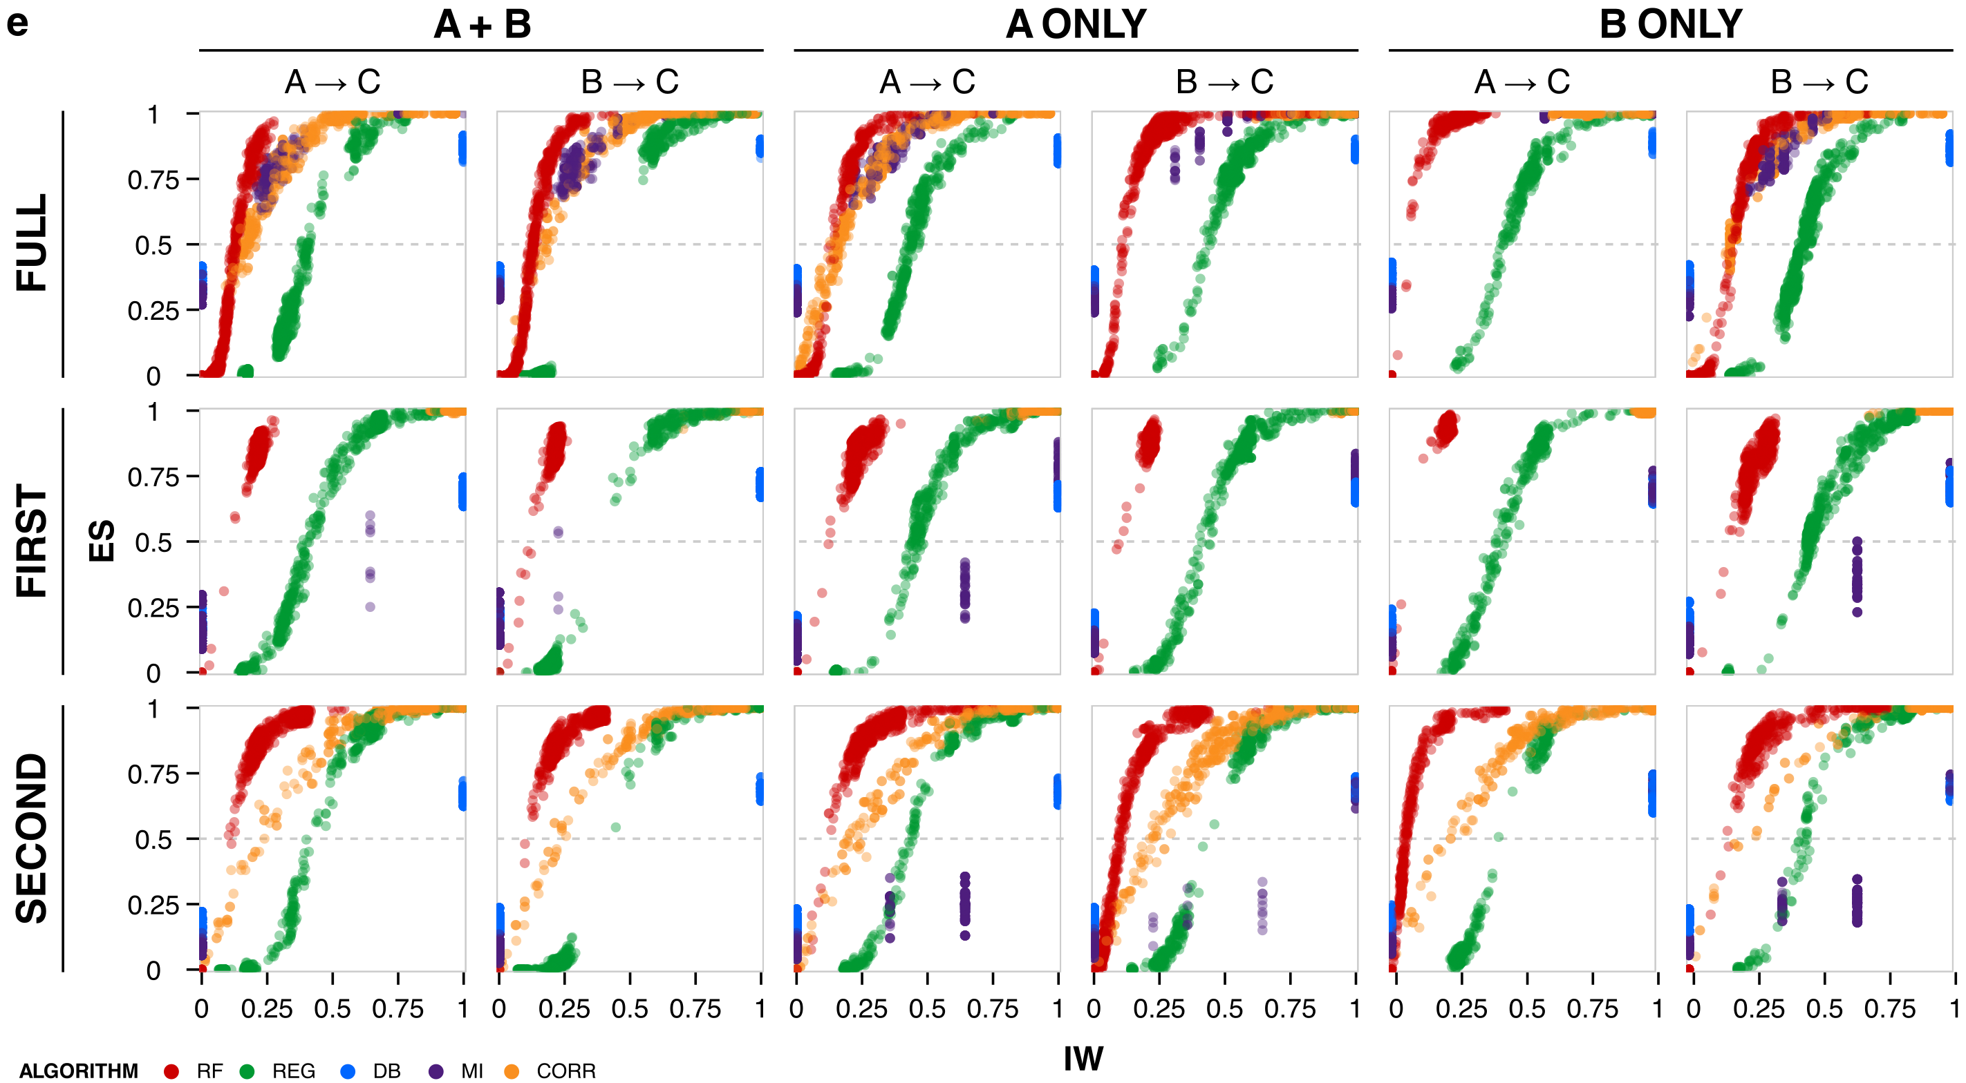

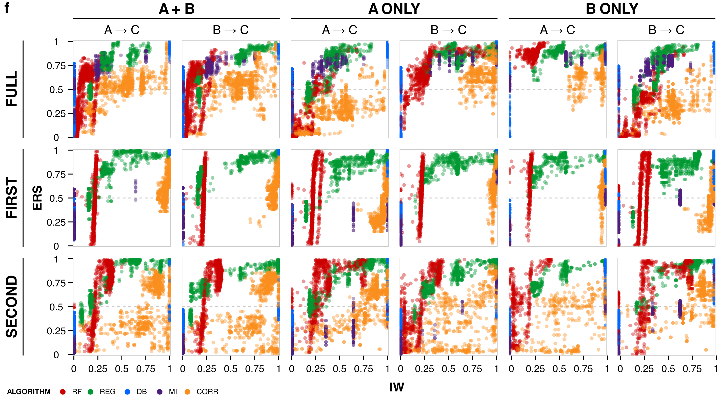

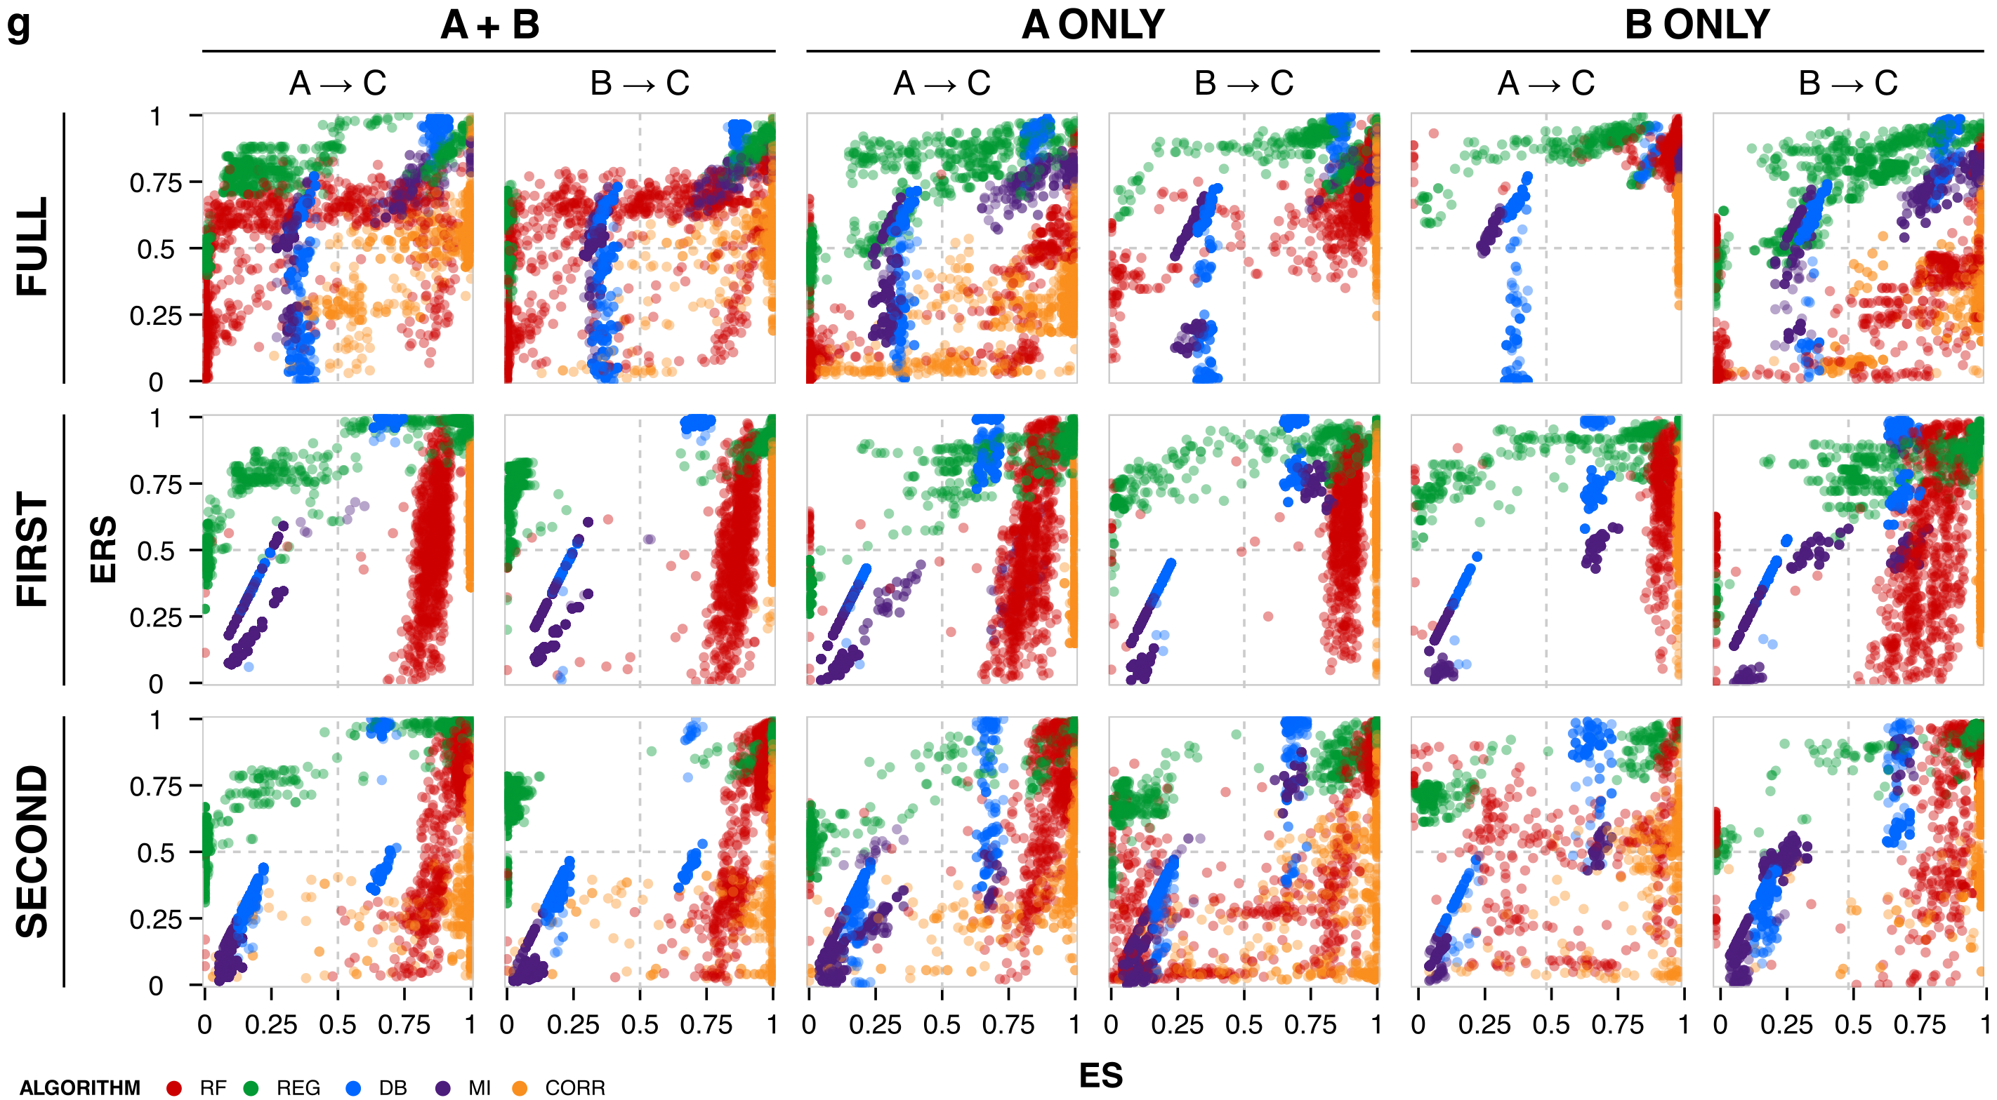

Figure S1 | Networks and performance metrics. Trajectories are shown for the parent nodes (A and B) and target node (C) from three-node motifs. (a) Formulations for different contexts. Initial values are steady-state solutions without stimulus. Parameters for the gate kinetics are set equal ($k_{A}=k_{B}=0.5$). The x-axis is time (0 to 20 a.u.), and the y-axis is node concentration (0 to 2 a.u.). For gene regulation, trajectories are shown for RNAs, not proteins. For kinase signaling, trajectories are shown for active, not inactive, kinases. (b–d) For the context-agnostic case, stimulus is applied to (b) node A only, (c) node B only, and (d) both A and B. Values for the gate kinetic parameters ($k_{A}$ and $k_{B}$) are 0.05, 0.5, and 5; values for other parameters are held constant ($k=0.5$). (e–g) Comparisons of inference outcomes for (e) IW vs. ES, (f) IW vs. ERS, and (g) ES vs. ERS for each stimulus condition (A and B, A only, B only), time interval (full, first half, second half), and gate edge (AC, BC). Algorithms are color-coded.

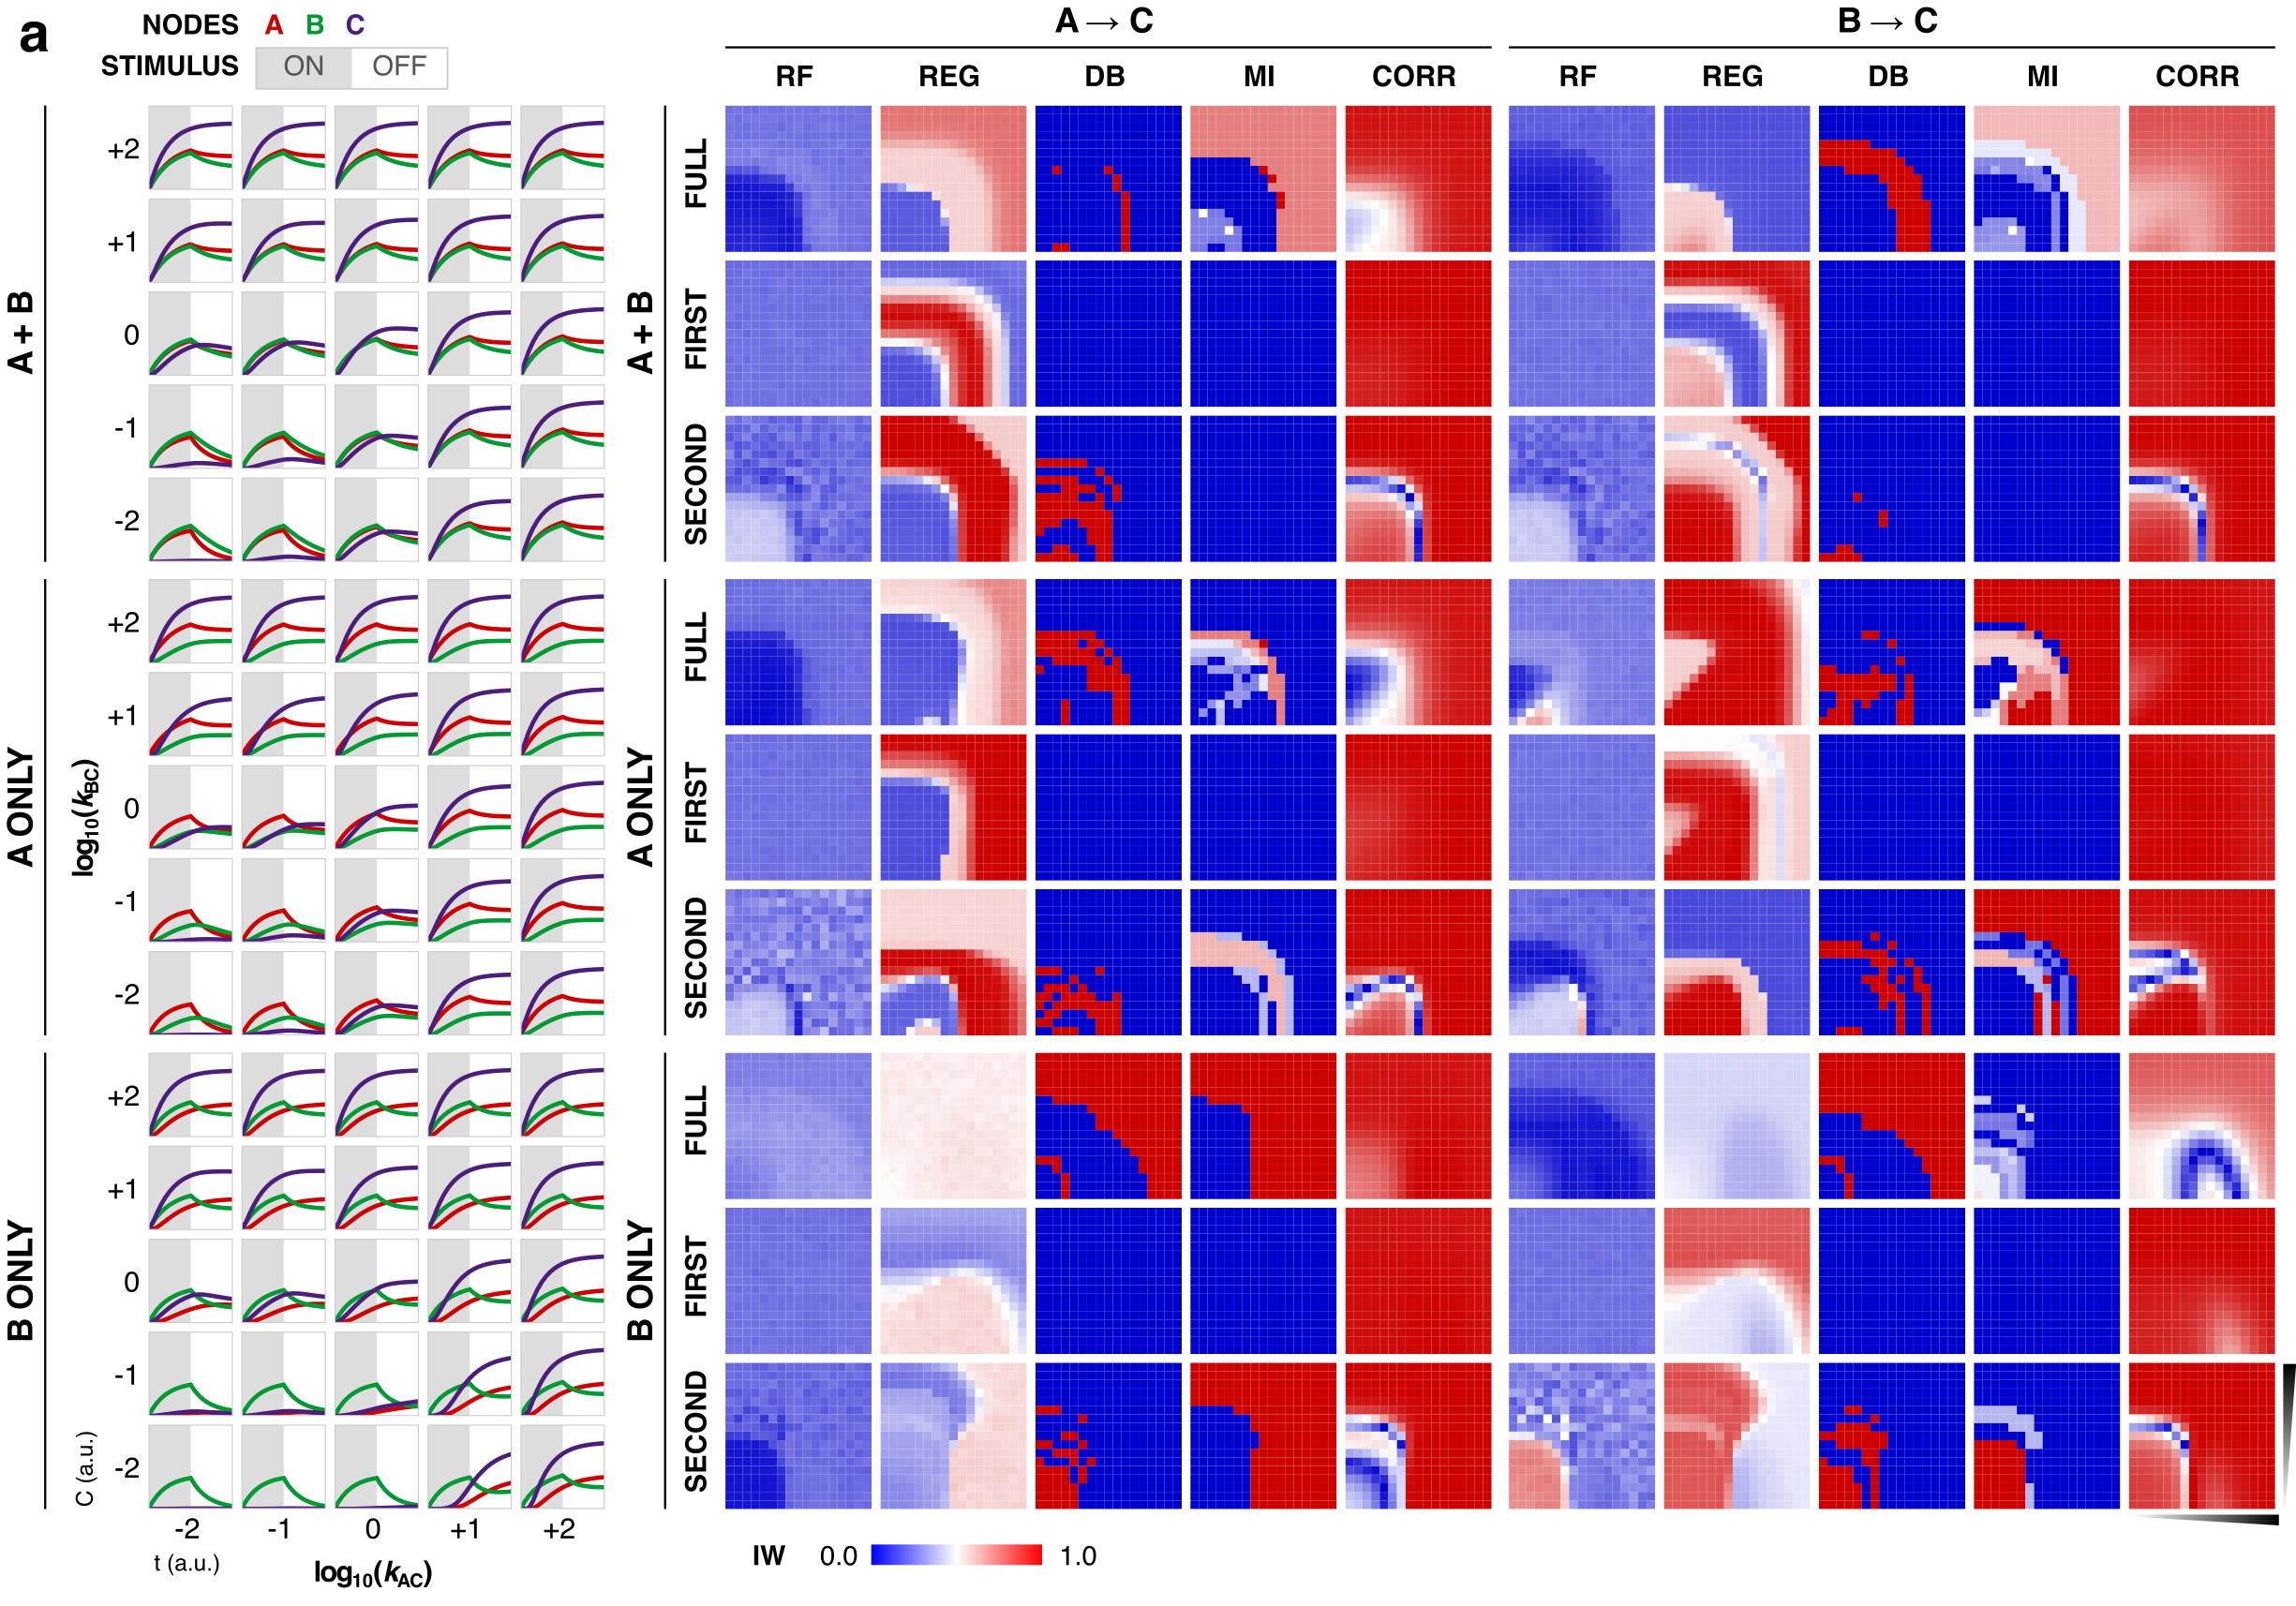
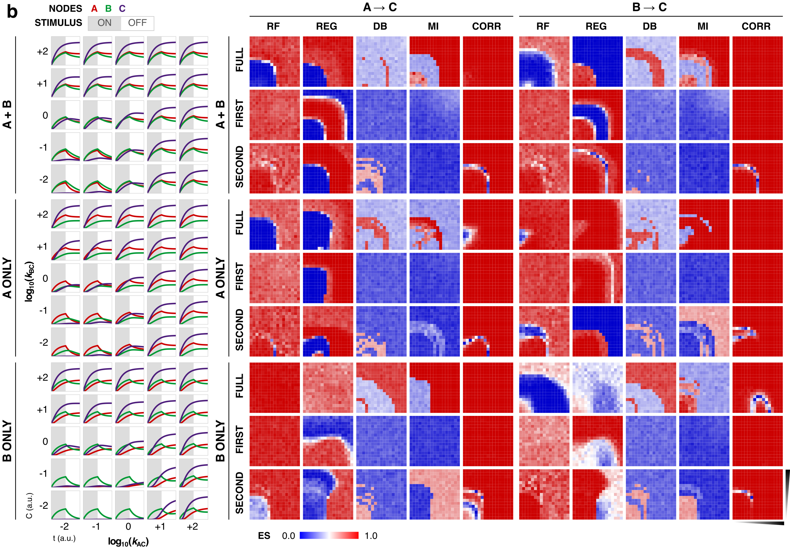
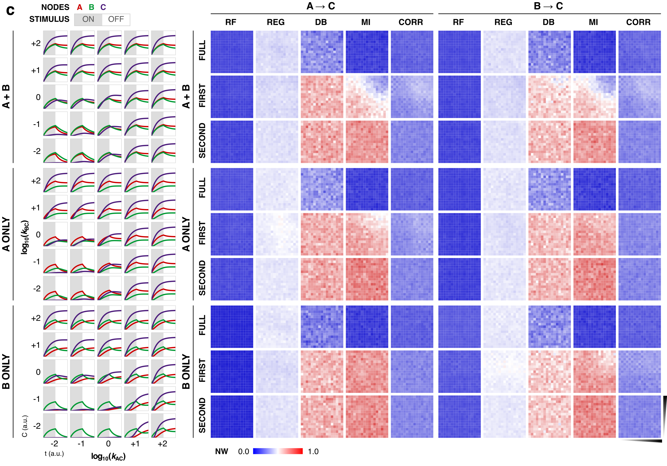
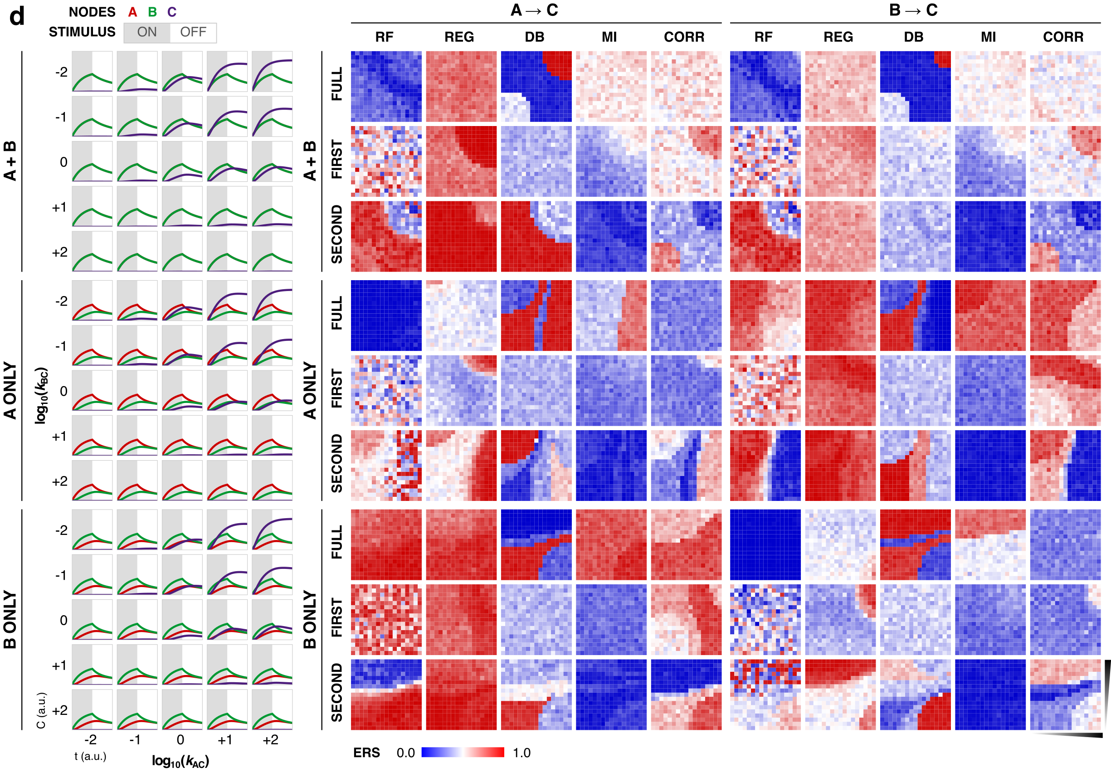
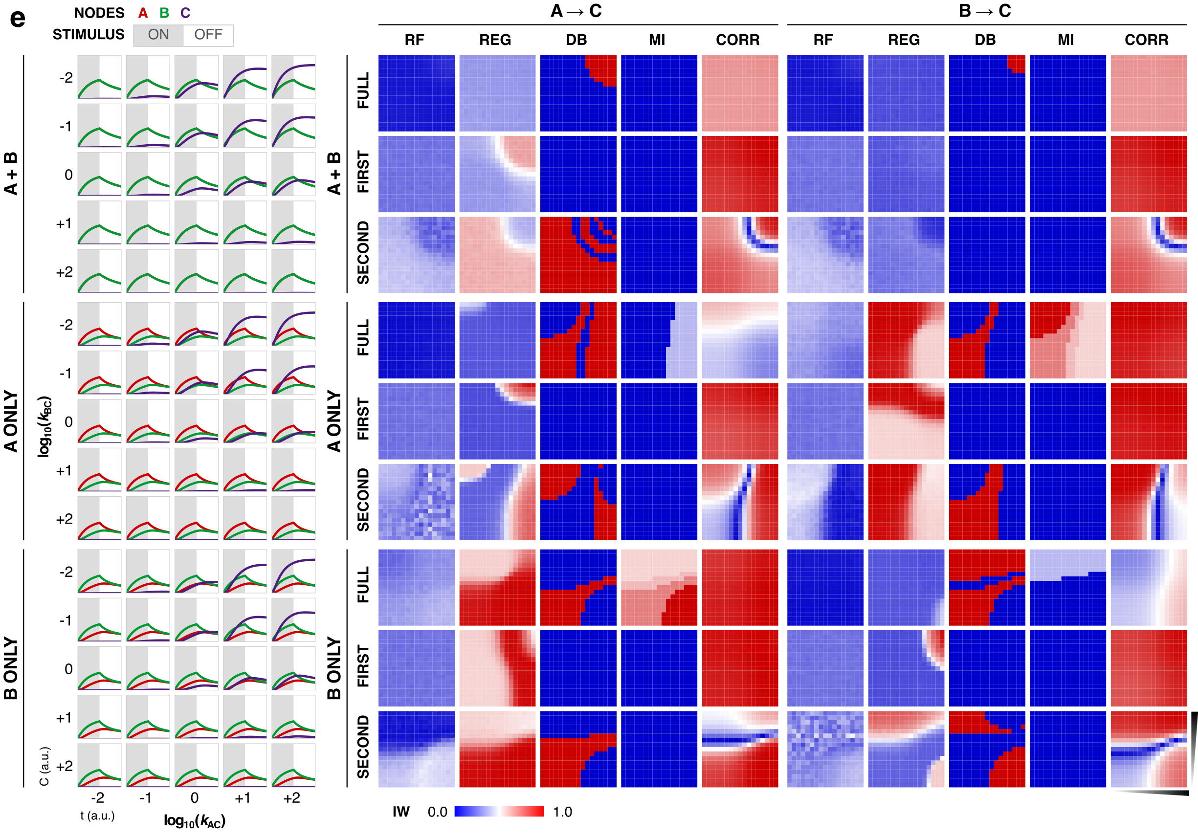

Figure S2 | Network dynamics and inference outcomes. Kinetic landscapes. Inference outcomes for FFFB motif with an OR gate as (a) inferred weight, (b) ES, and (c) null weight. Panels show outcomes across the kinetic parameter landscape for each algorithm, edge, stimulus (A and B, A only, B only), and time interval (full, first, and second). Inference outcomes for UFB motif with an AND gate as (d) ERS and (e) inferred weight.

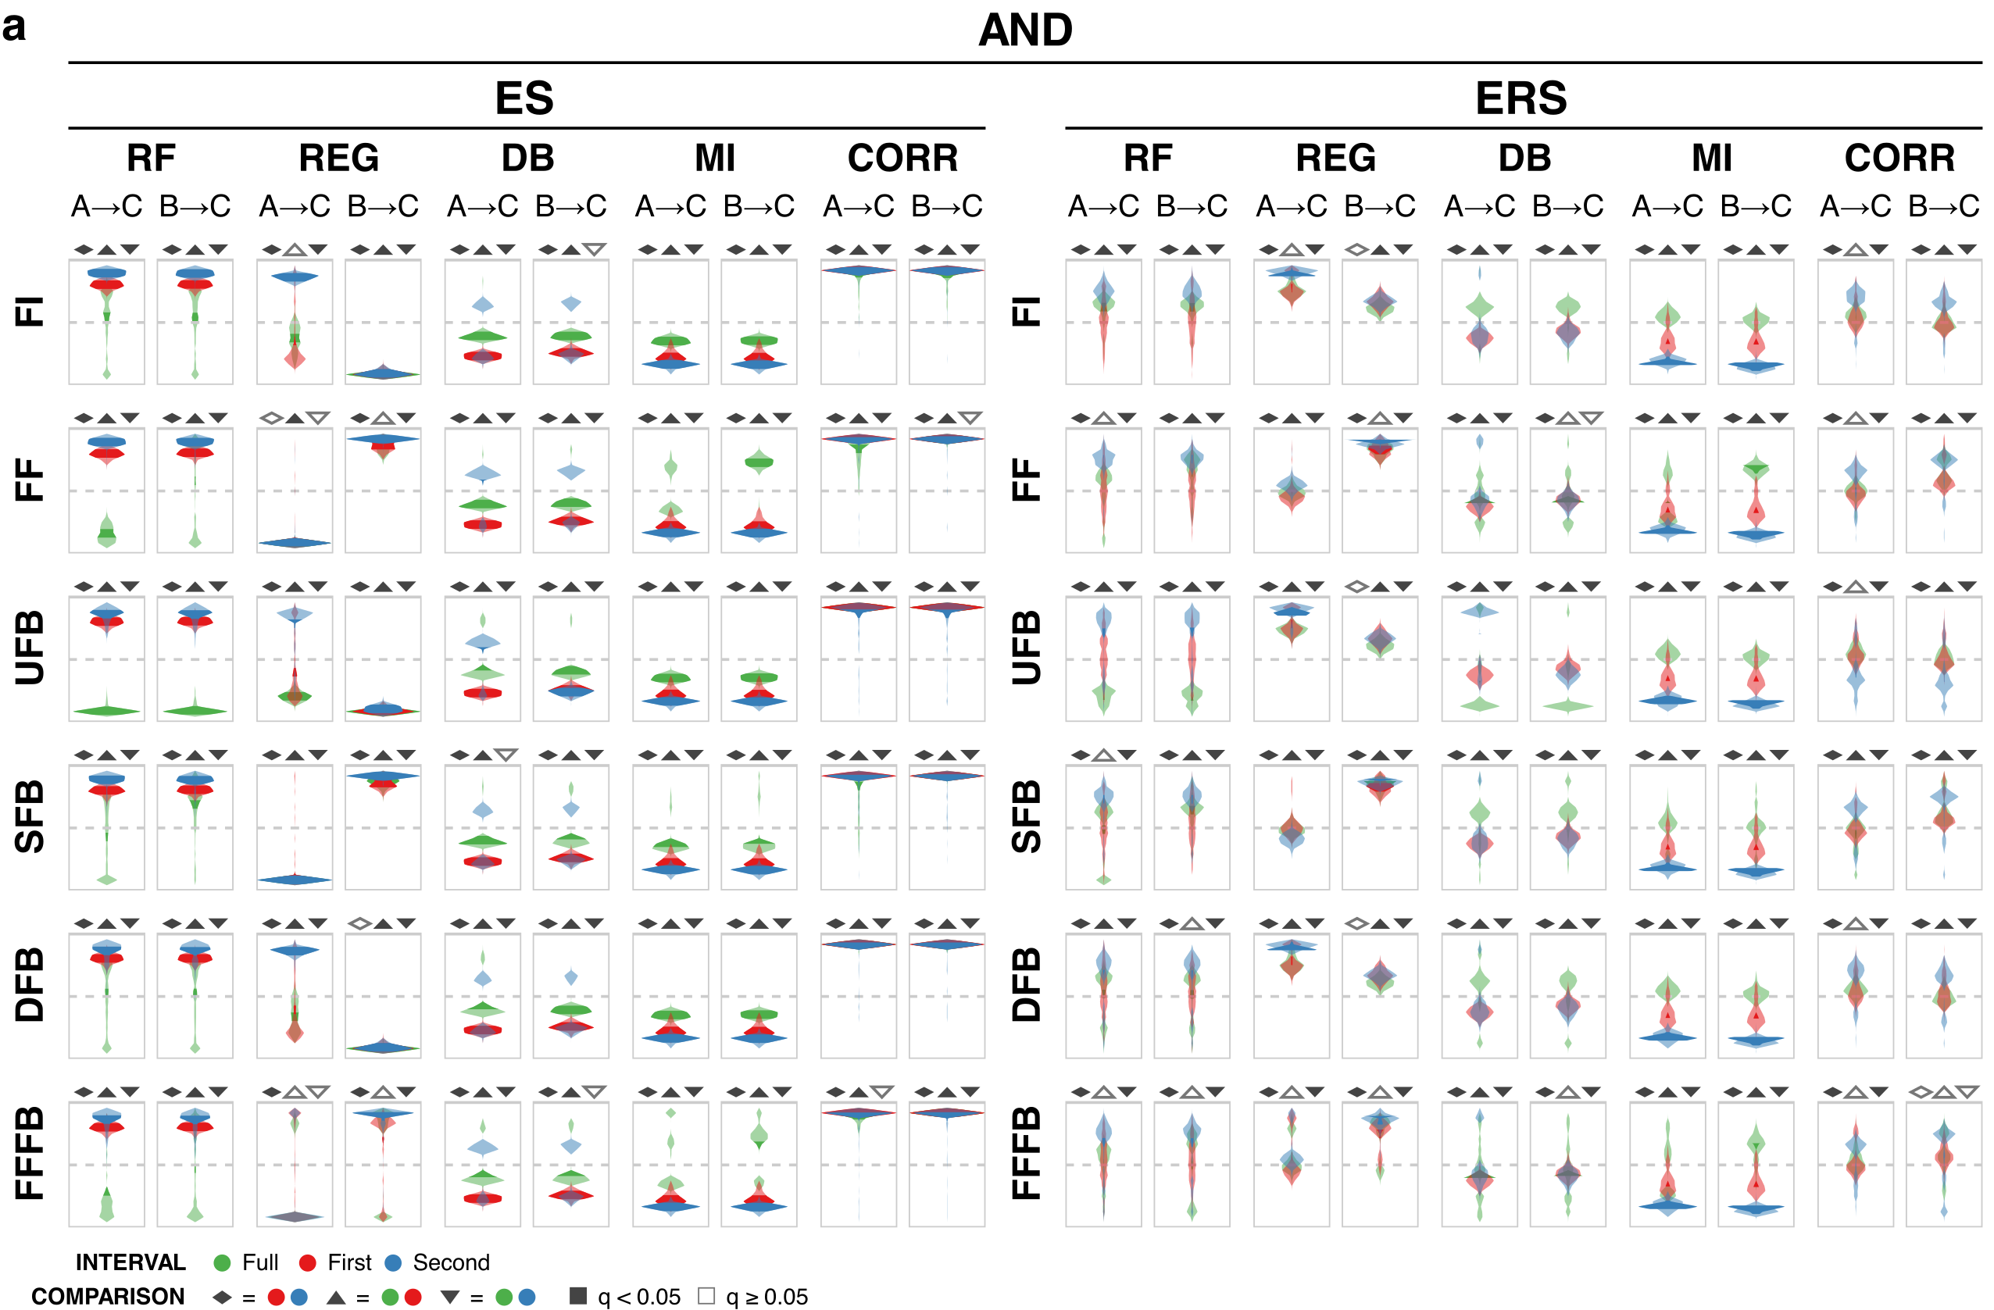

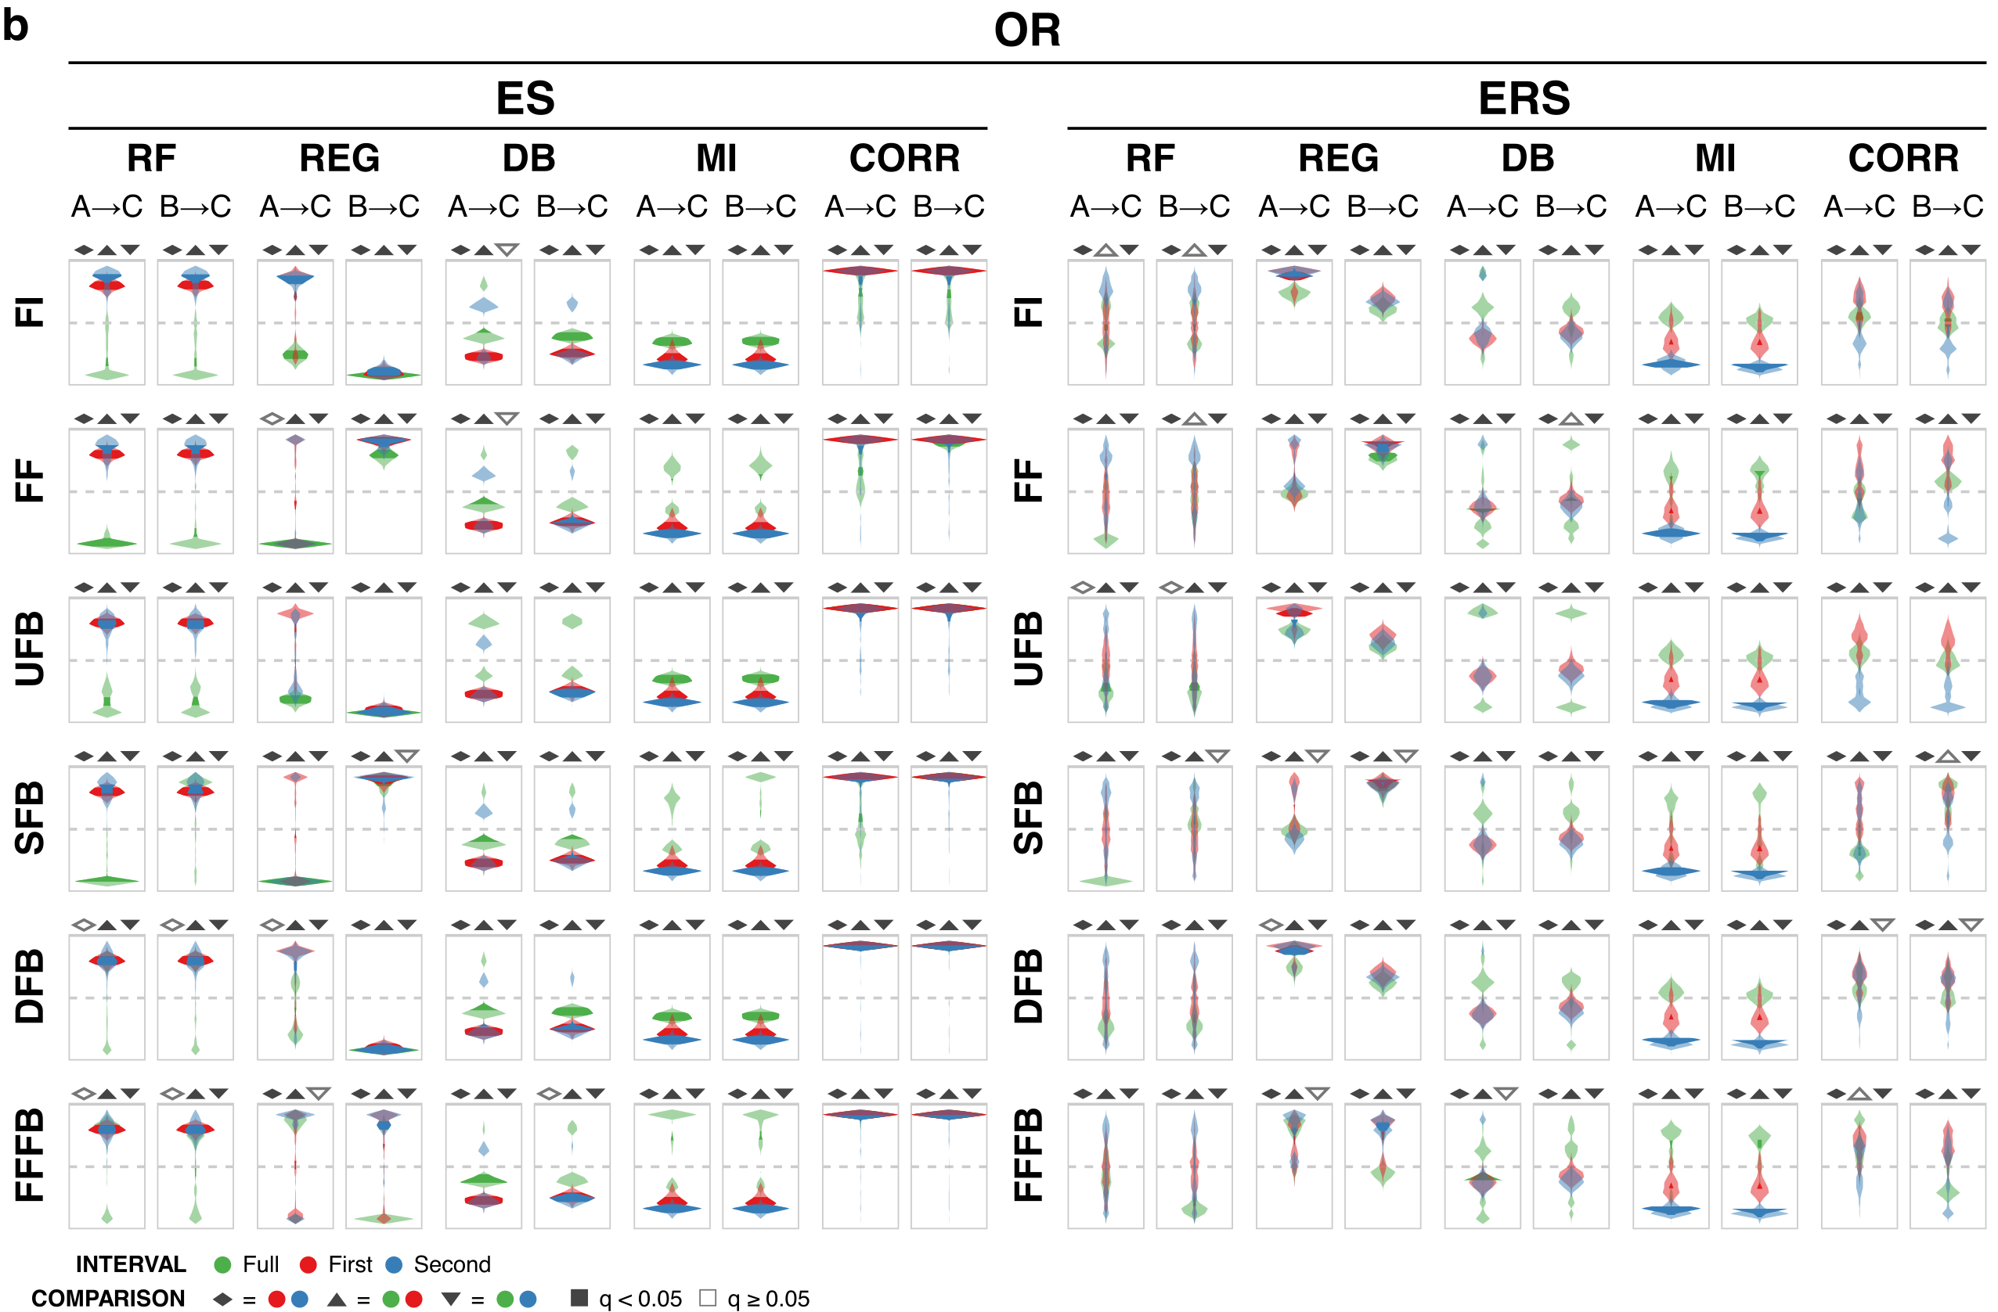
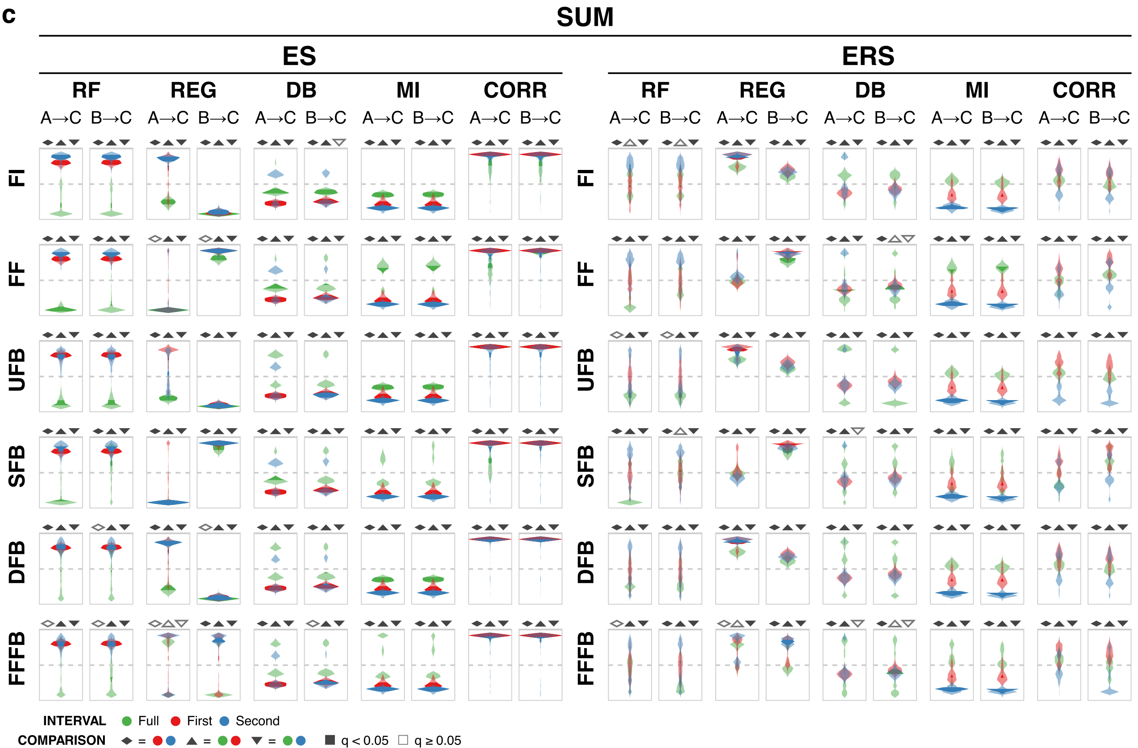

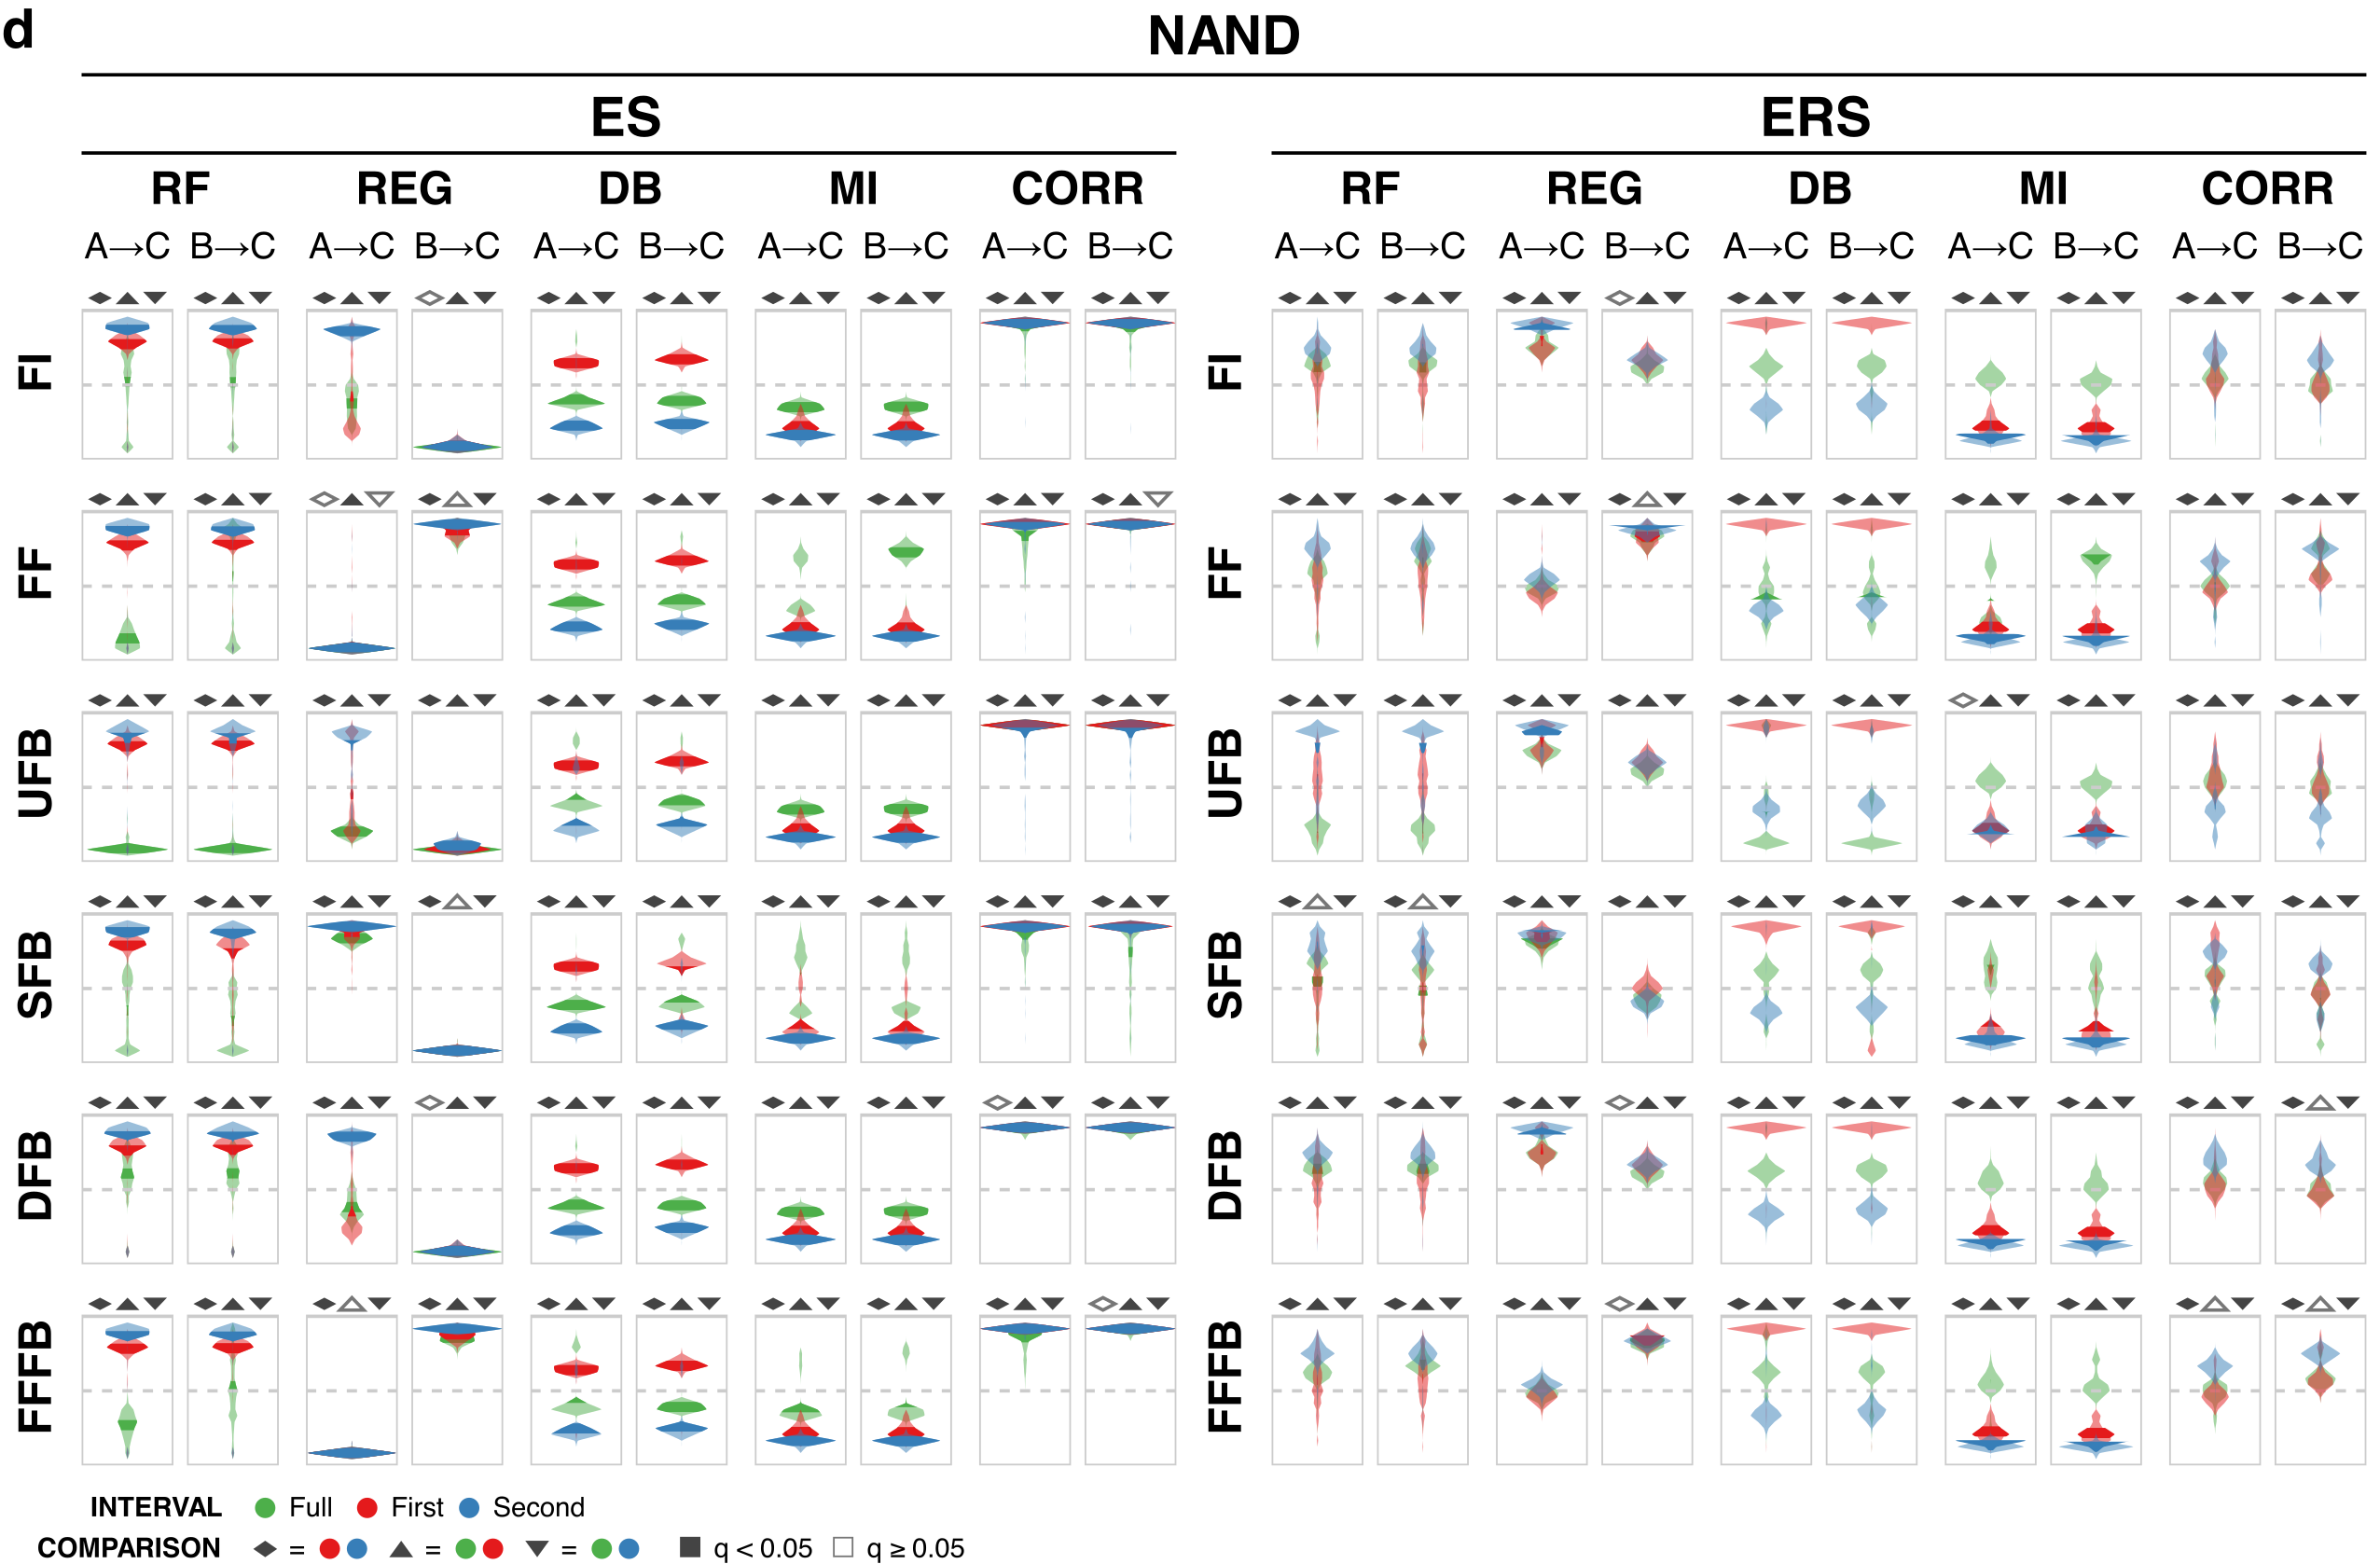
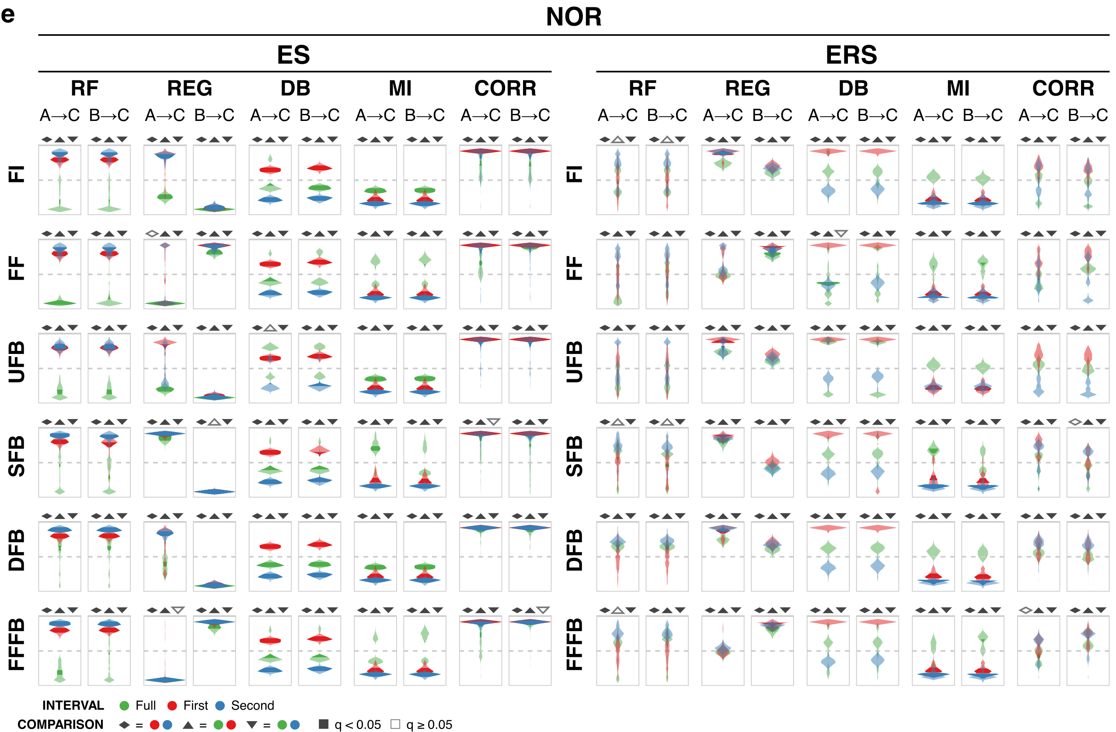

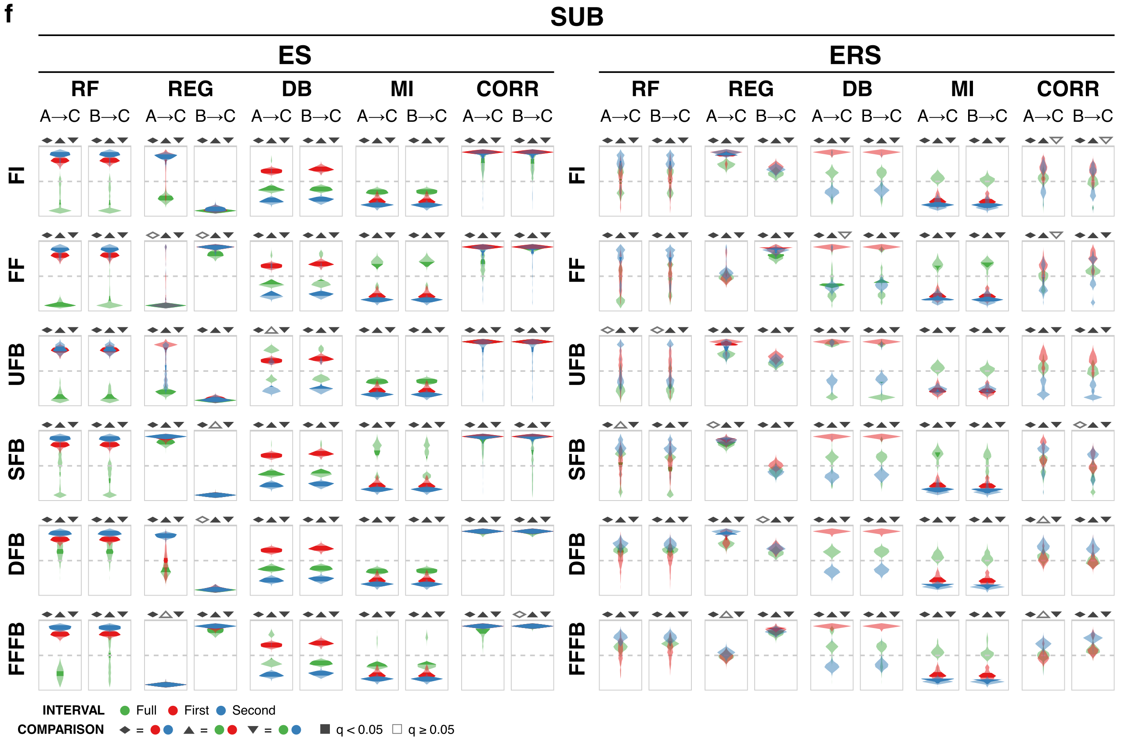
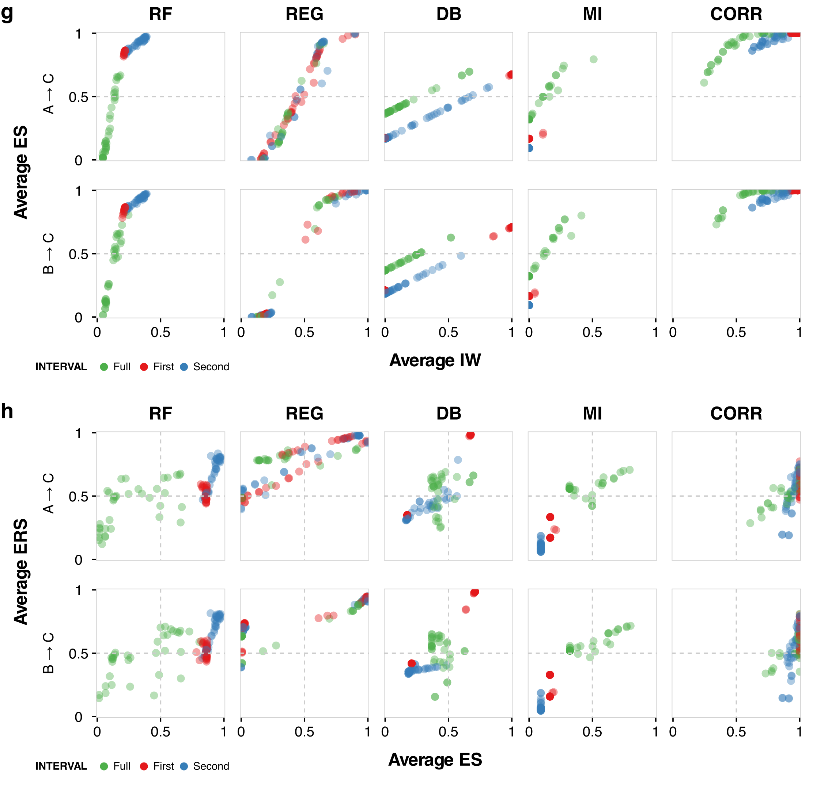

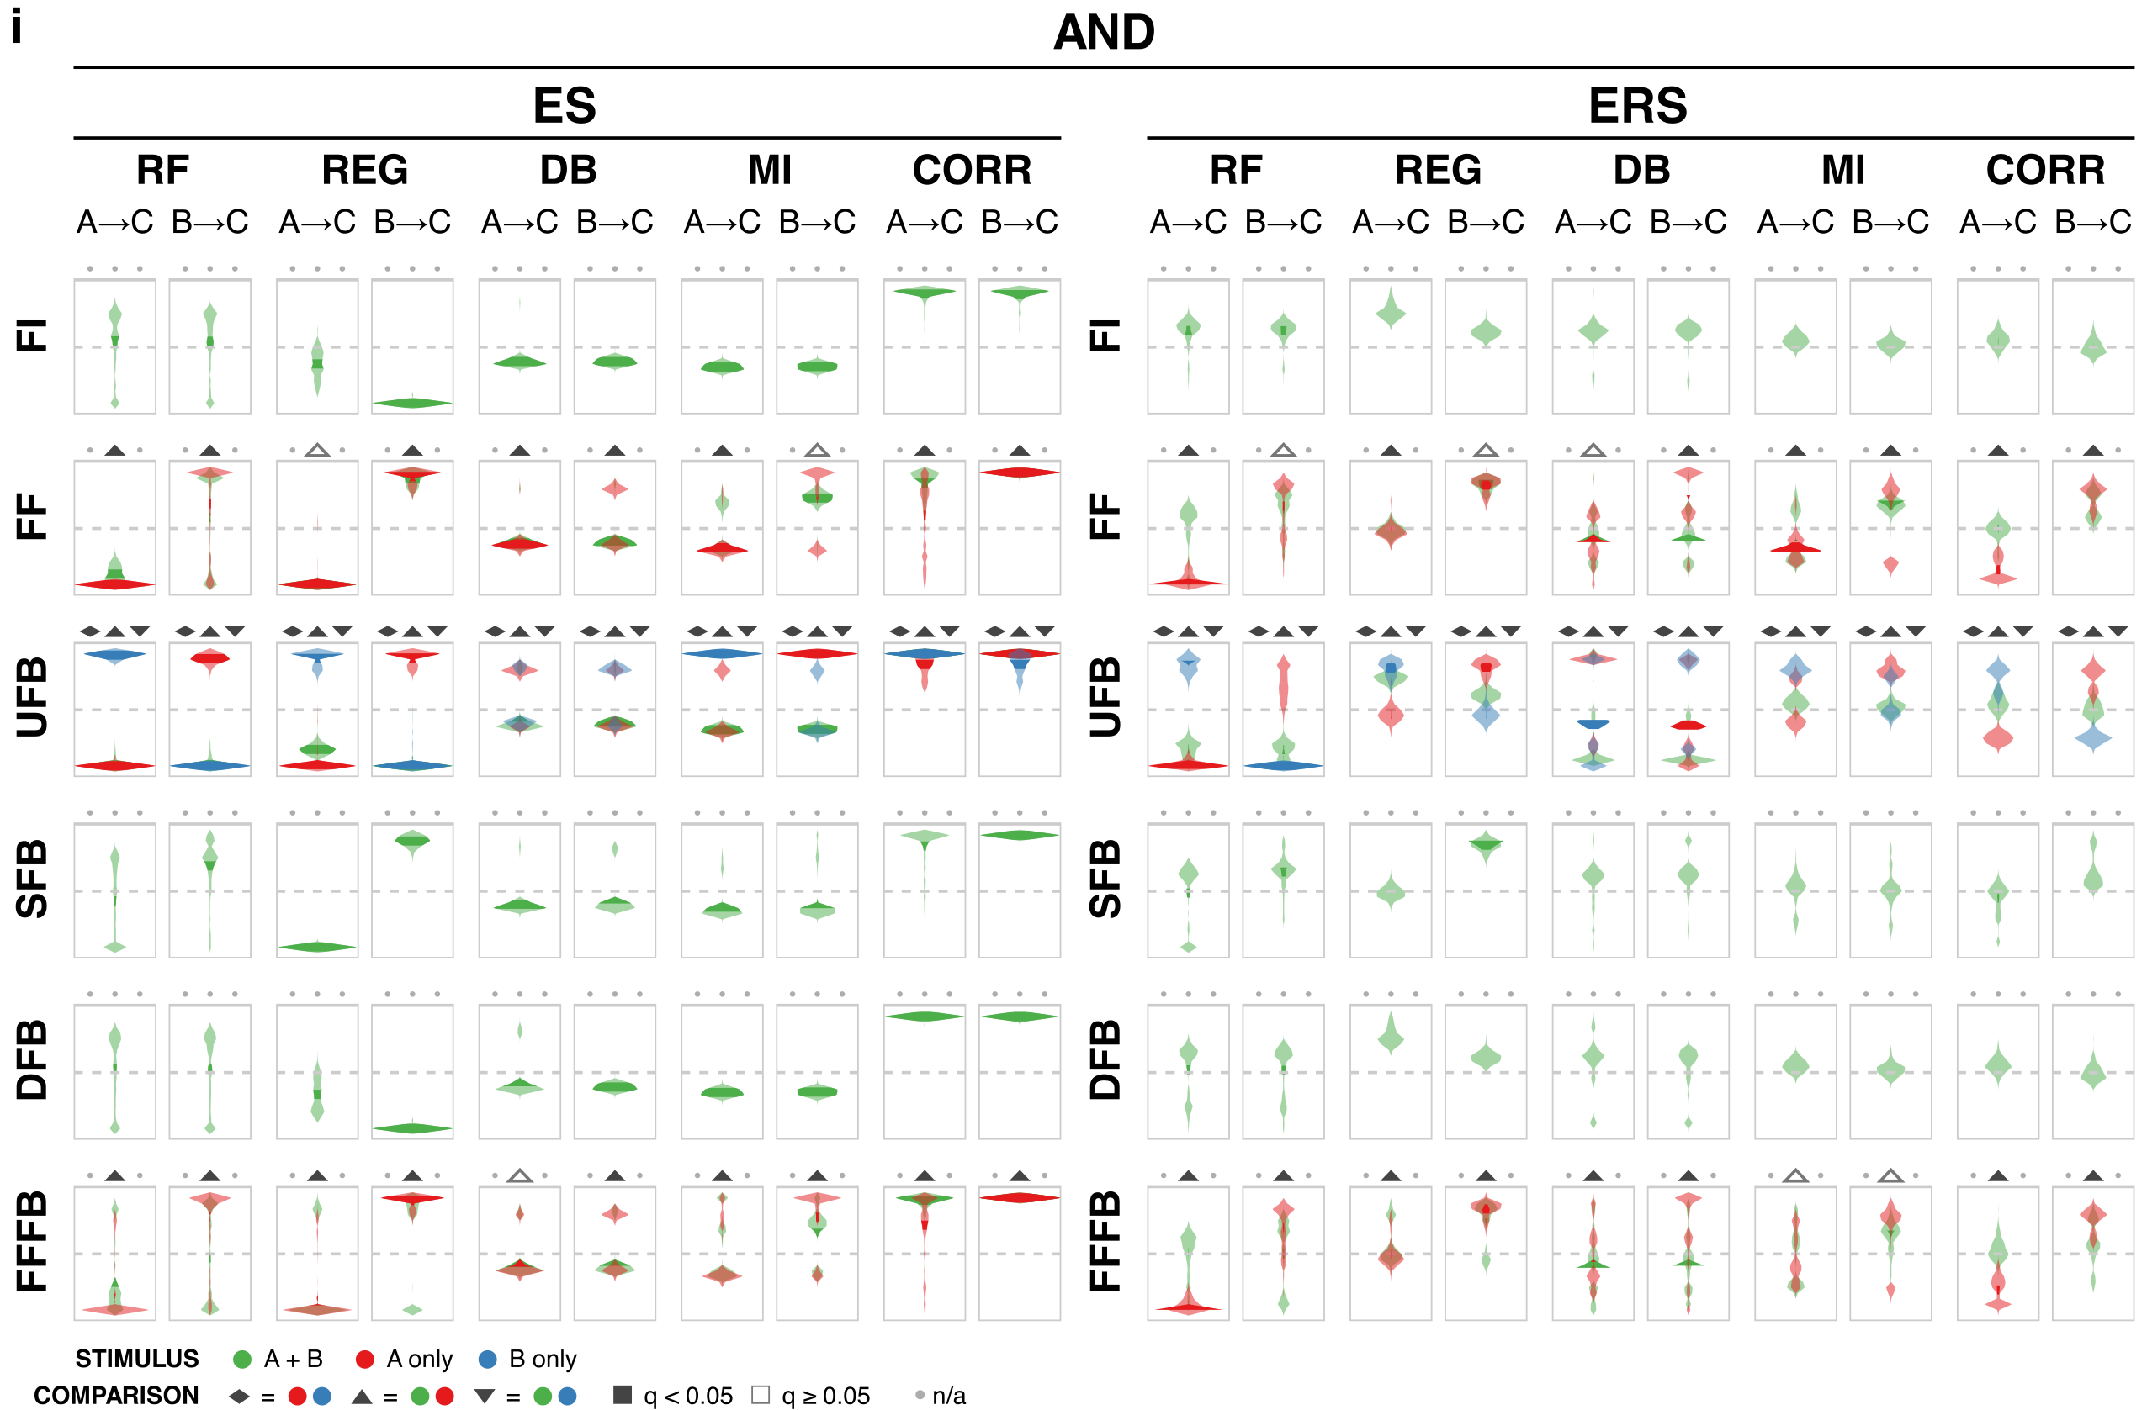

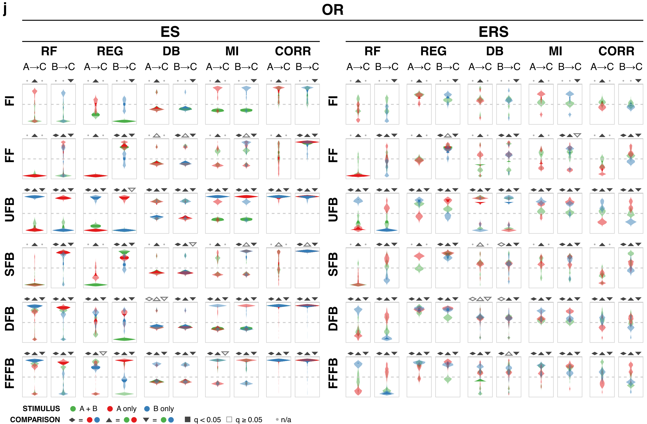
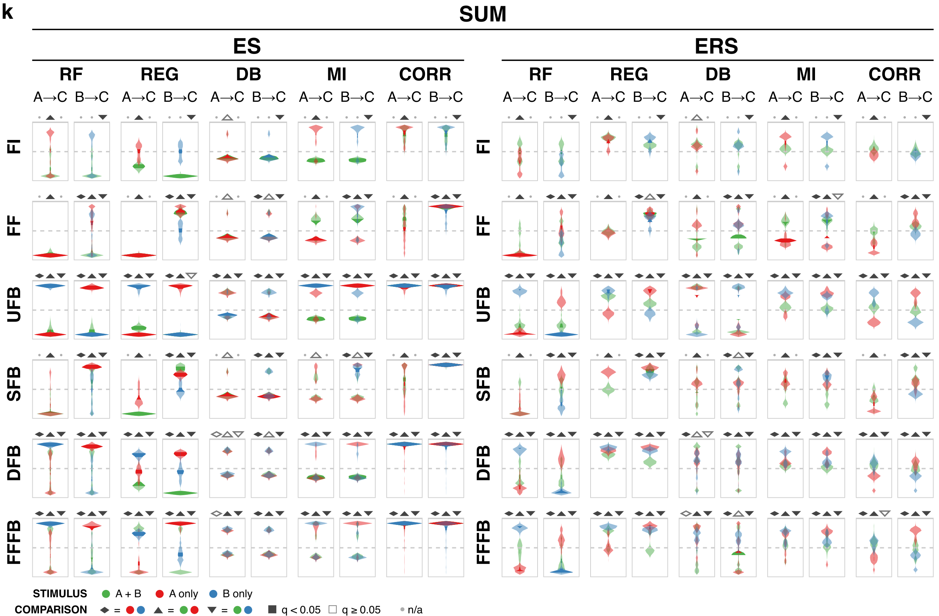

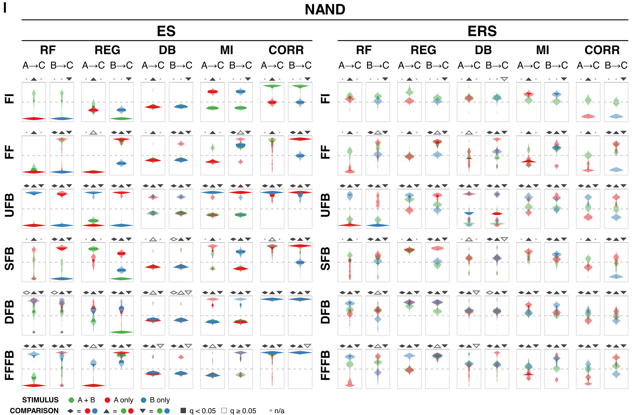
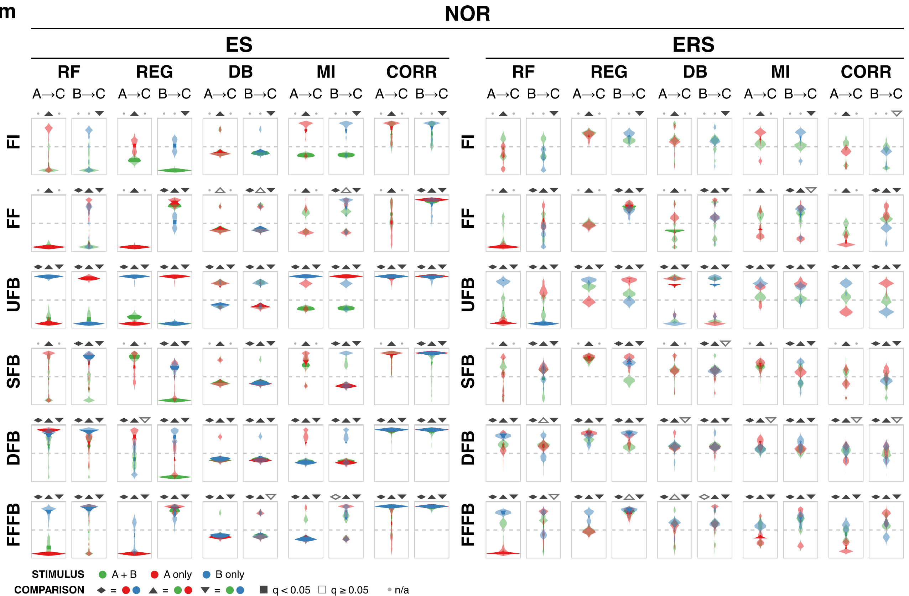

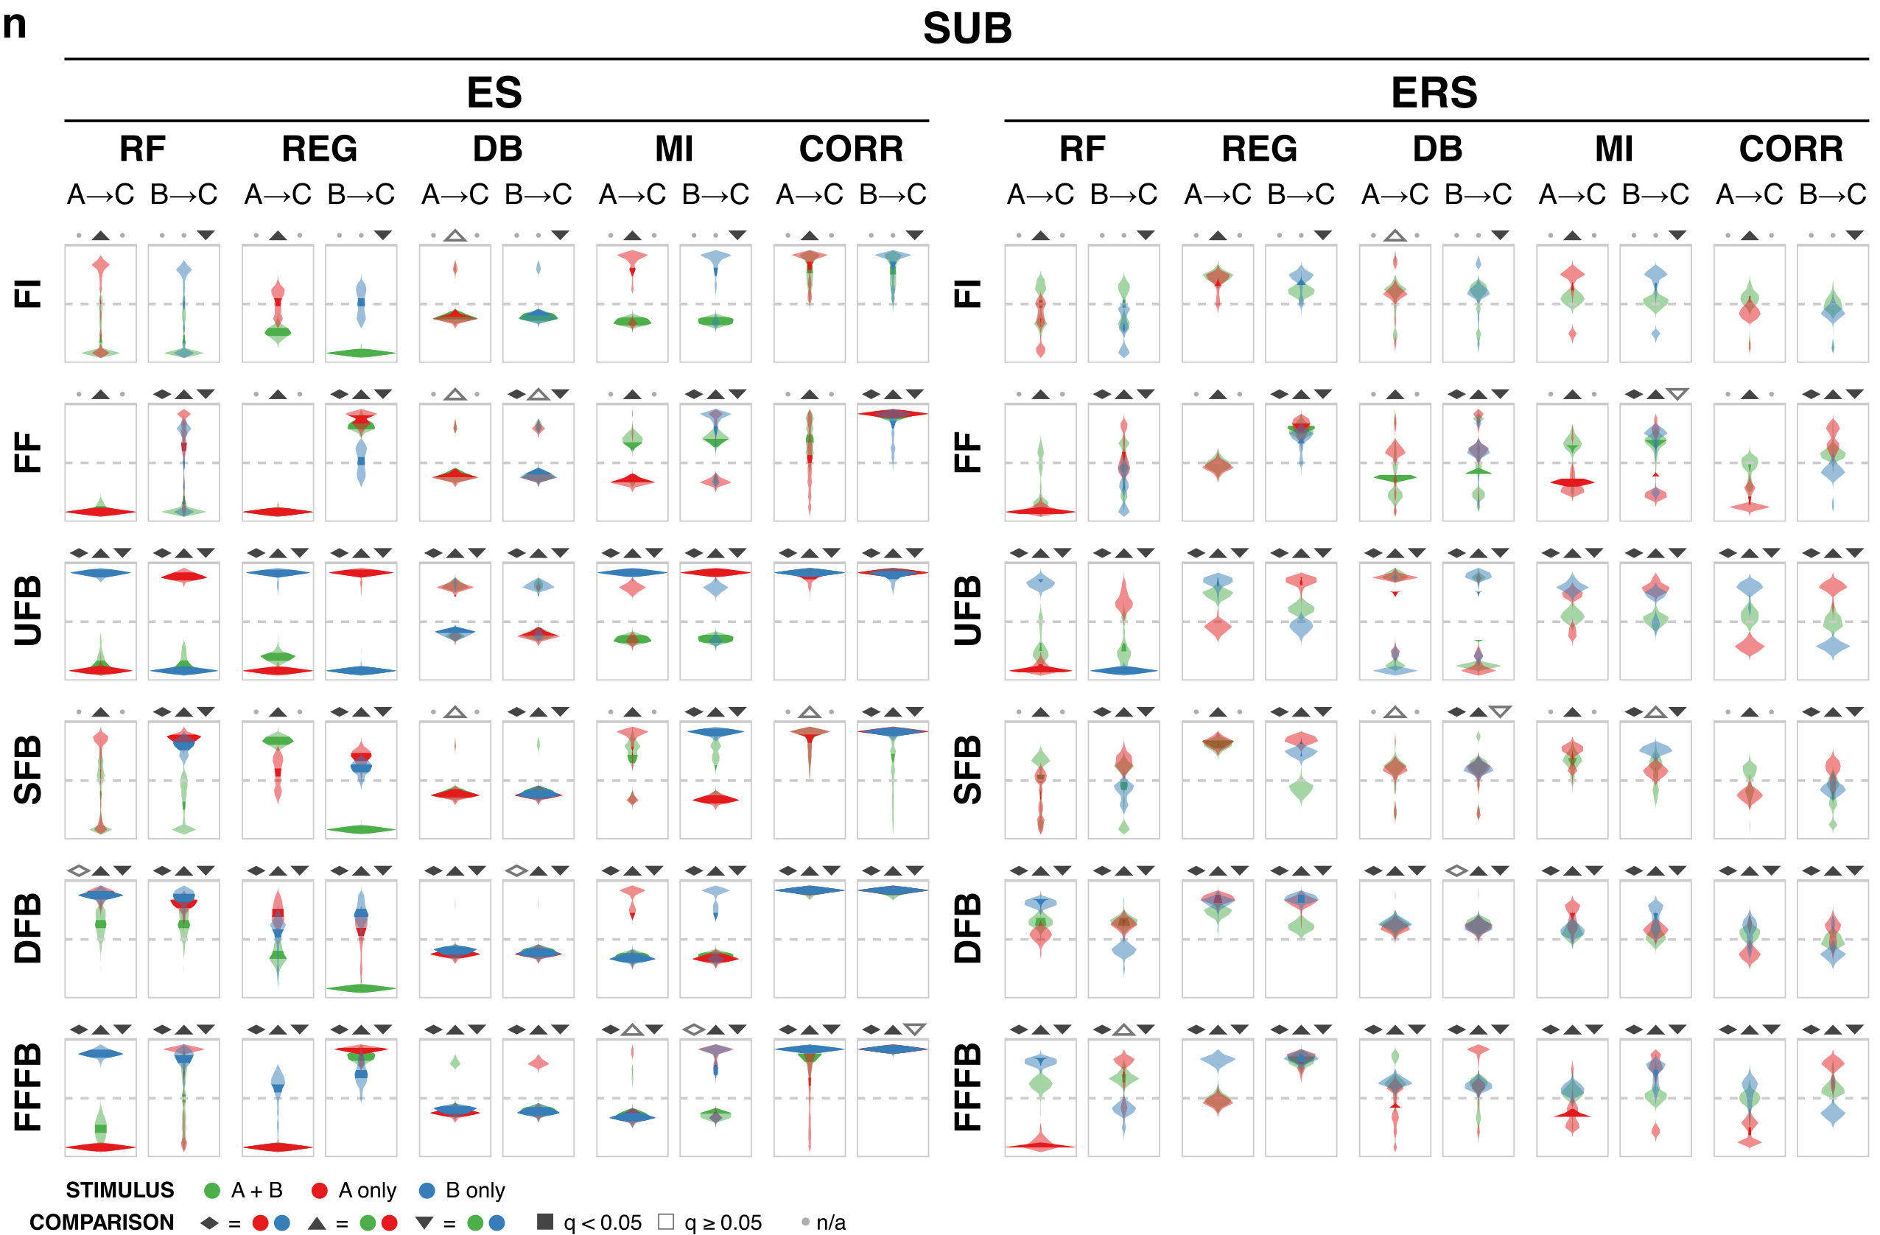
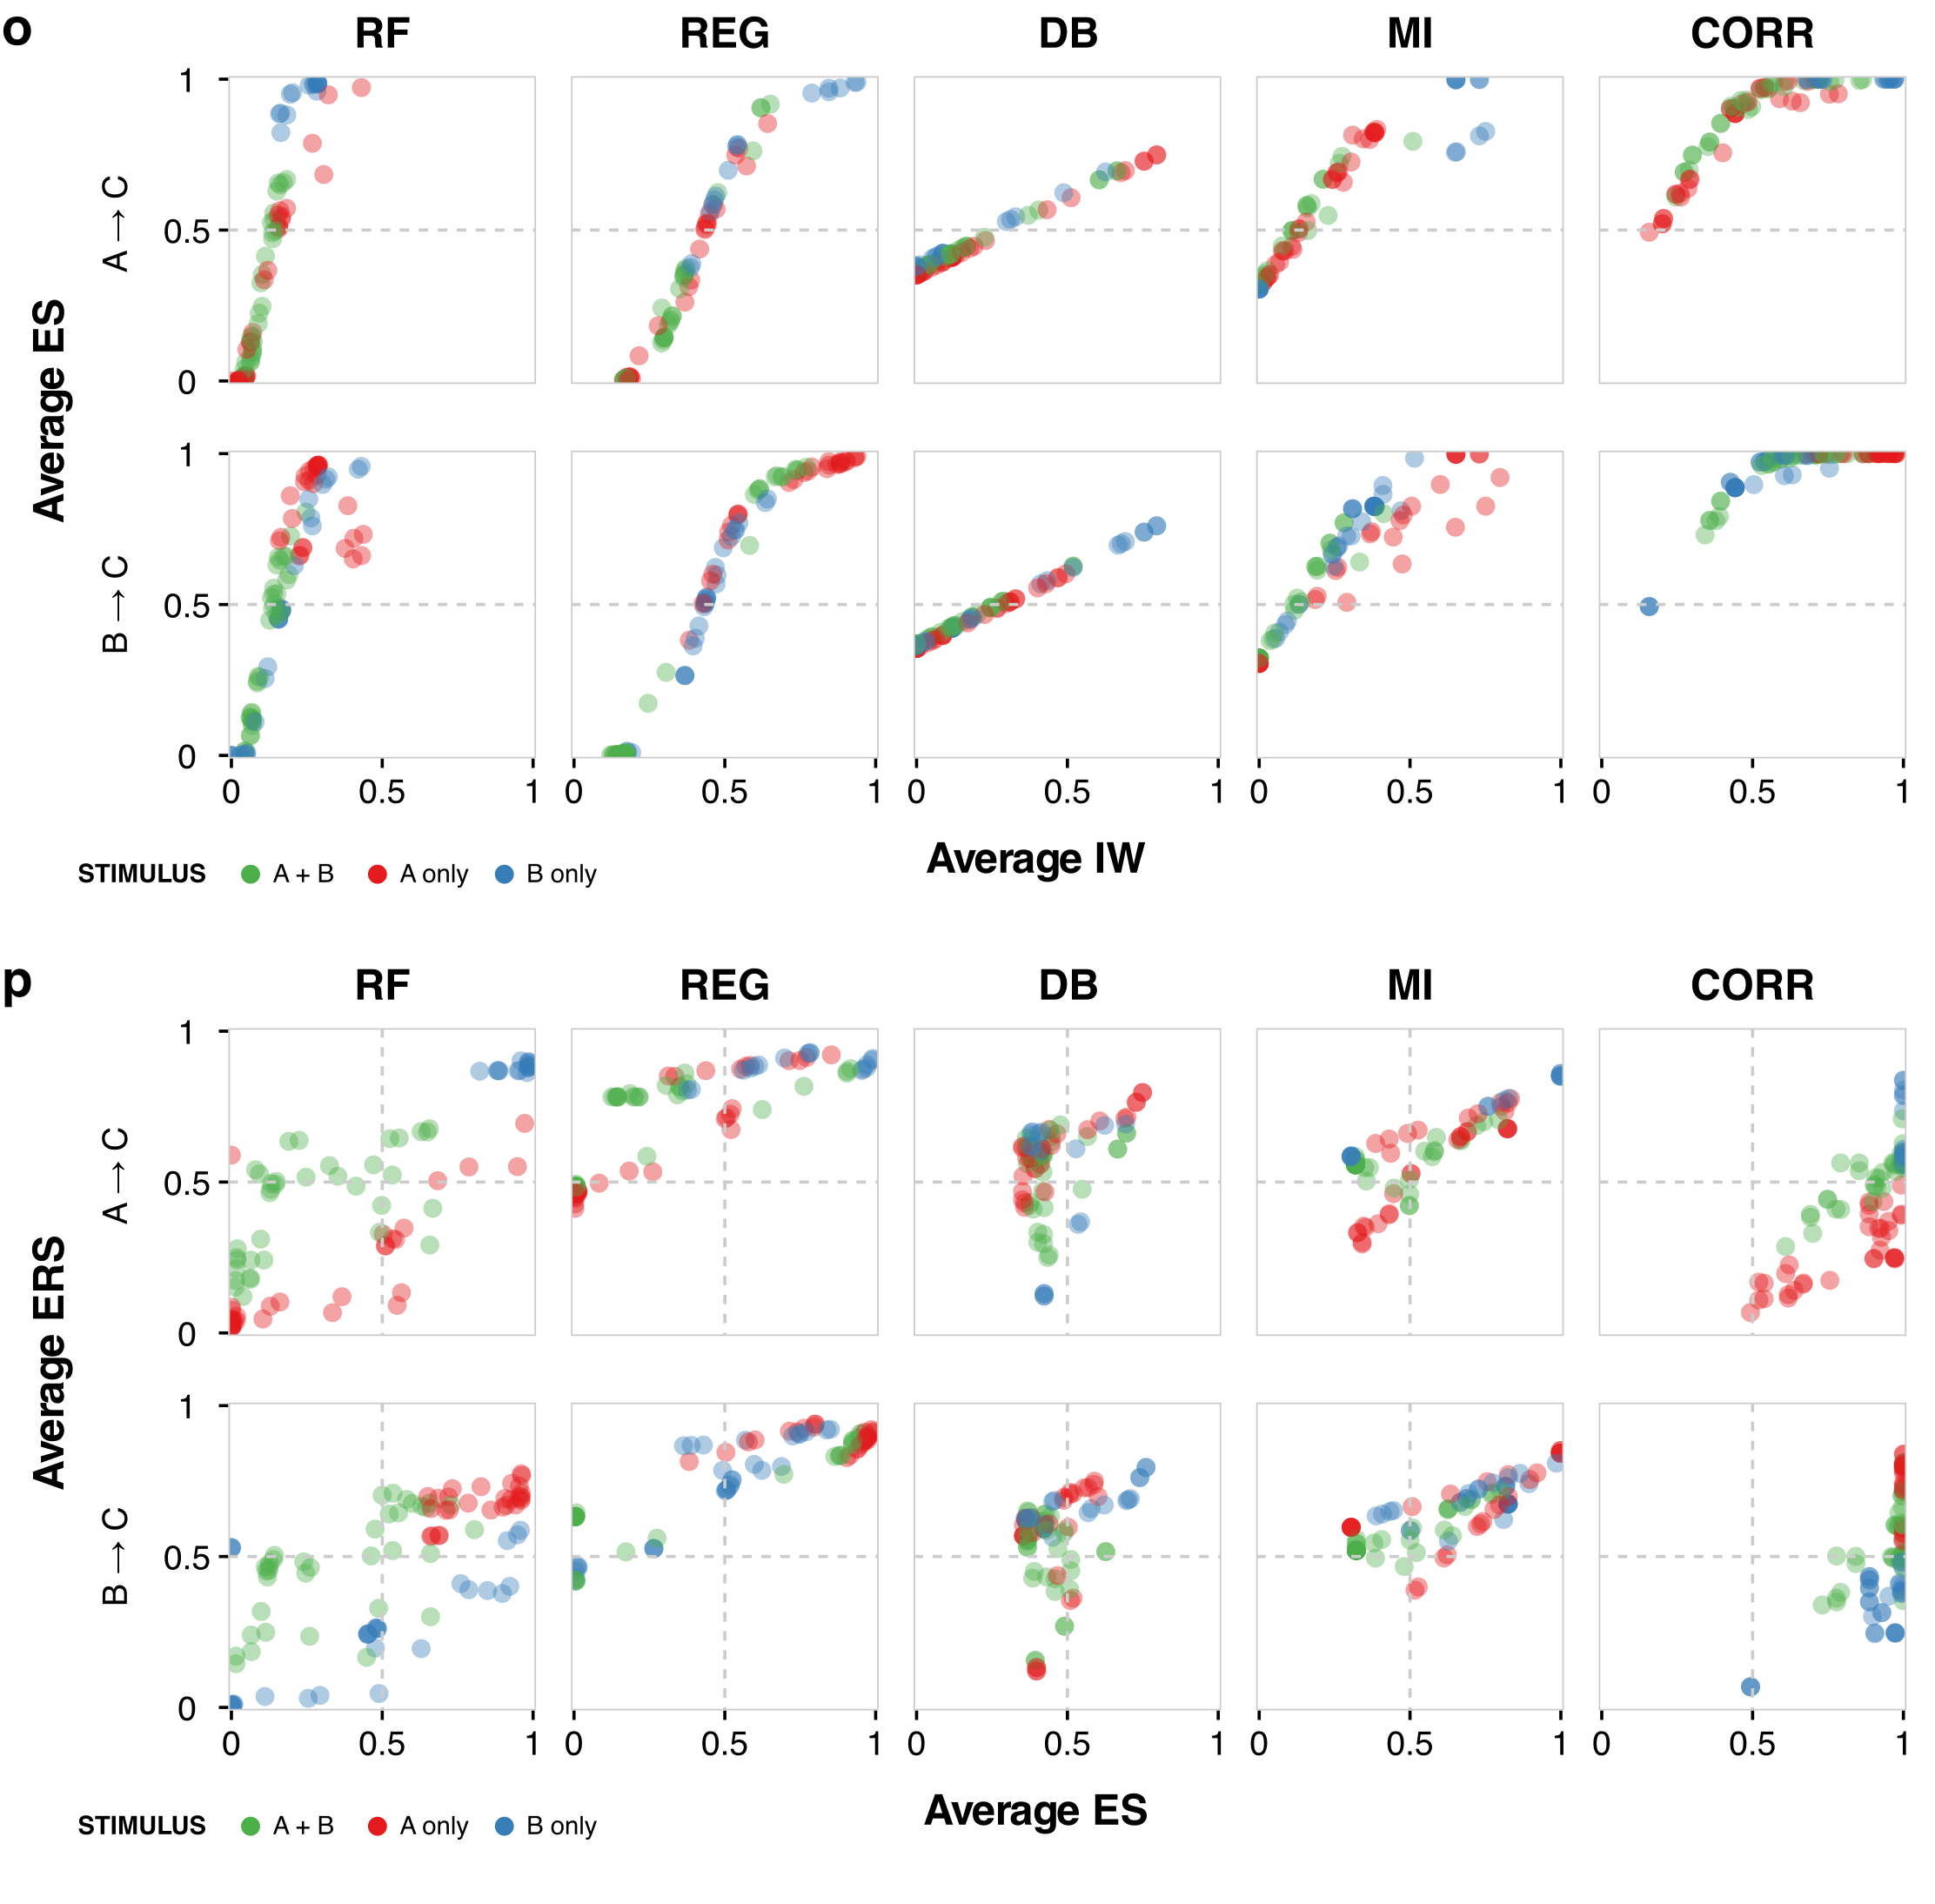

Figure S3 | Time interval and stimulus effects. (a–h) Time interval effects. Distribution of ES and ERS for (a) AND, (b) OR, (c) SUM, (d) NAND, (e) NOR, and (f) SUB logic gates across all six motifs and five algorithms for edge AC and edge BC by time interval. Pairwise hypothesis testing was performed using Welch’s t-test, which assumes the underlying distributions can have unequal variances. Multiple hypothesis correction was performed using the Benjamini-Hochberg procedure for all tests within a given algorithm and edge to obtain q values, the multiple hypothesis corrected p-value. Distribution of average ES compared to (g) average IW and (h) average ERS across all six motifs and all six gates. (i–p) Stimulus effects. Distribution of ES and ERS for (i) AND, (j) OR, (k) SUM, (l) NAND, (m) NOR, and (n) SUB gates across the six motifs and five algorithms for edges AC and BC, by stimulus condition. Pairwise hypothesis testing was conducted using Welch’s t-test, which assumes the underlying distributions can have unequal variances. Multiple hypothesis correction was conducted using the Benjamini-Hochberg procedure for all tests within a given algorithm and edge to obtain q values, the multiple hypothesis corrected p-value. Joint distribution of average ES with (o) average IW and (p) average ERS across all six motifs and all six gates.

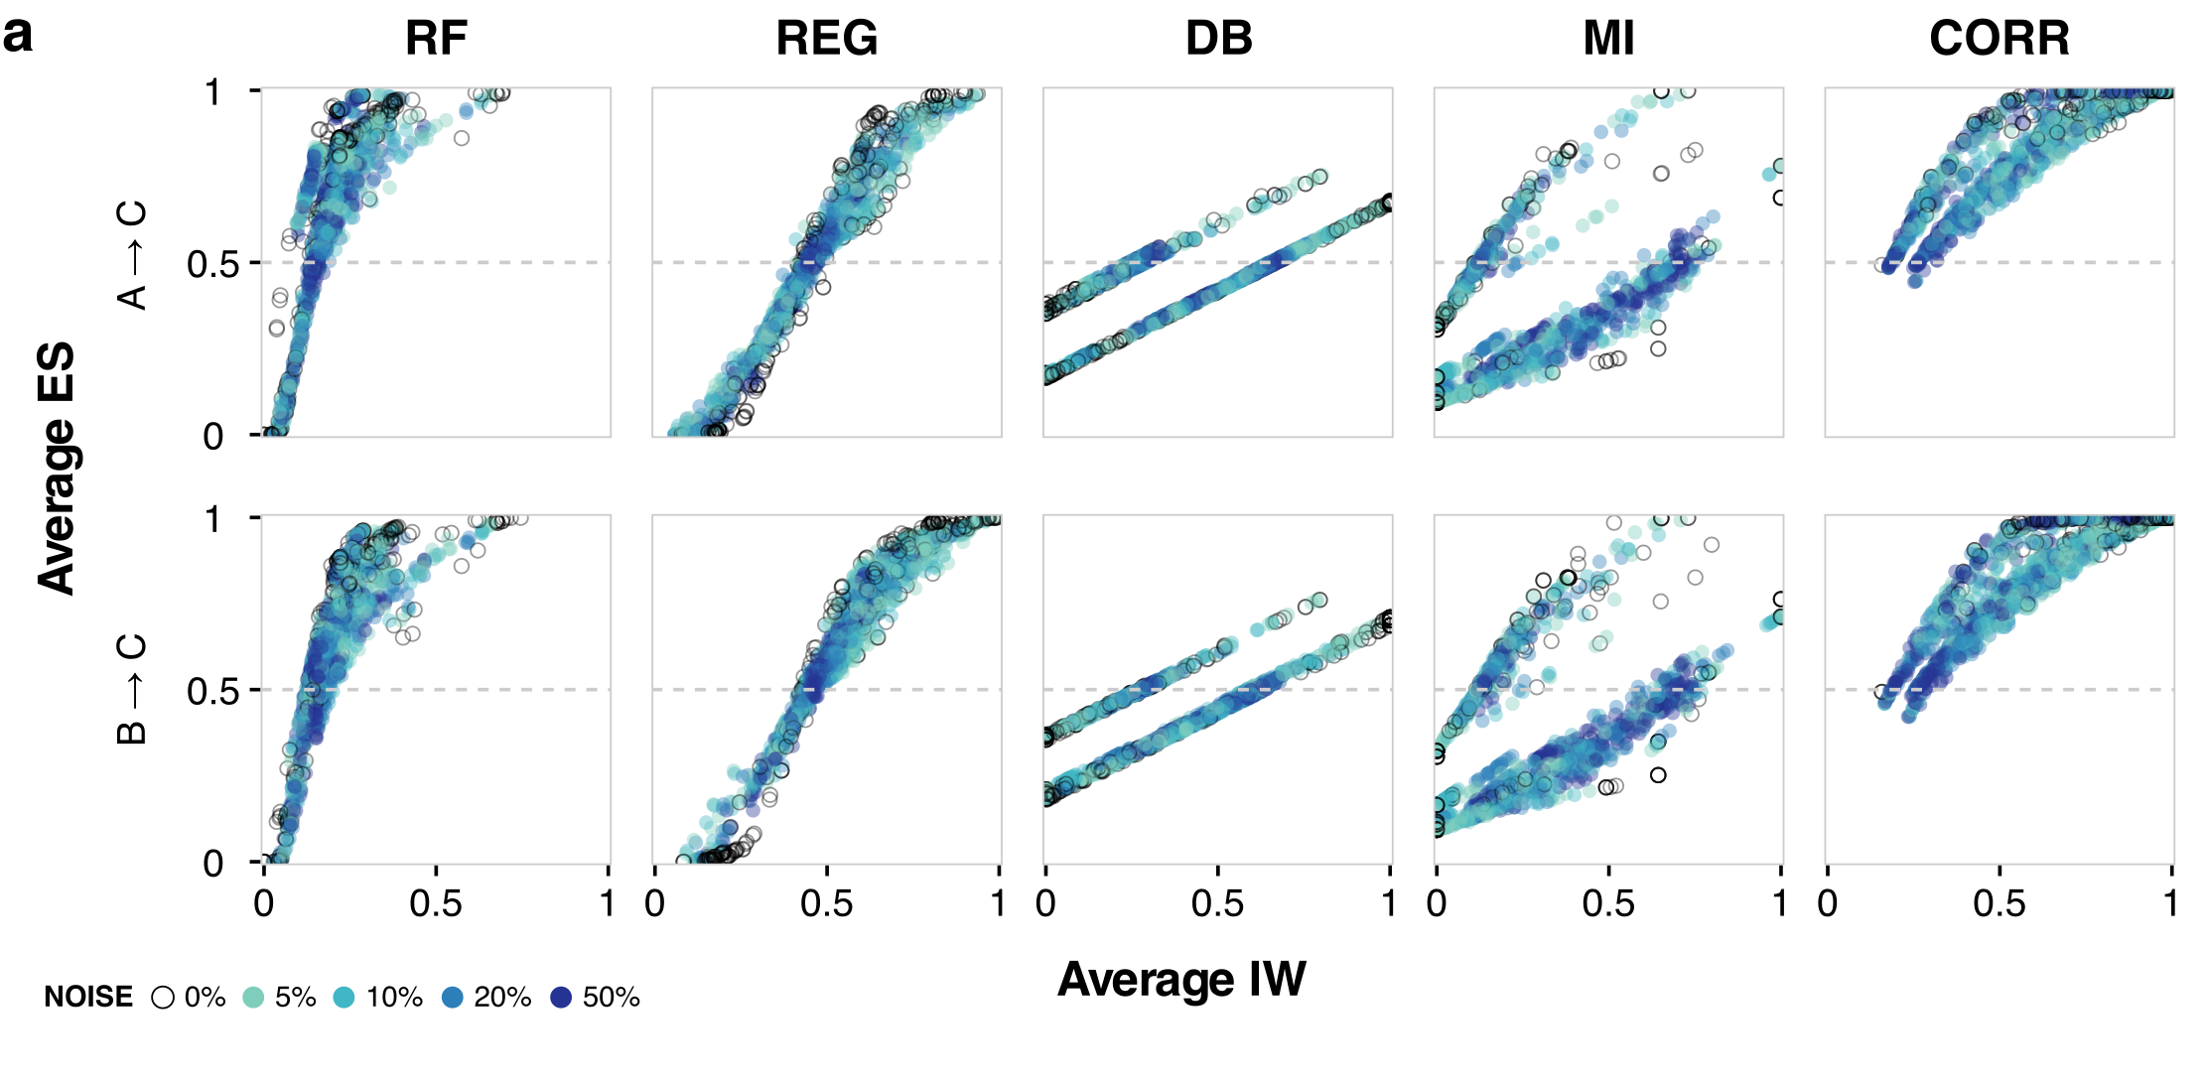
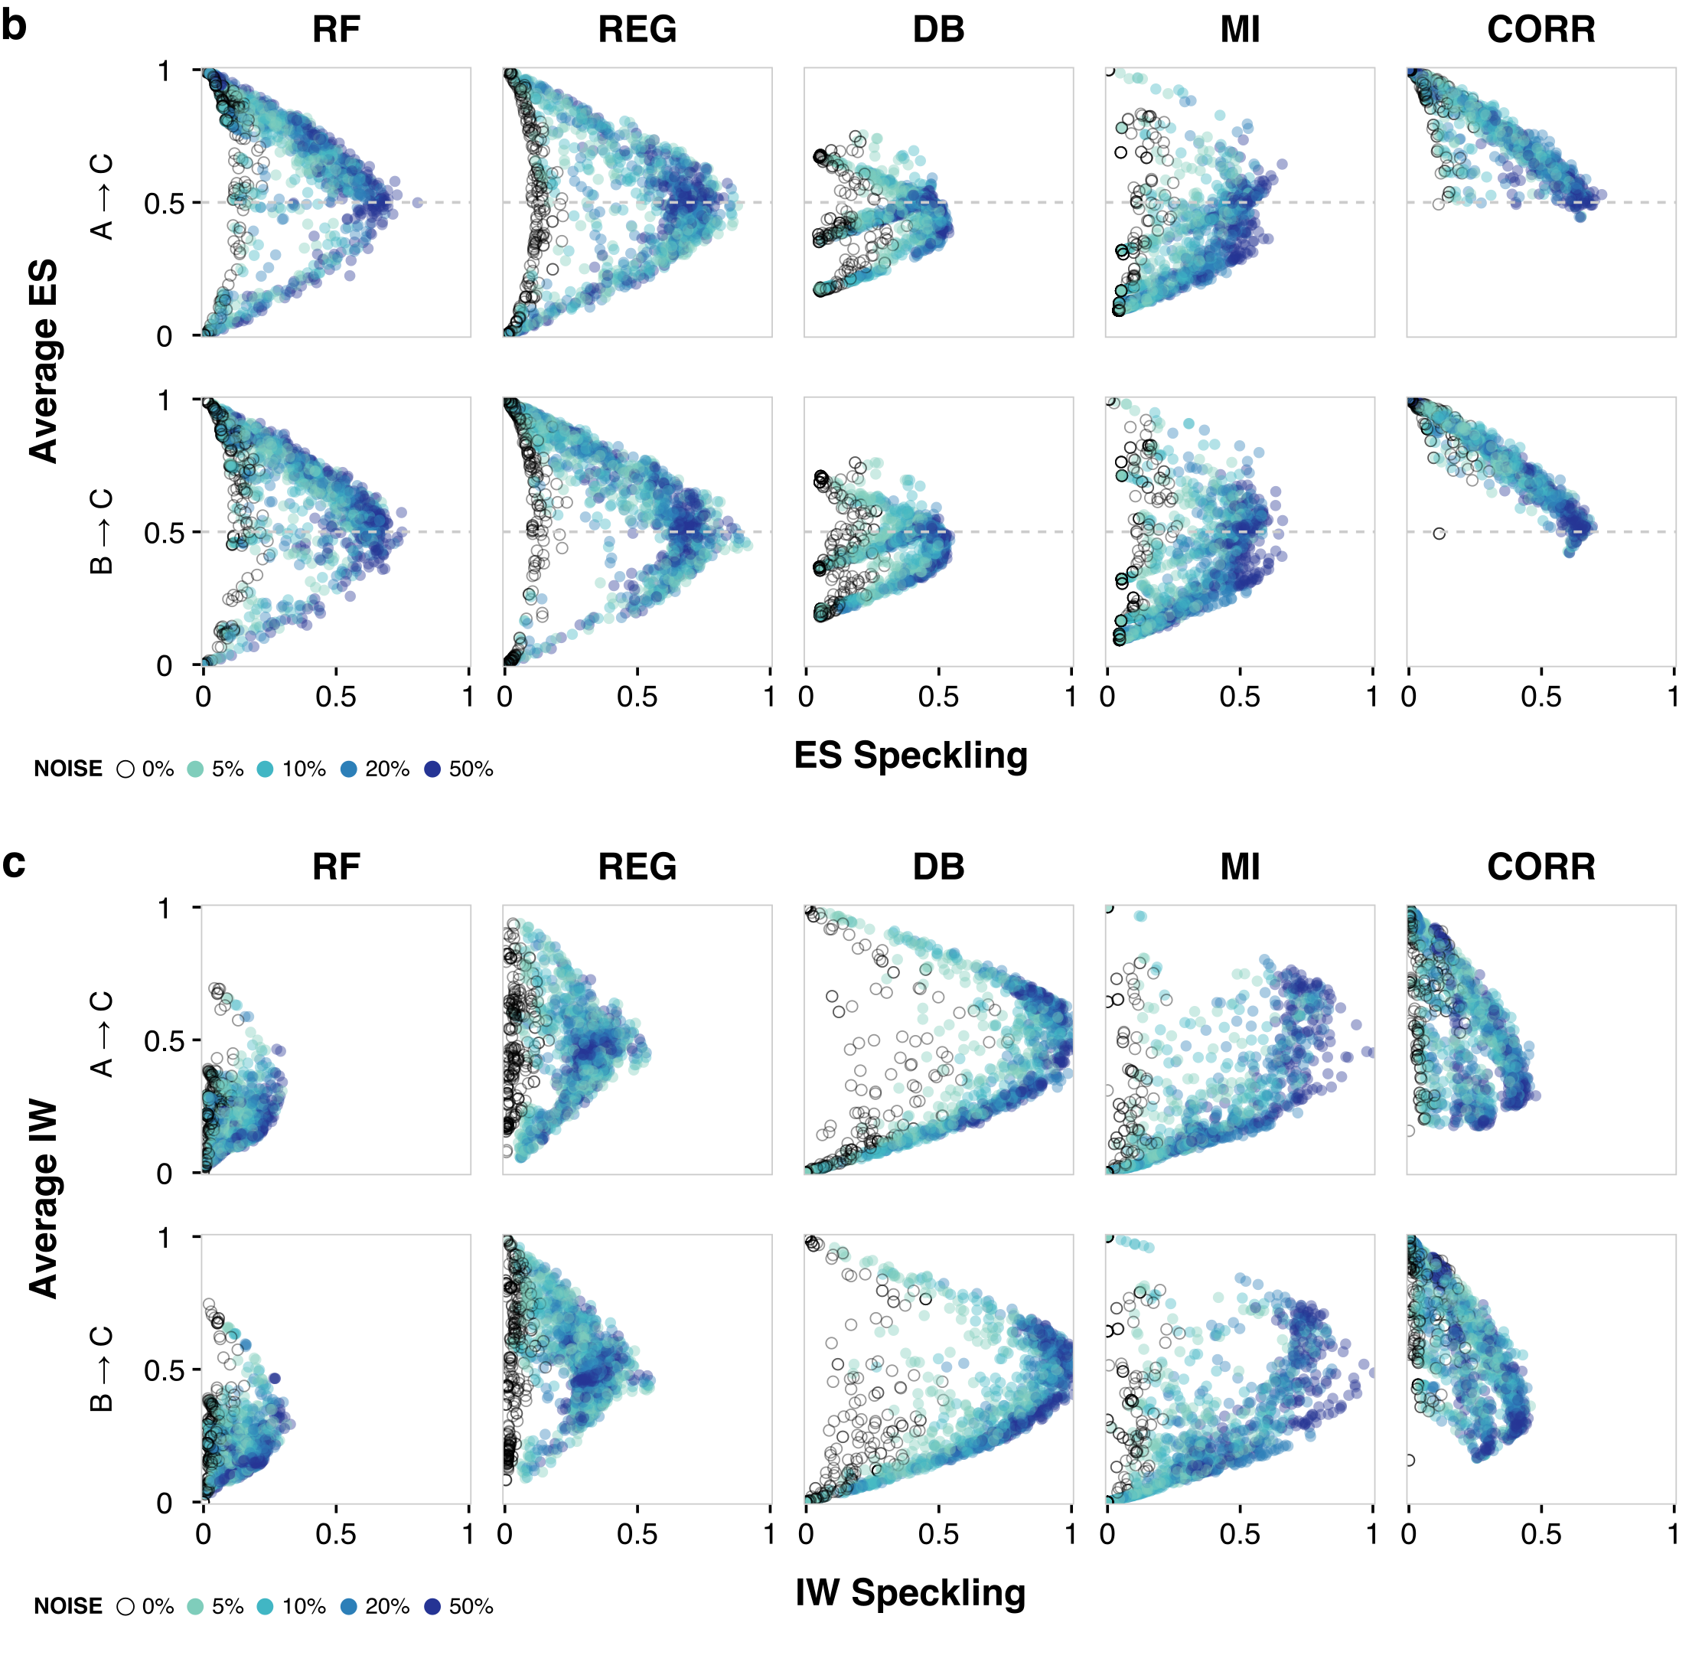
Figure S4 | Noise effects. (a) Joint distribution of average IW and average ES for the six motifs, six gates, three stimulus conditions, three time intervals, and varied levels of noise in the data (color-coded). (b) Joint distribution of ES speckling and average ES. (c) Joint distribution of IW speckling and average IW.
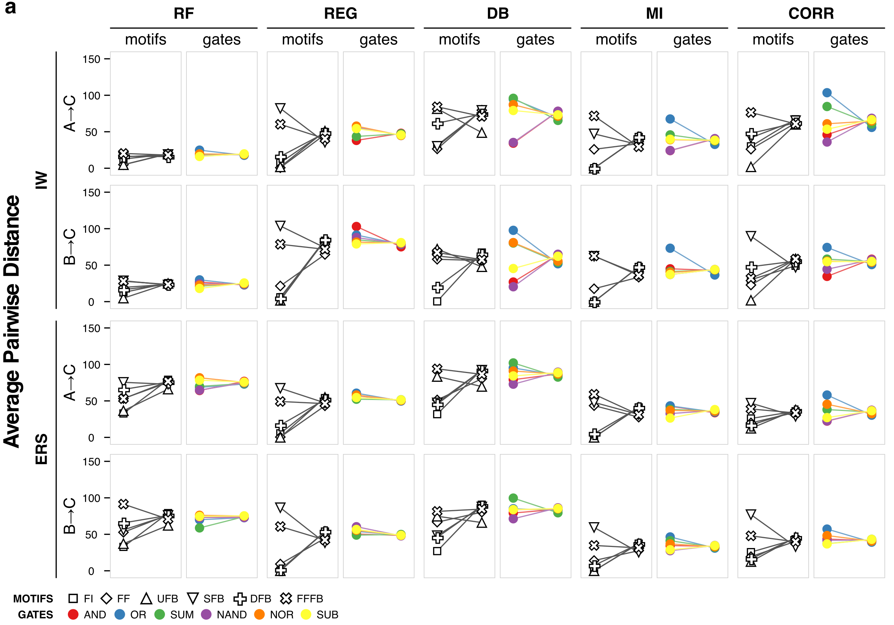

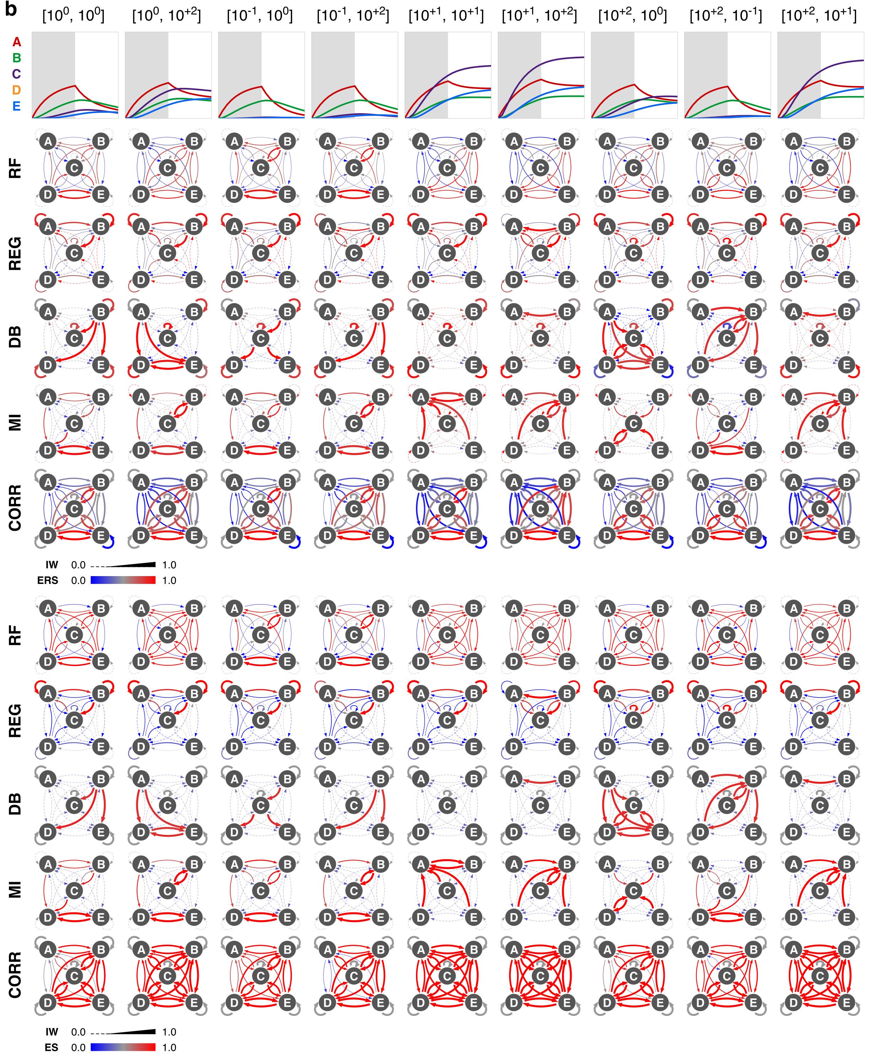

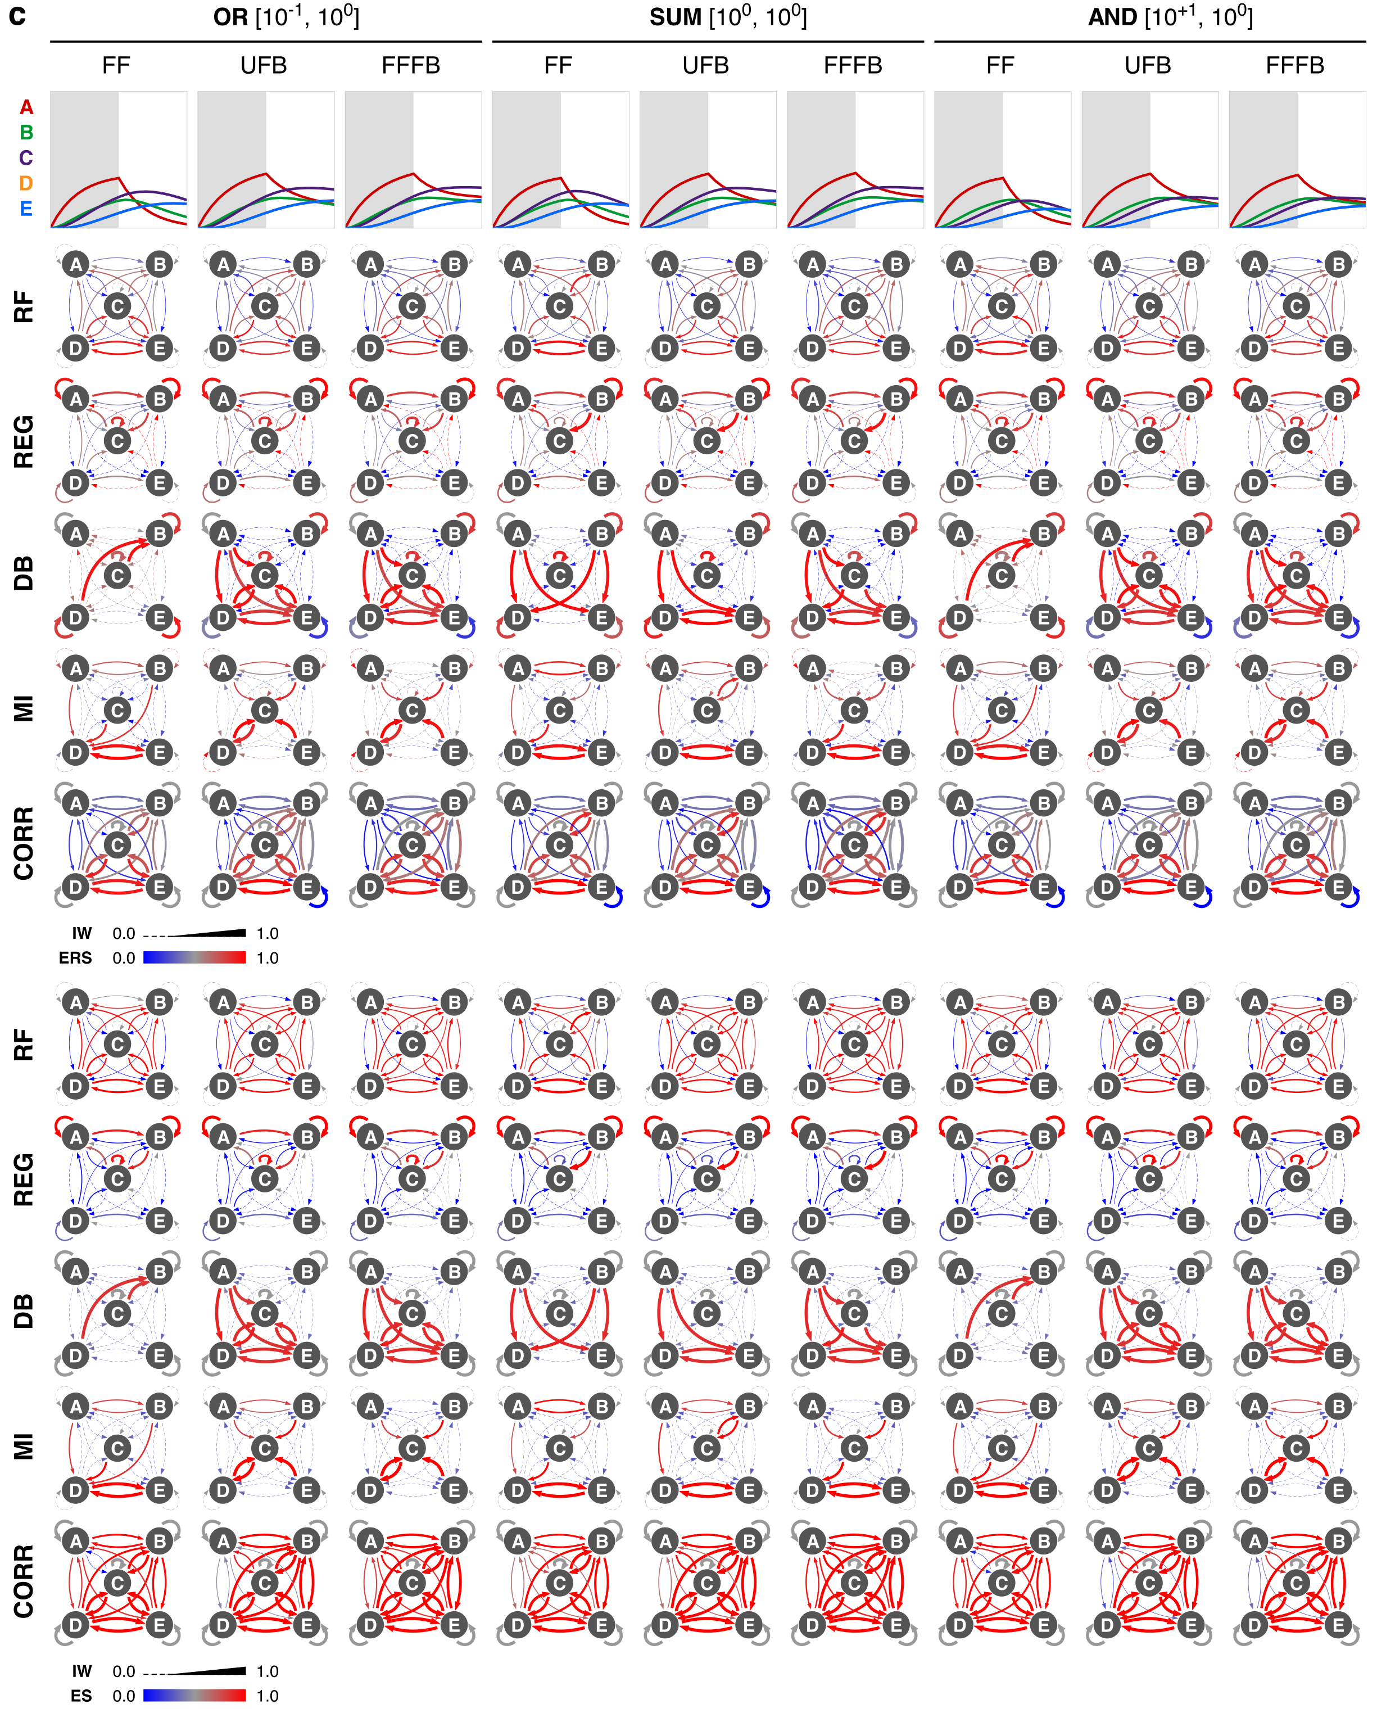

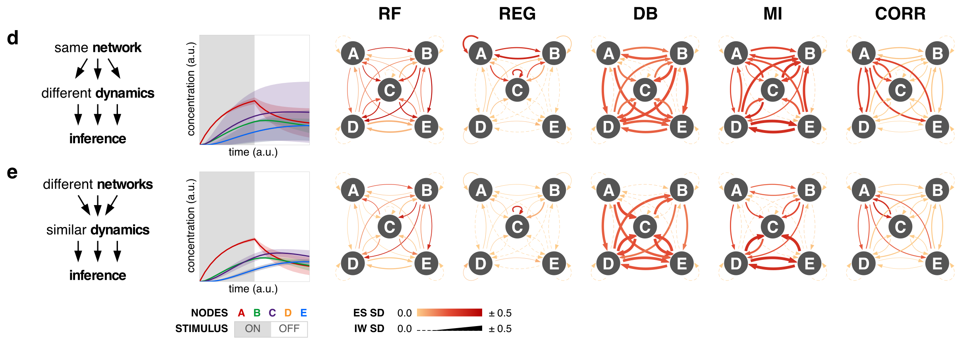

Figure S5 | Robustness to network dynamics and topology. (a) Comparisons among in-group (pairs for networks that share a specified feature) and out-group (pairs that do not share the feature) for motifs and for gates. With 6x6 (36) motif-gate combinations, for any feature, six will comprise an in-group and the remaining 30 are the out-group. In the figure, in-group is the left circle and out-group is the right circle, connected by a line for visualization. The score on y-axis uses the city block distance between kinetic landscapes; lower values indicate more similar inference outcomes. If the left circle is lower than the right, then the feature can be said to contribute to similar outcomes (in a manner agnostic to the specific outcomes). If circles are evenly matched, then the feature is not detected to contribute to in-group similarity. As an example, networks with an NAND gate are inferred similarly for IW using dynamic Bayesian. The dataset uses stimulus to A and B, 0% noise, and the full timecourse. (b) Robustness to dynamics in the data is evaluated with FFFB motif, AND gate, stimulus to A, 0% noise, and full timecourse with ERS (upper) and ES (lower). Networks with the same topology but different kinetics can produce varied trajectories. (c) Robustness to topology and kinetics, for the indicated networks, using ERS (upper) and ES (lower). Networks with different topologies and kinetics can produce similar trajectories. (d–e) Condensed standard deviation (SD) for (d) dynamics and (e) topology and kinetics, using ES.

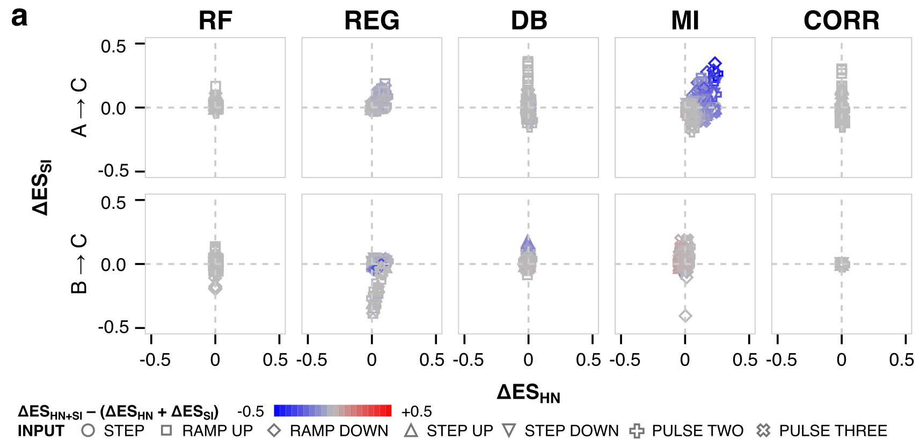

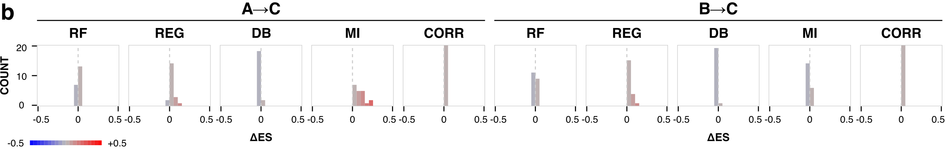

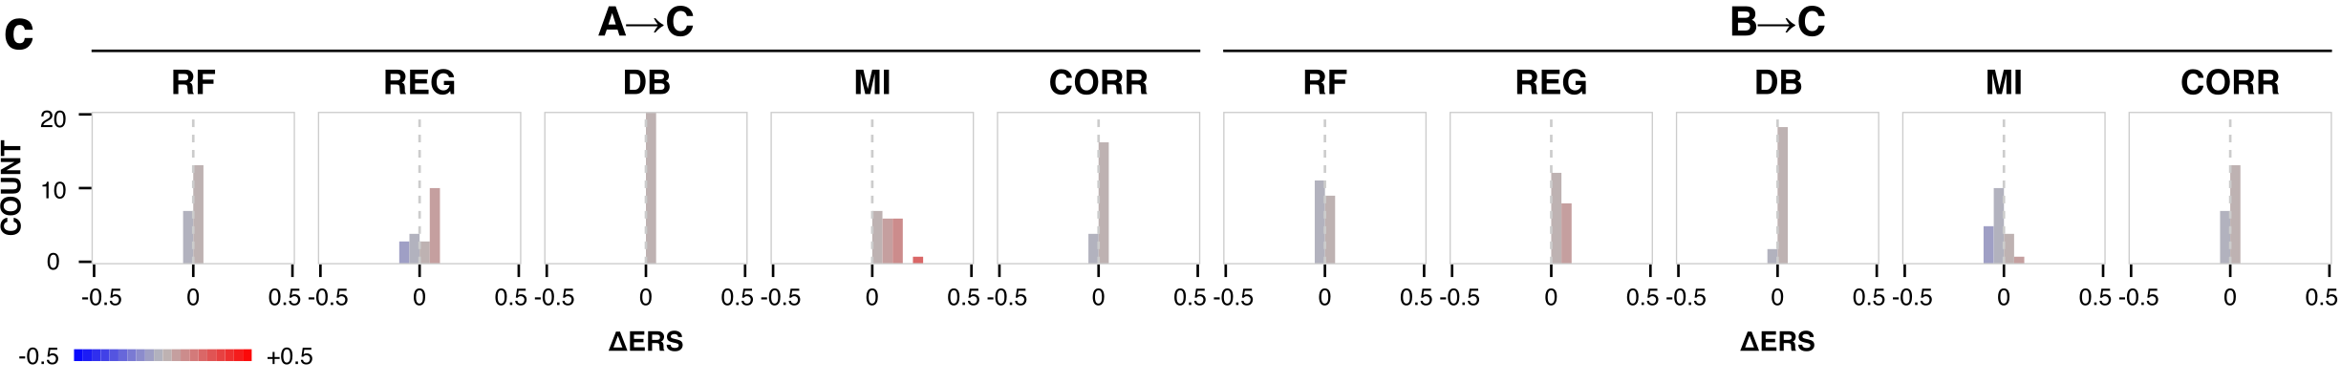

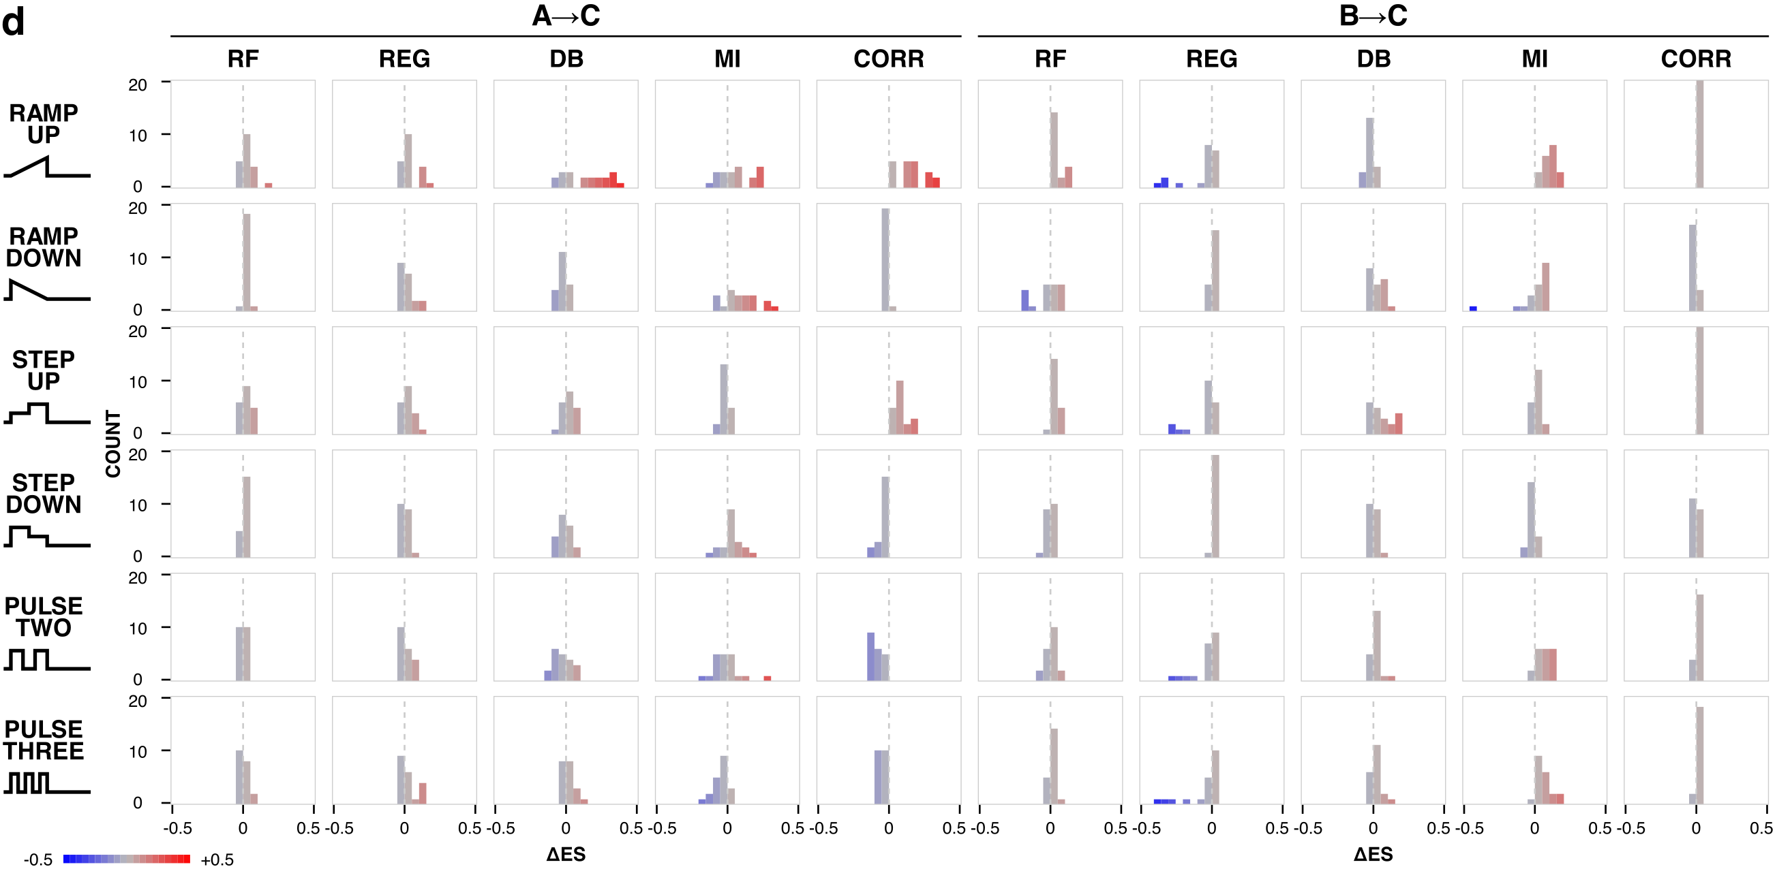

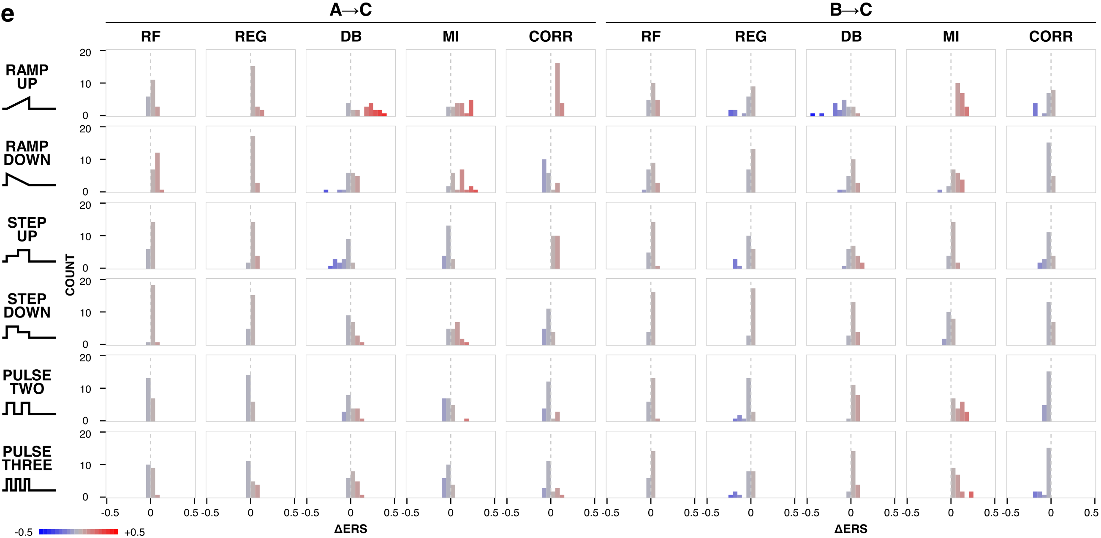

Figure S6 | Stimulus and algorithm modifications. (a) Distribution of change in ES for when either a hidden node for the stimulus is included, different stimulus inputs are used, or both. (b–c) Distribution of change in (b) ES and (c) ERS when a hidden stimulus node is used. (d–e) Distribution of change in (d) ES and (e) ERS when a different stimulus input is used. Values include results for two motifs (FF, FFFB), two gates (AND, OR), and five noise amounts, for a total of 20 cases (per stimulus profile). Change calculated as $(x-x_{0})$ where $x$and $x_{0}$ are the values of the metric with and without the change, respectively.

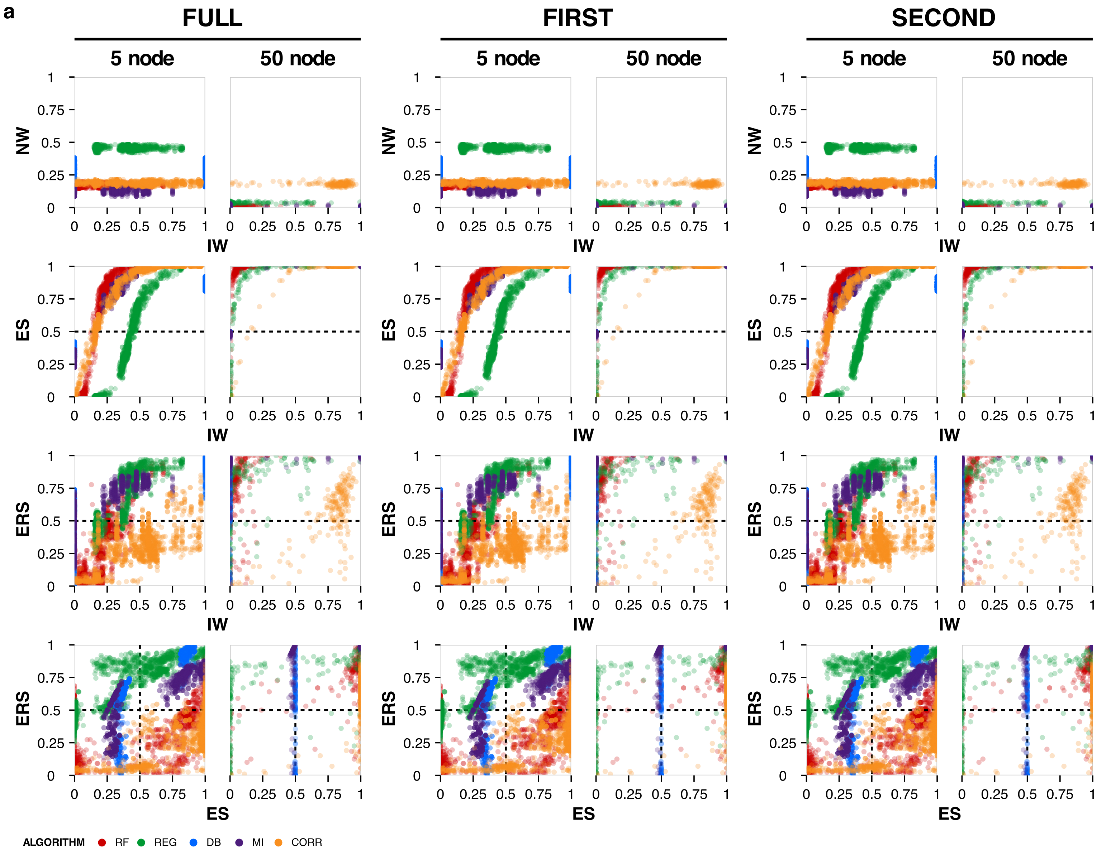

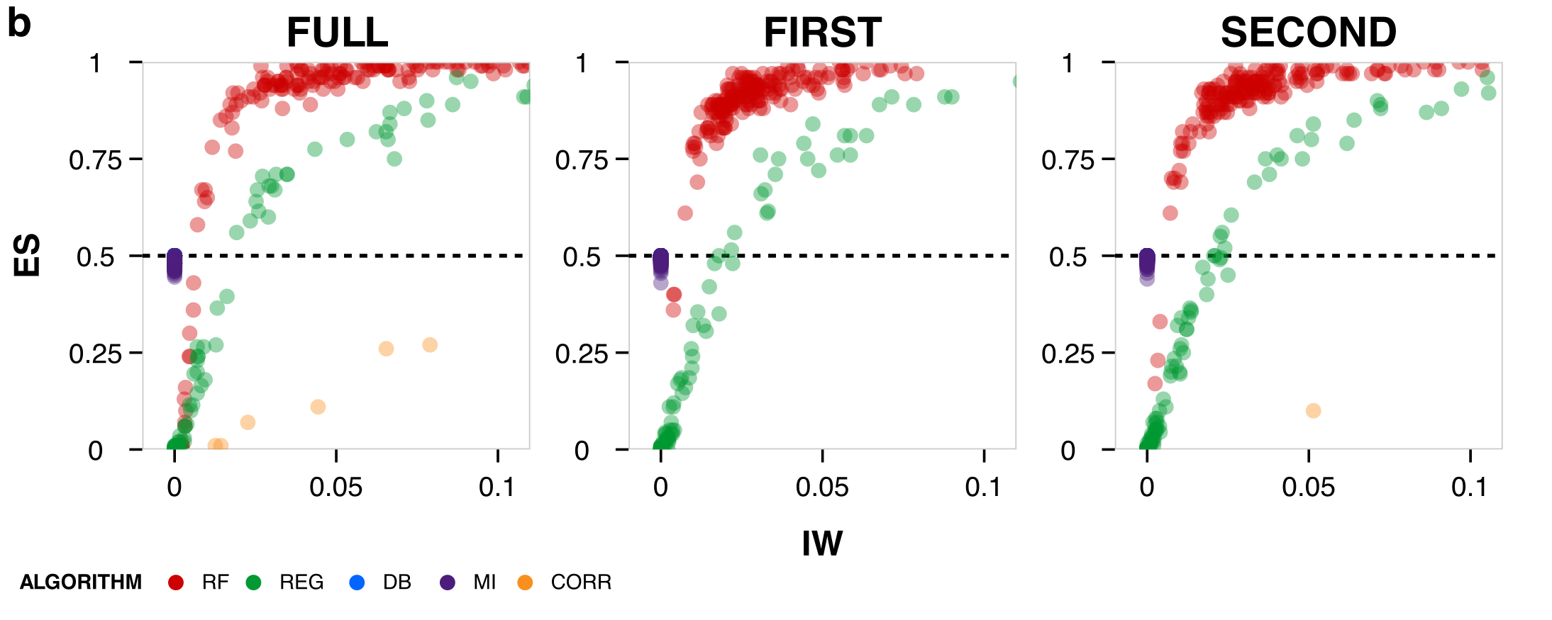
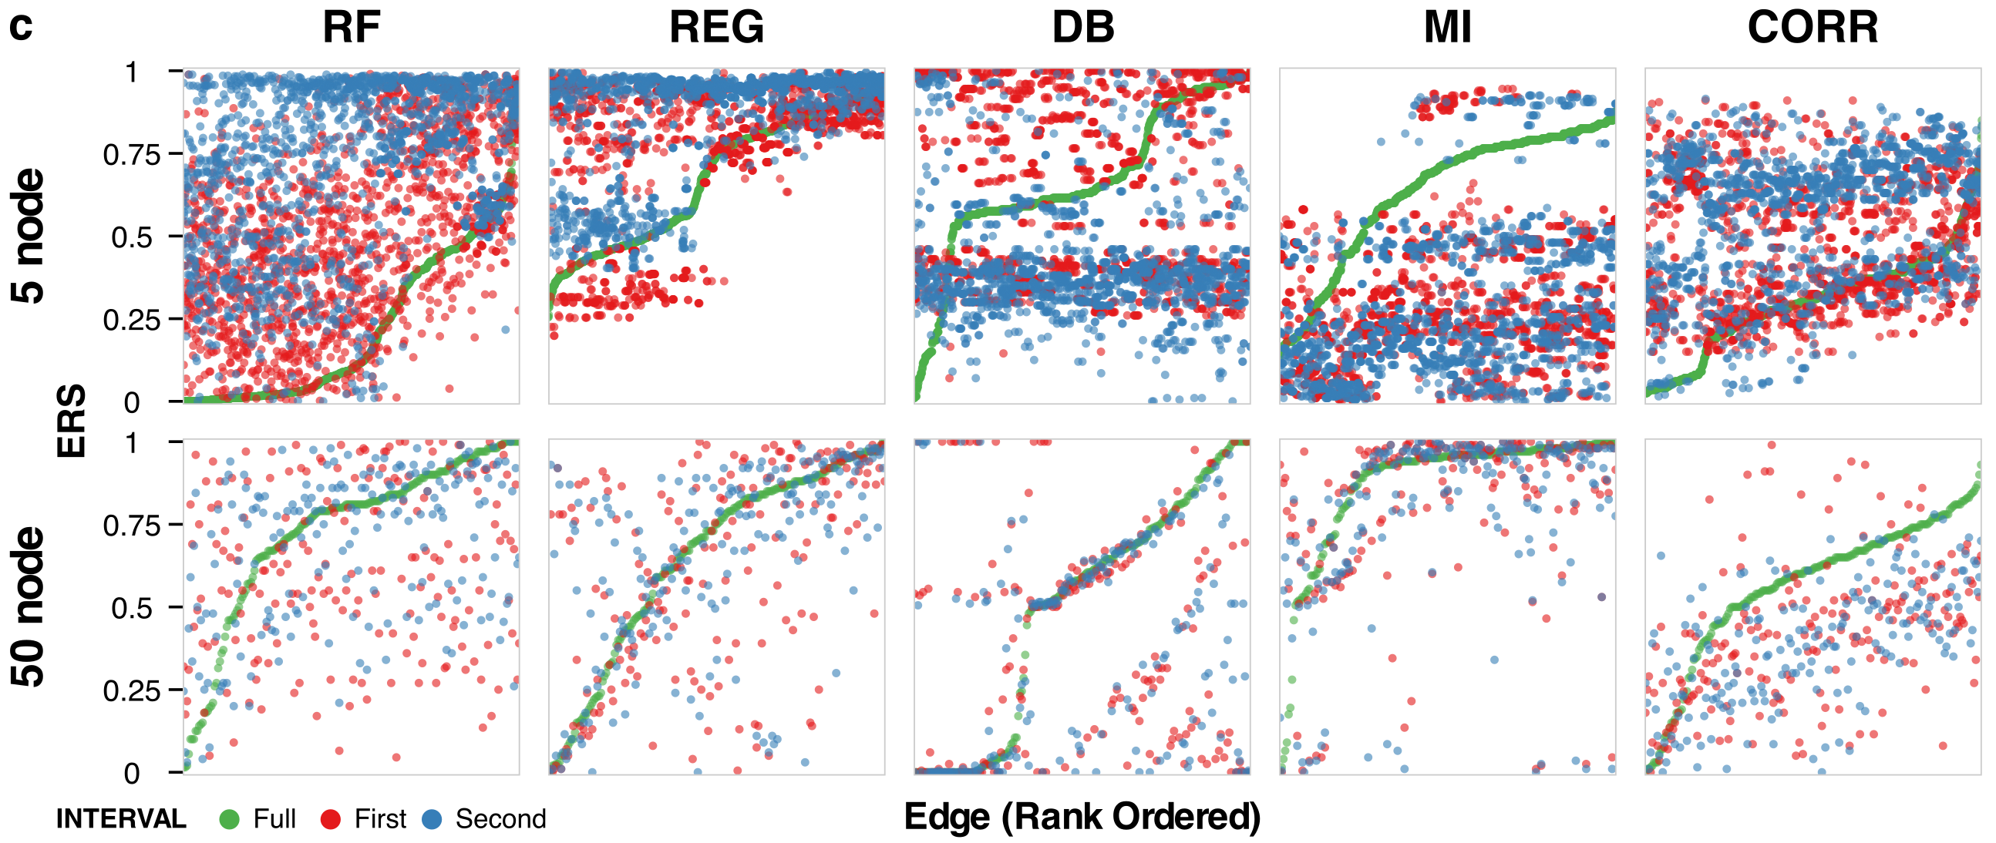

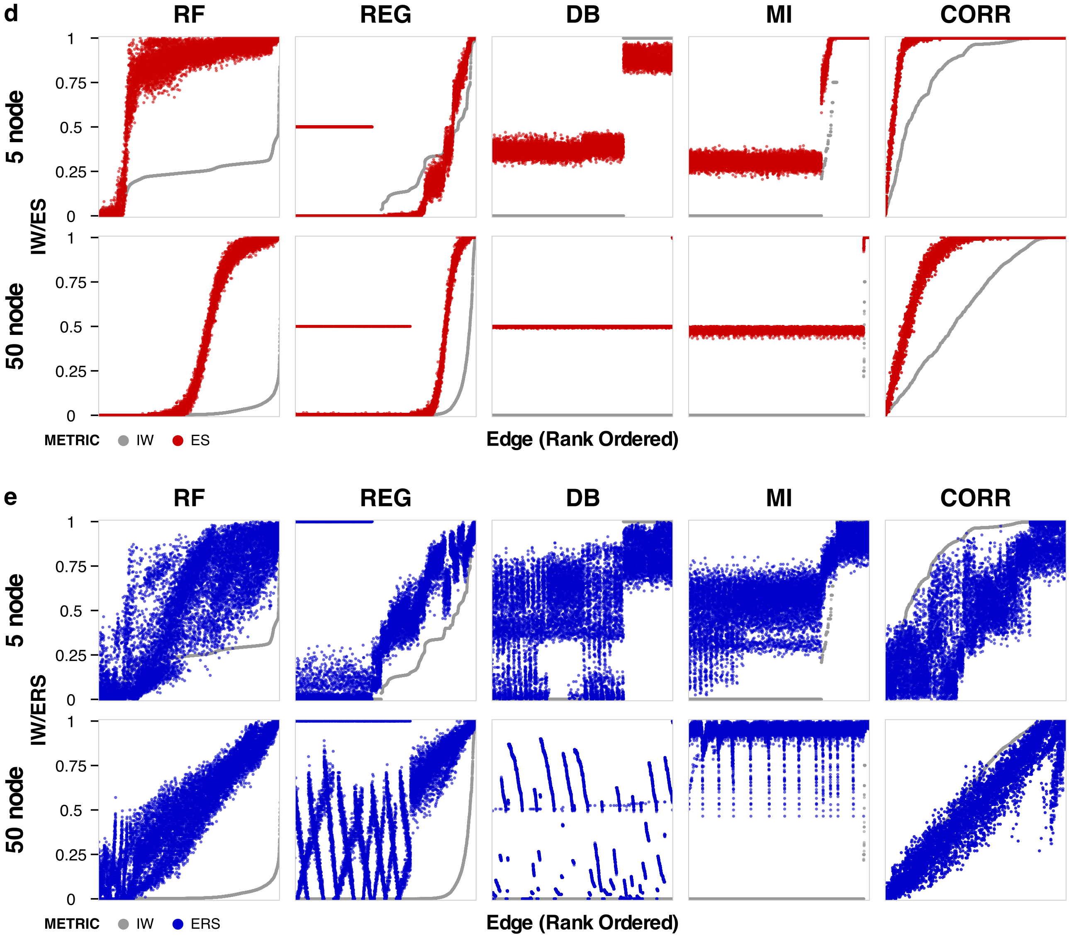
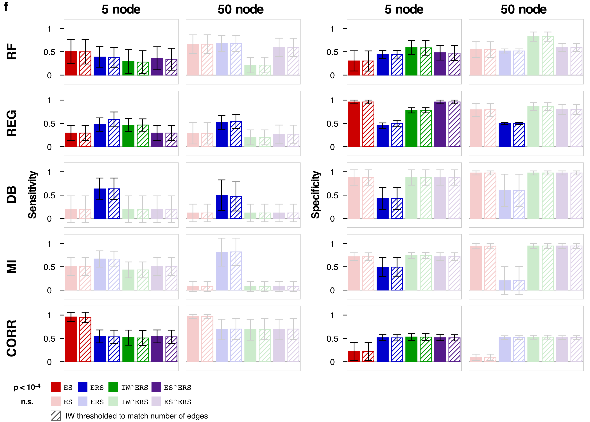

Figure S7 | Validation. (a) Relationship between inference outcomes from each algorithm (color-coded) for the original 5-node networks and ten 50-node GeneNetWeaver networks using different time intervals of data (full, first, and second). To make a more direct comparison between the two sets of networks, the GeneNetWeaver edges shown are those leading directly from the stimulated node to the target of two-parent fan-ins. For the 5-node networks, a representative subset of kinetic parameter space ($k_{A}∈\left\{{10}^{-2}, {10}^{-1}, {10}^{0},{10}^{1}, {10}^{2}\right\}$ and $k_{B}∈\left\{{10}^{-2}, {10}^{-1}, {10}^{0},{10}^{1}, {10}^{2}\right\}$) is shown. (b) Relationship between ES and IW. The x-axis scaling is zoomed in to [0, 0.1] to show that the monotonic relationship between IW and ES is maintained. (c) Edges from two-parent fan-ins leading to the target node are rank-ordered by ERS outcomes using the full data set (green) with corresponding values from the first interval (red) and second interval (blue). (d–e) All edges for networks (not constrained to gate edges) are rank-ordered by IW (gray). To limit the density of points on the plots for visualization, the FFFB motif with OR gate is used as a representative set for the 5-node networks, and one of the 50-node networks is used. Corresponding values are shown for (d) ES (red) and (e) ERS (blue). (f) Sensitivity (left) and specificity (right) are shown for different thresholding methods. As a control for each thresholding method, networks were also thresholded by IW to match the number of edges obtained with the corresponding method (hatched bars). Error bars depict the standard deviation across networks. Pairwise hypothesis testing was conducted for each thresholding method pair (solid vs. hatched bars) using a two-tailed Wilcoxon signed-rank test. Pairs with significant differences are in bright colors, and non-significant outcomes are in faded colors.

SuppLEMENTARY Tables
Table S1 | Network motifs. Six three-node motifs containing exactly one fan-in are considered. In each adjacency matrix, entries indicate the presence (1) or absence (0) of a directed edge from one node (row) to another node (column), for nodes A, B, and C. All networks also have two nodes (D and E) downstream of the fan-in.
Motif | Abbreviation | Adjacency Matrix
Two-node fan-in | FI | $$\left[\begin{matrix}0 & 0 & 1 \\ 0 & 0 & 1 \\ 0 & 0 & 0\end{matrix}\right]$$
Feedforward | FF | $$\left[\begin{matrix}0 & 1 & 1 \\ 0 & 0 & 1 \\ 0 & 0 & 0\end{matrix}\right]$$
Upstream feedback | UFB | $$\left[\begin{matrix}0 & 1 & 1 \\ 1 & 0 & 1 \\ 0 & 0 & 0\end{matrix}\right]$$
Single feedback | SFB | $$\left[\begin{matrix}0 & 0 & 1 \\ 0 & 0 & 1 \\ 0 & 1 & 0\end{matrix}\right]$$
Double feedback | DFB | $$\left[\begin{matrix}0 & 0 & 1 \\ 0 & 0 & 1 \\ 1 & 1 & 0\end{matrix}\right]$$
Feedforward with feedback | FFFB | $$\left[\begin{matrix}0 & 1 & 1 \\ 0 & 0 & 1 \\ 1 & 0 & 0\end{matrix}\right]$$

Table S2 | Logic gates. Functions defining the gates for the fan-in to node C, with parameters for edges $k_{A}$ and $k_{B}$ from nodes $A$ and $B$, respectively. NAND, NOR, and SUB are the respective inverses of AND, OR, and SUM.
Gate | Function
AND | $$\frac{k_{A}k_{B}AB}{1+k_{A}A+k_{B}B+k_{A}k_{B}AB}$$
OR | $$\frac{k_{A}A+k_{B}B+k_{A}k_{B}AB}{1+k_{A}A+k_{B}B+k_{A}k_{B}AB}$$
SUM | $$\frac{k_{A}A/2+k_{B}B/2+k_{A}k_{B}AB}{1+k_{A}A+k_{B}B+k_{A}k_{B}AB}$$
NAND | $$1-\frac{k_{A}k_{B}AB}{1+k_{A}A+k_{B}B+k_{A}k_{B}AB}$$
NOR | $$1-\frac{k_{A}A+k_{B}B+k_{A}k_{B}AB}{1+k_{A}A+k_{B}B+k_{A}k_{B}AB}$$
SUB | $$1-\frac{k_{A}A/2+k_{B}B/2+k_{A}k_{B}AB}{1+k_{A}A+k_{B}B+k_{A}k_{B}AB}$$
Table S3 | Non-inferable cases.
Non-inferable edges are those that cannot be inferred because the simulated data trajectory is flat. These data are withheld from algorithms, as algorithms cannot infer an edge if a variable’s measured values have no variance across conditions. This step is operationally similar to a step that can be taken with experimental data if a variable shows no statistically significant change over time or in response to a perturbation. In the table, scenarios in which edges from a gate parent node cannot be inferred are denoted by x, and those in which no edges can be inferred are denoted by N. Fully inferable cases are denoted by (-).
AC |  |  |  |  |  |  |  |  | BC
Stimulus | Motif | Logic Gate |  |  |  |  |  |  | Stimulus | Motif | Logic Gate
 |  | AND | OR | SUM | NAND | NOR | SUB |  |  |  | AND | OR | SUM | NAND | NOR | SUB
A only | FI | N | - | - | - | - | - |  | A only | FI | N | x | x | x | x | x
 | FF | - | - | - | - | - | - |  |  | FF | - | - | - | - | - | -
 | UFB | - | - | - | - | - | - |  |  | UFB | - | - | - | - | - | -
 | SFB | N | - | - | - | - | - |  |  | SFB | N | - | - | - | - | -
 | DFB | N | - | - | - | - | - |  |  | DFB | N | - | - | - | - | -
 | FFFB | - | - | - | - | - | - |  |  | FFFB | - | - | - | - | - | -
B only | FI | N | x | x | x | x | x |  | B only | FI | N | - | - | - | - | -
 | FF | N | x | x | x | x | x |  |  | FF | N | - | - | - | - | -
 | UFB | - | - | - | - | - | - |  |  | UFB | - | - | - | - | - | -
 | SFB | N | x | x | x | x | x |  |  | SFB | N | - | - | - | - | -
 | DFB | N | - | - | - | - | - |  |  | DFB | N | - | - | - | - | -
 | FFFB | N | - | - | - | - | - |  |  | FFFB | N | - | - | - | - | -

Table S4 | Selected cases. Based on the connectivity of the 50-node networks from GeneNetWeaver, stimulus to certain nodes have no effect on the trajectory of one or more nodes. Only stimulation cases that are both inferable and stimulatable (and have at least three downstream nodes, indicated in bold) are used in the analysis.
Network | Case
 | Inferable  Stimulated node has at least one downstream node. | Stimulatable  Stimulated node has at least one positive input edge | Inferable and Stimulatable  Cases with at least four non-zero trajectories indicated in bold
A | N = 25  1, 2, 3, 4, 5, 6, 7, 8, 9, 10, 11, 12, 13, 14, 15, 16, 17, 18, 19, 20, 22, 23, 25, 27, 30 | N = 35  1, 2, 3, 6, 7, 8, 9, 10, 11, 12, 13, 15, 18, 21, 24, 25, 28, 29, 30, 31, 32, 33, 34, 35, 37, 38, 39, 41, 42, 43, 45, 47, 48, 49, 50 | N = 15 (13)  1, 2, 3, 6, 7, 8, 9, 10, 11, 12, 13, 15, 18, 25, 30
B | N = 22  1, 2, 3, 4, 5, 6, 7, 8, 9, 10, 11, 12, 13, 14, 15, 16, 17, 18, 19, 20, 29, 30 | N = 34  1, 2, 4, 5, 6, 8, 9, 10, 12, 13, 15, 17, 21, 22, 23, 24, 25, 26, 28, 32, 33, 34, 35, 37, 38, 39, 40, 41, 42, 43, 44, 46, 47, 50 | N = 12 (11)  1, 2, 4, 5, 6, 8, 9, 10, 12, 13, 15, 17
C | N = 24  1, 2, 3, 4, 5, 6, 7, 8, 9, 10, 11, 12, 13, 14, 15, 16, 17, 18, 19, 20, 26, 27, 29, 30 | N = 38  1, 5, 7, 8, 9, 10, 12, 14, 16, 17, 18, 19, 20, 21, 22, 24, 25, 26, 28, 31, 32, 33, 34, 35, 36, 37, 38, 39, 40, 41, 42, 43, 44, 45, 47, 48, 49, 50 | N = 14 (13)  1, 5, 7, 8, 9, 10, 12, 14, 16, 17, 18, 19, 20, 26
.D | N = 23  1, 2, 3, 4, 5, 6, 7, 8, 9, 10, 11, 12, 13, 14, 15, 16, 17, 18, 19, 20, 23, 25, 28 | N = 30  3, 4, 5, 6, 7, 8, 9, 16, 17, 18, 19, 22, 24, 25, 26, 27, 30, 31, 32, 34, 36, 37, 38, 39, 40, 42, 45, 46, 47, 50 | N = 12 (11)  3, 4, 5, 6, 7, 8, 9, 16, 17, 18, 19, 25
E | N = 25  1, 2, 3, 4, 5, 6, 7, 8, 9, 10, 11, 12, 13, 14, 15, 16, 17, 18, 19, 20, 21, 25, 26, 28, 30 | N = 35  1, 3, 5, 6, 7, 9, 10, 12, 14, 17, 18, 22, 23, 24, 26, 27, 28, 29, 30, 32, 33, 34, 35, 37, 38, 39, 40, 41, 42, 43, 45, 46, 47, 48, 50 | N = 14 (13)  1, 3, 5, 6, 7, 9, 10, 12, 14, 17, 18, 26, 28, 30
F | N = 23  1, 2, 3, 4, 5, 6, 7, 8, 9, 10, 11, 12, 13, 14, 15, 16, 17, 18, 19, 21, 22, 23, 25 | N = 29  4, 5, 6, 7, 9, 11, 13, 14, 15, 16, 17, 19, 21, 24, 26, 28, 29, 30, 33, 34, 35, 37, 38, 39, 42, 44, 45, 46, 50 | N = 13 (11)  4, 5, 6, 7, 9, 11, 13, 14, 15, 16, 17, 19, 21
G | N = 25  1, 2, 3, 4, 5, 6, 7, 8, 9, 10, 11, 12, 13, 14, 15, 16, 17, 18, 19, 20, 22, 24, 26, 27, 30 | N = 33  1, 2, 3, 4, 5, 6, 7, 10, 11, 13, 14, 15, 16, 18, 19, 21, 22, 25, 30, 31, 32, 34, 35, 36, 37, 38, 40, 41, 42, 43, 44, 45, 50 | N = 17 (16)  1, 2, 3, 4, 5, 6, 7, 10, 11, 13, 14, 15, 16, 18, 19, 22, 30
H | N = 25  1, 2, 3, 4, 5, 6, 7, 8, 9, 10, 11, 12, 13, 14, 15, 16, 17, 18, 19, 20, 21, 22, 27, 28, 30 | N = 31  2, 3, 4, 6, 7, 9, 11, 14, 15, 19, 23, 24, 25, 26, 28, 32, 33, 35, 36, 38, 39, 40, 41, 43, 44, 45, 46, 47, 48, 49, 50 | N = 11 (10)  2, 3, 4, 6, 7, 9, 11, 14, 15, 19, 28
I | N = 24  1, 2, 3, 4, 5, 6, 7, 8, 9, 10, 11, 12, 13, 14, 15, 16, 18, 19, 20, 21, 23, 24, 27, 29 | N = 33  1, 2, 3, 4, 6, 8, 10, 11, 12, 13, 14, 16, 17, 18, 19, 20, 23, 25, 30, 31, 33, 34, 35, 36, 37, 38, 39, 40, 42, 45, 46, 47, 48 | N = 16 (13)  1, 2, 3, 4, 6, 8, 10, 11, 12, 13, 14, 16, 18, 19, 20, 23
J | N = 20  1, 2, 3, 4, 5, 6, 7, 8, 9, 10, 12, 13, 14, 15, 16, 17, 18, 19, 20, 28 | N = 36  1, 2, 3, 4, 5, 7, 8, 10, 11, 12, 13, 15, 16, 17, 20, 23, 25, 29, 30, 31, 32, 33, 34, 35, 36, 37, 39, 40, 41, 42, 44, 45, 46, 48, 49, 50 | N = 14 (12)  1, 2, 3, 4, 5, 7, 8, 10, 12, 13, 15, 16, 17, 20

