Supplementary data for
AutoDock CrankPep: Combining folding and docking to predict protein-peptide complexes

Yuqi Zhang¹ and Michel Sanner^{1*}

¹Department of Integrative Structural and Computational Biology, The Scripps Research Institute, La Jolla, California, United States of America
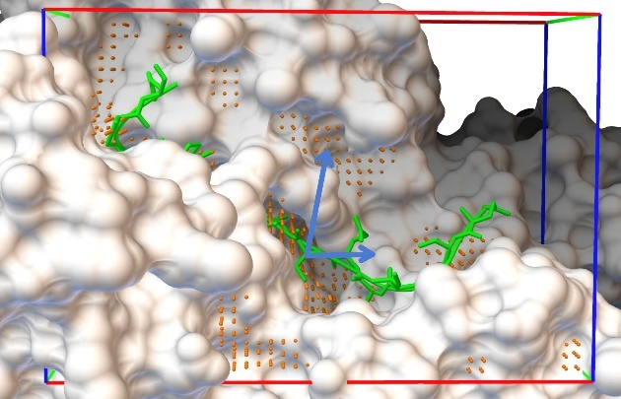
Figure S1. AutoDock CrankPep’s new Monte Carlo moves for exploring the docking box. AutoDock affinity maps are calculated for a rectilinear docking box (red, green and blue lines). Orange spheres show grid points identified as reasonable locations for placing the ligand by translating a central ligand position called the root to one of these points. Two blue arrows show MC moves added to help explore the docking box. The arrow pointing up illustrates moving the root to a new orange sphere (on the grid), while the second arrow illustrates performing a free translation to any point in the docking box.

Chart S1. Flow chart describing the algorithm for updating the pose cache used in AutoDock CrankPep to escape local minima.
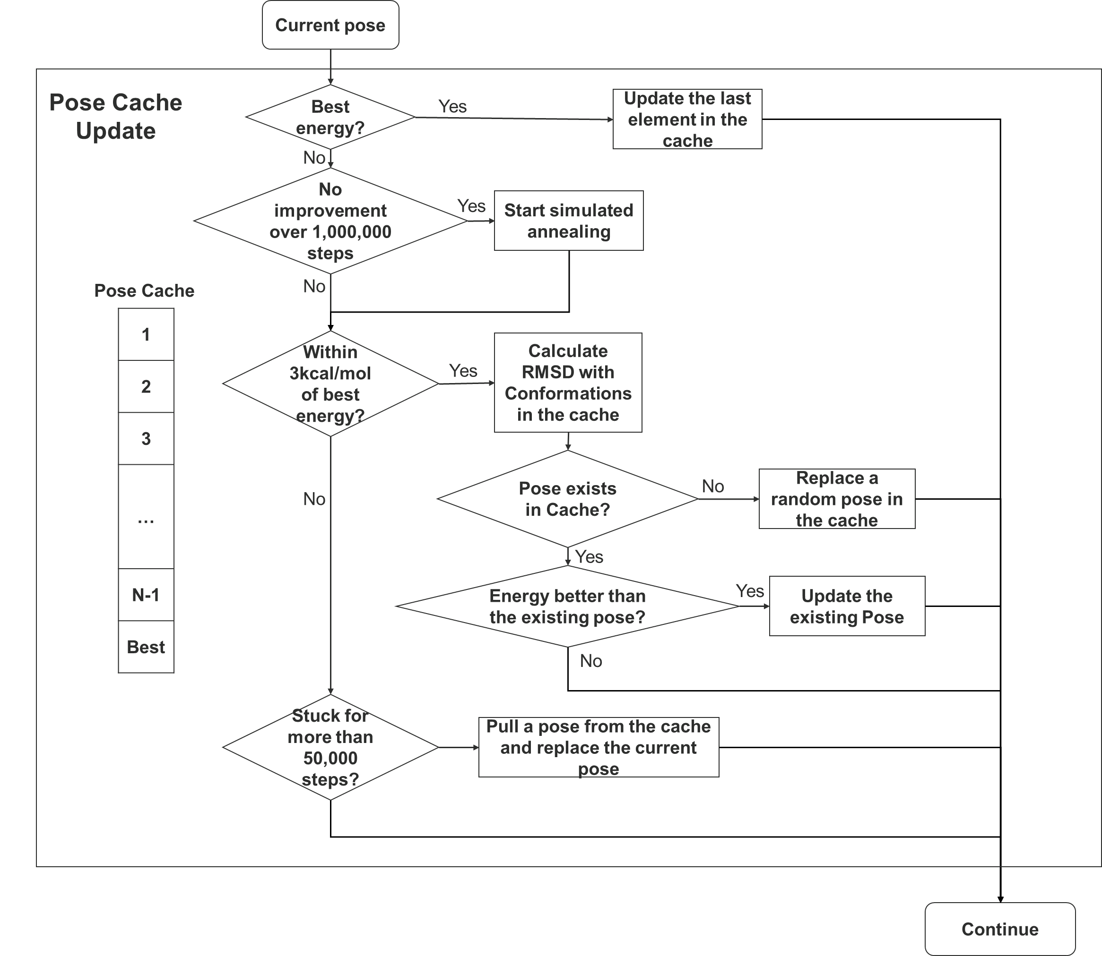

Table S1. Details information of the 12 systems containing longer peptides queried from PDB.
PDB ID | Peptide Chain | Contacting Receptor Segment(s):Chain(s)* | BioMolecule Number |  | Length |  | Apo PDB ID |  | Apo Receptor Chain
1CM1 | B | A |  | 0 |  | 18 | 1PRW | A
2F31 | B | A |  | 0 |  | 20
2IVZ | F | B |  | 1 |  | 16 | 1CRZ | A
2OBH | C | A-B-D |  | 0 |  | 16
2XAP | D | A-B-E |  | 0 |  | 16
4AK4 | P | I-J-K-L-M-N-O |  | 1 |  | 16
4RS9 | B | A |  | 0 |  | 19
4YZ6 | B | A |  | 0 |  | 18
5N4B | D | A |  | 0 |  | 17 | 5N4F | A
5UWI | D | A-B-C |  | 0 |  | 16 | 4HB2 | C
6CIT | D | A-B-C |  | 0 |  | 17 | 4HB2 | C
* This column lists the receptor chains contacting the peptide in the biomolecule. The segment information is created as chains are duplicated in the process of building the biomolecules.

Docking pose clustering
The docking poses from AutoDock CrankPep can be clustered based on either peptide backbone RMSD or contacts between predicted peptide and the receptor. The clustering algorithm is as following:
- Identify the cluster seed as the pose with the best score in the solution pool;
- Form a cluster containing all poses that are similar to the cluster seed. Depending on the user specified similarity measure, poses are deemed similar if (i) they have a backbone RMSD with the cluster seed pose below than a user-define value or, (ii) they reproduce more than a user-defined percentage of contacts identified in the cluster seed pose;
- Remove the clustered poses from the solution pool;
- Repeat until all poses are clustered.
Table S2. System specific comparison between AutoDock CrankPep and HPepDock on the complexes with peptides longer than 4 amino acids from the Leads_Pep dataset.
Size | PDB | ADCP |  |  | HPepDock |  |  | Median ADCP MC-replica time* (mins)
 |  | Top 1 | Top 10 | Top 1000 | Top1 | Top10 | Top 1000
5 | 1NVR | 3.2 | 1.2 | 0.7 | 9.9 | 1.5 | 0.8 | 3.88
5 | 2HPL | 3 | 0.9 | 0.8 | 1.3 | 1.2 | 0.7 | 7.82
5 | 2V3S | 3 | 3 | 1 | 1.8 | 1.4 | 0.9 | 44.02
5 | 3NFK | 8.3 | 1 | 0.4 | 1.4 | 0.8 | 0.5 | 41.17
5 | 3T6R | 8.2 | 5.9 | 0.9 | 1.9 | 1 | 1 | 62.40
5 | 4V3I | 5.3 | 4.1 | 2.3 | 4.5 | 1.8 | 0.9 | 54.78
6 | 1SVZ | 1.6 | 0.7 | 0.7 | 2.3 | 1.9 | 1.7 | 20.72
6 | 3D1E | 1.1 | 1.1 | 0.6 | 2.2 | 1.1 | 1.1 | 17.55
6 | 3IDG | 1.3 | 1 | 0.8 | 1.8 | 1.8 | 1.4 | 40.33
6 | 3LNY | 1.7 | 1.1 | 0.7 | 0.8 | 0.8 | 0.7 | 21.13
6 | 4NNM | 1.4 | 1.3 | 0.8 | 2.1 | 0.9 | 0.9 | 10.13
6 | 4Q6H | 1.1 | 0.8 | 0.5 | 2.9 | 1.1 | 0.5 | 53.22
7 | 3MMG | 0.5 | 0.5 | 0.5 | 1.6 | 1.4 | 1.4 | 74.03
7 | 3NJG | 1.6 | 1 | 0.7 | 1.2 | 0.5 | 0.5 | 72.18
7 | 3Q47 | 0.7 | 0.5 | 0.5 | 6.9 | 1.9 | 1.1 | 15.35
7 | 3UPV | 1.4 | 1.3 | 0.7 | 5.1 | 2.4 | 1.7 | 24.15
7 | 4QBR | 3.1 | 1 | 0.6 | 1.3 | 1.3 | 0.9 | 91.78
8 | 1ELW | 4.7 | 1.6 | 1.2 | 2.5 | 1.7 | 0.8 | 29.40
8 | 1N7F | 1.5 | 0.7 | 0.6 | 4.3 | 1.4 | 0.8 | 69.53
8 | 1OU8 | 1.1 | 0.9 | 0.7 | 2.9 | 2.9 | 1.9 | 28.43
8 | 3CH8 | 0.5 | 0.5 | 0.5 | 1.1 | 1.1 | 1.1 | 29.98
8 | 4WLB | 1.4 | 0.7 | 0.7 | 0.9 | 0.7 | 0.3 | 83.05
9 | 2QAB | 4.1 | 1.8 | 1 | 1.9 | 1.2 | 0.5 | 117.55
9 | 2W0Z | 15.3 | 6.7 | 0.7 | 1.6 | 1.1 | 1 | 96.03
9 | 3OBQ | 3.8 | 1.5 | 0.8 | 2.8 | 2 | 1.4 | 12.78
9 | 4BTB | 3.2 | 1.5 | 1.1 | 11.4 | 3.1 | 1.1 | 9.30
9 | 4N7H | 1.4 | 1.4 | 0.9 | 14.1 | 2.7 | 2.2 | 29.13
10 | 1H6W | 1 | 0.8 | 0.8 | 3.6 | 3.6 | 3.6 | 127.68
10 | 1NTV | 6.1 | 0.8 | 0.8 | 15.7 | 7.8 | 1.8 | 133.63
10 | 2O02 | 3.7 | 2.4 | 1.9 | 7.6 | 4.9 | 2.5 | 28.03
10 | 3BRL | 1 | 0.8 | 0.8 | 8.4 | 5.4 | 1.9 | 72.27
10 | 4DS1 | 1 | 1 | 0.9 | 1.1 | 0.7 | 1.6 | 50.58
11 | 1N12 | 0.6 | 0.6 | 0.6 | 23.3 | 4.3 | 4.3 | 111.15
11 | 2XFX | 1.9 | 1.6 | 1.6 | 7 | 4.5 | 3.5 | 139.72
11 | 3BFW | 0.7 | 0.7 | 0.7 | 2 | 1 | 0.9 | 159.83
11 | 3DS1 | 1.2 | 0.6 | 0.6 | 1.1 | 0.7 | 0.7 | 57.93
11 | 4EIK | 4.5 | 3.6 | 2 | 5.5 | 3.1 | 1.9 | 152.18
12 | 2B9H | 4 | 2.7 | 2.4 | 2.1 | 2.1 | 2.1 | 239.43
12 | 2W10 | 15.3 | 1.8 | 0.8 | 15.4 | 2.8 | 2.4 | 137.73
12 | 3JZO | 8.9 | 2.5 | 1.4 | 13 | 4.2 | 1.6 | 81.73
12 | 4DGY | 9.1 | 1.6 | 1.6 | 7.1 | 6.3 | 4.6 | 78.47
12 | 4J8S | 5.3 | 2.3 | 1.9 | 5 | 5 | 3.8 | 245.48
bbRMSD ≤ 1.0 |  | 8 | 20 | 32 | 2 | 9 | 18
bbRMSD ≤ 2.5 |  | 22 | 36 | 42 | 21 | 28 | 37
* The reported runtimes are median values as the various MC-replicas making up an ADCP docking were performed on a heterogeneous cluster comprising Intel Xeon CPUs dating from 2007 to 2012. The performances of these chips vary significantly (up to a factor 8) between the older and newer CPUs. This runtime is for one MC replica on one CPU. The total CPU time depends on how many replicas the users chooses to perform.

Table S3. ADCP docking results for 5 systems where apo receptors are available.
Holo PDB | Apo PDB | Fraction of native contacts
 |  | Top 5 Holo | Top 5 Apo
1CM1 | 1PRW | 0.94 | 0.11
2IVZ | 1CRZ | 0.73 | 0.35
5N4B | 5N4F | 0.46 | 0.57
5UWI | 4HB2 | 0.80 | 0.55
6CIT | 4HB2 | 0.71 | 0.35

