Supporting Information

MeLAD: an integrated resource for metalloenzyme-ligand associations
Gen Li^{1,†}, Yu Su^{2,†}, Yu-Hang Yan¹, Jia-Yi Peng², Qing-Qing Dai¹, Xiang-Li Ning¹, Cheng-Long Zhu¹, Chen Fu¹, Michael A. McDonough³, Christopher J. Schofield³, Cheng Huang^{2,}*, and Guo-Bo Li^{1,}*
¹ Key Laboratory of Drug Targeting and Drug Delivery System of Ministry of Education, West China School of Pharmacy, Sichuan University, Chengdu 610041, Sichuan, China
² College of Cybersecurity, Sichuan University, Chengdu 610065, Sichuan, China
³Department of Chemistry, University of Oxford, 12 Mansfield Road, Oxford, OX1 3TA, United Kingdom
† G. Li and Y. Su are co-first authors.
*To whom correspondence should be addressed: liguobo@scu.edu.cn (G.-B. Li) or codesec@scu.edu.cn (C. Huang).

Content
Additional Figures S2
Figure S1. Complementary metalloenzyme-ligand associations to Figure 1. S2
Figure S2. Database statistics.. S3
Figure S3. Statistic data for metalloenzymes.. S4
Figure S4. Statistic data for MeSIM and LigSIM results.. S5
Figure S5. Distribution of similar ligand pairs to LigSIM scores. S6
Figure S6. The detailed information page for an example. S7
Figure S7. An example of metalloenzyme profiling for Crisaborole. S8
Additional Tables S9
Table S1. The metal-involving cofactor identifiers in PDB database. S9
Table S2. Statistic data for MBP chemotypes. S10
Reference S33

Additional Figures
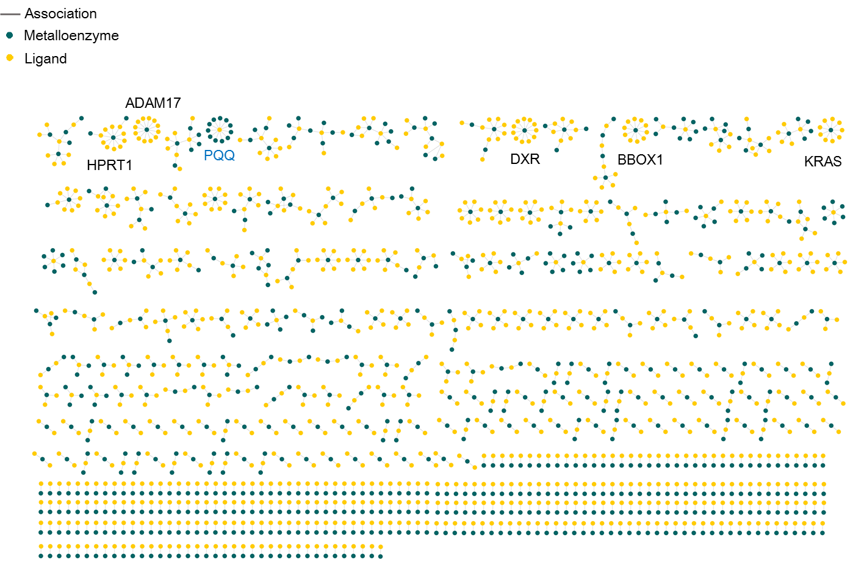

Figure S1. Complementary metalloenzyme-ligand associations to Figure 1.

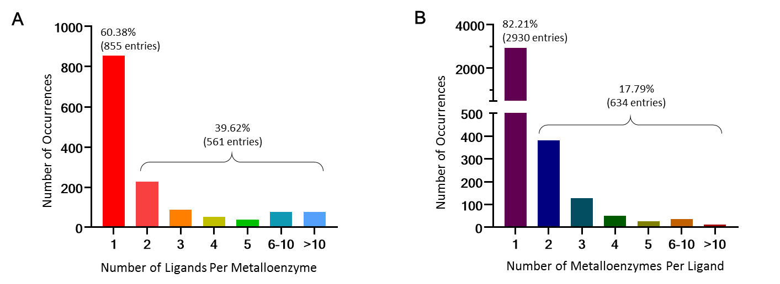

Figure S2. Database statistics. (A) Each bar represents the number of metalloenzymes for which there have a certain number of binding ligands in MeLAD. (B) Each bar shows the number of ligands for which there have a certain number of associated metalloenzymes in the database.

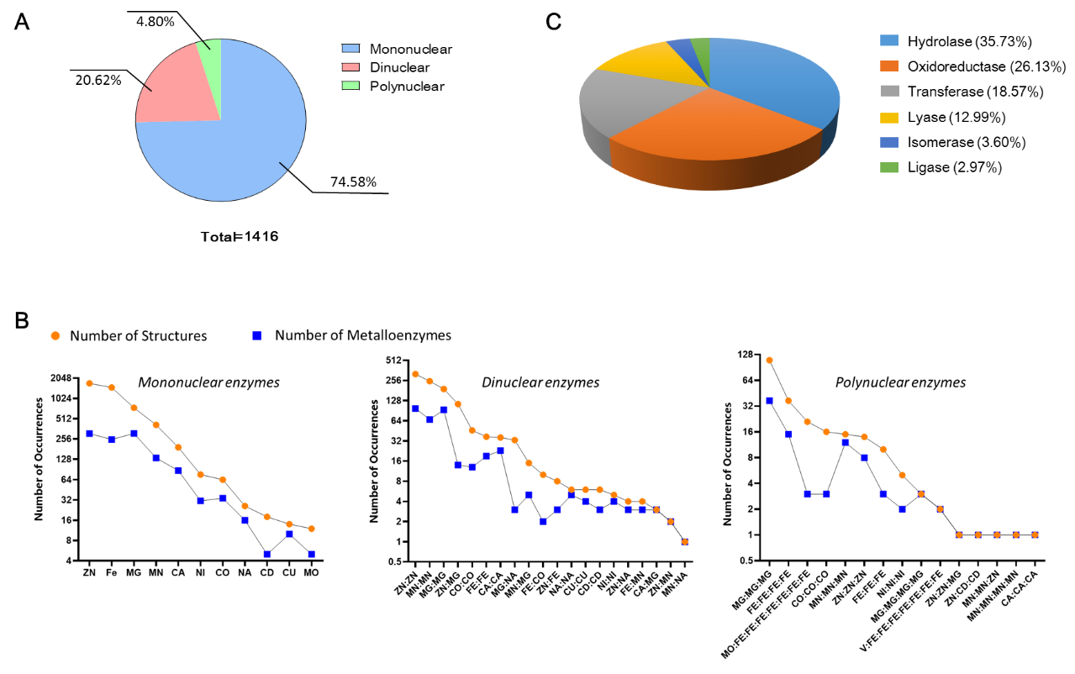

Figure S3. Statistic data for metalloenzymes. (A) Distribution of metalloenzymes according to mono-, bi-, and poly-nuclear classification. (B) Number of metalloenzyme or structure entries corresponding to active site metal ions. (C) Distribution of metalloenzymes according to the EC classes, i.e. hydrolase, oxidoreductase, transferase, lyase, isomerase, and ligase.

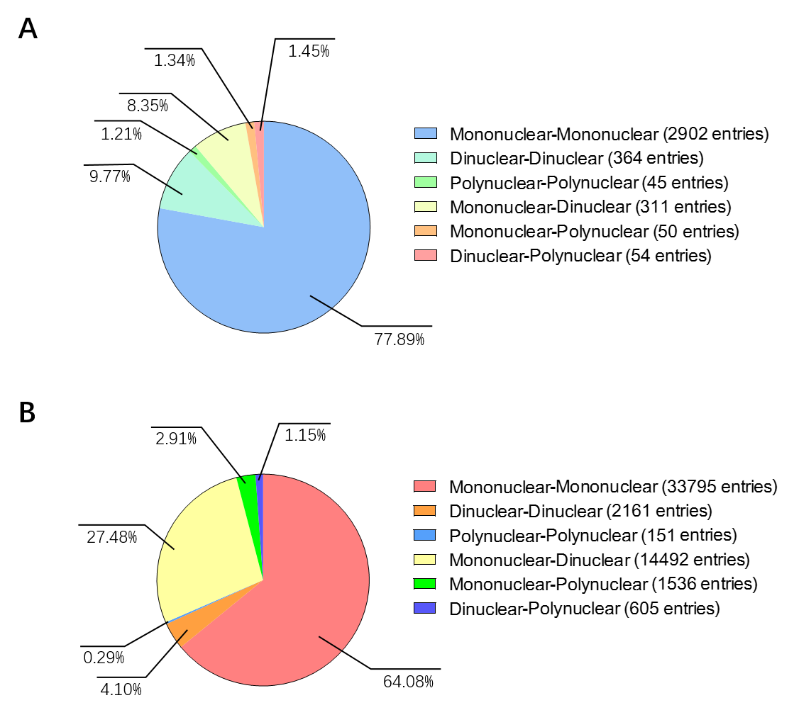

Figure S4. Statistic data for MeSIM and LigSIM results. (A) Distribution of structurally metalloenzyme related associations between/cross mono-, bi-, and poly-nuclear enzymes. (B) Distribution of ligand similarity related associations for mono-, bi-, and poly-nuclear enzymes.

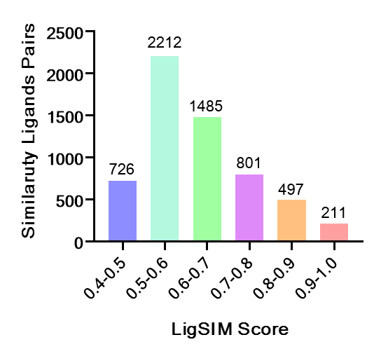

Figure S5. Distribution of similar ligand pairs to LigSIM scores.

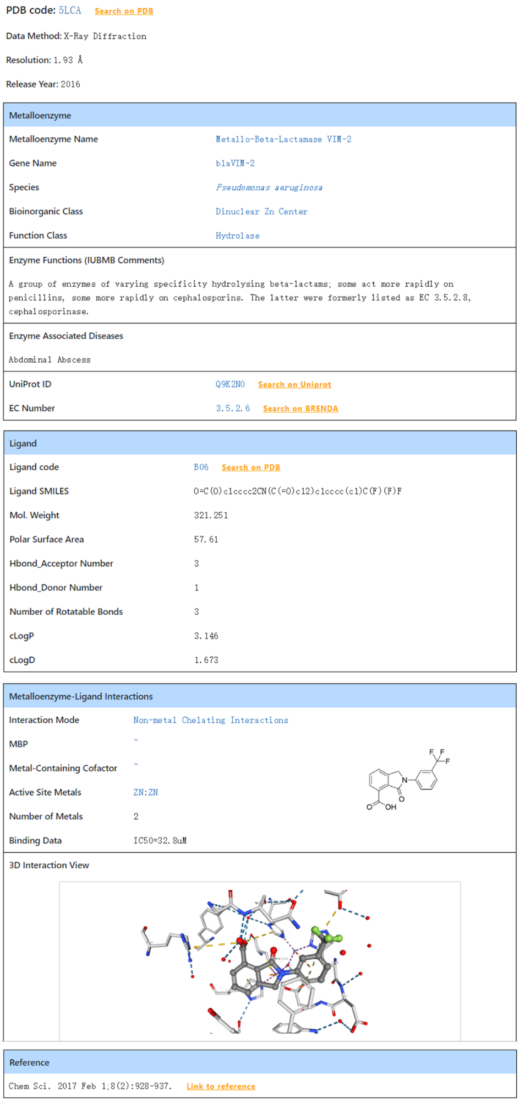

Figure S6. The detailed information page for an example.

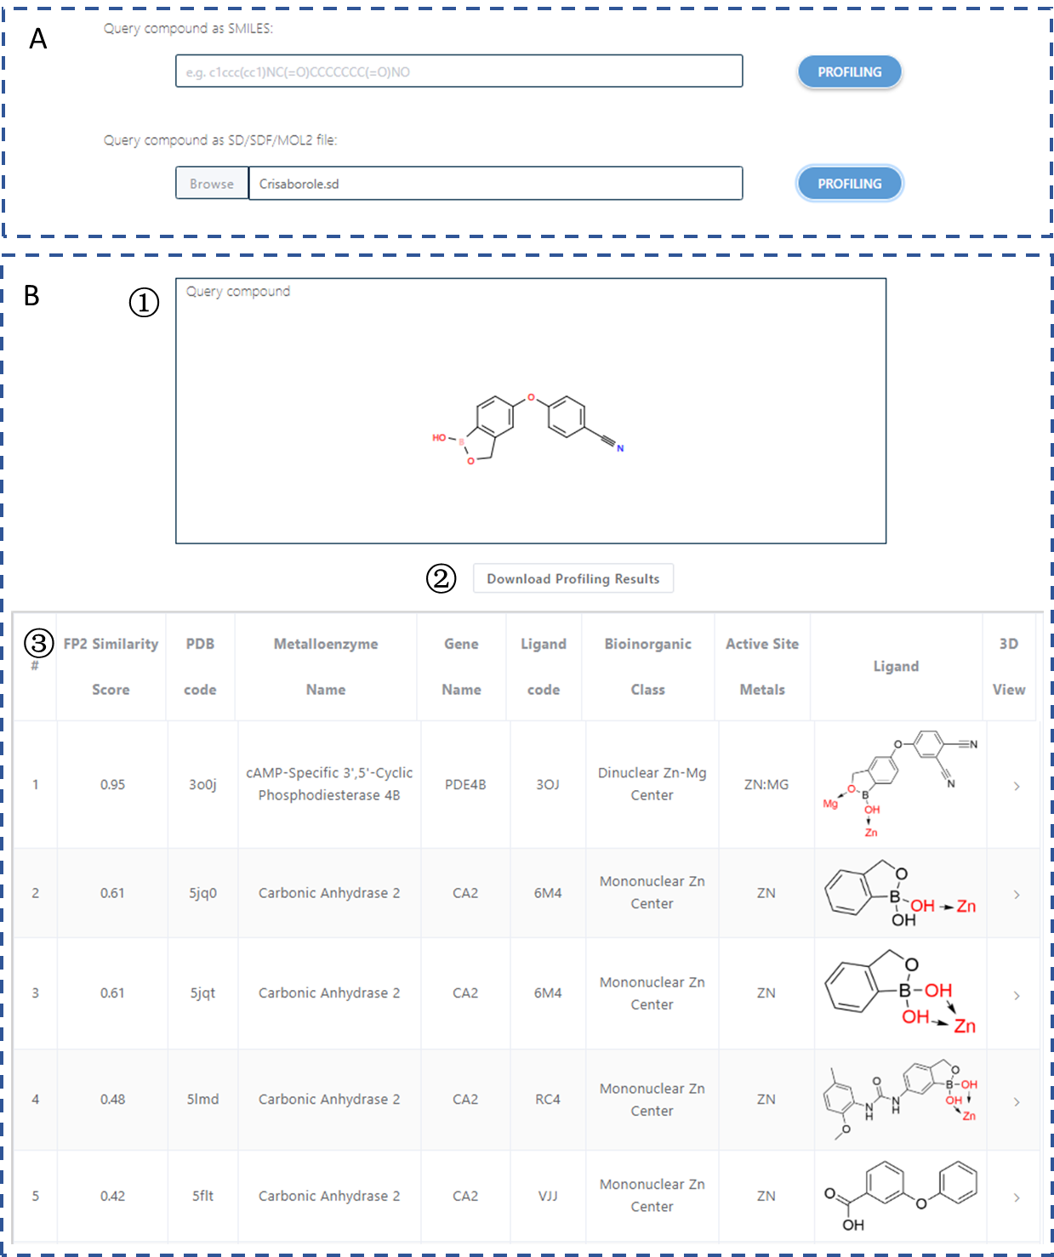

Figure S7. An example of metalloenzyme profiling for Crisaborole (Li, et al., 2018; Paton, 2017). (A) User interface. Users can query a molecule using canonical SMILES strings or sd/sdf/mol2 files. Once a molecule is uploaded, clicking ‘PROFILING’ tab will yield metalloenzyme profiling results. (B) The profiling results. ① The chemical structure of the query compound. ② The link to download the profiling results. ③ The information of resulted metalloenzymes ranked by FP2 fingerprint similarity; user can directly compare chemical similarity, MBP chemotypes, coordination modes, and binding modes.

Additional Tables

Table S1. The metal-involving cofactor identifiers in PDB database.
Metal ion | Records in the given PDB file | Ligand codes in PDB database
Magnesium (Mg) | MG | MD9, BCL, CLA, BCB, CHL, CL0, PMR, HEG, CL7, 68G, AOH, GB0, GBF
Vanadium (V) | V | VN4, VVO, 8P8, D6N
Manganese (Mn) | MN, MN3 | MNH, MH2, 76R,OEX, OEC, MNR, HNN
Iron (Fe) | FE, FE2 | SF4, FCO, FEO, ICS, NFU, FNE, FSO, CFO, FSX, FEA, NTE, FE9, OFO, HC1, VER, YOM, OFE, NWN, 402, 6CQ, 4HE, CCH, DDH, HC0, CN1, CNB, CNF, YOK, YOL, HCN, BTF, WPC, 0KA, ISW, FS5, ICE, ICG, ICH, 4WV, 4WW, 4WX, 82N, 6CO, FFE, 9SQ, HEM, FES, HEC, F3S, HEA, FCO, FEO, SRM, HDD, HAS, CLF, DHE, NFV, SF3, CFM, HEB, F4S, HDE, WCC, XCC, FDE, 9S8, CFN, FEC, NFS, MH0, 1CL, HEV, FSF, FMI, HKL, S3F, SFS, 6ML, FEL, CLP, NFE, NFC, NFO, FDD, 6HE, 7HE, VEA, 8JU, CUV, HE6, HIF, HDM, HCO, HFM, 2FH, 1FH, FS2, NFR, CLN, POR, HME, CZL, UFE, OBV, N7H, 522, 6WF, HP5, Q46, 8P8, 83L, WUP, WXP, WYP, WVP, 89R, FS0, BF8, BJ8, D6N, ER2
Cobalt (Co) | CO, 3CO | J1R, J1S, SIR, B12, COH, BVQ, CNC, CBY, COB, COY, DEU, I2A, B1Z, OBL, PC3, B1M, B13, HCB, 9QQ
Nickel (Ni) | NI, 3NI | NFU, FNE, NWN, PNI, 82N, F43, NFV, HNI, WCC, XCC, NFS, NFE, NFC, NFO, CUV, NFR, M43, BF8
Copper (Cu) | CU, CU1, CUA | CUZ, MP1, CUL, C2O, C1O, CUM, CUN, CUB, C2C, PCU
Zinc (Zn) | ZN | DTZ, HE5, 2GO, ZND, HES, BAZ, BOZ, DOZ, DAZ, 7BU, 9D7, ZNH, ZEM
Molybdenum (Mo) | MO, 6MO, 4MO | MOS, ICS, 2MO, MOM, SMO, MOW, RMO, ICE, ICG, ICH, CFM, CFN, CUM, 4SM
Tungsten (W) | W | 6WO

Table S2. Statistic data for MBP chemotypes.
MBP ID | MBP Chemical Structure | Number of Metalloenzymes / Structures | MBP ID | MBP Chemical Structure | Number of Metalloenzymes / Structures
1-1-1 |  | 43/71 | 1-2-107 |  | 1/1
1-1-2 |  | 3/3 | 1-2-108 |  | 1/2
1-1-3 |  | 1/1 | 1-3-1 |  | 45/108
1-1-4 |  | 1/1 | 1-3-2 |  | 1/1
1-1-5 |  | 3/4 | 1-3-3 |  | 1/3
1-1-6 |  | 7/13 | 1-3-4 |  | 2/4
1-1-7 |  | 2/3 | 1-3-5 |  | 1/1
1-1-8 |  | 5/9 | 1-3-6 |  | 2/2
1-1-9 |  | 3/3 | 1-3-7 |  | 2/5
1-1-10 |  | 3/3 | 1-3-8 |  | 1/1
1-1-11 |  | 3/5 | 1-3-9 |  | 1/1
1-1-12 |  | 4/21 | 1-3-10 |  | 1/1
1-1-13 |  | 12/18 | 1-3-11 |  | 1/2
1-1-14 |  | 2/7 | 1-3-12 |  | 2/2
1-1-15 |  | 2/4 | 1-3-13 |  | 1/1
1-1-16 |  | 1/2 | 1-3-14 |  | 1/4
1-1-17 |  | 6/8 | 1-3-15 |  | 1/1
1-1-18 |  | 1/2 | 1-3-16 |  | 2/3
1-1-19 |  | 33/42 | 1-3-17 |  | 1/1
1-1-20 |  | 1/1 | 1-3-18 |  | 1/3
1-1-21 |  | 3/4 | 1-3-19 |  | 1/1
1-1-22 |  | 7/8 | 1-4-1 |  | 1/1
1-1-23 |  | 7/12 | 1-4-2 |  | 1/1
1-1-24 |  | 7/9 | 1-4-3 |  | 1/1
1-1-25 |  | 3/4 | 1-4-4 |  | 1/1
1-1-26 |  | 33/71 | 1-4-5 |  | 1/1
1-1-27 |  | 1/1 | 1-5-1 |  | 1/2
1-1-28 |  | 4/4 | 1-6-1 |  | 3/4
1-1-29 |  | 3/5 | 2-1-1 |  | 12/16
1-1-30 |  | 1/3 | 2-1-2 |  | 1/1
1-1-31 |  | 1/1 | 2-1-3 |  | 22/38
1-1-32 |  | 4/8 | 2-1-4 |  | 12/28
1-1-33 |  | 6/9 | 2-1-5 |  | 14/27
1-1-34 |  | 18/24 | 2-1-6 |  | 58/127
1-1-35 |  | 3/3 | 2-1-7 |  | 6/16
1-1-36 |  | 137/228 | 2-1-8 |  | 5/7
1-1-37 |  | 35/65 | 2-1-9 |  | 101/315
1-1-38 |  | 21/42 | 2-1-10 |  | 1/1
1-1-39 |  | 10/20 | 2-1-11 |  | 7/19
1-1-40 |  | 6/21 | 2-1-12 |  | 6/6
1-1-41 |  | 1/2 | 2-1-13 |  | 1/1
1-1-42 |  | 8/9 | 2-1-14 |  | 1/2
1-1-43 |  | 1/1 | 2-1-15 |  | 4/4
1-1-44 |  | 6/9 | 2-1-16 |  | 1/1
1-1-45 |  | 2/2 | 2-1-17 |  | 2/4
1-1-46 |  | 1/1 | 2-1-18 |  | 3/6
1-1-47 |  | 6/37 | 2-1-19 |  | 2/5
1-1-48 |  | 1/1 | 2-1-20 |  | 2/2
1-1-49 |  | 1/1 | 2-1-21 |  | 3/8
1-1-50 |  | 1/1 | 2-1-22 |  | 6/12
1-1-51 |  | 1/2 | 2-1-23 |  | 2/2
1-1-52 |  | 1/1 | 2-1-24 |  | 1/1
1-1-53 |  | 1/2 | 2-1-25 |  | 1/1
1-1-54 |  | 1/1 | 2-1-26 |  | 1/1
1-1-55 |  | 1/1 | 2-1-27 |  | 136/317
1-1-56 |  | 2/9 | 2-1-28 |  | 2/2
1-1-57 |  | 1/1 | 2-1-29 |  | 4/4
1-1-58 |  | 1/1 | 2-1-30 |  | 21/24
1-1-59 |  | 4/4 | 2-1-31 |  | 13/16
1-1-60 |  | 1/1 | 2-1-32 |  | 16/86
1-1-61 |  | 1/2 | 2-1-33 |  | 1/2
1-1-62 |  | 1/1 | 2-1-34 |  | 6/8
1-1-63 |  | 1/1 | 2-1-35 |  | 1/2
1-1-64 |  | 1/2 | 2-1-36 |  | 1/1
1-1-65 |  | 4/5 | 2-1-37 |  | 1/3
1-1-66 |  | 2/2 | 2-1-38 |  | 2/2
1-1-67 |  | 5/6 | 2-1-39 |  | 3/11
1-1-68 |  | 2/4 | 2-1-40 |  | 2/2
1-1-69 |  | 2/2 | 2-1-41 |  | 6/13
1-1-70 |  | 1/2 | 2-1-42 |  | 2/2
1-1-71 |  | 1/2 | 2-1-43 |  | 3/4
1-1-72 |  | 1/1 | 2-1-44 |  | 1/2
1-1-73 |  | 1/1 | 2-1-45 |  | 1/2
1-1-74 |  | 11/19 | 2-1-46 |  | 1/4
1-1-75 |  | 4/9 | 2-1-47 |  | 1/5
1-1-76 |  | 3/5 | 2-1-48 |  | 7/14
1-1-77 |  | 8/16 | 2-1-49 |  | 11/20
1-1-78 |  | 1/1 | 2-1-50 |  | 2/2
1-1-79 |  | 2/7 | 2-1-51 |  | 1/1
1-1-80 |  | 1/1 | 2-1-52 |  | 1/1
1-1-81 |  | 1/1 | 2-1-53 |  | 1/1
1-1-82 |  | 2/3 | 2-1-54 |  | 1/2
1-1-83 |  | 2/2 | 2-1-55 |  | 1/1
1-1-84 |  | 1/1 | 2-1-56 |  | 1/1
1-1-85 |  | 1/1 | 2-1-57 |  | 1/1
1-1-86 |  | 2/2 | 2-1-58 |  | 1/1
1-1-87 |  | 9/15 | 2-1-59 |  | 5/10
1-1-88 |  | 1/5 | 2-1-60 |  | 4/6
1-1-89 |  | 1/4 | 2-1-61 |  | 21/91
1-1-90 |  | 1/1 | 2-1-62 |  | 2/4
1-1-91 |  | 2/2 | 2-1-63 |  | 10/28
1-1-92 |  | 1/1 | 2-1-64 |  | 3/4
1-1-93 |  | 1/1 | 2-1-65 |  | 2/4
1-1-94 |  | 1/1 | 2-1-66 |  | 1/1
1-1-95 |  | 1/3 | 2-1-67 |  | 1/1
1-1-96 |  | 1/1 | 2-1-68 |  | 1/2
1-1-97 |  | 1/1 | 2-1-69 |  | 1/1
1-1-98 |  | 1/1 | 2-1-70 |  | 1/1
1-1-99 |  | 2/5 | 2-1-71 |  | 2/3
1-1-100 |  | 1/1 | 2-1-72 |  | 10/22
1-1-101 |  | 3/4 | 2-1-73 |  | 1/2
1-1-102 |  | 2/3 | 2-1-74 |  | 1/1
1-1-103 |  | 1/1 | 2-1-75 |  | 1/1
1-1-104 |  | 2/2 | 2-1-76 |  | 1/1
1-1-105 |  | 2/2 | 2-1-77 |  | 1/1
1-1-106 |  | 1/1 | 2-1-78 |  | 2/3
1-1-107 |  | 5/11 | 2-1-79 |  | 2/2
1-1-108 |  | 1/1 | 2-1-80 |  | 2/4
1-1-109 |  | 2/2 | 2-1-81 |  | 1/2
1-1-110 |  | 1/1 | 2-1-82 |  | 2/2
1-1-111 |  | 1/1 | 2-1-83 |  | 2/2
1-1-112 |  | 1/1 | 2-1-84 |  | 4/8
1-1-113 |  | 1/1 | 2-1-85 |  | 2/23
1-1-114 |  | 1/2 | 2-1-86 |  | 2/2
1-1-115 |  | 3/3 | 2-1-87 |  | 2/3
1-1-116 |  | 1/1 | 2-1-88 |  | 3/5
1-1-117 |  | 1/1 | 2-1-89 |  | 1/1
1-1-118 |  | 1/1 | 2-1-90 |  | 1/1
1-1-119 |  | 2/4 | 2-1-91 |  | 1/1
1-1-120 |  | 1/1 | 2-1-92 |  | 1/1
1-1-121 |  | 1/2 | 2-1-93 |  | 1/1
1-1-122 |  | 1/2 | 2-1-94 |  | 2/5
1-1-123 |  | 1/1 | 2-1-95 |  | 1/1
1-1-124 |  | 1/2 | 2-1-96 |  | 1/1
1-1-125 |  | 2/4 | 2-1-97 |  | 1/1
1-1-126 |  | 1/1 | 2-1-98 |  | 1/1
1-1-127 |  | 5/7 | 2-1-99 |  | 2/9
1-1-128 |  | 1/2 | 2-1-100 |  | 2/2
1-1-129 |  | 1/2 | 2-1-101 |  | 1/1
1-2-1 |  | 9/15 | 2-1-102 |  | 3/3
1-2-2 |  | 1/1 | 2-1-103 |  | 3/4
1-2-3 |  | 1/1 | 2-1-104 |  | 1/3
1-2-4 |  | 1/2 | 2-1-105 |  | 1/1
1-2-5 |  | 1/1 | 2-1-106 |  | 1/1
1-2-6 |  | 1/1 | 2-1-107 |  | 2/3
1-2-7 |  | 1/1 | 2-1-108 |  | 1/2
1-2-8 |  | 2/2 | 2-2-1 |  | 5/14
1-2-9 |  | 2/2 | 2-2-2 |  | 6/7
1-2-10 |  | 2/3 | 2-2-3 |  | 1/1
1-2-11 |  | 1/1 | 2-2-4 |  | 1/1
1-2-12 |  | 1/1 | 2-2-5 |  | 1/1
1-2-13 |  | 5/9 | 2-2-6 |  | 1/1
1-2-14 |  | 1/1 | 2-2-7 |  | 6/20
1-2-15 |  | 2/3 | 2-2-8 |  | 2/2
1-2-16 |  | 23/61 | 2-2-9 |  | 1/1
1-2-17 |  | 1/2 | 2-2-10 |  | 1/1
1-2-18 |  | 2/2 | 2-2-11 |  | 6/13
1-2-19 |  | 1/1 | 2-2-12 |  | 11/14
1-2-20 |  | 1/1 | 2-2-13 |  | 1/1
1-2-21 |  | 1/1 | 2-2-14 |  | 1/2
1-2-22 |  | 1/1 | 2-2-15 |  | 3/8
1-2-23 |  | 1/1 | 2-2-16 |  | 1/1
1-2-24 |  | 1/6 | 2-2-17 |  | 1/1
1-2-25 |  | 1/1 | 2-2-18 |  | 1/1
1-2-26 |  | 31/70 | 2-2-19 |  | 1/1
1-2-27 |  | 1/1 | 2-2-20 |  | 1/1
1-2-28 |  | 23/32 | 2-2-21 |  | 1/2
1-2-29 |  | 1/5 | 2-2-22 |  | 2/14
1-2-30 |  | 4/4 | 2-2-23 |  | 1/3
1-2-31 |  | 1/1 | 2-2-24 |  | 1/1
1-2-32 |  | 1/4 | 2-2-25 |  | 1/1
1-2-33 |  | 1/1 | 2-2-26 |  | 1/1
1-2-34 |  | 1/1 | 2-2-27 |  | 17/19
1-2-35 |  | 9/33 | 2-2-28 |  | 3/5
1-2-36 |  | 1/1 | 2-2-29 |  | 1/1
1-2-37 |  | 1/1 | 2-2-30 |  | 1/1
1-2-38 |  | 2/7 | 2-2-31 |  | 1/2
1-2-39 |  | 2/2 | 2-2-32 |  | 1/1
1-2-40 |  | 4/6 | 2-2-33 |  | 1/1
1-2-41 |  | 1/1 | 2-2-34 |  | 1/1
1-2-42 |  | 2/2 | 2-2-35 |  | 1/12
1-2-43 |  | 5/9 | 2-2-36 |  | 7/12
1-2-44 |  | 1/4 | 2-2-37 |  | 1/1
1-2-45 |  | 1/1 | 2-2-38 |  | 1/7
1-2-46 |  | 1/2 | 2-2-39 |  | 1/1
1-2-47 |  | 1/2 | 2-2-40 |  | 1/1
1-2-48 |  | 1/1 | 2-2-41 |  | 2/2
1-2-49 |  | 1/1 | 2-2-42 |  | 1/1
1-2-50 |  | 4/4 | 2-2-43 |  | 2/17
1-2-51 |  | 1/2 | 2-2-44 |  | 1/1
1-2-52 |  | 1/2 | 2-3-1 |  | 3/7
1-2-53 |  | 3/4 | 2-3-2 |  | 3/5
1-2-54 |  | 3/3 | 2-3-3 |  | 1/1
1-2-55 |  | 3/3 | 2-3-4 |  | 1/1
1-2-56 |  | 1/1 | 2-3-5 |  | 1/1
1-2-57 |  | 2/2 | 2-3-6 |  | 1/2
1-2-58 |  | 1/1 | 2-3-7 |  | 1/8
1-2-59 |  | 1/1 | 2-3-8 |  | 1/3
1-2-60 |  | 1/9 | 2-3-9 |  | 1/1
1-2-61 |  | 1/1 | 2-3-10 |  | 1/2
1-2-62 |  | 1/2 | 2-3-11 |  | 2/2
1-2-63 |  | 2/2 | 2-3-12 |  | 1/1
1-2-64 |  | 1/1 | 2-3-13 |  | 1/1
1-2-65 |  | 1/3 | 2-4-1 |  | 1/1
1-2-66 |  | 1/1 | 2-4-2 |  | 2/2
1-2-67 |  | 1/1 | 2-4-3 |  | 6/8
1-2-68 |  | 1/1 | 2-4-4 |  | 1/2
1-2-69 |  | 3/8 | 2-4-5 |  | 1/1
1-2-70 |  | 1/1 | 2-4-6 |  | 1/1
1-2-71 |  | 2/3 | 2-4-7 |  | 2/2
1-2-72 |  | 1/1 | 2-4-8 |  | 1/1
1-2-73 |  | 1/1 | 2-4-9 |  | 1/1
1-2-74 |  | 1/5 | 2-4-10 |  | 3/3
1-2-75 |  | 2/2 | 2-4-11 |  | 6/15
1-2-76 |  | 1/1 | 2-4-12 |  | 1/1
1-2-77 |  | 1/1 | 2-4-13 |  | 1/1
1-2-78 |  | 1/1 | 2-4-14 |  | 1/1
1-2-79 |  | 1/1 | 2-4-15 |  | 1/1
1-2-80 |  | 6/35 | 2-4-16 |  | 1/1
1-2-81 |  | 3/31 | 2-4-17 |  | 2/7
1-2-82 |  | 2/8 | 2-4-18 |  | 1/1
1-2-83 |  | 2/2 | 2-4-19 |  | 1/1
1-2-84 |  | 1/1 | 2-4-20 |  | 2/13
1-2-85 |  | 3/12 | 2-5-1 |  | 1/6
1-2-86 |  | 16/40 | 2-6-1 |  | 1/1
1-2-87 |  | 4/6 | 2-7-1 |  | 1/1
1-2-88 |  | 10/285 | 2-8-1 |  | 1/1
1-2-89 |  | 1/2 | 2-8-2 |  | 2/4
1-2-90 |  | 1/1 | 2-8-3 |  | 2/2
1-2-91 |  | 1/2 | 3-1-1 |  | 15/35
1-2-92 |  | 1/2 | 3-1-2 |  | 2/3
1-2-93 |  | 1/2 | 3-1-3 |  | 1/1
1-2-94 |  | 1/4 | 3-1-4 |  | 1/8
1-2-95 |  | 4/9 | 3-1-5 |  | 1/1
1-2-96 |  | 1/3 | 3-1-6 |  | 1/1
1-2-97 |  | 2/9 | 3-1-7 |  | 14/18
1-2-98 |  | 1/11 | 3-1-8 |  | 5/5
1-2-99 |  | 1/1 | 3-2-1 |  | 1/1
1-2-100 |  | 1/1 | 3-2-2 |  | 2/2
1-2-101 |  | 1/2 | 3-2-3 |  | 2/2
1-2-102 |  | 1/1 | 3-2-4 |  | 1/1
1-2-103 |  | 1/1 | 3-2-5 |  | 1/1
1-2-104 |  | 1/1 | 3-2-6 |  | 10/13
1-2-105 |  | 1/1 | 3-2-7 |  | 1/1
1-2-106 |  | 1/1

Reference
Li, H., Zuo, J. and Tang, W. (2018) Phosphodiesterase-4 Inhibitors for the Treatment of Inflammatory Diseases, Front. Pharmacol., 9, 1048.
Paton, D.M. (2017) Crisaborole: Phosphodiesterase inhibitor for treatment of atopic dermatitis, Drug. Today, 53, 239-245.

