1. Supplementary information
1.1 Web server workflow
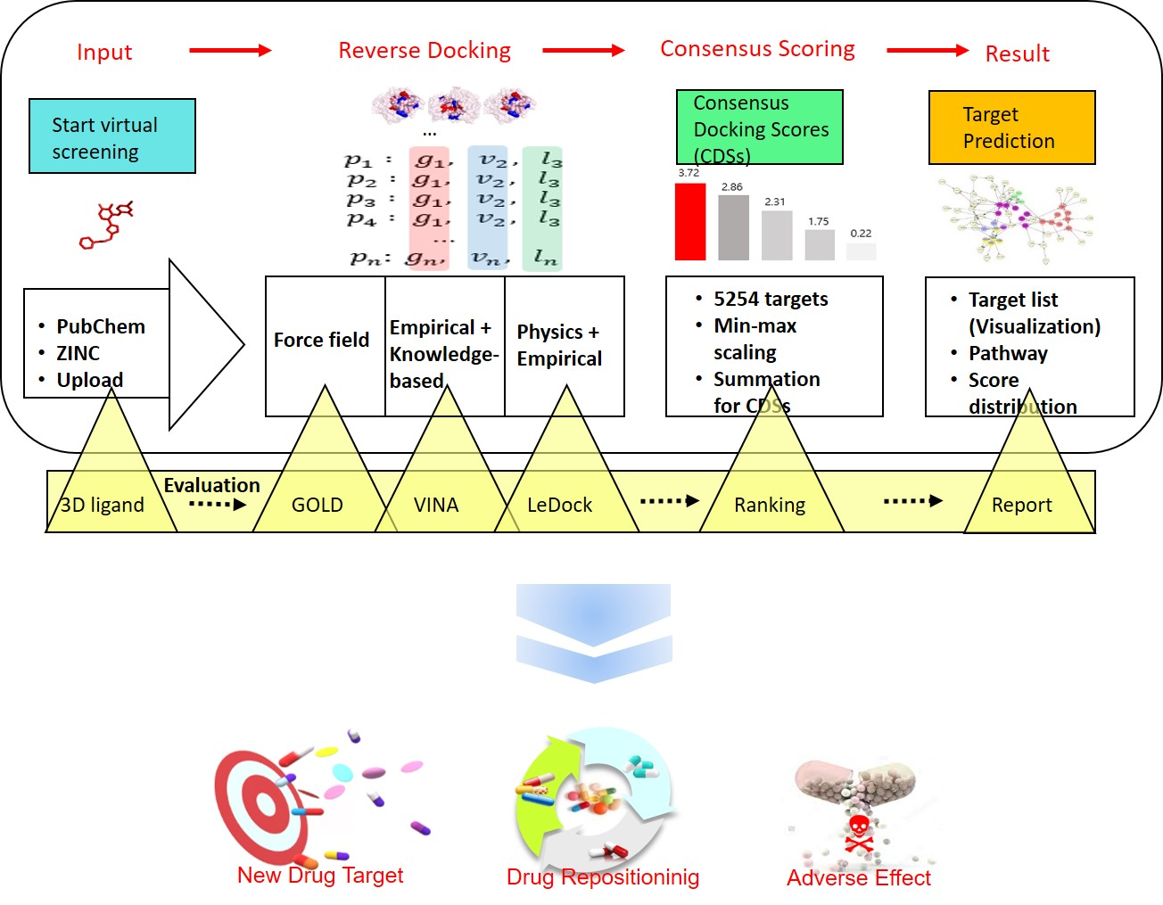
Here, we present a fully automated web-based tool named CRDS (Consensus Reverse Docking System), which can predict potential drug interaction sites for a given drug by reverse docking with consensus scores (Fig. S1). Users can query one ligand information from two well-known chemical databases or upload 3D structure file of small molecule or natural compound for interaction site screening in our job submission page. Then, CRDS carries out reverse docking with three different scoring functions (GoldScore, Vina, and LeDock from GOLD, AutoDock Vina, and LeDock, respectively) against 5,254 protein structures for a given drug information. Next, the resulting docking scores are combine into a single score named CDS (Consensus Docking Score). To do so, firstly, three docking values derived from each scoring methods are normalized using min-max scaling approach. Then, the sum of the normalized three docking values are arranged in descending order. Computational identification of drug binding partners could benefit in several ways. Better understanding of complex biological interactions accelerates of novel drug binding sites and those suggested sites could be prioritized for further investigations. The predicted target list also could be utilized as new therapeutic indications for existing drugs or used to uncover the putative adverse drug effects.
Fig. S1. Server workflow. The method of consensus scoring-based reverse docking simulation for new drug binding sites and applications of results.
1.2 Consensus Docking Score (CDS)
In CRDS, reverse docking is carried out in a large scale of 5,254 potential drug binding site database. Since the evaluation is done three times by GoldScore, Vina, and LeDock, a total of 15,762 docking simulations are performed for one ligand.
After reverse docking, GoldScore outputs docking results in terms of fitness score while Vina and LeDock yield results in terms of energy score. Therefore, firstly, we get the absolute docking values of Vina and LeDock. Next, to make a point employing three scoring functions, the three docking values will be scaled with min-max approach (Eq. 2.1) and summed to obtain a single score named CDS (Consensus Docking Score) (Fig. S2).

$z_{i}= \frac{x_{i}-min⁡(x)}{\max\left(x\right)-min⁡(x) }$ (Eq. 1.2)

where $x$ =($x_{i}$,…,$x_{n}$) and $z_{i}$ is ith normalized data. Finally, the results will be sorted in descending order to obtain the interaction sites with the high consensus scores.

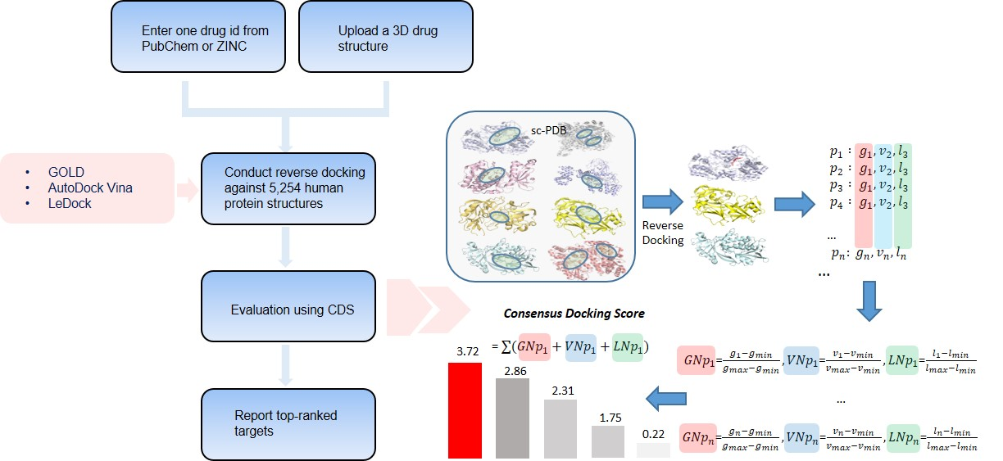
Fig. S2. A schematic diagram of consensus docking score. To make a point utilizing three scoring functions with disparate properties for evaluating protein-ligand complexes, the three values are normalized with min-max approach and summed. The results will sort from the targets with the highest consensus scores.

2. Supplementary validation results
2.1 Target retrieval
Is consensus reverse docking approach more efficient to retrieve the probable target proteins when comparing single scoring functions? We collected ligands that have target information and investigated how much the consensus scoring method would retrieve more well-known targets among 5,254 candidate targets.
To do so, we downloaded the drug and target data set from the DrugBank (http://www.drugbank.ca/) (Wishart, et al., 2008). We could match 121 drugs to binding partners by using external identifiers (UniProt IDs) based on the list of FDA-related drug names in BindingDB (http://www.bindingdb.org/) (Gilson, et al., 2016) and obtain PDB IDs.
Our strategy (CDS) retrieved more number of targets (n=242) within top ten than the existing functions (GOLD (n=119), AutoDock Vina (n=123), and LeDock (n=186)) when tested on 121 ligands with 6,311 known targets by applying min-max normalization method (Fig. S3 (a)).
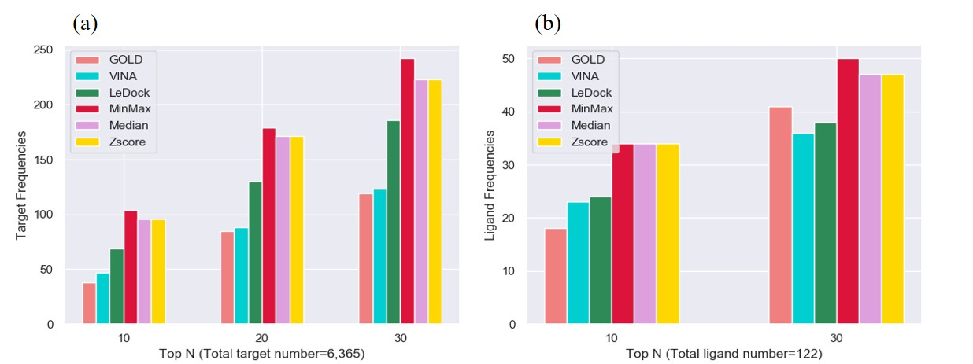
Fig. S3. The validation results for consensus docking scores. (a) Min-max normalization method was the most efficient to retrieve the known target proteins for a given ligand (top 10: GOLD=38, Vina=47, LeDock=69, min-max=104, median=96, zscore=96, top 20: GOLD=85, Vina=88, LeDock=130, min-max= 179, median=171, zscore=171, top30: GOLD=119, Vina=123, LeDock=186, min-max=242, media=223, zscore=223). (b) Min-max normalization method had the highest ligand number which predicted more than one known targets within top thirty (top10: Gold=18, Vina=23, LeDock=24, min-max, median, and zscore=34, top30: GOLD=41, Vina=36, LeDock=38, min-max=50, median and zscore=47).

Our consensus scoring scheme also recovered more number of ligands (n=34) with at least one correct target within top ten than the other functions (GOLD (n=18), AutoDock Vina (n=23), and LeDock (n=24)) (Fig. S3 (b)). We were also able to observe the rank improvement in most of the targets, which were retrieved using the CDS within top ten (Fig. S4).
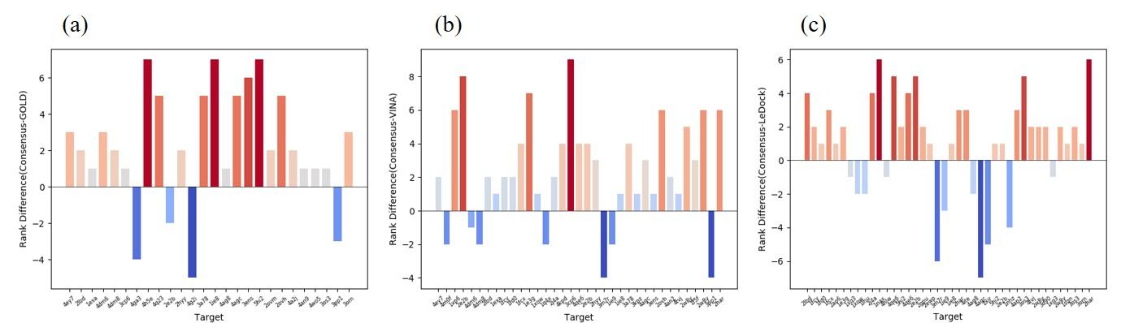
Fig. S4. Rank improvement. The most of the proteins using CDS predicted within top ten showed the rank improvement (red) in (a) GOLD, (b) Vina, and (c) LeDock (blue indicates the proteins showing the rank reduction).

2.2 Consensus scoring scheme
We compared the performance of the CDS to GOLD, Vina, and LeDock using DUD-E datasets to evaluate the reliability of consensus scoring approach in virtual screening. We wanted to observe how many actives the CDS could predict in top N results for a given set of known actives and decoys compared to other scoring schemes (GOLD, Vina, and LeDock). We downloaded all sets (all.tar.gz) (Mysinger, et al., 2012) and could obtain 76 targets (6,932 actives (binders) and 7,247 decoys (non-binders)). After reverse docking, the CDS ranked molecules based on their predicted binding affinities. The ROC (Receiver Operating Characteristic) curve was plotted for each methods to screen the number of actives found among the top N ligands against a given set of known actives and decoys. The ROC (receiver operating characteristic) statistics showed the CDS achieved the highest AUC (Area’s Under the Curve) scores (0.77) when compared to three existing scoring functions (GOLD (0.73), AutoDock Vina (0.74), and LeDock (0.68)) (Fig. S5).
For some protein groups, the CDS showed the synergistic effects (Fig. S6). The figure shows the case when the consensus docking score has the highest auc value or has the same auc value with one of the three scoring functions. The results tell us that the CDS predicted more true positives in this protein groups. Of the 76 targets, 47% corresponded to this case. For some protein groups, the CDS had mitigating effects (Fig. S7). The CDS did not have the highest auc values, but the CDS mitigated scoring bias. If one tries to predict the binding interaction between the target and the ligand with only one scoring function in large scale, the scoring bias would hinder the proper recovery of targets. This figure shows that the reverse docking with consensus docking score predicts less false positives when one wants to identify potential targets through virtual screening. Of the 76 targets, 42% corresponded to this case. Fig. S8. shows the case when not all three functions met the correct answer. Of the 76 targets, 10% corresponded to this case.
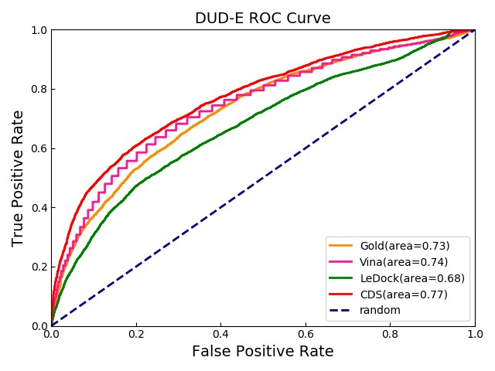
Fig. S5. The results of the ROC curve analysis. The number of actives found among the top N ligands was plotted for a given set of known actives and decoys of DUD-E (n=14,179).

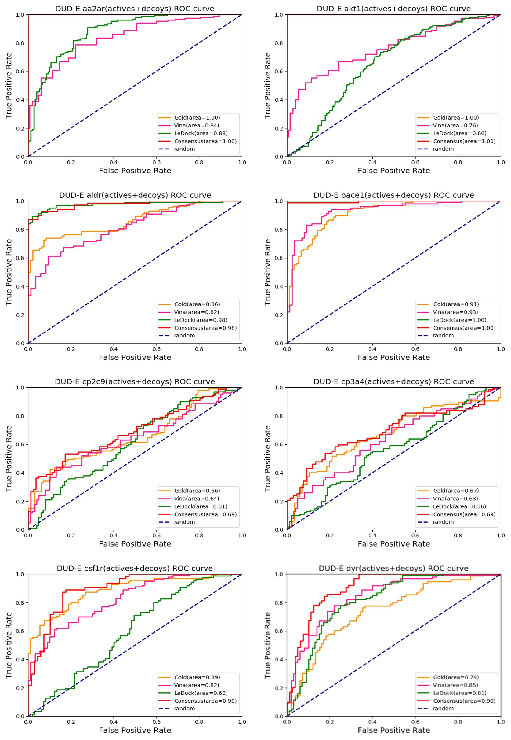
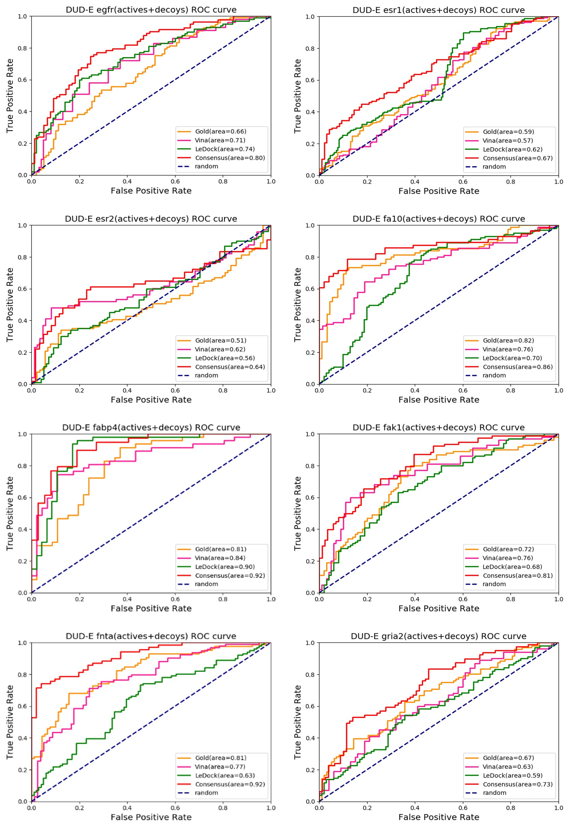
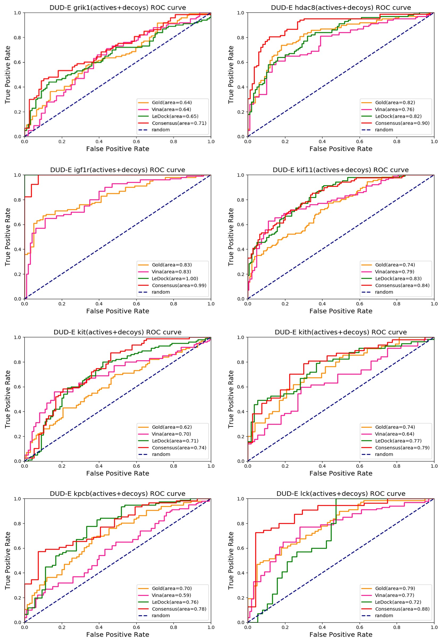
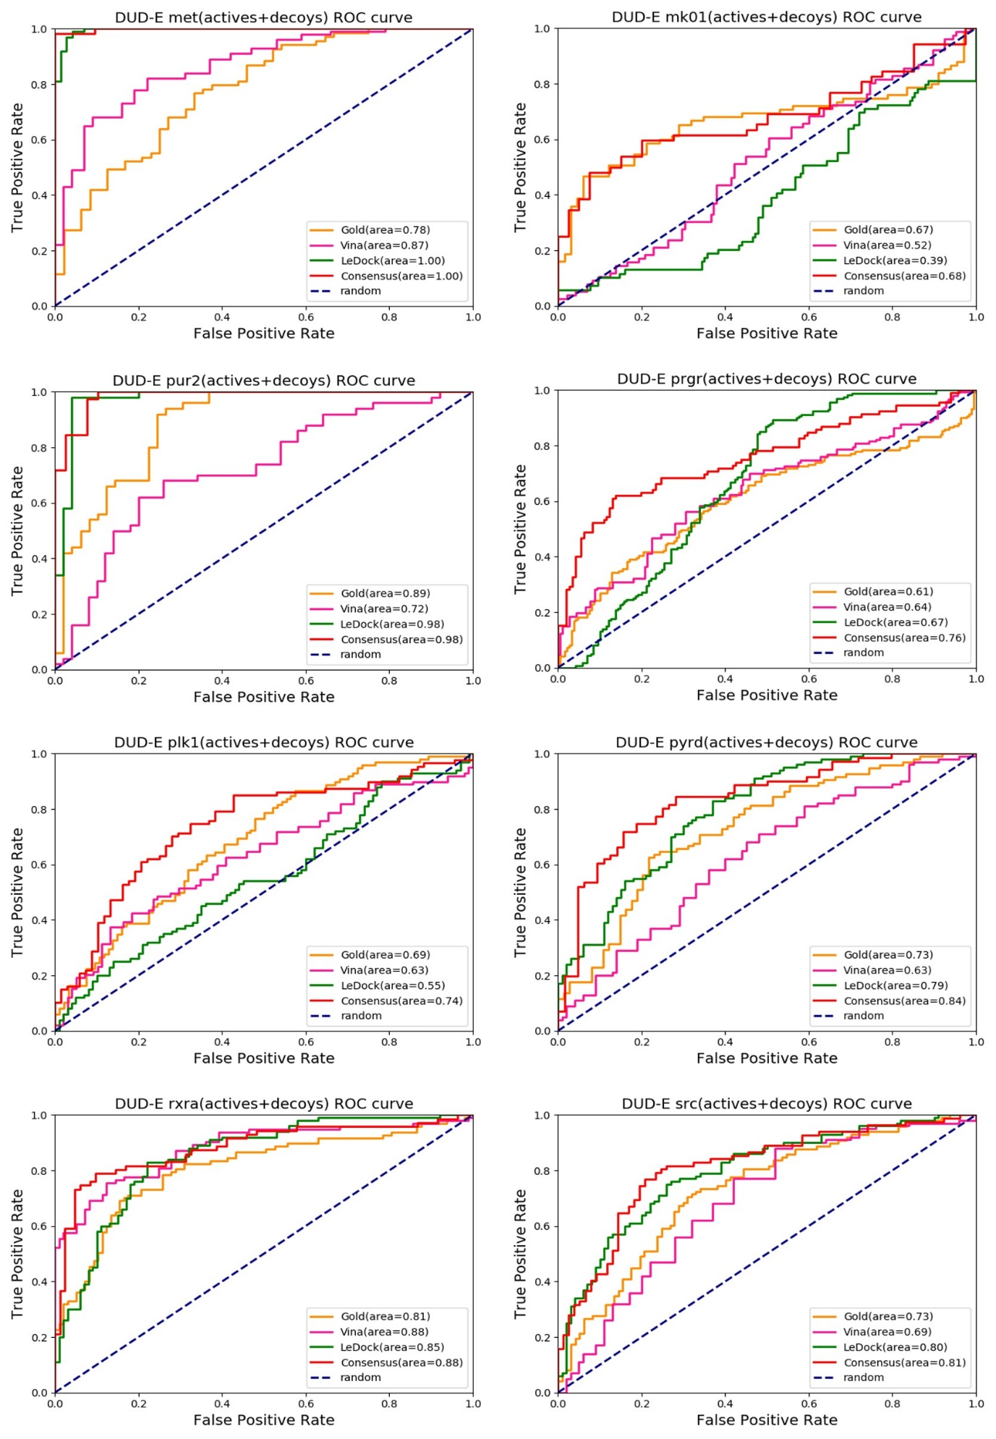
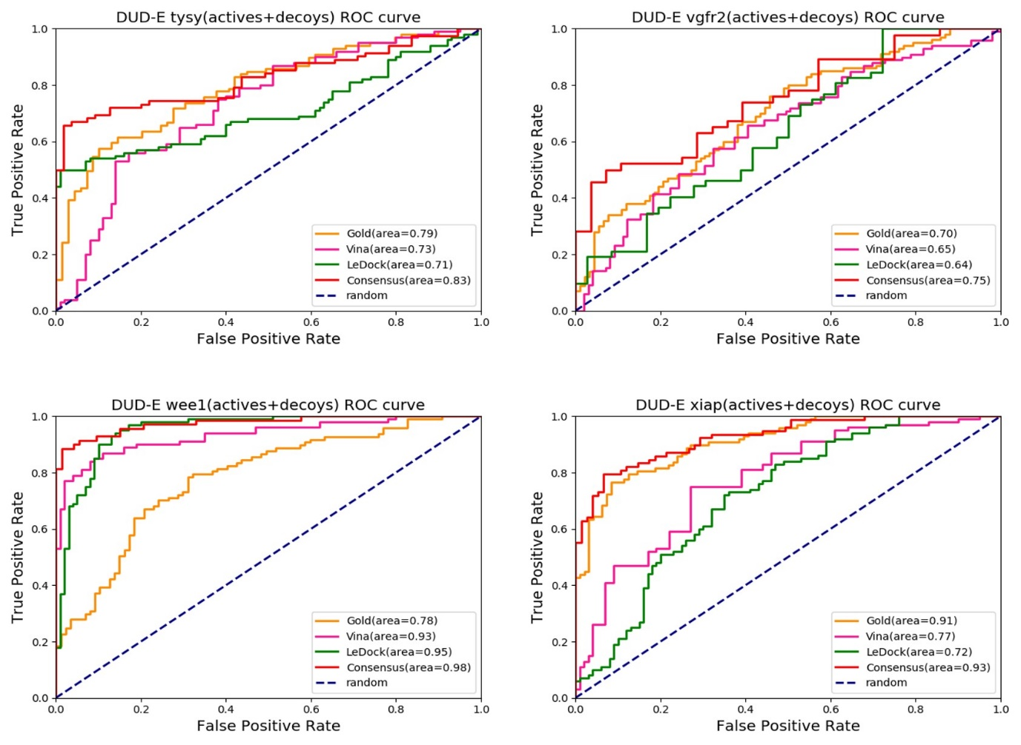
Fig. S6. The synergistic effect of the CDS. This target group shows the consensus docking score has the highest auc value among three scoring functions or the same auc value with one of the three scoring functions. This shows that the reverse docking with consensus docking score predicts more true positives when one wants to identify potential targets through virtual screening. Of the 76 targets, 47% corresponded to this case.

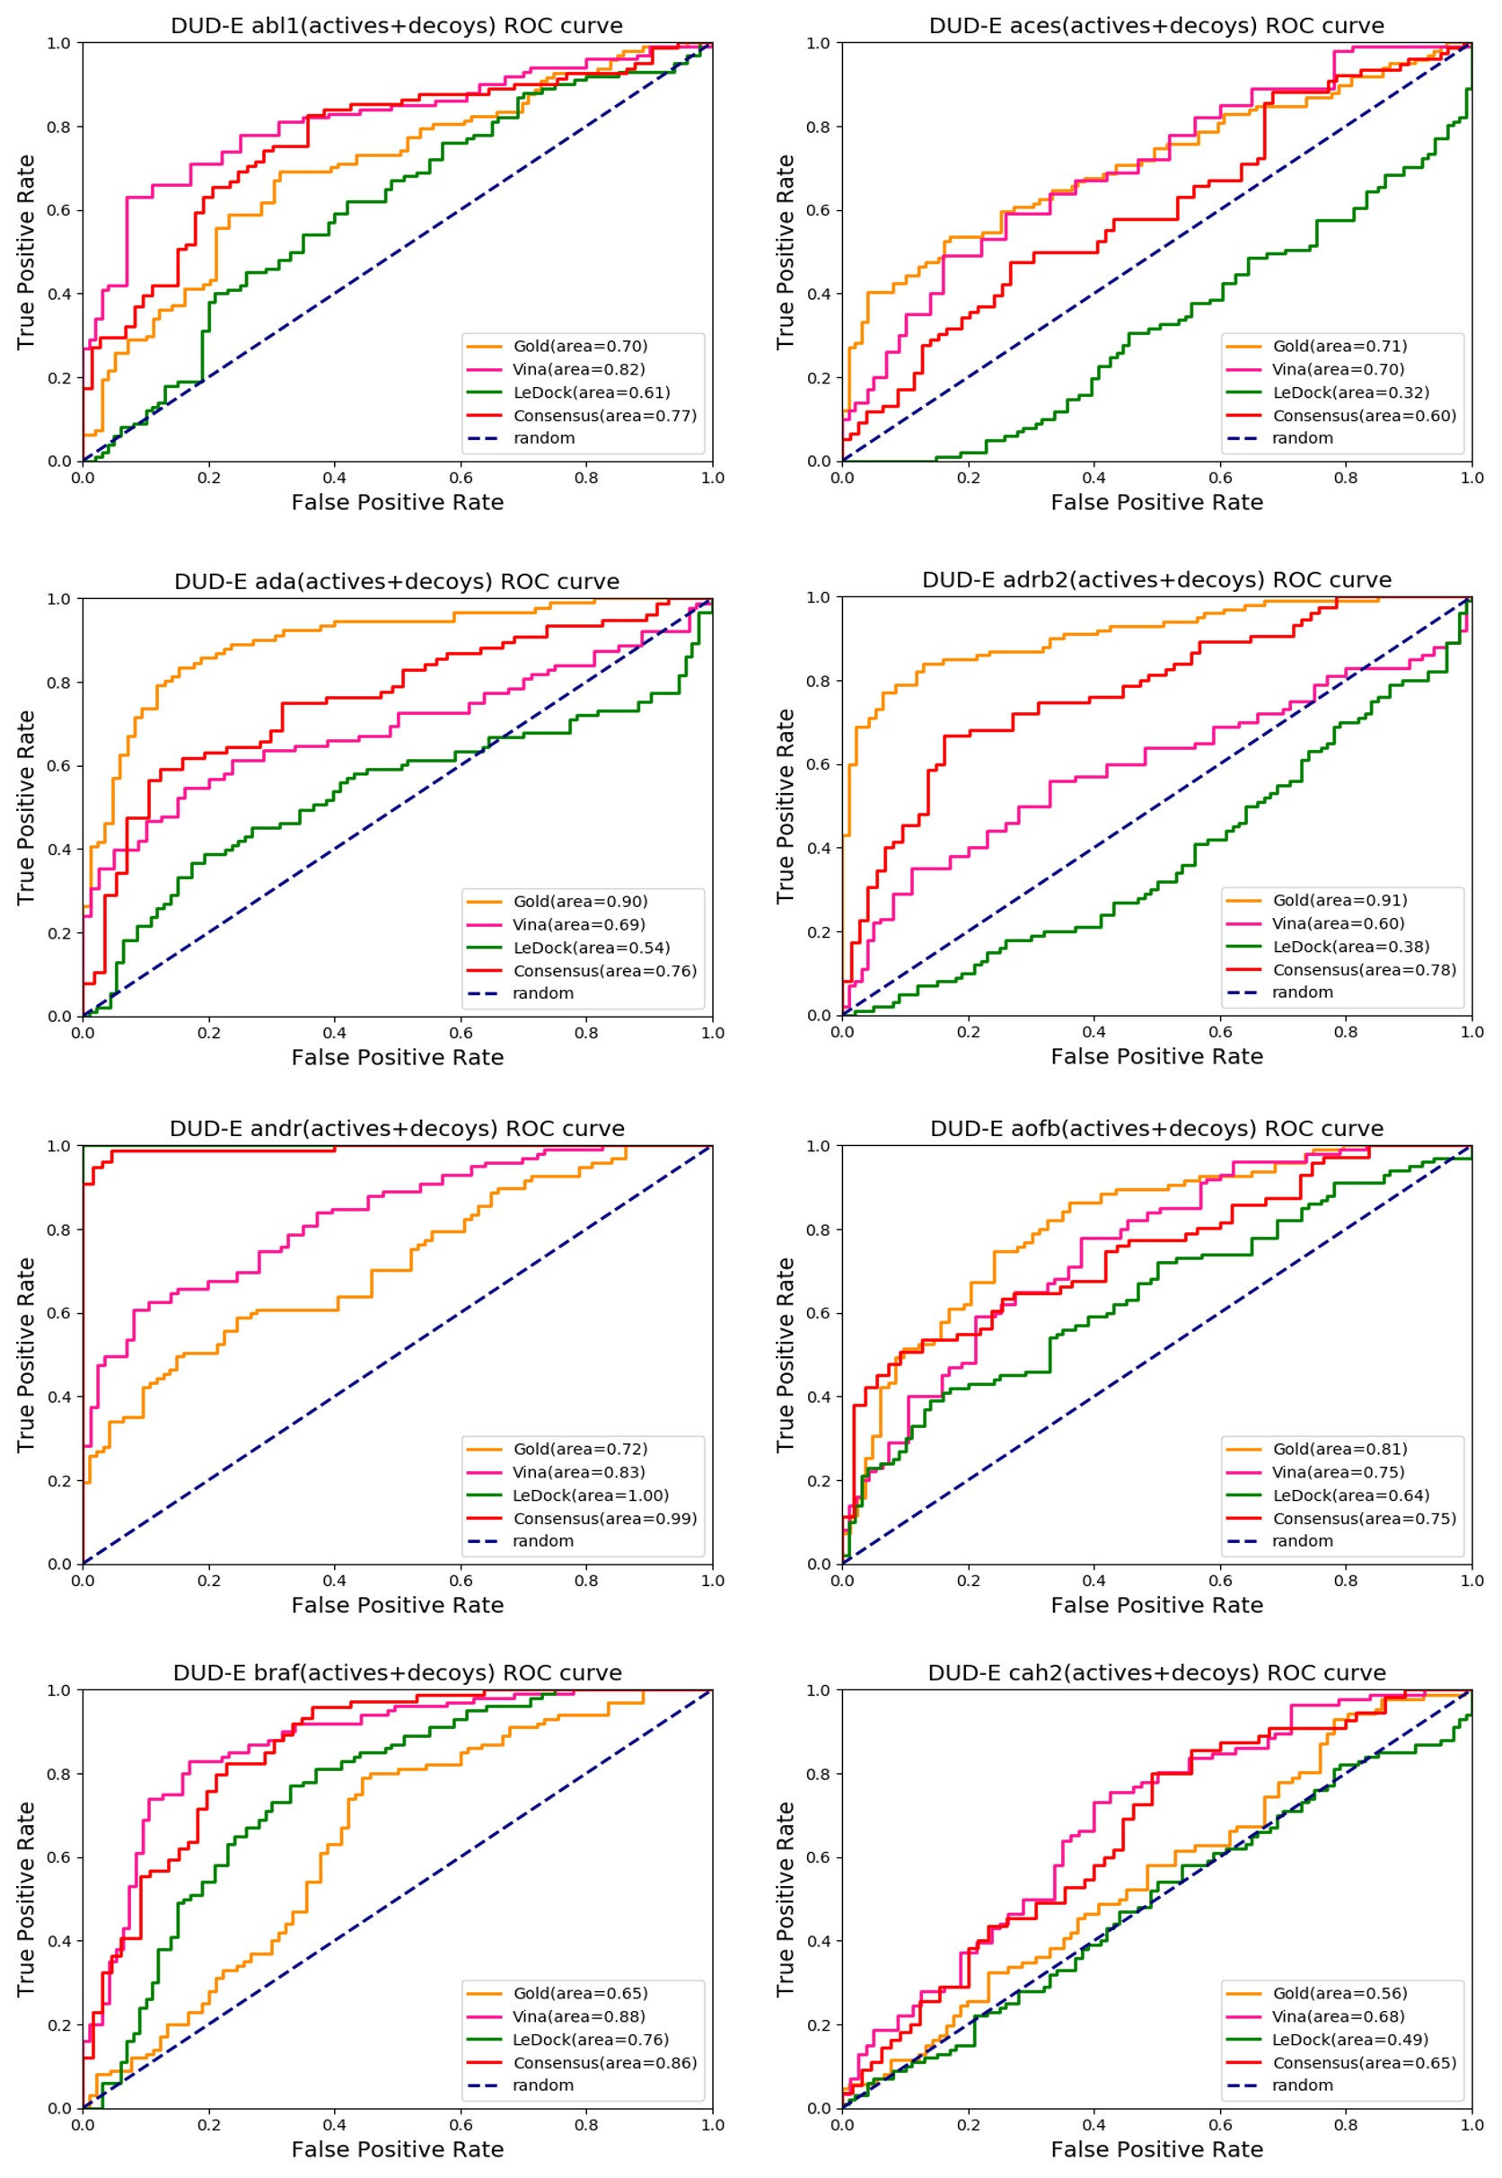
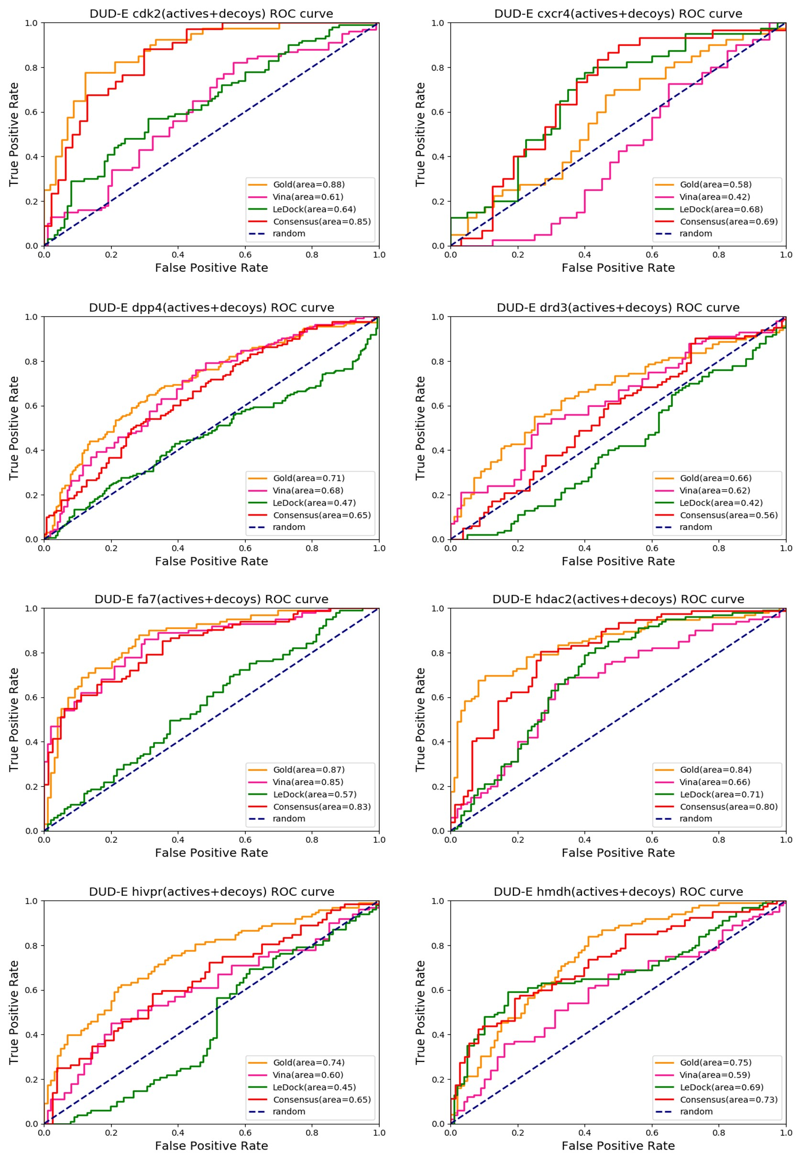
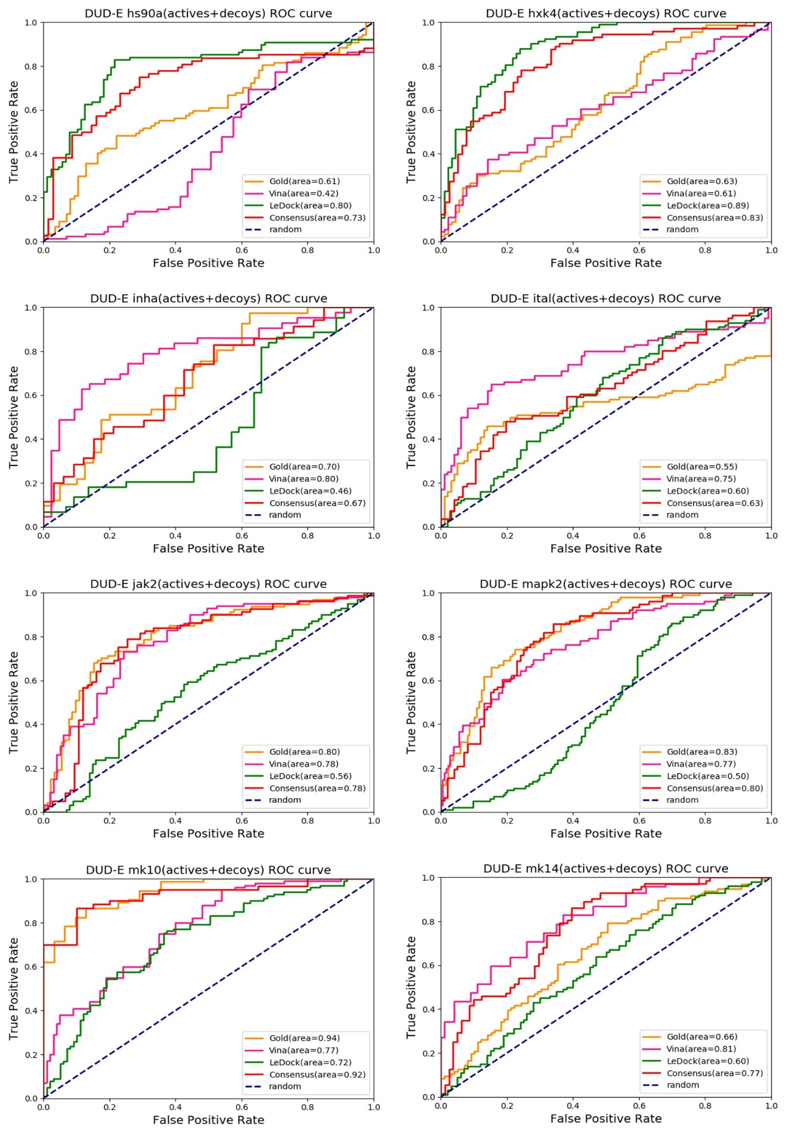
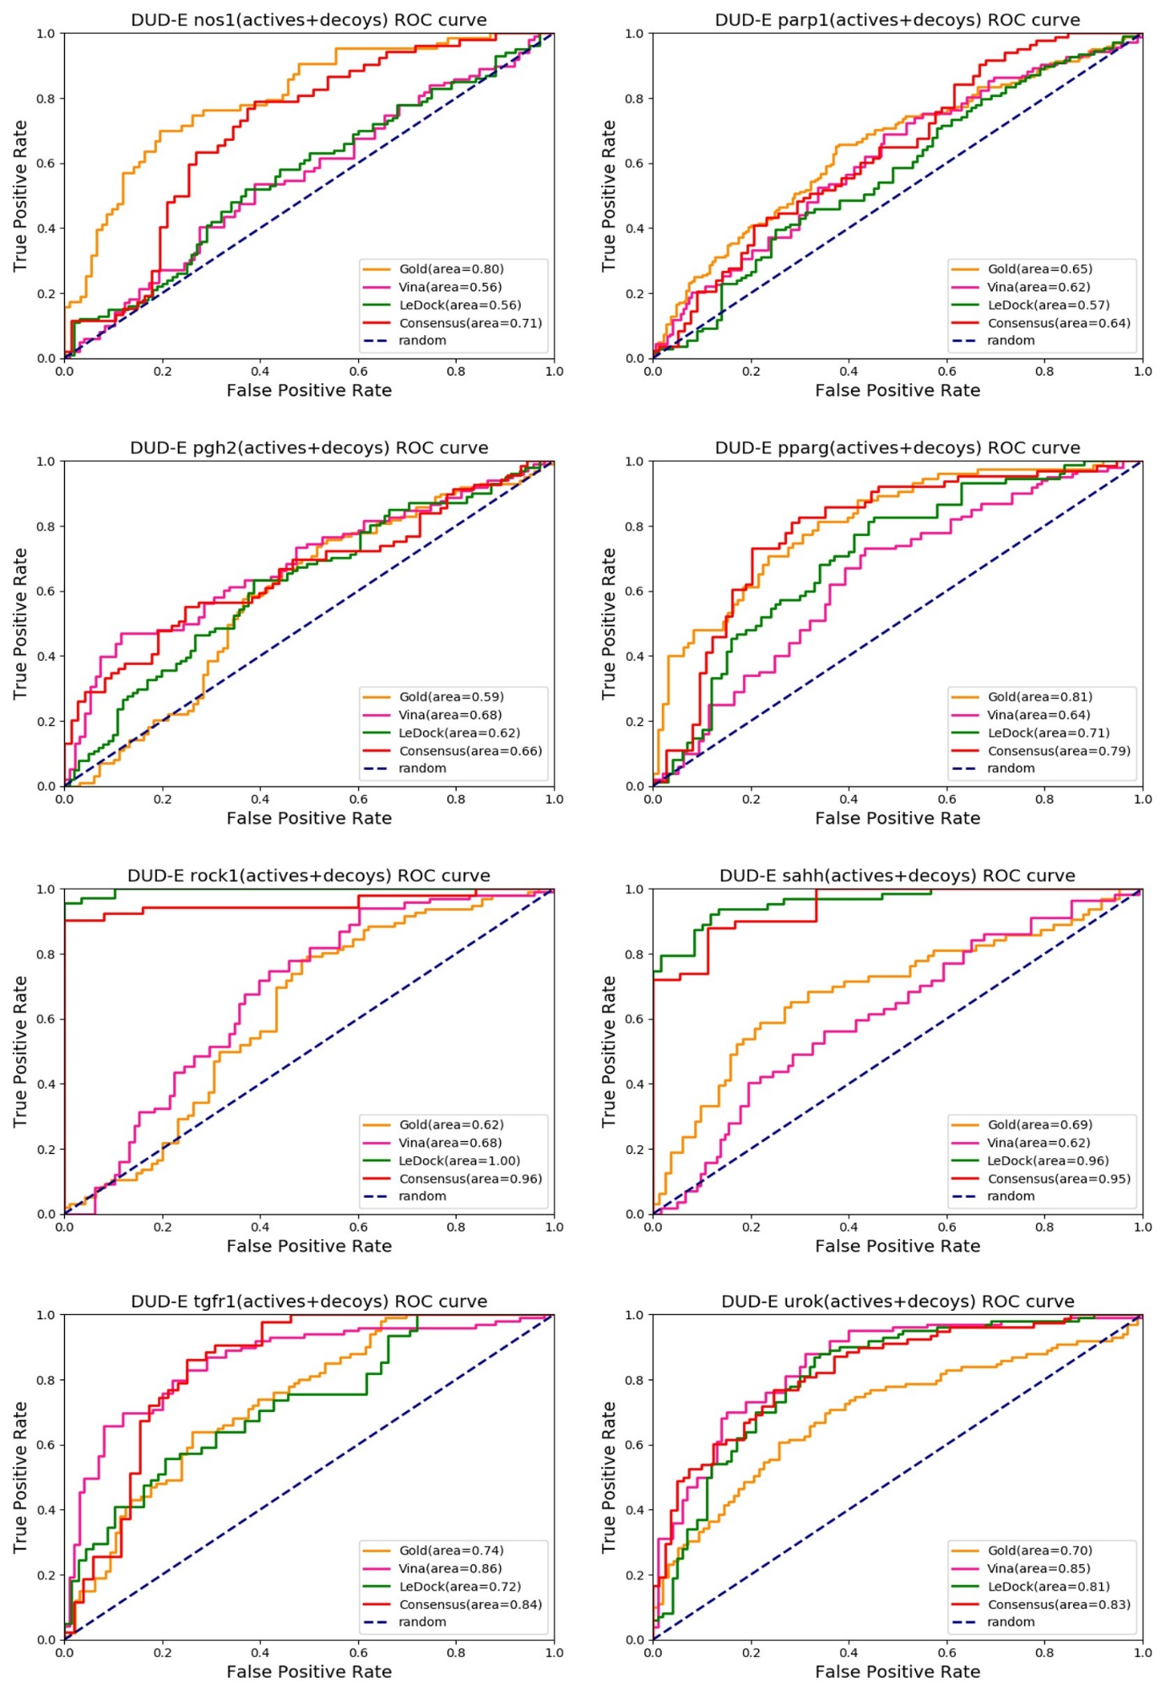
Fig. S7. The mitigating effect of the CDS. This result shows that scoring bias for particular proteins can be mitigated by consensus score. This demonstrates that the reverse docking with consensus docking score predicts less false positives when one wants to identify potential targets through virtual screening. Of the 76 targets, 42% corresponded to this case.

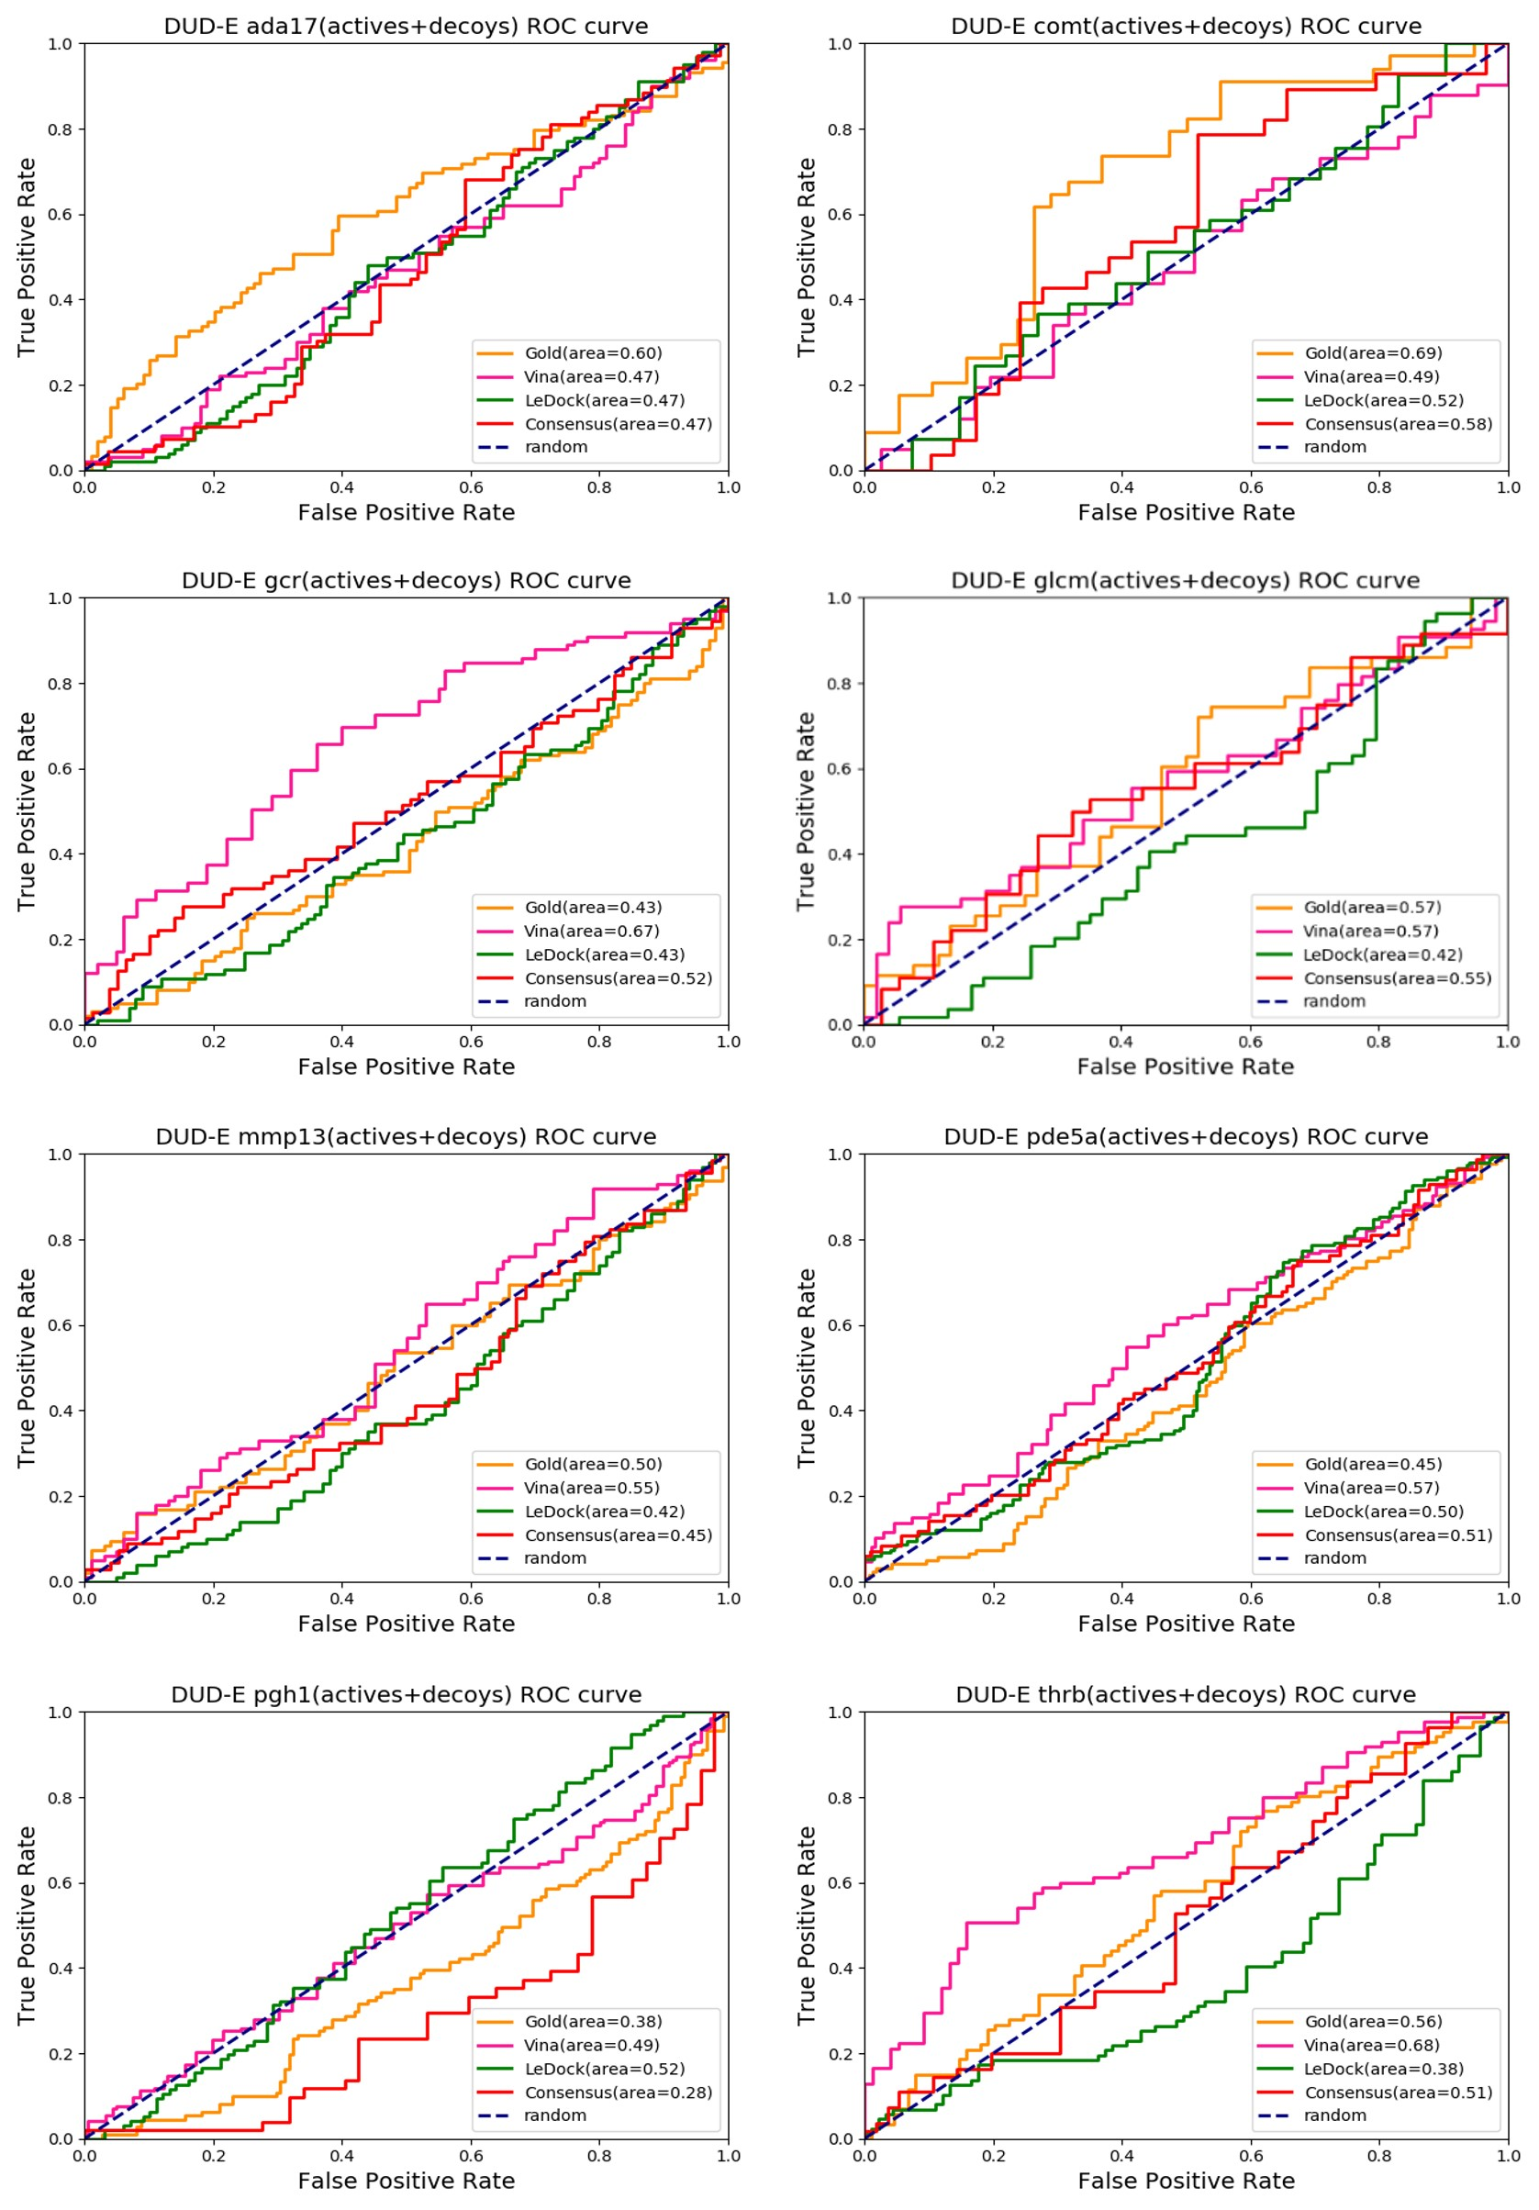
Fig. S8. The inutility of the CDS. This target group shows that all the three scoring functions failed to predict. Of the 76 targets, 10% corresponded to this case.
2.3 Targets with little ligand information
The docking-based target prediction approach should also be helpful for targets with little ligand information because the lead-similarity based methods, such as the QSAR (Quantitative Structural Activity Relationship) cannot be applied to those cases. Therefore, we looked for such cases of targets, conducted reverse docking with the CDS, and observed if the targets were in the top fifty results. These are the examples:
(i) The protein PHA (Phenylalanine-4-hydroxylase, UniProt ID: P00439) has only one pharmacological drug-target information (DrugBank ID: DB00360 (Sapropterin)) in the DrugBank database and two activity results tested using IC50 and Ki in the ChEMBL database (ChEMBL ID: CHEMBL3076). There are ten PAH structures (PDB IDs: 1j8u, 1tg2, 1mmk, 1dmw, 4pah, 4anp, 1kw0, 1lrm, 5pah, and 3pah) in our database. Among them, the 1kw0 and lmmk were ranked as the top $1^{st}$ (The CDS: 2.725) and $4^{th}$(2.702) binding targets, respectively.
(ii) The protein PARP3 (Protein mono-ADP-ribosyltransferase PARP3, UniProt ID: Q9Y6F1) has two pharmacological drug-target information (DrugBank IDs: DB09074 (Olaparib), DB12332 (Rucaparib)) in the DrugBank database. There are 59 ligands with activities lower than 10 $μM$ tested using IC50 and Kd in the ChEMBL database (ChEMBL ID: CHEMBL5083). There are seven PARP3 structures (PDB IDs: 3c4h, 3c49, 4ggv4, 3fhb, 3ce0, 4gv0, and 4gv2) in our database. The 4gv2, 4gv0, and 4gv4 were ranked as the top${ 35}^{th}$ (2.589), ${38}^{th} \left(2.575\right), and {41}^{th}$ (2.573) binding targets, respectively for Rucaparib.
(iiI) For some protein groups, the proteins such as CSF1R (Macrophage colony-stimulating factor 1 receptor, UniProt ID: P07333, ChEMBL ID: CHEMBL1844) and MAP2K1 (Dual specificity mitogen-activated protein kinase 1, UniProt ID: Q02750, ChEMBL ID: CHEMBL3587) have multiple ligands tested using IC50, EC50, Ki, and Kd in the ChEMBL database. However, their pharmacological drug-target information (Max Phase 4 (Compounds have been approved in at least one country or area)) is one (Sunitinib, DrugBank ID: DB01268) and two (DrugBank IDs: DB05239 (Cobimetinib), DB08911 (Trametinib)), respectively. There are seven CSF1R structures (PDB IDs: 3lcd, 4hw7, 3bea, 2ilm, 2i0v, 2i0y, and 4r7i) and thirteen MAP2K1 structures (PDB IDs: 3os3, 3zm4, 3orn, 2p55, 3pp1, 3zly, 3zlx, 3zls, 3zlw, 3w8q, 4an9, 4an2, and 3v01) in our database. For CSF1R, the 4r7i and 4hw7 were ranked as the top $4^{th}$(The CDS: 2.513) and ${10}^{th}$ (The CDS: 2.414) binding targets, respectively for Sunitinib. For MAP2K1, the 3os3, 3orn, 3pp1, and 4an2 were ranked as the $1^{st}$ (2.841), $3^{rd}$ (2.721), $6^{th}$ (2.61), and ${39}^{th}$ (2.394) binding targets, respectively for Trametinib and the 4an2, 3orn, 3os3, 4an9, and 3ppl1 were ranked as the top $1^{st}$ (2.826), $2^{nd}$ (2.643), $3^{rd}$ (2.621), $4^{th}$ (2.605), ${29}^{th}$ (2.437) binding targets, respectively for Cobimetinib.
3. Target database
We have conducted pairwise comparative analysis of 5,254 targets through the sequence alignment and the structural alignment for non-redundant protein structure datasets. BLOSUM62 matrix (Eddy, 2004) and Needleman and Wunsch algorithm (Rose and Eisenmenger, 1991) were chosen for global pairwise alignment. The result shows that the distribution of negative values occupies much bigger part (Fig. S9 (a)).
For protein structure comparison, TM-align structure alignment algorithm was applied. The distribution of TM-score less than 0.5 takes up bigger part when we set a threshold to 0.5 (Fig. S9 (b)) (Xu and Zhang, 2010). Both results indicate that the 5,254 candidate proteins consist of non-redundant tertiary structures.
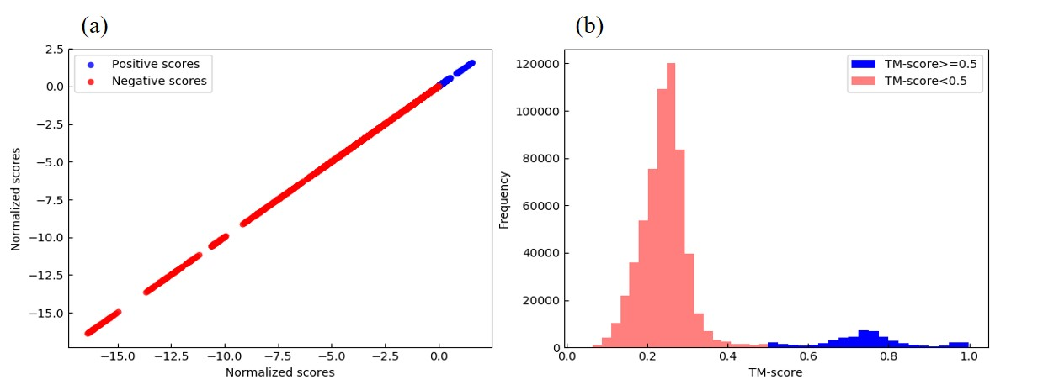
Fig. S9. Pairwise comparison analysis. (a) The values were normalized by Z-score after global sequence alignment of 5,254. The score distribution shows mainly negative z-scores. (b) The distribution of TM-scores that less than 0.5 occupies more part when a threshold was set to 0.5.

The UniProt frequency analysis results showed that the 5,254 structures consist of 869 different UniProt IDs. Among the 5,254 structures, the number of protein structures with a single UniProt ID is 366. The number of protein structures that share with same UniProt IDs varies (Fig. S10). For example, both the PDB IDs of 3wgw and 3vkx have the same UniProt ID (P12004) and there are 146 pairs of protein structures sharing the same UniProt IDs. The number of three different protein structures sharing the same UniProt IDs is 186. In this way, 53% of the 5,254 structures share less than 20 UniProt IDs. There are five kinds of proteins showing only one type of UniProt ID but multiple structures (HSP90AA1 (Heat shock protein HSP 90-alpha, P07900, #114), CA2 (Carbonic anhydrase 2, P00918, #146), MAPK14 (Mitogen-activated protein kinase 14, Q16539, #162), BACE1 (Beta-secretase, P56817, #192), CDK2 (Cyclin-dependent kinase 2, P24941, #218)).
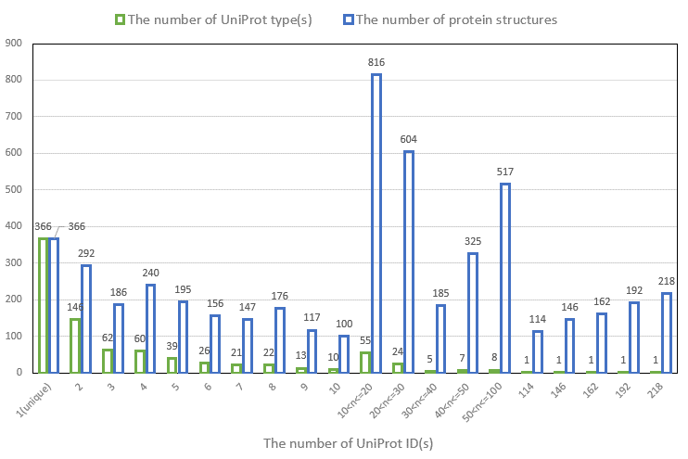
Fig. S10. The different number of UniProt ID(s) and their corresponding number of protein structures. The CRDS database consists of 869 different UniProt types and 366 proteins with unique UniProt IDs that do not share with any other structures. About fifty-three percent of the 5,254 structures share less than twenty UniProt IDs.

Table S1. The 122 test ligands with 6,365 PDB IDs of their known targets.
PubChem ID | Name | DrugBank ID | PDB
2145 | Aminoglutethimide | DB00357 | 3s79, 3na0, 3na1, 3n9y, 3n9z, 3eqm
2170 | Amoxapine | DB00543 | 4cof
2187 | Anastrozole | DB01217 | 3s79, 3eqm
2315 | Bendroflumethiazide | DB00436 | 3d8w, 1i9n, 3f4x, 3igp, 3l14, 1xpz, 4k13, 1bn4, 4m2v, 3t82, 3mho, 1g54, 4m2r, 2osm, 2osf, 4k0z, 3f7u, 3t85, 1g45, 3m67, 3po6, 3eft, 1okm, 1kwr, 1if6, 1cnx, 1ttm, 4hey, 3oim, 1g52, 4knj, 3kig, 3sbi, 3dcc, 3m40, 2nmx, 1i90, 3sax, 3daz, 3b4f, 3t84, 1i9q, 1yda, 1i91, 3dd8, 3p5a, 2x7t, 4itp, 5flt, 3mna, 4mo8, 2pow, 1i9o, 3nb5, 1oq5, 3mhi, 1i9p, 3mmf, 3oik, 3dc3, 3fw3, 1i8z, 1if8, 2eu3, 3f7b, 2x7s, 1eou, 2x7u, 1bnm, 2weh, 1zsb, 4ito, 1cny, 2wd2, 1bnw, 3dcw, 1bn3, 1bn1, 2h15, 3rz8, 1g4j, 3oy0, 1g4o, 3mhc, 3v2j, 3dd0, 1cil, 2wej, 4k0t, 3mhl, 3n0n, 3bet, 4bf1, 3ml2, 3s8x, 4kni, 3p5l, 3s9t, 1g1d, 1kwq, 3w6h, 3mzc, 4n16, 3oys, 3n2p, 3qyk, 1okl, 1okn, 2q1q, 3m2n, 3m2y, 3sbh, 4iwz, 3ffp, 3d9z, 1i9l, 2nn7, 1xq0, 2o4z, 4ilx, 2weg, 1bnu, 2h4n, 4bf6, 3bl1, 1i9m, 3hku, 3lxe, 3k2f, 1if4, 1cnw, 3m96, 1if5, 4riv, 3m98, 4kap, 3n3j, 3dcs, 1bzm, 3n4b, 3ni5, 1bnv, 1bnt, 1if7, 1a42, 3oyq, 4dz7, 3dbu, 4pxx, 3myq, 2weo, 3m5e, 1bnn, 1bnq
2343 | Benzthiazide | DB00562 | 3d8w, 1i9n, 3f4x, 3igp, 3l14, 1xpz, 4k13, 1bn4, 4m2v, 3t82, 3mho, 1g54, 4ht2, 4m2r, 2osm, 2osf, 4k0z, 3f7u, 3t85, 1g45, 3m67, 3po6, 3eft, 1okm, 1kwr, 1if6, 1cnx, 1ttm, 4hey, 3oim, 1g52, 4knj, 3kig, 3sbi, 3dcc, 3m40, 2nmx, 1i90, 3sax, 3daz, 3b4f, 3t84, 1i9q, 1yda, 1i91, 3dd8, 3p5a, 2x7t, 4itp, 5flt, 3mna, 4mo8, 2pow, 1i9o, 3nb5, 1oq5, 3mhi, 1i9p, 3mmf, 3oik, 3dc3, 3fw3, 1i8z, 1if8, 2eu3, 5fl4, 4kp5, 3f7b, 2x7s, 1eou, 2x7u, 1bnm, 2weh, 1zsb, 4ito, 1cny, 2wd2, 1bnw, 3dcw, 1bn3, 1bn1, 2h15, 3rz8, 1g4j, 3oy0, 1g4o, 3mhc, 3v2j, 3dd0, 1cil, 2wej, 4k0t, 3mhl, 3n0n, 3bet, 4bf1, 3ml2, 3s8x, 4kni, 3p5l, 3s9t, 1g1d, 1kwq, 3w6h, 3mzc, 4n16, 3oys, 3n2p, 3qyk, 1okl, 1okn, 2q1q, 3m2n, 3m2y, 3sbh, 4iwz, 3ffp, 3d9z, 1i9l, 2nn7, 1xq0, 2o4z, 4ilx, 2weg, 1bnu, 2h4n, 4bf6, 3bl1, 1i9m, 3hku, 3lxe, 3k2f, 1if4, 4kp8, 1cnw, 3m96, 1if5, 4riv, 3m98, 4kap, 3n3j, 3dcs, 1bzm, 3n4b, 3ni5, 1bnv, 1bnt, 1if7, 1a42, 1jd0, 3oyq, 4dz7, 3dbu, 4pxx, 3myq, 2weo, 3m5e, 1bnn, 1bnq
2375 | Bicalutamide | DB01128 | 2am9, 2piu, 2piw, 4ojb, 3v4a, 2yhd, 2ylq, 2ylo, 4oh5, 4oil, 2piq, 2q7k, 1xj7, 4okw, 4olm, 1gs4, 2pkl, 4ogh, 1z95, 4okx, 2piv, 2hvc, 2amb, 4oea, 2pir, 2pix, 4k7a, 3v49, 2ylp, 1xow, 2pio, 2pip, 1e3g, 4hlw, 4ok1, 4oha, 4okt, 2q7i, 2pit, 2pnu, 1xq3, 2ama
2662 | Celecoxib | DB00482 | 3d8w, 1i9n, 3f4x, 5f1a, 4xx9, 3igp, 3l14, 1xpz, 1z5m, 4k13, 1bn4, 4m2v, 3t82, 3mho, 3nus, 1g54, 4aw1, 4m2r, 2osm, 2osf, 4k0z, 3t85, 1g45, 3m67, 3po6, 3eft, 2pe1, 1okm, 1kwr, 3qcx, 1if6, 1cnx, 1ttm, 4hey, 3oim, 1g52, 4knj, 3kig, 3sbi, 3dcc, 2xch, 3m40, 4ct2, 1i90, 3sax, 3daz, 3b4f, 3t84, 1i9q, 1yda, 3sc1, 1i91, 3dd8, 3p5a, 2x7t, 4itp, 5ikr, 3nuy, 5flt, 3mna, 4mo8, 2pow, 1i9o, 3nb5, 1oq5, 3mhi, 1i9p, 3mmf, 3oik, 3dc3, 1i8z, 1if8, 2eu3, 3rwp, 1okz, 3qcy, 2x7s, 1eou, 3qcq, 1h1w, 3qcs, 3orz, 2x7u, 1bnm, 3qd3, 2weh, 1zsb, 4ito, 1cny, 2wd2, 1bnw, 3hrf, 3dcw, 1bn3, 1bn1, 4ct1, 4rqk, 4a06, 3otu, 2h15, 2xck, 3rz8, 1g4j, 4aw0, 3oy0, 1g4o, 3mhc, 3nun, 3v2j, 5ack, 3dd0, 1cil, 2wej, 4k0t, 3mhl, 2biy, 3n0n, 3bet, 4bf1, 3ml2, 3s8x, 4kni, 2pe0, 3p5l, 3s9t, 1uu3, 1g1d, 1kwq, 3mzc, 4n16, 1uu8, 3oys, 3n2p, 1oky, 3qyk, 1okl, 1okn, 2q1q, 3m2n, 2r7b, 3m2y, 3sbh, 4iwz, 3ffp, 3d9z, 1i9l, 1xq0, 2o4z, 3nuu, 4ilx, 1uvr, 2weg, 1bnu, 2h4n, 4bf6, 3bl1, 1i9m, 3hku, 5ikq, 3k2f, 5ikt, 1if4, 1cnw, 5ikv, 3m96, 1if5, 4riv, 3m98, 4kap, 3n3j, 3dcs, 3n4b, 2pe2, 3ni5, 1bnv, 1bnt, 1if7, 1a42, 3hrc, 3oyq, 4dz7, 3nax, 1uu7, 3dbu, 4pxx, 3myq, 2weo, 4rqv, 3m5e, 1bnn, 1bnq, 3qd4, 3qd0
2787 | Clinofibrate | DB09006 | 2xyj, 4fgy, 3vji, 2p54, 1knu, 2i4z, 3d5f, 2om9, 2q5g, 2q5p, 4l98, 4xta, 4xum, 4hee, 2p4y, 4a4w, 2gtk, 4ema, 2znn, 4xld, 3sp9, 1y0s, 2pob, 2xyx, 4o8f, 4bcr, 3vn2, 2j14, 2hwr, 2znp, 2hwq, 2i4j, 1kkq, 2ath, 3kdu, 2hfp, 3vjh, 2q59, 2i4p, 3vsp, 3dy6, 1i7i, 1k7l, 2g0g, 2q61, 3vso, 4em9, 4jaz, 4a4v, 2q6s, 4f9m, 4l96, 4y29, 2znq, 2zno, 4xuh, 4oj4, 2yfe, 2fvj, 1i7g, 2f4b, 2g0h, 3gbk, 3v9y, 2q8s, 2rew, 3lmp, 2npa, 1nyx, 4e4q, 3kdt, 1zeo
2800 | Clomifene | DB00882 | 1d2s, 1xp9, 1xp1, 1lho, 3os9, 2ayr, 2yat, 1r5k, 2ouz, 1yim, 1xpc, 1xqc, 1xp6, 1yin, 1lhn, 2qe4, 1f5f, 2iog, 1lhv, 1lhu, 1sj0, 1g50, 1uom, 5aav, 1x7e, 1err, 2pog, 1x7r, 2q70, 2yja, 1kdk, 1lhw, 1kdm, 2iok, 3ert
2801 | Clomipramine | DB01242 | 4pgt, 3hjo, 20gs, 4gss, 1aqx, 3pgt, 3gus, 13gs, 17gs, 3dgq, 2a2s, 3csj, 3n9j, 1pgt, 3ie3, 19gs, 2j9h, 1aqv, 2pgt, 9gss, 1gss, 12gs
2818 | Clozapine | DB00363 | 4pgt, 3hjo, 20gs, 4gss, 1aqx, 3pgt, 3gus, 13gs, 17gs, 3dgq, 2a2s, 3csj, 3n9j, 1pgt, 3ie3, 19gs, 2j9h, 1aqv, 2pgt, 9gss, 1gss, 12gs
2910 | Cyclothiazide | DB00606 | 3d8w, 1i9n, 3f4x, 3igp, 3l14, 1xpz, 4k13, 1bn4, 4m2v, 3t82, 3mho, 1g54, 4m2r, 2osm, 2osf, 4k0z, 3f7u, 3t85, 1g45, 3m67, 3po6, 3eft, 1okm, 1kwr, 1if6, 1cnx, 1ttm, 4hey, 3oim, 1g52, 4knj, 3kig, 3sbi, 3dcc, 3m40, 2nmx, 1i90, 3sax, 3daz, 3b4f, 3t84, 1i9q, 1yda, 1i91, 3dd8, 3p5a, 2x7t, 4itp, 5flt, 3mna, 4mo8, 2pow, 1i9o, 3nb5, 1oq5, 3mhi, 1i9p, 3mmf, 3oik, 3dc3, 3fw3, 1i8z, 1if8, 2eu3, 3f7b, 2x7s, 1eou, 2x7u, 1bnm, 2weh, 1zsb, 4ito, 1cny, 2wd2, 1bnw, 3dcw, 1bn3, 1bn1, 2h15, 3rz8, 1g4j, 3oy0, 1g4o, 3mhc, 3v2j, 3dd0, 1cil, 2wej, 4k0t, 3mhl, 3n0n, 3bet, 4bf1, 3ml2, 3s8x, 4kni, 3p5l, 3s9t, 1g1d, 1kwq, 3w6h, 3mzc, 4n16, 3oys, 3n2p, 3qyk, 1okl, 1okn, 2q1q, 3m2n, 3m2y, 3sbh, 4iwz, 3ffp, 3d9z, 1i9l, 2nn7, 1xq0, 2o4z, 4ilx, 2weg, 1bnu, 2h4n, 4bf6, 3bl1, 1i9m, 3hku, 3lxe, 3k2f, 1if4, 1cnw, 3m96, 1if5, 4riv, 3m98, 4kap, 3n3j, 3dcs, 1bzm, 3n4b, 3ni5, 1bnv, 1bnt, 1if7, 1a42, 3oyq, 4dz7, 3dbu, 4pxx, 3myq, 2weo, 3m5e, 1bnn, 1bnq
3108 | Dipyridamole | DB00975 | 4fcb, 4oew, 4oex, 4fcd, 3sn7, 3sni, 4lm4, 3bjc, 1udt, 1uho, 2y0j, 4g2w, 4hf4, 4llk, 4ajf, 2our, 4muw, 4bbx, 4ddl, 1rkp, 4mvh, 4heu, 1udu, 2ouy, 4ajm, 4i9z, 4ajd, 4ael, 2wey, 4g2y, 3wi2, 4ajg, 2h44, 2h42, 4lm0, 4ia0, 3tvx, 2ouu
3117 | Disulfiram | DB00822 | 2vle, 2onp, 1nzw, 1nzz, 3inl, 1o01, 3n82, 1cw3, 1nzx, 2onm, 4fr8, 4fqf, 3inj, 1o04, 3n83, 1o02, 1o00
3152 | Donepezil | DB00843 | 4ey6, 4ey7, 4m0e, 5hfa, 4m0f
3339 | Fenofibrate | DB01039 | 2xyj, 4fgy, 3vji, 2p54, 1knu, 2i4z, 3d5f, 1m13, 2om9, 2q5g, 2q5p, 4l98, 4xta, 4xum, 4hee, 2p4y, 4a4w, 2gtk, 4ema, 2znn, 4xld, 3sp9, 1y0s, 2pob, 2xyx, 4o8f, 4bcr, 3vn2, 2j14, 2hwr, 2znp, 2hwq, 2i4j, 1kkq, 2ath, 3kdu, 2hfp, 3vjh, 2q59, 2i4p, 3vsp, 3dy6, 1i7i, 1k7l, 2g0g, 2q61, 3vso, 4em9, 4jaz, 4a4v, 2q6s, 4f9m, 4l96, 4y29, 2znq, 2zno, 4xuh, 4oj4, 2yfe, 2fvj, 1i7g, 2f4b, 2g0h, 3gbk, 3v9y, 2q8s, 2rew, 3lmp, 2npa, 1nyx, 4e4q, 3kdt, 1zeo
3372 | Fluphenazine | DB00623 | 2am9, 2piu, 2piw, 4ojb, 3v4a, 2yhd, 2ylq, 2ylo, 4oh5, 4oil, 2piq, 2q7k, 1xj7, 4okw, 4olm, 1gs4, 2pkl, 4ogh, 1z95, 4okx, 2piv, 2hvc, 2amb, 4oea, 2pir, 1ctr, 2pix, 4k7a, 3v49, 2ylp, 1xow, 2pio, 2pip, 1e3g, 4hlw, 4ok1, 4oha, 4okt, 2q7i, 2pit, 2pnu, 1xq3, 2ama
3440 | Furosemide | DB00695 | 3d8w, 1i9n, 3f4x, 3igp, 3l14, 1xpz, 4k13, 1bn4, 4m2v, 3t82, 3mho, 1g54, 4m2r, 2osm, 2osf, 4k0z, 3t85, 1g45, 3m67, 3po6, 3eft, 1okm, 1kwr, 1if6, 1cnx, 1ttm, 4hey, 3oim, 1g52, 4knj, 3kig, 3sbi, 3dcc, 3m40, 1i90, 3sax, 3daz, 3b4f, 3t84, 1i9q, 1yda, 1i91, 3dd8, 3p5a, 2x7t, 4itp, 5flt, 3mna, 4mo8, 2pow, 1i9o, 3nb5, 1oq5, 3mhi, 1i9p, 3mmf, 3oik, 3dc3, 1i8z, 1if8, 2eu3, 2x7s, 1eou, 2x7u, 1bnm, 2weh, 1zsb, 4ito, 1cny, 2wd2, 1bnw, 3dcw, 1bn3, 1bn1, 2h15, 3rz8, 1g4j, 3oy0, 1g4o, 3mhc, 3v2j, 3dd0, 1cil, 2wej, 4k0t, 3mhl, 3n0n, 3bet, 4bf1, 3ml2, 3s8x, 4kni, 3p5l, 3s9t, 1g1d, 1kwq, 3mzc, 4n16, 3oys, 3n2p, 3qyk, 1okl, 1okn, 2q1q, 3m2n, 3m2y, 3sbh, 4iwz, 3ffp, 3d9z, 1i9l, 1xq0, 2o4z, 4ilx, 2weg, 1bnu, 2h4n, 4bf6, 3bl1, 1i9m, 3hku, 3k2f, 1if4, 1cnw, 3m96, 1if5, 4riv, 3m98, 4kap, 3n3j, 3dcs, 3n4b, 3ni5, 1bnv, 1bnt, 1if7, 1a42, 3oyq, 4dz7, 3dbu, 4pxx, 3myq, 2weo, 3m5e, 1bnn, 1bnq
3672 | Ibuprofen | DB01050 | 4man, 5f1a, 4fgy, 3vji, 2p54, 1knu, 5d3e, 2i4z, 2om9, 2q5p, 4l98, 4xta, 4xum, 4hee, 2p4y, 4a4w, 4lxd, 2gtk, 4ema, 2znn, 4xld, 5ikr, 2pob, 4o8f, 4bcr, 3vn2, 2hwr, 2hwq, 2i4j, 1kkq, 5d3f, 2ath, 3kdu, 2hfp, 3vjh, 2q59, 2i4p, 3vsp, 1i7i, 1k7l, 2g0g, 2q61, 3vso, 4em9, 4jaz, 4a4v, 2q6s, 4f9m, 4l96, 4y29, 3akm, 2zno, 4xuh, 4oj4, 2yfe, 2fvj, 1i7g, 5ikq, 2f4b, 5ikt, 5ikv, 2g0h, 3gbk, 3v9y, 2q8s, 2rew, 3lmp, 2npa, 1nyx, 4lvt, 4e4q, 3kdt, 1zeo
3676 | Lidocaine | DB00281 | 3vjo, 3apv, 5cnn, 3poz, 3apw, 3w2r, 3w32, 4i23, 2itz, 2itq, 4wkq, 4jrv, 2itn, 2itp, 2gs7, 3apx, 5cno, 3w33, 3w2s, 1m17, 2itt, 1xkk, 3vjn, 4zse, 4i22, 4jq7, 3w2o, 4jq8, 2eb3, 4jr3, 2itx, 2itu, 4hjo, 2itw, 2itv
3715 | Indomethacin | DB00328 | 5f1a, 4fgy, 3vji, 3r8g, 2p54, 1knu, 3vw9, 1qip, 4dbu, 4dbs, 3r8h, 2i4z, 2om9, 2q5p, 1db5, 4l98, 4xta, 4xum, 4hee, 3uwe, 2p4y, 4a4w, 1zq5, 3w0u, 1ry0, 2w4q, 1ry8, 1bh5, 2zb4, 2zb8, 2gtk, 4ema, 1kqu, 2znn, 4xld, 3u8h, 5ikr, 2pob, 3u8d, 4o8f, 1s1r, 3ugr, 4bcr, 4fam, 1fro, 3vn2, 4fa3, 1s1p, 2hwr, 2hwq, 2i4j, 1kkq, 4dbw, 4h7c, 2ath, 3ufy, 3kdu, 4hmn, 2hfp, 3vjh, 1s2c, 3r6i, 2q59, 2i4p, 3vsp, 1xf0, 1i7i, 1k7l, 1db4, 1dcy, 2g0g, 1ayp, 2q61, 3vso, 4em9, 4jaz, 4a4v, 2q6s, 4f9m, 3w0t, 4l96, 4y29, 1kvo, 2f38, 2zno, 4xuh, 4oj4, 2yfe, 3r7m, 3ug8, 2zb7, 2fvj, 4fal, 1i7g, 3r43, 2vna, 5ikq, 2f4b, 2w98, 5ikt, 3r58, 5ikv, 2g0h, 3gbk, 3r94, 3v9y, 2q8s, 2rew, 3lmp, 2npa, 4dz5, 1nyx, 4e4q, 3kdt, 1qin, 1zeo
3779 | Isoprenaline | DB01064 | 1tvo, 4n0s, 4fv8, 4nif, 4fv5, 4fv7, 4fv1, 4fv3, 4h3p, 4fmq, 2ojg, 3i60, 4zxt, 1pme, 4g6o, 2ojj, 3w55, 4fux, 4fuy, 3sa0, 4fv6, 4fv0, 4fv2, 4fv4, 4fv9, 4g6n, 1wzy, 3tei, 2oji, 3i5z
3902 | letrozole | DB01006 | 3s79, 3eqm
4413 | Nafamostat | DB12598 | 1uvs, 2vwm, 2vvc, 1iqe, 1jwt, 1lpk, 1nfx, 1nfy, 2y82, 1mq6, 2cji, 3qdz, 4btt, 2anm, 2xc5, 4bti, 2xbx, 2g00, 1iqh, 2p3u, 2y5h, 2vh0, 4hfp, 2j34, 2y5g, 2xby, 2bok, 2wyj, 1c4y, 2pks, 1c4v, 2ei7, 7kme, 3p70, 4btu, 3ens, 1iqg, 3kqe, 4rn6, 1lqd, 3kqb
4680 | Papaverine | DB01113 | 4fcb, 1ro6, 4fcd, 3sn7, 3sni, 1ro9, 4lm4, 3hmv, 3g45, 2y0j, 4hf4, 4llk, 3o57, 3o56, 4ajf, 3w5e, 2our, 4myq, 3d3p, 4muw, 4bbx, 4ddl, 4mvh, 4heu, 2ouy, 4ajm, 4ajd, 4ael, 2wey, 4kp6, 3wi2, 4ajg, 4lm0, 2ouu, 3wd9
4829 | Pioglitazone | DB01132 | 2xyj, 4fgy, 3vji, 2p54, 1knu, 2i4z, 3d5f, 2om9, 2q5g, 2q5p, 4l98, 4xta, 4xum, 4hee, 2p4y, 4a4w, 2gtk, 4ema, 2znn, 4xld, 3sp9, 1y0s, 2pob, 2xyx, 4o8f, 4bcr, 3vn2, 2j14, 2hwr, 2znp, 2hwq, 2i4j, 1kkq, 2ath, 2xfn, 3kdu, 2hfp, 3vjh, 2xfo, 2q59, 2i4p, 3vsp, 3dy6, 1i7i, 1k7l, 2g0g, 2q61, 3vso, 4em9, 4jaz, 4a4v, 2q6s, 4f9m, 2v5z, 4l96, 4y29, 2znq, 2zno, 4xuh, 4oj4, 2yfe, 2fvj, 1i7g, 2f4b, 4a7a, 2g0h, 3gbk, 3v9y, 2v61, 4a79, 2q8s, 2rew, 3lmp, 2npa, 1nyx, 4e4q, 3kdt, 1zeo
4923 | Proguanil | DB01131 | 1hfp, 4m6j, 4kfj, 4m6l, 1u71, 1s3v, 1pd9, 4kd7, 3eig, 3gyf, 4qjc, 1kmv, 2w3b, 3ghw, 2w3m, 3nxo, 3nxx, 1s3u, 1boz, 1hfq, 3nu0, 3s3v, 3ntz, 1kms, 1ohk, 4m6k, 1hfr, 4keb, 3gi2, 1u72, 1s3w, 4g95, 4kak, 1mvs, 1pd8, 4kbn, 1dls, 3s7a, 1mvt, 3l3r, 2w3a, 4ddr, 1dhf, 2dhf, 3nxt, 1dlr, 3nxr, 3nxy, 1drf, 3oaf, 3ghv, 3n0h, 1ohj, 3nxv
4992 | Pyrilamine | DB06691 | 2baq, 3o8p, 3zsg, 4eh2, 1tvo, 3hv5, 3oc1, 3o8t, 4r3c, 4l8m, 3hv4, 3iph, 4n0s, 3k3j, 3uvq, 3c5u, 3o8u, 2zb0, 3fc1, 3lfb, 3dt1, 3hp5, 4fv8, 4kip, 2qd9, 3iw5, 2rg6, 3zs5, 4nif, 2yiw, 3fi4, 4aac, 4fv5, 4fv7, 3fmk, 3lfe, 3fmm, 4e6a, 1w84, 4fv1, 3uvr, 4e6c, 4fv3, 4h3p, 3nnw, 3zsh, 3fly, 3fls, 3flq, 4dlj, 3iw6, 1bmk, 1w7h, 4f9w, 1w83, 3qud, 4fmq, 3e92, 1di9, 3pg3, 3d7z, 1wbw, 4eh8, 2gfs, 1wbo, 1kv1, 2ojg, 3obg, 3fmn, 4eh3, 3hl7, 3i60, 3bv2, 3u8w, 3lfa, 4eh7, 4zxt, 4eh5, 3gcv, 3gcp, 1pme, 3hv3, 4g6o, 3hv7, 2ojj, 3w55, 1zz2, 3ds6, 3gfe, 4fux, 3fkl, 3fkn, 3iw7, 4aa5, 3hub, 2bal, 3flw, 3mpa, 1kv2, 3mpt, 4aa0, 1zzl, 3nnx, 4zth, 1zyj, 3fsf, 3fmh, 3gi3, 3uvp, 3kq7, 3itz, 3l8x, 4kiq, 3ocg, 3s4q, 3bx5, 3k3i, 4kin, 3kf7, 4fuy, 3sa0, 4fv6, 3zsi, 4fv0, 4fv2, 4fv4, 3flz, 3lfc, 4dli, 4fv9, 3hp2, 2zaz, 4f9y, 1w82, 4a9y, 3mvm, 3e93, 3nnu, 3iw8, 3fln, 1bl7, 3fmj, 3mvl, 4ewq, 2zb1, 1wbn, 1wbs, 3fl4, 4g6n, 1oz1, 1bl6, 1ouy, 1m7q, 2rg5, 1ouk, 4eh4, 4eh6, 1ove, 1wzy, 3ha8, 3lff, 1wbv, 3tei, 1wbt, 4eh9, 3rin, 3hll, 2yix, 3roc, 1yqj, 2bak, 3new, 3nww, 3gcq, 3bv3, 3fml, 4aa4, 3d83, 3gcu, 3l8s, 4ehv, 3gcs, 3hv6, 3que, 3gc7, 3fko, 3fsk, 2yis, 3huc, 3hvc, 2oji, 3i5z
5035 | Raloxifene | DB00481 | 2fsz, 1xp9, 1xp1, 4j26, 1u3q, 1qkm, 3os9, 2ayr, 2yat, 1r5k, 1u9e, 2ouz, 1l2j, 2z4b, 1nde, 1yim, 1xpc, 4j24, 1xqc, 1xp6, 1yin, 2jj3, 2qe4, 2iog, 1sj0, 1g50, 1uom, 5aav, 1x7e, 1err, 2giu, 2pog, 1x7r, 2q70, 2yja, 2iok, 3ert
5212 | Sildenafil | DB00203 | 4oew, 4oex, 3bjc, 1udt, 1uho, 4g2w, 1rkp, 1udu, 4i9z, 4g2y, 2h44, 2h42, 4ia0
5291 | Imatinib | DB00619 | 4hvs, 2gqg, 2hyy, 3qri, 4xey, 1pkg, 4wa9, 3lcd, 4ckr, 3g0e, 2i0v, 2f4j, 2hz0, 2hz4, 4hw7, 2g2f, 2hzi, 4aoj, 3cs9, 4twp, 5bvw, 2i0y, 2i1m, 2v7a, 4r7i, 3pyy, 4bkj, 2e2b, 3g0f, 2hiw, 4u0i, 3ue4, 3zos, 2g2h
5311 | Vorinostat | DB02546 | 2v5x, 5d1b, 3sff, 1w22, 4qa2, 4qa0, 1t64, 3ezp, 3f0r, 1vkg, 1t69, 4qa1, 3sfh, 5dc5
5538 | Tretinoin | DB00755 | 4wb9, 4ec0, 1v40, 4dm8, 4m8h, 1exa, 2lbd, 1mzn, 1fd0, 1mvc, 2zdx, 3oap, 1fby, 3vi5, 3vi7, 2vcx, 2vcw, 2vcq, 1fcy, 2p1t, 2p1v, 2vcz, 4k4j, 4x2q, 2cvd, 4edy, 2vd1, 3fmz, 4dm6, 3d2r, 2vd0, 2e0a, 4ee0, 2p1u, 4m8e, 4x4l, 1brp, 4k6i, 1fcx, 2zkj, 2zdy, 4edz, 3ee2, 3kxo
5578 | Trimethoprim | DB00440 | 1juj, 1hfp, 4m6j, 4kfj, 4m6l, 1u71, 1s3v, 1pd9, 4kd7, 3eig, 3gyf, 1hvy, 4qjc, 1ju6, 1kmv, 2w3b, 3ghw, 2w3m, 3nxo, 3nxx, 1s3u, 1boz, 1hfq, 3nu0, 3s3v, 3ntz, 1kms, 1ohk, 4m6k, 1hfr, 4keb, 3gi2, 1u72, 1s3w, 4g95, 4kak, 3hb8, 1i00, 1mvs, 1pd8, 4kbn, 1dls, 3s7a, 1mvt, 3l3r, 2w3a, 4ddr, 1dhf, 2dhf, 3nxt, 1dlr, 3nxr, 3nxy, 1drf, 3oaf, 3ghv, 3n0h, 1ohj, 3nxv
5732 | Zolpidem | DB00425 | 4cof
5757 | Estradiol | DB00783 | 5dx3, 2fsz, 3erd, 4iv2, 2g44, 2g5o, 1xp9, 1xp1, 4j26, 1m13, 2ewp, 1u3q, 1qkm, 3os9, 4iv4, 2ayr, 2p15, 1t65, 4iw6, 1gwr, 2b1v, 4ivy, 1t63, 5dxg, 2yat, 4iui, 1m2z, 2p7z, 2fai, 1r5k, 1u9e, 2q7j, 2ouz, 4iu7, 1l2j, 4p6x, 4zn7, 2z4b, 1nde, 1yim, 1xpc, 4j24, 1xqc, 1xp6, 1yin, 2jj3, 2qe4, 2iog, 1gwq, 4p6w, 1sj0, 1g50, 4udc, 2gpu, 1uom, 4iw8, 5aav, 4ivw, 2b1z, 1p93, 1x7e, 4iwf, 2ao6, 1err, 1zky, 2q7l, 4pp6, 2giu, 2pog, 1x7r, 4iwc, 3q95, 2q70, 2yja, 4pxm, 2iok, 3ert
5870 | Estrone | DB00655 | 1d2s, 2am9, 2fsz, 2piu, 2piw, 1xp9, 4ojb, 1xp1, 4j26, 1lho, 1u3q, 3v4a, 1qkm, 3os9, 2yhd, 2ylq, 2ayr, 2ylo, 4oh5, 4oil, 2piq, 2q7k, 1xj7, 4okw, 4olm, 1gs4, 2pkl, 2yat, 4ogh, 3s79, 1z95, 1r5k, 1u9e, 2ouz, 1l2j, 4okx, 2piv, 2hvc, 2z4b, 1nde, 2amb, 1yim, 1xpc, 4j24, 4oea, 1xqc, 2pir, 3eqm, 1xp6, 1yin, 1lhn, 2jj3, 2qe4, 1f5f, 2iog, 2pix, 4k7a, 3v49, 2ylp, 1xow, 1lhv, 2pio, 2pip, 1lhu, 1sj0, 1g50, 1e3g, 4hlw, 1uom, 4ok1, 4oha, 5aav, 4okt, 1x7e, 1err, 2q7i, 2giu, 2pog, 1x7r, 2pit, 2pnu, 2q70, 1xq3, 2yja, 1kdk, 1lhw, 2ama, 1kdm, 2iok, 3ert
5920 | Liothyronine | DB00279 | 1nax, 3wgw, 1n46, 2j4a, 3vkx, 1nav, 1nq1, 2pin, 3d57, 1r6g, 1q4x, 1nq2, 1nq0
6013 | Testosterone | DB00624 | 2am9, 1ya3, 2piu, 2piw, 1xp9, 4ojb, 1xp1, 3v4a, 3os9, 3wfg, 2yhd, 2ylq, 2ayr, 2ylo, 4oh5, 4oil, 2piq, 2q7k, 1xj7, 4okw, 4olm, 1gs4, 2pkl, 2yat, 4ogh, 1z95, 1r5k, 2ouz, 2ab2, 4okx, 2piv, 2hvc, 2oax, 2amb, 1yim, 1xpc, 4oea, 1xqc, 2pir, 1xp6, 1yin, 2aa5, 2aa7, 2qe4, 2iog, 2pix, 4k7a, 3v49, 3wff, 2ylp, 1xow, 2pio, 2pip, 1sj0, 1g50, 1e3g, 4hlw, 1uom, 3vhu, 4ok1, 4oha, 2aax, 5aav, 4okt, 1x7e, 1err, 2q7i, 2pog, 1x7r, 1y9r, 2pit, 2pnu, 2q70, 1xq3, 2yja, 2ama, 2aa6, 2abi, 2iok, 3ert, 2aa2
6279 | Medroxyprogesterone acetate | DB00603 | 1xp9, 1xp1, 2ovh, 3os9, 1sr7, 2ayr, 1e3k, 1sqn, 3zra, 3d90, 2yat, 1r5k, 2ouz, 1yim, 1xpc, 1xqc, 1xp6, 1yin, 3hq5, 4apu, 1zuc, 2qe4, 2iog, 2ovm, 1sj0, 1g50, 3zrb, 1uom, 5aav, 3zr7, 1x7e, 1err, 2w8y, 2pog, 1x7r, 2q70, 4a2j, 2yja, 2iok, 3ert
8556 | Kappadione | DB09332 | 1uvs, 2vwm, 2vvc, 1iqe, 1jwt, 1lpk, 1nfx, 1nfy, 2y82, 1mq6, 2cji, 3qdz, 4btt, 2anm, 2xc5, 4bti, 2xbx, 2g00, 1iqh, 2p3u, 2y5h, 2vh0, 4hfp, 2j34, 2y5g, 2xby, 2bok, 2wyj, 1c4y, 2pks, 1c4v, 2ei7, 7kme, 3p70, 4btu, 3ens, 1iqg, 3kqe, 4rn6, 1lqd, 3kqb
10133 | Chenodeoxycholic acid | DB06777 | 4l1x, 1j96, 1m13, 4jtr, 4jq3, 4jqa, 4xo7, 4jq2, 4jq4, 4jtq, 2hdj, 4qe6, 2ipj, 1ihi, 4jq1, 3bej, 4wvd
17676 | Acetophenazine | DB01063 | 2am9, 2piu, 2piw, 4ojb, 3v4a, 2yhd, 2ylq, 2ylo, 4oh5, 4oil, 2piq, 2q7k, 1xj7, 4okw, 4olm, 1gs4, 2pkl, 4ogh, 1z95, 4okx, 2piv, 2hvc, 2amb, 4oea, 2pir, 2pix, 4k7a, 3v49, 2ylp, 1xow, 2pio, 2pip, 1e3g, 4hlw, 4ok1, 4oha, 4okt, 2q7i, 2pit, 2pnu, 1xq3, 2ama
20279 | Cladribine | DB00242 | 2oc9, 1rsz, 2wgh, 2a0y, 1ulb, 1rt9, 1v2h, 1rr6, 2q7o, 3k8o, 1pf7, 3ggs, 3k8q, 3iny, 1yry, 1rct, 1v41, 4ear, 2a0x, 4ece, 2a0w, 1v3q, 1pwy, 3bgs, 2oc4, 1rfg, 1v45, 2on6
27812 | Gestrinone | DB11619 | 1d2s, 2am9, 2piu, 2piw, 1xp9, 4ojb, 1xp1, 1lho, 2ovh, 3v4a, 4lsj, 3os9, 2yhd, 2ylq, 1sr7, 2ayr, 2ylo, 1e3k, 1sqn, 4oh5, 3zra, 4oil, 2piq, 2q7k, 1xj7, 4okw, 4olm, 1gs4, 1nhz, 2pkl, 3d90, 2yat, 4ogh, 1z95, 1r5k, 2ouz, 4okx, 2piv, 2hvc, 2amb, 1yim, 1xpc, 4oea, 1xqc, 2pir, 1xp6, 1yin, 3hq5, 4apu, 1lhn, 1zuc, 2qe4, 1f5f, 2iog, 2pix, 4k7a, 3v49, 2ylp, 1xow, 1lhv, 2pio, 2pip, 1lhu, 2ovm, 1sj0, 1g50, 3zrb, 1e3g, 4hlw, 1uom, 4ok1, 4oha, 5aav, 3zr7, 4okt, 1x7e, 1err, 2w8y, 2q7i, 2pog, 1x7r, 2pit, 2pnu, 2q70, 4a2j, 1xq3, 2yja, 1kdk, 1lhw, 2ama, 1kdm, 2iok, 3ert
28417 | Danazol | DB01406 | 2am9, 2piu, 2piw, 1xp9, 4ojb, 1xp1, 2ovh, 3v4a, 3os9, 2yhd, 2ylq, 1sr7, 2ayr, 2ylo, 1e3k, 1sqn, 4oh5, 3zra, 4oil, 2piq, 2q7k, 1xj7, 4okw, 4olm, 1gs4, 2pkl, 3d90, 2yat, 4ogh, 1z95, 1r5k, 2ouz, 4okx, 2piv, 2hvc, 2amb, 1yim, 1xpc, 4oea, 1xqc, 2pir, 1xp6, 1yin, 3hq5, 4apu, 1zuc, 2qe4, 2iog, 2pix, 4k7a, 3v49, 2ylp, 1xow, 2pio, 2pip, 2ovm, 1sj0, 1g50, 3zrb, 1e3g, 4hlw, 1uom, 4ok1, 4oha, 5aav, 3zr7, 4okt, 1x7e, 1err, 2w8y, 2q7i, 2pog, 1x7r, 2pit, 2pnu, 2q70, 4a2j, 1xq3, 2yja, 2ama, 2iok, 3ert
39042 | Bezafibrate | DB01393 | 2xyj, 4fgy, 3vji, 2p54, 1knu, 2i4z, 3d5f, 1m13, 2om9, 2q5g, 2q5p, 4l98, 4xta, 4xum, 4hee, 2p4y, 4a4w, 2gtk, 4ema, 2znn, 4xld, 3sp9, 1y0s, 2pob, 2xyx, 4m8h, 4o8f, 1mzn, 1mvc, 4bcr, 3oap, 3vn2, 2j14, 2hwr, 2znp, 1fby, 2hwq, 2i4j, 1kkq, 2ath, 3kdu, 2hfp, 3vjh, 2q59, 2i4p, 3vsp, 3dy6, 1i7i, 2p1t, 2p1v, 1k7l, 2g0g, 2q61, 3vso, 4k4j, 4em9, 4jaz, 4a4v, 2q6s, 4f9m, 4l96, 4y29, 2znq, 2zno, 4xuh, 4oj4, 2yfe, 2fvj, 2p1u, 1i7g, 4m8e, 2f4b, 2g0h, 3gbk, 4k6i, 3v9y, 2q8s, 2rew, 3lmp, 2npa, 1nyx, 4e4q, 3kdt, 1zeo
39912 | Dexibuprofen | DB09213 | 4man, 5f1a, 4fgy, 3vji, 1knu, 5d3e, 2i4z, 2om9, 2q5p, 4l98, 4xta, 4xum, 4hee, 2p4y, 4a4w, 4lxd, 2gtk, 4ema, 4xld, 5ikr, 2pob, 4o8f, 3vn2, 2hwr, 2hwq, 2i4j, 5d3f, 2ath, 2hfp, 3vjh, 2q59, 2i4p, 3vsp, 1i7i, 2g0g, 2q61, 3vso, 4em9, 4jaz, 4a4v, 2q6s, 4f9m, 4l96, 4y29, 3akm, 2zno, 4xuh, 4oj4, 2yfe, 2fvj, 5ikq, 2f4b, 5ikt, 5ikv, 2g0h, 3gbk, 3v9y, 2q8s, 3lmp, 1nyx, 4lvt, 4e4q, 1zeo
40973 | Desogestrel | DB00304 | 1xp9, 1xp1, 2ovh, 3os9, 1sr7, 2ayr, 1e3k, 1sqn, 3zra, 3d90, 2yat, 1r5k, 2ouz, 1yim, 1xpc, 1xqc, 1xp6, 1yin, 3hq5, 4apu, 1zuc, 2qe4, 2iog, 2ovm, 1sj0, 1g50, 3zrb, 1uom, 5aav, 3zr7, 1x7e, 1err, 2w8y, 2pog, 1x7r, 2q70, 4a2j, 2yja, 2iok, 3ert
44257 | Sapropterin | DB00360 | 1m9q, 1dmw, 4d1o, 4pah, 1kw0, 1j8u, 3nos, 3hfb, 4anp, 5pah, 3hf8, 1m9r, 1m9j, 3eah, 3pah, 3hf6, 1lrm, 1mmk, 1tg2, 1m9k, 1m9m
50599 | Didanosine | DB00900 | 2oc9, 1rsz, 2a0y, 1ulb, 1rt9, 1v2h, 1rr6, 2q7o, 3k8o, 1pf7, 3ggs, 3k8q, 3iny, 1yry, 1rct, 1v41, 4ear, 2a0x, 4ece, 2a0w, 1v3q, 1pwy, 3bgs, 2oc4, 1rfg, 1v45, 2on6
60750 | Gemcitabine | DB00441 | 1juj, 1hvy, 2wgh, 1ju6, 3hb8, 1i00
60823 | Atorvastatin | DB01076 | 3vjk, 1hw8, 2q1l, 1hwj, 2rgu, 3ccc, 3opm, 1dq9, 3g0c, 3g0g, 1dqa, 2r4f, 3g0d, 1hw9, 3qbj, 4g1f, 2q6c, 2q6b, 4a5s, 1hwk, 1hwl, 3ccb, 3vjl, 4dtc, 3cd5, 1dq8, 3g0b, 3f8s
65981 | Repaglinide | DB00912 | 4fgy, 3vji, 1knu, 2i4z, 2om9, 2q5p, 4l98, 4xta, 4xum, 4hee, 2p4y, 4a4w, 2gtk, 4ema, 4xld, 2pob, 4o8f, 3vn2, 2hwr, 2hwq, 2i4j, 2ath, 2hfp, 3vjh, 2q59, 2i4p, 3vsp, 1i7i, 2g0g, 2q61, 3vso, 4em9, 4jaz, 4a4v, 2q6s, 4f9m, 4l96, 4y29, 2zno, 4xuh, 4oj4, 2yfe, 2fvj, 2f4b, 2g0h, 3gbk, 3v9y, 2q8s, 3lmp, 1nyx, 4e4q, 1zeo
65999 | Telmisartan | DB00966 | 4fgy, 3vji, 1knu, 2i4z, 2om9, 2q5p, 4l98, 4xta, 4xum, 4hee, 2p4y, 4a4w, 2gtk, 4ema, 4xld, 2pob, 4o8f, 3vn2, 2hwr, 2hwq, 2i4j, 2ath, 2hfp, 3vjh, 2q59, 2i4p, 3vsp, 1i7i, 2g0g, 2q61, 3vso, 4em9, 4jaz, 4a4v, 2q6s, 4f9m, 4l96, 4y29, 2zno, 4xuh, 4oj4, 2yfe, 2fvj, 2f4b, 2g0h, 3gbk, 3v9y, 2q8s, 3lmp, 1nyx, 4e4q, 1zeo
68740 | Zoledronic acid | DB00399 | 3cp6, 4q23, 4h5e, 4h5c, 4jvj, 4l2x, 2opm, 4ga3, 3rye, 4kqs, 4h5d, 4lfv, 1yq7, 4dem, 1yv5, 2opn, 2f94, 4nke, 1zw5, 4kpd, 4kqu
68844 | Brinzolamide | DB01194 | 3d8w, 1i9n, 3f4x, 3igp, 3l14, 1xpz, 4k13, 1bn4, 4m2v, 3t82, 3mho, 1g54, 4m2r, 2osm, 2osf, 4k0z, 3f7u, 3t85, 1g45, 3m67, 3po6, 3eft, 1okm, 1kwr, 1if6, 1cnx, 1ttm, 4hey, 3oim, 1g52, 4knj, 3kig, 3sbi, 3dcc, 3m40, 2nmx, 1i90, 3sax, 3daz, 3b4f, 3t84, 1i9q, 1yda, 1i91, 3dd8, 3p5a, 2x7t, 4itp, 5flt, 3mna, 4mo8, 2pow, 1i9o, 3nb5, 1oq5, 3mhi, 1i9p, 3mmf, 3oik, 3dc3, 3fw3, 1i8z, 1if8, 2eu3, 3f7b, 2x7s, 1eou, 2x7u, 1bnm, 2weh, 1zsb, 4ito, 1cny, 2wd2, 1bnw, 3dcw, 1bn3, 1bn1, 2h15, 3rz8, 1g4j, 3oy0, 1g4o, 3mhc, 3v2j, 3dd0, 1cil, 2wej, 4k0t, 3mhl, 3n0n, 3bet, 4bf1, 3ml2, 3s8x, 4kni, 3p5l, 3s9t, 1g1d, 1kwq, 3w6h, 3mzc, 4n16, 3oys, 3n2p, 3qyk, 1okl, 1okn, 2q1q, 3m2n, 3m2y, 3sbh, 4iwz, 3ffp, 3d9z, 1i9l, 2nn7, 1xq0, 2o4z, 4ilx, 2weg, 1bnu, 2h4n, 4bf6, 3bl1, 1i9m, 3hku, 3lxe, 3k2f, 1if4, 1cnw, 3m96, 1if5, 4riv, 3m98, 4kap, 3n3j, 3dcs, 1bzm, 3n4b, 3ni5, 1bnv, 1bnt, 1if7, 1a42, 3oyq, 4dz7, 3dbu, 4pxx, 3myq, 2weo, 3m5e, 1bnn, 1bnq
77991 | Rivastigmine | DB00989 | 1p0p, 4ey6, 4b0o, 4ey7, 4m0e, 5hfa, 4m0f
91270 | Moexipril | DB00691 | 1o8a, 1r4l, 4ca5, 2xyd, 2oc2, 3nxq, 4bxk, 4ca6, 4c2p, 4bzr, 3bkk, 2iux, 1uze, 2xy9, 1o86
110634 | Vardenafil | DB00862 | 4oew, 4oex, 3bjc, 1udt, 1uho, 4g2w, 1rkp, 1udu, 4i9z, 4g2y, 2h44, 2h42, 4ia0
110635 | Tadalafil | DB00820 | 4oew, 4oex, 3bjc, 1udt, 1uho, 4g2w, 1rkp, 1udu, 4i9z, 4g2y, 2h44, 2h42, 4ia0
119607 | Valdecoxib | DB00580 | 3d8w, 1i9n, 3f4x, 5f1a, 3igp, 3l14, 1xpz, 4k13, 1bn4, 4m2v, 3t82, 3mho, 1g54, 4m2r, 2osm, 2osf, 4k0z, 3t85, 1g45, 3m67, 3po6, 3eft, 1okm, 1kwr, 1if6, 1cnx, 1ttm, 4hey, 3oim, 1g52, 4knj, 3kig, 3sbi, 3dcc, 3m40, 1i90, 3sax, 3daz, 3b4f, 3t84, 1i9q, 1yda, 1i91, 3dd8, 3p5a, 2x7t, 4itp, 5ikr, 5flt, 3mna, 4mo8, 2pow, 1i9o, 3nb5, 1oq5, 3mhi, 1i9p, 3mmf, 3oik, 3dc3, 1i8z, 1if8, 2eu3, 2x7s, 1eou, 2x7u, 1bnm, 2weh, 1zsb, 4ito, 1cny, 2wd2, 1bnw, 3dcw, 1bn3, 1bn1, 2h15, 3rz8, 1g4j, 3oy0, 1g4o, 3mhc, 3v2j, 3dd0, 1cil, 2wej, 4k0t, 3mhl, 3n0n, 3bet, 4bf1, 3ml2, 3s8x, 4kni, 3p5l, 3s9t, 1g1d, 1kwq, 3mzc, 4n16, 3oys, 3n2p, 3qyk, 1okl, 1okn, 2q1q, 3m2n, 3m2y, 3sbh, 4iwz, 3ffp, 3d9z, 1i9l, 1xq0, 2o4z, 4ilx, 2weg, 1bnu, 2h4n, 4bf6, 3bl1, 1i9m, 3hku, 5ikq, 3k2f, 5ikt, 1if4, 1cnw, 5ikv, 3m96, 1if5, 4riv, 3m98, 4kap, 3n3j, 3dcs, 3n4b, 3ni5, 1bnv, 1bnt, 1if7, 1a42, 3oyq, 4dz7, 3dbu, 4pxx, 3myq, 2weo, 3m5e, 1bnn, 1bnq
123631 | Gefitinib | DB00317 | 3vjo, 5cnn, 3poz, 3w2r, 3w32, 4i23, 2itz, 2itq, 4wkq, 4jrv, 2itn, 2itp, 2gs7, 5cno, 3w33, 3w2s, 1m17, 2itt, 1xkk, 3vjn, 4zse, 4i22, 4jq7, 3w2o, 4jq8, 2eb3, 4jr3, 2itx, 2itu, 4hjo, 2itw, 2itv
644019 | Cannabidiol | DB09061 | 4fgy, 3vji, 1knu, 2i4z, 2om9, 2q5p, 5u3q, 4l98, 4xta, 4xum, 4hee, 2p4y, 4a4w, 2gtk, 4ema, 4xld, 2pob, 4o8f, 2q6s, 4f9m, 4l96, 4y29, 2zno, 4xuh, 4oj4, 2yfe, 2fvj, 2f4b, 2g0h, 3u9q, 3gbk, 3v9y, 2q8s, 3lmp, 1nyx, 4e4q, 1zeo
126941 | Methotrexate | DB00563 | 1hfp, 4m6j, 4kfj, 4m6l, 1u71, 1s3v, 1pd9, 4kd7, 3eig, 3gyf, 4qjc, 1kmv, 2w3b, 3ghw, 2w3m, 3nxo, 3nxx, 1s3u, 1boz, 1hfq, 3nu0, 3s3v, 3ntz, 1kms, 1ohk, 4m6k, 1hfr, 4keb, 3gi2, 1u72, 1s3w, 4g95, 4kak, 1mvs, 1pd8, 4kbn, 1dls, 3s7a, 1mvt, 3l3r, 2w3a, 4ddr, 1dhf, 2dhf, 3nxt, 1dlr, 3nxr, 3nxy, 1drf, 3oaf, 3ghv, 3n0h, 1ohj, 3nxv
171548 | Biotin | DB00121 | 3jrx
176870 | Erlotinib | DB00530 | 3vjo, 5cnn, 3poz, 1m13, 3w2r, 3w32, 4i23, 2itz, 2itq, 4wkq, 4jrv, 2itn, 2itp, 2gs7, 5cno, 3w33, 3w2s, 1m17, 2itt, 1xkk, 3vjn, 4zse, 4i22, 4jq7, 3w2o, 4jq8, 2eb3, 4jr3, 2itx, 2itu, 4hjo, 2itw, 2itv
208908 | Lapatinib | DB01259 | 3vjo, 5cnn, 3poz, 3w2r, 3w32, 4i23, 2itz, 2itq, 4wkq, 4jrv, 2itn, 2itp, 2gs7, 5cno, 3w33, 3w2s, 1m17, 2itt, 1xkk, 3vjn, 4zse, 4i22, 4jq7, 3w2o, 4jq8, 2eb3, 4jr3, 2itx, 2itu, 4hjo, 2itw, 2itv
216239 | Sorafenib | DB00398 | 2qu6, 1y6a, 4hvs, 4agd, 5hi2, 4e26, 2p2h, 3be2, 3dtw, 2fgi, 4agc, 5hid, 3hng, 1pkg, 2x2l, 4ksp, 4f65, 2rl5, 2x2m, 3prf, 4ase, 3g0e, 4nka, 3efl, 3cp9, 1agw, 4nks, 3b8r, 4f64, 4asd, 5amn, 3ppk, 1ywn, 3wze, 2fb8, 1fgi, 1y6b, 4fk3, 4ag8, 4fc0, 2x2k, 2ivu, 4wo5, 2oh4, 3vhk, 3vhe, 2ivv, 2xir, 1uwh, 3c7q, 3vo3, 3g0f, 4u0i, 2p2i, 4ihl, 3js2, 4f63, 4ckj, 4v01, 3cjf, 4nk9, 4cki, 3vnt, 3cjg, 3vid, 2qu5, 3b8q
216326 | Lenalidomide | DB00480 | 5f1a, 5ikr, 5ikq, 5ikt, 5ikv
221493 | Cholic acid | DB02659 | 2qd4, 1ya8, 1hrk, 2ewp, 4kmm, 2qd3, 2po7, 1mx5, 3w1w, 4mk4, 2p7z, 3hcr, 4kla, 4qe6, 2hrc, 3hco, 4f4d, 1u3w, 2gpu, 3bej, 2qd2, 1ht0, 2po5, 2pnj, 4wvd, 4klr, 2qd5
446541 | Mycophenolic acid | DB01024 | 1nf7, 1nfb
446556 | Pemetrexed | DB00642 | 1juj, 1hfp, 1rbq, 4m6j, 1rc1, 4kfj, 4m6l, 1u71, 1rc0, 1s3v, 1pd9, 1p4r, 4kd7, 3eig, 3gyf, 1hvy, 4qjc, 4ew2, 1ju6, 1kmv, 2w3b, 3ghw, 1rby, 2w3m, 3nxo, 3nxx, 1s3u, 1zly, 1boz, 1hfq, 3nu0, 3s3v, 3ntz, 1kms, 1ohk, 1men, 4m6k, 1hfr, 4keb, 3gi2, 1u72, 1s3w, 4g95, 1njs, 4kak, 3hb8, 1i00, 1mvs, 1pd8, 4kbn, 1dls, 3s7a, 1mvt, 3l3r, 4ew3, 2w3a, 4ddr, 1dhf, 1rbm, 2dhf, 3nxt, 1dlr, 3nxr, 3nxy, 1drf, 3oaf, 1rbz, 3ghv, 3n0h, 1ohj, 3nxv
449193 | Roflumilast | DB01656 | 1ro6, 1q9m, 3sl4, 1tbb, 3sl6, 1ro9, 3hmv, 1mkd, 3g45, 3iak, 3g4k, 3g4i, 3o57, 1oyn, 3o56, 1zkn, 3sl8, 1xor, 3w5e, 1y2e, 2fm5, 4myq, 3d3p, 1y2b, 1y2d, 3k4s, 2fm0, 1xom, 1xon, 3g4l, 1xoq, 3g4g, 1y2c, 4kp6, 3g58, 3tvx, 3wd9, 1y2k
644241 | Nilotinib | DB04868 | 4hvs, 2gqg, 2hyy, 3qri, 4xey, 1pkg, 4wa9, 3g0e, 2f4j, 2hz0, 2hz4, 2g2f, 2hzi, 3cs9, 4twp, 2v7a, 3pyy, 2e2b, 3g0f, 2hiw, 4u0i, 3ue4, 2g2h
2733526 | Tamoxifen | DB00675 | 1d2s, 2am9, 2fsz, 2piu, 2piw, 1zrz, 1xp9, 4ojb, 1xp1, 4j26, 1m13, 2ewp, 1lho, 1u3q, 3v4a, 1qkm, 3os9, 2yhd, 2ylq, 3a8w, 2ayr, 2ylo, 4oh5, 4oil, 2piq, 2q7k, 1xj7, 4okw, 4olm, 1gs4, 2pkl, 2yat, 4ogh, 2p7z, 1z95, 1r5k, 1u9e, 2ouz, 3iw4, 1l2j, 4okx, 2piv, 2hvc, 2z4b, 1nde, 2amb, 1yim, 1xpc, 4j24, 4oea, 1xqc, 2pir, 1xp6, 1yin, 1lhn, 2jj3, 2qe4, 1f5f, 2iog, 2pix, 4k7a, 3v49, 2i0e, 2ylp, 1xow, 1lhv, 2pio, 2pip, 1lhu, 1sj0, 1g50, 2gpu, 1e3g, 4hlw, 1uom, 1xjd, 4ok1, 2jed, 3zh8, 4oha, 5aav, 4okt, 1x7e, 1err, 2q7i, 2giu, 2pog, 1x7r, 2pit, 2pnu, 2q70, 1xq3, 2yja, 1kdk, 1lhw, 2ama, 1kdm, 2iok, 3ert
3001055 | Ranitidine | DB00863 | 1p0p, 4ey6, 4b0o, 4ey7, 4m0e, 5hfa, 4m0f
3062316 | Dasatinib | DB01254 | 2baq, 3o8p, 2pl0, 3zsg, 4eh2, 4k11, 3hv5, 1qpe, 4hvs, 3oc1, 3o8t, 2gqg, 4r3c, 2ofv, 4aw5, 4l8m, 3ac2, 3ac4, 2hyy, 3hv4, 2vx1, 3iph, 3k3j, 3qri, 3uvq, 3c5u, 3b2w, 2vwv, 3o8u, 2zb0, 3oct, 5hes, 2x9f, 3m3z, 4xey, 3fc1, 3lfb, 1pkg, 4mxo, 3dt1, 3hp5, 4kip, 2qd9, 3iw5, 2zm1, 2rg6, 3zs5, 2og8, 2yiw, 4wa9, 3fi4, 2vwy, 3a4o, 4aac, 4mxz, 3fmk, 3lfe, 3fmm, 4e6a, 1w84, 3uvr, 4e6c, 3ad6, 3nnw, 3zsh, 3fly, 3fls, 3flq, 4dlj, 3iw6, 1bmk, 1w7h, 4f9w, 1w83, 3qud, 2vx0, 3e92, 1di9, 4mxx, 3pg3, 2xyn, 3d7z, 1wbw, 3g0e, 4eh8, 2gfs, 1wbo, 2f4j, 1kv1, 3obg, 3fmn, 4eh3, 3hl7, 3bv2, 2hz0, 3u8w, 2hz4, 2g2f, 3lfa, 4eh7, 2hzi, 4eh5, 3cs9, 3gcv, 3fzf, 3gcp, 3hv3, 3hv7, 1zz2, 2bdf, 3fzm, 3ds6, 4twp, 3gfe, 1yol, 1qpj, 3fkl, 3fkn, 3iw7, 1qpd, 4aa5, 3hub, 2bal, 3flw, 3mpa, 1kv2, 3mpt, 4aa0, 1zzl, 3nnx, 4zth, 1zyj, 3zew, 3fsf, 3fmh, 3gi3, 4bb4, 3uvp, 2xvd, 2zm4, 2of2, 2v7a, 3kq7, 3itz, 3l8x, 4kiq, 3ocg, 3s4q, 3gvu, 3bx5, 3ac3, 2vwx, 3k3i, 3ac5, 4kin, 3kf7, 3ac1, 3zsi, 4mxy, 2vwu, 2vww, 3flz, 3pyy, 3lfc, 4dli, 2h8h, 3hp2, 2zaz, 2e2b, 4f9y, 1w82, 4a9y, 3mvm, 3e93, 3nnu, 3iw8, 3fln, 1bl7, 3fmj, 3mvl, 3g0f, 4ewq, 2zb1, 4h5t, 1wbn, 2zyb, 2dq7, 2hiw, 1wbs, 3fl4, 4u0i, 1oz1, 1bl6, 1ouy, 2vwz, 1m7q, 2rg5, 1ouk, 4eh4, 4eh6, 1ove, 3ue4, 3ha8, 3lff, 1wbv, 1wbt, 3acj, 4eh9, 3rin, 3hll, 2yix, 3roc, 1yqj, 2bak, 3new, 1byg, 2g2h, 3nww, 3gcq, 3bv3, 3fml, 4aa4, 3d83, 1mqb, 2of4, 3gcu, 3l8s, 4ehv, 3gcs, 1y57, 2bdj, 3ocs, 3hv6, 3que, 3gc7, 3fko, 3fsk, 2yis, 3huc, 3hvc, 4c3f, 2yn8
3081361 | Vandetanib | DB05294 | 3vjo, 5cnn, 3poz, 3w2r, 3bea, 3w32, 2x2l, 4i23, 2x2m, 2itz, 3l8p, 2itq, 4wkq, 4jrv, 2itn, 5amn, 2itp, 2gs7, 5cno, 3w33, 3w2s, 2x2k, 2ivu, 2osc, 1m17, 2itt, 2ivv, 2p4i, 1xkk, 3vjn, 4zse, 4i22, 4jq7, 3w2o, 4jq8, 2eb3, 4jr3, 2itx, 4ckj, 2itu, 4hjo, 2itw, 4cki, 2wqb, 2itv
4369359 | Sitagliptin | DB01261 | 3vjk, 2rgu, 3ccc, 3opm, 3g0c, 3g0g, 3g0d, 3qbj, 4g1f, 4a5s, 3ccb, 3vjl, 4dtc, 3g0b, 3f8s
5280795 | Cholecalciferol | DB00169 | 2ham, 1s0z, 1db1, 1ie8, 1txi, 4g2i, 4itf, 3w0c, 3w0a, 2hb7, 2has, 2har, 2hb8, 4ite, 1ie9, 3m7r, 1s19, 3w0y, 3a78, 3kpz
5282452 | Pitavastatin | DB08860 | 1hw8, 2q1l, 1hwj, 1dq9, 1dqa, 2r4f, 1hw9, 2q6c, 2q6b, 1hwk, 1hwl, 3cd5, 1dq8
5284513 | Acitretin | DB00459 | 4dm8, 4m8h, 1exa, 2lbd, 1mzn, 1fd0, 1mvc, 5hbs, 3oap, 1fby, 1fcy, 2p1t, 2p1v, 4k4j, 5h8t, 4dm6, 2p1u, 4m8e, 4k6i, 1fcx
5284549 | Dorzolamide | DB00869 | 3d8w, 1i9n, 3f4x, 3igp, 3l14, 1xpz, 4k13, 1bn4, 4m2v, 3t82, 3mho, 1g54, 4m2r, 2osm, 2osf, 4k0z, 3f7u, 3t85, 1g45, 3m67, 3po6, 3eft, 1okm, 1kwr, 1if6, 1cnx, 1ttm, 4hey, 3oim, 1g52, 4knj, 3kig, 3sbi, 3dcc, 3m40, 2nmx, 1i90, 3sax, 3daz, 3b4f, 3t84, 1i9q, 1yda, 1i91, 3dd8, 3p5a, 2x7t, 4itp, 5flt, 3mna, 4mo8, 2pow, 1i9o, 3nb5, 1oq5, 3mhi, 1i9p, 3mmf, 3oik, 3dc3, 3fw3, 1i8z, 1if8, 2eu3, 3f7b, 2x7s, 1eou, 2x7u, 1bnm, 2weh, 1zsb, 4ito, 1cny, 2wd2, 1bnw, 3dcw, 1bn3, 1bn1, 2h15, 3rz8, 1g4j, 3oy0, 1g4o, 3mhc, 3v2j, 3dd0, 1cil, 2wej, 4k0t, 3mhl, 3n0n, 3bet, 4bf1, 3ml2, 3s8x, 4kni, 3p5l, 3s9t, 1g1d, 1kwq, 3w6h, 3mzc, 4n16, 3oys, 3n2p, 3qyk, 1okl, 1okn, 2q1q, 3m2n, 3m2y, 3sbh, 4iwz, 3ffp, 3d9z, 1i9l, 2nn7, 1xq0, 2o4z, 4ilx, 2weg, 1bnu, 2h4n, 4bf6, 3bl1, 1i9m, 3hku, 3lxe, 3k2f, 1if4, 1cnw, 3m96, 1if5, 4riv, 3m98, 4kap, 3n3j, 3dcs, 1bzm, 3n4b, 3ni5, 1bnv, 1bnt, 1if7, 1a42, 3oyq, 4dz7, 3dbu, 4pxx, 3myq, 2weo, 3m5e, 1bnn, 1bnq
5284627 | Topiramate | DB00273 | 3d8w, 1i9n, 3f4x, 3igp, 3l14, 1xpz, 4k13, 1bn4, 4m2v, 3t82, 3mho, 1g54, 4m2r, 2osm, 2osf, 4k0z, 3f7u, 3t85, 1g45, 3m67, 3po6, 3eft, 1okm, 1kwr, 1if6, 1cnx, 1ttm, 4hey, 3oim, 1g52, 4knj, 3kig, 3sbi, 3dcc, 3m40, 2nmx, 1i90, 3sax, 3daz, 3b4f, 3t84, 1i9q, 1yda, 1i91, 3dd8, 3p5a, 2x7t, 4itp, 5flt, 3mna, 4mo8, 2pow, 1i9o, 3nb5, 1oq5, 3mhi, 1i9p, 3mmf, 3oik, 3dc3, 3fw3, 1i8z, 1if8, 2eu3, 3f7b, 2x7s, 1eou, 2x7u, 1bnm, 2weh, 1zsb, 4ito, 1cny, 2wd2, 1bnw, 3dcw, 1bn3, 1bn1, 2h15, 3rz8, 1g4j, 3oy0, 1g4o, 3mhc, 3v2j, 3dd0, 1cil, 2wej, 4k0t, 3mhl, 3n0n, 3bet, 4bf1, 3ml2, 3s8x, 4kni, 3p5l, 3s9t, 1g1d, 1kwq, 3w6h, 3mzc, 4n16, 3oys, 3n2p, 3qyk, 1okl, 1okn, 2q1q, 3m2n, 3m2y, 3sbh, 4iwz, 3ffp, 3d9z, 1i9l, 2nn7, 1xq0, 2o4z, 4ilx, 2weg, 1bnu, 2h4n, 4bf6, 3bl1, 1i9m, 3hku, 3lxe, 3k2f, 1if4, 1cnw, 3m96, 1if5, 4riv, 3m98, 4kap, 4cof, 3n3j, 3dcs, 1bzm, 3n4b, 3ni5, 1bnv, 1bnt, 1if7, 1a42, 3oyq, 4dz7, 3dbu, 4pxx, 3myq, 2weo, 3m5e, 1bnn, 1bnq
5288783 | Calcipotriene | DB02300 | 2ham, 1s0z, 1db1, 1ie8, 1txi, 4g2i, 4itf, 3w0c, 3w0a, 2hb7, 2has, 2har, 2hb8, 4ite, 1ie9, 3m7r, 1s19, 3w0y, 3a78, 3kpz
5311067 | Desoximetasone | DB00547 | 4lsj, 1nhz
5311309 | Nateglinide | DB00731 | 4fgy, 3vji, 1knu, 2i4z, 2om9, 2q5p, 4l98, 4xta, 4xum, 4hee, 2p4y, 4a4w, 2gtk, 4ema, 4xld, 2pob, 4o8f, 3vn2, 2hwr, 2hwq, 2i4j, 2ath, 2hfp, 3vjh, 2q59, 2i4p, 3vsp, 1i7i, 2g0g, 2q61, 3vso, 4em9, 4jaz, 4a4v, 2q6s, 4f9m, 4l96, 4y29, 2zno, 4xuh, 4oj4, 2yfe, 2fvj, 2f4b, 2g0h, 3gbk, 3v9y, 2q8s, 3lmp, 1nyx, 4e4q, 1zeo
5328940 | Bosutinib | DB06616 | 3vs6, 4lyn, 4eok, 2iw8, 4fkt, 1oi9, 2c6l, 2c5x, 1b39, 3r7e, 2hk5, 4fkl, 4fkj, 4bgh, 3qtz, 3r8p, 4k11, 2c0t, 4ez7, 3vs4, 3r7u, 2gqg, 3r8l, 2w1h, 2i40, 4acm, 2vtq, 2c5y, 2vtl, 3v04, 2b53, 3qtx, 2vv9, 3vvh, 2hyy, 3vry, 3wbl, 4lmn, 3unk, 3rkb, 3qri, 3dy7, 3rpy, 1oit, 3zm4, 3rm7, 3os3, 3lfn, 4xey, 3uli, 1p2a, 1ogu, 4mxo, 3ezv, 3rmf, 3rjc, 3sw7, 2vtn, 2vtp, 2vtr, 4wa9, 1ckp, 1h0w, 1ke6, 3a4o, 3s2p, 4mxz, 1ke9, 3pj8, 1s9j, 1gih, 2c4g, 1pxj, 3r8v, 2r3k, 2xmy, 3s1h, 2r3g, 3tiy, 1y8y, 2xnb, 3r9o, 3le6, 4erw, 3r7y, 1pxp, 2r3r, 3rpo, 2wxv, 2r3l, 3rk5, 3rai, 2r3p, 5ani, 4ark, 1vyz, 4fkw, 4mxx, 2w05, 2duv, 1aq1, 3rk7, 4eos, 3qwk, 3e8n, 2f4j, 2uzb, 2uzd, 1vyw, 3qtw, 3ral, 3qqk, 1qcf, 2c68, 3qtu, 1pxl, 4fkv, 3qtr, 2hz0, 4anb, 1fin, 2hz4, 2g2f, 1pf8, 2hzi, 2b52, 3qu0, 1ad5, 3qxp, 3cs9, 3zlx, 2b54, 3rk9, 4cfn, 4an9, 3dv3, 3sls, 4eoo, 4eoi, 2cjm, 1p5e, 4ek6, 3ig7, 4ek8, 4fx3, 2a0c, 1oiu, 1oiq, 3s0o, 2iw9, 2wip, 3pxy, 2bdf, 2a4l, 2bhh, 3r28, 1h1p, 1h1r, 1e1v, 4an2, 4fkg, 1ykr, 1w0x, 1pxk, 4twp, 3r83, 4fko, 1fvt, 4fki, 2j9m, 4eom, 1yol, 3vs1, 3r7v, 3vs7, 3vs5, 3fz1, 1qmz, 2bhe, 4bcp, 3r1y, 1gz8, 2b55, 3qzf, 3vs2, 3qwj, 3ezr, 3vs0, 3qzi, 4fkq, 2c6t, 3py0, 3r1q, 3vrz, 4fks, 2c6m, 1r78, 3unj, 3r71, 3r8z, 3rzb, 3r8u, 3qrt, 3r7i, 2v7a, 3rm6, 1pkd, 2bts, 3v01, 2vto, 4nj3, 3r6x, 2vts, 2vtm, 3ti1, 3qxo, 3r9h, 2vtj, 3r73, 2btr, 2w17, 3lfq, 4mxy, 3lfs, 3rpr, 3pyy, 3tiz, 3rpv, 4ez3, 4h3q, 3qru, 2h8h, 3sw4, 1e9h, 3qx2, 1hck, 3qx4, 2e2b, 2r3m, 3qqh, 2r3o, 1w8c, 2r3i, 2vta, 2p55, 2vti, 1dm2, 2r3q, 1jst, 2r3j, 1ke5, 1g5s, 2bkz, 1h0v, 1fvv, 1ke7, 1di8, 3qqf, 2c0o, 2c0i, 1ke8, 2w06, 2exm, 3r1s, 2uzl, 1pxo, 2fvd, 1pxm, 2uze, 2c69, 3rak, 3r9n, 2uzo, 3r9d, 2hiw, 3orn, 3qql, 4kd1, 1b38, 3qts, 2hck, 3rah, 2c5n, 1urw, 3ue4, 1gij, 3w8q, 3zly, 3zlw, 3zls, 3qqg, 3roy, 3sqq, 2vtt, 4eol, 4eon, 3rni, 2vu3, 3qtq, 3s00, 2g2h, 3ql8, 1e1x, 2vth, 1h1q, 1h1s, 4an3, 1y91, 1v1k, 1pye, 4eor, 2uzn, 3vs3, 1y57, 4eop, 2bdj, 3qzh, 3pp1, 3igg, 2wih, 2r3f, 1oir, 1gii, 3qzg, 1oiy, 2c6i, 2c6o, 2wpa, 4bcm, 2iw6, 4fkr, 4fkp, 2r64, 2ds1, 2c6k
5329102 | Sunitinib | DB01268 | 2qu6, 1y6a, 4hvs, 4agd, 2p2h, 3be2, 3dtw, 4agc, 3hng, 1pkg, 3lcd, 2rl5, 4ase, 3g0e, 2i0v, 3efl, 3cp9, 4hw7, 3b8r, 4asd, 1ywn, 3wze, 1y6b, 2i0y, 4ag8, 2i1m, 2oh4, 4r7i, 3vhk, 3vhe, 2xir, 3c7q, 3vo3, 3g0f, 4u0i, 2p2i, 3cjf, 3vnt, 3cjg, 3vid, 2qu5, 3b8q
5359476 | Sulfasalazine | DB00795 | 5f1a, 4fgy, 3vji, 1knu, 2i4z, 2om9, 2f2s, 2q5p, 4l98, 4xta, 4xum, 4hee, 2p4y, 4a4w, 2gtk, 4ema, 2ibw, 2iby, 4xld, 5ikr, 2pob, 4o8f, 2ibu, 3vn2, 2hwr, 2hwq, 2i4j, 2ath, 2hfp, 3vjh, 2q59, 2i4p, 3vsp, 1i7i, 2g0g, 2q61, 3vso, 4kik, 4em9, 4jaz, 4a4v, 2q6s, 4f9m, 4l96, 4y29, 2zno, 4xuh, 4oj4, 2yfe, 2fvj, 5ikq, 2f4b, 5ikt, 5ikv, 2g0h, 3gbk, 3v9y, 2q8s, 3lmp, 1nyx, 4e4q, 1zeo
5484727 | Trandolapril | DB00519 | 1o8a, 4ca5, 2xyd, 2oc2, 3nxq, 4bxk, 4ca6, 4c2p, 4bzr, 3bkk, 2iux, 1uze, 2xy9, 1o86
6450551 | Axitinib | DB06626 | 2qu6, 1y6a, 4agd, 2p2h, 3be2, 3dtw, 4agc, 3hng, 2rl5, 4ase, 3efl, 3cp9, 3b8r, 4asd, 1ywn, 3wze, 1y6b, 4ag8, 2oh4, 3vhk, 3vhe, 2xir, 3c7q, 3vo3, 2p2i, 3cjf, 3vnt, 3cjg, 3vid, 2qu5, 3b8q
6917715 | Etonogestrel | DB00294 | 1xp9, 1xp1, 2ovh, 3os9, 1sr7, 2ayr, 1e3k, 1sqn, 3zra, 3d90, 2yat, 1r5k, 2ouz, 1yim, 1xpc, 1xqc, 1xp6, 1yin, 3hq5, 4apu, 1zuc, 2qe4, 2iog, 2ovm, 1sj0, 1g50, 3zrb, 1uom, 5aav, 3zr7, 1x7e, 1err, 2w8y, 2pog, 1x7r, 2q70, 4a2j, 2yja, 2iok, 3ert
6918638 | Belinostat | DB05015 | 2v5x, 5d1b, 3sff, 3zns, 1w22, 2vqq, 4qa2, 4qa0, 3c10, 2vqj, 1t64, 4cby, 3ezp, 2vqo, 3f0r, 3znr, 1vkg, 1t69, 4qa1, 3c0z, 3sfh, 5dc5
7019255 | Enzacamene | DB11219 | 2am9, 2fsz, 2piu, 2piw, 1xp9, 4ojb, 1xp1, 4j26, 2ovh, 1u3q, 3v4a, 1qkm, 3os9, 2yhd, 2ylq, 1sr7, 2ayr, 2ylo, 1e3k, 1sqn, 4oh5, 3zra, 4oil, 2piq, 2q7k, 1xj7, 4okw, 4olm, 1gs4, 2pkl, 3d90, 2yat, 4ogh, 1z95, 1r5k, 1u9e, 2ouz, 1l2j, 4okx, 2piv, 2hvc, 2z4b, 1nde, 2amb, 1yim, 1xpc, 4j24, 4oea, 1xqc, 2pir, 1xp6, 1yin, 3hq5, 4apu, 1zuc, 2jj3, 2qe4, 2iog, 2pix, 4k7a, 3v49, 2ylp, 1xow, 2pio, 2pip, 2ovm, 1sj0, 1g50, 3zrb, 1e3g, 4hlw, 1uom, 4ok1, 4oha, 5aav, 3zr7, 4okt, 1x7e, 1err, 2w8y, 2q7i, 2giu, 2pog, 1x7r, 2pit, 2pnu, 2q70, 4a2j, 1xq3, 2yja, 2ama, 2iok, 3ert
9809715 | Nintedanib | DB09079 | 2qu6, 2pl0, 1y6a, 4k11, 1qpe, 2ofv, 4agd, 2pz5, 3ac2, 3ac4, 2p2h, 3be2, 3dtw, 2fgi, 3b2w, 4agc, 3hng, 4mxo, 2zm1, 2og8, 3a4o, 4mxz, 4f65, 2rl5, 3ad6, 4mxx, 4ase, 4nka, 3efl, 3cp9, 1agw, 4nks, 4j97, 3b8r, 4f64, 2pvy, 2bdf, 4asd, 1ywn, 3wze, 1yol, 1qpj, 1qpd, 1fgi, 1y6b, 4ag8, 2zm4, 2of2, 3cly, 3ac3, 3ac5, 3ac1, 2oh4, 3vhk, 4mxy, 3vhe, 2pwl, 2h8h, 4j99, 2xir, 4j95, 3c7q, 3vo3, 2zyb, 2p2i, 3b2t, 3acj, 3js2, 4f63, 1oec, 4v01, 3cjf, 4j98, 4nk9, 3vnt, 2of4, 2py3, 3cjg, 2pzp, 2pzr, 1y57, 3vid, 2qu5, 2bdj, 2q0b, 4k33, 3b8q, 4c3f
9823820 | Lenvatinib | DB09078 | 2qu6, 1y6a, 4hvs, 4agd, 2pz5, 2p2h, 3be2, 3dtw, 2fgi, 4agc, 3hng, 1pkg, 4f65, 2rl5, 4ase, 3g0e, 4nka, 3efl, 3cp9, 1agw, 4nks, 4j97, 4qrc, 3b8r, 4tyj, 4f64, 2pvy, 4uxq, 4asd, 1ywn, 3wze, 1fgi, 1y6b, 4ag8, 3cly, 2oh4, 3vhk, 3vhe, 2pwl, 4j99, 2xir, 4j95, 3c7q, 3vo3, 3g0f, 4u0i, 2p2i, 3b2t, 3js2, 4f63, 1oec, 4v01, 3cjf, 4j98, 4nk9, 3vnt, 2py3, 3cjg, 2pzp, 2pzr, 3vid, 2qu5, 2q0b, 4k33, 3b8q
9875401 | Rivaroxaban | DB06228 | 2vwm, 2vvc, 1iqe, 1lpk, 1nfx, 1nfy, 2y82, 1mq6, 2cji, 4btt, 2xc5, 4bti, 2xbx, 2g00, 1iqh, 2p3u, 2y5h, 2vh0, 2j34, 2y5g, 2xby, 2bok, 2wyj, 2ei7, 4btu, 3ens, 1iqg, 3kqe, 1lqd, 3kqb
10113978 | Pazopanib | DB06589 | 2qu6, 1y6a, 4hvs, 4agd, 2p2h, 3be2, 3dtw, 4agc, 3hng, 1pkg, 3v8w, 3v8t, 2rl5, 3v5l, 4l7s, 4ase, 3g0e, 3efl, 3cp9, 3v5j, 3b8r, 4asd, 4mf1, 1snu, 1ywn, 3wze, 1sm2, 1y6b, 4ag8, 4m15, 4kio, 2oh4, 3vhk, 3vhe, 2xir, 3c7q, 3vo3, 3g0f, 4u0i, 2p2i, 4mf0, 3cjf, 3vnt, 3cjg, 3vid, 2qu5, 4k33, 3b8q
10182969 | Apixaban | DB06605 | 2vwm, 2vvc, 1iqe, 1lpk, 1nfx, 1nfy, 2y82, 1mq6, 2cji, 4btt, 2xc5, 4bti, 2xbx, 2g00, 1iqh, 2p3u, 2y5h, 2vh0, 2j34, 2y5g, 2xby, 2bok, 2wyj, 2ei7, 4btu, 3ens, 1iqg, 3kqe, 1lqd, 3kqb
10184653 | Afatinib | DB08916 | 3vjo, 5cnn, 3poz, 3w2r, 3w32, 4i23, 2itz, 2itq, 4wkq, 4jrv, 2itn, 2itp, 2gs7, 5cno, 3w33, 3w2s, 1m17, 2itt, 1xkk, 3vjn, 4zse, 4i22, 4jq7, 3w2o, 4jq8, 2eb3, 3bbt, 4jr3, 2itx, 2itu, 4hjo, 2itw, 2itv
10280735 | Edoxaban | DB09075 | 2vwm, 2vvc, 1iqe, 1lpk, 1nfx, 1nfy, 2y82, 1mq6, 2cji, 4btt, 2xc5, 4bti, 2xbx, 2g00, 1iqh, 2p3u, 2y5h, 2vh0, 2j34, 2y5g, 2xby, 2bok, 2wyj, 2ei7, 4btu, 3ens, 1iqg, 3kqe, 1lqd, 3kqb
11167602 | Regorafenib | DB08896 | 2qu6, 1y6a, 4hvs, 2gqg, 4agd, 2pz5, 2hyy, 5hi2, 4e26, 2p2h, 3be2, 3qri, 3dtw, 2fgi, 4xey, 4agc, 5hid, 3bea, 3hng, 1pkg, 2x2l, 4wa9, 4ksp, 4f65, 2rl5, 3gc8, 2x2m, 3prf, 4ase, 3g0e, 2f4j, 4nka, 3efl, 3cp9, 2hz0, 1agw, 2hz4, 2g2f, 2hzi, 4nks, 4aoj, 3cs9, 3l8p, 4j97, 3b8r, 4f64, 2pvy, 3gc9, 4asd, 5amn, 3ppk, 4twp, 1ywn, 3wze, 2fb8, 1fgi, 1y6b, 4fk3, 4ag8, 2v7a, 4fc0, 3cly, 2x2k, 2ivu, 2osc, 4wo5, 2oh4, 3vhk, 3vhe, 3pyy, 2ivv, 2p4i, 2pwl, 4j99, 2xir, 4j95, 2e2b, 1uwh, 3c7q, 3vo3, 3g0f, 2hiw, 4u0i, 2p2i, 3b2t, 3ue4, 4ihl, 3js2, 4f63, 2g2h, 1oec, 4ckj, 4v01, 3cjf, 4j98, 4nk9, 4cki, 3vnt, 1mqb, 2py3, 3cjg, 2pzp, 2pzr, 3vid, 2qu5, 2q0b, 3b8q, 2wqb
11561674 | Apremilast | DB05676 | 1pw6, 1ro6, 1q9m, 1m9q, 3sl4, 1tbb, 4d1o, 3sl6, 1ro9, 3hmv, 1mkd, 3g45, 3iak, 3g4k, 3g4i, 3nos, 1qvn, 3o57, 1oyn, 3o56, 1zkn, 3sl8, 1xor, 3w5e, 1y2e, 2fm5, 4myq, 3d3p, 1y2b, 1m9r, 1y2d, 1m9j, 3k4s, 3eah, 2fm0, 1xom, 1xon, 3g4l, 1xoq, 3g4g, 1y2c, 4kp6, 3g58, 3tvx, 3wd9, 1y2k, 1m9k, 1m9m
11626560 | Crizotinib | DB08865 | 3c1x, 3a4p, 4eev, 3ctj, 3cth, 4fny, 2wgj, 3aox, 2yfx, 4deg, 4gg7, 5aab, 2xb7, 3zze, 3f82, 3zxz, 4ap7, 4joa, 4fnz, 3zc5, 2xp2, 2wkm, 3zbx, 3ce3, 4cd0, 4fob, 3lct, 4gg5, 4foc, 2xba, 5aaa, 4iwd, 4aoi, 5aac, 4ans, 4anq, 4fod, 4ccb, 4ccu, 4dce, 3vw8
11707110 | Trametinib | DB08911 | 3v04, 3vvh, 4lmn, 3dy7, 3zm4, 3os3, 1s9j, 4ark, 3e8n, 4anb, 3zlx, 4an9, 3dv3, 3sls, 4an2, 3v01, 4h3q, 2p55, 3orn, 3w8q, 3zly, 3zlw, 3zls, 4an3, 3pp1
13559281 | Ulipristal | DB08867 | 2am9, 2piu, 2piw, 4ojb, 2ovh, 3v4a, 4lsj, 2yhd, 2ylq, 1sr7, 2ylo, 1e3k, 1sqn, 4oh5, 3zra, 4oil, 2piq, 2q7k, 1xj7, 4okw, 4olm, 1gs4, 1nhz, 2pkl, 3d90, 4ogh, 1z95, 4okx, 2piv, 2hvc, 2amb, 4oea, 2pir, 3hq5, 4apu, 1zuc, 2pix, 4k7a, 3v49, 2ylp, 1xow, 2pio, 2pip, 2ovm, 3zrb, 1e3g, 4hlw, 4ok1, 4oha, 3zr7, 4okt, 2w8y, 2q7i, 2pit, 2pnu, 4a2j, 1xq3, 2ama
15951529 | Enzalutamide | DB08899 | 2am9, 2piu, 2piw, 4ojb, 3v4a, 2yhd, 2ylq, 2ylo, 4oh5, 4oil, 2piq, 2q7k, 1xj7, 4okw, 4olm, 1gs4, 2pkl, 4ogh, 1z95, 4okx, 2piv, 2hvc, 2amb, 4oea, 2pir, 2pix, 4k7a, 3v49, 2ylp, 1xow, 2pio, 2pip, 1e3g, 4hlw, 4ok1, 4oha, 4okt, 2q7i, 2pit, 2pnu, 1xq3, 2ama
16222096 | Cobimetinib | DB05239 | 3v04, 3vvh, 4lmn, 3dy7, 3zm4, 3os3, 1s9j, 4ark, 3e8n, 4anb, 3zlx, 4an9, 3dv3, 3sls, 4an2, 3v01, 2p55, 3orn, 3w8q, 3zly, 3zlw, 3zls, 4an3, 3pp1
23725625 | Olaparib | DB09074 | 3gjw, 4gv4, 1uk1, 3c4h, 4hhz, 4gv2, 4gv0, 3l3m, 3gn7, 2rcw, 3fhb, 4l6s, 4tvj, 1uk0, 4hhy, 4gv7, 3l3l, 5dsy, 2rd6, 3c49, 4r5w, 5ds3, 3ce0
24821094 | Ibrutinib | DB09053 | 3oct, 3ocs
25102847 | Cabozantinib | DB08875 | 2qu6, 3c1x, 1y6a, 3a4p, 4agd, 4eev, 3ctj, 3cth, 2p2h, 3be2, 3dtw, 4agc, 2x2l, 2wgj, 2rl5, 4deg, 2x2m, 4gg7, 4ase, 3efl, 3cp9, 3zze, 3b8r, 3f82, 3zxz, 4ap7, 4asd, 5amn, 1ywn, 3wze, 3zc5, 2wkm, 1y6b, 3zbx, 3ce3, 4ag8, 2x2k, 2ivu, 2oh4, 3vhk, 3vhe, 2ivv, 2xir, 4gg5, 3c7q, 3vo3, 4iwd, 2p2i, 4aoi, 4ckj, 3cjf, 4cki, 3vnt, 3cjg, 3vid, 2qu5, 3b8q, 3vw8
25126798 | Ruxolitinib | DB08877 | 2b7a, 4iva, 4c61, 4hge, 3iok, 4ei4, 4fk6, 4gmy, 3eyh, 4f08, 4bbe, 4f09, 4jia, 4e6q, 4ivc, 4k77, 4ji9, 3ugc, 4c62, 4fvq, 4ehz, 3rvg, 4e6d, 4e4l, 4e4n, 3zmm, 4fvr, 4e5w, 4i5c, 4bbf, 4aqc, 4ivb, 4ivd, 5i4n, 2xa4, 3lpb, 4e4m, 4k6z
42611257 | Vemurafenib | DB08881 | 5hi2, 4e26, 5hid, 4ksp, 3prf, 3ppk, 2fb8, 4fk3, 4fc0, 4wo5, 1uwh
44205240 | Baricitinib | DB11817 | 2b7a, 4iva, 4c61, 4hge, 3iok, 4ei4, 3zep, 4fk6, 4gmy, 3eyh, 4f08, 3h3c, 4bbe, 4f09, 4jia, 1yvj, 4e6q, 4ivc, 4k77, 4ji9, 3ugc, 4c62, 4fvq, 3lxk, 4hvh, 4ehz, 3rvg, 4e6d, 3fzs, 4e4l, 4h1j, 4e4n, 3fzr, 3zmm, 4h1m, 4hvg, 4hvi, 4fvr, 3fzt, 3pjc, 4e5w, 4i5c, 4bbf, 4aqc, 4ivb, 4ivd, 5i4n, 2xa4, 3lpb, 3fzp, 3et7, 3zc6, 4e4m, 4k6z
44462760 | Dabrafenib | DB08912 | 5hi2, 4e26, 5hid, 4ksp, 3prf, 5hvj, 3ppk, 2fb8, 4fk3, 4fc0, 5l6w, 4wo5, 1uwh, 4ihl
46705423 | Doxercalciferol | DB06410 | 2ham, 1s0z, 1db1, 1ie8, 1txi, 4g2i, 4itf, 3w0c, 3w0a, 2hb7, 2has, 2har, 2hb8, 4ite, 1ie9, 3m7r, 1s19, 3w0y, 3a78, 3kpz
54677470 | Meloxicam | DB00814 | 5f1a, 5ikr, 5ikq, 5ikt, 5ikv
57379345 | Ceritinib | DB09063 | 4fny, 3aox, 2yfx, 5aab, 2xb7, 4joa, 4fnz, 2xp2, 4cd0, 4fob, 3lct, 4foc, 2xba, 5aaa, 5aac, 4ans, 4anq, 4fod, 4ccb, 4ccu, 4dce
68165256 | Brigatinib | DB12267 | 3vjo, 3c1x, 3a4p, 2gqg, 5cnn, 3poz, 2hyy, 4eev, 3ctj, 3cth, 3qri, 3w2r, 4xey, 4ibm, 3w32, 4fny, 4wa9, 2wgj, 3aox, 4i23, 2yfx, 4deg, 4gg7, 5aab, 2f4j, 4xlv, 2xb7, 2itz, 2oj9, 2hz0, 2hz4, 2g2f, 3zze, 2hzi, 3cs9, 3f82, 3zxz, 2itq, 4ap7, 3f5p, 4wkq, 4jrv, 2itn, 4joa, 2itp, 4twp, 2gs7, 4fnz, 3zc5, 5cno, 3w33, 2xp2, 2wkm, 3zbx, 3ce3, 4cd0, 2v7a, 3w2s, 4fob, 1m17, 2itt, 3pyy, 1xkk, 3lct, 2e2b, 4gg5, 3eta, 4foc, 3vjn, 4zse, 2xba, 5aaa, 4i22, 2hiw, 4jq7, 1ir3, 4iwd, 3w2o, 3ue4, 4aoi, 4jq8, 2eb3, 3bbt, 5aac, 2g2h, 3lw0, 4jr3, 4ans, 2itx, 4anq, 2itu, 4hjo, 2itw, 4fod, 1jqh, 3i81, 4ccb, 1i44, 4ccu, 4dce, 3vw8, 2itv
71496458 | Osimertinib | DB09330 | 3vjo, 5cnn, 3poz, 3w2r, 3w32, 4i23, 2itz, 2itq, 4wkq, 4jrv, 2itn, 2itp, 2gs7, 5cno, 3w33, 3w2s, 1m17, 2itt, 1xkk, 3vjn, 4zse, 4i22, 4jq7, 3w2o, 4jq8, 2eb3, 4jr3, 2itx, 2itu, 4hjo, 2itw, 2itv

