Supporting Information for:
ChaperISM: improved chaperone binding prediction using position-independent scoring matrices
M.B.B. Gutierres¹, C.B.C. Bonorino^{2,3}, M. M. Rigo^{4,*},
¹ Escola de Ciências, Pontifícia Universidade Católica do Rio Grande do Sul, Porto Alegre, Brazil, ² Laboratório de Imunoterapia, Universidade Federal de Ciências da Saúde de Porto Alegre, Porto Alegre, Brazil, ³School of Medicine, University of Califórnia San Diego, La Jolla CA 92037, ⁴ Escola de Medicina, Pontifícia Universidade Católica do Rio Grande do Sul, Porto Alegre, Brazil
*To whom correspondence should be addressed.
Email: mauricio.rigo@pucrs.br
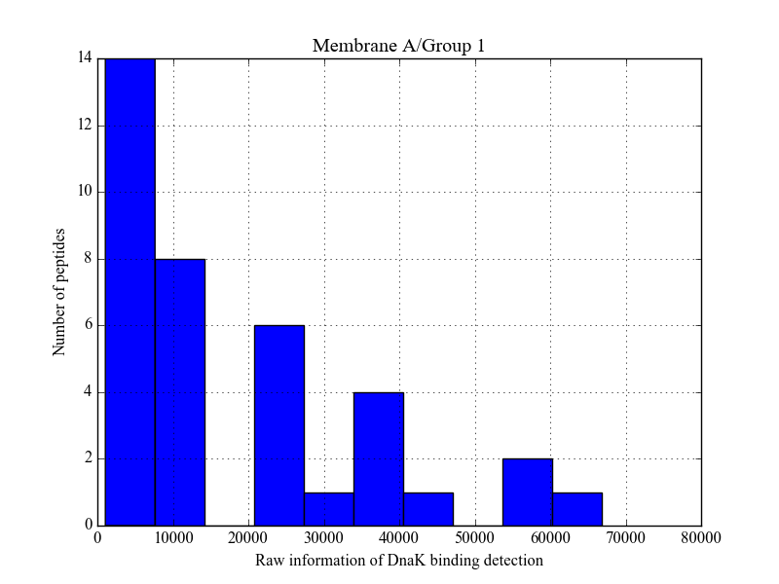
Supplementary Figure S1. Distribution of Membrane A/Group 1 peptides according to raw DnaK detection data.

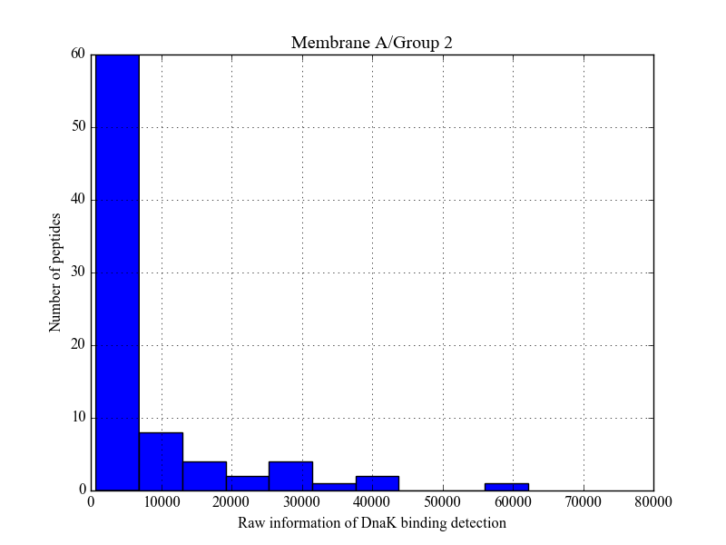
Supplementary Figure S2. Distribution of Membrane A/Group 2 peptides according to raw DnaK detection data.

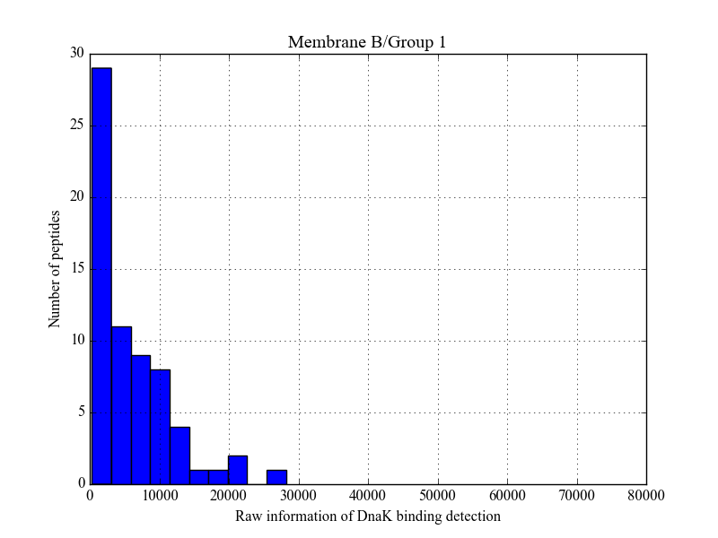
Supplementary Figure S3. Distribution of Membrane B/Group 1 peptides according to raw DnaK detection data.

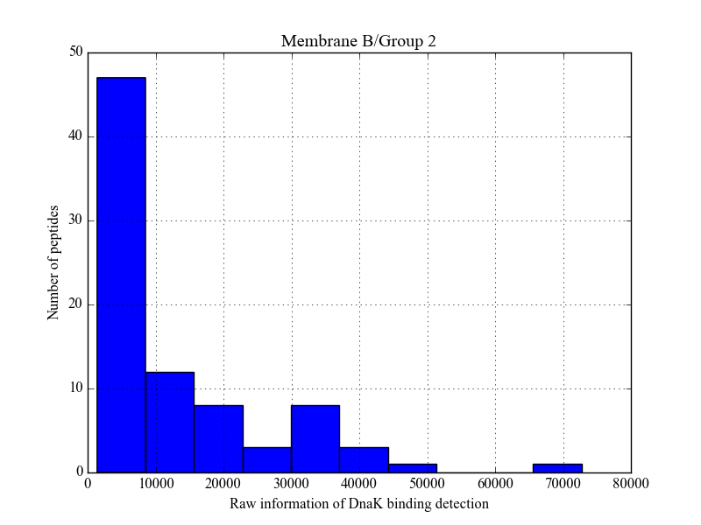
Supplementary Figure S4. Distribution of Membrane B/Group 2 peptides according to raw DnaK detection data.

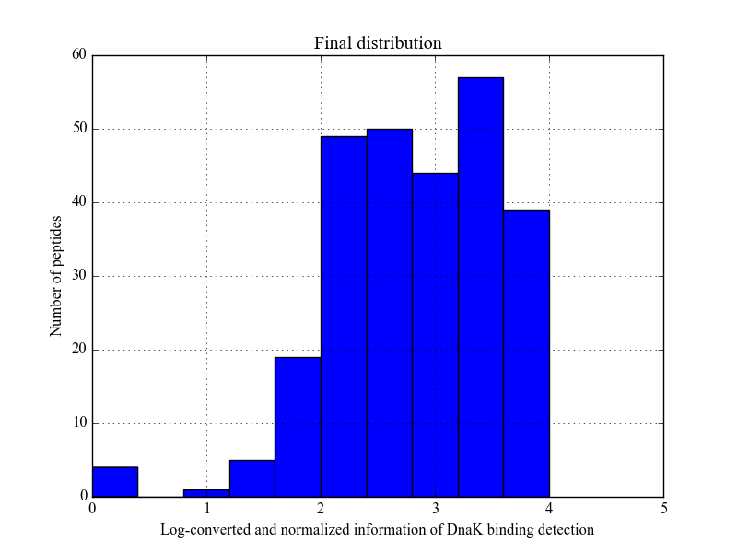
Supplementary Figures S5. Distribution for all 268 peptides from figures S1-S4 after preprocessing.

Supplementary Figure S6. Workflow of normalization, preprocessing and force-field based filtering steps from raw data. The 268 peptides depicted in Supplementary Figures S1-S4 were normalized as explained in Material & Methods section, split, and if the peptide source was considered as a binder (above 3.0) subjected to an energy filter. Energy and DnaK binding score inverse correlation shown in Figures 2A and 2B are also indicated.

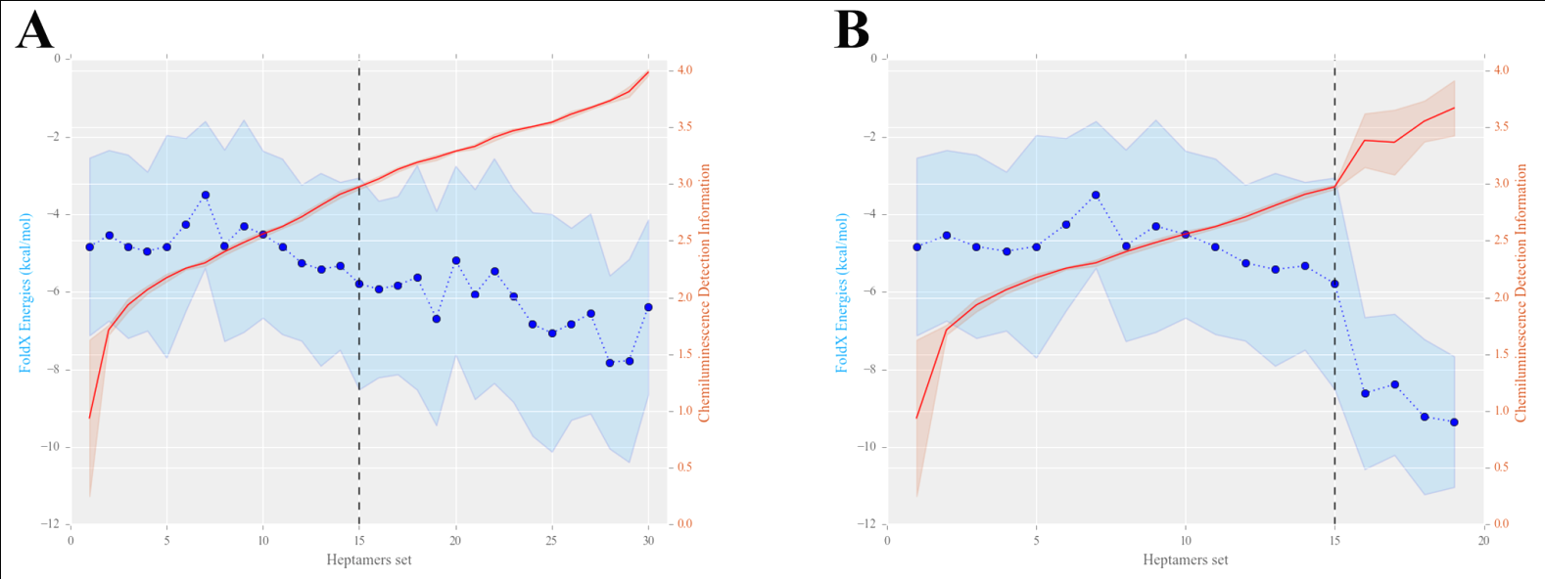
Supplementary Figure S7. The normalized DnaK binding score and the interaction energies with DnaK SBD are shown for 1,488 (A) and 892 (B) heptamers. Data were grouped for every 50 heptamers and the mean values were plotted as a red solid line (DnaK binding score) and as blue points (interaction energy computed with FoldX force field). The shadowed area represents standard deviation (+-1 SD).

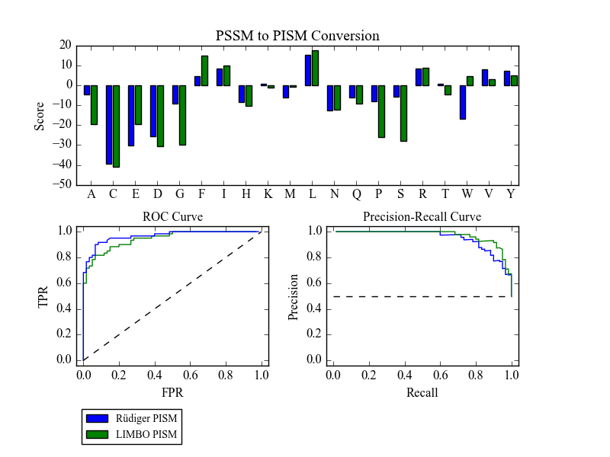
Supplementary Figure S8. Matrices from Rüdiger and LIMBO were converted from PSSM to PISM. Despite the simplification, this modification does not causes a decrease in performance evaluated through ROC and PR analysis in the validation set defined in manuscript main text. In addiction, both PISMs have a similar structure. Rüdiger and LIMBO PISMs are shown in blue and green, respectively. ROC and PR analysis solid line describes the PISM-converted predictive performance.
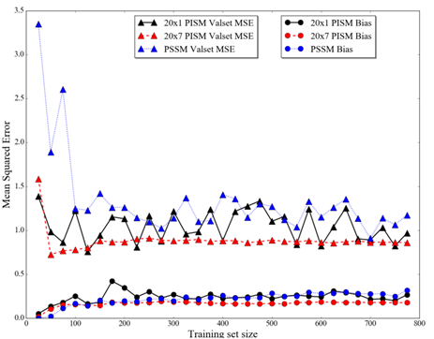

Supplementary Figure S9. Estimation of bias (MSE from training set, circles) and validation set MSE (triangles). Each point represents a classifier trained on a progressively increasing training set. In each step, twenty-five randomly selected heptamers are added to the training set.

Performance of models trained without normalization step in data preprocessing (Figure S10—S11)
Contextualization: One step in the preprocessing of the 4 experiments consists in normalizing different experiments to the range of 1-10,000. This range was chosen after analysis of Supplementary Figures S1-S4. As a result, from this range distribution, the conversion to log10 leads to a new range of 0-4. Normalization, however, could change how true binders and true non-binders are distributed among the other experiments. For instance, the best interactor in Membrane B/Group 1 possess raw detection data of 28,208.86, while in Membrane A/Group 2 is 72,729.74. Normalizing to 1-10,000 independently for each experiment causes both peptides to possess an equal DnaK binding score of 10,000. Thus, we performed the same steps from workflow in Supplementary Figure S6 only removing normalization to evaluate this effect. Raw information from the 268 peptides was directly log10 converted. Minimum and maximum DnaK detection data after this were, respectively, 2.5118 and 4.8617. Selected threshold for energy filtering was chosen as 3.7, to similarly separate the same amount of binders and non-binders as the original threshold of 3.0. An independent validation set of 120 examples was extracted similarly as described in manuscript main text. Herein, we show ROC and PR analysis to one model derived from 20x7 PISM algorithm.
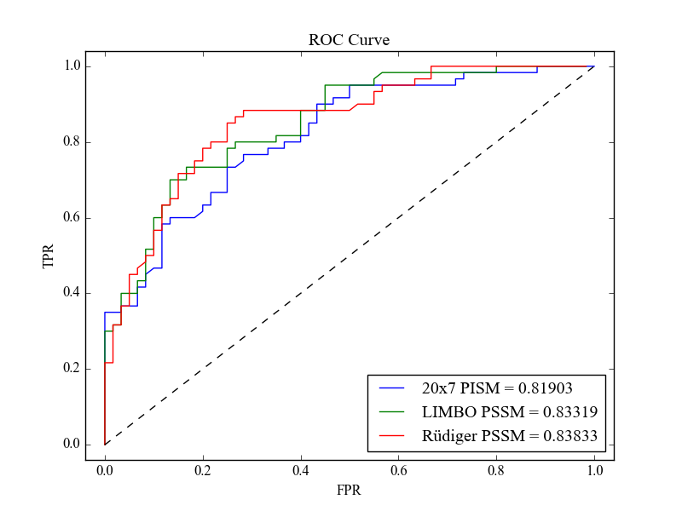
Supplementary Figure S10. ROC curve built upon validation set extracted without performing normalization. Area under the curves for each predictor is shown. Note both PSSMs from Rüdiger (red) and LIMBO (green) shown a decrease in performance in comparison to evaluation with validation set defined in manuscript main text (with normalization). Despite a reasonable performance, the 20x7 PISM (blue) does not outperform these matrices. Dashed line describes the behavior of a random predictor.

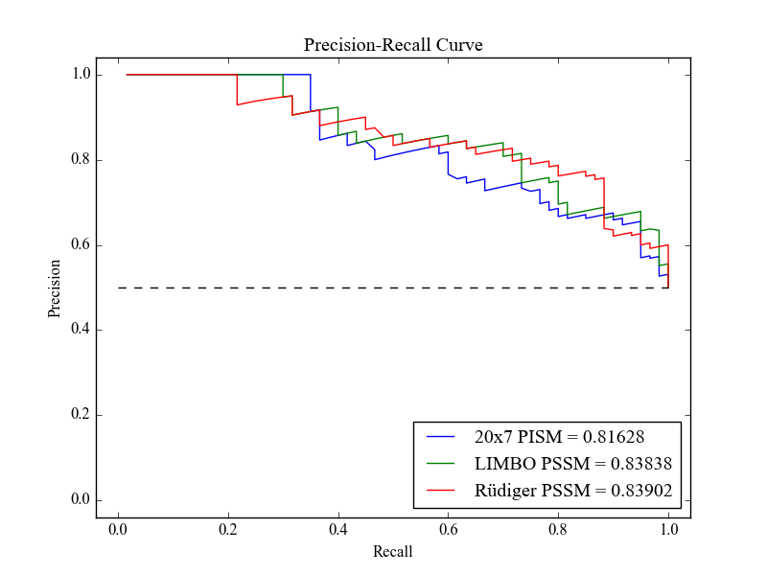
Supplementary Figure S11. PR curve built upon validation set extracted without performing normalization. Area under the curves for each predictor is shown. Dashed line describes the behavior of a random predictor. Area under curve is shown for PSSMs from Rüdiger (red), LIMBO (green) and 20x7 PISM (blue).

Performance of models trained without energy filtering step in data preprocessing (S12-S15)

Contextualization: Another preprocessing step we evaluated was the energy filtering (See Material and Methods in main text). This step removed 574 heptamers from the 1,488 total. After merging duplicates, the final available data to compose both training and validation steps consisted of 892 heptamers. Without performing this step, there is more available data to compose larger sets of training and validation. Merging duplicates leads to 1,364 heptamers (from the 1,488 total). As more data was available, we extracted a balanced validation set of 200 examples. 100 binders were randomly selected from the 200 top scored, while 100 non-binders were randomly extracted from the 200 least scored heptamers. Training set was composed of 1,164 examples. Herein, we show the performance of a model trained employing the 20x7 PISM algorithm in the validation set defined here, and for CD dataset obtained from Schneider et al.

A 20x7 PISM outperforms Rüdiger and LIMBO PSSMs on the validation set defined in this section

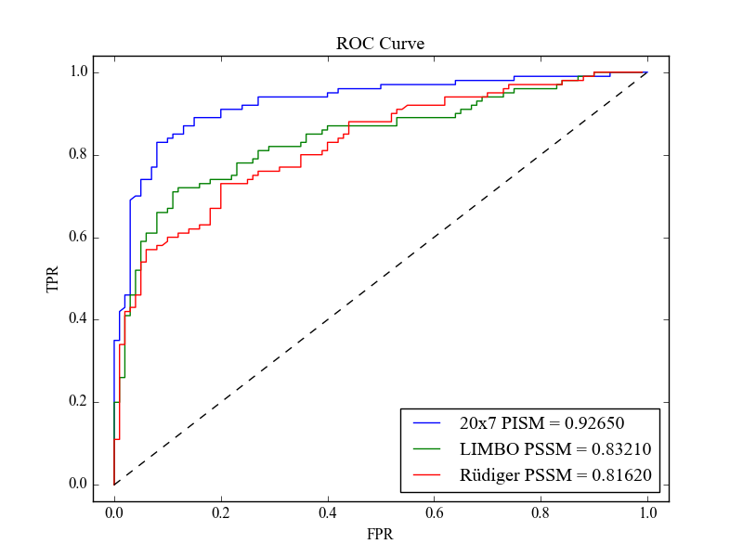
Supplementary Figure S12. ROC curve built upon validation set extracted without performing energy filtering. Area under the curves for each predictor is shown. Dashed line describes the behavior of a random predictor. Area under curve is shown for PSSMs from Rüdiger (red), LIMBO (green) and 20x7 PISM (blue).
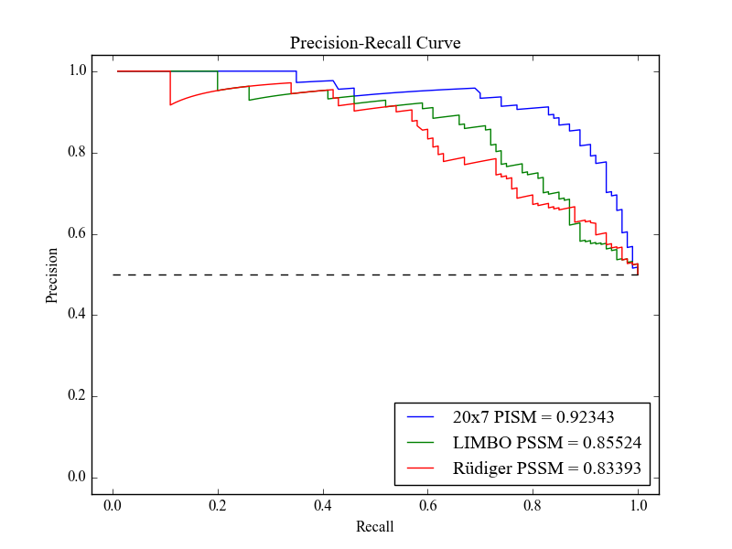
Supplementary Figure S13. PR curve built upon validation set extracted without performing energy filtering. Area under the curves for each predictor is shown. Dashed line describes the behavior of a random predictor. Area under curve is shown for PSSMs from Rüdiger (red), LIMBO (green) and 20x7 PISM (blue).

Both Rüdiger and LIMBO PSSMs outperform a 20x7 PISM on the BiP related CD dataset
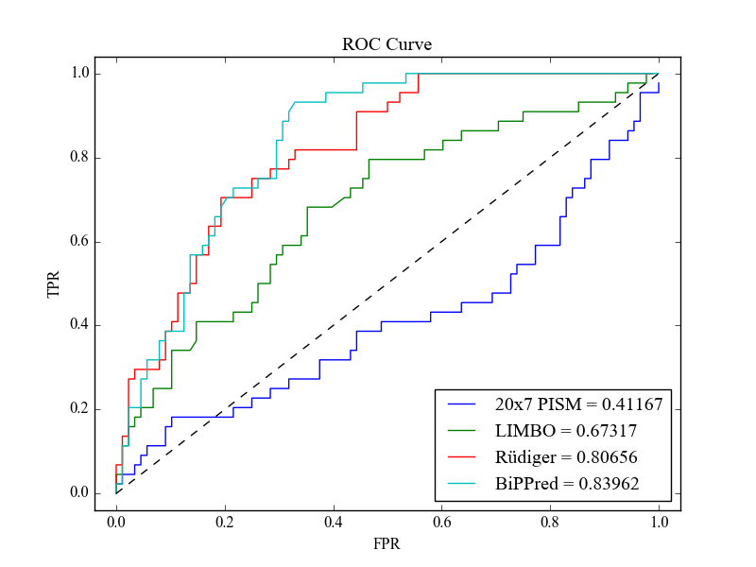
Supplementary Figure S14. ROC curve built upon CD dataset. Area under the curves for each predictor is shown. Dashed line describes the behavior of a random predictor. Area under curve is shown for PSSMs from Rüdiger (red), LIMBO (green), 20x7 PISM trained without energy filtering step in preprocessing (blue) and BiPPred’s maximum predicted score (light green).

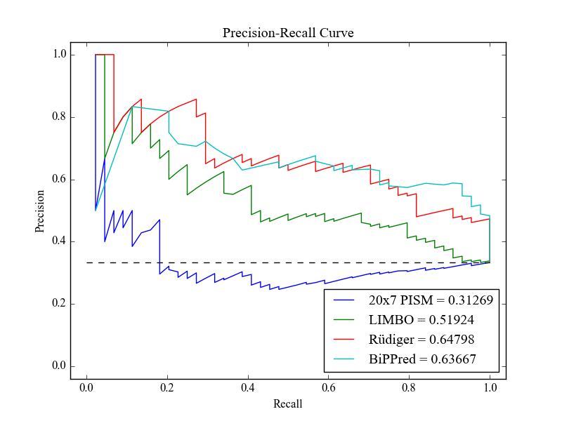

Supplementary Figure S15. PR curve built upon CD dataset. Area under the curves for each predictor is shown. Dashed line describes the behavior of a random predictor. Area under curve is shown for PSSMs from Rüdiger (red), LIMBO (green), 20x7 PISM trained without energy filtering step in preprocessing (blue) and BiPPred maximum predicted score (light green).

Analysis of interaction energies for all possible permutations of a true binder and a true non-binder

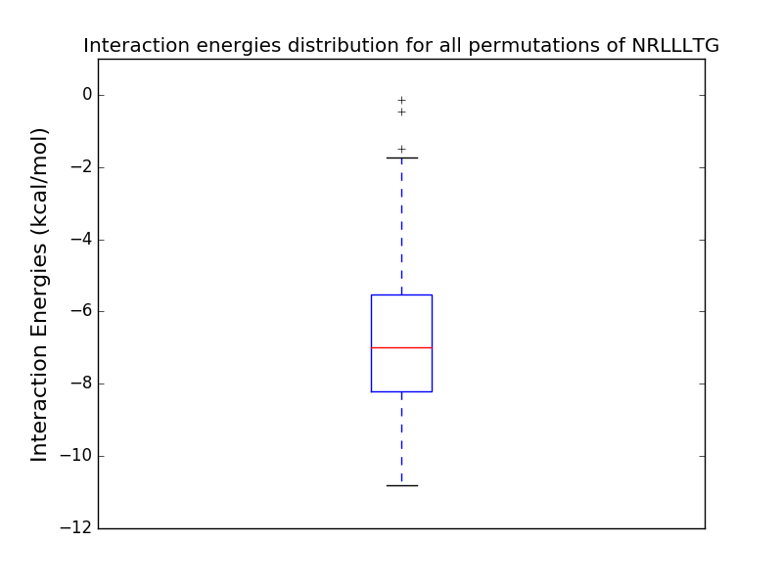
Contextualization: As a PISM does not account different scores for the different positions in the heptamer, it is expected that the interaction energies of all heptamers must be similar in order to explain the PISM superior performance over a regular PSSM. Therefore, we selected a true binder (NRLLLTG) and a true non-binder (EKIDNEE), performed its mutations in the crystal structure of DnaK bound to a heptamer to each possible permutation and computed the energy with FoldX. Figures below highlight that the variation is larger than expected.

Supplementary Figure S16. Interaction energies of all permutations of NRLLLTG computed with FoldX force field based on mutations of the crystal structure of DnaK SBD bound to NRLLLTG heptamer (PDB ID.: 1DKX).

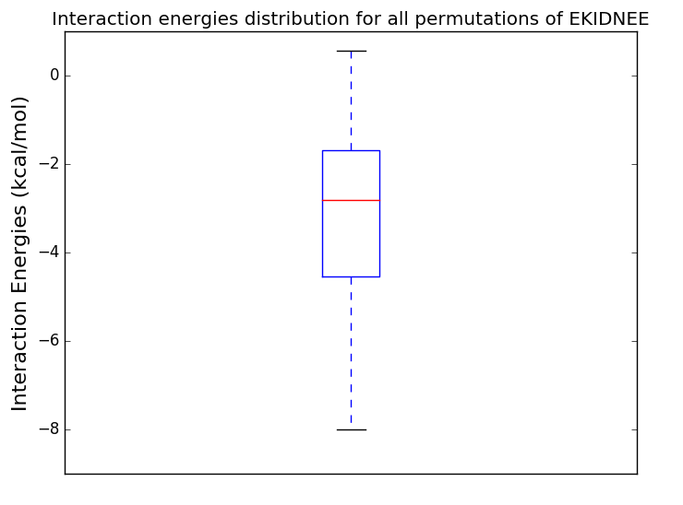

Supplementary Figure S17. Interaction energies of all permutations of EKIDNEE computed with FoldX force field based on mutations of the crystal structure of DnaK SBD bound to a heptamer (PDB ID.: 1DKX).

Next, to investigate why it is possible that a PISM could outperform other PSSMs, we focused our analysis to sub-permutations. Thus, we grouped pairs of adjacent residues (e.g. NR-LTGLL, NR-LLGTL, NR-GLLLT …), and plotted the interaction energy variation in this context. The figures below indicate that variation is extremely reduced when residues fixed are in positions 4 and 5. This reveals that the PISM superior performance is most likely due to the fact that pockets 1, 2, 3, 6 and 7 show a character more ‘position-independent’ than the central pockets.

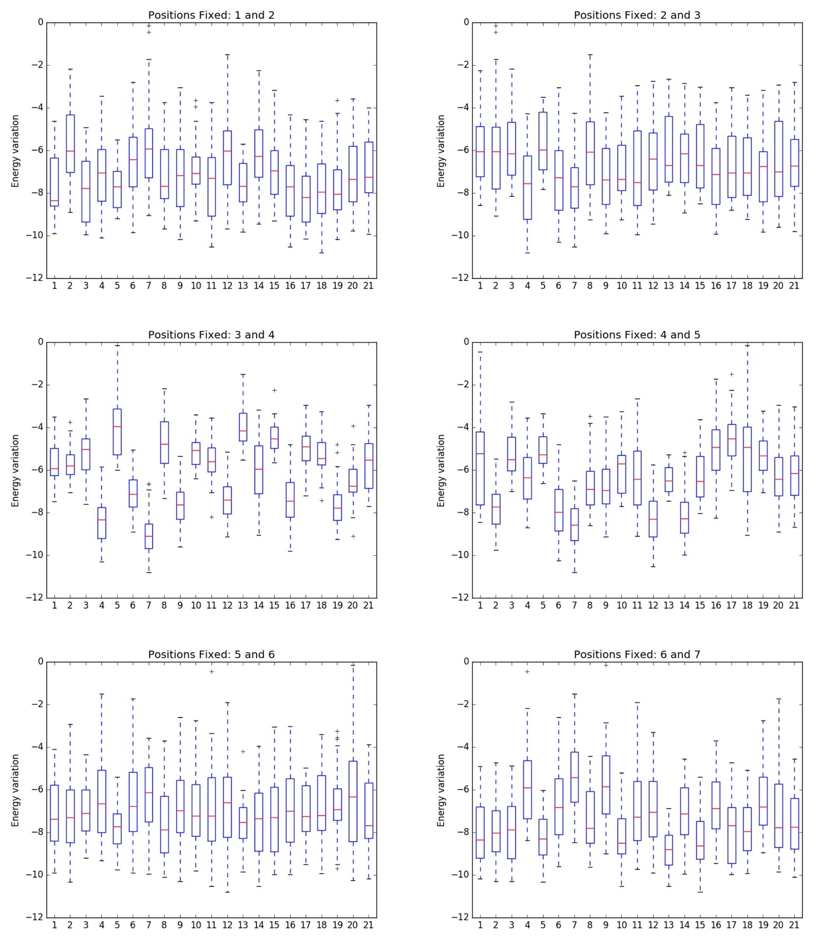
Supplementary Figure S18. Pairs of adjacent amino acids were grouped for the pool of NRLLLTG permutations, and the DnaK interaction energies were plotted. Positions 1 to 21 refers to residues RT, LG, GT, NL, GR, LN, LL, TR, TL, NG, TN, LT, RG, LR, TG, RL, GN, RN, GL, NT, NR.

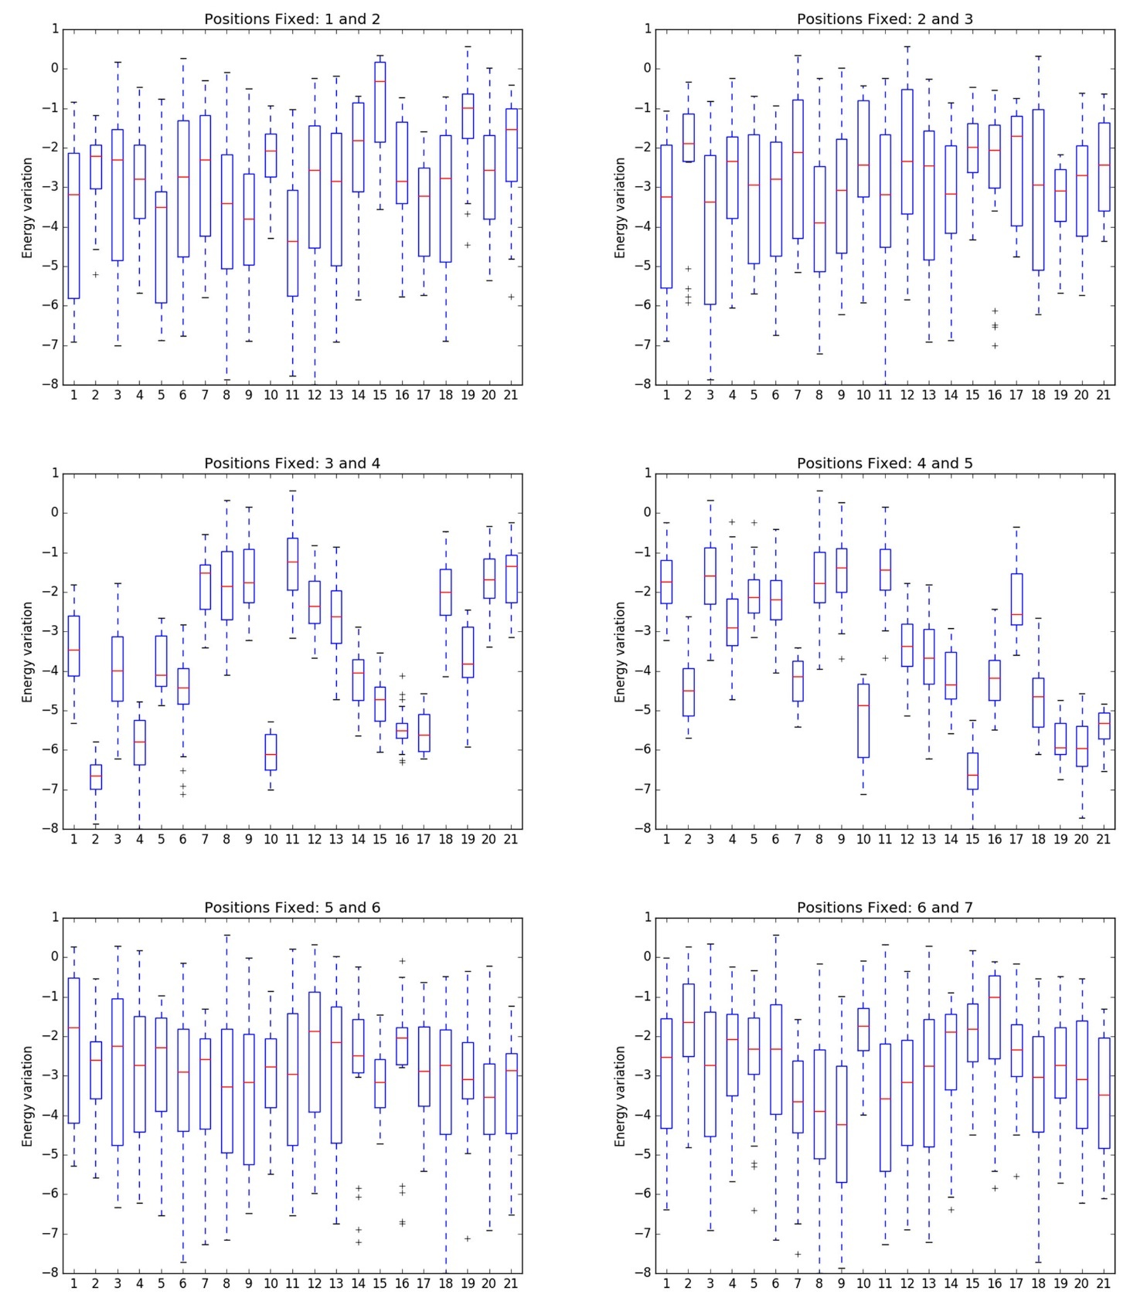
Supplementary Figure S19. Pairs of adjacent amino acids were grouped for the pool of EKIDNEE permutations, and the DnaK interaction energies were plotted. Positions 1 to 21 refers to residues DN, NI, EN, EI, DK, EK, KD, EE, ED, KI, DE, ND, NE, KN, IK, NK, DI, KE, IN, IE, ID.

Finally, in agreement to pockets 4 and 5 being more relevant to the interaction energy of the whole heptamer, we performed a mutation scanning of a polyalanine heptamer in DnaK SBD. We mutated each position to the remaining amino acids and plotted the interaction energies for all positions.

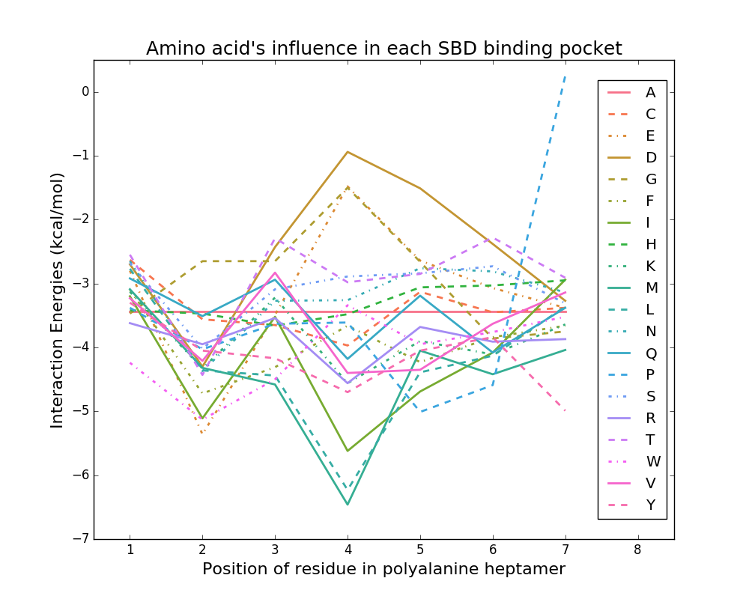

Supplementary Figure S20. The crystal structure of NRLLTG peptide bound to DnaK SBD (PDB ID.: 1DKX) was mutated to a polyalanine heptamer. Next, all positions were sequentially mutated to the other 19 amino acids. The interaction energies were computed with FoldX force field.

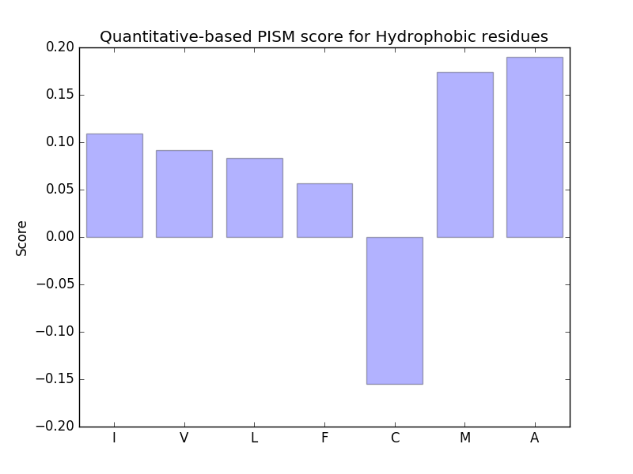

Supplementary Figure S21. The score of hydrophobic amino acids sorted by Kyte and Doolitle hydrophobicity scale according to quantitative-based 20x7 PISM.
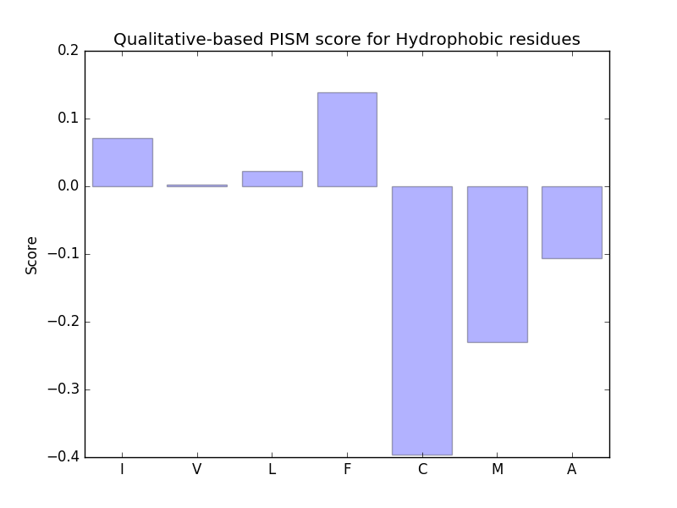

Supplementary Figure S22. The core of hydrophobic amino acids sorted by Kyte and Doolitle hydrophobicity scale according to qualitative-based 20x7 PISM.

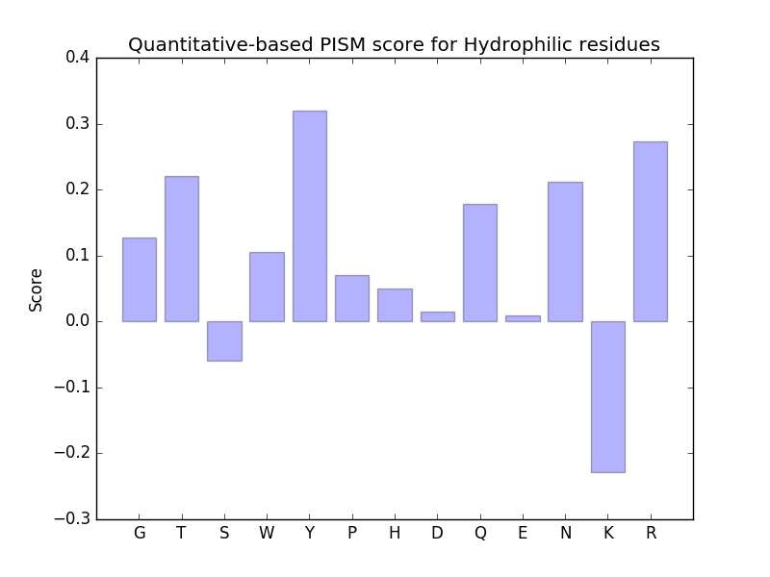

Supplementary Figure S23. The score of hydrophilic amino acids sorted by Kyte and Doolitle hydrophobicity scale according to quantitative-based 20x7 PISM.
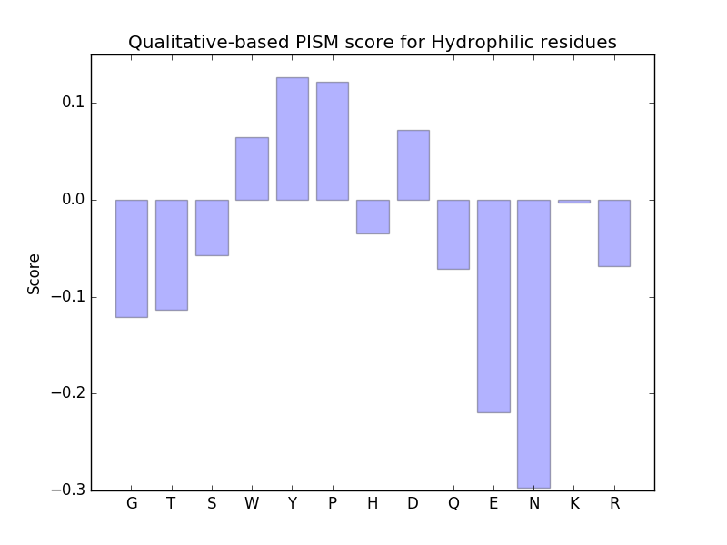

Supplementary Figure S24. The score of hydrophilic amino acids sorted by Kyte and Doolitle hydrophobicity scale according to qualitative-based 20x7 PISM.
Supplementary Tables
Supplementary Table 1. Description of available DnaK peptide binding data from Van Durme et al.
Membrane/ Group | Number of Peptides | Min. Length | Max. Length | Min. Raw Data | Max. Raw Data | Avg Raw Data | Min. Converted Data | Max. Converted Data | Avg Converted Data
A/G1 | 37 | 10 | 15 | 1,056.56 | 66,870.97 | 18,839.39 | 1 | 10,000 | 2,702.69
A/G2 | 82 | 10 | 20 | 724.37 | 62,212.7 | 7,674.09 | 1 | 10,000 | 1,131.14
B/G1 | 66 | 7 | 14 | 325.01 | 28,208.86 | 5,828.84 | 1 | 10,000 | 1,974.65
B/G2 | 83 | 10 | 10 | 1,393.81 | 72,729.74 | 12,623.25 | 1 | 10,000 | 1,575.01

Supplementary Table 2. Performance in the independent validation set defined in manuscript main text for models generated from five independents rounds of training with all six algorithms.
PSSM - Qualitative information | auROC | auPR
Model 1 | 0.870 | 0.894
Model 2 | 0.829 | 0.856
Model 3 | 0.824 | 0.830
Model 4 | 0.696 | 0.688
Model 5 | 0.791 | 0.810
PSSM - Quantitative information | auROC | auPR
Model 1 | 0.818 | 0.825
Model 2 | 0.718 | 0.763
Model 3 | 0.768 | 0.735
Model 4 | 0.783 | 0.778
Model 5 | 0.758 | 0.747
PISM - Qualitative information | auROC | auPR
Model 1 | 0.664 | 0.674
Model 2 | 0.898 | 0.912
Model 3 | 0.926 | 0.933
Model 4 | 0.946 | 0.956
Model 5 | 0.940 | 0.939
PISM - Quantitative information | auROC | auPR
Model 1 | 0.801 | 0.793
Model 2 | 0.934 | 0.925
Model 3 | 0.784 | 0.806
Model 4 | 0.925 | 0.913
Model 5 | 0.924 | 0.923
PISM (20x7) - Qualitative information | auROC | auPR
Model 1 | 0.973 | 0.974
Model 2 | 0.972 | 0.974
Model 3 | 0.972 | 0.974
Model 4 | 0.972 | 0.974
Model 5 | 0.972 | 0.974
PISM (20x7) - Quantitative information | auROC | auPR
Model 1 | 0.982 | 0.967
Model 2 | 0.982 | 0.968
Model 3 | 0.983 | 0.970
Model 4 | 0.982 | 0.969
Model 5 | 0.982 | 0.969

Datasets and Associated codes

Supplementary Table 3. Internal evaluation set.
True Positives |  | True Negatives
Heptamer | Normalized Score | Heptamer | Normalized Score
HILLFTR | 3,511519714 | IMQKEQC | 1,751243833
DLLIVPF | 3,654485032 | VAGTLTN | 0
TVHNPII | 3,425429496 | EKIDNEE | 0
AALLSPY | 3,567143371 | MAGAAAA | 1,675798196
KLVFFAE | 3,661326413 | NTLVDVT | 1,775518858
IRAIRAK | 3,610918029 | LDDATPE | 0
EKYLYII | 3,506734632 | KIDNEEV | 0
ALLAVSL | 3,592400989 | LENGHVV | 1,668333133
LYWLGRK | 3,709111333 | VLIMSES | 1,165210652
LFIINLH | 3,518556963 | EEVLIMS | 1,165210652
QSLLLAL | 3,731889472 | TLVDVTA | 1,775518858
LYFVLDF | 3,676453226 | LVDVTAD | 1,775518858
LLKNKSD | 3,394746561 | GIPEMIP | 1,833501684
SITLFII | 3,518556963 | GNTLVDV | 1,775518858
HILLFIR | 3,660630544 | MKIEEIS | 1,763702146
WPKTKLR | 3,640307756 | IDNEEVL | 0
GNRLLTG | 3,376461844 | MFRVELE | 1,311808169
ERRLARG | 3,773782387 | VGGLGAA | 1,675798196
YRGMINK | 3,521151914 | STVIIEA | 1,689732383
HILLFSR | 3,447478986 | LQGDSDA | 1,687157027
PLVIVTA | 3,350586045 | TLPNTMF | 1,650779866
AFFTIAK | 3,938085754 | PEKLENE | 1,477440775
SLLLLLG | 3,801363908 | IPDIQVE | 1,693750851
IINLHRS | 3,518556963 | LETLPNT | 1,775770109
SLLLLFA | 3,563869677 | RSELLLE | 1,354751509
HILLFVR | 3,497134301 | AGAAAAG | 1,675798196
HILLFRR | 3,649090441 | LENEIEV | 1,477440775
WIVMRQN | 3,725304385 | VDVTADH | 1,775518858
AALLAVS | 3,592400989 | IMEGARD | 1,678356642
DEIYYIS | 3,452509343 | KHMAGAA | 1,675798196
HILLFFR | 3,684748511 | VLETLPN | 1,775770109
NLYLVLH | 3,439526679 | GAAAAGA | 1,675798196
KGRIVFR | 3,834998851 | NMKHMAG | 1,675798196
RLLLLLG | 3,851552662 | GHVVTAH | 1,668333133
DKLLLFT | 3,610676292 | NTMFRVE | 1,650779866
LLLLFAL | 3,563869677 | GTVLETL | 1,775770109
LKNKSDN | 3,394746561 | ELQGDSD | 1,687157027
AFFSIGV | 3,935443438 | EGNTLVD | 1,775518858
GRIVFRS | 3,834998851 | ENGHVVT | 1,668333133
LYWLNPR | 3,547588346 | DVTADHA | 1,775518858
NFALEIL | 3,43227955 | AGTLTNK | 0
SLLLALR | 3,731889472 | FIMEGAR | 1,678356642
LILSHLR | 4 | KLENEIE | 1,477440775
DRVIVKR | 3,673321884 | VLEPTGP | 1,450937305
IIELGQR | 3,585774357 | RVELENG | 1,311808169
True Positives |  | True Negatives
Normalized Score | Heptamer | Heptamer | Normalized Score
QKLVFFA | 3,579513835 | PDIQVEA | 1,693750851
YKLTKNI | 3,604380787 | NIEMQGT | 1,244947169
TQHLTPS | 3,397645565 | DATPEKL | 0
EKLLRNF | 3,782072752 | MKHMAGA | 1,675798196
HSFINRL | 3,661197618 | MEGARDG | 1,678356642
QKLIVLG | 3,731817171 | DNEEVLI | 0
HILLFKR | 3,802235048 | AAAGAVV | 1,675798196
HILLFAR | 3,439874078 | SDMIVAG | 0
IIKIFFI | 3,749989277 | EHMKIEE | 1,763702146
GKLAKKH | 3,508689765 | MIVAGTL | 0
TLVIVRA | 3,492958501 | AFIMEGA | 1,678356642
FLLIMRE | 3,539354667 | IELQGDS | 1,687157027
KLLLFTA | 3,789982713 | AAAAGAV | 1,675798196
PLMVKVL | 3,896366999 | EMQGTVL | 1,244947169
RLARGLK | 3,773782387 | AAGAVVG | 1,675798196

Supplementary Table 4. Training set.
Heptamer | Normalized Score | Heptamer | Normalized Score
VKRKEVE | 3,322304665 | KVTVELT | 2,38993065
LKLNYPE | 3,345576219 | TVELTPY | 2,38993065
RGLKLNY | 3,345576219 | VTVELTP | 2,38993065
GNTLVIV | 3,346048239 | EVLAVGN | 2,3950255
SFYLLYY | 3,365748416 | GEVLAVG | 2,3950255
KLVTVHN | 3,425429496 | RGEVLAV | 2,3950255
VVFILYD | 3,432981805 | TRGEVLA | 2,3950255
RLVIVRA | 3,434746113 | GITLENE | 2,39532425
LYLVLHN | 3,439526679 | ITLENEH | 2,39532425
KNYIRIL | 3,457753029 | LENEHMK | 2,39532425
HILLFYR | 3,475520463 | TLENEHM | 2,39532425
GIVKTFD | 3,485106354 | PSRSQGL | 2,41275532
KLVIVKA | 3,493533229 | RSQGLEA | 2,41275532
HILLFQR | 3,502227789 | SRSQGLE | 2,41275532
TLFIINL | 3,518556963 | TPSRSQG | 2,41275532
GLFSFSV | 3,522003044 | CDLLVCG | 2,41597753
SDGLFSF | 3,522003044 | EQCDLLV | 2,41597753
TLVIVTA | 3,539741074 | KEQCDLL | 2,41597753
VYLLYWL | 3,547588346 | QCDLLVC | 2,41597753
FILYDQM | 3,630446145 | ATGIAVQ | 2,42728643
QWPKTKL | 3,640307756 | GIAVQIL | 2,42728643
NRLMPAY | 3,641712898 | MATGIAV | 2,42728643
HIIKVLY | 3,644052696 | TGIAVQI | 2,42728643
RVIVKRK | 3,673321884 | HNQGITL | 2,43438929
KLRIERG | 3,694843612 | LHNQGIT | 2,43438929
KTKLRIE | 3,694843612 | NQGITLE | 2,43438929
QVHISAF | 3,696799841 | VLHNQGI | 2,43438929
VWIVMRQ | 3,725304385 | ALVNLSA | 2,43656533
KLYKLTK | 3,728745878 | LVNLSAV | 2,43656533
HILLFLR | 3,743046707 | MALVNLS | 2,43656533
EIIIKIF | 3,749989277 | VNLSAVA | 2,43656533
Normalized Score | Heptamer | Heptamer | Normalized Score
IIIKIFF | 3,749989277 | DADHAAA | 2,43772501
VMVIPET | 3,759188377 | DLVIVDA | 2,43772501
KEKLLRN | 3,782072752 | EGNDLVI | 2,43772501
FAFFSIG | 3,935443438 | IVDADHA | 2,43772501
FFSIGVQ | 3,935443438 | LVIVDAD | 2,43772501
KGLIAVV | 4 | NDLVIVD | 2,43772501
KTLILSH | 4 | VDADHAA | 2,43772501
SILLMFS | 4 | VIVDADH | 2,43772501
TLIVLAA | 4 | DGYGVKS | 2,43787702
ATPEKLE | 0 | FNDGYGV | 2,43787702
DDATPEK | 0 | IFNDGYG | 2,43787702
DFNKFAA | 0 | NDGYGVK | 2,43787702
DMIVAGT | 0 | EAMIRAI | 2,46031149
GTLTNKM | 0 | GLEAMIR | 2,46031149
IVAGTLT | 0 | LEAMIRA | 2,46031149
TLTNKMA | 0 | QGLEAMI | 2,46031149
EVLIMSE | 1,165210652 | DRSPQNS | 2,46441134
LIMSESD | 1,165210652 | PQNSIQG | 2,46441134
IEMQGTV | 1,244947169 | RSPQNSI | 2,46441134
MQGTVLE | 1,244947169 | SPQNSIQ | 2,46441134
FRVELEN | 1,311808169 | ADVISAF | 2,47020364
VELENGH | 1,311808169 | AFGSVLS | 2,47020364
MSSRSEL | 1,354751509 | DVISAFG | 2,47020364
SRSELLL | 1,354751509 | FGSVLSD | 2,47020364
SSRSELL | 1,354751509 | GSVLSDP | 2,47020364
EPTGPLH | 1,450937305 | ISAFGSV | 2,47020364
LEPTGPL | 1,450937305 | SAFGSVL | 2,47020364
PTGPLHT | 1,450937305 | VISAFGS | 2,47020364
EKLENEI | 1,477440775 | ETKSAGG | 2,49199925
LPNTMFR | 1,650779866 | EVETKSA | 2,49199925
PNTMFRV | 1,650779866 | TKSAGGI | 2,49199925
NGHVVTA | 1,668333133 | VETKSAG | 2,49199925
AGAVVGG | 1,675798196 | HIDDGLS | 2,51169936
AVVGGLG | 1,675798196 | IDDGLSE | 2,51169936
GAVVGGL | 1,675798196 | IHIDDGL | 2,51169936
HMAGAAA | 1,675798196 | LIHIDDG | 2,51169936
KTNMKHM | 1,675798196 | EILGVVI | 2,51223086
TNMKHMA | 1,675798196 | GEILGVV | 2,51223086
VVGGLGA | 1,675798196 | GVVIVES | 2,51223086
IIELQGD | 1,687157027 | ILGVVIV | 2,51223086
DIQVEAT | 1,693750851 | KQGEILG | 2,51223086
MIPDIQV | 1,693750851 | LGVVIVE | 2,51223086
EIMQKEQ | 1,751243833 | QGEILGV | 2,51223086
LEIMQKE | 1,751243833 | VVIVESG | 2,51223086
MQKEQCD | 1,751243833 | ARHNDAH | 2,51370242
HMKIEEI | 1,763702146 | HNDAHLT | 2,51370242
NEHMKIE | 1,763702146 | LARHNDA | 2,51370242
TVLETLP | 1,775770109 | RHNDAHL | 2,51370242
EGIPEMI | 1,833501684 | DEYMMIY | 2,51572986
IPEMIPD | 1,833501684 | EYMMIYG | 2,51572986
PEMIPDI | 1,833501684 | MMIYGVC | 2,51572986
ANDEYMM | 1,859445901 | YMMIYGV | 2,51572986
DANDEYM | 1,859445901 | GSAAAKS | 2,51917508
LSDANDE | 1,859445901 | LTGSAAA | 2,51917508
Normalized Score | Heptamer | Heptamer | Normalized Score
SDANDEY | 1,859445901 | TGSAAAK | 2,51917508
ATFPDGS | 1,873269249 | VLTGSAA | 2,51917508
EATFPDG | 1,873269249 | AVTKGRG | 2,520623
QVEATFP | 1,873269249 | DVIAVTK | 2,520623
VEATFPD | 1,873269249 | EIDVIAV | 2,520623
GNNQQNY | 1,891561098 | IAVTKGR | 2,520623
NNQQNYA | 1,891561098 | IDVIAVT | 2,520623
NQQNYAA | 1,891561098 | SEIDVIA | 2,520623
TVIIEAA | 1,895956269 | VIAVTKG | 2,520623
CPVLEPT | 1,931132413 | VTKGRGV | 2,520623
FSCPVLE | 1,931132413 | INKLSAD | 2,52721767
SCPVLEP | 1,931132413 | KLSADLL | 2,52721767
VFSCPVL | 1,931132413 | MINKLSA | 2,52721767
AMSRPII | 1,966053077 | NKLSADL | 2,52721767
FGSDYED | 1,966053077 | EKMALTQ | 2,54588842
GSAMSRP | 1,966053077 | FEKMALT | 2,54588842
GSDYEDA | 1,966053077 | KMALTQH | 2,54588842
HFGSDYE | 1,966053077 | MALTQHL | 2,54588842
IHFGSDY | 1,966053077 | HVTLSQA | 2,54615728
IIHFGSD | 1,966053077 | NHVTLSQ | 2,54615728
LGSAMSR | 1,966053077 | VTLSQAA | 2,54615728
MLGSAMS | 1,966053077 | DAAIVKG | 2,56950722
MSRPIIH | 1,966053077 | DSDAAIV | 2,56950722
PIIHFGS | 1,966053077 | GDSDAAI | 2,56950722
RPIIHFG | 1,966053077 | SDAAIVK | 2,56950722
SAMSRPI | 1,966053077 | IIPSDGR | 2,57571664
SDYEDAA | 1,966053077 | IPSDGRK | 2,57571664
SRPIIHF | 1,966053077 | PSDGRKE | 2,57571664
YMLGSAM | 1,966053077 | SDGRKEV | 2,57571664
AEVLIPG | 1,969772595 | AKTAAAL | 2,57599607
DAEVLIP | 1,969772595 | KTAAALH | 2,57599607
EVLIPGL | 1,969772595 | MAKTAAA | 2,57599607
VLIPGLR | 1,969772595 | TAAALHI | 2,57599607
DYGILQI | 1,994944121 | DGFITIT | 2,58506629
GILQINS | 1,994944121 | FITITGG | 2,58506629
ILQINSR | 1,994944121 | GFITITG | 2,58506629
INSRWWC | 1,994944121 | GLDGFIT | 2,58506629
LQINSRW | 1,994944121 | ITGGKLM | 2,58506629
NSRWWCA | 1,994944121 | ITITGGK | 2,58506629
QINSRWW | 1,994944121 | LDGFITI | 2,58506629
SRWWCAA | 1,994944121 | TITGGKL | 2,58506629
STDYGIL | 1,994944121 | EVKPLDV | 2,58631507
TDYGILQ | 1,994944121 | GEVKPLD | 2,58631507
YGILQIN | 1,994944121 | NGEVKPL | 2,58631507
AKEDNIE | 2,016147514 | VKPLDVK | 2,58631507
EDNIEMQ | 2,016147514 | FPTDNSN | 2,58707049
KEDNIEM | 2,016147514 | GKFPTDN | 2,58707049
MAKEDNI | 2,016147514 | KFPTDNS | 2,58707049
NNQQNYQ | 2,028249555 | PTDNSNF | 2,58707049
NQQNYQA | 2,028249555 | NFLVHAA | 2,59416033
QQNYQAA | 2,028249555 | AGAQSLL | 2,61312839
GVKSEKI | 2,034989728 | EAGAQSL | 2,61312839
KSEKIDN | 2,034989728 | GAQSLLL | 2,61312839
VKSEKID | 2,034989728 | YEAGAQS | 2,61312839
Normalized Score | Heptamer | Heptamer | Normalized Score
YGVKSEK | 2,034989728 | AVGGGSR | 2,61358494
AALMEEG | 2,048076005 | AVVMAVG | 2,61358494
KSVAALM | 2,048076005 | EFQAVVM | 2,61358494
SVAALME | 2,048076005 | FQAVVMA | 2,61358494
VAALMEE | 2,048076005 | MAVGGGS | 2,61358494
EEISSSD | 2,054104511 | QAVVMAV | 2,61358494
EISSSDN | 2,054104511 | VMAVGGG | 2,61358494
IEEISSS | 2,054104511 | VVMAVGG | 2,61358494
ISSSDNK | 2,054104511 | GLRGPTA | 2,61433407
AQGIIEL | 2,059681035 | LRGPTAA | 2,61433407
NAQGIIE | 2,059681035 | NGLRGPT | 2,61433407
QGIIELQ | 2,059681035 | VNGLRGP | 2,61433407
QNAQGII | 2,059681035 | ADFGKLA | 2,6144971
GQMVPAF | 2,074819432 | GADFGKL | 2,6144971
MVPAFDK | 2,074819432 | KNGADFG | 2,6144971
QMVPAFD | 2,074819432 | NGADFGK | 2,6144971
VPAFDKV | 2,074819432 | DNKHYYA | 2,61608275
ETLLEIM | 2,076685948 | NKHYYAG | 2,61608275
MPETLLE | 2,076685948 | SDNKHYY | 2,61608275
PETLLEI | 2,076685948 | SSDNKHY | 2,61608275
TLLEIMQ | 2,076685948 | GRILENG | 2,61656308
ELTPREK | 2,087115652 | ILENGEV | 2,61656308
LTPREKD | 2,087115652 | LENGEVK | 2,61656308
MELTPRE | 2,087115652 | RILENGE | 2,61656308
TPREKDK | 2,087115652 | AALHILV | 2,618235
STVIFEA | 2,098955672 | ALHILVK | 2,618235
TVIFEAA | 2,098955672 | HILVKEE | 2,618235
KTVIIEA | 2,102180154 | LHILVKE | 2,618235
AMSAAVG | 2,107403357 | IQGCQSQ | 2,62769673
IAMSAAV | 2,107403357 | NSIQGCQ | 2,62769673
MSAAVGL | 2,107403357 | QGCQSQV | 2,62769673
VIAMSAA | 2,107403357 | SIQGCQS | 2,62769673
DVRPWFE | 2,11789237 | ESVALIS | 2,6317037
PWFEKMA | 2,11789237 | NYPESVA | 2,6317037
RPWFEKM | 2,11789237 | PESVALI | 2,6317037
VRPWFEK | 2,11789237 | YPESVAL | 2,6317037
EQVMEGI | 2,122784541 | GPYLCYE | 2,63619353
QVMEGIP | 2,122784541 | LCYEAGA | 2,63619353
REQVMEG | 2,122784541 | PYLCYEA | 2,63619353
VMEGIPE | 2,122784541 | YLCYEAG | 2,63619353
EEKLALD | 2,123794752 | EPHILLF | 2,64252883
KEEKLAL | 2,123794752 | PEPHILL | 2,64252883
LVKEEKL | 2,123794752 | ATEDILQ | 2,65305296
VKEEKLA | 2,123794752 | FPATEDI | 2,65305296
EGNTLVE | 2,137914622 | PATEDIL | 2,65305296
EVTADHA | 2,137914622 | YFPATED | 2,65305296
GNTLVEV | 2,137914622 | CVNITIK | 2,66477221
LVEVTAD | 2,137914622 | DCVNITI | 2,66477221
NTLVEVT | 2,137914622 | HTVTTTT | 2,66477221
TLVEVTA | 2,137914622 | IKQHTVT | 2,66477221
VEVTADH | 2,137914622 | ITIKQHT | 2,66477221
EFRQGQM | 2,16073412 | KQHTVTT | 2,66477221
FRQGQMV | 2,16073412 | NITIKQH | 2,66477221
GEFRQGQ | 2,16073412 | QHTVTTT | 2,66477221
Normalized Score | Heptamer | Heptamer | Normalized Score
RQGQMVP | 2,16073412 | TIKQHTV | 2,66477221
AFTPRDA | 2,172693856 | TVTTTTA | 2,66477221
FTPRDAE | 2,172693856 | VNITIKQ | 2,66477221
PRDAEVL | 2,172693856 | VTTTTAA | 2,66477221
TPRDAEV | 2,172693856 | KSMENLY | 2,68007344
SVTSTFA | 2,178492525 | SMENLYL | 2,68007344
VTSTFAA | 2,178492525 | VKSMENL | 2,68007344
CREKDAA | 2,181363726 | VVKSMEN | 2,68007344
FCREKDA | 2,181363726 | ELTPYDL | 2,68418191
HILLFCR | 2,181363726 | LTPYDLS | 2,68418191
ILLFCRE | 2,181363726 | PYDLSKG | 2,68418191
LFCREKD | 2,181363726 | TPYDLSK | 2,68418191
LLFCREK | 2,181363726 | ALLPDKE | 2,69510208
PHILLFC | 2,181363726 | LLPDKEK | 2,69510208
DVKVGDI | 2,188287941 | LPDKEKL | 2,69510208
LDVKVGD | 2,188287941 | MALLPDK | 2,69510208
PLDVKVG | 2,188287941 | EFCRVNG | 2,70487552
VKVGDIV | 2,188287941 | FCRVNGL | 2,70487552
DREKDAA | 2,220999021 | RVEFCRV | 2,70487552
FDREKDA | 2,220999021 | VEFCRVN | 2,70487552
HILLFDR | 2,220999021 | GNDLVIV | 2,72952038
ILLFDRE | 2,220999021 | DVVNFDV | 2,72973524
LFDREKD | 2,220999021 | NFDVRPW | 2,72973524
LLFDREK | 2,220999021 | VNFDVRP | 2,72973524
PHILLFD | 2,220999021 | VVNFDVR | 2,72973524
AANVYLS | 2,227294045 | CPSGKRG | 2,73365107
GPTAANV | 2,227294045 | GKRGGDL | 2,73365107
PTAANVY | 2,227294045 | PSGKRGG | 2,73365107
TAANVYL | 2,227294045 | SGKRGGD | 2,73365107
ARDGKSV | 2,235353661 | AAIVALE | 2,73896535
DGKSVAA | 2,235353661 | AIVALEA | 2,73896535
GARDGKS | 2,235353661 | ELMAAIV | 2,73896535
RDGKSVA | 2,235353661 | IVALEAL | 2,73896535
AISGNEE | 2,242879295 | LMAAIVA | 2,73896535
GVAISGN | 2,242879295 | MAAIVAL | 2,73896535
IGVAISG | 2,242879295 | MELMAAI | 2,73896535
VAISGNE | 2,242879295 | RMELMAA | 2,73896535
EGNTLVP | 2,251544281 | AACFLET | 2,75043429
GNTLVPV | 2,251544281 | ACFLETL | 2,75043429
LVPVTAD | 2,251544281 | FAACFLE | 2,75043429
NTLVPVT | 2,251544281 | KLQQFAA | 2,75043429
PVTADHA | 2,251544281 | LKLQQFA | 2,75043429
TLVPVTA | 2,251544281 | LQQFAAC | 2,75043429
VPVTADH | 2,251544281 | QFAACFL | 2,75043429
EEDALLV | 2,26092081 | QQFAACF | 2,75043429
GNEEDAL | 2,26092081 | GQRLPEL | 2,75835714
NEEDALL | 2,26092081 | LPELRDE | 2,75835714
SGNEEDA | 2,26092081 | QRLPELR | 2,75835714
AILSSAA | 2,26334659 | RLPELRD | 2,75835714
FGAILSS | 2,26334659 | ALLVNKA | 2,78172912
GAILSSA | 2,26334659 | DALLVNK | 2,78172912
NFGAILS | 2,26334659 | LLVNKAL | 2,78172912
NNFGAIL | 2,26334659 | LVNKALE | 2,78172912
SNNFGAI | 2,26334659 | EADHAAA | 2,78611146
Normalized Score | Heptamer | Heptamer | Normalized Score
CYVSFHP | 2,265819382 | EGNELVI | 2,78611146
DIEVDLL | 2,265819382 | ELVIVEA | 2,78611146
EVDLLKA | 2,265819382 | IVEADHA | 2,78611146
FHPSDIE | 2,265819382 | LVIVEAD | 2,78611146
FLNCYVS | 2,265819382 | NELVIVE | 2,78611146
HPSDIEV | 2,265819382 | VEADHAA | 2,78611146
IEVDLLK | 2,265819382 | VIVEADH | 2,78611146
LNCYVSF | 2,265819382 | ILTGDKV | 2,80038712
NCYVSFH | 2,265819382 | LTGDKVT | 2,80038712
NFLNCYV | 2,265819382 | RILTGDK | 2,80038712
PSDIEVD | 2,265819382 | TGDKVTV | 2,80038712
SDIEVDL | 2,265819382 | KMTGIVK | 2,81237392
SFHPSDI | 2,265819382 | MSRKMTG | 2,81237392
SNFLNCY | 2,265819382 | RKMTGIV | 2,81237392
VDLLKAA | 2,265819382 | SRKMTGI | 2,81237392
VSFHPSD | 2,265819382 | EGNTLVK | 2,82052236
YVSFHPS | 2,265819382 | GNTLVKV | 2,82052236
EQIKNGA | 2,266847724 | KVTADHA | 2,82052236
LEQIKNG | 2,266847724 | LVKVTAD | 2,82052236
LLEQIKN | 2,266847724 | NTLVKVT | 2,82052236
QIKNGAD | 2,266847724 | TLVKVTA | 2,82052236
MTPQDVV | 2,267421536 | VKVTADH | 2,82052236
PQDVVNF | 2,267421536 | KMMTSYV | 2,83717422
QMTPQDV | 2,267421536 | LTKMMTS | 2,83717422
TPQDVVN | 2,267421536 | MMTSYVI | 2,83717422
ERGEMPE | 2,268905705 | MTSYVIG | 2,83717422
GEMPETL | 2,268905705 | SYVIGQA | 2,83717422
IERGEMP | 2,268905705 | TKMMTSY | 2,83717422
RGEMPET | 2,268905705 | TSYVIGQ | 2,83717422
AAAKSTR | 2,27201631 | YVIGQAM | 2,83717422
AAKSTRG | 2,27201631 | AEKIGIG | 2,84910992
AKSTRGE | 2,27201631 | EKIGIGS | 2,84910992
KSTRGEV | 2,27201631 | FAEKIGI | 2,84910992
AVGNGRI | 2,282817426 | KFAEKIG | 2,84910992
GNGRILE | 2,282817426 | ALDLLEQ | 2,85070309
LAVGNGR | 2,282817426 | KLALDLL | 2,85070309
VGNGRIL | 2,282817426 | LALDLLE | 2,85070309
EIEVVVK | 2,287283648 | LDLLEQI | 2,85070309
EVVVKSM | 2,287283648 | AHISGKM | 2,85840591
IEVVVKS | 2,287283648 | TAHISGK | 2,85840591
NEIEVVV | 2,287283648 | VTAHISG | 2,85840591
EEGRHVL | 2,299377752 | VVTAHIS | 2,85840591
EGRHVLS | 2,299377752 | FHREKDA | 2,86378018
LMEEGRH | 2,299377752 | HILLFHR | 2,86378018
MEEGRHV | 2,299377752 | HREKDAA | 2,86378018
DEDRSPQ | 2,303809329 | ILLFHRE | 2,86378018
ELRDEDR | 2,303809329 | LFHREKD | 2,86378018
LRDEDRS | 2,303809329 | LLFHREK | 2,86378018
RDEDRSP | 2,303809329 | PHILLFH | 2,86378018
DGSKLVT | 2,309263764 | GKMRKNY | 2,89175403
FPDGSKL | 2,309263764 | ISGKMRK | 2,89175403
GSKLVTV | 2,309263764 | KMRKNYI | 2,89175403
PDGSKLV | 2,309263764 | SGKMRKN | 2,89175403
FNENRLC | 2,3235216 | AYKHIGV | 2,90630513
Normalized Score | Heptamer | Heptamer | Normalized Score
ISFNENR | 2,3235216 | KHIGVAI | 2,90630513
NENRLCS | 2,3235216 | MAYKHIG | 2,90630513
SFNENRL | 2,3235216 | YKHIGVA | 2,90630513
FGSVQFV | 2,324629805 | AALLSMP | 2,92168964
GSVQFVA | 2,324629805 | AVGAALL | 2,92168964
NFGSVQF | 2,324629805 | GAALLSM | 2,92168964
SVQFVAA | 2,324629805 | LQRVAVG | 2,92168964
AENGGPY | 2,341325716 | QRVAVGA | 2,92168964
ENGGPYL | 2,341325716 | RVAVGAA | 2,92168964
FAENGGP | 2,341325716 | VAVGAAL | 2,92168964
NGGPYLC | 2,341325716 | VGAALLS | 2,92168964
ESDILAI | 2,345031392 | ALISAFI | 2,92719723
MSESDIL | 2,345031392 | ISAFIME | 2,92719723
SDILAIV | 2,345031392 | LISAFIM | 2,92719723
SESDILA | 2,345031392 | VALISAF | 2,92719723
ANWEEKY | 2,348908948 | AQKTVEG | 2,938638
CANWEEK | 2,348908948 | AVAQKTV | 2,938638
NWEEKYL | 2,348908948 | AVVTGVT | 2,938638
RCANWEE | 2,348908948 | GAVVTGV | 2,938638
DLGEFRQ | 2,358326604 | GVTAVAQ | 2,938638
GDLGEFR | 2,358326604 | KTVEGAA | 2,938638
GGDLGEF | 2,358326604 | QKTVEGA | 2,938638
RGGDLGE | 2,358326604 | TAVAQKT | 2,938638
AGGIVLT | 2,365913198 | TGVTAVA | 2,938638
GGIVLTG | 2,365913198 | TVEGAAA | 2,938638
GIVLTGS | 2,365913198 | VAQKTVE | 2,938638
SAGGIVL | 2,365913198 | VTAVAQK | 2,938638
GFIIPSD | 2,373450242 | VTGVTAV | 2,938638
GKGFIIP | 2,373450242 | VVTGVTA | 2,938638
KGFIIPS | 2,373450242 | EGNTLVR | 2,94631143
SGKGFII | 2,373450242 | GNTLVRV | 2,94631143
TADHAAA | 2,386362309 | LVRVTAD | 2,94631143
VTADHAA | 2,386362309 | NTLVRVT | 2,94631143
DKVTVEL | 2,389930651 | RVTADHA | 2,94631143
PHILLFG | 2,988107989 | TLVRVTA | 2,94631143
GNELVIV | 2,989034466 | VRVTADH | 2,94631143
ALRFPLD | 2,990098958 | HSICPSG | 2,94977
FPLDDAT | 2,990098958 | KHSICPS | 2,94977
LRFPLDD | 2,990098958 | KKHSICP | 2,94977
RFPLDDA | 2,990098958 | SICPSGK | 2,94977
ELLLEKF | 2,990464812 | EREKDAA | 2,95839323
LEKFAEK | 2,990464812 | FEREKDA | 2,95839323
LLEKFAE | 2,990464812 | HILLFER | 2,95839323
LLLEKFA | 2,990464812 | ILLFERE | 2,95839323
GLLTTLN | 2,995859596 | LFEREKD | 2,95839323
HVGLLTT | 2,995859596 | LLFEREK | 2,95839323
LLTTLNF | 2,995859596 | PHILLFE | 2,95839323
LTTLNFG | 2,995859596 | DKVVFSC | 2,96571015
SHVGLLT | 2,995859596 | FDKVVFS | 2,96571015
TLNFGDG | 2,995859596 | KVVFSCP | 2,96571015
TTLNFGD | 2,995859596 | VVFSCPV | 2,96571015
VGLLTTL | 2,995859596 | FGREKDA | 2,98810799
GLRVEFC | 2,999080324 | GREKDAA | 2,98810799
IPGLRVE | 2,999080324 | HILLFGR | 2,98810799
Normalized Score | Heptamer | Heptamer | Normalized Score
LRVEFCR | 2,999080324 | ILLFGRE | 2,98810799
PGLRVEF | 2,999080324 | LFGREKD | 2,98810799
VCGKFPT | 3,005469211 | LLFGREK | 2,98810799
DLVIVTA | 3,021315746 | RNFLRCA | 3,17738367
HLTLIHI | 3,027755686 | GIYFPAT | 3,18815474
LTLIHID | 3,027755686 | PGIYFPA | 3,18815474
RHVLSRE | 3,032731728 | ELVIVTA | 3,19195747
HILLFNR | 3,050698636 | GPLHTQF | 3,19639177
IRPLHDR | 3,062532886 | GNKLVIV | 3,2095174
MNIRPLH | 3,062532886 | KLVIVTA | 3,2095174
ALEILNA | 3,064671901 | SLLMKLF | 3,21117998
RLCSFAI | 3,0673361 | TLVIVDA | 3,21210143
LGVLGIR | 3,082889793 | QYLLAVD | 3,22032032
QEVISLG | 3,082889793 | TQYLLAV | 3,22032032
VLAVYAE | 3,101603515 | RKEVQVH | 3,22651438
TLVIVPA | 3,113378376 | IYYISLS | 3,24275138
FDRKSGK | 3,136026965 | LSELYPG | 3,25205027
HILLFWR | 3,141946561 | LQLLKNK | 3,26453923
VEKVVFW | 3,145072335 | AALLAER | 3,27149824
VFWLHDS | 3,145072335 | ANLWFAE | 3,27575539
VVFWLHD | 3,145072335 | NANLWFA | 3,27575539
LLVCGHH | 3,145973852 | HIARNYA | 3,28037596
DIVIFND | 3,14788463 | VVHIARN | 3,28037596
ALAVLAV | 3,161492051 | TLVIVEA | 3,28630221
HILLFMR | 3,167157782 | AFPLFAL | 3,28781133
HILLFPR | 3,308676875 | AYLVYNA | 3,2950841
TLVIVKA | 3,319167049 | QVWIVMR | 3,2960842
GNRLVIV | 3,320153495 | SQVWIVM | 3,2960842
ALELARH | 3,320316204 | PLVIVPA | 3,29960681
NKALELA | 3,320316204 | GIGSISF | 3,30332329
IVKRKEV | 3,322304665 | RKEVETK | 3,32230467

Supplementary Table 5. Final quantitative-based 20x7 PISM.
Position | 1 | 2 | 3 | 4 | 5 | 6 | 7
A | 0,14567794 | 0,04818767 | 0,00665627 | 0,03211395 | -0,0343707 | 0,01161968 | 0,04473559
C | -0,2715942 | -0,0557392 | 0,06694989 | 0,08702948 | 0,17277077 | 0,02670373 | 0,11699927
E | 0,02432079 | -0,1914373 | 0,09043395 | -0,0054715 | 0,08613284 | 0,08931813 | -0,015254
D | 0,09261986 | -0,2061135 | 0,18241395 | 0,23323361 | 0,0322968 | -0,1602488 | -0,0773423
G | 0,18166801 | 0,0677326 | 0,08549923 | -0,1114399 | 0,02749219 | -0,0182826 | -0,0549524
F | -0,0847618 | 0,01291043 | -0,144703 | 0,03835858 | 0,19123185 | 0,25543387 | 0,1412575
I | 0,09966293 | 0,04018111 | 0,08091449 | 0,18619379 | -0,0613654 | -0,0156231 | 0,00960857
H | 0,00316637 | 0,00750568 | 0,19636926 | 0,31979451 | -0,2408857 | -0,0387696 | 0,04646512
K | -0,2337895 | 0,2867628 | 0,18598707 | 0,33846578 | -0,1075575 | -0,0788761 | 0,00537582
M | -0,0194343 | -0,3557637 | 0,01043346 | 0,26776317 | 0,01824333 | -0,0335918 | 0,19372862
L | 0,01698865 | -0,0024529 | 0,07489881 | -0,0249672 | 0,09667284 | 0,15280091 | 0,06608233
N | 0,0287688 | -0,070507 | -0,0358937 | 0,06284256 | 0,29931243 | -0,3519158 | 0,18299936
Q | 0,2429028 | 0,05286953 | -0,0763199 | 0,38173389 | -0,2521255 | -0,0676313 | -0,0646074
P | -0,0598986 | -0,0213685 | 0,35385948 | 0,05360025 | -0,4068352 | 0,07202069 | 0,13091775
S | 0,07414246 | 0,1579762 | 0,1366677 | -0,0164196 | -0,0157308 | -0,021856 | -0,1328965
R | -0,2389082 | 0,01013346 | 0,18307768 | -0,1126362 | 0,07725322 | 0,00154875 | 0,51172313
T | 0,14647671 | 0,15445086 | -0,1768573 | 0,13509232 | 0,04916194 | -0,1691293 | 0,07435063
W | -0,0654971 | -0,020803 | -0,0776952 | 0,19539848 | -0,0520748 | 0,13122955 | 0,17026478
V | -0,06889 | -0,0009964 | 0,17202196 | 0,12998881 | -0,004906 | -0,0391157 | 0,16087556
Y | 0,05127709 | -0,145112 | 0,22904897 | 0,06417733 | 0,30099858 | -0,2997115 | 0,26846789
Offset term: 0.718675619345

Supplementary Table 6. Final qualitative-based 20x7 PISM.
Position | 1 | 2 | 3 | 4 | 5 | 6 | 7
A | 0,02772892 | 0,03356412 | -0,0274479 | 0,0080969 | 0,02334192 | 0,01645188 | -0,1345558
C | -0,2423557 | -0,0190308 | -0,0902136 | 0,04371711 | -0,0402091 | 0,31587864 | -0,153475
E | -0,3546581 | 0,0237687 | -0,0043667 | 0,01545498 | -0,076613 | 0,13557834 | 0,13511838
D | 0,0767015 | -0,0619147 | -0,0055943 | -0,0617203 | -0,064502 | -0,0140991 | -0,004613
G | -0,1504576 | 0,24528891 | 0,07361844 | -0,0087505 | -0,0562485 | -0,2506829 | 0,0293025
F | 0,12160976 | 0,00636235 | 0,04975532 | 0,14426455 | 0,02620517 | -0,311801 | 0,01742275
I | 0,07188344 | 0,20029367 | -0,1223247 | -0,0539893 | -0,0511216 | 0,00709132 | -0,000248
H | -0,0026876 | 0,19977328 | -0,1245267 | 0,13262339 | 0,02067887 | -0,2147967 | -0,0323243
K | -0,0571738 | -0,0699915 | -0,0732875 | -0,0829186 | 0,29446825 | -0,0488725 | 0,05478155
M | -0,2181167 | 0,01953522 | 0,10066954 | 0,02882645 | 0,00856765 | -0,0218294 | -0,0124394
L | -0,1406314 | -0,1510123 | 0,07858373 | -0,1653882 | 0,01463639 | 0,24639886 | 0,16340288
N | 0,04451703 | -0,0036594 | 0,0359383 | 0,08069534 | 0,07544078 | 0,03416336 | -0,3420097
Q | -0,1512499 | 0,19934364 | -0,2552993 | 0,22905532 | -0,013511 | -0,1447299 | 0,08011651
P | -0,0463946 | 0,07141876 | -0,0750862 | -0,1527967 | -0,0228232 | -0,0004052 | 0,16872326
S | 0,06522657 | -0,0322716 | 0,11654486 | 0,04817205 | 0,01227283 | -0,1620065 | -0,1222289
R | 0,08174114 | 0,17448505 | 0,13144211 | 0,08108816 | 0,09652098 | -0,348292 | -0,1500995
T | -0,0262457 | 0,03703667 | -0,234901 | 0,25541162 | -0,0215262 | 0,00726724 | -0,0873706
W | -0,0055601 | -0,0265819 | 0,10839476 | 0,043646 | -0,0339119 | -0,0136019 | 0,07059761
V | 0,20890139 | 0,17162778 | -0,0839869 | -0,0590273 | -0,0153962 | 0,00423243 | -0,206164
Y | -0,093552 | 0,01138308 | -0,0933564 | 0,08862024 | -0,0353932 | 0,0206736 | 0,22008913
Offset term: 0.338948385187

Code 1: Python 2.7 program for training a PSSM based on quantitative information.
Input:
‘Training.txt’ is a text file containing two columns, the first being the sequence of the heptamer, and the second the normalized detection score.
‘True_Positives.txt’ is a text file in the same format as ‘Training.txt containing the information for true binders.
‘True_Negatives.txt’ is a text file in the same format as ‘Training.txt containing the information for true non binders.
Output:
A vector containing the PSSM information saved with pickle library. To read and use the PSSM, use the funcion convert.

def readfiles(fname):
ret = {}
with open(fname,'r') as F:
lines = F.readlines()
for line in lines:
linesplit = line.split()
score = linesplit[1]
score = score.replace(']','')
score = score.replace('[','')
ret.update({linesplit[0]:float(score)})
return ret

def runMat(pep,mat,offset):
ret = 0.0
for x in xrange(len(pep)):
ret += mat[pep[x]][x]
return ret+offset

def phi(dat, dict_mat,offset):
ret_sum = 0.0
for key in dat:
score = runMat(key,dict_mat,offset)
ret_sum+=(score-dat[key])**2
return ret_sum

def compute_Bias(vector):
data = readfiles('Training.txt')
mat, offset = convert(vector)
firstTerm = phi(data,mat,offset)
return firstTerm/len(data)

def compute_Variance(vector):
dataP = readfiles('True_Negatives.txt')
dataN = readfiles('True_Positives.txt')
mat, offset = convert(vector)
firstTermP = phi(dataP,mat,offset)
firstTermN = phi(dataN,mat,offset)
firstTerm = firstTermP + firstTermN
n = len(dataP) + len(dataN)
return firstTerm/n

def convert(vec):
ret = {}
aas = ('A','C','D','E','F','G','H','I','K','L','M','N','P','Q','R','S','T','V','W','Y')
lines = []
y = 0
offset = vec[0]
for x in xrange(1,141,7):
ret.update({aas[y]:vec[x:x+7]})
y+=1
return ret,offset

def psi(vector):
data = readfiles('Training.txt')
mat, offset = convert(vector)
firstTerm = phi(data,mat,offset)
return firstTerm

def gen_mat():
import random
import numpy
range1 = -0.2
range2 = 0.2
rangeoffset1 = -0.5
rangeoffset2 = 0.5
mat = []
mat.append(random.uniform(rangeoffset1,rangeoffset2))
for x in xrange(140):
mat.append(random.uniform(range1,range2))
return numpy.array(mat)

def callback_func(x):
ret,offset=convert(x)
print "*"
print compute_Bias(x),',',compute_Variance(x),',',psi(x)

def minimize_all_methods(function, initialGuess):
from scipy.optimize import minimize
ret = {}
methods = ['nelder-mead']#,'cg','bfgs','l-bfgs-b','tnc','slsqp')

for m in methods:
print "Method:",m
res = minimize(psi, matVec,method=m,
options={'xtol': 1e-9,'disp': False},
callback=callback_func)
print "_"
ret.update({m:res})
return ret
# Main:
import numpy
matVec=gen_mat()
dic = minimize_all_methods(psi,matVec)
import pickle
for key in dic:
with open('%s_Gutierres_2019.pickle'%key, 'wb') as handle:
pickle.dump(dic[key].x, handle, protocol=pickle.HIGHEST_PROTOCOL)

Code 2: Python 2.7 program for training a PISM based on quantitative information.
Input:
‘Training.txt’ is a text file containing two columns, the first being the sequence of the heptamer, and the second the normalized detection score.
‘True_Positives.txt’ is a text file in the same format as ‘Training.txt containing the information for true binders.
‘True_Negatives.txt’ is a text file in the same format as ‘Training.txt containing the information for true non binders.
Output:
A vector containing the PISM information saved with pickle library. To read and use the PISM, use the funcion convert.

def readfiles(fname):
ret = {}
with open(fname,'r') as F:
lines = F.readlines()
for line in lines:
linesplit = line.split()
score = linesplit[1]
score = score.replace(']','')
score = score.replace('[','')
ret.update({linesplit[0]:float(score)})
return ret

def runMat(pep,mat,offset):
ret = 0.0
for aa in pep:
ret += mat[aa]
return ret+offset

def phi(dat, dict_mat,offset):
ret_sum = 0.0
for key in dat:
score = runMat(key,dict_mat,offset)
ret_sum+=(score-dat[key])**2
return ret_sum

def compute_Bias(vector):
data = readfiles('Training.txt')
mat, offset = convert(vector)
firstTerm = phi(data,mat,offset)
return firstTerm/len(data)

def compute_Variance(vector):
dataP = readfiles('True_Negatives.txt')
dataN = readfiles('True_PositIves.txt')
mat, offset = convert(vector)
firstTermP = phi(dataP,mat,offset)
firstTermN = phi(dataN,mat,offset)
firstTerm = firstTermP + firstTermN
n = len(dataP) + len(dataN)
return firstTerm/n

def convert(vec):
ret = {}
aas = ('A','C','D','E','F','G','H','I','K','L','M','N','P','Q','R','S','T','V','W','Y')
lines = []
y = 0
offset = vec[0]
for x in xrange(1,21,1):
ret.update({aas[y]:vec[x]})
y+=1
return ret,offset

def psi(vector):
data = readfiles('Training.txt')
mat, offset = convert(vector)
firstTerm = phi(data,mat,offset)
return firstTerm

def gen_mat():
import random
import numpy
range1 = -0.2
range2 = 0.2
rangeoffset1 = -0.5
rangeoffset2 = 0.5
mat = []
mat.append(random.uniform(rangeoffset1,rangeoffset2))
for x in xrange(20):
mat.append(random.uniform(range1,range2))
return numpy.array(mat)

def callback_func(x):
ret,offset=convert(x)
print "*"
print compute_Bias(x),',',compute_Variance(x),',',psi(x)

def minimize_all_methods(function, initialGuess):
from scipy.optimize import minimize
ret = {}
methods = ['nelder-mead']#,'cg','bfgs','l-bfgs-b','tnc','slsqp')

for m in methods:
print "Method:",m
res = minimize(psi, matVec,method=m,
options={'xtol': 1e-10,'disp': False},
callback=callback_func)
print "_"
ret.update({m:res})
return ret

# Main:

import numpy
matVec=gen_mat()
dic = minimize_all_methods(psi,matVec)
import pickle

for key in dic:
with open('%s_Gutierres_2019.pickle'%key, 'wb') as handle:
pickle.dump(dic[key].x, handle, protocol=pickle.HIGHEST_PROTOCOL)

Code 3: Python 2.7 program for training a 20x7 PISM based on quantitative information.
Input:
‘Training.txt’ is a text file containing two columns, the first being the sequence of the heptamer, and the second the normalized detection score.
‘True_Positives.txt’ is a text file in the same format as ‘Training.txt containing the information for true binders.
‘True_Negatives.txt’ is a text file in the same format as ‘Training.txt containing the information for true non binders.
Output:
A vector containing the 20x7 PISM information saved with pickle library. To read and use the 20x7 PISM, use the funcion convert.

def readfiles(fname):
ret = {}
with open(fname,'r') as F:
lines = F.readlines()
for line in lines:
linesplit = line.split()
score = linesplit[1]
score = score.replace(']','')
score = score.replace('[','')
ret.update({linesplit[0]:float(score)})
return ret

def runMat(pep,mat,offset):
ret = 0.0
for aa in pep:
ret += mat[aa]
return ret+offset

def phi(dat, dict_mat,offset):
ret_sum = 0.0
for key in dat:
score = runMat(key,dict_mat,offset)
ret_sum+=(score-dat[key])**2
return ret_sum

def compute_Bias(vector):
data = readfiles('Training.txt')
mat, offset = convert(vector)
firstTerm = phi(data,mat,offset)
return firstTerm/len(data)

def compute_Variance(vector):
dataP = readfiles('True_Negatives.txt')
dataN = readfiles('True_Positives.txt')
mat, offset = convert(vector)
firstTermP = phi(dataP,mat,offset)
firstTermN = phi(dataN,mat,offset)
firstTerm = firstTermP + firstTermN
n = len(dataP) + len(dataN)
return firstTerm/n

def convert(vec):
ret = {}
aas = ('A','C','D','E','F','G','H','I','K','L','M','N','P','Q','R','S','T','V','W','Y')
lines = []
y = 0
offset = vec[0]
for x in xrange(1,141,7):
ret.update({aas[y]:vec[x:x+7]})
y+=1
return ret,offset

def psi(vector):
data = readfiles('Training.txt')
mat, offset = convert(vector)
firstTerm = phi(data,mat,offset)
return firstTerm

def gen_mat():
import random
import numpy
range1 = -0.2
range2 = 0.2
rangeoffset1 = -0.5
rangeoffset2 = 0.5
mat = []
mat.append(random.uniform(rangeoffset1,rangeoffset2))
for x in xrange(20):
mat.append(random.uniform(range1,range2))
return numpy.array(mat)

def callback_func(x):
ret,offset=convert(x)
print "*"
print compute_Bias(x),',',compute_Variance(x),',',psi(x)

def minimize_all_methods(function, initialGuess):
from scipy.optimize import minimize
ret = {}
methods = ['nelder-mead']#,'cg','bfgs','l-bfgs-b','tnc','slsqp')

for m in methods:
print "Method:",m
res = minimize(psi, matVec,method=m,
options={'xtol': 1e-10,'disp': False},
callback=callback_func)
print "_"
ret.update({m:res})
return ret

# Main:

import numpy
matVec=gen_mat()
dic = minimize_all_methods(psi,matVec)
import pickle

for key in dic:
with open('%s_Gutierres_2019.pickle'%key, 'wb') as handle:
pickle.dump(dic[key].x, handle, protocol=pickle.HIGHEST_PROTOCOL)

# For training a PISM, PSSM or 20x7 PISM based on qualitative information use the function readfiles below.

def readfiles(fname):
ret = {}
with open(fname,'r') as F:
lines = F.readlines()
for line in lines:
linesplit = line.split()
score = linesplit[1]
score = score.replace(']','')
score = score.replace('[','')
if float(score) <= 3.0: # threshold to consider positive
ret.update({linesplit[0]:0})
else:
ret.update({linesplit[0]:1})
return ret

