PoseFilter: A PyMOL Plugin for filtering and analyzing small molecule docking in symmetric binding sites
Justine C. Williams, Subha Kalyaanamoorthy*
Department of Chemistry, University of Waterloo, Waterloo, ON N2L 3G1
*To whom correspondence should be addressed.
Note: PoseFilter plugin is designed to handle multiple file formats and therefore, we show the capabilities of the plugin by performing docking in two different software. Docking for the trimer example provided in the main text of the article was carried out using the MOE package using PDB format output; whereas the docking of the dimer, tetramer example reported in this supplementary information was performed using AutoDock Vina. Please note, our plugin automatically converts the .pdbqt format to .pdb format as can be noted in the heatmap labels.
Dimer Example:
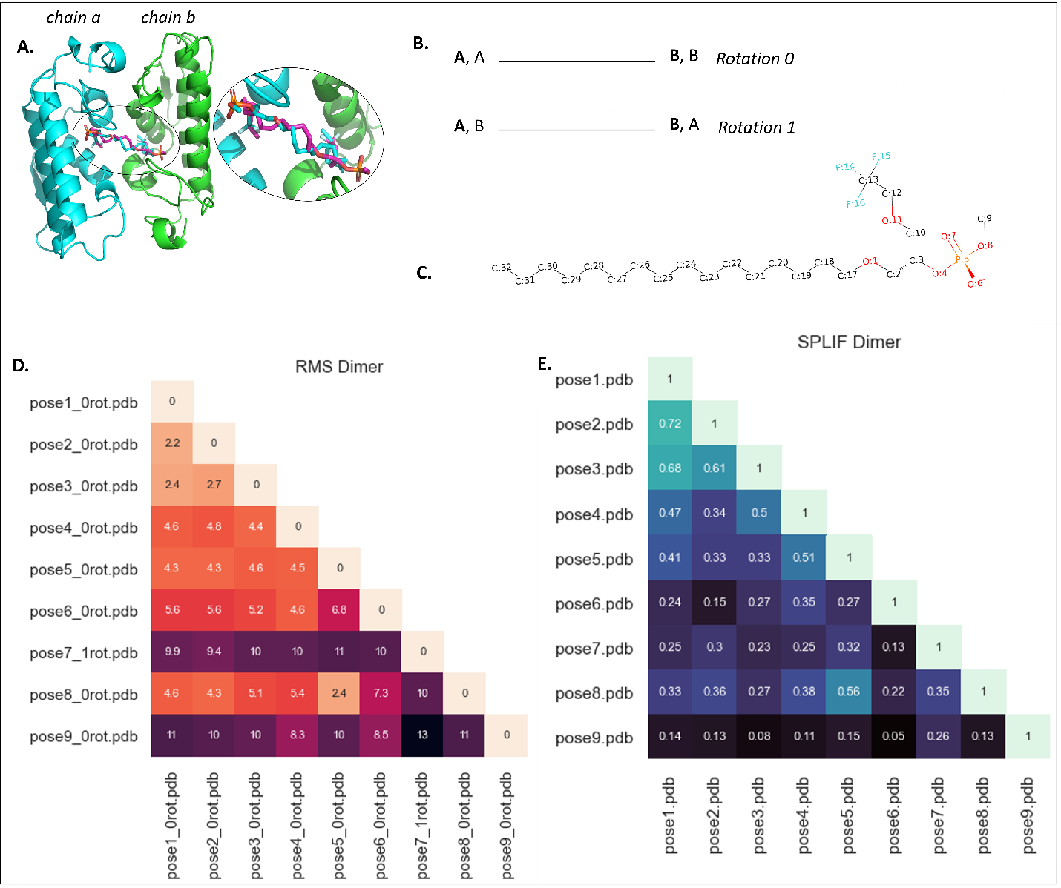
Figure S1: Snapshot of the results from PoseFilter using a dimer as an example. A: Cartoon representation of dimeric carboxylic ester hydrolase complex bound to 1-Hexadecyl-3-trifluoroethyl-sn-glycero-2-phosphate methane (PDB id: 1FX9). B: Diagrammatic representation of the rotations performed in homo-dimeric states). C: 2D ligand structural representations of the dimer ligand created using rdkit. D: Heatmap showing the minimum RMSD of the poses among the different rotations (lower RMSD values indicate more similar poses). E: Heatmap showing the similarity between the poses as assessed by SPLIF Fingerprint (1 represents identical pose and 0 represents no similarity.
Table S1: Ligand interaction report generated from the protein-ligand interaction report checkbox for the first pose of 1-Hexadecyl-3-trifluoroethyl-sn-glycero-2-phosphate methane with protein 1FX9. The oddt (Open Drug Discovery Toolkit) Python module’s functionality was used to prepare this data. Eight different interactions were checked. In this case hydrophobic, hydrogen bond, and halogen bond interactions were determined. The distance was calculated by using the 3D coordinates of the protein and ligand atoms.
Ligand interactions with protein residues
Ligand hydrophobic interactions with protein residues
Ligand Atom Numbering | Residue Atom Numbering | Resn | Resi | Ligand to Protein Distance (Angstrom)
C 21 | CD2 1850 | TYR | 69 | 3.39
C 18 | CB 1829 | ASN | 67 | 3.53
C 31 | CB 1675 | TYR | 52 | 3.65
C 25 | CD2 296 | LEU | 31 | 3.75
C 32 | CB 1648 | ASP | 49 | 3.9
C 18 | CG2 1863 | THR | 70 | 3.93
Ligand hydrogen bond interactions with protein residues
Ligand Atom Numbering | Residue Atom Numbering | Resn | Resi | Ligand to Protein Distance (Angstrom)
O 7 | OG 313 | SER | 34 | 2.83
O 4 | OG1 1147 | THR | 120 | 2.84
O 7 | N 303 | GLY | 33 | 3.14
Ligand halogen bond interactions with protein residues
Ligand Atom Numbering | Residue Atom Numbering | Resn | Resi | Ligand to Protein Distance (Angstrom)
F 15 | O 280 | CYS | 29 | 3.04
F 16 | O 254 | GLY | 26 | 3.31
F 14 | O 240 | TYR | 25 | 3.32
F 14 | O 259 | CYS | 27 | 3.41
F 15 | O 287 | GLY | 30 | 3.55

Tetramer Example:
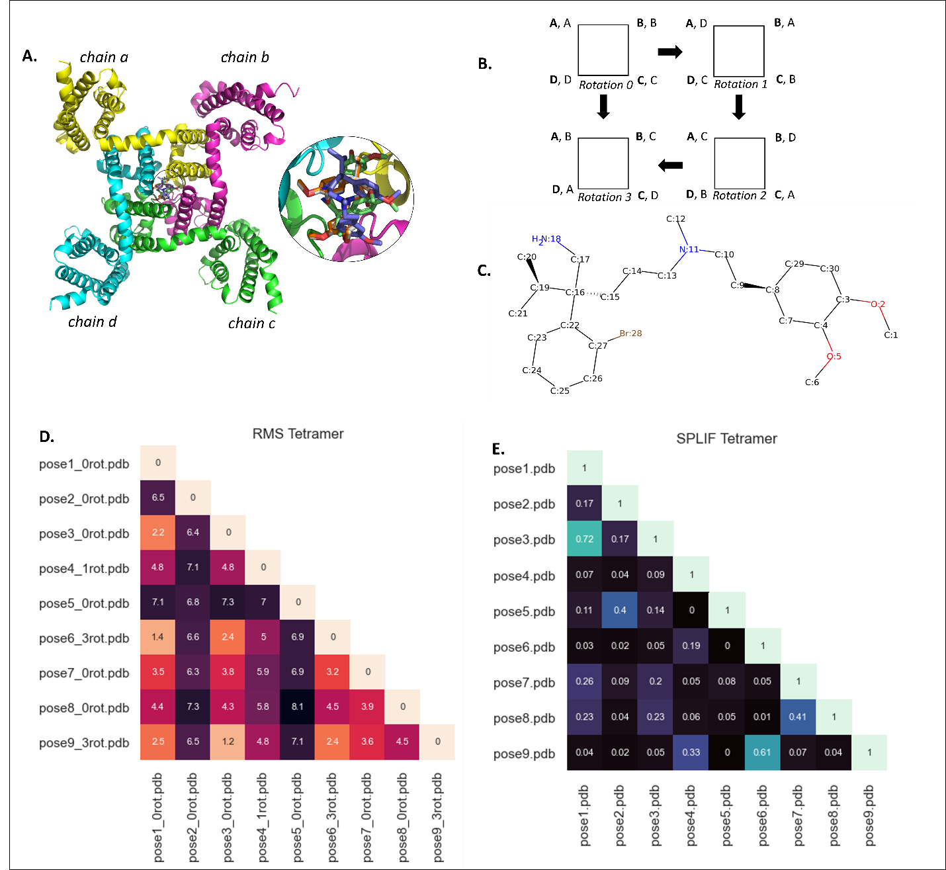
Figure S2: Snapshot of the results from PoseFilter using a tetramer as an example. A: Cartoon representation of tetrameric CavAb transport protein bound to Verapamil (PDB id: 5KMH). B: Diagrammatic representation of the rotations performed in homo-tetrameric states. C: 2D structural representation of tetramer ligand created using rdkit. D: Heatmap showing the minimum RMSD of the poses among the different rotations (lower RMSD values indicate more similar poses). E: Heatmap showing the similarity between the poses as assessed by SPLIF Fingerprint (1 represents identical pose and 0 represents no similarity).

Table S2: Residue interaction report generated from the protein-ligand interaction report checkbox for the first pose of Verapamil with protein 5KMH. The oddt (Open Drug Discovery Toolkit) Python module’s functionality was used to prepare this data. Eight different interactions were checked. In this case only hydrophobic and hydrogen bond interactions were determined. The distance was calculated by using the 3D coordinates of the protein and ligand atoms.
Ligand interactions with protein residues
Ligand hydrophobic interactions with protein residues
Ligand Atom Numbering | Residue Atom Numbering | Resn | Resi | Ligand to Protein Distance (Angstrom)
C 23 | CB 1439 | LEU | 1176 | 3.57
C 10 | OG1 3500 | THR | 1206 | 3.61
Ligand hydrogen bond interactions with protein residues
Ligand Atom Numbering | Residue Atom Numbering | Resn | Resi | Ligand to Protein Distance (Angstrom)
N 20 | N 6831 | THR | 1175 | 3.46
N 20 | C 3238 | LEU | 1176 | 3.48

Monomer example:
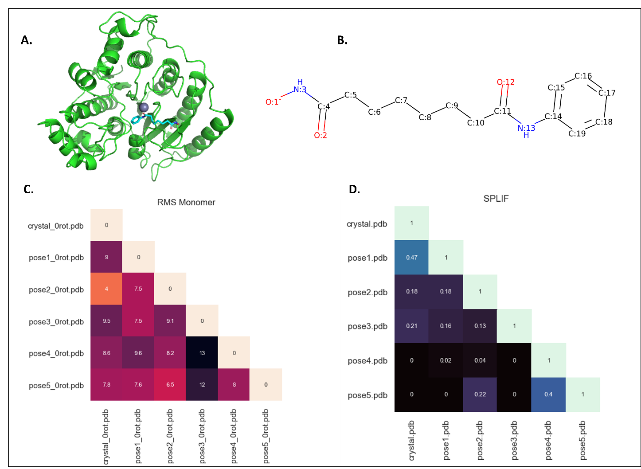
Figure S3: Snapshot of the results from PoseFilter using a monomer as an example. A: Cartoon representation of monomeric human HDAC8 in a complex with octanedioic acid hydroxyamide phenylamide (SAHA) (PDB id: 1T69). B: 2D labelled structure of SAHA, prepared using rdkit. C: Heatmap showing the minimum RMSD of the poses among the different rotations (lower RMSD values indicate more similar poses). D: Heatmap showing the similarity between the poses as assessed by SPLIF Fingerprint (1 represents identical pose and 0 represents no similarity.

Table S3: Residue interaction report generated from the protein-ligand interaction report checkbox for the first pose of SAHA with protein 1T69. The oddt (Open Drug Discovery Toolkit) Python module’s functionality was used to prepare this data. Eight different interactions were checked. In this case hydrophobic and hydrogen bond interactions were determined. The distance was calculated by using the 3D coordinates of the protein and ligand atoms.
Ligand interactions with protein residues
Ligand hydrophobic interactions with protein residues
Ligand Atom Numbering | Residue Atom Numbering | Resn | Resi | Ligand to Protein Distance (Angstrom)
C 17 | CB 1288 | PHE | 152 | 2.92
C 19 | CD1 195 | ILE | 34 | 3.32
C 5 | CG 1846 | PHE | 208 | 3.66
C 21 | CE2 2743 | TYR | 306 | 3.87
C 18 | CZ2 1183 | TRP | 141 | 3.9
Ligand hydrogen bond interactions with protein residues
Ligand Atom Numbering | Residue Atom Numbering | Resn | Resi | Ligand to Protein Distance (Angstrom)
N 14 | O 1282 | GLY | 151 | 2.99
N 9 | OD1 848 | ASP | 101 | 3.06
O 13 | N 2724 | GLY | 304 | 3.11
N 14 | OH 2745 | TYR | 306 | 3.37
O 13 | OD1 1569 | ASP | 178 | 3.46

Heteromer Example:
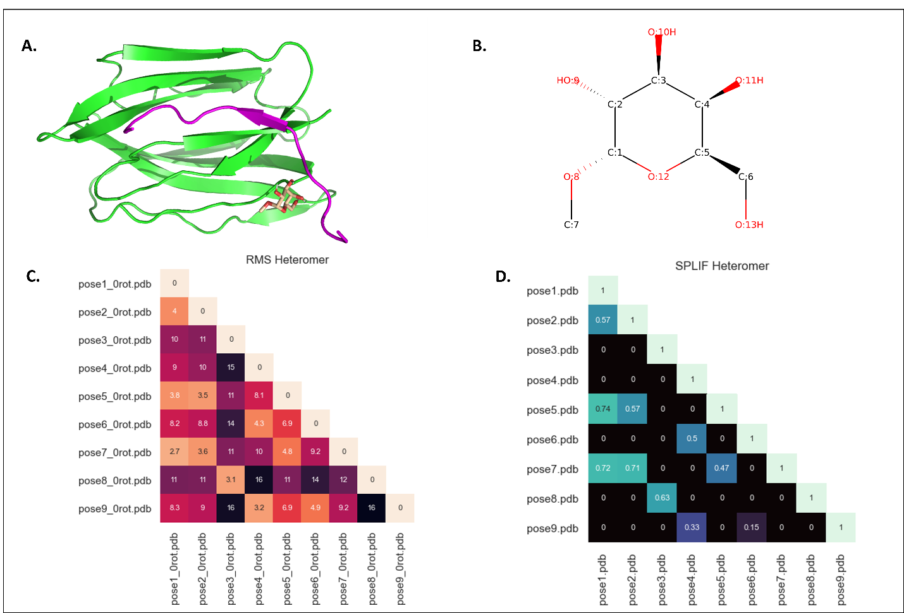
Figure S4: Snapshot of the results from PoseFilter using a heterodimer as an example. A: Cartoon representation of a galactose specific lectin bound to methyl alpha-D-galactopyranoside (AMG) (PDB id: 1TOQ). B: 2D labelled structure of AMG, prepared using rdkit. C: Heatmap showing the minimum RMSD of the poses among the different rotations (lower RMSD values indicate more similar poses). D: Heatmap showing the similarity between the poses as assessed by SPLIF Fingerprint (1 represents identical pose and 0 represents no similarity).

Table S4: Residue interaction report generated from the protein-ligand interaction report checkbox for the first pose of AMG with protein 1TOQ. The oddt (Open Drug Discovery Toolkit) Python module’s functionality was used to prepare this data. Eight different interactions were checked. In this case only hydrogen bond interactions were determined. The distance was calculated by using the 3D coordinates of the protein and ligand atoms.
Ligand interactions with protein residues
Ligand hydrogen bond interactions with protein residues
Ligand Atom Numbering | Residue Atom Numbering | Resn | Resi | Ligand to Protein Distance (Angstrom)
O 8 | O 65 | ALA | 8 | 2.83
O 12 | OG1 1307 | THR | 9 | 2.96
O 10 | O 1285 | SER | 7 | 3.02
O 14 | OH 1224 | TYR | 130 | 3.17

