Supplementary TABLE 1: Characteristics of study subjects (values are mean and standard deviation)
 | Study 1 | Study 2 | Study 3 | Study 4
 | (n= 5) | (n= 10) | (n= 5) | (n= 40)
Age (years) | 23 ± 3 | 25 ± 4 | 24 ± 2 | 33 ± 6
Weight (kg) | 76 ± 1 | 81 ± 7 | 81 ± 7 | 76 ± 1
BMI (kg/m²) | 24 ± 3 | 24 ± 2 | 24 ± 3 | 24 ± 3
SBP (mmHg) | 124 ± 11 | 119 ± 6 | 122 ± 7 | 128 ± 10
DBP (mmHg) | 71 ± 9 | 68 ± 4 | 73 ± 8 | 75 ± 9
Heart rate (bpm) | 67 ± 11 | 56 ± 9 | 68 ± 14 | 65 ± 10
Total cholesterol (mg/dL) | 160 ± 38 | 186 ± 29 | 162 ± 9 | 178 ± 40
Triglycerides (mg/dL) | 86 ± 20 | 136 ± 55 | 66 ± 28 | 93 ± 59
HDL (mg/dL) | 60 ± 10 | 56 ± 10 | 58 ± 7 | 55 ± 11
LDL (mg/dL) | 100 ± 30 | 118 ± 16 | 104 ± 10 | 114 ± 36
Glucose (mg/dL) | 82 ± 12 | 80 ± 8 | 82 ± 12 | 82 ± 12
Supplementary TABLE 2: Metabolomic profile - Plasma concentrations of 63 analyzed anthocyanin metabolites at baseline (0h), 2 h, 0h at day 28 and 2 h at 1 month, (modified from from (7))

 | Plasma concentration (nM)
 | Day 1 |  | 1 Month
 | Baseline (0h) | 2h | 0h | 2h
Benzoic acid derivatives
Benzoic acid | 794 ± 56 | 932 ± 62.6 | 981 ± 72 | 926 ± 47
2-Hydroxybenzoic acid | 80 ± 22 | 131 ± 59.6 | 103 ± 15 | 106 ± 15
3-Hydroxybenzoic acid | 17 ± 3 | 13 ± 2 | 21 ± 5 | 17 ± 3
4-Hydroxybenzoic acid | 27 ± 8 | 23 ± 6 | 18 ± 4 | 18 ± 3
2,3-Dihydroxybenzoic acid | 8,891 ± 1,550 | 7,430 ± 1,323 | 8,070 ± 1,210 | 8,658 ± 1,641
2,4-Dihydroxybenzoic acid | 13 ± 5 | 11.2 ± 3 | 25 ± 7 | 18 ± 3
2,5-Dihydroxybenzoic acid | 71 ± 11 | 55 ± 6 | 101 ± 10 | 94 ± 11
Protocatechuic acid | 23 ± 6 | 18 ± 6 | 11.2 ± 4 | 8 ± 3
Syringic acid | 4 ± 1 | 8 ± 2 | 9 ± 3 | 11 ± 3
Vanillic acid | 290 ± 48 | 397 ± 53 | 644 ± 122 | 730 ± 109
Vanillic acid-4-O-sulfate | 30 ± 6 | 29 ± 6 | 34 ± 6 | 34 ± 6
Isovanillic acid | 429 ± 51 | 447 ± 58 | 426 ± 46 | 430 ± 57
4-Methylgallic-3-O-sulfate | 43 ± 28 | 48 ± 11 | 28 ± 7 | 58 ± 15
Phenylacetic acid derivatives
Homovanillic acid | 74 ± 7 | 54 ± 3 | 86 ± 14 | 71 ± 11
Homovanillic acid sulfate | 4 ± 1 | 4 ± 1 | 6 ± 1 | 5 ± 1
Phenylacetic acid | 2,854 ± 1,319 | 2,599 ± 1,578 | 1,634 ± 603 | 1,130 ± 315
3,4-Dihydroxyphenyl acetic acid | 91 ± 13 | 76 ± 9 | 89 ± 14 | 87 ± 11
3-Hydroxyphenyl acetic acid | 142 ± 32 | 103 ± 25 | 174 ± 29 | 152 ± 27
4-Hydroxyphenyl acetic acid | 333 ± 50 | 215 ± 31 | 289 ± 61 | 230 ± 49
Propionic acid derivatives
2-(4-hydroxyphenoxy)propionic acid | 4.2 ± 0.9 | 2.6 ± 0.7 | 1.8 ± 0.4 | 2.1 ± 0.6
Benzaldehyde derivatives
4-Hydroxybenzaldehyde | 62 ± 17 | 58 ± 16 | 55 ± 10 | 46 ± 10
3,4-Dihydroxybenzaldehyde | 1.2 ± 0.1 | 1.1 ± 0.1 | 1.3 ± 0.1 | 1.2 ± 0.1
Pyrogallol derivatives
Pyrogallol-O-1-sulfate | 22 ± 6 | 15 ± 2 | 23 ± 5 | 15 ± 2
Pyrogallol-O-2-sulfate | 135 ± 60 | 99 ± 48 | 104 ± 45 | 62 ± 23
1-Methylpyrogallol-O-sulfate | 87 ± 24 | 57 ± 16 | 113 ± 36 | 90 ± 31
2-Methylpyrogallol-O-sulfate | 61 ± 18 | 58 ± 18 | 29 ± 7 | 22 ± 4
Catechol derivatives
Catechol-O-sulfate | 1,228 ± 231 | 1,759 ± 179 | 2,726 ± 440 | 1,565 ± 195
4-Methylcatechol-O-sulfate | 693 ± 104 | 468 ± 81 | 861 ± 250 | 775 ± 234
Hippuric acid derivatives
Hippuric acid* | 14,420 ± 2,336 | 12,367 ± 2,465 | 24,842 ± 3,795 | 22,977 ± 3,343
2-Hydroxyhippuric acid | 5 ± 2 | 9 ± 4 | 8 ± 2 | 8 ± 2
3-Hydroxyhippuric acid | 290 ± 72 | 320 ± 84 | 708 ± 159 | 416 ± 87
4-Hydroxyhippuric acid | 77 ± 12 | 59 ± 8 | 76 ± 12 | 64 ± 8
α-Hydroxyhippuric acid | 485 ± 66 | 385 ± 43 | 539 ± 82 | 463 ± 63
Cinnamic acid derivatives
Cinnamic acid | 22 ± 5 | 22 ± 5 | 21 ± 5 | 20 ± 6
Caffeic acid | 7 ± 2 | 7 ± 2 | 6 ± 2 | 7 ± 2
Caffeic acid 3-O-β-D-glucuronide | 2 ± 1 | 2 ± 1 | 5 ± 3 | 3 ± 1
Caffeic acid 4-O-β-D-glucuronide | 0.5 ± 0.3 | 0.4 ± 0.4 | 2.2 ± 1.9 | 1.7 ± 1.1
Dihydro caffeic acid 3-O-sulfate | 53 ± 12 | 41 ± 11 | 104 ± 28 | 73 ± 15
Dihydro caffeic acid 3-O-β-D-glucuronide | 9 ± 1 | 8 ± 1 | 11 ± 2 | 10 ± 2
Ferulic acid | 6.1 ± 2.3 | 6 ± 2.5 | 6.8 ± 2.4 | 6 ± 1.4
Ferulic acid 4-O-glucuronide | 156 ± 40 | 182 ± 32 | 195 ± 76 | 223 ± 67
Ferulic acid 4-O-sulfate | 90 ± 33 | 106 ± 40 | 74 ± 26 | 80 ± 17
Dihydro ferulic acid 4-O-sulfate | 154 ± 26 | 96 ± 19 | 139 ± 29 | 90 ± 17
Dihydro ferulic acid 4-O-β-D-glucuronide | 116 ± 23 | 76 ± 16 | 124 ± 31 | 100 ± 25
Isoferulic acid | 1,941 ± 348 | 1,633 ± 312 | 1,842 ± 377 | 1,686 ± 319
Isoferulic acid 3-O-sulfate | 19 ± 3 | 18 ± 2 | 22 ± 5 | 20 ± 4
Isoferulic acid 3-O-β-D-glucuronide | 38 ± 10 | 38 ± 8 | 74 ± 13 | 77 ± 16
Dihydro isoferulic acid 3-O-sulfate | 102 ± 64 | 73 ± 39 | 44 ± 11 | 40 ± 8
Dihydro isoferulic acid 3-O-ß-D-glucuronide | 8 ± 2 | 6 ± 2 | 9 ± 2 | 9 ± 2
m-Coumaric acid | 0.7 ± 0.3 | 0.7 ± 0.3 | 1.2 ± 0.5 | 0.9 ± 0.4
o-Coumaric acid | 1.0 ± 0.3 | 1.0 ± 0.3 | 1 ± 0.2 | 0.9 ± 0.2
p-Coumaric acid | 3 ± 0.4 | 4 ± 1 | 4 ± 1 | 4 ± 1
Sinapic acid | 11 ± 3 | 7 ± 1 | 8 ± 1 | 7 ± 1
Chlorogenic acid | 22 ± 10 | 61 ± 18 | 20 ± 5 | 63 ± 22

Supplementary TABLE 3: Differentially expressed miRNA after chronic blueberry consumption. Micro RNAs marked in green are upregulated and the ones marked in red are downregulated.

miRNA | fold change | p
miR-181c-3p | 13.7 | 0.01
miR-126-5p | -1.1 | 0.02
miR-30c-5p | -1.1 | 0.03

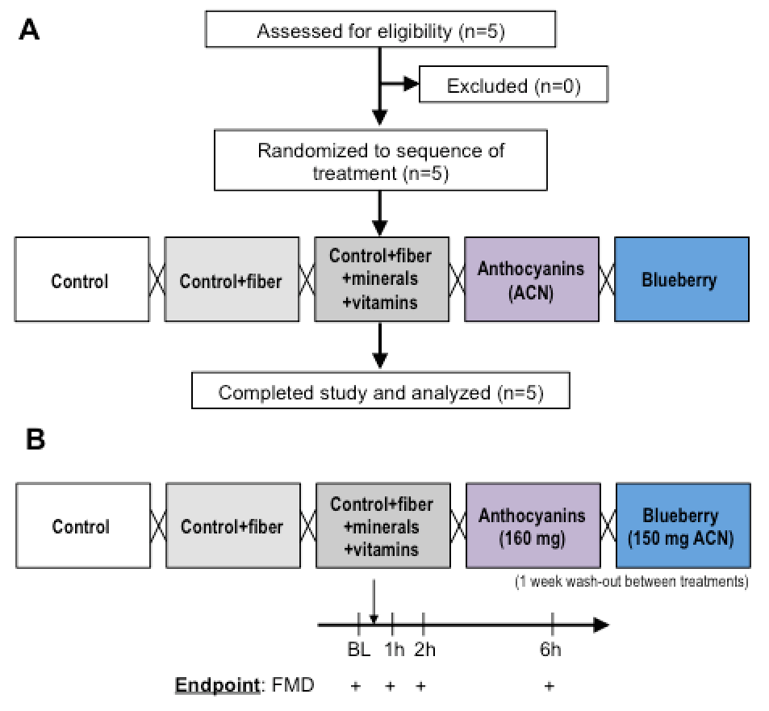
Supplementary FIGURE 1: (A) Study flow (CONSORT diagram) and (B) study protocol of study 1 to evaluate the contribution of individual blueberry components to increase endothelial function as measured by flow-mediated dilation (FMD).
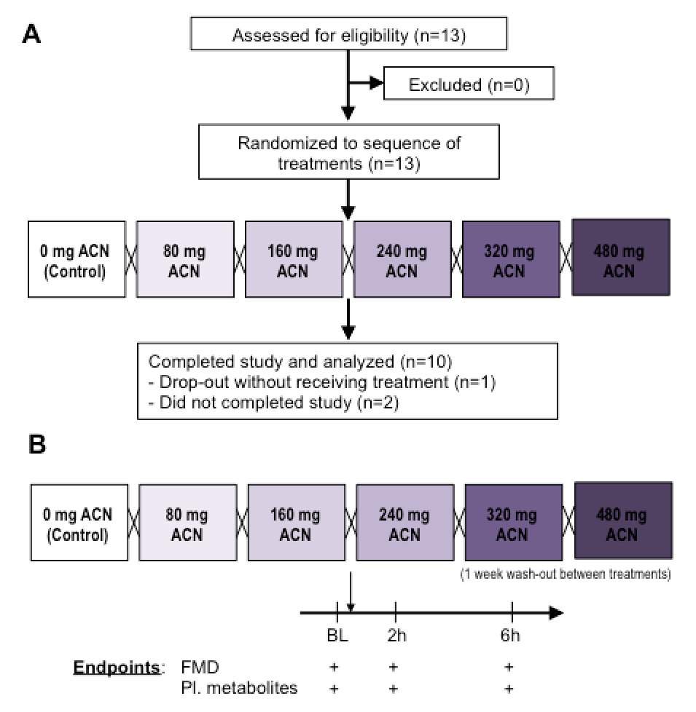
Supplementary FIGURE 2: (A) Study flow (CONSORT diagram) and (B) study protocol of study 2 to evaluate the dose response of pure anthocyanins to increase endothelial function as measured by flow-mediated dilation (FMD).
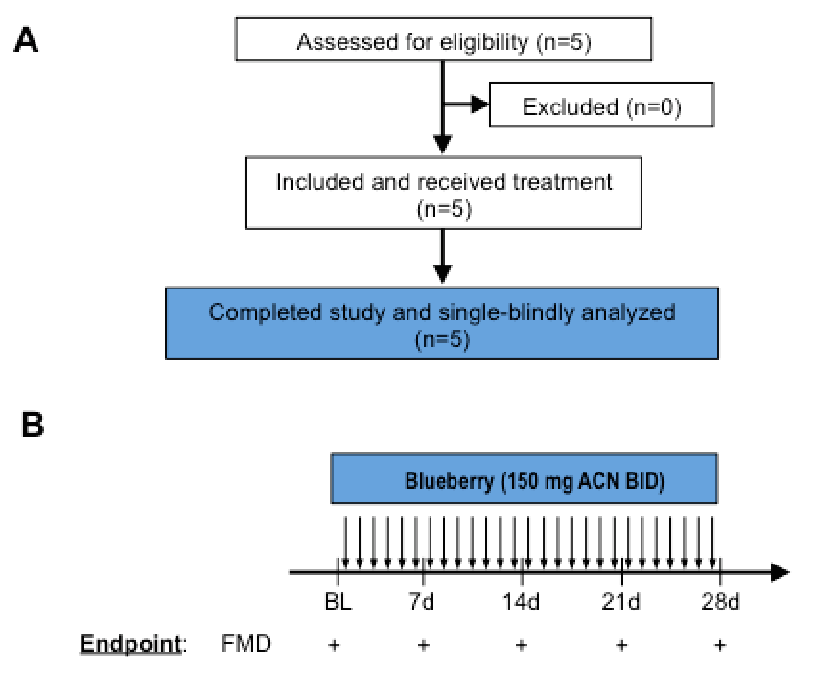
Supplementary FIGURE 3: (A) Study flow (CONSORT diagram) and (B) study protocol of study 3 to evaluate the timecourse of increase in endothelial function as measured by flow-mediated dilation (FMD) during bi daily (BID) blueberry consumption of 28 days.
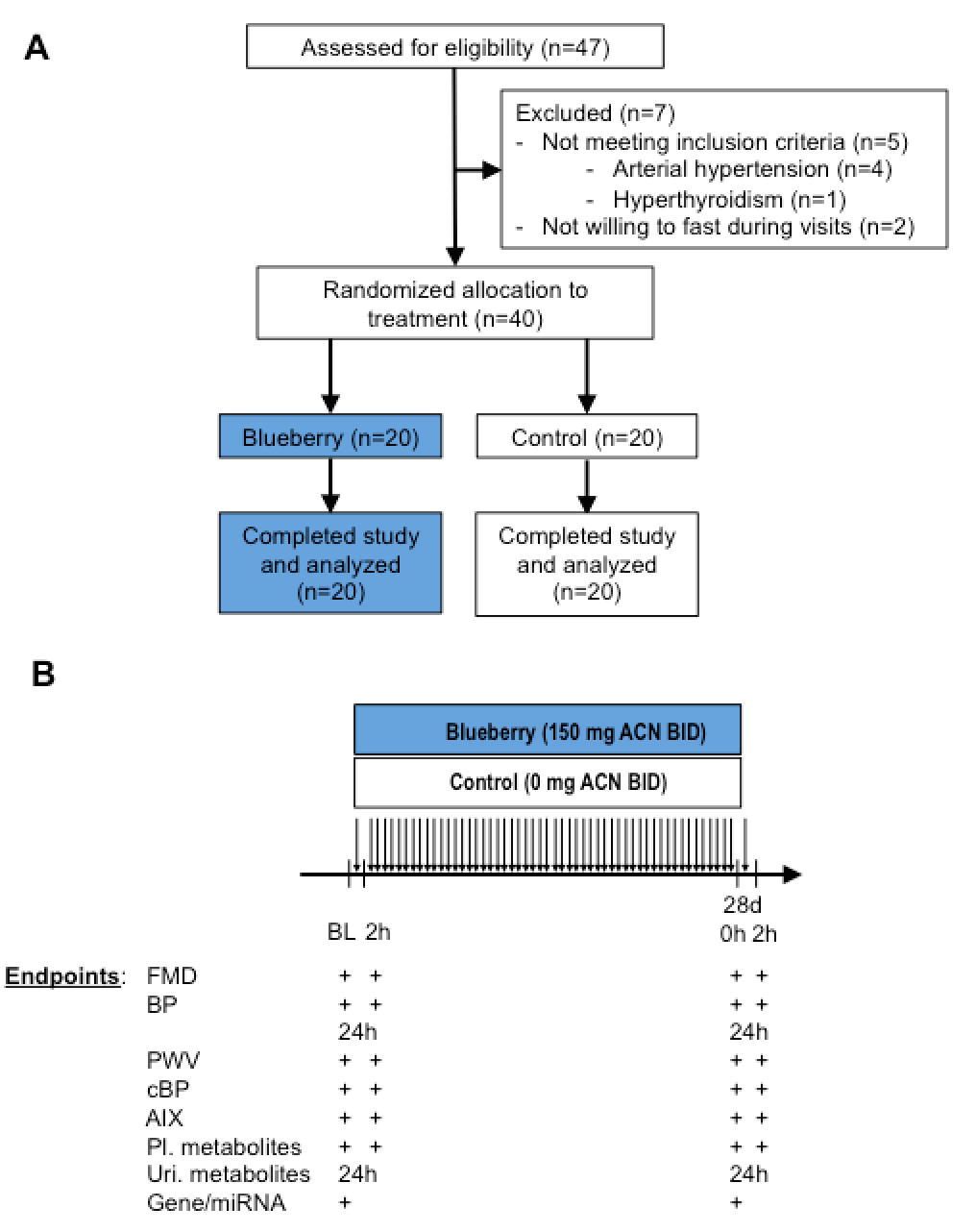
Supplementary FIGURE 4: (A) Study flow (CONSORT diagram) and (B) study protocol of study 4 to evaluate the acute and chronic response of pure anthocyanins to increase endothelial function as measured by flow-mediated dilation (FMD) along with other key readouts of vascular function (PWV, pulse wave velocity; BP, blood pressure; AIX, aortic augmentation index), anthocyanin metabolites in plasma and urine and acquire peripheral blood mononuclear cells to perform genetic and miRNA analyses.

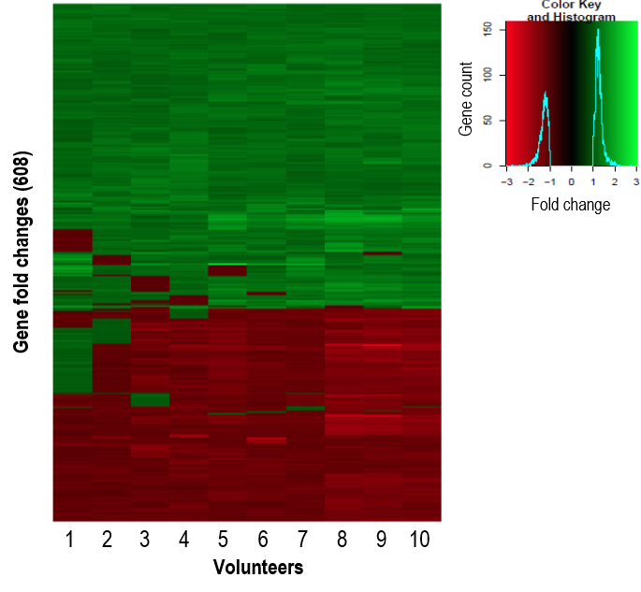
Supplementary FIGURE 5. Fold change heatmap. The 608 significant differentially expressed genes following 28 day blueberry intervention are represented by the heatmap. Red represents negative fold changes and green shows positive fold changes. The heatmap shows that gene expression patterns are very homogenous between the 10 individuals. The blue line in the legend represents the abundance of genes at any given fold change where it shows that the majority of the genes have a fold change between 1 and 2 or between -1 and -2.
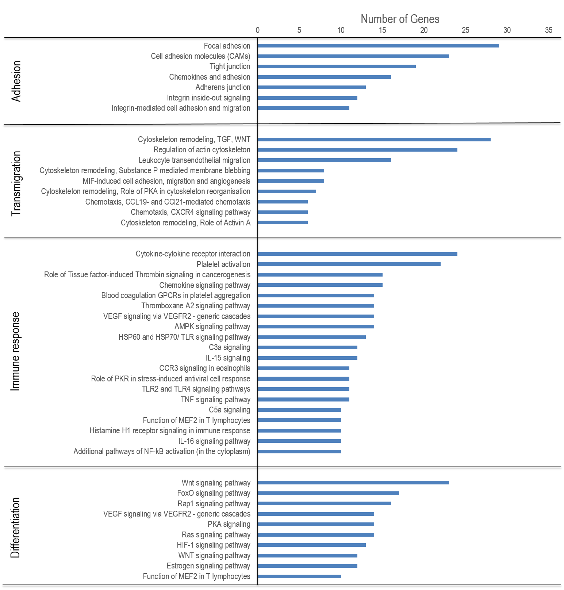
Supplementary FIGURE 6. Functional annotation of genes differentially expressed following 28-day consumption of blueberry. Histogram of significant and over-represented cell signalling pathways involved in GO biological cell processes segregated by cell adhesion, transmigration, immune response and differentiation. Pathway analysis was performed by using KEGG and Metacore.

