Jensen et al. Attracting diverse students to field experiences requires adequate pay, flexibility, and inclusion

SUPPLEMENTAL INFORMATION

Figures
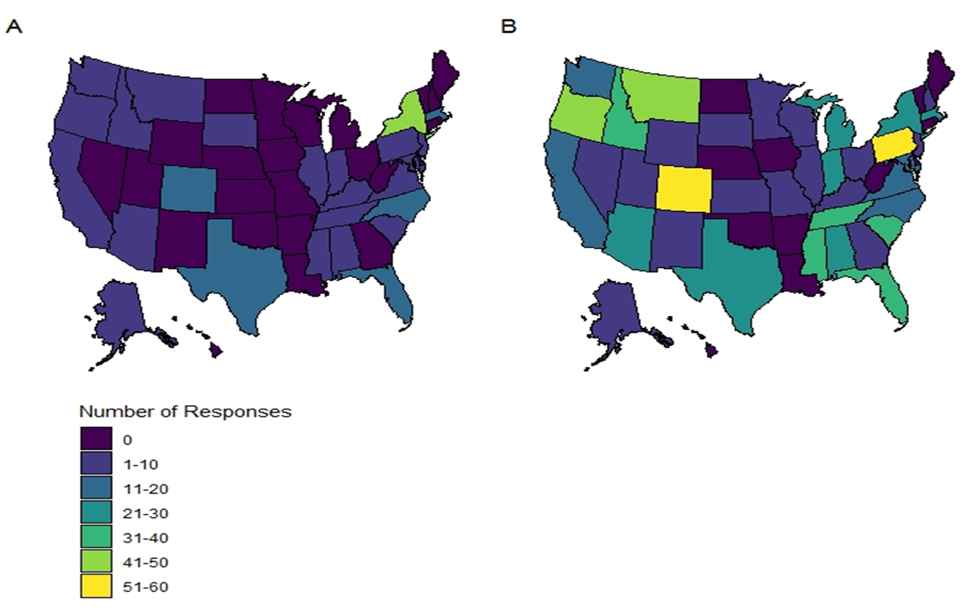
Supplemental Figure 1: Responses to the question: “In which state do you attend school?” from (A) non-white respondents and (B) white respondents.

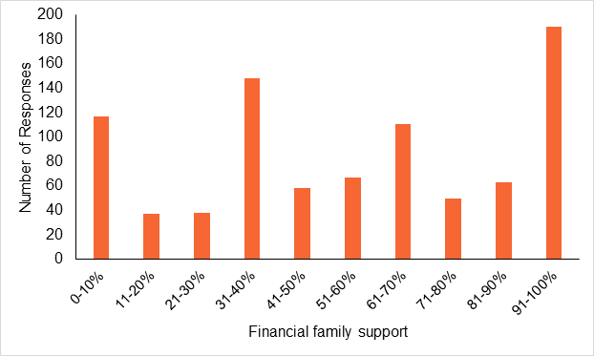
Supplemental Figure 2: An additive index of family support combining answers to the questions: “What percentage of your tuition is covered by your family?”, “what percentage of your total insurance costs (e.g., health, life, car, combined) are covered by your family?”, and “what percentage of your rent and utilities are covered by your family?”

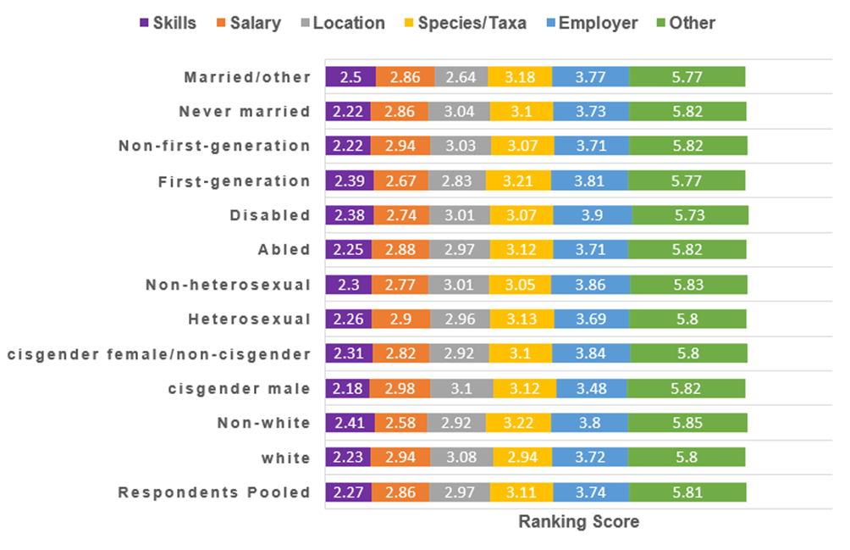
Supplemental Figure 3: Average ranking for different internship factors for all respondents and race/ethnicity, gender, sexuality, disability, first-generation status, and marital status. A lower number indicates a higher average ranking.

Tables
Supplemental Table 1: Socio-demographic variables of interest
Variable | Description | Units
Annual Income | Annual income after taxes (not including family support or financial aid). Options were $0-$9,999, $10,000-$19,999, $20,000-$29,999, $30,000-$39,999, $40,000-$49,999, and $50,000+. | Ordinal integer representing each income category
Family Support (Tuition) | Percentage of tuition covered by family. Options were 0-10%, 11-20%, 21-30%, 31-40%, 41-50%, 51-60%, 61-70%, 71-80%, 81-90%, and 91-100%. | Ordinal integer representing each covered category
Family Support (Insurance) | Percentage of insurance costs covered by family. Options were 0-10%, 11-20%, 21-30%, 31-40%, 41-50%, 51-60%, 61-70%, 71-80%, 81-90%, and 91-100%. | Ordinal integer representing each covered category
Family Support (Housing) | Percentage of housing costs (rent and utilities) covered by family. Options were 0-10%, 11-20%, 21-30%, 31-40%, 41-50%, 51-60%, 61-70%, 71-80%, 81-90%, and 91-100%. | Ordinal integer representing each covered category
Paid Job | Whether the student had a paid job or not during the academic year. | Binary (yes or no)
Marital Status | Marital status of the participant. Categories were never married, married, not married but cohabitating, and divorced. | Categorical
Children | Number of child dependents. | Integer
Race / Ethnicity | How the participant identifies along racial or ethnic lines. Categories were American Indian/Native American/Alaska Native/First Nations, Asian, Native Hawaiian/Pacific Islander, Black/African American, Hispanic/LatinX, White/Caucasian, Middle Eastern/North African, prefer to self describe, and prefer not to answer. Simplified to white and non-white. | Categorical
Gender | How the participant identifies along gender lines. Categories were female, male, gender variant/gender non-conforming, transgender, prefer to self describe, and prefer not to answer. Simplified to cisgender male, cisgender female, and other (transgender, gender non-conforming, genderfluid, self-describe, and prefer not to answer). | Categorical
Sexuality | How the participant identifies their sexuality. Categories were heterosexual or straight, gay or lesbian, bisexual, prefer to self describe, and prefer not to answer. Simplified to heterosexual or non-heterosexual/other (bisexual, gay or lesiban, self-describe, or prefer not to answer). | Categorical

Supplemental Table 2: Respondent representation from various demographic groups and variation in average reported needed pay across demographic groups. Total respondents = 879.
Demographic Group | Category | N | Percentage | Average Needed Pay
Race/Ethnicity | White | 676 | 77% | $1494
 | Multi-ethnic | 59 | 7% | $1566
 | Asian | 64 | 7% | $2264
 | Hispanic/LatinX | 35 | 4% | $1617
 | American Indian/Native American | 7 | 1% | $1550
 | Black/African American | 16 | 2% | $1818
 | Middle Eastern/North African | 5 | 1% | $2440
 | Other | 3 | 0% | $1500
 | No Answer | 14 | 2% | $1829
Gender | Cisgender Female | 584 | 66% | $1510
 | Cisgender Male | 261 | 30% | $1724
 | Gender-expansive (Non Binary, prefer not to answer, trans, genderfluid | 34 | 4% | $1593
Sexuality | Heterosexual | 637 | 72% | $1585
 | Bisexual | 128 | 15% | $1482
 | Gay or lesbian | 36 | 4% | $1526
 | Prefer not to answer | 49 | 6% | $1818
 | Pansexual | 14 | 2% | $1320
 | Asexual | 8 | 1% | $1242
 | Other | 7 | 1% | $1217
Disability | No | 759 | 86% | $1582
 | Yes | 86 | 10% | $1473
 | Prefer not to answer | 34 | 4% | $1574
First Generation | No | 627 | 71% | $1546
 | Yes | 252 | 29% | $1632
Respondent had a Paid Job | Yes | 559 | 64% | $1516
 | No | 320 | 36% | $1668

Supplemental Table 3: Responses to the question: “What is your major?”
Major | Overall Responses
Wildlife | 402 (46%)
Biology/Ecology | 131 (15%)
Environmental Science | 130 (15%)
Natural Resources | 130 (15%)
Forestry | 40 (5%)
Non-Natural Resources | 37 (4%)
Education/Recreation | 8 (1%)
NA | 1 (0%)

Supplemental Table 4: Responses to the question: “What is your undergraduate status as of October 2019 based on completed credits?”
Undergraduate status | Overall Responses
Senior | 326 (37%)
Junior | 280 (32%)
Sophomore | 157 (18%)
Freshman | 110 (13%)
NA | 6 (1%)

Supplemental Table 5: Results from the Wave Analysis. We tested for significant differences for 13 variables between the first 50 respondents from the first wave and the last 50 responses from the last wave. “D.f.” = Degrees of freedom.
Variable | Test Statistic | D.f. | p
Minimum monthly salary | t = 0.228 | 97 | 0.82
Decrease salary for preferred species/taxa | t = -1.021 | 31 | 0.32
Decrease salary for preferred skills | t = -1.292 | 13 | 0.22
Increase salary for distance from home | t = -0.516 | 50 | 0.61
Decrease salary for preferred employer | t = 0.040 | 19 | 0.97
Annual income | t = -1.710 | 81 | 0.03
Race/Ethnicity | χ = 0.037 | 1 | 0.85
Gender | χ = 0.109 | 1 | 0.74
Sexuality | χ = 0.018 | 1 | 1
Disability | χ = 0.696 | 1 | 0.42
Marital status | χ = 0.725 | 1 | 0.62
Whether or not student had a paid job during the academic year | χ = 0.011 | 1 | 0.92
Whether income has been a barrier to the student’s academic career | χ = 14.075 | 16 | 0.59

Supplemental Table 6: Respondent agreement with the statement: “my level of income has been a barrier in my academic career” by race/ethnicity, gender, sexuality, disability, first-generation status, and marital status. *indicates the majority response within each demographic.
 |  | Race/ethnicity |  | Gender |  | Sexuality |  | Disability |  | First-generation |  | Marital status
 | Total | White | Non-white | Cisgen-der male | Cisgender female and non-cisgender | Hetero-sexual | Non-hetero-sexual | No | Other | No | Yes | Never married | Other
Strongly agree | 152  (17%) | 114  (17%) | 38  (20%) | 36 (14%) | 116 (19%) | 96 (15%) | 56  (23%) | 123 (16%) | 29  (24%) | 84 (13%) | 68 (27%) | 108  (15%) | 44 (30%)*
Agree | 223  (25%)* | 166  (24%)* | 57  (30%)* | 65 (25%)* | 158 (26%)* | 157  (25%)* | 66  (27%)* | 195 (26%)* | 28  (23%) | 140 (22%) | 83 (33%)* | 182  (25%)* | 41 (28%)
Neither agree nor disagree | 202  (23%) | 161  (23%) | 41  (22%) | 61 (23%) | 141 (23%) | 150  (24%) | 52  (21%) | 169 (22%) | 33  (28%)* | 146 (23%) | 56 (22%) | 165  (23%) | 37 (25%)
Disagree | 192  (22%) | 156  (23%) | 36  (19%) | 58 (22%) | 134 (22%) | 152  (24%) | 40  (17%) | 171 (23%) | 21  (18%) | 158 (25%)* | 34 (13%) | 173  (24%) | 19 (13%)
Strongly disagree | 110  (13%) | 93  (13%) | 17  (9%) | 41 (16%) | 69  (11%) | 82  (13%) | 28  (12%) | 101 (13%) | 9  (8%) | 99 (16%) | 11 (4%) | 102  (14%) | 8 (5%)
Column Total | 879 | 690 | 189 | 261 | 618 | 637 | 242 | 759 | 120 | 627 | 252 | 730 | 149

Supplemental Table 7: Summary results from respondents who selected a response for “Is your preferred internship location:”. Options were a) close to important family members (which may or may not be where you currently attend school), b) close to the place you currently attend school, c) international location, or d) other US location (no priority for internships near school or family). Select demographic groups are shown here because at least one of the proportions for a certain location differs by at least 5%.
Desired Location | All respondents (N=843) |  | Non-cisgender respondents (N=30) | Non-never married respondents (N=145) | Affected by disability (N=117) |  | First-generation (N=248)
Close to important family members |  | 271 (32%) | 11 (37%) | 61 (42%) | 31 (26%) | 94 (38%)
Close to the place you currently attend school |  | 239 (28%) | 11 (37%) | 39 (27%) | 39 (33%) | 69 (28%)
International location |  | 81 (10%) | 0 | 11 (8%) | 9 (8%) | 19 (8%)
Other US location |  | 252 (30%) | 8 (27%) | 34 (23%) | 38 (32%) | 66 (27%)

Supplemental Table 8: Average pay from 849 positions posted on Environmental and Natural Resources job boards from March 18 – April 8, 2019.
Pay Metric | Mean | Median
Hourly | $10.48 | $11.56
Monthly | $1821 | $2009

Supplemental Table 9: Average pay from 849 positions posted on Environmental and Natural Resources job boards from March 18 – April 8, 2019 by pay or cost category. Paid positions were those that paid the minimum wage or more (net ≥$7.25/hour), underpaid were those that paid below the US federal minimum wage (net $0.01-$7.24/hour), and pay to work were those in which the participant pays a fee (or is responsible for travel expenses to an international location) to volunteer (net <$0/hour).
 | Paid (≥$7.25/hour) |  | Underpaid (<$7.25/hour) |  | Pay to Work
Pay Metric | Mean | Median | Mean | Median | Mean | Median
Hourly | $13.60 | $13.70 | $4.44 | $4.23 | -$11.30 | -$7.99
Monthly | $2367 | $2386 | $770 | $734 | -$1968 | -$1389

Supplemental Table 10: Summary of housing and work vehicle benefits from 849 positions posted on Environmental and Natural Resources job boards from March 18 – April 8, 2019.
Benefit | Yes | No | Unclear | Percent Yes
Housing Provided | 440 | 297 | 112 | 52%
Vehicle Provided | 439 | 154 | 256 | 52%

Supplemental Table 11: Average pay from 849 positions posted on Environmental and Natural Resources job boards from March 18 – April 8, 2019 by whether or not a BS was required or preferred.
 | BS Required or Preferred (n=147) |  | BS Not Required (n=702)
Pay Metric | Mean | Median | Mean | Median
Hourly | $13.45 | $14.62 | $9.86 | $10.94
Monthly | $2,337 | $2,520 | $1,713 | $1,900

Supplemental Table 12: Summary of average needed pay for pooled respondents, non-whites, cisgender females/non-cisgender, and $10,000-$19,999 earning respondents. Non-white and $10,000-$19,999 earning respondents needed more than the average respondent, while cisgender females/non-cisgender needed less than the average respondent.
 | Pooled Respondents |  | Non-white |  | Cisgender female/non-cisgender |  | Annual Income 10-20K
Pay Metric | Predicted Mean | Median | Predicted Mean | Median | Predicted Mean | Median | Predicted Mean | Median
Hourly | $8.68 | $8.63 | $10.80 | $9.21 | $7.47 | $8.40 | $9.22 | $8.63
Monthly | $ 1508 | $1500 | $1876 | $1600 | $1299 | $1459 | $1602 | $1500

Appendix 1 – Survey
Undergraduate Internships in Wildlife & Conservation Survey
Q01 Internship: For the purposes of our study, we define an internship as a type of work experience for entry-level job-seekers wherein the intern (typically a student) works in their field of study/interest, either during a semester or over the summer. Compensation for the intern may include pay and may also include housing and/or a work vehicle. Per our definition, have you ever participated in an internship? (Select Yes or No)
o Yes
o No
Q02 Do you intend to apply for an internship in the next 3 years? (Select one)
o Definitely Not
o Probably not
o Possibly
o Probably
o Very Probably
o Definitely
Q03 Do you know how or where to search for internships in your field? (Select Yes or No)
o Yes
o No
Q04 What is the minimum monthly salary you would need to earn in order to accept a full-time (40 hrs/week for 3 months) internship that includes housing and a work vehicle in your major or field of study? (Enter amount in US $ per month after taxes)
________________________________________________________________
Q05 Would the minimum monthly salary you would accept be the same, more, or less if the internship allowed you to work with your favorite/ideal study species/taxa? (Select one)
o Same
o More
o Less
Display This Question:
If Would the minimum monthly salary you would accept be the same, more, or less if the internship al... = More
Q06 I would increase my minimum salary by ________ (US $ after taxes) if I got to work with my desired species (Enter value below)
________________________________________________________________

Display This Question:
If Would the minimum monthly salary you would accept be the same, more, or less if the internship al... = Less
Q07 I would decrease my minimum salary by ________ (US $ after taxes) if I got to work with my desired species (Enter value below)
________________________________________________________________
Q08 Would the minimum monthly salary you would accept be the same, more, or less if the internship specifically provided you with training in skills you need to make you more competitive for jobs? (Select one)
o Same
o More
o Less
Display This Question:
If Would the minimum monthly salary you would accept be the same, more, or less if the internship sp... = More
Q09 I would increase my minimum salary by ________ (US $ after taxes) if the internship provided training in desired skills (Enter value below)
________________________________________________________________
Display This Question:
If Would the minimum monthly salary you would accept be the same, more, or less if the internship sp... = Less
Q10 I would decrease my minimum salary by ________ (US $ after taxes) if the internship provided training in desired skills (Enter value below)
________________________________________________________________
Q11 Would the minimum monthly salary you would accept be the same, more, or less if the internship occurred within driving distance from home? (Select one)
o Same
o More
o Less
Display This Question:
If Would the minimum monthly salary you would accept be the same, more, or less if the internship oc... = More
Q12 I would increase my minimum salary by ________ (US $ after taxes) if the internship occurred within driving distance from home (Enter value below)
________________________________________________________________

Display This Question:
If Would the minimum monthly salary you would accept be the same, more, or less if the internship oc... = Less
Q13 I would decrease my minimum salary by ________ (US $ after taxes) if the internship occurred within driving distance from home (Enter value below)
________________________________________________________________
Q14 Would the minimum monthly salary you would accept be the same, more, or less if the internship occurred at your preferred location away from home (which could be in the U.S. or international)? (Select one)
o Same
o More
o Less
Display This Question:
If Would the minimum monthly salary you would accept be the same, more, or less if the internship oc... = More
Q15 I would increase my minimum salary by ________ (US $ after taxes) if the internship occurred at my preferred location away from home (enter value below)
________________________________________________________________
Display This Question:
If Would the minimum monthly salary you would accept be the same, more, or less if the internship oc... = Less
Q16 I would decrease my minimum salary by ________ (US $ after taxes) if the internship occurred at my preferred location away from home (enter value below)
________________________________________________________________
Q17 Would the minimum monthly salary you would accept be the same, more, or less if the internship was with your preferred employer or organization? (Select one)
o Same
o More
o Less
Display This Question:
If Would the minimum monthly salary you would accept be the same, more, or less if the internship wa... = More
Q18 I would increase my minimum salary by ________ (US $ after taxes) if the internship was with my preferred employer or organization (enter value below)
________________________________________________________________
Display This Question:
If Would the minimum monthly salary you would accept be the same, more, or less if the internship wa... = Less
Q19 I would decrease my minimum salary by ________ (US $ after taxes) if the internship was with my preferred employer or organization (enter value below)
________________________________________________________________
Q20 Do you consider it to be unimportant or important to be able to work with your desired study species/ taxonomic group when applying for an internship? (Select one)
o Unimportant
o Of Little Importance
o Moderately Important
o Important
o Very Important
Display This Question:
If Do you consider it to be unimportant or important to be able to work with your desired study spec... != Unimportant
Q21 What is your desired study species/taxonomic group? (Fill in the blank)
________________________________________________________________
Q22 Please indicate how unimportant or important it is for you to be able to gain training in skills you need to make you more competitive for jobs when applying for an internship (Select one)
o Unimportant
o Of Little Importance
o Moderately Important
o Important
o Very Important
Display This Question:
If Please indicate how unimportant or important it is for you to be able to gain training in skills... != Unimportant
Q23 What skills do you desire to learn? (List 1-3 skills in the blank, separated by commas; avoid using uncommon acronyms)
________________________________________________________________
Q24 Please indicate how unimportant or important it is for you to work in your desired location when applying for an internship? (Select one)
o Unimportant
o Of Little Importance
o Moderately Important
o Important
o Very Important
Display This Question:
If Please indicate how unimportant or important it is for you to work in your desired location when... != Unimportant
Q25 Is your preferred internship location: (Select one)
o Close to the place you currently attend school
o Close to important family members (which may or may not be where you currently attend school)
o Other US location (no priority for internships near school or family)
o International location
Q26 Please indicate how unimportant or important the employer/organization that is offering the internship is when applying for an internship? (Select one)
o Unimportant
o Of Little Importance
o Moderately Important
o Important
o Very Important
Display This Question:
If Please indicate how unimportant or important the employer/organization that is offering the inter... != Unimportant
Q27 What is your ideal employer or organization to work for? (Fill in the blank)
________________________________________________________________
Q28 Rank how important the following criteria are to you when applying for an internship by dragging the options to place them in order of preference (most important at the top). The 'Other' category is optional, so if you don't have an 'Other' criteria, place it at the bottom.
______ Salary
______ Study Species/Taxonomic Group
______ Location
______ Skills Developed
______ Employer/Organization
______ Other (specify)

End of Block: Survey Questions

Start of Block: Demographics
In order for us to more fully understand your responses to the previous questions, we need to know a few things about your background. Remember that your responses are completely confidential and your name will not be directly linked to your responses in any way.
Q29 What is your current annual income after taxes (not including family support or financial aid)? (Select one)
o $0-$9,999
o $10,000-$19,999
o $20,000-$29,999
o $30,000-$39,999
o $40,000-$49,999
o $50,000+
Q30 What percentage of your tuition is covered by your family? (Select one)
o 0 to 10%
o 11 to 20%
o 21 to 30%
o 31 to 40%
o 41 to 50%
o 51 to 60%
o 61 to 70%
o 71 to 80%
o 81 to 90%
o 91 to 100%

Q31 What percentage of your total insurance costs (e.g., health, life, car combined) are covered by your family? (Select one)
o 0 to 10%
o 11 to 20%
o 21 to 30%
o 31 to 40%
o 41 to 50%
o 51 to 60%
o 61 to 70%
o 71 to 80%
o 81 to 90%
o 91 to 100%
Q32 What percentage of your rent and utilities are covered by your family? (Select one)
o 0-10%
o 11-20%
o 21-30%
o 31-40%
o 41-50%
o 51-60%
o 61-70%
o 71-80%
o 81-90%
o 91-100%
Q33 Did you receive financial aid for the 2019-2020 academic year? (Select one, if not applicable select NA)
o Yes
o No
o NA
Q34 Do your parents claim you on their taxes? (Select one)
o Yes
o No
o Unsure
Q35 Do you work in a paid position during the school year? (Select Yes or No)
o Yes
o No
Q36 Please indicate your disagreement or agreement with the following statement: (Select one)
My level of income has been a barrier in my academic career
o Strongly Disagree
o Disagree
o Neither Agree nor Disagree
o Agree
o Strongly Agree
Q37 What is your current marital status? (Select one)
o Married
o Never Married
o Divorced
o Separated
o Not Married but Living Together
Q38 How many children do you have? (Select one)
o 0
o 1
o 2
o 3
o 4
o 5
o Other (Specify) ________________________________________________
Q39 Do you provide care for family members other than a spouse or child? (Select one)
o Yes
o No
Q40 To which racial or ethnic group(s) do you most identify? (Select all that apply)
▢ American Indian/Native American/Alaska Native/First Nations
▢ Asian
▢ Black/African American
▢ Hispanic/LatinX
▢ Middle Eastern/North African
▢ Native Hawaiian/Pacific Islander
▢ White/Caucasian
▢ Prefer to self describe ___________________________________________
▢ Prefer not to answer
Q41 To which gender do you most identify? (Select one)
o Male
o Female
o Gender Non-conforming
o Trans ________________________________________________
o Prefer to self describe ______________________________________________
o Prefer not to answer
Q42 Do you consider yourself to be (Select one)
o Gay or lesbian
o Heterosexual
o Bisexual
o Prefer to self-describe ______________________________________________
o Prefer not to answer
Q43 Are you currently affected by a disability or impairment? (Select one)
o Yes
o No
o Prefer not to answer
Q44 Are you a first generation college student? (Select Yes or No)
o Yes
o No
Q45 In which state do you attend school? (Fill in the blank)
________________________________________________________________
Q46 In which state did you spend most of your childhood (0-12 years old)? (Fill in the blank; if international type "NA")
________________________________________________________________

Q47 In what year were you born?
I was born in: ()

Q48 What is your major? (Fill in the blank)
________________________________________________________________

Q49 What is your undergraduate status as of October 2019 based on completed credits? (Select one)
o Freshman
o Sophomore
o Junior
o Senior
Q50 Are there any other factors that affect or limit your willingness to participate in field internships that we have not asked about that you would like to share? (If Yes, describe)
o Yes ________________________________________________
o No
End of Block: Demographics
Questions and comments should be directed to Alex Jensen (ajense2@clemson.edu, 909-283-0756), or Sara Bombaci (sbombac@clemson.edu, 970-217-3995),
THANK YOU for your participation!

