Out of sight, out of mind: ethnic inequalities in child protection and out-of-home care intervention rates: Supplementary material.

Figure 1
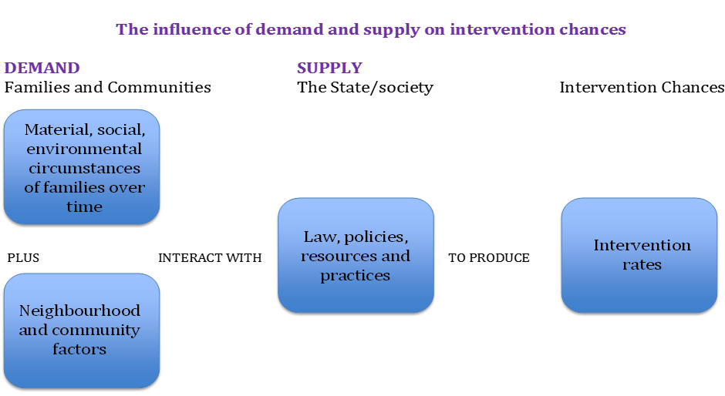

Table S1: Ethnic Codes for Children in Need (DfE, 2014c)
White: English/Welsh/Scottish/Northern Irish/British | WBRI
White: Irish | WIRI
White: Traveller of Irish Heritage | WIRT
White: Any other White Heritage | WOTH
White: Gypsy/Roma | WROM
Mixed/multiple ethnic group: White and Black Caribbean | MWBC
Mixed/multiple ethnic group: White and Black African | MWBA
Mixed/multiple ethnic group: White and Asian | MWAS
Mixed/multiple ethnic group: Other Mixed | MOTH
Asian/Asian British: Indian | AIND
Asian/Asian British: Pakistani | APKN
Asian/Asian British: Bangladeshi | ABAN
Asian/Asian British: Other Asian | AOTH
Black/African/Caribbean/Black British: Caribbean | BCRB
Black/African/Caribbean/Black British: African | BAFR
Black/African/Caribbean/Black British: Other Black | BOTH
Asian/Asian British: Chinese | CHNE
Other ethnic group: Any other ethnic group | OOTH

Table S2: Percentage of children by broad ethnic category, 13 West Midlands Local Authorities, 2011
 | White | Mixed | Asian | Black | Other | All
Birmingham | 42 | 9 | 35 | 11 | 3 | 100
Coventry | 66 | 6 | 18 | 8 | 2 | 100
Dudley | 83 | 5 | 10 | 2 | 1 | 100
Herefordshire | 97 | 2 | <1 | <1 | <1 | 100
Sandwell | 58 | 8 | 25 | 6 | 2 | 100
Solihull | 83 | 6 | 9 | 2 | <1 | 100
Staffordshire | 93 | 3 | 3 | <1 | <1 | 100
Stoke | 82 | 4 | 12 | 2 | <1 | 100
Telford and Wrekin | 89 | 5 | 5 | 1 | <1 | 100
Walsall | 69 | 6 | 22 | 3 | <1 | 100
Warwickshire | 89 | 4 | 5 | <1 | <1 | 100
Wolverhampton | 58 | 11 | 21 | 8 | 2 | 100
Worcestershire | 92 | 3 | 4 | <1 | <1 | 100
All | 72 | 6 | 16 | 5 | 1 | 100

Table S3: Percentage of all children who were recorded as White, by age group, 13 West Midlands Local Authorities, 2011
Age (years) | 0- 4 | 5 to 9 | 10 to 15 | 16 to 17
Birmingham | 40 | 39 | 44 | 48
Coventry | 62 | 64 | 69 | 72
Dudley | 80 | 81 | 85 | 86
Herefordshire | 97 | 97 | 97 | 98
Sandwell | 56 | 56 | 62 | 64
Solihull | 81 | 82 | 85 | 85
Staffordshire | 92 | 93 | 94 | 94
Stoke | 78 | 80 | 84 | 85
Telford and Wrekin | 87 | 88 | 90 | 91
Walsall | 66 | 66 | 72 | 74
Warwickshire | 88 | 89 | 90 | 91
Wolverhampton | 55 | 57 | 61 | 62
Worcestershire | 91 | 92 | 94 | 92
All | 70 | 71 | 75 | 77

Table S4: Percentage of West Midlands children aged 0-17 by ethnic category and deprivation quintile (5 is most deprived).
Quintile | 1 | 2 | 3 | 4 | 5 | N
WBRI | 15.3 | 19.9 | 18.3 | 19.3 | 27.2 | 824553
MWBC | 4.9 | 12.8 | 11.4 | 18.6 | 57.6 | 35204
MWBA | 6.8 | 21.8 | 11.5 | 18.9 | 51.6 | 4845
MWAS | 10.1 | 26.9 | 13.6 | 17.8 | 46.1 | 18224
MOTH | 8.1 | 18.3 | 12.3 | 17.8 | 52.2 | 10938
AIND | 8.8 | 23.0 | 15.3 | 19.0 | 46.3 | 49772
APKN | 1.5 | 2.9 | 5.6 | 12.3 | 78.3 | 89318
ABAN | 1.4 | 2.2 | 4.5 | 8.0 | 84.3 | 22016
AOTH | 4.6 | 10.1 | 10.0 | 17.7 | 61.5 | 22031
BAFR | 1.7 | 3.7 | 5.5 | 12.1 | 77.8 | 22978
BCRB | 1.5 | 4.7 | 8.2 | 14.4 | 72.4 | 17210
BOTH | 1.2 | 2.8 | 5.1 | 11.8 | 79.7 | 12355

Table S5: West Midlands CPP Rates (per 10000 children) by Ethnic Category and Deprivation Quintile, where the number of children is greater than 10.
Quintile | 1 | 2 | 3 | 4 | 5 | All | N
WBRI | 10.2 | 17.2 | 27.7 | 43.0 | 79.4 | 39.9 | 3294
WIRI |  |  |  |  |  | 33.0 | 11
WIRT+WROM |  |  |  |  |  | 75.6 | 12
WOTH |  |  |  |  | 26.9 | 21.6 | 53
MWBC |  |  | 47.4 | 48.8 | 63.1 | 52.6 | 185
MWBA |  |  |  |  | 60.0 | 43.3 | 21
MWAS |  |  | 56.4 | 61.8 | 86.9 | 61.5 | 112
MOTH |  |  | 103.9 | 77.1 | 140.0 | 107.0 | 117
AIND |  |  |  |  | 16.5 | 11.9 | 59
APKN |  |  | 25.8 | 20.1 | 26.6 | 25.1 | 224
ABAN |  |  |  |  | 29.6 | 29.1 | 64
AOTH |  |  |  | 25.7 | 33.2 | 26.8 | 59
BCRB |  |  |  |  | 73.8 | 61.0 | 105
BAFR |  |  |  |  | 22.4 | 22.6 | 52
BOTH |  |  |  |  | 10.2 | 17.8 | 22
CHNE |  |  |  |  |  | 7.8 | 4
OOTH |  |  |  |  | 31.1 | 33.1 | 50
ALL | 9.5 | 17.6 | 27.8 | 39.7 | 58.0 | 37.7 | 4444

Table S6: LAC Rates by Ethnic Category and Deprivation Quintile, where the number of children is greater than 10.
 | 1 | 2 | 3 | 4 | 5 | All | N =
WBRI | 17.6 | 26.1 | 44.7 | 76.6 | 125.4 | 64.9 | 5355
WIRI |  |  |  |  | 110.9 | 57.1 | 19
WIRT+WROM |  |  |  |  | 215.1 | 119.7 | 19
WOTH |  | 3.8 | 6.6 | 10.6 | 14.3 | 10.4 | 109
MWBC |  | 69.1 | 57.4 | 111.3 | 126.1 | 107.4 | 378
MWBA |  |  |  | 164.1 | 84.0 | 86.7 | 42
MWAS |  |  | 64.5 | 77.3 | 204.7 | 124.0 | 226
MOTH |  | 124.4 | 96.5 | 179.9 | 245.0 | 185.6 | 203
AIND |  |  |  | 10.6 | 14.3 | 10.4 | 52
APKN |  |  |  | 11.9 | 20.9 | 18.8 | 168
ABAN |  |  |  |  | 21.0 | 20.4 | 45
AOTH |  |  |  | 46.3 | 31.0 | 30.9 | 68
BCRB |  |  |  | 72.9 | 172.4 | 142.9 | 246
BAFR |  |  |  | 50.5 | 39.1 | 40.5 | 93
BOTH |  |  |  |  | 30.5 | 31.6 | 39
CHNE |  |  |  |  |  | 9.7 | 5
OOTH |  |  |  |  | 52.8 | 46.9 | 71
ALL | 17.9 | 26.7 | 42.7 | 69.4 | 91.2 | 60.5 | 7138

Table S7: West Midlands Age Related Inequalities in CPP Rates (per 10000 children) by Ethnicity, Quintile 5
Age | 0 to 4 | 5 to 9 | 10 to 15 | 16 to 17
White | 112.6 | 87.4 | 57.1 | 13.4
Mixed | 109.6 | 97.2 | 50.9 | 5.9
Asian | 27.7 | 29.6 | 25.0 | 6.7
Black | 43.2 | 40.5 | 33.7 | 0.0
Other | 54.4 | 37.2 | 23.2 | 0.0
All | 81.0 | 65.0 | 45.1 | 9.8

Table S8: West Midlands Age Related Inequalities in LAC Rates (per 10000 children) by Ethnicity, Quintile 5
Age | 0 to 4 | 5 to 9 | 10 to 15 | 16 to 17
White | 110.0 | 106.9 | 140.0 | 137.5
Mixed | 158.0 | 128.6 | 170.8 | 221.7
Asian | 16.6 | 16.7 | 21.6 | 41.1
Black | 53.4 | 56.4 | 107.7 | 130.9
Other | 60.2 | 41.0 | 46.3 | 146.7
All | 82.1 | 74.8 | 105.2 | 119.0

