Supplementary Figures
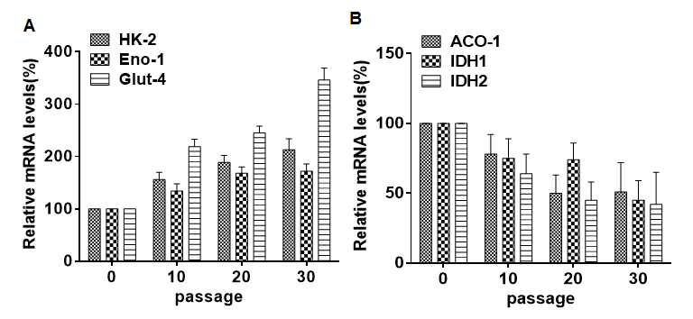
Fig. s1 Arsenite-induced neoplastic transformation has effects on the levels of metabolism-related genes in L-02 cells. GAPDH levels, measured in parallel, served as controls. L-02 cells were exposed to 0 or 2 μM of arsenite for 0, 10, 20, or 30 passages. (A) Quantitative RT-PCR was used to measure the levels of HK-2, Enol-1, and Glut-4. (B) Quantitative RT-PCR was used to measure the transcript levels of ACO-1, IDH1, and IDH2 (means ± SD, n = 3).
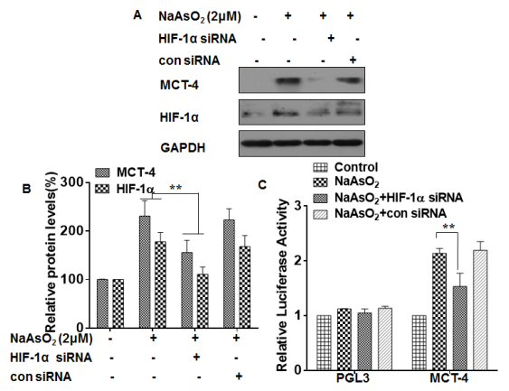
Fig. s2 In THLE-3 cells, arsenite-induced up-regulation of MCT-4 is dependent on HIF-1α. Densities of bands were quantified by Eagle Eye II software. GAPDH levels, measured in parallel, served as controls. THLE-3 cells were exposed to 20 nM of control siRNA or to 10 nM HIF-1α siRNA for 24 h, and then incubated with 0 or 2 μM arsenite for 24 h. (A) Western blots were performed, and (B) relative protein levels (means ± SD, n = 3) of HIF-1α and MCT-4 were determined. **P < 0.01, different from arsenite-treated cells in the absence of HIF-1α siRNA. (C) Luciferase activities of MCT-4 were measured and normalized to Renilla luciferase activity (means ± SD, n = 3); ** P< 0.01 different from arsenite-treated cells in the absence of HIF-1α siRNA.
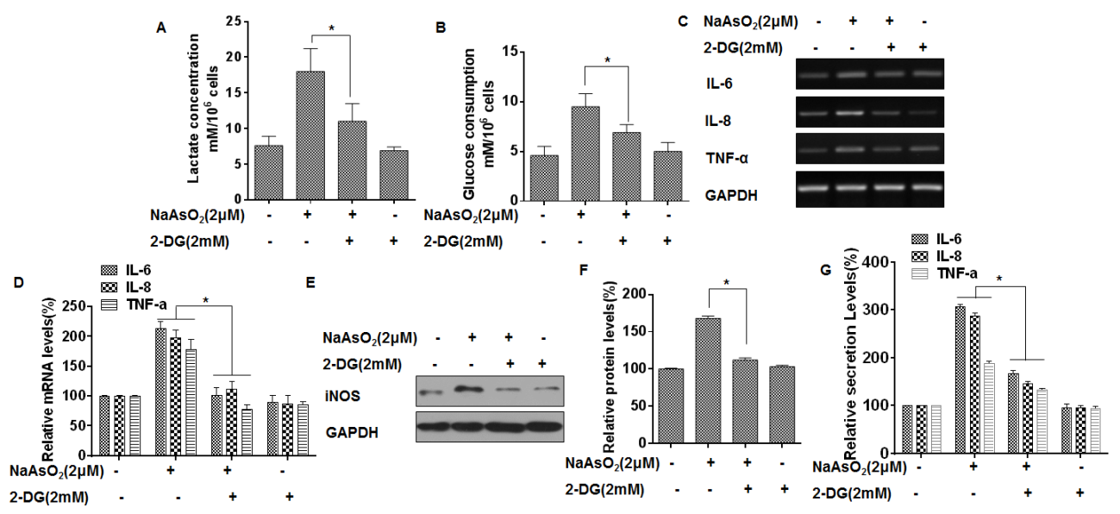
Fig. s3 Arsenite increases the levels of glycolysis, which are involved in arsenite-induced inflammation. Densities of bands were quantified by Eagle Eye II software. GAPDH levels, measured in parallel, served as controls. After L-02 cells were treated with 2 mM 2-DG for 3 h, they were exposed to 0 or 2 μM arsenite for 24 h. (A) Levels of lactate in the culture medium were measured and normalized to cell numbers. (B) Glucose consumption was determined for cells as in A; the numbers are means ± SD (n = 3) from three independent experiments. (C) The mRNA levels of IL-6, IL-8, and TNF-α were determined by RT-PCR. (D) Quantitative RT-PCR was used to measure the transcript levels of IL-6, IL-8, and TNF-α (means ± SD, n = 3). (E) The levels of iNOS were determined by Western blot analyses, and (F) the relative protein levels (means ± SD, n = 3) of iNOS were derived. (G) The levels of IL-6, IL-8, and TNF-α present in the media (means ± SD, n = 3) were measured by ELISA. *P < 0.05, different from arsenite-treated cells in the absence of 2-DG.

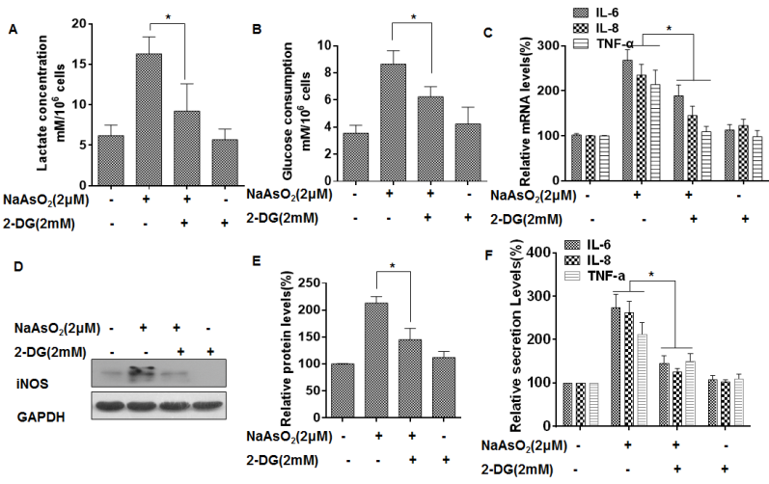
Fig. s4 In THLE-3 cells, arsenite increases the levels of glycolysis, which are involved in arsenite-induced inflammation. Densities of bands were quantified by Eagle Eye II software. GAPDH levels, measured in parallel, served as controls. After THLE-3 cells were treated with 2 mM 2-DG for 3 h, they were exposed to 0 or 2 μM arsenite for 24 h. (A) Levels of lactate in the culture medium were measured and normalized to cell numbers. (B) Glucose consumption was determined for cells as in A; the numbers are means ± SD (n = 3) from three independent experiments. (C) Quantitative RT-PCR was used to measure the transcript levels of IL-6, IL-8, and TNF-α (means ± SD, n = 3). (D) The levels of iNOS were determined by Western blot analyses. (E) The relative protein levels (means ± SD, n = 3) of iNOS were determined. (F) The levels of IL-6, IL-8, and TNF-α present in the media (means ± SD, n = 3) were measured by ELISA. *P < 0.05, different from arsenite-treated cells in the absence of 2-DG.
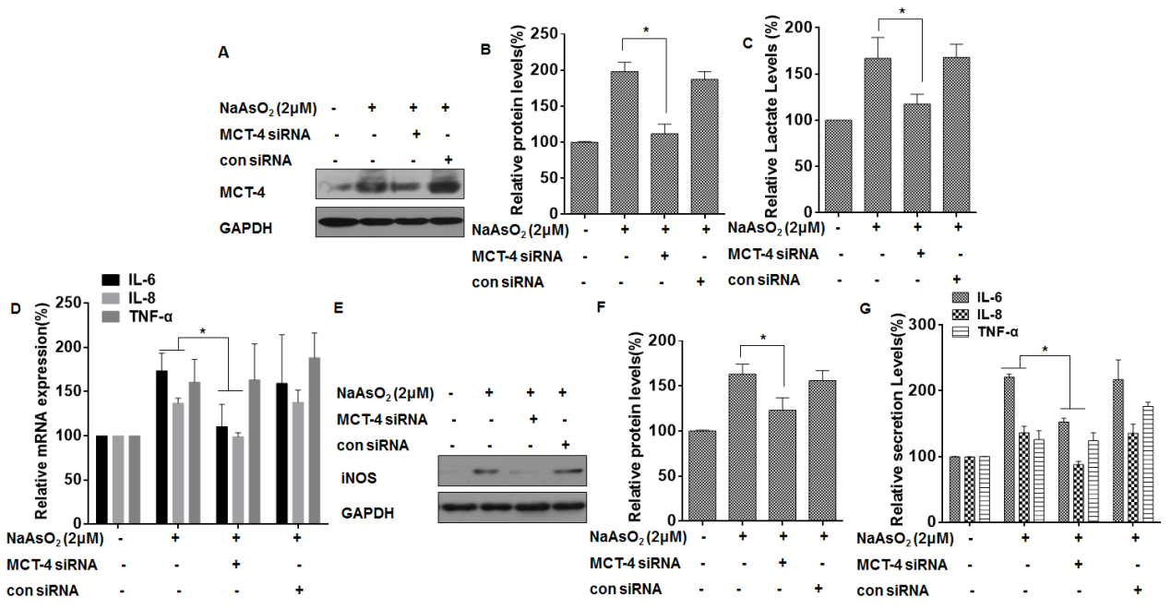
Fig. s5 MCT-4 is involved in the inflammatory properties of THLE-3 cells exposed to arsenite. Densities of bands were quantified by Eagle Eye II software. GAPDH levels, measured in parallel, served as controls. THLE-3 cells were exposed to 20 nM of control siRNA or to 10 nM MCT-4 siRNA for 24 h and then incubated with 0 or 2 μM arsenite for 24 h. (A) Western blots were performed, and (B) relative protein levels (means ± SD, n = 3) of MCT-4 were determined. (C) Levels of lactate in the culture medium were measured and normalized to cell numbers. (D) Quantitative RT-PCR was used to measure the transcript levels of IL-6, IL-8, and TNF-α (means ± SD, n = 3). (E) The levels of iNOS were determined by Western blot analyses, and (F) the relative protein levels (means ± SD, n = 3) of iNOS were derived. (G) The levels of IL-6, IL-8, and TNF-α present in the media (means ± SD, n = 3) were measured by ELISA. *P < 0.05, different from arsenite-treated cells in the absence of MCT-4 siRNA.
Fig. s6 Levels of TNF-α in the serum samples, and the relationships with lactate levels and with arsenic in hair. Abbreviations: 1, External control; 2, Internal control; 3, Mild; 4, Intermediate; 5, Severe. (A) The levels of serum TNF-α were measured (n=30 per group, values are means ± SD). *P < 0.05, different from the external and internal control groups. n.s, no different from the internal control groups. (B) There is a positive correlation between the levels of lactate and TNF-α in the sera of the external control, internal control, mild, intermediate, or severe populations (n = 30, R=0.227, p=0.005). (C) The correlation between the levels of arsenic in hair and TNF-α in the sera of the external control, internal control, mild, intermediate, or severe populations (n = 30, R=0.131, p=0.109).

Table
Table 1: Primer sequences used.
HK-2 | 5'-ATGAGGGGCGGATGTGTATCA-3′
 | 5'-GGTTCAGTGAGCCCATGTCAA-3′
Eno-1 | 5'-AAAGCTGGTGCCGTTGAGAAG-3′
 | 5'-AGC ATGAGAACCGCCATTGAT-3′
Glut-4 | 5'-GTCGGGCTTCCAACAGATAG-3′
 | 5'-ACCCCAATGTTGTACCCAAA-3′
IL-6 | 5'-AGTAGTGAGGAACAAGCCAGA-3′
 | 5'-TACATTTGCCGAAGAGCC-3′
IL-8 | 5'-ACTTCTCCACAACCCTCTG-3′
 | 5'-ACTCCAAACCTTTCCACC-3′
TNF-α | 5'-TTGAAGAGGACCTGGGAGTAGAT-3′
 | 5'-CGAGTGACAAGCCTGTAGCC-3′
ACO-1 | 5'-TTGGAGGATTCAAGATATGG-3′
 | 5'-ACTCATCACAATTCCGAAT-3′
IDH1 | 5'-GAGATAACCTACACACCAAGT-3′
 | 5'-AACACCACCACCTTCTTC-3′
IDH2 | 5'-GATGGATGGTGATGAGAT-3′
 | 5'-AAATACTTTAGCTGGATGTC-3′
GAPDH | 5'-GCATCCTGGGCTACACTG-3'
 | 5'-TGGTCGTTGAGGGCAAT-3'

Table 2: Arsenite-induced changes (means ± SD), as determined by measurements of arsenic in hair and of various serum components, in villagers (30/group) from Guizhou Province. The groups were those exposed to arsenic and showing symptoms of arsenicosis (mild, intermediate, and severe); those exposed with no symptoms (internal controls); and those not exposed (external controls).
Group | Hair As (μg/g) | TP (g/L) | Alb (g/L) | Globulin(g/L) | A/G | ALT(U/L) | AST(U/L) | γ-GT (U/L) | TBA (μmol/L)
External control | 0.17±0.13 | 78.52±3.68 | 48.39±3.08 | 30.13±2.49 | 1.62±0.18 | 22.88±9.01 | 28.12±6.10 | 20.15±8.51 | 2.38±1.24
Internal control | 0.18±0.15 | 76.39±5.32 | 46.37±2.64^{b} | 30.68±3.70 | 1.59±0.32 | 23.75±10.73 | 25.70±5.55 | 22.34±13.65 | 2.13±1.65
Mild | 0.34±0.23^{a,c} | 76.38±4.64 | 46.06±2.45ª | 30.31±4.00 | 1.54±0.20 | 25.19±10.43 | 30.48±7.22^{c} | 25.18±13.21 | 3.36±2.27^{b,d}
Intermediate | 0.31±0.19^{a,c} | 75.05±4.54ª | 44.54±2.39^{a,c,f} | 30.51±3.79 | 1.48±0.19ª | 24.60±10.21 | 27.38±5.77 | 29.20±19.19^{b} | 3.88±2.84^{a,c}
Severe | 0.43±0.28^{a,c,f,g} | 74.51±5.91ª | 43.98±3.74^{a,c,f} | 30.53±4.00 | 1.46±0.20ª | 24.84±11.19 | 27.44±6.88 | 31.05±16.91^{a,d} | 4.88±1.86^{a,c,e}

Abbreviations: As, total arsenite; TP, total protein; Alb, albumin; A/G, the ratio of albumin and globulin; ALT, glutamic-pyruvic transaminase; AST, glutamic-oxalacetic transaminase; γ-GT, γ-glutamyl transpeptidase; TBA, total bile acids. ªSignificantly different compared with the external control group (p < 0.01 using ANOVA). ^{b}Significantly different compared with the external control group (p < 0.05 using ANOVA). ^{c}Significantly different compared to the internal control group (p < 0.01 using ANOVA). ^{d}Significantly different compared with the internal control group (p < 0.05 using ANOVA). ^{e}Significantly different compared with the mild group (p < 0.01 using ANOVA). ^{f}Significantly
different compared with mild group (p < 0.05 using ANOVA). ^{g}Significantly different compared with the intermediate group (p < 0.05 using ANOVA).

