Repair of O⁶-carboxymethylguanine adducts by
O⁶-methylguanine-DNA methyltransferase in human colon epithelial cells
- Supplementary Material -

Tina Kostka^{1, 2, †}, Michael T. Empl^{1, †}, Nina Seiwert^{3, †}, Susanne M. Geisen⁴, Pascal Hoffmann⁵, Janine Adam¹, Bettina Seeger^{1, 6}, Jerry W. Shay⁷, Markus Christmann⁸, Shana J. Sturla⁴, Jörg Fahrer³, Pablo Steinberg^{1, 9, *}
¹ Institute for Food Toxicology, University of Veterinary Medicine Hannover, Hannover, Germany
² Current address: Institute of Food Science and Human Nutrition, Gottfried Wilhelm Leibniz University Hannover, Hannover, Germany
³ Division of Food Chemistry and Toxicology, Department of Chemistry, Technical University of Kaiserslautern, Kaiserslautern, Germany
⁴ Department of Health Sciences and Technology, ETH Zurich, Zurich, Switzerland
⁵ Institute for Physiology and Cell Biology, University of Veterinary Medicine Hannover, Hannover, Germany
⁶ Current address: Institute for Food Quality and Food Safety, University of Veterinary Medicine Hannover, Hannover, Germany
⁷ Department of Cell Biology, University of Texas Southwestern Medical Center, Dallas, TX 75390, USA
⁸ Department of Toxicology, University Medical Center Mainz, Mainz, Germany
⁹ Current address: Max Rubner-Institut, Federal Research Institute of Nutrition and Food, Karlsruhe, Germany

* Corresponding author: Pablo Steinberg (email: Pablo.Steinberg@mri.bund.de)
† These authors contributed equally to this work

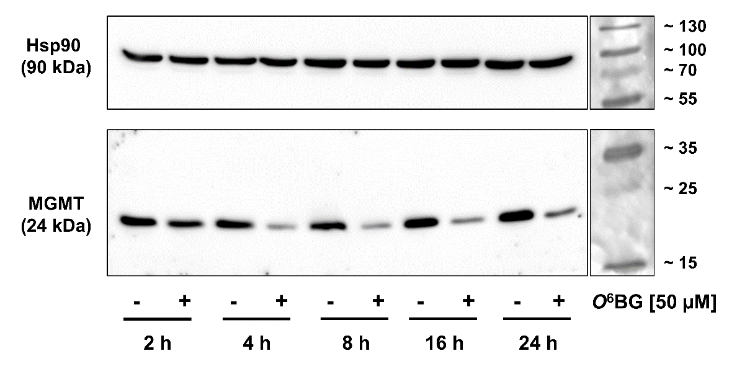
Supplementary Fig. 1: Western blot images showing time-dependent depletion of MGMT protein expression levels upon treatment with 0.1 % DMSO (-) or O⁶BG (+) in HCEC 1CT cells. The intensity signal of Hsp90 served as loading control, while molecular markers verified the protein sizes.

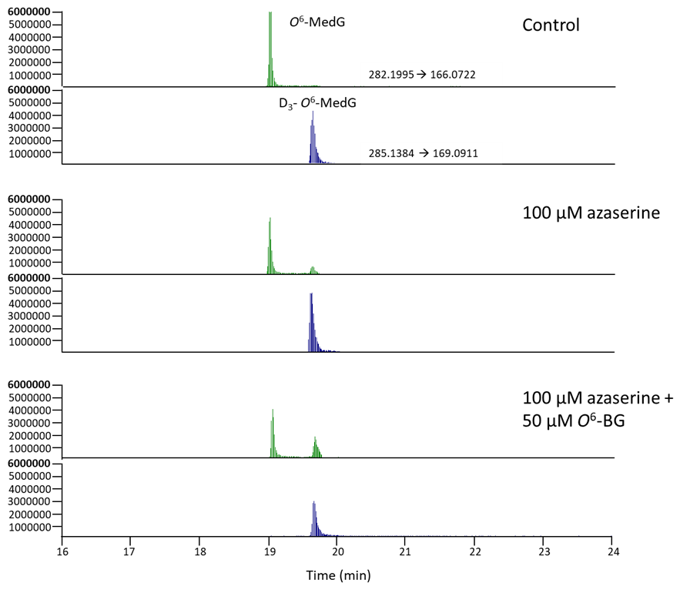
100 µM AZA +
50 µM O⁶BG
100 µM AZA
Control
Abundance
Supplementary Fig. 2: Representative ion chromatograms of O⁶-MedG adducts extracted from HCEC 1CT cells after cellular treatment. D₃-O⁶-MedG was used as internal standard. The peak with m/z 282.1995→166.0722 is N2-MedG.
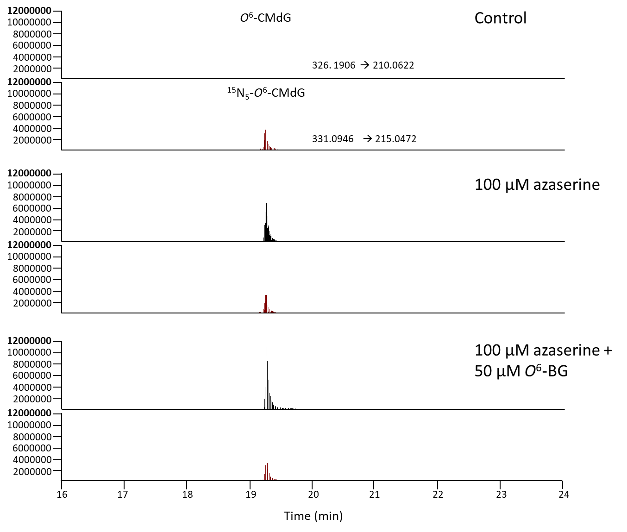
100 µM AZA +
50 µM O⁶BG
100 µM AZA
Control
Abundance
Supplementary Fig. 3: Representative ion chromatograms of O⁶-CMdG adducts extracted from HCEC 1CT cells after cell treatment. ¹⁵N₅-O⁶-CMdG was used as internal standard.

Supplementary Table I: Reduced MGMT activity in HCEC 1CT cells induced by various concentrations of O⁶BG. The activity of MGMT-deficient HeLa MR cells served as blank and was used for the calculation of corrected radioactivity. Significance levels are given in Figure 2C of the main manuscript.
Sample | Radioactivity  [cpm] in triplicate | Corrected radioactivity [cpm] | MGMT activity  [fmol/mg protein] | Mean (± SEM)
DMSO | 1627.19 | 1427.19 | 211.30 | 203.93 (± 7.43)
 | 1502.19 | 1277.02 | 189.06
 | 1652.93 | 1428.10 | 211.43
0.1 µM O⁶BG | 901.12 | 701.12 | 103.80 | 90.57 (± 7.44)
 | 752.31 | 527.15 | 78.04
 | 831.78 | 606.95 | 89.86
1 µM O⁶BG | 342.38 | 142.38 | 21.08 | 15.94 (± 2.60)
 | 310.63 | 85.47 | 12.65
 | 319.91 | 95.08 | 14.08
10 µM O⁶BG | 275.97 | 75.97 | 11.25 | 5.03 (± 3.12)
 | 240.62 | 15.46 | 2.29
 | 235.23 | 10.40 | 1.54
HeLa MR blank | 200.00
 | 225.17
 | 224.83

Supplementary Table II: Targeted m/z of compounds and fractions after neutral loss of deoxyribose (dR) detected using tandem mass spectrometry in different modes. D₃-O⁶-MedG and ¹⁵N₅-O⁶-CMdG were used as internal standards.
Compound | MS^{n} | Molecular ions | m/z | Chemical structure of  compounds and fractions
O⁶-MedG | MS¹ | [M+H]⁺ | 282 | 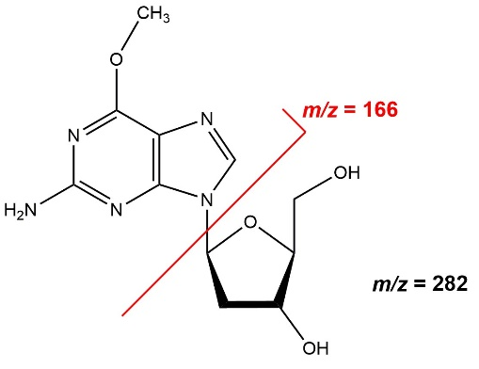
 | MS² | [M+H-dR]⁺ | 166
D₃-O⁶-MedG | MS¹ | [M+H]⁺ | 285 | 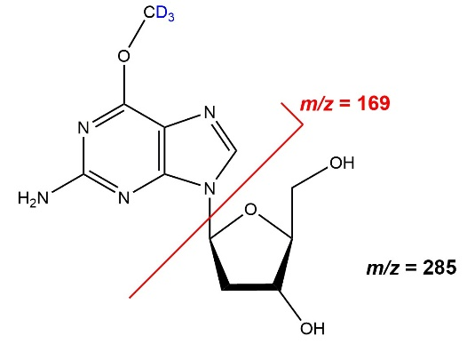
 | MS² | [M+H-dR]⁺ | 169
O⁶-CMdG | MS¹ | [M+H]⁺ | 326 | 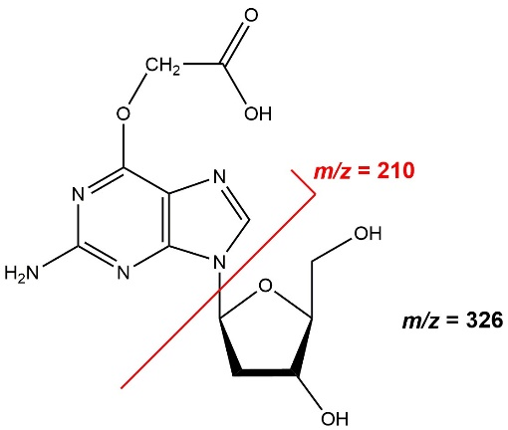
 | MS² | [M+H-dR]⁺ | 210
¹⁵N₅-O⁶-CMdG | MS¹ | [M+H]⁺ | 331 | 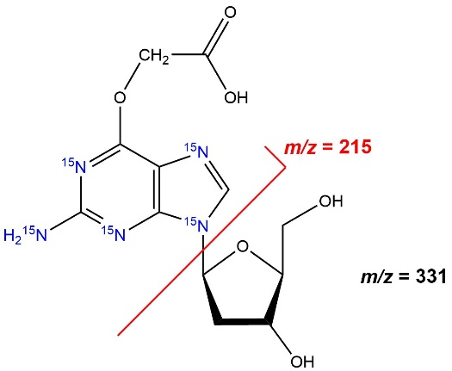
 | MS² | [M+H-dR]⁺ | 215

