**Supplementary Materials for:**

Brain activity tracks population information sharing by

capturing consensus judgments of value

**Notation for multilevel models**

A multilevel model can be described with a series of equations. These equations emphasize the distribution of the outcome variable (Stroup, 2012), an approach that is standard in Bayesian modeling (e.g., Gelman et al., 2013) and that simplifies the notation for heterogeneity.

Equation 1: Yij ~ N(μj + βjXij + σe)

Equation 2:  μj ~ N(μ, σμ)

Equation 3: βj ~ N(β, σβ)

In Eq. 1, the observations of the outcome variable Y for subject *j* (1, 2, ... 41) on trial *i* are specified to be drawn from a normal distribution with a mean μ that varies across subjects *j*, a linear function of Xij described by a coefficient β, that can vary from subject to subject *j,* and a common residual standard deviation, σe. In Eq. 2, the subject-specific μj means are specified to be normally distributed with mean that represents the population mean and a standard deviation that represents population heterogeneity (i.e., between-subject variability) in the coefficients. In Eq. 3, the subject-specific βj coefficients are specified to be normally distributed with mean that represents the population average coefficient and a standard deviation that represents population heterogeneity (i.e., between-subject variability) in the coefficients.

**Notation for models fit for analyses described in main manuscript**

**Activity in vmPFC tracked with consensus value and population article sharing, with variability from person to person**

ConsensusValueij ~ N(μj + vmPFCjXij + σe), μj ~ N(μ, σμ), vmPFCj ~ N(β, σβ)

ConsensusValueij ~ N(μj + vmPFCjXij + ratingjXij + σe), μj ~ N(μ, σμ),vmPFCj ~ N(β, σβ), ratingj ~ N(β, σβ)

logShareij ~ N(μj + vmPFCjXij + σe), μj ~ N(μ, σμ), vmPFCj ~ N(β, σβ)

logShareij ~ N(μj + vmPFCjXij + ratingjXij + σe), μj ~ N(μ, σμ), vmPFCj ~ N(β, σβ), ratingj ~ N(β, σβ)

**Infrequent news readers showed lower self-reported reading intentions and lower average vmPFC activity**

PersonlogShareEffectj ~ N(μ + PersonConsensusValueEffectjXj + σe)

PersonVMPFCactivityj ~ N(μ + PersonNewsReadingjXj + σe)

PersonReadingIntentionsj ~ N(μ + PersonNewsReadingjXj + σe)

**Infrequent news readers showed greater vmPFC population predictive capacity, mediated by superior tracking of consensus value**

ConsensusValueij ~ N(μ + vmPFCjXij + PersonNewsReadingjXij + vmPFCjXij*PersonNewsReadingjXij + σe), , vmPFCj ~ N(β, σβ)

logShareij ~ N(μ + vmPFCjXij + PersonNewsReadingjXij + vmPFCjXij*PersonNewsReadingjXij + σe), vmPFCj ~ N(β, σβ)

PersonShareEffectj ~ N(μ + NewsReadingjXj + σe) (c path)

PersonConsensusValueEffectj ~ N(μ + NewsReadingjXj + σe) (a path)

PersonShareEffectj ~ N(μ + NewsReadingjXj + PersonConsensusValueEffectjXj +  σe) (b path)

**Infrequent news readers tended to show lower vmPFC-dlPFC connectivity, which was associated with superior consensus value tracking**

PersonNewsReadingj ~ N(μ + ConnectivityjXj + σe); Connectivityj ~Laplace(0, σj)

**News reading, vmPFC predictive capacity, and consensus value tracking were not strongly related to other demographics**

ConsensusValueij ~ N(μj + vmPFCjXij + NewsReadingjXij + AgejXij + EducationjXij + GenderFemalejXij + RaceAsianjXij +RaceBlackjXij +RaceHispanicjXij + vmPFCjNewsReadingjXij + vmPFCjRaceOtherjXij + vmPFCjAgejXij + vmPFCjEducationjXij + vmPFCjGenderFemalejXij + vmPFCjRaceAsianjXij + vmPFCjRaceBlackjXij + vmPFCjRaceHispanicjXij + vmPFCjRaceOtherjXij + σe), μj ~ N(μ, σμ), vmPFCj ~ N(β, σβ)

logShareij ~ N(μj + vmPFCjXij + NewsReadingjXij + AgejXij + EducationjXij + GenderFemalejXij + RaceAsianjXij +RaceBlackjXij +RaceHispanicjXij + vmPFCjNewsReadingjXij + vmPFCjRaceOtherjXij + vmPFCjAgejXij + vmPFCjEducationjXij + vmPFCjGenderFemalejXij + vmPFCjRaceAsianjXij + vmPFCjRaceBlackjXij + vmPFCjRaceHispanicjXij + vmPFCjRaceOtherjXij + σe), μj ~ N(μ, σμ), vmPFCj ~ N(β, σβ)

Agej ~ N(μ + PersonNewsReadingjXj + σe)

**Comparing trial-by-trial ratings of reading intentions and trial-by-trial variation in vmPFC activity in terms of relationships with consensus value and population article sharing**

We fit models to compare trial-by-trial behavioral ratings of reading intentions and vmPFC activity in terms of the relationships these two predictor variables showed with consensus value ratings (i.e., group average reading intentions) and population article sharing. In separate bivariate models, we saw relationships with consensus value, as well as population sharing, for both ratings and vmPFC activity (see black coefficients plotted in Supplementary Figure S2). When including both variables as simultaneous predictors, both ratings and vmPFC showed independent relationships with both consensus value and population sharing (see gray coefficients plotted in Supplementary Figure S2). Notably, the magnitudes of the coefficients for ratings were somewhat larger than those for vmPFC, especially with consensus value as the outcome variable

**Follow-up analyses investigating relationships with consensus value and population sharing for ventral striatum, self-related regions and social-cognition-related brain regions**

Although our primary theoretical interest was in better understanding relationships between vmPFC activity, consensus value, and population behavior, we also conducted follow-up analyses using ventral striatum, a mask of self-related brain regions (anterior mPFC and precuneus) defined with a self-relevance judgment task (Falk et al., 2015), and a mask of social cognition-related regions (dmPFC, TPJ, and lateral temporal cortex) defined with a social judgment task (Dufour et al., 2013), masks that were used in previous analyses of these data (Scholz et al., 2017). We modified the self- and social-related masks to remove clusters showing mutual overlap or overlap with vmPFC. In separate bivariate models, we saw relationships between brain activity and consensus value, as well as population sharing, for each of these predictors (see black coefficients plotted in Supplementary Figure S3, left and right panel). We also saw person to person variability in the coefficients relating brain activity to population sharing for ventral striatum, SD=.08, 95%CI[.004,.21], for the self-related regions, SD=.10, 95%CI[.01, .22], and for the social cognition-related regions, SD=.08, 95%CI[.01, .20]. However, for none of these regions did we see clear evidence that this person-to-person variability corresponded with individual differences in news reading frequency; future studies are needed to examine other potential variables that could explain this heterogeneity.

.

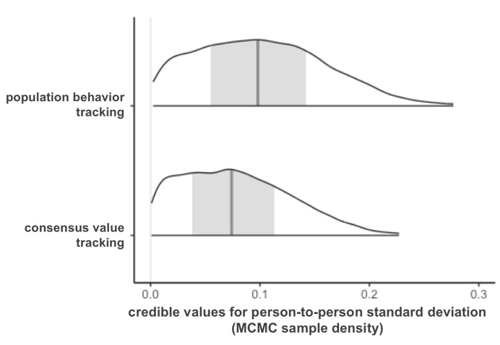

**Supplementary Figure S1.** Posterior distributions (smoothed histograms) of model-estimated credible values for the degree of person-to-person variation (i.e., the standard deviation) in vmPFC population behavior tracking and vmPFC consensus *value tracking. Central gray line and band reflect posterior mean and 50% credibility interval.*

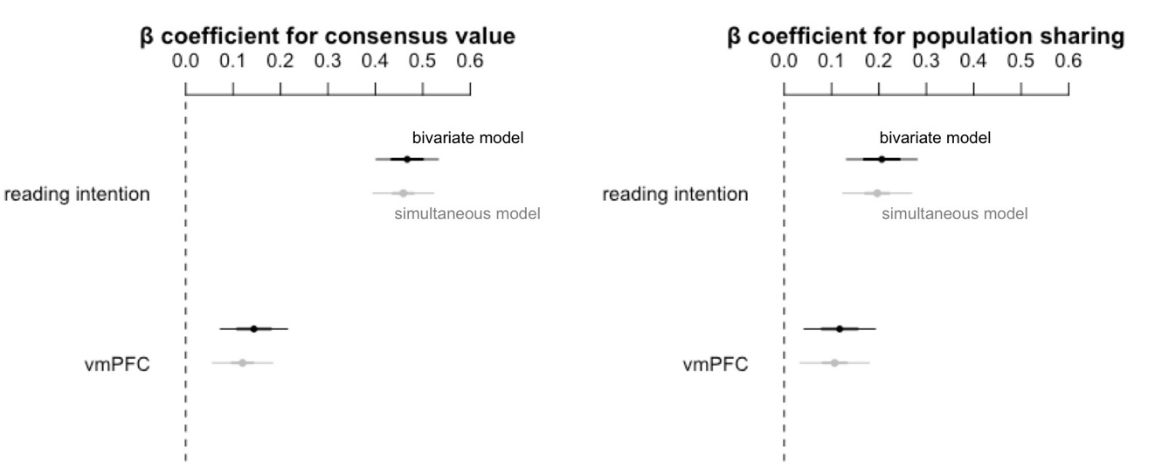

**Supplementary Figure S2.** Standardized beta coefficients indicating the average magnitude of the within-person relationship between trial-by-trial variation in (top row) ratings of reading intentions and (bottom row) vmPFC activity with consensus article value (left) and population article sharing (right). Black coefficients reflect estimates (with 68% and 95%CI) from bivariate models. Gray coefficients reflect estimates (with 68% and 95%CI) from models with reading intention ratings and vmPFC activity as simultaneous predictors.

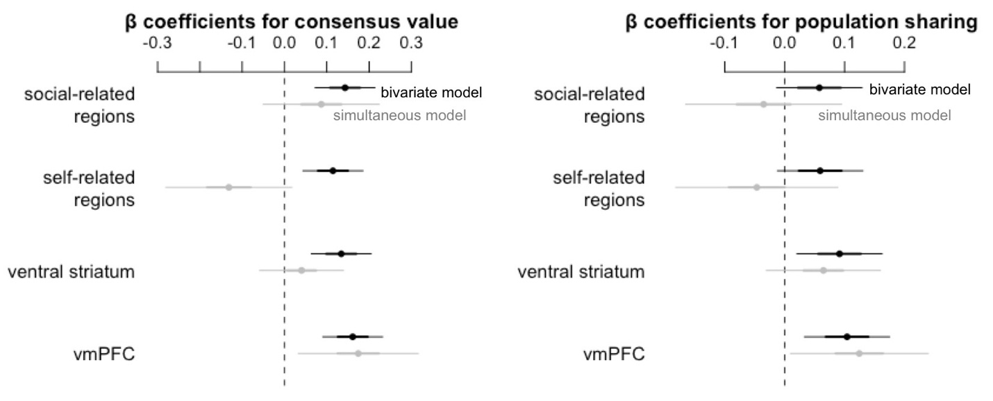

**Supplementary Figure S3.** Standardized beta coefficients indicating the average magnitude of the within-person relationship between trial-by-trial variation in social-cognition related brain activity, self-related brain activity, ventral striatal activity, and vmPFC activity with consensus article value (left) and population article sharing (right). Black coefficients reflect estimates (with 68% and 95%CI) from bivariate models. Gray coefficients reflect estimates (with 68% and 95%CI) from models with social-cognition related activity, self-related activity, ventral striatum activity, and vmPFC activity as simultaneous predictors.



**Supplementary Figure S4.** The overall pattern of data indicated that news consumption frequency showed a moderating effect; frequent news readers (top 33%) tended to show high ventromedial prefrontal cortex (vmPFC) responses across all articles, whereas infrequent readers (bottom 33%) tended to show high vmPFC only to articles that would be heavily shared. Thick black line reflects the mean estimate for each tertile (i.e., the average relationship for frequent readers and the average relationship for infrequent readers). Light gray lines reflect person-specific estimates regularized toward these mean estimates for each tertile. Gray dots reflect trial-level observations.

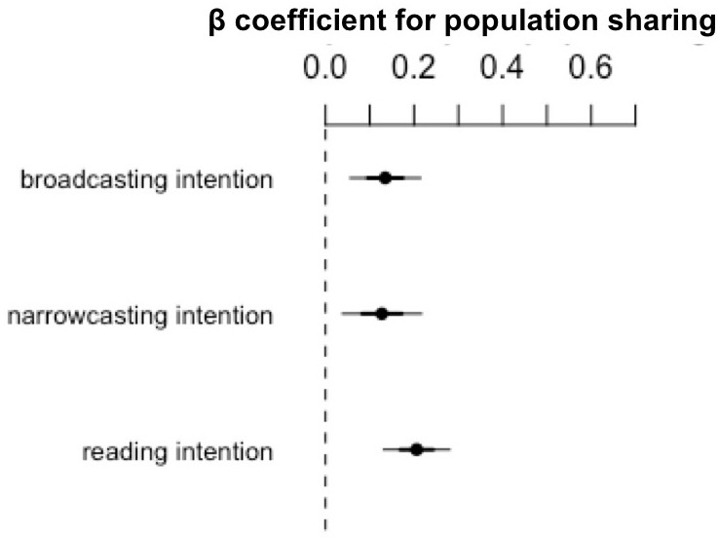

**Supplementary Figure S5.** Standardized coefficients indicating the (average within-person) magnitude of bivariate relationships between different kinds of intentions and population sharing behavior. Reading intentions reflect rated intentions to read the article oneself, narrowcasting intentions reflect rated intentions to share the article with a specific friend, and broadcasting intentions reflect rated intentions to share the article with all of one’s followers on a social media network.

**Supplementary References**

Dufour N, Redcay E, Young L, Mavros PL, Moran JM, Triantafyllou C, Gabrieli JDE, Saxe R. 2013. Similar brain activation during false belief tasks in a large sample of adults with and without autism. PLoS One. 8:e75468.

Falk EB, O’Donnell MB, Cascio CN, Tinney F, Kang Y, Lieberman MD, Taylor SE, An L, Resnicow K, Strecher VJ. 2015. Self-affirmation alters the brain’s response to health messages and subsequent behavior change. Proc Natl Acad Sci U S A. 112:1977–1982.

Gelman A, Carlin JB, Stern HS, Dunson DB, Vehtari A, Rubin DB. 2014. Bayesian data analysis. CRC Press Boca Raton, FL.

Scholz C, Baek EC, O’Donnell MB, Kim HS, Cappella JN, Falk EB. 2017. A neural model of valuation and information virality. Proc Natl Acad Sci U S A. 114:2881–2886.

Stroup WW. 2012. Generalized Linear Mixed Models: Modern Concepts, Methods and Applications. CRC Press Boca Raton, FL.