Supplementary Material
Reorganization of sound location processing in the auditory cortex of blind humans.
Kiki van der Heijden, Elia Formisano, Giancarlo Valente, Minye Zhan, Ron Kupers, Beatrice de Gelder.

SUPPLEMENTARY DATA ANALYSIS
Post-hoc power estimation for multivariate analysis
To estimate the statistical power of the result obtained in this study with the multivariate analysis we performed post-hoc simulations based on an independent data set acquired with an identical experimental paradigm (Derey, Valente et al. 2015). Specifically, we used the fMRI responses in planum temporale from the prior study to construct regression weight maps similar to those included here. From these maps, we first estimated for each voxel first and second order statistics (i.e. mean and variance) across subjects. The power estimation then considered multiple scenarios to characterize the power of the set-up in the current experiment (i.e. twelve participants per group) as a function of effect size (i.e. decoding accuracy). To achieve this, we injected a difference in a subset of voxels in one group for each scenario, resulting in a difference that could be picked up by the decoding algorithm. The injected difference values were selected to correspond to a range of average decoding accuracy from 50% (i.e. chance) to 100%. For each scenario (fourteen in total, see Figure 10), we then performed the multivariate analysis identical to the procedure described in the main text (leave-one-out cross-validation, 30 repetitions) including the permutation testing procedure (2000 random permutations) to establish the significance (p value). For each scenario, we repeated the whole procedure (data generation, decoding, and permutation testing) 100 times. We then estimate the mean decoding accuracy and power (i.e. the percentage of rejections of the null hypothesis with α = 0.05).
The results of the simulations show that for the present study, a power of 80% or more – with twelve participants per group – is achieved with a decoding accuracy of 78% (see Figure S1). Importantly, the actual accuracies that we observe in the present study range from ~80% to ~82%, corresponding to a power of around 90%.
Multivariate searchlight analysis
Classifying the activation maps in response to the binaural sum regressor (i.e. reflecting the general auditory response to sound, independent of sound position) with a SVM decoder suggested a difference between sighted and blind individuals in the auditory cortex, outside of HG and PT (Figure 6). To identify more precisely where in the auditory cortex this difference is located, we performed an additional multivariate searchlight analysis on the cortical surface. First, we created disk-shaped searchlights, using every vertex in the anatomically defined mask of the auditory cortex as seed once (the mask is shown in Figure 6 A). To preserve the local anatomy, the construction of searchlight disks was based on the geodesic distance between vertices (Chen et al, 2011). Specifically, we used modified versions of the Dijkstra algorithm (Dijkstra, 1959) and the Matlab Surfing Toolbox (Oosterhof, Wiestler, and Diedrichsen, 2011) to identify the shortest path between vertices in term of geodesic distance. We used this information to construct searchlight disks from the seed vertex and the neighboring vertices within a radius of 2 of the seed vertex. This resulted in searchlights disks consisting of 52 vertices on average (standard deviation = 15).
Next, we performed a searchlight classification in which we decoded subject group from the subject-specific beta maps using a Fast Gaussian Naïve Bayes classifier (FGNB; Ontivero-Ortega et al., 2017). This classifier generates similar results as SVM decoding, but has a much higher speed of computation and is therefore ideally suited for searchlight analyses (Ontivero-Ortega et al., 2017). Otherwise, the procedure was similar to the procedure described in the main text for the SVM decoder. Specifically, for each searchlight, we performed a twelve-fold cross-validation procedure in which the classifier was trained on 22 labeled beta maps (eleven per participant group), and tested on two left-out unlabeled beta maps (one per participant group). For each fold, training and testing data were subdivided such that overall, each subject belonged to the test set one time. We performed this twelve-fold cross-validation procedure 30 times, scrambling the order of participants within the groups on each iteration (see also main text). Classification accuracy was then calculated as the average percentage of correct classifications across the thirty repetitions.
For each searchlight, we assessed whether the classifier performed above chance level with a permutation testing procedure (2,000 repetitions) with scrambled beta map labels similar to the procedure used for the SVM (see main text). For each permutation, we performed the entire twelve-fold cross-validation procedure and thirty iterations with scrambled subject order. We computed the significance level of each classifier as the number of times the permuted accuracy was equal or exceeded the observed accuracy divided by the number of permutations (with a one added to both the numerator and denominator to avoid zero p-values).
Finally, to correct for multiple comparisons we performed a cluster extent based thresholding procedure (see main text). That is, for each of the permutations we identified false positive searchlights as those with p < 0.05 and used these to construct a cortical map of false positives. We then constructed a distribution of maximum cluster sizes by determining for each cortical map the maximum extent of false-positive clusters. Observed clusters in the data were thresholded at p_{cluster} < 0.05 with this distribution.
With the FGNB classifier operating on searchlights on the cortical surface, we could successfully decode participant group from a cluster in left medial temporal cortex (~ 1200 vertices, decoding accuracy = 74.3 %, p_{clust} < 0.05; see Figure S6). In the right hemisphere, we also observed clusters in which the FGNB classifier performed above chance level as judged on the single-searchlight level, but these clusters were smaller (largest cluster contained ~ 425 vertices) and more distributed over the auditory cortex and therefore did not survive the stringent cluster size thresholding procedure used here. Thus, the difference in activation maps for the general auditory response to sound (independent of sound location) as identified with the SVM decoder is concentrated in the left hemisphere in medial temporal cortex, while more distributed in the right hemisphere. These findings confirm the results of the univariate analysis as well as the multivariate SVM decoder.
References
Chen Y, Namburi P, Elliott LT, Heinzle J, Soon CS, Chee MW, Haynes JD. 2011. Cortical surface-based searchlight decoding. Neuroimage. 56:582-592.
Dijkstra EW. 1959. A note on two problems in connexion with graphs. Numerische mathematic. 1:269-271.
Ontivero-Ortega M, Lage-Castellanos A, Valente G, Goebel R, Valdes-Sosa M. 2017. Fast Gaussian Naïve Bayes for searchlight classification analysis. Neuroimage. 163:471-479.
Oosterhof NN, Wiestler T, Diedrichsen J. 2011. Surfing Toolbox. Available online at: https://github.com/nno/surfing
SUPPLEMENTARY FIGURES AND TABLES
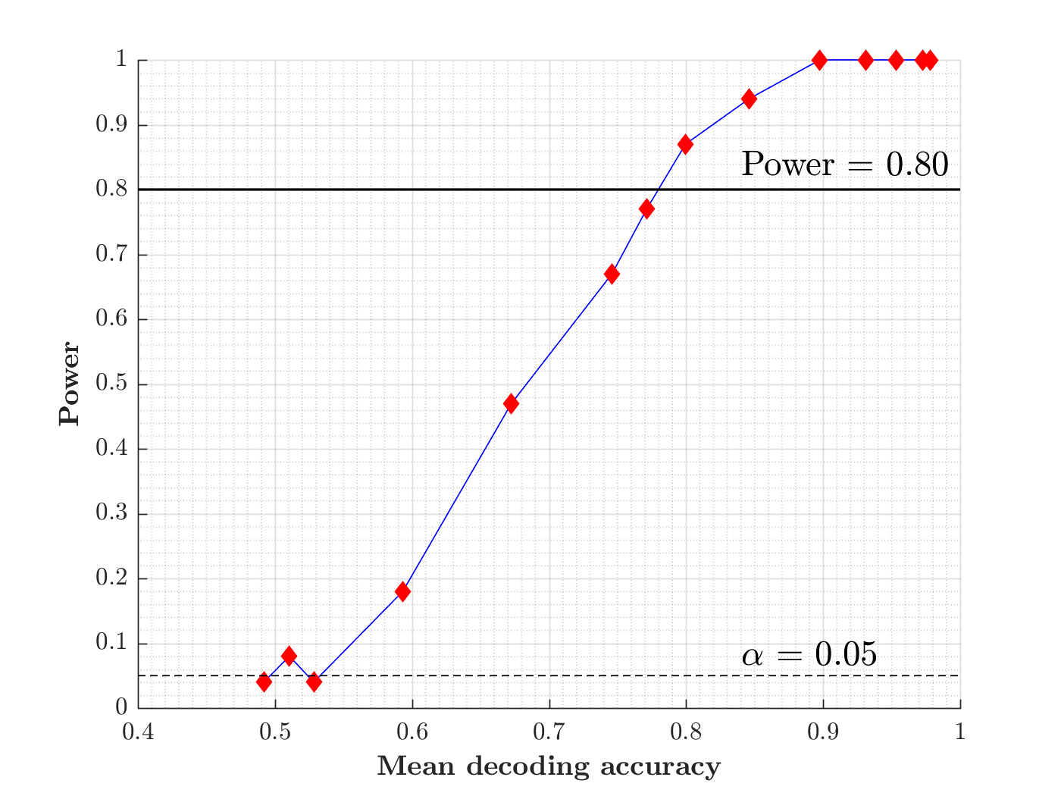
Figure S1. Post-hoc estimation of power. Plotted are the results of a post-hoc power estimation based on an independent data set acquired with an identical experimental paradigm (Derey, Valente et al. 2015). The line displays power as a function of decoding accuracy (i.e. effect size), red diamonds correspond to each of the fourteen scenarios tested (see Supplementary Information main text). The horizontal, dashed line indicates α = 0.05, the horizontal, solid line indicates a power of 80%. The results show that for the decoding accuracies observed in the present experiment (~80% to ~82% with twelve participants per group), power is around 90%.

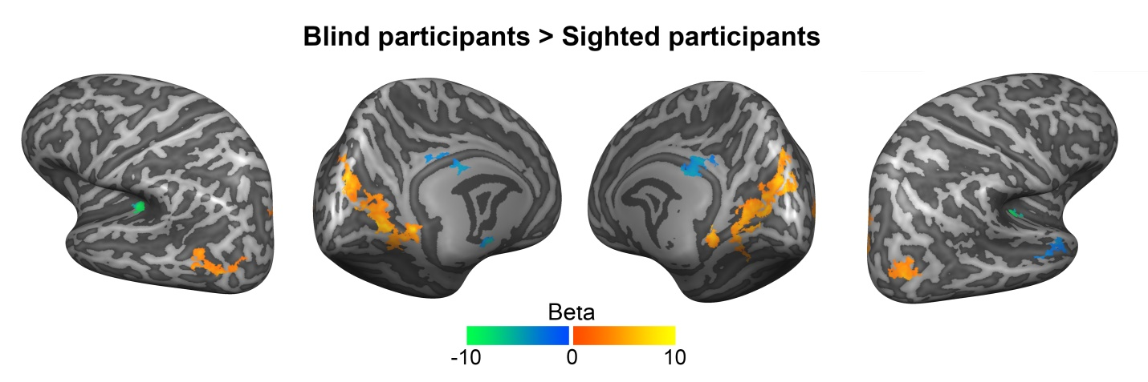
Figure S2. Uncorrected maps of functional activation in response to long-duration, sustained sounds reflect clusters of lower activation in the medial temporal cortex of blind participants. Similar to Figure 1 (third row), this figure shows the mean regression weights for the between-group comparison for the contrast sustained + transient > baseline. Maps were thresholded with a non-parametric testing procedure at p < 0.05, but not corrected for multiple comparisons.

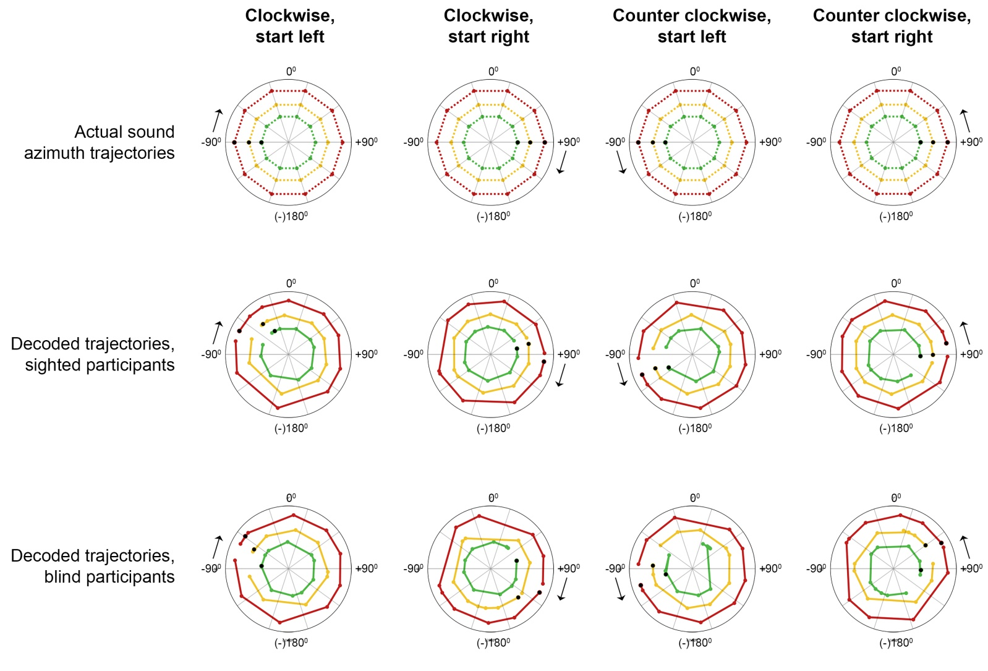
Figure S3. Decoding sound azimuth trajectories from the population fMRI response in the auditory cortex of sighted and blind participants with an opponent coding model. Polar plots show the actual sound azimuth trajectory of the stimuli in the frequency range 250 – 700 Hz (first row), and the sound azimuth trajectories reconstructed from the fMRI responses of spatially sensitive vertices in the auditory cortex of sighted participants (second row), and blind participants (third row). Colors indicate the sound intensity condition: green = soft; yellow = medium; red = loud (radius is arbitrarily selected for ease of visualization). Colored dots indicate the position of the sound at each measured time point (that is, every 2 seconds). Black arrows signal the starting point and the motion direction of the sound azimuth trajectory.

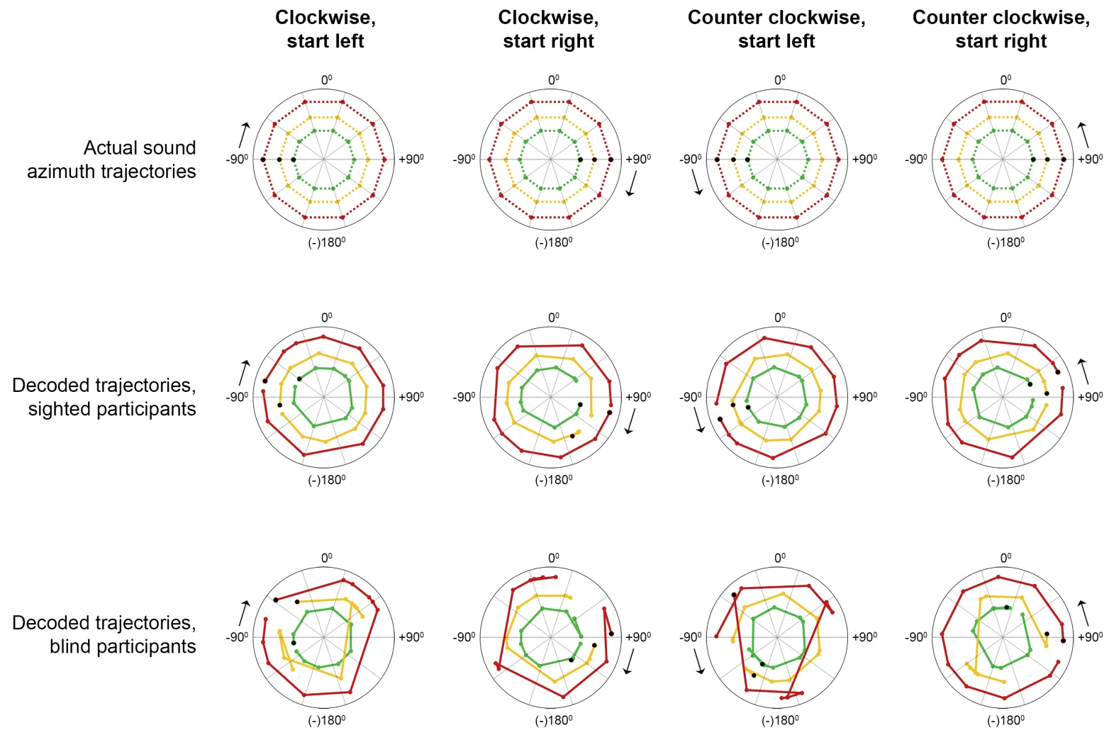
Figure S4. Decoding sound azimuth trajectories from the population fMRI response in the auditory cortex of sighted and blind participants with an opponent coding model. Similar to Figure S3 but for stimuli in the frequency range 500 – 1400 Hz.
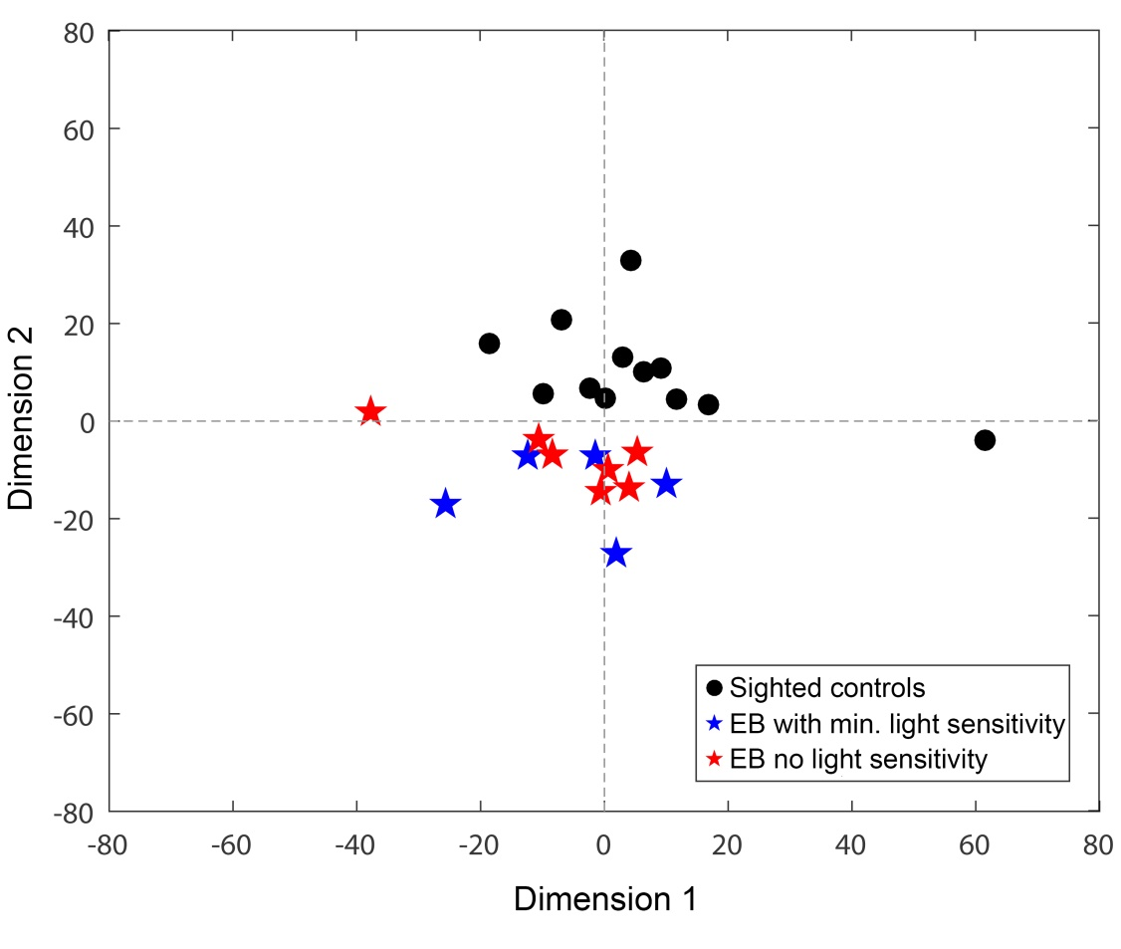
Figure S5. Multidimensional scaling of fMRI activity patterns in response to binaural differences in sighted and blind participants. The spatial organization of the icons illustrates the separation in the activity patterns between sighted and blind participants as shown by the MVPA results previously (see main text), indicating that the response to binaural differences for sighted participants is distinct from that for blind participants. Icons for blind participants with and without minimal light sensivity cluster together, highlighting that there is no distinct difference in the fMRI activity patterns between these groups. We performed nonmetric multidimensional scaling on the beta maps in PT used for the MVPA, including the 1500 voxels that were most informative for the MVPA (i.e. with the largest absolute MVPA weight).

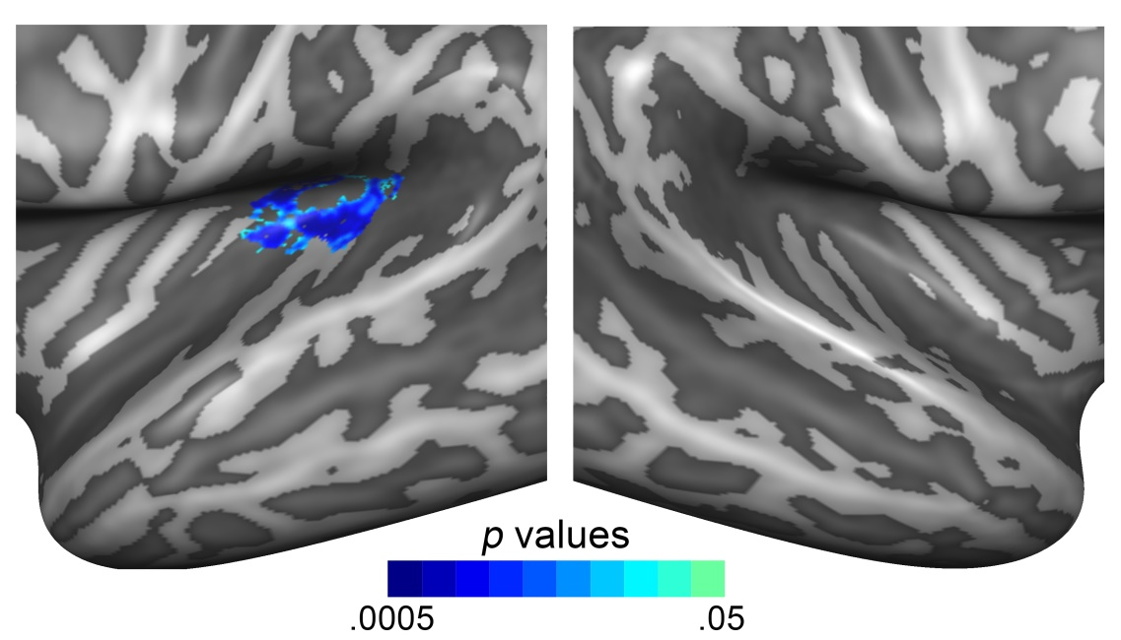

Figure S6. Decoding participant group with a multivariate searchlight decoder on the cortical surface. The colored region in located medially with respect to HG indicates the cortical area where participant group can be decoded significantly from local patterns by the FGNB decoder. We color coded seed vertices (i.e. the center of the searchlights), color indicates the statistical significance (cluster-size thresholded to correct for multiple comparisons, see main text).

Table S1. Statistical comparison of the presence of spatial cues (interaural level and time differences [ILDs and ITDs, respectively]) in the binaural recordings of early blind and sighted participants for stimuli in the 500 – 1400 Hz range. Reported are the mean difference in ITD and ILD between the participant groups, the uncorrected p values, and the q[FDR] values. FDR correction was performed across the frequency bins in a single stimulus, which corresponds to 43 bins for stimuli in the 500 – 1400 Hz range. See text for details on the non-parametric permutation analysis.
 | ILDs at -90⁰ |  |  |  | ILDs at +90⁰ |  |  |  | ITDs at -90⁰ |  |  |  |  |  | ITDs at +90⁰
Frequency bin (Hz) | EB - SC (dB) |  | p | q | EB - SC (dB) | p | q |  | EB - SC (ms) |  | p |  | q |  | EB - SC (ms) |  | p | q
495 | 0.70 |  | 0.279 | 0.92 | 0.24 | 0.735 | 0.93 |  | 0.00 |  | 0.980 |  | 0.99 |  | 0.07 |  | 0.223 | 0.99
517 | 0.61 |  | 0.262 | 0.92 | 0.73 | 0.263 | 0.86 |  | 0.06 |  | 0.215 |  | 0.80 |  | 0.01 |  | 0.915 | 0.99
538 | 1.07 |  | 0.211 | 0.91 | 0.43 | 0.628 | 0.93 |  | 0.05 |  | 0.423 |  | 0.85 |  | 0.10 |  | 0.155 | 0.99
560 | 0.23 |  | 0.660 | 0.96 | 1.26 | 0.137 | 0.86 |  | 0.04 |  | 0.502 |  | 0.85 |  | 0.00 |  | 0.991 | 0.99
581 | 0.24 |  | 0.510 | 0.96 | 0.15 | 0.799 | 0.93 |  | 0.01 |  | 0.875 |  | 0.98 |  | 0.07 |  | 0.449 | 0.99
603 | 0.92 |  | 0.189 | 0.90 | 0.50 | 0.301 | 0.86 |  | 0.08 |  | 0.297 |  | 0.80 |  | 0.08 |  | 0.279 | 0.99
625 | 1.39 |  | 0.051 | 0.41 | 0.09 | 0.823 | 0.93 |  | 0.06 |  | 0.231 |  | 0.80 |  | 0.04 |  | 0.526 | 0.99
646 | 1.22 |  | 0.069 | 0.42 | 0.02 | 0.969 | 0.98 |  | 0.10 |  | 0.201 |  | 0.80 |  | 0.06 |  | 0.329 | 0.99
668 | 0.27 |  | 0.681 | 0.96 | 0.18 | 0.761 | 0.93 |  | 0.02 |  | 0.751 |  | 0.92 |  | 0.05 |  | 0.364 | 0.99
689 | 0.44 |  | 0.569 | 0.96 | 0.59 | 0.485 | 0.89 |  | 0.04 |  | 0.656 |  | 0.92 |  | 0.02 |  | 0.766 | 0.99
711 | 0.04 |  | 0.946 | 0.98 | 0.50 | 0.368 | 0.89 |  | 0.03 |  | 0.552 |  | 0.88 |  | 0.01 |  | 0.941 | 0.99
732 | 0.11 |  | 0.851 | 0.96 | 0.65 | 0.318 | 0.86 |  | 0.01 |  | 0.887 |  | 0.98 |  | 0.00 |  | 0.974 | 0.99
754 | 0.77 |  | 0.150 | 0.81 | 0.82 | 0.245 | 0.86 |  | 0.08 |  | 0.263 |  | 0.80 |  | 0.01 |  | 0.896 | 0.99
775 | 1.32 |  | 0.015 | 0.26 | 1.09 | 0.017 | 0.63 |  | 0.00 |  | 0.936 |  | 0.98 |  | 0.03 |  | 0.556 | 0.99
797 | 1.79 |  | 0.001 | 0.03* | 1.26 | 0.125 | 0.86 |  | 0.01 |  | 0.835 |  | 0.98 |  | 0.02 |  | 0.811 | 0.99
818 | 1.21 |  | 0.058 | 0.41 | 0.38 | 0.550 | 0.89 |  | 0.06 |  | 0.107 |  | 0.80 |  | 0.03 |  | 0.509 | 0.99
840 | 0.77 |  | 0.367 | 0.94 | 0.11 | 0.856 | 0.93 |  | 0.07 |  | 0.118 |  | 0.80 |  | 0.01 |  | 0.910 | 0.99
861 | 0.03 |  | 0.968 | 0.98 | 0.29 | 0.578 | 0.89 |  | 0.04 |  | 0.442 |  | 0.85 |  | 0.02 |  | 0.833 | 0.99
883 | 0.18 |  | 0.849 | 0.96 | 0.71 | 0.411 | 0.89 |  | 0.05 |  | 0.467 |  | 0.85 |  | 0.01 |  | 0.885 | 0.99
904 | 1.62 |  | 0.018 | 0.26 | 0.79 | 0.426 | 0.89 |  | 0.03 |  | 0.479 |  | 0.85 |  | 0.01 |  | 0.899 | 0.99
926 | 1.03 |  | 0.261 | 0.92 | 0.72 | 0.563 | 0.89 |  | 0.06 |  | 0.296 |  | 0.80 |  | 0.06 |  | 0.447 | 0.99
948 | 0.02 |  | 0.975 | 0.98 | 0.79 | 0.305 | 0.86 |  | 0.02 |  | 0.700 |  | 0.92 |  | 0.07 |  | 0.239 | 0.99
969 | 0.35 |  | 0.621 | 0.96 | 0.17 | 0.802 | 0.93 |  | 0.04 |  | 0.272 |  | 0.80 |  | 0.03 |  | 0.564 | 0.99
991 | 0.54 |  | 0.354 | 0.94 | 0.95 | 0.205 | 0.86 |  | 0.07 |  | 0.031 |  | 0.72 |  | 0.00 |  | 0.939 | 0.99
1012 | 0.28 |  | 0.702 | 0.96 | 1.71 | 0.029 | 0.63 |  | 0.05 |  | 0.224 |  | 0.80 |  | 0.01 |  | 0.799 | 0.99
1034 | 1.59 |  | 0.038 | 0.41 | 0.53 | 0.458 | 0.89 |  | 0.09 |  | 0.044 |  | 0.72 |  | 0.02 |  | 0.556 | 0.99
1055 | 0.12 |  | 0.860 | 0.96 | 0.41 | 0.433 | 0.89 |  | 0.02 |  | 0.627 |  | 0.92 |  | 0.01 |  | 0.822 | 0.99
1077 | 0.08 |  | 0.865 | 0.96 | 0.38 | 0.561 | 0.89 |  | 0.03 |  | 0.321 |  | 0.80 |  | 0.01 |  | 0.841 | 0.99
1098 | 0.41 |  | 0.400 | 0.96 | 0.19 | 0.675 | 0.93 |  | 0.02 |  | 0.337 |  | 0.80 |  | 0.00 |  | 0.964 | 0.99
1120 | 0.57 |  | 0.355 | 0.94 | 0.15 | 0.827 | 0.93 |  | 0.05 |  | 0.050 |  | 0.72 |  | 0.00 |  | 0.910 | 0.99
1141 | 0.50 |  | 0.371 | 0.94 | 0.94 | 0.158 | 0.86 |  | 0.03 |  | 0.196 |  | 0.80 |  | 0.01 |  | 0.784 | 0.99
1163 | 0.23 |  | 0.661 | 0.96 | 0.62 | 0.305 | 0.86 |  | 0.03 |  | 0.382 |  | 0.82 |  | 0.00 |  | 0.927 | 0.99
1184 | 0.14 |  | 0.811 | 0.96 | 0.01 | 0.984 | 0.98 |  | 0.01 |  | 0.712 |  | 0.92 |  | 0.00 |  | 0.977 | 0.99
1206 | 0.08 |  | 0.872 | 0.96 | 0.11 | 0.865 | 0.93 |  | 0.02 |  | 0.249 |  | 0.80 |  | 0.00 |  | 0.845 | 0.99
1227 | 0.23 |  | 0.678 | 0.96 | 0.62 | 0.452 | 0.89 |  | 0.00 |  | 0.990 |  | 0.99 |  | 0.00 |  | 0.937 | 0.99
1249 | 0.33 |  | 0.721 | 0.96 | 0.14 | 0.857 | 0.93 |  | 0.02 |  | 0.513 |  | 0.85 |  | 0.02 |  | 0.552 | 0.99
1271 | 0.45 |  | 0.587 | 0.96 | 0.11 | 0.888 | 0.93 |  | 0.00 |  | 0.888 |  | 0.98 |  | 0.04 |  | 0.205 | 0.99
1292 | 0.41 |  | 0.628 | 0.96 | 0.83 | 0.302 | 0.86 |  | 0.01 |  | 0.748 |  | 0.92 |  | 0.02 |  | 0.328 | 0.99
1314 | 0.07 |  | 0.942 | 0.98 | 0.79 | 0.313 | 0.86 |  | 0.03 |  | 0.370 |  | 0.82 |  | 0.01 |  | 0.643 | 0.99
1335 | 0.14 |  | 0.847 | 0.96 | 0.20 | 0.766 | 0.93 |  | 0.00 |  | 0.928 |  | 0.98 |  | 0.04 |  | 0.209 | 0.99
1357 | 0.24 |  | 0.783 | 0.96 | 1.07 | 0.094 | 0.86 |  | 0.03 |  | 0.303 |  | 0.80 |  | 0.03 |  | 0.302 | 0.99
1378 | 0.43 |  | 0.567 | 0.96 | 1.27 | 0.221 | 0.86 |  | 0.02 |  | 0.591 |  | 0.91 |  | 0.06 |  | 0.049 | 0.99
1400 | 0.38 |  | 0.545 | 0.96 | 0.54 | 0.564 | 0.89 |  | 0.01 |  | 0.698 |  | 0.92 |  | 0.03 |  | 0.206 | 0.99
EB = early blind. SC = sighted control. ILD = interaural level difference. ITD = interaural time difference. Hz = Hertz. dB = decibel. Ms = millisecond. FDR = False Discovery Rate. * indicates a significant difference at q[FDR] < 0.05.
Table S2. Statistical comparison of the presence of spatial cues (interaural level and time differences [ILDs and ITDs, respectively]) in the binaural recordings of early blind and sighted participants for stimuli in the 250 – 700 Hz range. Reported are the mean difference between the participant groups, the uncorrected p values, and the q[FDR] values. FDR correction was performed across the frequency bins in a single stimulus, which corresponds to 22 bins for stimuli in the 250 – 700 Hz range. See text for details on the non-parametric permutation analysis procedure.
 | ILDs at -90⁰ |  |  |  | ILDs at +90⁰ |  |  |  |  | ITDs at -90⁰ |  |  |  |  |  | ITDs at +90⁰
Frequency bin (Hz) | EB - SC (dB) | p |  | q | EB - SC (dB) | p |  | q |  | EB - SC (ms) |  | p |  | q |  | EB - SC (ms) | p | q
258 | 0.37 | 0.042 |  | 0.26 | 0.83 | 0.009 |  | 0.08 |  | 0.01 |  | 0.693 |  | 1.00 |  | 0.01 | 0.720 | 1.00
280 | 0.01 | 0.968 |  | 1.00 | 1.04 | 0.010 |  | 0.08 |  | 0.04 |  | 0.076 |  | 0.61 |  | 0.10 | 0.006 | 0.13
301 | 0.11 | 0.712 |  | 0.90 | 0.32 | 0.327 |  | 0.98 |  | 0.09 |  | 0.032 |  | 0.38 |  | 0.01 | 0.830 | 1.00
323 | 0.43 | 0.200 |  | 0.50 | 0.33 | 0.526 |  | 1.00 |  | 0.07 |  | 0.012 |  | 0.29 |  | 0.07 | 0.371 | 0.92
345 | 0.75 | 0.007 |  | 0.09 | 0.08 | 0.811 |  | 1.00 |  | 0.02 |  | 0.562 |  | 1.00 |  | 0.03 | 0.692 | 1.00
366 | 0.03 | 0.945 |  | 1.00 | 0.86 | 0.032 |  | 0.19 |  | 0.04 |  | 0.428 |  | 1.00 |  | 0.03 | 0.588 | 1.00
388 | 0.30 | 0.429 |  | 0.64 | 0.79 | 0.007 |  | 0.08 |  | 0.03 |  | 0.432 |  | 1.00 |  | 0.00 | 0.920 | 1.00
409 | 0.83 | 0.088 |  | 0.30 | 0.25 | 0.558 |  | 1.00 |  | 0.01 |  | 0.788 |  | 1.00 |  | 0.03 | 0.661 | 1.00
431 | 0.91 | 0.008 |  | 0.09 | 0.50 | 0.174 |  | 0.69 |  | 0.01 |  | 0.821 |  | 1.00 |  | 0.02 | 0.625 | 1.00
452 | 0.74 | 0.194 |  | 0.50 | 0.44 | 0.368 |  | 0.98 |  | 0.05 |  | 0.225 |  | 0.87 |  | 0.02 | 0.765 | 1.00
474 | 0.25 | 0.525 |  | 0.74 | 0.84 | 0.077 |  | 0.37 |  | 0.05 |  | 0.102 |  | 0.61 |  | 0.00 | 0.956 | 1.00
495 | 0.43 | 0.296 |  | 0.61 | 0.12 | 0.809 |  | 1.00 |  | 0.01 |  | 0.790 |  | 1.00 |  | 0.08 | 0.382 | 0.92
517 | 0.57 | 0.375 |  | 0.61 | 0.22 | 0.755 |  | 1.00 |  | 0.03 |  | 0.582 |  | 1.00 |  | 0.12 | 0.075 | 0.60
538 | 0.58 | 0.353 |  | 0.61 | 0.24 | 0.764 |  | 1.00 |  | 0.01 |  | 0.900 |  | 1.00 |  | 0.07 | 0.222 | 0.76
560 | 0.97 | 0.064 |  | 0.26 | 0.19 | 0.694 |  | 1.00 |  | 0.00 |  | 0.920 |  | 1.00 |  | 0.01 | 0.923 | 1.00
581 | 0.19 | 0.644 |  | 0.86 | 0.16 | 0.740 |  | 1.00 |  | 0.01 |  | 0.905 |  | 1.00 |  | 0.02 | 0.691 | 1.00
603 | 0.64 | 0.210 |  | 0.50 | 0.04 | 0.929 |  | 1.00 |  | 0.07 |  | 0.291 |  | 0.87 |  | 0.07 | 0.167 | 0.69
624 | 1.30 | 0.064 |  | 0.26 | 0.11 | 0.830 |  | 1.00 |  | 0.04 |  | 0.577 |  | 1.00 |  | 0.08 | 0.165 | 0.69
646 | 0.61 | 0.383 |  | 0.61 | 0.36 | 0.489 |  | 1.00 |  | 0.02 |  | 0.766 |  | 1.00 |  | 0.04 | 0.421 | 0.92
668 | 0.80 | 0.316 |  | 0.61 | 0.11 | 0.876 |  | 1.00 |  | 0.02 |  | 0.802 |  | 1.00 |  | 0.13 | 0.173 | 0.69
689 | 0.17 | 0.816 |  | 0.98 | 0.56 | 0.558 |  | 1.00 |  | 0.08 |  | 0.274 |  | 0.87 |  | 0.16 | 0.028 | 0.33
711 | 1.27 | 0.065 |  | 0.26 | 0.63 | 0.332 |  | 0.98 |  | 0.08 |  | 0.289 |  | 0.87 |  | 0.06 | 0.409 | 0.92
EB = early blind. SC = sighted control. ILD = interaural level difference. ITD = interaural time difference. Hz = Hertz. dB = decibel. Ms = millisecond. FDR = False Discovery Rate.

Table S3. Statistical comparison of the spectrum of the binaural recordings of early blind and sighted participants for stimuli with a frequency range of 500 – 1400 Hz at -90⁰ (left) and +90⁰ (right). Reported are the mean between-groups difference, the uncorrected p values, and the q[FDR] values (see text).
 | Left (-90⁰) |  |  | Right (+90⁰)
Frequency bin (Hz) | EB - SC (dB) | p | q | EB - SC (dB) | p | q
517 | 0.00 | 1.000 | 1.00 | 0.68 | 0.483 | 0.99
538 | 3.58 | 0.050 | 0.54 | 0.82 | 0.482 | 0.99
560 | 1.67 | 0.051 | 0.54 | 2.83 | 0.609 | 0.99
581 | 1.72 | 0.051 | 0.54 | 0.86 | 0.502 | 0.99
603 | 1.54 | 0.046 | 0.54 | 0.23 | 0.710 | 0.99
625 | 1.31 | 0.149 | 0.86 | 0.14 | 0.867 | 0.99
646 | 0.92 | 0.429 | 0.86 | 0.04 | 0.961 | 0.99
668 | 0.68 | 0.513 | 0.86 | 0.11 | 0.889 | 0.99
689 | 0.28 | 0.635 | 0.86 | 0.05 | 0.944 | 0.99
711 | 0.33 | 0.626 | 0.86 | 0.10 | 0.901 | 0.99
732 | 0.37 | 0.607 | 0.86 | 0.20 | 0.848 | 0.99
754 | 0.68 | 0.373 | 0.86 | 0.52 | 0.594 | 0.99
775 | 1.17 | 0.107 | 0.86 | 0.68 | 0.484 | 0.99
797 | 0.81 | 0.290 | 0.86 | 0.34 | 0.713 | 0.99
818 | 0.24 | 0.822 | 0.91 | 0.55 | 0.503 | 0.99
840 | 0.07 | 0.956 | 1.00 | 0.84 | 0.286 | 0.99
861 | 0.17 | 0.903 | 0.97 | 1.14 | 0.134 | 0.99
883 | 1.90 | 0.439 | 0.86 | 3.08 | 0.337 | 0.99
904 | 4.24 | 0.302 | 0.86 | 2.42 | 0.552 | 0.99
926 | 1.95 | 0.664 | 0.86 | 0.37 | 0.962 | 0.99
948 | 6.47 | 0.223 | 0.86 | 2.25 | 0.574 | 0.99
969 | 3.89 | 0.315 | 0.86 | 2.33 | 0.300 | 0.99
991 | 1.70 | 0.423 | 0.86 | 2.72 | 0.124 | 0.99
1012 | 0.71 | 0.573 | 0.86 | 0.03 | 0.985 | 0.99
1034 | 0.01 | 0.997 | 1.00 | 0.27 | 0.821 | 0.99
1055 | 0.46 | 0.611 | 0.86 | 0.11 | 0.898 | 0.99
1077 | 0.32 | 0.750 | 0.86 | 0.12 | 0.868 | 0.99
1098 | 0.52 | 0.578 | 0.86 | 0.41 | 0.598 | 0.99
1120 | 0.94 | 0.310 | 0.86 | 0.61 | 0.463 | 0.99
1141 | 1.18 | 0.283 | 0.86 | 0.34 | 0.696 | 0.99
1163 | 1.08 | 0.347 | 0.86 | 0.03 | 0.967 | 0.99
1184 | 0.31 | 0.757 | 0.86 | 0.08 | 0.921 | 0.99
1206 | 0.43 | 0.605 | 0.86 | 0.06 | 0.945 | 0.99
1227 | 0.27 | 0.753 | 0.86 | 0.07 | 0.933 | 0.99
1249 | 0.30 | 0.744 | 0.86 | 0.25 | 0.752 | 0.99
1271 | 0.80 | 0.687 | 0.86 | 1.21 | 0.584 | 0.99
1292 | 1.46 | 0.506 | 0.86 | 4.78 | 0.075 | 0.99
1314 | 1.67 | 0.452 | 0.86 | 2.47 | 0.375 | 0.99
1335 | 1.70 | 0.483 | 0.86 | 1.87 | 0.523 | 0.99
1357 | 1.72 | 0.523 | 0.86 | 2.96 | 0.099 | 0.99
1378 | 0.39 | 0.753 | 0.86 | 2.14 | 0.372 | 0.99
1400 | 1.47 | 0.348 | 0.86 | 1.66 | 0.698 | 0.99
EB = early blind. SC = sighted control. ILD = interaural level difference. ITD = interaural time difference. Hz = Hertz. dB = decibel. Ms = millisecond. FDR = False Discovery Rate.

Table S4. Statistical comparison of the spectrum of the binaural recordings of early blind and sighted participants for stimuli with a frequency range of 250 – 700 Hz at -90⁰ (left) and +90⁰ (right). Reported are the mean between-groups difference, the uncorrected p values, and the q[FDR] values (see text).
 | Left (-90⁰) |  |  | Right (+90⁰)
Frequency bin (Hz) | EB - SC (dB) | p | q | EB - SC (dB) | p | q
237 | 0.00 | 1.000 | 1.00 | 0.00 | 1.000 | 1.00
258 | 2.27 | 0.664 | 0.85 | 2.37 | 0.822 | 0.90
280 | 6.30 | 0.045 | 0.63 | 7.60 | 0.112 | 0.61
301 | 2.51 | 0.091 | 0.63 | 3.63 | 0.321 | 0.71
323 | 1.60 | 0.119 | 0.63 | 3.12 | 0.298 | 0.71
345 | 1.22 | 0.250 | 0.63 | 1.47 | 0.305 | 0.71
366 | 1.00 | 0.373 | 0.63 | 1.47 | 0.266 | 0.71
388 | 1.16 | 0.349 | 0.63 | 1.69 | 0.165 | 0.71
409 | 1.26 | 0.286 | 0.63 | 1.88 | 0.104 | 0.61
431 | 1.37 | 0.285 | 0.63 | 6.69 | 0.038 | 0.42
452 | 3.81 | 0.313 | 0.63 | 8.71 | 0.038 | 0.42
474 | 3.04 | 0.599 | 0.85 | 4.86 | 0.369 | 0.74
495 | 2.92 | 0.158 | 0.63 | 5.78 | 0.257 | 0.71
517 | 0.21 | 0.734 | 0.85 | 0.57 | 0.633 | 0.77
538 | 0.54 | 0.275 | 0.63 | 0.37 | 0.590 | 0.76
560 | 0.47 | 0.419 | 0.66 | 0.51 | 0.528 | 0.76
581 | 0.29 | 0.691 | 0.85 | 0.75 | 0.426 | 0.76
603 | 0.17 | 0.844 | 0.93 | 0.70 | 0.544 | 0.76
624 | 0.09 | 0.910 | 0.95 | 0.72 | 0.576 | 0.76
646 | 0.23 | 0.723 | 0.85 | 0.08 | 0.962 | 1.00
668 | 4.52 | 0.205 | 0.63 | 2.40 | 0.547 | 0.76
689 | 6.34 | 0.093 | 0.63 | 1.93 | 0.675 | 0.78
EB = early blind. SC = sighted control. ILD = interaural level difference. ITD = interaural time difference. Hz = Hertz. dB = decibel. Ms = millisecond. FDR = False Discovery Rate.

