**Supplementary Material**

**List of supplementary material**

**Detailed assay description**

**Supplementary Figures**

1. Supplementary Figure 1. Safety parameters of total CD4+ T cell count and neutrophil count were unchanged during MGN1703 dosing
2. Supplementary Figure 2. Gating strategy for CD123pos/CD11neg plasmacytoid dendritic cells (pDCs)
3. Supplementary Figure 3. Heatmap depicting RNA sequencing of interferon-stimulated genes during TLR9 treatment
4. Supplementary Figure 4. Gating strategy for NK CD56dimCD16+ cells and the activation marker CD69 and receptors NKG2A, NKG2D and NKp46
5. Supplementary Figure 5. NK CD56dimCD16+ cells expressing NKG2A, NKp46 and NKG2D
6. Supplementary Figure 6. Gating strategy for CD8+ and CD4+ T cell subsets and double positive activation markers HLA-DR and CD38
7. Supplementary Figure 7. (A) HIV-1 DNA (integrated) (n=15) and (B) IUPM (n=10).
8. Supplementary Figure 8. HIV-1 DNA (total and integrated), individualized

**Supplementary Tables**

1. Supplementary Table 1. Primers and Probes used for CA US HIV-1 RNA, total HIV-1 DNA and integrated HIV-1 assay

**References**

**List of Abbreviations**

**Materials and Methods**

**RNA sequencing of blood-derived CD4+ T cells**

RNA samples were quantified using Qubit 2.0 Fluorometer (Life Technologies, Carlsbad, CA, USA) and RNA integrity was checked with 2100 Bioanalyzer (Agilent Technologies, Palo Alto, CA, USA). RNA sequencing libraries were prepared using the NEBNext Ultra RNA Library Prep Kit for Illumina following manufacturer’s recommendations (NEB, Ipswich, MA, USA). Briefly, mRNA was first enriched with Oligod(T) beads. Enriched mRNAs were fragmented for 15 minutes at 94 °C. First strand and second strand cDNA were subsequently synthesized. cDNA fragments were end repaired and adenylated at 3’ends, and universal adapter was ligated to cDNA fragments, followed by index addition and library enrichment with limited cycle PCR. Sequencing libraries were validated using a DNA Chip on the Agilent 2100 Bioanalyzer (Agilent Technologies, Palo Alto, CA, USA), and quantified by using Qubit 2.0 Fluorometer (Invitrogen, Carlsbad, CA) as well as by quantitative PCR (Applied Biosystems, Carlsbad, CA, USA).

The sequencing libraries were multiplexed and clustered onto a flowcell. After clustering, the flowcell was loaded on the Illumina HiSeq 2500 instrument according to manufacturer’s instructions. The samples were sequenced using a 1x50bp Single Read (SR) configuration. Image analysis and base calling were conducted by the HiSeq Control Software (HCS) on the HiSeq 2500 instrument. Raw sequence data (.bcl files) generated from Illumina HiSeq 2500 was converted into fastq files and de-multiplexed using Illumina bcl2fastq v 1.8.4 program. One mis-match was allowed for index sequence identification. The sequencing reactions were conducted at GENEWIZ, LLC. (South Plainfield, NJ, USA).

**Plasma levels of cytokines**

Plasma was isolated from whole blood by a two-step centrifugation protocol. First, the sample was centrifuged at 400*g* for 10 minutes. Second, plasma was transferred to a 15 ml tube followed by a second centrifugation at 1350*g* for 15 minutes. Cleared plasma was stored at -80°C until analysis. Plasma levels of cytokines were measured at baseline, during the first (day 4) and last week (day 24) of treatment (both 24h after dosing) and at follow-up (14 days after last dose) by electrochemi-luminscence assays, utilizing the Meso Scale technology (MSD). Samples were run in duplicates. Levels of IFN-α2 and CXCL10 were measured on singleplex assays (#K151ACC; #K151NVD). IL-6, IL-8, TNF-α and IFN-γ were run in one multiplex assay (#K15049D). Assays were performed according to manufacturer’s protocols and analyzed on the Meso Scale QuickPlex SQ 120. For IFN-α2 baseline and follow-up values (but none on-MGN1703) that were below the limit of quantification (LoQ was 1.08 pg/mL), yet above limit of detection, the Meso Scale QuickPlex-system generates a “calculated value” that is by convention 2.5 SD above the background/limit of detection [1]. The lowest calculated value was used as limit of detection. All other measured cytokines were above LoQ.

**Analyses of dendritic cells, NK cells and T cells by flow cytometry**

Flow cytometric analyses were performed on either red blood cell (RBC)-lysed leukocytes (antibody panels A and B) (RBC lysis buffer, Biolegend (BL), CA, USA) or Ficoll-isolated PBMCs (antibody panel C). Whole-blood RBC-lysed leukocyte isolation was performed according to manufacturer’s protocol. Briefly, whole blood samples were incubated in 1X RBC lysis buffer for 15 minutes at room temperature. Following centrifugation at 350*g* for 5 minutes the leukocytes were washed twice in PBS + 2% FBS. PBMCs were isolated in 50 ml SepMate™ tubes (StemCell Technologies, Grenoble, France) according to manufacturer’s protocol. Briefly, whole blood samples were diluted with an equal volume of PBS + 2% fetal bovine serum (FBS) and dispersed on top of Ficoll, followed by 10 minutes of centrifugation at 1200*g* at room temperature (RT). PBMCs were washed twice in PBS + 2% FBS. Fc-receptors were blocked with Human Trustain FcX blocking buffer (Biolegend, USA), and cells were stained with the following antibody panels. **Panel A**; plasmacytoid dendritic cell (pDC) activation – lineage (CD3, CD19, CD20, CD56) APC; CD14 PE-Cy7 (M5E2); CD40 BV605 (5C3) or IgG1,κ BV605 (MOPC-21) (all from Biolegend, USA). HLA-DR APC-Cy7 (L243); CD123 FITC (7G3); CD11c BV421 (B-ly6); CD86 PerCP-Cy5.5 (FUN-1) or IgG1,κ PerCP-Cy5.5 (MOPC-21) (all from BD Biosciences, CA, USA). Isotype controls were used to set positive gates for CD40 and CD86. **Panel B**; NK cell activation – CD3 APC-Cy7 (OKT3); CD14 PE (M5E2); CD56 BV421 (HCD56); CD16 PerCP-Cy5.5 (3G8); CD69 APC (FN50) (all from Biolegend, USA). **Panel C**: T cell activation – CD4 PE-Cy7 (SK3); CD8 PerCP-Cy5.5 (RPA-T8); CCR7 FITC (G043H7); CD45RA BV421 (HI100); HLA-DR PE (L243); CD38 BV605 (HIT2) (all from Biolegend, USA). Antibodies were mixed in BD Horizon™ Brilliant Stain Buffer (BD Biosciences, USA). Cells were incubated in the dark for 20 minutes at 4°C, then washed twice in PBS + 2% FBS. All sample data were acquired on a FACSVerse (BD) and analyses were performed using FlowJo software (v. 10.0.8r1) (Treestar, Inc., OR, USA).

**Plasma HIV-RNA**

Plasma HIV-RNA was analyzed using the commercially standardized Roche Cobas® TaqMan® HIV-1 Test v2.0 according to manufacturer’s instructions. This assay is used for the routine monitoring of pVL for participant’s control visits in the outpatient clinic.

**Cell-Associated Unspliced HIV-1 RNA**

CA US HIV-1 RNA was analyzed as previously described [2]. CD4+ T cells were isolated from cryopreserved PBMCs (purity>95%) using magnetic-activated cell sorting (MACS) columns (Miltenyi Biotec, Germany). Cells were lysed using RLT+ buffer (Qiagen, Germany), aliquots of lysates equivalent to 1x106 cells were subsequently stored at -80°C until RNA was extracted according to manufacturer’s description (Allprep isolation kit, Qiagen, Germany). For cDNA template preparation and denaturation, a 13.5 μL reaction volume was prepared from 11.5 μL extracted RNA, 1 μL of 10 mM Deoxynucleoside Triphosphates mix (Promega, California, USA), 0.5 μL 3μg/μL Random Hexamers (Life Technologies, Denmark) and 0.5μg/μl Oligo dT(12-18) Primer (Life Technologies, Denmark). For first-strand cDNA production, a mixture of 5X First-Strand Buffer (250 mM Tris-HCl (pH 8.3), 375 mM KCl, 15 mM MgCl2), 0.1M DTT, SuperScript III Reverse Transcriptase (all from Invitrogen, USA) and RNase-OUT Recombinant RNase Inhibitor (Invitrogen, USA) was added. Samples were run in triplicates. For quantification of CA US HIV-1 RNA, a mixture of Droplet PCR Supermix for probes (no dUTP) (Bio-Rad, Denmark), primer/probe mix SL30M (S1 Table), and MGB probe SL30MIDDLE, nuclease-free water and 3 μL patient-derived cDNA was mixed to a final volume of 20 μL. The relative copy numbers in each replicate was adjusted, by normalizing to endogenous control genes: TBP PL (VIC) (assay ID: Hs00183533_m1, Applied Biosystems (AB), Denmark) and IPO8 (FAM) (assay ID: Hs00427620_m1, AB, Denmark). CA-US HIV-1 RNA from one participant was not amplifiable. For this, an alternative GAG primer/probe set was successfully used (S1 Table). Samples were assayed in six replicates and the reference genes in duplicates. Droplet generation was performed according to manufacturer’s instructions and droplets were read by the QX100 droplet reader (Bio-Rad, USA). Data was analyzed using QuantaSoftTM analysis software (Bio-Rad, USA).

**HIV-1 DNA from peripheral CD4+ T cells (total and integrated)**

For HIV-DNA (total and integrated), CD4+ T cells were isolated from cryopreserved PBMCs (viability>90%), with MACS columns (Miltenyi Biotec, Germany) and subsequently lysed using RLT+ buffer (Qiagen, Germany). Aliquots of lysates equivalent to 5x106 CD4+ T cell were subsequently stored at -80°C until DNA was extracted according to manufacturer’s description (Allprep isolation kit, Qiagen, Germany). **Total HIV-1 DNA** was quantified as previously described on a QX200™ droplet digital™ PCR platform (ddPCR, Bio-Rad, Belgium) [3]. First, a restriction digestion was performed of 8.65 µL total gDNA, in a total reaction of 10 µL, for 1 hour at room temperature, using the EcoRI restriction enzyme (Promega, The Netherlands). The ddPCR reaction mix consisted of 10 µL 2x ddPCR Supermix for Probes (Bio-Rad, USA), 800 nM and 300 nM sequence specific primers and probes (S1 Table), respectively. For the quantification of total HIV-1 DNA and the human *RPP30* gene, 2 µL and 1 µL of the restricted total gDNA were used, respectively, and nuclease-free water was added to a final volume of 20 µL. The ddPCR cycling conditions started with an initial denaturation step at 95°C for 5 minutes, followed by 40 cycles of a 30 second denaturation at 95°C and a subsequent annealing/elongation step at 58°C for 1 minute. Total HIV-1 DNA quantification was performed in triplicate and *RPP30* was measured in duplicate. Samples of gDNA from non-infected PBMCs were used as no-template controls (NTCs). The threshold fluorescent values to discriminate positive from negative partitions were calculated using a custom analysis tool (available at: <http://www.ddpcrquant.ugent.be/>) using extreme value theory with a threshold interval set at 99.95% [4]. The average concentration of the triplicate reactions are reported in copies per million, using the *RPP30* output to normalize for cell equivalents per reaction.

**Integrated HIV-1 DNA** was quantified using the repetitive sampling nested *Alu-*HIV PCR [5,6]. Total gDNA samples were distributed in a first set of 40 replicates containing the human *Alu* and HIV-1 specific primers (Gag) and in a second set of 20 replicates containing only HIV-1 specific primers as background controls. Each replicate contained 1-2 HIV DNA copies, based on the total HIV-1 DNA quantification by ddPCR. The PCR mix consisted of 10 µL gDNA samples with 10 µL mix consisting of 5x GoTaq® G2 master mix (Promega, USA), 0.2 µl GoTaq® G2 DNA polymerase, 0.4 mM of dNTP mix (Promega, USA), 200 nM of *Alu* Primers and 1200 nM of HIV-1 specific primers (S1 Table). The PCR conditions of the first amplification cycle consisted of an initial denaturation at 95°C for 2 minutes, followed by 40 cycles of a 15 second denaturation at 95°C a subsequent annealing at 50°C for 15 seconds and an elongation step at 70°C for 3.5 minutes. Subsequently, 2 µl of each replicate was processed in the subsequent nested qPCR reaction using the LightCycler® 480 System (Roche Applied Science, Germany). The qPCR mix contained 2x LightCycler® 480 Probes Master Mix (Roche Applied Science, Germany), 400 nM nested HIV-1 specific primers and 200 nM HIV-1 specific probe (RU5, S1 Table). The qPCR cycling conditions consisted of an initial denaturation at 95°C for 5 minutes, followed by 45 cycles of a 15 second denaturation at 95°C, a subsequent annealing/elongation at 60°C for 1 minute. The amount of integrated HIV-1 DNA was estimated by quantifying the number of *Alu*-HIV reactions that had significantly lower quantification cycle values (Cq) compared to the background Cq-values of the HIV-only reactions. Subsequently, absolute numbers of integrated HIV-1 DNA were obtained by using the Poisson distribution [5]. Integrated HIV-1 copies are reported in copies per million, using the *RPP30* output from the ddPCR to normalize for cell equivalents per reaction.

**Quantitative viral outgrowth assay (qVOA)**

Viral outgrowth assays were performed as previously described with some modification [7–9]. Briefly, CD4+ T cells from HIV-1 infected patients were isolated by negative selection (Affymetrix) using 100x106 cryopreserved PBMCs from baseline and follow-up (day 79; 42 days after last dose of MGN1703), and plated at 50,000 cells/well in R10 (RPMI 1640 medium supplemented with 10% FBS, 100 U/ml penicillin and 100 µg/ml streptomycin). Subsequently, cells were stimulated with phytohemagglutinin (PHA) (2 µg/ml), recombinant IL-2 (20U/ml) and irradiated allogenic PBMCs (50 Gy in Cs-source irradiator) obtained from HIV-negative healthy donors (100.000 cells/well). Cells were cultured at 37ºC and 5% CO2 incubator for 48h. Afterwards, PHA was extensively washed and MOLT-4/CCR5 cells were added to the wells at 10.000 cells/well on day 2 and again on day 9 of the culture. On day 6 a volume of 100 µl of media was removed and replenished with fresh complete medium containing rhIL-2 (20 U/ml). On day 9 a volume of 100 μl of the cell suspension was removed and replenished with fresh complete medium containing rhIL-2 (20 U/ml). After 12 days, cell supernatant from each well was collected and the number of wells containing infectious HIV-1 was assessed by incubation of the supernatant with TZM-bl cells. This cell line contains HIV-1 Tat-responsive reporter genes for firefly luciferase under control of the HIV-1 LTR, permitting sensitive and accurate measurements of infection. Luciferase activity was quantified on day 14 by luminescence, according to manufacturer’s instructions (Britelite plus kit, Perkin Elmer), and is directly proportional to the number of infectious virus particles present in the initial inoculum. Latently HIV-1 infected ACH-2 cells were used as positive controls. Estimated frequencies of cells with replication-competent HIV-1 were calculated using limiting dilution analysis as previously described [10].

**Supplementary Figure 1. Safety parameters of total CD4+ T cell count and neutrophil count were unchanged during MGN1703 dosing**



**(A)** CD4+ T cells and **(B)** neutrophil leucocytes were analyzed as safety parameters during MGN1703 treatment, using the same standard assay as for frequent patient-monitoring in the outpatient clinic (n=15).

**Supplementary Figure 2. Gating strategy for CD123pos/CD11neg plasmacytoid dendritic cells (pDCs)**

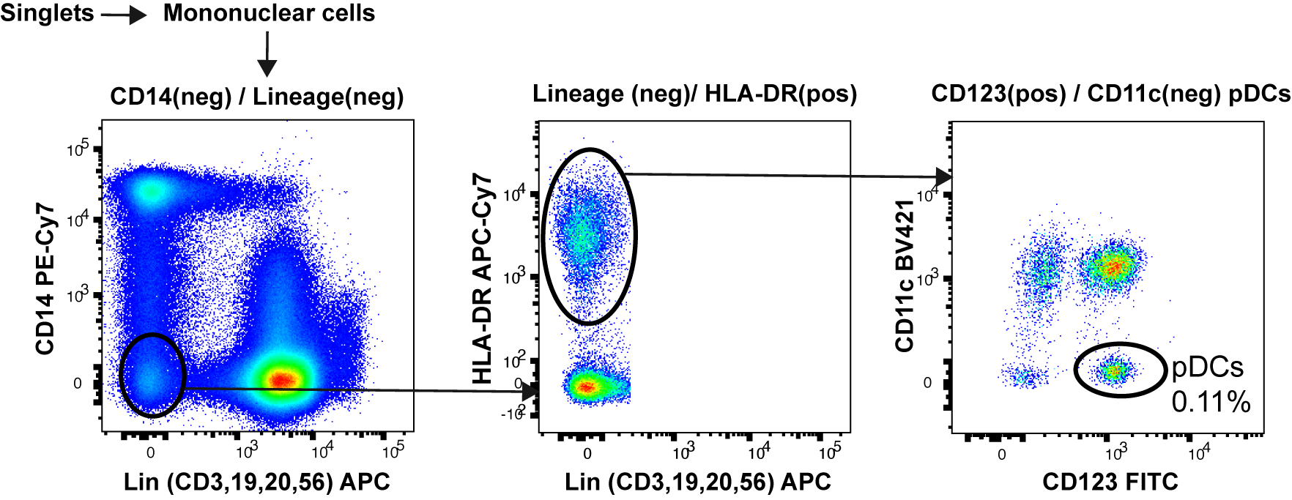

Initially, singlets were gated using an FSC-A – FSC-H plot, followed by an FSC-A – SSC-A plot to separate the mononuclear cells from the granulocytes. A CD14 negative – CD3, CD19, CD20, CD56 lineage negative gate is separated into HLA-DR positive and HLA-DR negative, after which the HLA-DR positive population were continued to isolate the CD123 positive – CD11 negative pDC population. This population was analyzed for the median fluorescence of BV605 (CD40) and PerCP-Cy5.5 (CD86). Percentage of pDCs is of total mononuclear cells.

**Supplementary Figure 3. Heatmap depicting RNA sequencing of interferon-stimulated genes during TLR9 treatment**

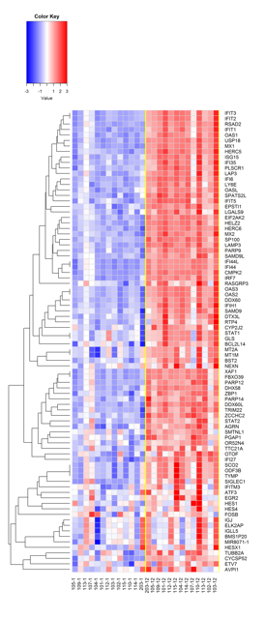

A total of 84 interferon-stimulated genes were analyzed from peripheral blood CD4+ T cells. We assessed baseline (day 0) (left side of the heatmap) against late (day 25; 24h after last dose of MGN1703) (right side of the heatmap) (n=13). Statistical analyses: For RNA sequencing, false discovery rates (FDR) were computed using the Benjamini-Hochberg procedure to adjust for multiple comparisons in the RNA-seq data. The heatmap was generated using standardized Z-scores, and the clustering dendrogram depicting relatedness between gene expression profiles was generated using hierarchical clustering with complete linkage (created using the R statistical package).

**Supplementary Figure 4. Gating strategy for NK CD56dimCD16+ cells and the activation marker CD69 and receptors NKG2A, NKG2D and NKp46**

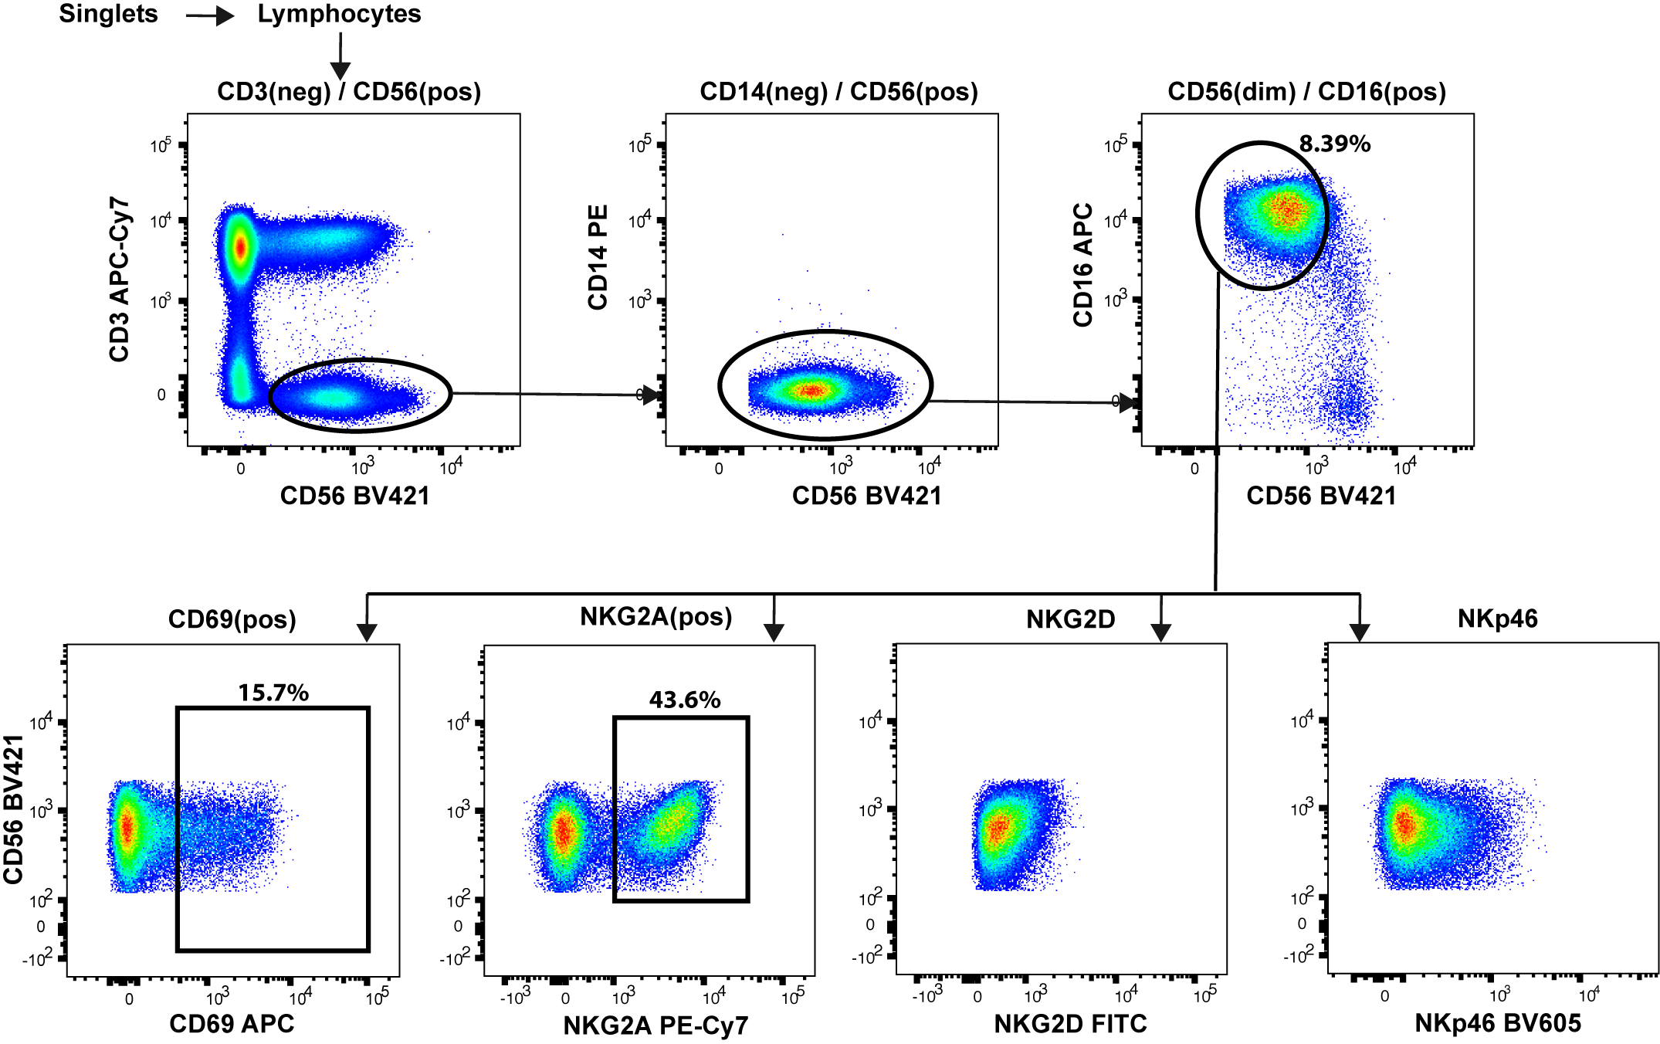

Initially, singlets were gated using an FSC-A – FSC-H plot, followed by an FSC-A – SSC-A plot to separate the lymphocytes from the granulocytes, monocytes and dendritic cells.

A CD3 negative – CD56 positive gate were applied to the lymphocyte gate to remove T cells and B cells, after which a CD14 negative gate ensures a monocyte-free population. The CD3 negative – CD14 negative – CD56 positive gate was analyzed for the presence of CD16 and the expression level of CD56 thereby isolating the CD56dimCD16+ cells. This population was analyzed for the proportions of CD69 positive and NKG2A positive, whereas the median fluorescence intensity was analyzed for FITC (NKG2D) and BV605 (NKp46). Percentage of CD56dimCD16+ cells is of total lymphocytes. Percentages of CD69 and NKG2A positive are of the total CD56dimCD16+ population.

**Supplementary Figure 5.** **NK CD56dimCD16+ cells expressing NKG2A, NKp46 and NKG2D**



Flow cytometry analyses of fresh PBMCs were performed at the indicated time-points: “Baseline”: day 0, “Early”: day 5 (48h after 2nd dose), “Late”: day 24 (24h after 8th/last dose) and “follow-up”: day 37 (which is 14 days after the last dose). NK CD56dimCD16+ cells were gated as shown in S4 Fig. All data is shown in fold change (FC) comparing changes from Early, Late and Follow-up to the Baseline measurement **(A)** Proportions of NK CD56dimCD16+ cells expressing the inhibitory receptor NKG2A **(B)** NK CD56dimCD16+ cells expression of the activating receptor NKp46 (Median fluorescence intensity, MFI) **(C)** NK CD56dimCD16+ cells expression of the activating receptor NKG2D (Median fluorescence intensity, MFI) (n=15). *, P > 0.05; **. Statistical comparisons were Wilcoxon Signed Rank comparisons as paired analysis against baseline.

**Supplementary Figure 6. Gating strategy for CD8+ and CD4+ T cell subsets and double positive activation markers HLA-DR and CD38**

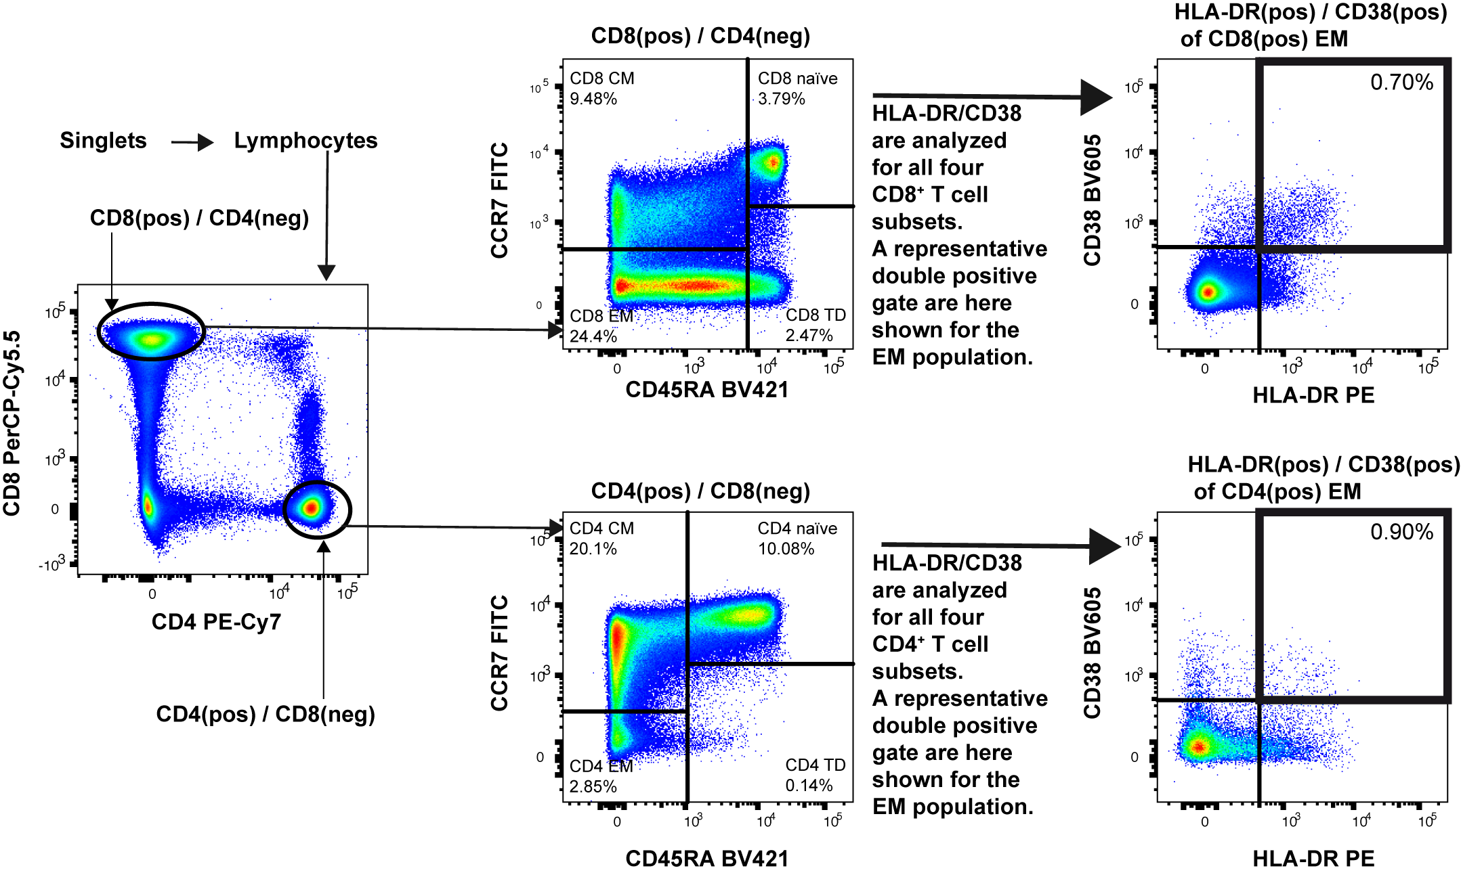

Initially, singlets were gated using an FSC-A – FSC-H plot, followed by an FSC-A – SSC-A plot to separate the lymphocytes from the granulocytes, monocytes and dendritic cells. CD8 positive and CD4 positive populations were separately subjected to a subset analysis using CD45RA – CCR7 dividing each population into four subsets. Subsets are; Naïve (TN), Central memory (TCM), Effector memory (TEM), Terminal differentiated (TTD). Each of the four subsets from both the CD8 positive and CD4 positive population were analyzed for activation using an HLA-DR – CD38 double positive gating. Percentages of CD8+ and CD4+ T cell subsets are of total lymphocytes. Percentages of double positive HLA-DR and CD38 are from the specific subset.

**Supplementary Figure 7. (A) HIV-1 DNA (integrated) (n=15) and (B) IUPM (n=10)**



**(A)** Integrated HIV-1 DNA was analyzed on CD4+ T cells by repetitive sampling nested *Alu-*HIV PCR on Baseline and Follow-up (14 days after last dose) (integrated HIV-1 DNA, n=15). **(B)** Quantitative viral outgrowth Assay (qVOA) was analyzed at Baseline and Follow-up. Data is shown as infectious units per million (IUPM) infected CD4+ T cells (n=10). Statistical comparisons were Wilcoxon Signed Rank comparisons as paired analysis against baseline.

**Supplementary Figure 8. HIV-1 DNA (total and integrated), individualized****Supplementary Table 1. Primers and Probes used for CA US HIV-1 RNA, total HIV-1 DNA and integrated HIV-1 assay**

|  |  |  |  |
| --- | --- | --- | --- |
| **Assay** | **Genomic**  **Region** |  | **Sequence** |
| **CA US HIV-1 RNA** | *Gag* | Forward | 5-TCTCTAGCAGTGGCGCC CGAACA-3 |
|  |  | Reverse | 5-TCTCCTTCTAGCCTCCG CTAGTC-3 |
|  |  | Probe | 5’-TACTCACCAGTCGCCGC-3 |
|  | *Gag*  *(Alternative primer)* | Forward | 5-TCAGCCCAGAAGTAATACCCATGT-3 |
|  |  | Reverse | 5-CACTGTGTTTAG CATGGTGTTT-3 |
|  |  | Probe | FAM-ATTATCAGAAG- GAGCCACCCCACAAGA-MGB |
| **Total HIV-1 DNA/ Nested *Alu*-HIV qPCR** | *RU5* | Sense | TTAAGCCTCAATAAAGCTTGCC |
|  | *RU5* | Antisense | GTTCGGGCGCCACTGCTAGA |
|  | *RU5* | Probe | FAM/CCAGAGTCA/ZEN/ CACAACAGACGGGCACA/3IABkFQ |
| ***Alu*-HIV PCR** | *Alu* | Sense | GCCTCCCAAAGTGCTGGGATTACAG |
|  | *Gag* | Antisense | GTTCCTGCTATGTCACTTCC |
| ***RPP30*** | *RPP30* | Sense | AGATTTGGACCTGCGAGCG |
|  | *RPP30* | Antisense | GAGCGGCTGTCTCCACAAGT |
|  | *RPP30* | Probe | FAM/TTCTGACCT/ZEN/GAAGGCTCTGCGCG/3IABkFQ |

**References**

1. MSD Technology Platform. https://www.mesoscale.com/~/media/files/brochures/techbrochure.pdf.

2. Leth S, Nymann R, Jørgensen S, et al. HIV-1 transcriptional activity during frequent longitudinal sampling in aviremic patients on ART. AIDS **2015**; 30:713–21. Available at: http://www.ncbi.nlm.nih.gov/pubmed/26595541%5Cnhttp://content.wkhealth.com/linkback/openurl?sid=WKPTLP:landingpage&an=00002030-900000000-97911.

3. Kiselinova M, De Spiegelaere W, Buzon MJ, Malatinkova E, Lichterfeld M, Vandekerckhove L. Integrated and Total HIV-1 DNA Predict Ex Vivo Viral Outgrowth. PLoS Pathog. **2016**; 12:e1005472. Available at: http://dx.plos.org/10.1371/journal.ppat.1005472.

4. Trypsteen W, Vynck M, De Neve J, et al. ddpcRquant: threshold determination for single channel droplet digital PCR experiments. Anal. Bioanal. Chem. **2015**; 407:5827–5834. Available at: http://link.springer.com/10.1007/s00216-015-8773-4.

5. De Spiegelaere W, Malatinkova E, Lynch L, et al. Quantification of integrated HIV DNA by repetitive-sampling Alu-HIV PCR on the basis of poisson statistics. Clin. Chem. **2014**; 60:886–895.

6. Malatinkova E, De Spiegelaere W, Bonczkowski P, et al. Impact of a decade of successful antiretroviral therapy initiated at HIV-1 seroconversion on blood and rectal reservoirs. Elife **2015**; 4:e09115.

7. Buzon MJ, Sun H, Li C, et al. HIV-1 persistence in CD4+ T cells with stem cell-like properties. Nat. Med. **2014**; 20:139–42.

8. Buzon MJ, Martin-Gayo E, Pereyra F, et al. Long-term antiretroviral treatment initiated at primary HIV-1 infection affects the size, composition, and decay kinetics of the reservoir of HIV-1-infected CD4 T cells. J. Virol. **2014**; 88:10056–65. Available at: http://www.ncbi.nlm.nih.gov/pubmed/24965451%5Cnhttp://www.pubmedcentral.nih.gov/articlerender.fcgi?artid=4136362&tool=pmcentrez&rendertype=abstract%5Cnhttp://www.pubmedcentral.nih.gov/articlerender.fcgi?artid=PMC4136362.

9. Rasmussen T a, Tolstrup M, Brinkmann CR, et al. Panobinostat, a histone deacetylase inhibitor, for latent-virus reactivation in HIV-infected patients on suppressive antiretroviral therapy: a phase 1/2, single group, clinical trial. Lancet HIV **2014**; 1:e13–e21. Available at: http://linkinghub.elsevier.com/retrieve/pii/S2352301814700141.

10. Hu Y, Smyth GK. ELDA: Extreme limiting dilution analysis for comparing depleted and enriched populations in stem cell and other assays. J. Immunol. Methods **2009**; 347:70–78. Available at: http://dx.doi.org/10.1016/j.jim.2009.06.008.

**List of abbreviations**

AE: Adverse Events

ART: Antiretroviral Therapy

CA US HIV-1 RNA: Cell-Associated Unspliced HIV-1 RNA

CD: Cluster of Differentiation

Copies/mL: C/mL

CXCL10: C-X-C Motif Chemokine 10

ddPCR: Digital Droplet PCR

HDAC: Histone Deacetylase

IQR: Interquartile Range

LoQ: Limit of Quantification

LRA: Latency Reversing Agents

MACS: Magnetic-Activated Cell Sorting

MFI: Median Fluorescence Intensity

NTCs: No-Template Controls

pDCs: Plasmacytoid Dendritic Cells

pVL: Plasma Viral Load

RT: Room Temperature

TCM: Central Memory T cell

TEM: Effector Memory T cells

TN: Naïve T cells

TTD: Terminally Differentiated T cells

TLR9: Toll-Like Receptor 9

qVOA: Quantitative Viral Outgrowth Assay