SUPPLEMENTARY APPENDIX
Supplementary Table 1: List of all deviations of the Singapore point prevalence survey (PPS) from the patient-based protocol developed by European Centre for Disease Prevention and Control (ECDC) [1].

Original ECDC protocol [1] |  | Deviations
Patient Inclusion and Exclusion
- All patients admitted to the ward before or at 8 a.m. and not discharged from the ward at the time of survey, including neonates on maternity and pediatric wards, were included |  |  | - Only adults ≥18-year-olds admitted to the ward before or at 8 a.m. and not discharged from the ward at the time of survey were included
Data Collection Processes
- Composition of the team responsible for data collection varied from one hospital to another |  |  | - The same data collectors collected data for all hospitals in the PPS
- Total time frame for data collection for all wards of a single hospital did not exceed two to three weeks |  |  | - Total time frame for data collection for all wards of a single hospital did not exceed one month
Data Fields and Definitions
- McCabe score was employed to classify the severity of underlying medical conditions |  |  | - Charlson’s comorbidity index was employed to classify the severity of underlying medical conditions
- Presence of CVC, PVC, IDC or endotracheal intubation, documented for all patients as denominator data, was defined as presence of CVC, PVC, IDC or endotracheal intubation in situ at time of the PPS |  |  | - Presence of CVC, PVC, IDC or endotracheal intubation was defined as CVC, PVC, or endotracheal intubation in situ within 48 hours prior to the time of the survey, or presence of IDC within seven days from survey date.
- Indication of antimicrobial treatment was further classified to hospital infection, community infection and long-term care infection |  |  | - Indication of antimicrobial treatment was not further sub-classified.
- Appropriateness of the antimicrobial use was discussed and documented |  |  | - Appropriateness of the antimicrobial use was not determined
Data Validation
- Recommended sample size at the national level was 750 patients in 25 hospitals |  |  | - Validation was conducted in at least 50% of all surveyed patients [no. of patients validated = 3,562 (65.8%)]
- Validation team consisted was separate from the original data collection team |  |  | - Validation team members consisted of the original data collection team, who cross-checked the data
- Blinded data validation recommended |  |  | - Data validation was unblinded (systemically not possible)
NOTE: CVC, central venous catheter; IDC, indwelling catheter; PVC, peripheral vascular catheter

Supplementary Table 2: List of data fields and definitions employed for the Singapore healthcare-associated infections (HAI) and antimicrobial use (AMU) prevalence point survey (PPS)

Data Type |  | Data Fields Collected |  | Definitions
Hospital Level Data
Hospital Statistics |  | - Hospital size  - Number of acute care beds  - No. of ICU beds  - No. of wards  - No. of included wards  - No. of beds in included wards  - No. of admissions  - No. of patient-days |  | All hospital level data were based on data obtained from each hospital for the year of 2014
Hospital Indicators |  | - No. of infection control physician FTE  - No. of infection prevention and control nurse FTE  - Presence of established ASP and year established  - Presence of electronic HAI surveillance system and year established
Patient Level – Denominator Data
Patient Demographics |  | - Age  - Gender  - Ethnicity
Admission Details |  | - Date of admission  - Ward type (ICU/general ward)  - Ward specialty  - Consultant specialty  - Time at risk |  | Time at risk was defined as the number of days from the date of admission to date of onset of HAI for patients with HAI, and from the time of admission to date of survey for patients without HAI.
Comorbidities |  | - Charlson’s comorbidity index
Instrumentation |  | - Surgery in current admission  - PVC  - CVC and type of CVC  - IDC  - Endotracheal intubation |  | Surgery was defined as any procedure in which an incision (not needle puncture) is made, with breach of mucosa and/or skin, and classified into major (NHSN) and minimally-invasive (non-NHSN) surgery [2]. Presence of CVC and PVC was respectively defined as CVC and PVC in situ within 48 hours prior to the time of the survey. Presence of IDC was defined as presence of IDC in situ (including intermittent catheterization) within seven days from survey date. Presence of endotracheal intubation was defined as the presence of an endotracheal tube in situ within 48 hours prior to the time of the survey.
Presence of HAI |  | - Presence of active HAI |  | Active HAI was defined as (i) symptoms of infection was present on the survey date or if signs and symptoms were present previously and the patient was receiving treatment on the survey date, and (ii) the HAI met the ECDC surveillance criteria for HAI [1].  Unspecified sepsis was defined as (i) presence of fever, hypotension, or oliguria, and (ii) no organisms detected in blood, and (iii) no apparent infection at another site, and (iv) physician institutes antimicrobial treatment, and (v) the timing of symptoms onset met the ECDC surveillance criteria for HAI [1].
Presence of AMU |  | - Presence of active AMU |  | Active AMU was defined as (i) the presence of systemic  antibiotic or antifungal surgical prophylaxis within 24 hours  before 8:00 am on the day of the survey, or (ii) the  presence of any systemic antibiotics or antifungals on the  survey date [1].
Patient Level – HAI data
Details of HAI |  | - Presence of device-associated HAI  - Type of HAI  - Date of HAI onset  - Causative organism  - Susceptibility data |  | Device-associated HAI was defined as HAI in a patient with a relevant device in situ within 48 hours (or within seven days for IDC) from the onset of HAI [1]. Susceptibility data was documented only if the causative organism was Staphylococcus aureus, Enterococcus spp., Acinetobacter spp., Pseudomonas aeruginosa or an Enterobacteriaceae.
Patient Level – AMU data
Details of AMU |  | - Type of AMU  - Route of administration  - Indications of AMU  - Anatomical site diagnoses (for treatment) |  | To classify the type of AMU, the ATC classification system  of the WHO Collaborating Centre for Drug Statistics  Methodology was employed [3]. Indications for AMU were  defined as the physicians’ intention for antimicrobial  prescription, and were classified as treatment, surgical  prophylaxis, medical prophylaxis, and other reasons (e.g.  erythromycin for prokinetic use). Anatomical site diagnoses  describes the physicians’ diagnosis of a suspected or  confirmed site of infection for antimicrobial prescription, as  stated by the physician in the patient’s notes.
NOTE: ASP, antimicrobial stewardship; ATC, Anatomical Therapeutic Classification; CVC, central venous catheter; ECDC, European Centre for Disease Prevention and Control; FTE, full-time equivalent; IDC, indwelling urinary catheter; ICU, intensive care unit; NHSN, National Healthcare Safety Network; PVC, peripheral vascular catheter; WHO, World Health Organization

Supplementary Table 3: Details of measures taken for the Singapore healthcare-associated infections (HAI) and antimicrobial use (AMU) prevalence point survey (PPS), to ensure the validity and reliability of data collected by surveyors

Measures Taken |  | Details
Study Design
Electronic data collection instrument |  | - The REDCap electronic data collection instrument, with data validation rules incorporated, was employed to ascertain reliable data entry [4].  - Branching logics were incorporated into the instrument to ensure consistency in the application of the ECDC definitions (Supplementary Figure 1) [1].
Training and Pilot Survey
Training and competency assessments |  | - Three-month training, consisting of (1) a one-month attachment with a hospital infection control unit to be familiarized with common ward processes and procedures (2)didactic teaching and case discussions conducted by the survey leaders.  - After each didactic session, the surveyors’ competency was assessed by the survey leaders using case-based discussions.  - Additional didactic sessions were conducted if deemed insufficiently competent by the survey leaders.
Pilot surveys |  | - A pilot survey was conducted in two pilot wards to determine the validity and reliability of the data collected.  - In the first pilot ward, unblinded cross-checking was conducted for all patients in the ward by the survey leaders, with an overall data concordance of 96.0%.  - In the second pilot ward, unblinded cross-checking was conducted for randomly selected patients, by an infectious disease physician.  - De-brief sessions was conducted after each pilot survey, to review errors made during the pilot survey.
Primary Data Collection
Same-day data validation (cross-checking) |  | - The surveyors were split into 2 teams daily. Each team would complete the primary data collection in one ward.  - On completion of the primary data collection, the ward list was exchanged between the two teams; each team then acted as the validation team (VT) for the other team.  - Patients for validation were randomly selected by selecting every n^{th} patient from the ward list by the VT (at least 50% of the patients surveyed are validated).  - Validation was conducted by the VT by unblinded cross-checking of all data fields. Any discordant data were identified and documented.  - All discordant data were discussed and reconciled with the survey leaders. Corrections (if necessary) were made on the same day.
Frequently Asked Questions (FAQ) |  | - To ensure standardization of data collection processes, all questions asked during primary PPS, as well as the answers provided by the survey leaders were compiled into an FAQ sheet for future reference by the survey team.
Upon Completion of PPS in an Institution
Validation of data entry |  | - Validation of data entry was performed done by the survey leaders upon the completion of each PPS in an institution.  - Validation of data entry includes checking for missing data, presence of outliers (range check) and logic check.  - All potentially erroneous data were verified and corrected by the surveyors.
NOTE: REDCap, Research Electronic Data Capture; VT, validation team
Supplementary Table 4: Types of data errors found during data validation of the Singapore healthcare-associated infections (HAI) and antimicrobial use (AMU) prevalence point survey

Types of data error | N=484  Number (%)
Errors in documentation of denominator data | 303 (62.6)
Charlson’s comorbidity indexª | 128 (26.4)
Details of surgery^{b} | 23 (4.8)
Details of instrumentation ^{c} | 152 (31.4)
Errors in documentation of HAIs^{d} | 52 (10.7)
HAI missed | 12 (2.5)
Extra HAI documented | 11 (2.3)
Other errors pertaining to details of HAIe | 29 (6.0)
Errors in documentation of AMUs^{f} | 129 (26.7)
AMU missed | 13 (2.7)
Extra AMU documented | 6 (1.2)
Other errors pertaining to the details of AMU^{g} | 110 (22.7)
ª Types of error in the Charlson’s comorbidity index included missed comorbidities or extra comorbidities documented
^{b} Types of error in details of surgery included missed surgery or incorrect surgery type documented
^{c} Types of error in details of instrumentation included missed instrumentation, instrumentation incorrectly documented or errors in documentation of the date of instrumentation
^{d} Overall, the sensitivity and specificity of detecting and reporting an HAI were 97.3% and 99.7%
^{e} Other types of error pertaining to the details of HAI included omission of data entry in details of HAI, incorrect causative organism, or incorrect resistance mechanism of the organism
^{f} Overall, the sensitivity and specificity of detecting and reporting an AMU were 99.3% and 99.6%
^{g} Other types of error pertaining to the details of AMU included errors in route, indication or intended anatomical site of an antimicrobial agent

Supplementary Table 5: Antimicrobial susceptibility patterns of selected microorganisms implicated in the 727 healthcare-associated infections (HAIs)

Pathogen | All infections | Bloodstream infections
All Enterococcus spp. | 28 | 3
Vancomycin non-susceptible – no. (%) | 4 (14.2) | 1 (33.3)
All Staphylococcus aureus | 62 | 12
Methicillin non-susceptible – no. (%) | 36 (58.1) | 9 (75.0)
All Acinetobacter spp. | 32 | 4
Carbapenem non-susceptible – no. (%) | 23 (71.9) | 3 (75.0)
All Escherichia coli | 50 | 12
3GC non-susceptible, carbapenem susceptible – no. (%) | 21 (42.0) | 8 (66.7)
Carbapenem non-susceptible – no. (%) | 2 (4.0) | 0 (0)
All Klebsiella spp. | 49 | 15
3GC non-susceptible, carbapenem susceptible – no. (%) | 21 (42.9) | 8 (53.3)
Carbapenem non-susceptible – no. (%) | 5 (10.2) | 2 (13.3)
All Enterobacter spp. | 28 | 3
3GC non-susceptible, carbapenem susceptible – no. (%) | 12 (42.9) | 2 (66.7)
Carbapenem non-susceptible – no. (%) | 3 (10.7) | 1 (33.3)
All Pseudomonas aeruginosa | 55 | 5
Carbapenem non-susceptible – no. (%) | 13 (23.6) | 1 (20.0)
NOTE: 3GC, 3rd generation cephalosporins
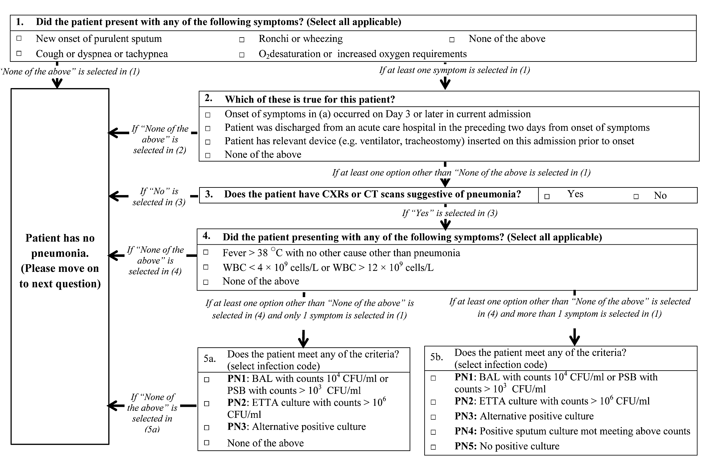
Supplementary Figure 1: An illustration of the branching logics incorporated into the REDCap electronic data collection system to ensure consistency in the application of the ECDC healthcare associated infections (HAI) definitions [1]. The example shown is for determination of pneumonia in patients without underlying cardiac or pulmonary disease – A set of questions are available for each infection type and are answered sequentially by the data collector for each patient; depending on the answer selected, the next option appears.

NOTE: BAL, bronchoalveolar lavage; CFU, colony forming unit; CXR, chest X-ray; CT, computerized tomography;; ETTA, endotracheal tube aspirate;; PSB, protected specimen brush; WBC, white blood cell

Supplementary Figure 2: Prevalence of healthcare-associated infections (HAIs) in Singapore Hospitals according to hospital type and number of acute beds. Hospitals 1 – 11 are general hospitals, while Hospitals 12 and 13 are specialty hospitals; number of acute beds was shown beside the hospital type.

REFERENCES
1. European Centre for Disease Prevention and Control. Point prevalence survey of healthcare-associated infections and antimicrobial use in European acute care hospitals-protocol version 4.3. Stockholm, Sweden: ECDC. 2012.
2. Centers for Disease Control and Prevention. Surgical Site Infection (SSI) Event. Available at: http://www.cdc.gov/nhsn/PDFs/pscManual/9pscSSIcurrent.pdf. Accessed 18th August 2016.
3. World Health Organization (WHO) Collaborating Centre for Drug Statistics Methodology. The ATC/DDD system:International language for drug utilization research. Oslo: WHO Collaborating Centre for Drug Statistics Methodology. 2007.
4. Harris PA, Taylor R, Thielke R, Payne J, Gonzalez N, Conde JG. Research electronic data capture (REDCap)--a metadata-driven methodology and workflow process for providing translational research informatics support. Journal of biomedical informatics 2009; 42(2): 377-81.

