SUPPLEMENTAL DATA
Bioaerosol Sampling to Detect Avian Influenza Virus in
Hanoi’s Largest Live Poultry Market

Vuong N. Bui¹, Tham T. Nguyen², Hung Nguyen-Viet^{3,4}, Anh N. Bui¹, Katie McCallion⁵, Hu-Suk Lee³, Son T. Than¹, Kristen K. Coleman², and Gregory C. Gray^{2,6,7}

- Virology Department, National Institute of Veterinary Research, Hanoi, Vietnam
- Program in Emerging Infectious Diseases, Duke-NUS Medical School, Singapore
- International Livestock Research Institute, Hanoi, Vietnam
- Center for Public Health and Ecosystem Research, Hanoi University of Public Health, Hanoi, Vietnam
- College of Veterinary Medicine, North Carolina State University, USA
- Division of Infectious Diseases, Global Health Institute, & Nicholas School of the Environment, Duke University, Durham, North Carolina, USA
- Global Health Research Center, Duke-Kunshan University, Kunshan, China

Supplemental Figure 1. Location of Ha Vi poultry market in the greater Hanoi area.
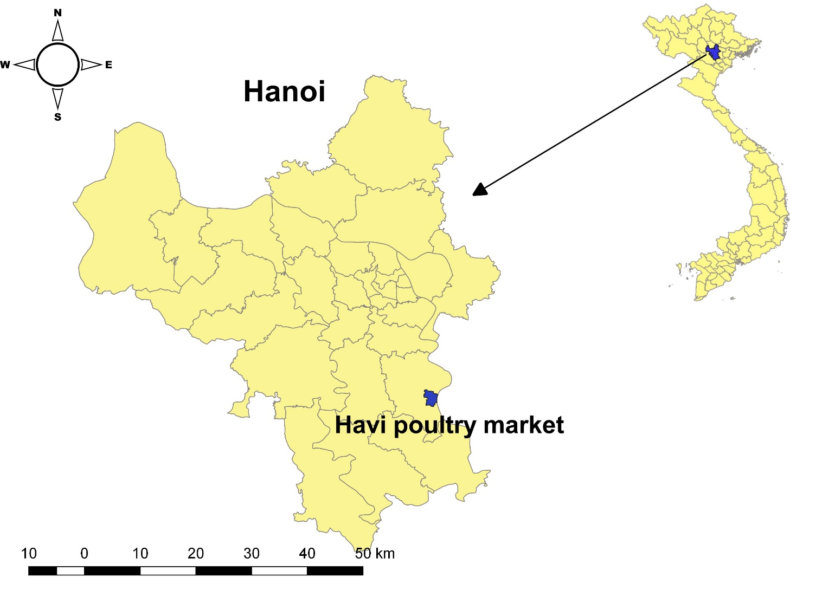
Supplemental Figure 2. This is a not-to-scale, rough graphical depiction of Ha Vi live poultry market where sampling was performed during three weeks of October 2017. Rectangles represent the general locations of covered bird stalls. Oval figures represent the general location of non-covered poultry pens. The bird stalls and duck pens were more numerous than the figures shown here. Sampling was performed at area A (sampling days 1, 5, and 9; area B (sampling days 2, 6, and 10); area C (sampling days 3 and 7) and area D (sampling days 4 and 8). Three NIOSH samplers collected aerosol samples at three positions (NIOSH 1, NIOSH2, and NIOSH3) for four hours during each of the 10 days when sampling was performed. Fifteen to twenty poultry oral swab samples were concomitantly collected near each NIOSH sampler.
NIOSH 1
NIOSH 2
NIOSH 3
AREA A
CHICKENSsS
AREA B
CHICKENS
AREA C
CHICKENS+ DUCKS
AREA D
DUCKS

NIOSH 1
NIOSH 2
NIOSH 3
NIOSH 3
NIOSH 3
NIOSH 2
NIOSH 1
NIOSH 1
NIOSH 2
Swabs
Swabs
Swabs
Swabs
Swabs
Swabs
Swabs
Swabs
Swabs
Swabs
Swabs
Swabs
Swabs
Swabs
Swabs
Swabs
Swabs
Swabs
Swabs
Swabs
Swabs
Swabs
Swabs
Swabs
Swabs
Swabs
Swabs
Swabs
Swabs
Swabs
Swabs
Swabs
Swabs
Swabs
Swabs
Swabs
Swabs
Swabs
Swabs
Swabs
Swabs
Swabs
Swabs
Swabs
Swabs
Swabs
Swabs
Swabs

