**SUPPLEMENT**

**Supplement Figure 1.** Adjusted VE against influenza A(H3N2)-associated hospitalization by number of days elapsed between vaccination and symptom onset, HAIVEN, 2016-2018 (n=3016; p=0.046). Average VE was 20%; maximum VE was 41% at day 14 post-vaccination, and minimum VE was -2% at day 180 post-vaccination. VE reached 0% at day 174. Absolute VE decline per 30 days (median, 95%CI) was 7.5% (0.3, 16.3). Model included 754 cases and 2262 matched controls.

**Supplement Figure 2.** Adjusted VE against influenza A(H1N1)pdm09-associated hospitalization by number of days elapsed between vaccination and symptom onset, HAIVEN, 2015-2016 and 2018-2019 (n=1492; p=0.003). Average VE was 62%; maximum VE was 81% at day 14 post-vaccination and minimum VE was 34% at day 180 post-vaccination. Absolute VE decline per 30 days (median, 95%CI) was 8.5% (3.0, 17.0). Model included 373 cases and 1119 matched controls.

**Supplement Figure 3**. Adjusted VE against influenza B(Yamagata)-associated hospitalization by number of days elapsed between vaccination and symptom onset, HAIVEN, 2016-2018 (n=1060; p=0.015). Average VE was 52%; maximum VE was 74% at day 14 post-vaccination, and minimum VE was 24% at day 180 post-vaccination. Absolute VE decline per 30 days (median, 95%CI) was 8.0% (1.4, 21.9). Model included 265 B(Yamagata) cases and 795 matched controls.

**Supplement Figure 4.** Adjusted VE against influenza A(H3N2)-associated hospitalization by number of days elapsed between vaccination and symptom onset, among study participants ≥65 years of age, HAIVEN, 2016-2018 (n=1580; p=0.02). Average VE was 21%; maximum VE was 51% at day 14 post-vaccination, and minimum VE was -16% at day 180 post-vaccination. VE reached 0% at day 152. Absolute VE decline per 30 days (median, 95%CI) was 10.8% (2.6, 23.8). Model included 395 cases and 1185 matched controls.

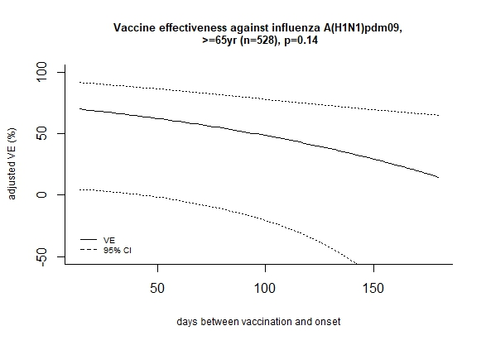

**Supplement Figure 5**. Adjusted VE against influenza A(H1N1)pdm09-associated hospitalization by number of days elapsed between vaccination and symptom onset, among study participants aged ≥65 yr, HAIVEN, 2015-2016 and 2018-2019 (n=528; p=0.14). Average VE was 43%; maximum VE was 70% at day 14 post-vaccination and minimum VE was 15% at day 180 post-vaccination. Absolute VE decline per 30 days (median, 95%CI) was 9.6% (-3.3, 32.7). Model included 132 cases and matched 396 controls.

**Supplement Figure 6**. Adjusted VE against influenza B(Yamagata)-associated hospitalization by number of days elapsed between vaccination and symptom onset, among study participants aged ≥65 yr, HAIVEN, 2016-2018 (n=536; p=0.03). Average VE was 48%; maximum VE was 75% at day 14 post-vaccination, and minimum VE was 10% at day 180 post-vaccination. Absolute VE decline per 30 days (median, 95%CI) was 10.8% (1.4, 33.9). Model included 134 B(Yamagata cases) and matched 402 controls.

**Table S1.** Characteristics of study participants in analysis of waning of VE against influenza A(H3N2), HAIVEN, 2016-2018



**Table S2.** Characteristics of study participants in analysis of waning of VE against influenza A(H1N1)pdm09, HAIVEN, 2015-2016 and 2018-2019



**Table S3.** Characteristics of study participants in analysis of waning of VE against influenza B(Yamagata), HAIVEN, 2016-2018



**Table S3.** Distribution of vaccination dates by season and overall, HAIVEN, 2015-2019

