**eFigure 1. Patient Selection flowsheet.**

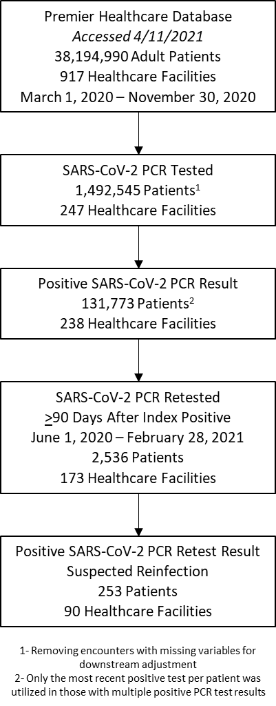

**eFigure 2. Cumulative Incidence of Suspected SARS-CoV-2 Reinfection, (A) Overall and by (B) Age, (C) Gender, and (D) Census Region — 238 U.S. Healthcare Facilities, March 1, 2020–February 28, 2021**



Cox proportional hazards models were used to determine the cumulative incidence of SARS-CoV-2 reinfection among the study population with an index positive test during their exposure period (i.e., ≥90 days post index SARS-CoV-2 infection). Incidence among the overall study population [A] as well as patients with specific covariates including age (dichotomized as <65 years or ≥65 years) [B] (P = 0.0777), gender [C] (P < 0.0001), and U.S. census region where the healthcare facility was located [D] (P=0.9012 for Midwest vs Northeast, P = 0.7197 for Midwest vs South, and P = 0.9365 for Northeast vs South). Model outputs can be viewed in eTable 1.

* reflects number of days (following the 90-day interval period) in which no positive SARS-CoV-2 test results were documented

eTable 1*:* Rates of Potential SARS-CoV-2 Reinfection for Select Exposures — 90 U.S. Healthcare Facilities, June 1, 2020–February 28, 2021

|  |  |  |
| --- | --- | --- |
| **Variable** | **Hazard Ratio**  **(95% Confidence Interval)** | **p-value** |
| **Age, years** |  |  |
| >65 vs <65 | 1.292 (0.972, 1.718) | 0.078 |
| **U.S. Census Region** |  |  |
| Midwest vs Northeast | 1.055 (0.454, 2.449) | 0.901 |
| Midwest vs South | 1.089 (0.683, 1.737) | 0.720 |
| Northeast vs South | 1.033 (0.469, 2.275) | 0.936 |
| **Gender** |  |  |
| Female vs Male | 1.579 (1.283, 1.941) | <0.0001 |
| **SARS-CoV-2 PCR Testing Rate** |  |  |
| High vs Low* | 1.250 (0.851, 1.836) | 0.256 |