Supplemental Table 1: HWE equilibrium for the eleven KLOTHO SNPs analyzed
 | Homozygote Reference |  | Heterozygote |  | Homozygote variant |  | p value
 | Observed | Expected | Observed | Expected | Observed | Expected
rs9536254 | 1846 | 1848 | 326 | 322 | 12 | 14 | 0.557
rs567170 | 869 | 870.5 | 1019 | 1016 | 296 | 296.5 | 0.891
rs577912 | 1426 | 1426.2 | 677 | 676.5 | 80 | 80.2 | 0.974
rs580332 | 900 | 886.8 | 984 | 1010.4 | 301 | 287.8 | 0.222
rs495392 | 1194 | 1185.9 | 830 | 846.1 | 159 | 150.9 | 0.372
rs2320762 | 829 | 831.4 | 1037 | 1032.2 | 318 | 320.4 | 0.828
rs562020 | 980 | 978.2 | 964 | 967.5 | 241 | 239.2 | 0.864
rs576404 | 863 | 854.8 | 1006 | 1022.5 | 314 | 305.8 | 0.451
rs385564 | 1089 | 1091.7 | 906 | 900.6 | 183 | 185.7 | 0.778
rs9536282 | 1220 | 1221.8 | 410 | 406.4 | 32 | 33.8 | 0.718
rs2283368 | 801 | 800 | 202 | 204 | 14 | 13 | 0.755
Comparison between groups by means of a Chi-squared test

Supplemental Table 2: Klotho polymorphisms and its relation to CVD, Non CVD, and Any Death
SNP(n) | CV Death |  |  |  |  | Non CV Death |  |  |  |  | Any Death
 | Hom.Dom | Heterz | Hom.Rec | Total | p value | Hom.Dom | Heterz | Hom.Rec | Total | p value | Hom.Dom | Heterz | Hom.Rec | Total | p value
rs9536254(2184) | 55(3%) | 7(2.1%) | 0(0%) | 62(2.8%) | 0.592 | 1(8.3%) | 18(5.5%) | 89(4.8%) | 108(4.9%) | 0.747 | 144(7.8%) | 25(7.7%) | 1(8.3%) | 170(7.8%) | 0.994
rs567170(2183) | 26(3%) | 27(2.6%) | 9(3.1%) | 62(2.8%) | 0.881 | 49(5.6%) | 47(4.6%) | 12(4.1%) | 108(4.9%) | 0.447 | 75(8.6%) | 74(7.3%) | 21(7.1%) | 170(7.8%) | 0.488
rs577912(2183) | 42(2.9%) | 20(3%) | 0(0%) | 62(2.8%) | 0.297 | 76(5.3%) | 31(4.6%) | 1(1.3%) | 108(4.9%) | 0.227 | 118(8.3%) | 51(7.5%) | 1 (1.3%) | 170(7.8%) | 0.071
rs580332(2185) | 26(2.9%) | 28(2.8%) | 8(2.7%) | 62(2.8%) | 0.978 | 53(5.9%) | 42(4.3%) | 13(4.3%) | 108(4.9%) | 0.233 | 79(8.8%) | 70(7.1%) | 21(7%) | 170(7.8%) | 0.345
rs495392(2183) | 40(3.4%) | 19(2.3%) | 3(1.9%) | 62(2.8%) | 0.278 | 60(5%) | 40(4.8%) | 8(5%) | 108(4.9%) | 0.977 | 100(8.4%) | 59(7.1%) | 11(6.9%) | 170(7.8%) | 0.529
rs2320762(2184) | 24(2.9%) | 27(2.6%) | 11(3.5%) | 62(2.8%) | 0.719 | 27(3.3%) | 55(5.3%) | 26(8.2%) | 108(4.9%) | 0.002 | 51(6.2%) | 82(7.9%%) | 37(11.6%) | 170(7.8%) | 0.008
rs562020(2185) | 28(2.9%) | 31(3.2%) | 3(1.2%) | 62(2.8%) | 0.257 | 52(5.3%) | 49(5.1%) | 7(2.9%) | 108(4.9%) | 0.294 | 80(8.2%) | 80(8.3%) | 10(4.1%) | 170(7.8%) | 0.083
rs576404(2183) | 25(2.9%) | 27(2.7%) | 10(3.2%) | 62(2.8%) | 0.890 | 49(5.7%) | 45(4.5%) | 14(4.5%) | 108(4.9%) | 0.445 | 74(8.6%) | 72(7.2%) | 24(7.6%) | 170(7.8%) | 0.519
rs385564(2178) | 26(2.4%) | 28(3.1%) | 8(4.4%) | 62(2.8%) | 0.278 | 49(4.5%) | 51(5.6%) | 7(3.8%) | 107(4.9%) | 0.395 | 75(6.9%) | 79(8.7%) | 15(8.2%) | 169(7.8%) | 0.305
rs9536282(1662) | 29(2.4%) | 8(2%) | 0(0%) | 37(2.2%) | 0.607 | 51(4.2%) | 16(3.9%) | 1(3.1%) | 68(4.1%) | 0.933 | 8 (6.6%) | 24(5.9%) | 1(3.1%) | 105(6.3%) | 0.664
rs2283368(1017) | 27(3.4%) | 7(3.5%) | 0(0%) | 34(3.3%) | 0.781 | 33(4.1%) | 19(9.4%) | 3(21.4%) | 55(5.4%) | 0.000 | 60(7.5%) | 26(12.9%) | 3(21.4%) | 89(8.8%) | 0.013

Supplemental Table 3: Allele frequency in the cohort
rs562020 | GG | 980 | G | 0,669
 | GA | 964 | A | 0,33
 | AA | 241
rs2283368 | CC | 14 | C | 0,113
 | CG | 202 | T | 0,886
 | GG | 801
rs2320762 | GG | 318 | G | 0,383
 | GT | 1037 | T | 0,616
 | TT | 829

Supplemental Table 4: Linkage disequilibrium (r²) for the three proposed SNPs ( Control Patients Excluded)
rs562020-rs2283368 | 0.0091
rs562020-rs2320762 | 0.1078
rs2283368- rs2320762 | 0.1838

Supplemental Figure 1

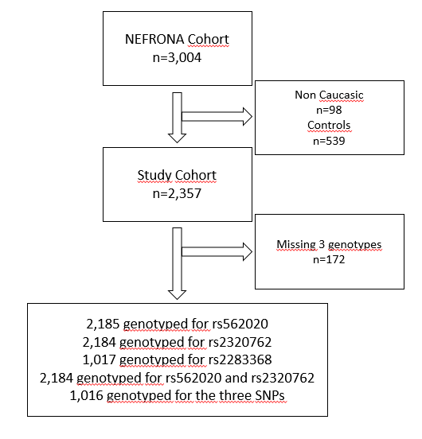
Supplemental Figure 1: Flow diagram of experiment design. From the initial 3,004 volunters, 2,185 were considered for current study. 2184 were genotyped for both, rs562020 and rs2320762 genotypes, and 1,016 were genotyped for the three SNPs.

