SUPPLEMENT
TO
Building façade-level correlates of bird-window collisions
in a small urban area

Corey S. Riding,* Timothy J. O’Connell, and Scott R. Loss

Oklahoma State University, Department of Natural Resource Ecology & Management, Stillwater, Oklahoma, USA
* Corresponding author: corey.riding@okstate.edu

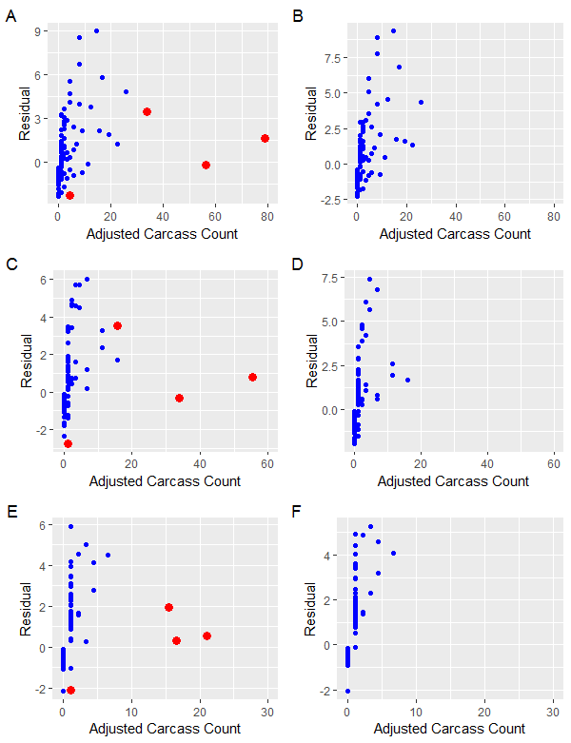
Figure S1. Residuals plotted against dependent variables (adjusted carcass counts) for multi-season (A & B), spring (C & D), and summer models (E & F). For plots A, C, and E, n=235 and the 4 façades of building OS12 are highlighted in red. For plots B, D, and F, n=231 and building OS12 is excluded.

Table S1. Results for spring models of relationship between façade variables and bias-adjusted carcass counts based on Akaike’s Information Criterion (ΔAICc).
Variables | ΔAICc | K | ω_{i}
Glass, Height, Length, Type | 0.0 | 10 | 1.000
Glass, Height, Length | 89.4 | 6 | <0.001
Glass, Length, Type | 96.0 | 9 | <0.001
Glass, Height, Type | 96.4 | 9 | <0.001
Glass, Height | 100.6 | 5 | <0.001
Height, Length, Type | 107.5 | 9 | <0.001
Length, Type | 116.9 | 8 | <0.001
Glass, Length | 118.5 | 5 | <0.001
Glass, Type | 123.3 | 8 | <0.001
Height, Length | 125.4 | 5 | <0.001
Null | 147.6 | 3 | <0.001

Table S2. Results for summer models of relationship between façade variables and bias-adjusted carcass counts based on Akaike’s Information Criterion (ΔAICc).
Variables | ΔAICc | K | ω_{i}
Glass, Height, Length, Lawn | 0.0 | 7 | 1.000
Glass, Height, Length | 5.6 | 6 | <0.001
Glass, Height, Lawn | 6.7 | 6 | <0.001
Glass, Height | 8.3 | 5 | <0.001
Glass, Length, Type, Lawn | 15.8 | 10 | <0.001
Glass, Length, Lawn | 19.8 | 6 | <0.001
Glass, Length, Type | 22.7 | 9 | <0.001
Glass, Length | 28.6 | 5 | <0.001
Glass, Type, Lawn | 28.7 | 9 | <0.001
Glass, Type | 30.6 | 8 | <0.001
Glass, Lawn | 33.7 | 5 | <0.001
Height, Length | 34.3 | 5 | <0.001
Null | 50.9 | 3 | <0.001

Table S3. Results for fall models of relationship between façade variables and bias-adjusted carcass counts based on Akaike’s Information Criterion (ΔAICc). This analysis excluded the class ‘corner’ from the façade type variable, and thus n = 215.
Variables | ΔAICc | K | ω_{i}
Glass, Height, Type, Tree, Lawn | 0.0 | 10 | 0.382
Glass, Height, Tree, Lawn | 2.4 | 7 | 0.116
Glass, Height, Tree | 2.6 | 6 | 0.106
Glass, Type, Tree, Lawn | 2.6 | 9 | 0.104
Glass, Type, Tree | 3.0 | 8 | 0.084
Glass, Height, Type, Lawn | 3.6 | 9 | 0.062
Glass, Height, Type | 3.7 | 8 | 0.060
Glass, Type, Lawn | 5.2 | 8 | 0.028
Glass, Type | 5.4 | 7 | 0.025
Glass, Tree, Lawn | 6.4 | 6 | 0.015
Glass, Tree | 7.4 | 5 | 0.009
Glass, Height, Lawn | 9.7 | 6 | 0.003
Glass, Height | 9.8 | 5 | 0.003
Glass, Lawn | 11.5 | 5 | 0.001
Glass, Length | 11.8 | 5 | 0.001
Null | 38.7 | 3 | <0.001

Table S4. Results for Lincoln’s Sparrow models of relationship between façade variables and bias-adjusted carcass counts based on Akaike’s Information Criterion (ΔAICc).
Variables | ΔAICc | K | ω_{i}
Glass, Tree, Flower | 0.0 | 6 | 0.55
Glass, Tree | 0.4 | 5 | 0.45
Glass, Length, Flower | 44.3 | 9 | <0.001
Glass, Flower | 45.1 | 5 | <0.001
Glass | 45.3 | 4 | <0.001
Null | 61.7 | 3 | <0.001

Table S5. Results for American Robin models of relationship between façade variables and bias-adjusted carcass counts based on Akaike’s Information Criterion (ΔAICc).
Variables | ΔAICc | K | ω_{i}
Length, Impervious | 0.0 | 5 | 0.432
Length, Lawn | 0.6 | 5 | 0.318
Tree, Impervious | 2.7 | 5 | 0.113
Length | 2.7 | 4 | 0.110
Null | 5.5 | 3 | 0.027

Table S6. Results for European Starling models of relationship between façade variables and bias-adjusted carcass counts based on Akaike’s Information Criterion (ΔAICc). This analysis excluded the classes ‘corner’ and ‘portico’ from the façade type variable, and thus n = 176.
Variables | ΔAICc | K | ω_{i}
Type, Flower | 0.0 | 6 | 0.484
Height, Type | 2.0 | 6 | 0.182
Glass, Tree | 2.3 | 6 | 0.151
Length, Glass, Flower | 2.4 | 6 | 0.146
Null | 5.1 | 3 | 0.038

Table S7. Results for Mourning Dove models of relationship between façade variables and bias-adjusted carcass counts based on Akaike’s Information Criterion (ΔAICc).
Variables | ΔAICc | K | ω_{i}
Glass, Height, Length | 0.0 | 6 | 0.817
Glass, Height, Impervious | 5.4 | 6 | 0.055
Glass, Height | 6.3 | 5 | 0.035
Glass, Length | 6.4 | 5 | 0.034
Height, Length, Impervious | 7.0 | 6 | 0.025
Height, Length | 7.1 | 5 | 0.024
Length, Impervious | 8.8 | 5 | 0.010
Null | 16.8 | 3 | <0.001

Table S8. Results for Indigo Bunting models of relationship between façade variables and bias-adjusted carcass counts based on Akaike’s Information Criterion (ΔAICc). This analysis excluded the class ‘portico’ from the façade type variable, and thus n = 196.
Variables | ΔAICc | K | ω_{i}
Length, Height, Type | 0.0 | 8 | 0.582
Length, Type | 0.9 | 7 | 0.372
Glass, Length, Type | 6.7 | 8 | 0.021
Height, Type | 7.2 | 7 | 0.016
Type, Lawn | 10.1 | 7 | 0.004
Glass, Height | 10.4 | 5 | 0.003
Type | 11.4 | 6 | 0.002
Glass, Lawn | 17.0 | 5 | <0.001
Null | 37.6 | 3 | <0.001

Table S9. Results for Swainson’s Thrush models of relationship between façade variables and bias-adjusted carcass counts based on Akaike’s Information Criterion (ΔAICc). This analysis excluded the class ‘corner’ from the façade type variable, and thus n = 215.
Variables | ΔAICc | K | ω_{i}
Glass, Type, Height, Length | 0.0 | 9 | 0.649
Glass, Type, Height | 1.2 | 8 | 0.349
Glass, Type, Length | 11.0 | 8 | 0.003
Glass, Height | 30.8 | 5 | <0.001
Glass, Type | 365.0 | 7 | <0.001
Glass | 43.7 | 4 | <0.001
Glass, Length | 43.7 | 5 | <0.001
Null | 60.0 | 3 | <0.001

Table S10. Results for House Finch models of relationship between façade variables and bias-adjusted carcass counts based on Akaike’s Information Criterion (ΔAICc). This analysis excluded the class ‘corner’ from the façade type variable, and thus n = 215.
Variables | ΔAICc | K | ω_{i}
Glass, Height, Length, Tree, Impervious | 0.0 | 8 | 0.327
Glass, Height, Type | 0.6 | 8 | 0.244
Glass, Height, Length, Impervious | 0.8 | 7 | 0.215
Glass, Height, Impervious | 3.2 | 6 | 0.066
Glass, Type | 4.1 | 7 | 0.042
Glass, Height | 4.3 | 5 | 0.037
Height, Length, Tree, Impervious | 4.9 | 7 | 0.028
Height, Type | 5.5 | 7 | 0.021
Type | 5.7 | 6 | 0.019
Null | 21.2 | 3 | <0.001

Table S11. Results for Painted Bunting models of relationship between façade variables and bias-adjusted carcass counts based on Akaike’s Information Criterion (ΔAICc). This analysis excluded the class ‘corner’ from the façade type variable, and thus n = 215.
Variables | ΔAICc | K | ω_{i}
Glass, Height, Impervious | 0.0 | 6 | 0.348
Glass, Height, Type | 0.7 | 8 | 0.242
Height, Type | 2.2 | 7 | 0.113
Glass, Height, Length, Flower | 2.5 | 7 | 0.101
Glass, Height, Flower | 2.6 | 6 | 0.093
Glass, Height | 2.7 | 5 | 0.092
Height, Impervious | 8.1 | 5 | 0.006
Height, Flower | 9.1 | 5 | 0.004
Height | 11.4 | 4 | 0.001
Null | 25.9 | 3 | <0.001

