**Figure S1.** Full Organism data browse page

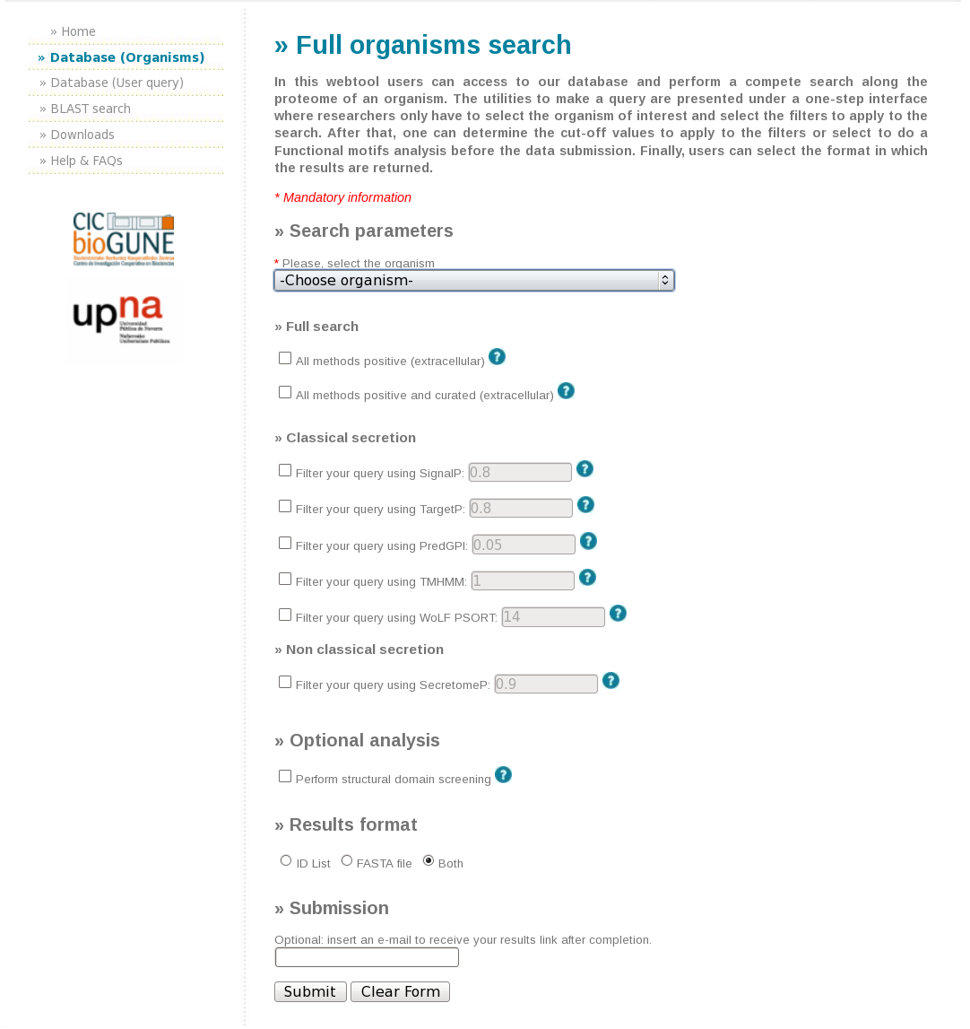

**Figure S2.** Results table example

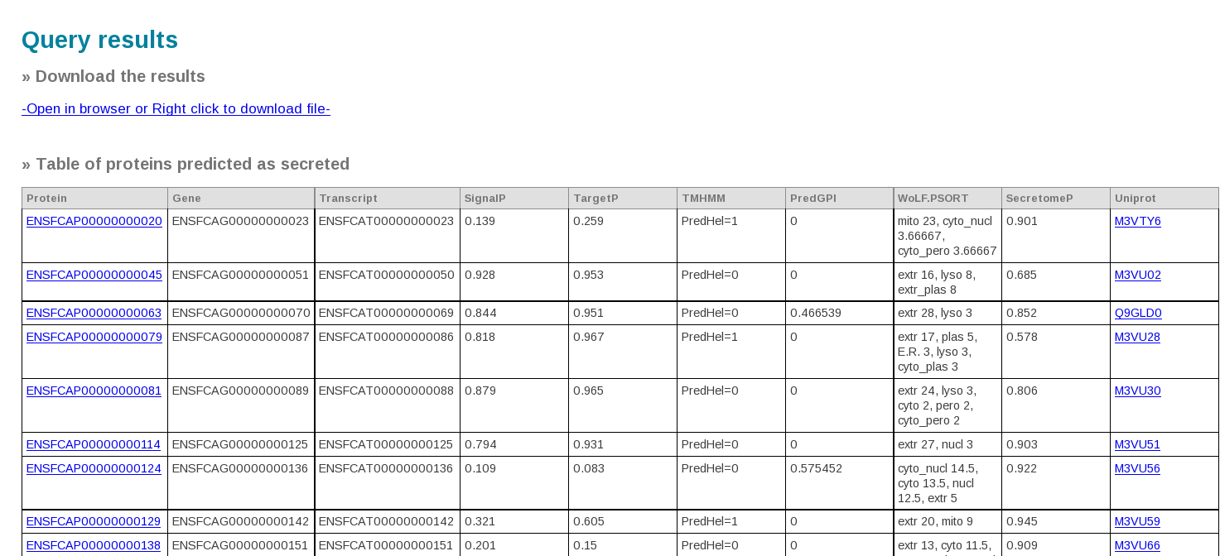

**Figure S3.** Individual protein results page

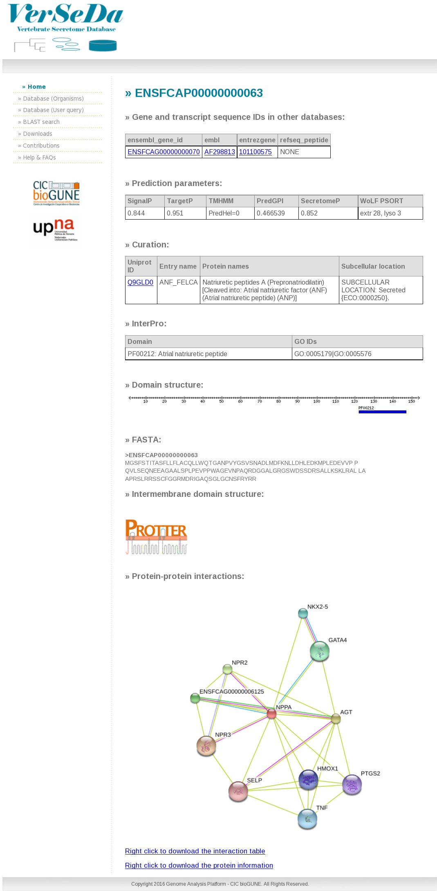

**Figure S4.** User Query interface

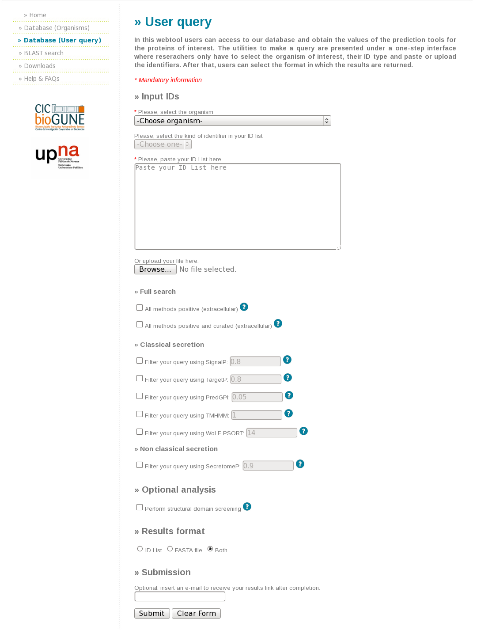

**Figure S5.** LocalBLAST tool

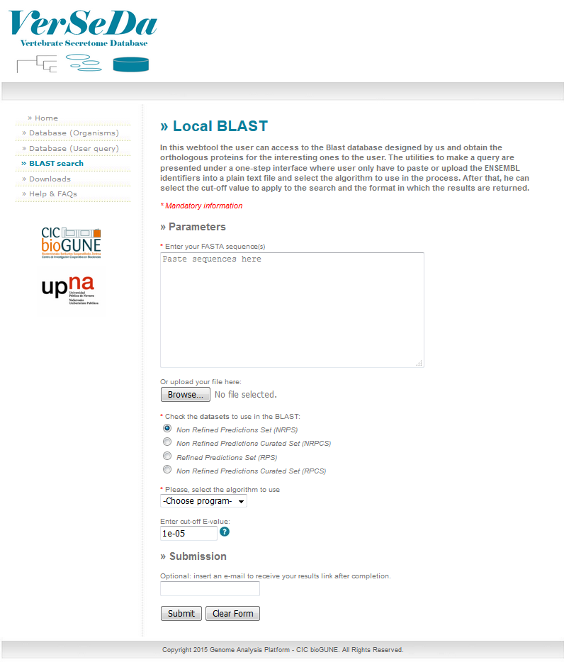

**Figure S6.** Database downloads section

