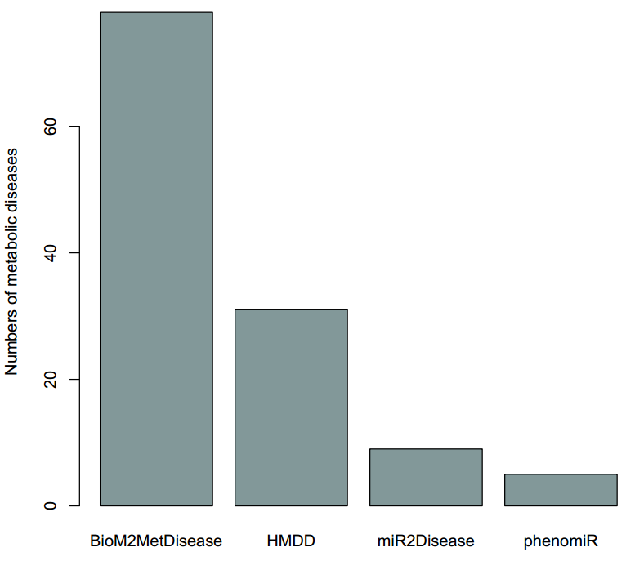
Figure S1. The amount of metabolic diseases involved in BioM2MetDisease, HMDD, miR2Disease and phenomiR.

Table S1. The name list of metabolic diseases as keyword searched in PubMed
The name of metabolic diseases
2-Methyl-3-hydroxybutyryl-CoA dehydrogenase (MHBD) deficiency
3-Hydroxy-3-methylglutaryl-CoA lyase deficiency
3-Hydroxyacyl-CoA dehydrogenase deficiency
3-Methylcrotonylglycinuria
3-Methylglutaconic aciduria (MGCA)
3-Phosphoglycerate dehydrogenase (3-PGDH) deficiency
46,XX disorders of sex development (Disorders related to androgen excess)
46,XY disorders of sex development (Disorders in androgen synthesis or action)
Abetalipoproteinemia
Abnormal thyroid hormone metabolism
Acatalasia
Achalasia-Addisonianism-Alacrima synrrome
Acid phosphatase deficiency
Acne
Acne vulgaris
Acquired generalized lipodystrophy (AGL)
Acrodermatitis enteropathica
Acromegaly
Acute gouty arthritis
Adenylosuccinate lyase deficiency
Adrenocorticotropic hormone deficiency
Adrenoleukodystrophy
Adrenoleukodystrophy, neonatal (NALD)
Adult-onset autosomal dominant leukodystrophy (ADLD)
adult-onset type II citrullinemia
Aging
AICA-ribosiduria
Albuminuria
Aldosterone synthase deficiency
Alkaptonuria
Allan-Herndon-Dudley syndrome
alpha-Mannosidosis
Alpha-methylacetoacetic aciduria
Alpha-N-acetylgalactosaminidase deficiency
Alport's syndrome
Alstrom syndrome (AS)
Alzheimer's disease
Apparent mineralocorticoid excess syndrome
Argininosuccinic aciduria (ARGINSA)
Aristolochic acid nephropathy
Aromatase excess syndrome
Aspartylglucosaminuria
Ataxia with isolated vitamin E deficiency (AVED)
Atherosclerosis
Bamforth-Lazarus syndrome
Barth syndrome (BTHS)
Bartter syndrome
beta-Mannosidosis
Beta-ureidopropionase deficiency
Biotinidase deficiency
Brunner syndrome
Canavan disease
Carbamoyl phosphate synthetase I deficiency
Cerebrotendinous xanthomatosis
Choreoathetosis, hypothyroidism, and neonatal respiratory distress
Chylomicron retention disease (CRD)
Citrullinemia
cobalamin deficiency type C (cblC)
Combined lipase deficiency (CLD)
Combined SAP deficiency
Congenital adrenal hyperplasia
Congenital disorders of glycosylation (CDG) type I
Congenital disorders of glycosylation (CDG) type II
Congenital generalized lipodystrophy (CGL)
Congenital glucose-galactose malabsorption (GGM)
Congenital hyperthyroidism
Congenital lactase deficiency
Congenital nongoitrous hypothyroidism (CHNG)
Congenital sucrase-isomaltase deficiency
Congenital systemic glutamine deficiency (CSGD)
Corticosteroid-binding globulin (CBG) deficiency
Cortisone reductase deficiency (CRD)
Creatine deficiency syndrome
Cushing's syndrome
Cutis laxa
cystathionine β-synthase (CBS) deficiency
Cystathioninuria
Cystic fibrosis
Cystic leukoencephalopathy without megalencephaly
Cystinosis
Cystinuria
Danon disease
Defects in RecQ helicases
Defects in the degradation of ganglioside
Defects in the degradation of sphingomyelin
Defects in the degradation of sulfatide
Diabetes-related atherosclerosis
Diabetes-related cognitive dysfunction
Diabetes-related microvascular disease
Diabetes mellitus
Diabetic atherosclerosis
Diabetic cardiomyopathy
Diabetic coma
Diabetic macular edema
Diabetic microangiopathy
Diabetic nephropathy
Diabetic neuropathy
Diabetic retinopathy
Diabetic vascular disease
Dihydropyrimidine dehydrogenase deficiency
Dimethylglycine dehydrogenase deficiency (DMGDHD)
Diseases of the tricarboxylic acid cycle
Disorders of fatty-acid oxidation
Dorfman-Chanarin syndrome
Dyslipidemia
Dyslipidemic obesity
Erythropoietic porphyria
Fabry disease
Fabry nephropathy
Familial amyloidosis
Familial combined hyperlipidemia
Familial glucocorticoid deficiency (FGD)
Familial hyperinsulinemic hypoglycemia (HHF)
Familial hypobetalipoproteinemia (FHBL)
Familial hypocalciuric hypercalcemia (FHH1)
Familial Mediterranean fever
Familial partial lipodystrophy (FPL)
Familial renal glucosuria (FRG)
Fanconi renotubular syndrome (FTS)
Farber lipogranulomatosis
Fatty liver disease
Formiminotransferase deficiency
Fructose-1,6-bisphosphatase deficiency
Fucosidosis
GABA-transaminase deficiency
Galactosemia
Galactosialidosis
Gangliosidosis
Gaucher disease
Gestational diabetes mellitus
Gitelman syndrome
Globoid leukodystrophy
Glucocorticoid-remediable aldosteronism (GRA)
Glutaric acidemia
Glutaric aciduria type 1
Glycerol kinase deficiency (GKD)
Glycogen storage diseases
Glycoproteinoses
Glycosylphosphatidylinositol (GPI) deficiency
GM1 gangliosidosis
GM2 gangliosidoses
Gout
Graves' disease
Growth delay due to insulin-like growth factor I resistance
Growth hormone insensitivity with immunodeficiency
Guanidinoacetate methyltransferase (GAMT) deficiency
Hartnup disorder
Hashimoto's thyroiditis
Hemochromatosis
Hepatic porphyria
Hereditary fructose intolerance
Hermansky-Pudlak syndrome
Histidinemia
HMG-CoA synthase (HMGCS) deficiency
Holocarboxylase synthetase deficiency
Homocystinuria
Huntington's disease
Hutchinson-Gilford progeria syndrome
Hyperaldosteronism
Hyperalphalipoproteinemia
Hyperammonemia
Hyperargininemia
Hyperbilirubinemia
Hypercalcemia infantile
Hypercarotenemia and vitamin A deficiency
Hypercholesterolemia
Hyperglucagonemia
Hyperglycemia
Hyperinsulinemia
Hyperlipidemia
Hyperlipoproteinemia, type I
Hyperlipoproteinemia, type III
Hyperlipoproteinemia, type V
Hyperlysinemia
Hypermethioninemia
Hyperornithinemia
Hyperornithinemia-hyperammonemia-homocitrullinuria syndrome
Hyperprolactinemia
Hyperprolinemia
Hyperthyroidism
Hypertriglyceridemia
Hyperuricemia
Hypoalphalipoproteinemia
Hypocalcemia
Hypoglycemic
Hypogonadotropic hypogonadism
Hypomagnesemia
Hypoparathyroidism
Hypophosphatasia
Hypophosphatemic osteomalacia
Hypophosphatemic rickets
Hypothyroidism
IgA nephropathy
Iminoglycinuria
Insulin-resistant diabetes mellitus
Insulin-resistant diabetes mellitus with acanthosis nigricans (IRAN)
Isobutyryl-CoA dehydrogenase (IBD) deficiency
Isolated follicle-stimulating hormone deficiency (IFSHD)
Isolated short stature
Isovaleric acidemia
Ketosis
Krabbe disease
LDL Receptor Disorder
Lecithin:cholesterol acyltransferase deficiency
Leprechaunism
Lesch-Nyhan syndrome
Leukodystrophy
Leukoencephalopathy with brain stem and spinal cord involvement and lactate elevation (LBSL)
Leukoencephalopathy with dystonia and motor neuropathy
Leukoencephalopathy with vanishing white matter
Lipodystrophy
Lipoid proteinosis
Lowe syndrome
Lysinuric protein intolerance (LPI)
Lysosomal acid lipase deficiency
Malonyl-CoA decarboxylase deficiency
Maple syrup urine disease
Maturity onset diabetes of the young (MODY)
Megalencephalic leukoencephalopathy with subcortical cysts (MLC)
Menkes disease
Metabolic syndrome
Metachromatic leukodystrophy
Methacrylic aciduria
Methylcobalamin deficiency type G (cblG)
Methylmalonate semialdehyde dehydrogenase (MMSDH) deficiency
Methylmalonic acidemia
Methylmalonic aciduria
Mitochondrial DNA depletion syndrome (MDS)
Mitochondrial dysfunction
Mitochondrial respiratory chain deficiencies (MRCD)
Mitochondrial trifunctional protein (TFP) deficiency
Muckle-Wells syndrome
Mucolipidosis II and III
Mucolipidosis IV
Mucopolysaccharidosis (MPS)
Mucopolysaccharidosis type I (MPS1)
Mucopolysaccharidosis type II (MPS2)
Mucopolysaccharidosis type III (MPS3)
Mucopolysaccharidosis type IV (MPS4)
Mucopolysaccharidosis type IX (MPS9)
Mucopolysaccharidosis type VI (MPS6)
Mucopolysaccharidosis type VII (MPS7)
Multiple sulfatase deficiency
N-acetylglutamate synthase (NAGS) deficiency
Nephrogenic syndrome of inappropriate antidiuresis (NSIAD)
Neurohypophyseal diabetes insipidus (NPDI)
Neuronal ceroid lipofuscinosis
Neutral lipid storage disease with myopathy
Niemann-Pick disease
Niemann-Pick disease type A
Niemann-Pick disease type B
Niemann-Pick disease type C
Non-alcoholic fatty liver disease
Non-alcoholic steatohepatitis
Non-insulin-dependent diabetes mellitus
Nonketotic hyperglycinemia
Obesity
Obesity-associated cardiovascular diseases
Obesity-induced diabetes
Obesity-related inflammation
Ocular albinism
Oculocutaneous albinism
Ornithinaemia
Ornithine transcarbamylase deficiency
Osteoarthritis
Osteomalacia
Osteoporosis
Parkinson's disease
Pelizaeus-Merzbacher disease
Pentosuria
Peroxisomal beta-oxidation enzyme deficiency
Phenylketonuria
Photoaging
Piebaldism
pigmented micronodular adrenocortical disease (PPNAD)
Pituitary Dwarfism (PD)
POLG related disorders
Polycystic lipomembranous osteodysplasia with sclerosing leukoencephalopathy (PLOSL)
Postmenopausal osteoporosis
Precocious puberty
Premature ovarian failure
Primary aldosteronism
Primary hyperammonemic disorders
Primary hyperoxaluria
Primary hyperparathyroidism
Prolidase deficiency (PD)
Propionic acidemia
Propionic aciduria
Proteinuria
Pseudohypoparathyroidism
Pycnodysostosis
Pyruvate carboxylase deficiency
Pyruvate dehydrogenase complex deficiency
Rabson-Mendenhall syndrome
Rickets
Saccharopinuria
Secondary hyperammonemia
Sialidosis
Sialuria/ Sialic acid storage disease
Sitosterolemia
Sjogren-Larsson syndrome
Steatohepatitis
Succinic semialdehyde dehydrogenase (SSADH) deficiency
Succinyl CoA:3-oxoacid CoA transferase (SCOT) deficiency
Sulfite oxidase deficiency
Tangier disease
Thiopurine S-methyltransferase deficiency (TPMT deficiency)
Thyroid dyshormonogenesis
Thyroid hormone resistance syndrome
Transaldolase (TALDO) deficiency
Trimethylaminuria (TMAU)
Type I diabetes mellitus
type I tyrosinemia
Type II diabetes mellitus
Tyrosinemia
Urocanase deficiency
vitamin A deficiency
Vitamin D-dependent rickets
vitamin D deficiency
vitamin E deficiency
Waardenburg syndrome (WS)
Weight loss
Wilson disease
Wolcott-Rallison syndrome
Wolfram syndrome (WFS)
Xanthinuria

