Python script to compare microRNAs present in RumimiR to small microRNAs extracted from several database.
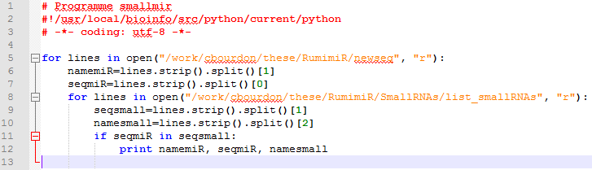
Python script to compare microRNAs present in RumimiR to human or mouse microRNA sequences extracted from miRBase.