Supplemental materials

DeepScreening: a deep learning-based screening web server for accelerating drug discovery
Zhihong Liu^{1,#}, Jiewen Du^{2,#}, Jiansong Fang³, Yulong Yin¹, Guohuan Xu¹, Liwei Xie*^{,1,4}
¹State Key Laboratory of Applied Microbiology Southern China, Guangdong Provincial Key Laboratory of Microbial Culture Collection and Application, Guangdong Open Laboratory of Applied Microbiology, Guangdong Institute of Microbiology, Guangdong Academy of Sciences, Guangzhou 510070, China.
²Beijing Jingpai Technology Co., Ltd. 1500-1, Hailong Building Z-Park, Beijing, 100090, China
³Genomic Medicine Institute, Lerner Research Institute, Cleveland Clinic, Cleveland, OH 44106, USA
⁴Zhujiang Hospital, Southern Medical University, Guangzhou 510282, China

*Corresponding author: E-mail: xielw@gdim.cn
# These authors contribute equally.

Supplementary Table S1. Fingerprints available in DeepScreening
Fingerprint | Number | Remarks | Description
CDK fingerprint | 1024 | CDKFP | Fingerprint of length 1024 and search depth of 8
CDK extended fingerprint | 1024 | ExtFP | Extends the Fingerprint with additional bits describing ring features
Estate fingerprint | 79 | EStateFP | E-State fragments
CDK graph only fingerprint | 1024 | GraphFP | Specialized version of the Fingerprint which does not take bond orders into account
MACCS fingerprint | 166 | MACCSFP | MACCS keys
Pubchem fingerprint | 881 | PubchemFP | Pubchem fingerprint
Substructure fingerprint | 307 | SubFP | Presence of SMARTS Patterns for Functional Group Classification by Christian Laggner
Substructure fingerprint count | 307 | SubFPC | Count of SMARTS Patterns for Functional Group Classification by Christian Laggner
Klekota-Roth fingerprint | 4860 | KRFP | Presence of chemical substructures
Klekota-Roth fingerprint count | 4860 | KRFPC | Count of chemical substructures
2D atom pairs | 780 | AP2D | Presence of atom pairs at various topological distances
2D atom pairs count | 780 | APC2D | Count of atom pairs at various topological distances

Supplementary Table S2. Hyper-parameters available in DeepScreening
Hyper parameters | Values
Learning rate | 0.1, 0.01, 0.001
Epochs | 30,50,100,200
Batch size | 16, 32, 64, 128, 256
Hidden layers | 1, 2, 3, 4, 5, 6, 7, 8, 9, 10
Number neurons | 10, 50, 100, 200, 500,1000
Activation function | ReLU, Sigmoid, Tanh
Dropout | 0, 10%, 20%, 50%
Batch normalization | Yes, No
Loss function | MSELoss, cross_entropy
Output function | self or sigmoid

Supplementary Table S3. Tools used for creating DeepScreening
# | Tools | Purpose | Link
1 | ChEMBL24 | target and ligands source | www.ebi.ac.uk/chembl
2 | ChemDoodle Web | structure draw and 3D display | web.chemdoodle.com
3 | PaDEL | fingerprints and properties calculation | padel.nus.edu.sg/software/padeldescriptor
4 | Pytorch | Deep learning package | pytorch.org
5 | REINVENT | de novo design | github.com/MarcusOlivecrona/REINVENT
6 | MySQL | storage database | www.mysql.com
7 | Golang | web server language | golang.org
8 | sklearn | model performance metrics calculation | scikit-learn.org
9 | Echarts | chart visulization | echarts.baidu.com
10 | bootstrap | table and web visualization | getbootstrap.com

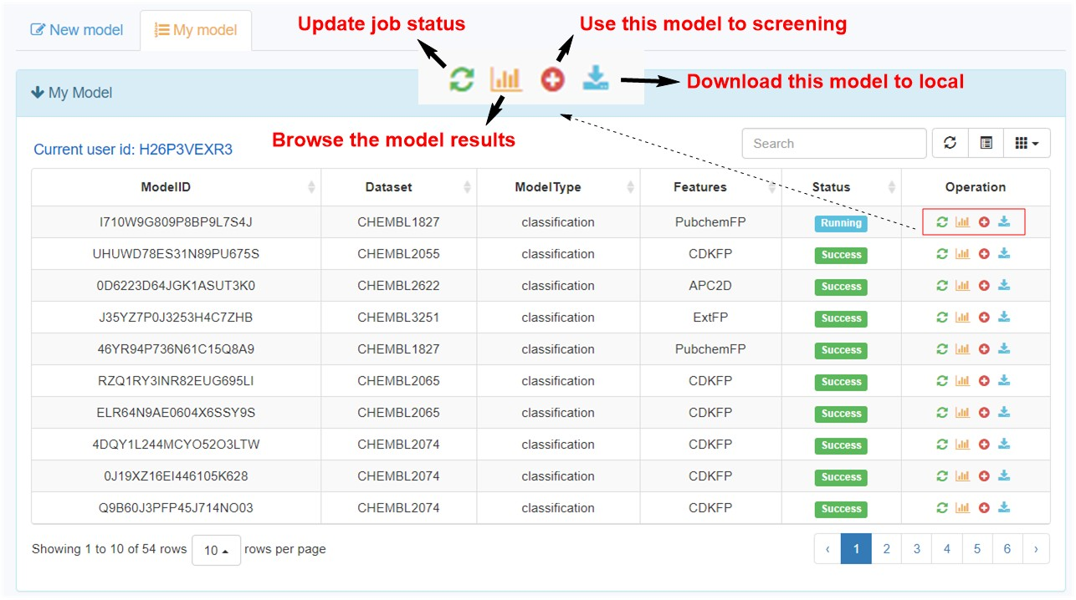

Supplementary Figure S4. Snapshot of My model section.
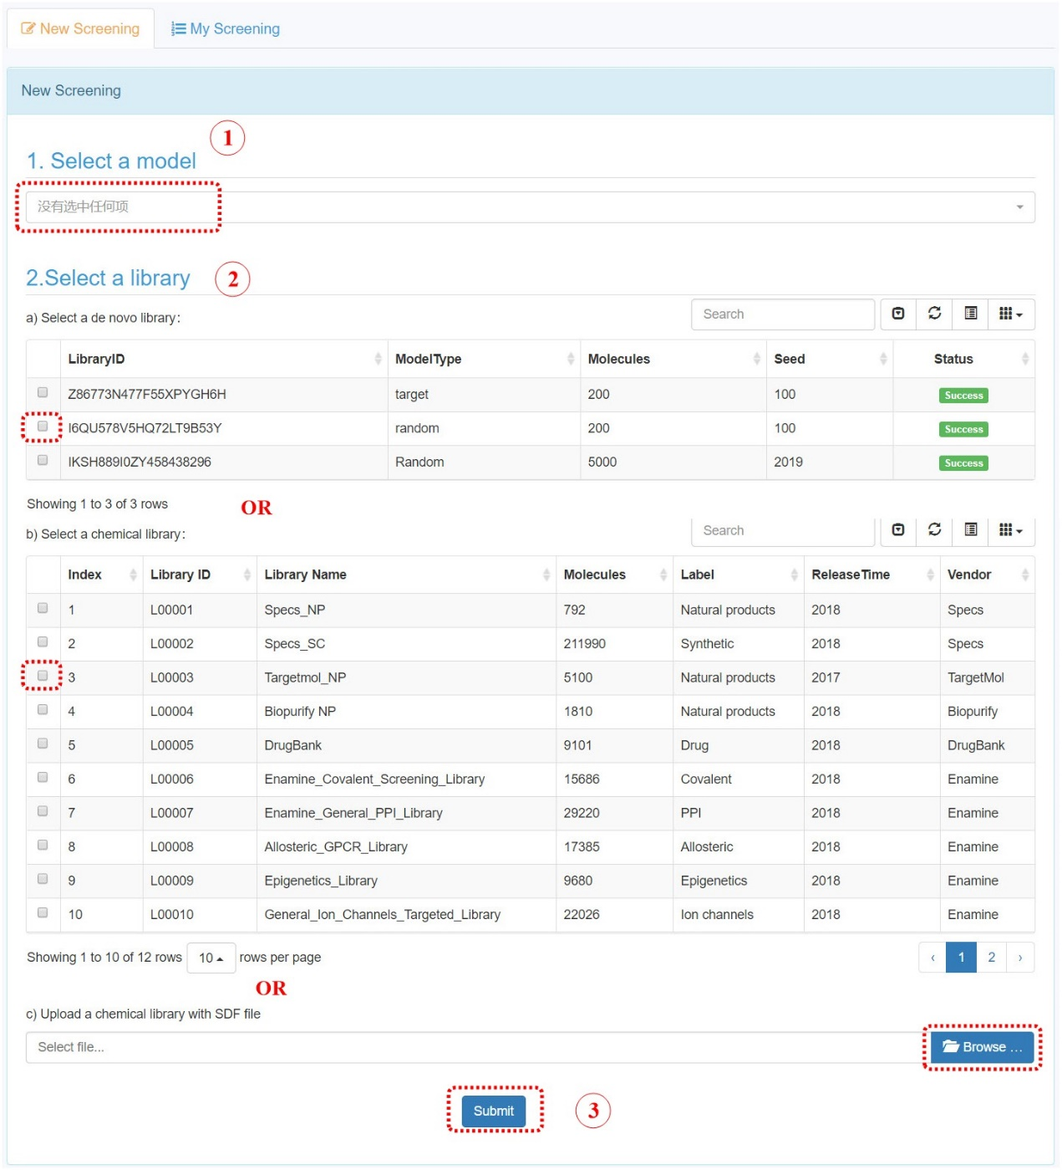

Supplementary Figure S5. Steps to submit a screening job.

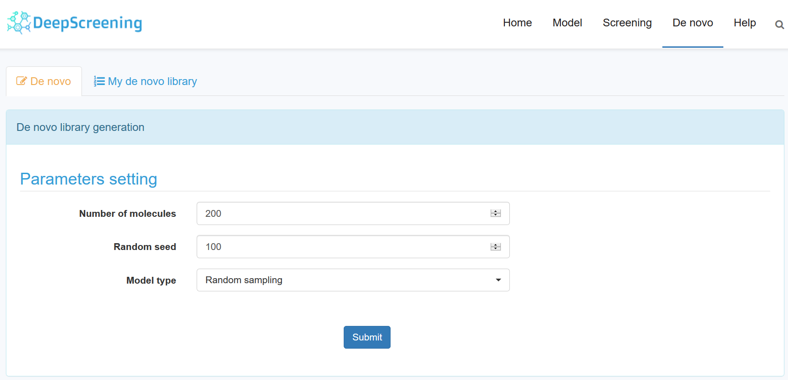

Supplementary Figure S6. Snapshot of de novo submission.

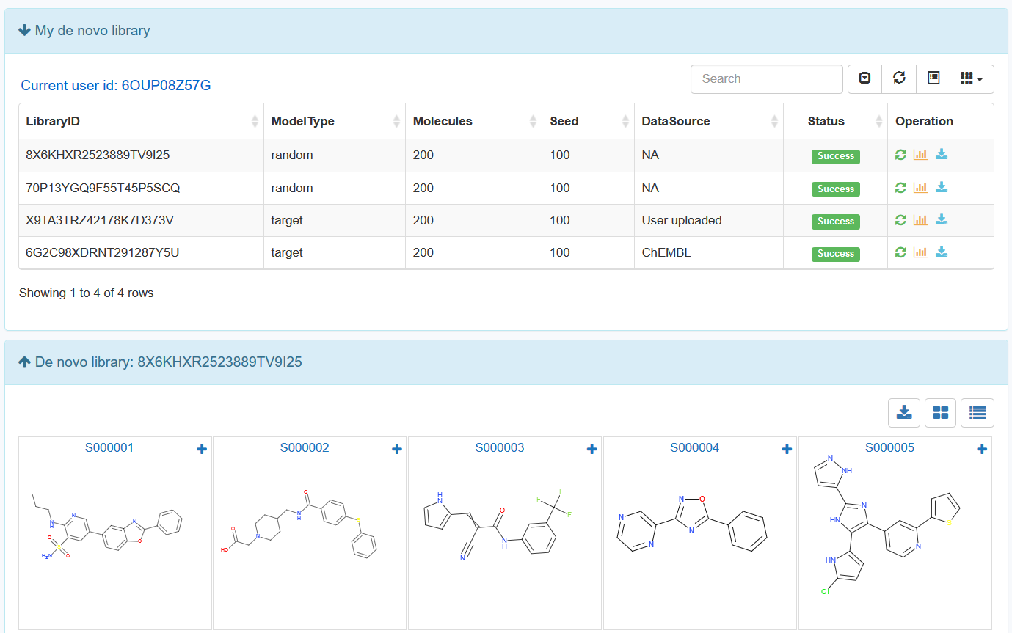

Supplementary Figure S7. Snapshot of de novo library results.

Supplementary Table S8. The model performance metrics for classification model of Estrogen receptor alpha (CHEMBL206).
Epochs | Loss | Accuracy | Recall | Precision | F1 | MCC | AUC
1 | 0.581668 | 0.7115 | 0.8333 | 0.6186 | 0.7101 | 0.4545 | 0.8254
2 | 0.523406 | 0.7782 | 0.6829 | 0.7682 | 0.723 | 0.5418 | 0.8376
3 | 0.521085 | 0.7861 | 0.7292 | 0.7572 | 0.7429 | 0.5601 | 0.8371
4 | 0.514967 | 0.792 | 0.6875 | 0.7941 | 0.737 | 0.5704 | 0.8349
5 | 0.525505 | 0.7772 | 0.7153 | 0.7482 | 0.7314 | 0.5416 | 0.8293
6 | 0.511973 | 0.7939 | 0.7361 | 0.7681 | 0.7518 | 0.5761 | 0.8398
7 | 0.515521 | 0.7939 | 0.7616 | 0.7546 | 0.7581 | 0.5786 | 0.8395
8 | 0.520469 | 0.7861 | 0.6134 | 0.8386 | 0.7086 | 0.5626 | 0.835
9 | 0.507035 | 0.8027 | 0.6644 | 0.8367 | 0.7406 | 0.595 | 0.8389
10 | 0.496707 | 0.8155 | 0.7245 | 0.8194 | 0.769 | 0.6196 | 0.8467
11 | 0.521767 | 0.789 | 0.7708 | 0.7416 | 0.756 | 0.5706 | 0.84
12 | 0.499951 | 0.8027 | 0.6875 | 0.8182 | 0.7472 | 0.5934 | 0.841
13 | 0.512617 | 0.7949 | 0.794 | 0.7408 | 0.7665 | 0.5851 | 0.8444
14 | 0.506904 | 0.8018 | 0.75 | 0.7751 | 0.7624 | 0.5926 | 0.8412
15 | 0.490455 | 0.8194 | 0.7222 | 0.8298 | 0.7723 | 0.628 | 0.8496
16 | 0.500751 | 0.8047 | 0.6968 | 0.8157 | 0.7516 | 0.5973 | 0.8423
17 | 0.51059 | 0.7988 | 0.7778 | 0.7551 | 0.7662 | 0.5899 | 0.8421
18 | 0.51611 | 0.787 | 0.7801 | 0.7342 | 0.7565 | 0.5684 | 0.8479
19 | 0.503383 | 0.8037 | 0.7569 | 0.7749 | 0.7658 | 0.5971 | 0.8359
20 | 0.486775 | 0.8243 | 0.7014 | 0.8584 | 0.772 | 0.64 | 0.847
21 | 0.493972 | 0.8145 | 0.7269 | 0.8156 | 0.7687 | 0.6176 | 0.8424
22 | 0.480169 | 0.8292 | 0.7454 | 0.8342 | 0.7873 | 0.6483 | 0.8506
23 | 0.500965 | 0.8077 | 0.7662 | 0.777 | 0.7716 | 0.6055 | 0.8418
24 | 0.486789 | 0.8214 | 0.706 | 0.8472 | 0.7702 | 0.6331 | 0.847
25 | 0.506797 | 0.8037 | 0.6481 | 0.8537 | 0.7368 | 0.5991 | 0.8344
26 | 0.504121 | 0.8047 | 0.6782 | 0.83 | 0.7465 | 0.5982 | 0.8397
27 | 0.497142 | 0.8096 | 0.7731 | 0.7767 | 0.7749 | 0.61 | 0.8467
28 | 0.486747 | 0.8214 | 0.7593 | 0.8079 | 0.7828 | 0.6323 | 0.8466
29 | 0.489614 | 0.8194 | 0.7083 | 0.8407 | 0.7688 | 0.6286 | 0.8455
30 | 0.497178 | 0.8096 | 0.7731 | 0.7767 | 0.7749 | 0.61 | 0.8453

Supplementary Table S9. The top 50 predicted score of model performance metrics for classification model of Estrogen receptor alpha (CHEMBL206).
Name | Score
AK-693/21164007 | 1
AC-542/20643023 | 1
AK-693/21141015 | 1
AA-504/21004033 | 0.9994
AO-774/41465372 | 0.9993
AO-774/41465647 | 0.9992
AC-542/20643019 | 0.9992
AJ-738/21166027 | 0.9991
AP-163/40806811 | 0.9978
AA-504/20956008 | 0.9969
AA-504/20956012 | 0.9967
AK-693/41507048 | 0.9963
AI-899/21173006 | 0.9962
AO-774/41465568 | 0.9957
AA-504/20956007 | 0.9943
AO-229/21213030 | 0.9937
AO-774/41465663 | 0.9934
AE-641/20167039 | 0.9931
AA-504/20956019 | 0.9922
AA-504/20956013 | 0.9921
AC-542/20316002 | 0.9907
AO-774/41465653 | 0.9874
AJ-738/21061004 | 0.9827
AQ-152/42730357 | 0.9825
AC-542/20643020 | 0.9795
AA-504/20956014 | 0.9704
AJ-738/21161009 | 0.9696
AO-774/41465514 | 0.9695
AK-693/21087002 | 0.9689
AO-774/41465578 | 0.9684
AA-504/21004030 | 0.9654
AA-504/07224063 | 0.9484
AE-562/43462182 | 0.9424
AE-508/21131014 | 0.941
AJ-292/21122010 | 0.9365
AK-693/40760141 | 0.9362
AK-087/42718300 | 0.9176
AE-842/20720002 | 0.907
AA-504/21001015 | 0.8922
AP-123/40765213 | 0.8644
AH-034/21084004 | 0.8584
AP-715/41001588 | 0.8448
AO-774/41465369 | 0.8448
AJ-292/21168044 | 0.837
AK-693/40962738 | 0.806
AE-848/32605045 | 0.8022
AA-504/07225031 | 0.7783
AQ-152/42730386 | 0.7734
AP-163/40806740 | 0.7273
AJ-160/21107003 | 0.7075

