Supplementary Materials

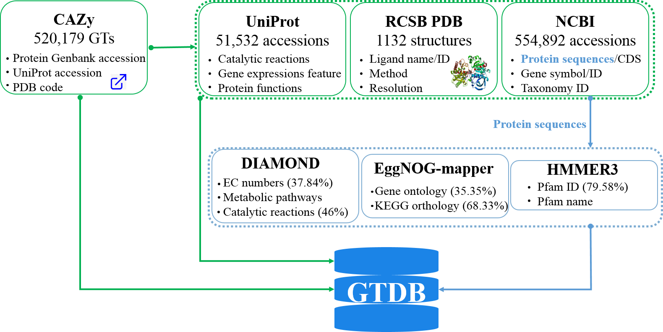
Figure S1. The workflow of data required in GTDB.
The contents in green are integrated from third-party database and those in blue are from bioinformatics algorithms.

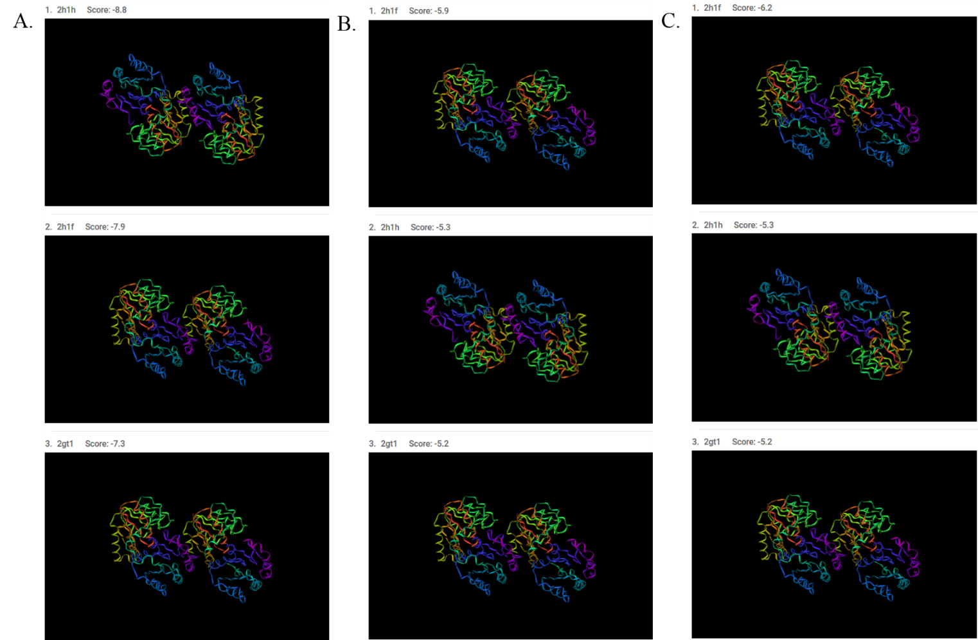
Figure S2. ADP- L-glycero-D-manno-heptose, D-galactose, D-glucose were docked into entire HepI structure with different configurations (2GT1 and 2H1H are “open” apo HepI structures, 2H1F is the “closed” apo model).
These docking results are basically consistent with Table S3 in (Bioorg Med Chem Lett. 2018 February 15; 28(4): 594–600. doi: 10.1016/j.bmcl.2018.01.040), which shows that ADP- L-glycero-D-manno-heptose was the tightest binding ligand and shorter-chained alkylated monosaccharides had somewhat weaker binding affinities.
- The binding modes of ADP- L-glycero-D-manno-heptose and HepI. B. The binding modes of D-galactose and HepI. C. The binding modes of D-glucose and HepI.

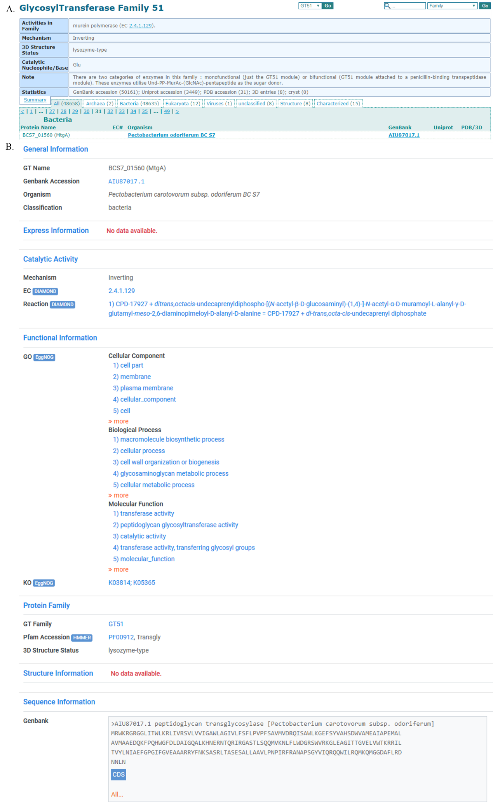Figure S3. The information of BCS7_01560 (MtgA) [Pectobacterium carotovorum subsp. odoriferum BC S7] in CAZy database and GTDB, respectively.
- The information of BCS7_01560 (MtgA) [Pectobacterium carotovorum subsp. odoriferum BC S7] in CAZy database. B. The information of BCS7_01560 (MtgA) [Pectobacterium carotovorum subsp. odoriferum BC S7] in GTDB.

