Supplemental files
- Supplemental Figure S1. Streamlined schema indicating the relational data structure for names, type material (and the biorepositories for it), publications and taxonomic authorities, amongst others
- Supplemental Figure S2. Partial display of a data entry for a TaxNode, with various unique entries, seen in TaxEdit. Some drop down lists are not fully shown.
- Supplemental Table S1. Additional sources recently used by NCBI Curators (this list is dynamic and will change over time).
- Supplemental Table S2. Commonly curated nomenclatural status and related terms used in NCBI Taxonomy.
- Supplemental Table S3 Currently used rank and other group names in NCBI Taxonomy. (Not all names listed are governed by a code of nomenclature.)

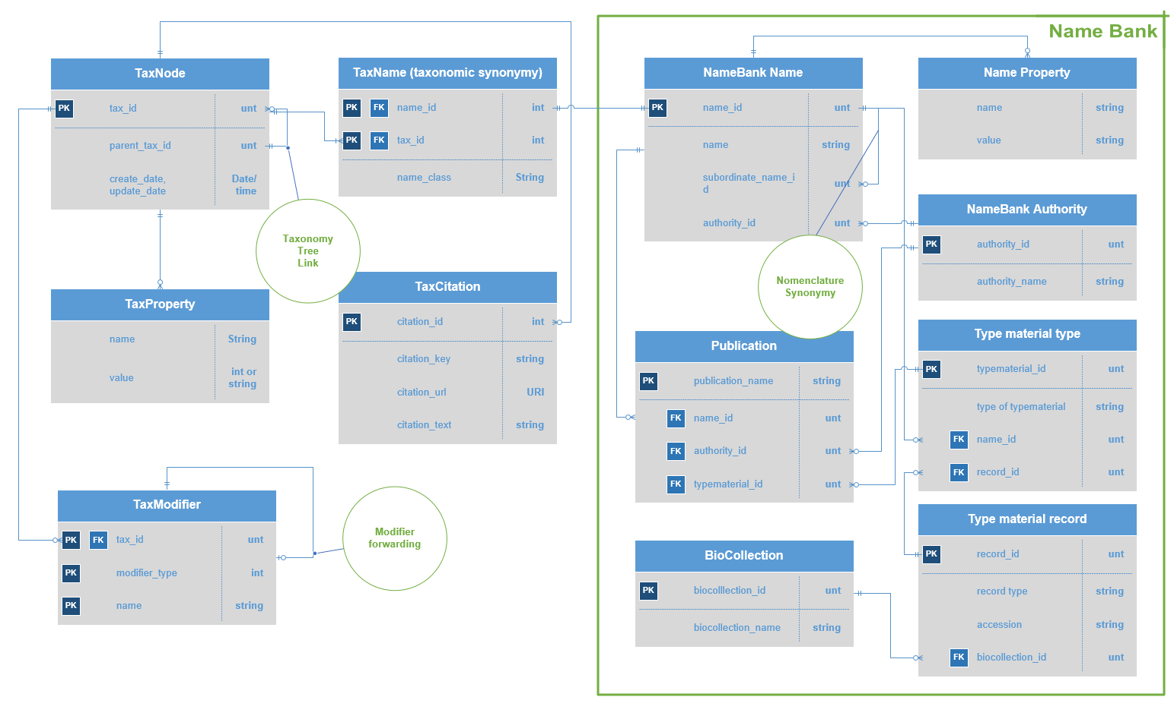
Supplemental Figure S1. Streamlined schema indicating the relational data structure for names, type material (and the biorepositories for it), publications and taxonomic authorities, amongst others.
Supplemental Figure S2. Partial display of a data entry for a TaxNode, with various unique entries, seen in TaxEdit. Some drop down lists are not fully shown.
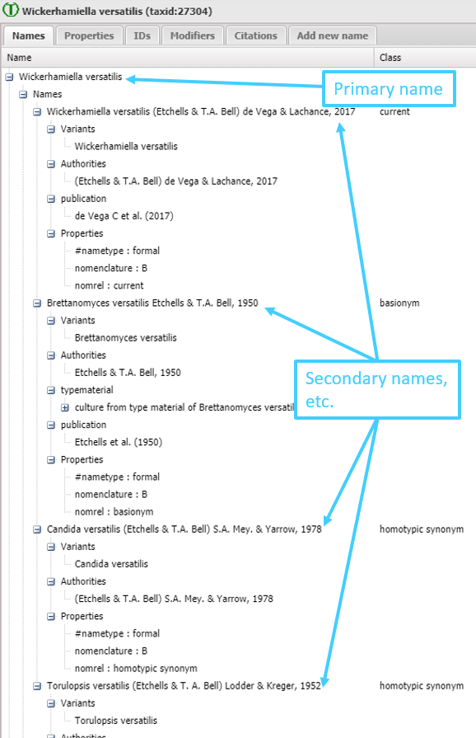

Supplemental Table S1. Additional sources recently used by NCBI Curators (this list is dynamic and will change over time).
Additional informative sites (used occasionally)
3i Interactive Key and Taxonomic Database | http://dmitriev.speciesfile.org/3i.asp | Taxonomic databases for Auchenorrhyncha and part of Curculionidae
Apoidea at Discover Life | https://www.discoverlife.org/mp/20q?search=apoidea | Taxonomic database for bees and apoid wasps
Afromoths | http://www.afromoths.net | Online database of Afrotropical moth species
Amanitaceae.org | http://www.amanitaceae.org/ | Comprehensive resource on taxonomy of Amanitaceae
AntWeb | https://www.antweb.org | Database of images, specimen records, and natural history information on ants
AntWiki | https://www.antwiki.org/wiki/ | A wealth of information on the world's ants
APNI | https://biodiversity.org.au/nsl/services/APNI | Focused on vascular plants of Australia
BioLib | https://www.biolib.cz/en/main/ | An international encyclopedia of plants, fungi and animals.
Cercopoidea Organised On Line (COOL) | https://www.hemiptera-databases.org/cool/ | Systematic based database on the Cercopoidea
Checklist of the Collembola | https://www.collembola.org/index.html | Taxonomic checklist of Collembola
ChiloBase | http://chilobase.biologia.unipd.it | Taxonomic database of all known extant centipedes (Chilopoda) of the world including a modern taxonomic system
Coleoptera Neotropical | http://coleoptera-neotropical.org/paginaprincipalhome.html | Database of beetles of Neotropical regions, with special emphasis on South American countries
eFloras | http://www.efloras.org/index.aspx | Includes Flora of North America and Flora of China
Ephemeroptera of the World | http://www.insecta.bio.spbu.ru/index.htm#Ephemeroptera | Phylogeny, taxonomy and fauna of Ephemeroptera
FigWeb | http://www.figweb.org/Figs_and_fig_wasps/index.htm | Figs and fig wasps of the world
FishBase | https://www.fishbase.us/home.htm | Supplemental source for fish names
Fulgoromorpha Lists On the WEB (FLOW) | https://www.hemiptera-databases.org/flow/ | Database for available published primary data on planthoppers
Hymenoptera Online | https://hol.osu.edu/index.html | Hymenopteran data of species and specimens
IUCN Red List of Threatened Species | https://www.iucnredlist.org/ | Inventory of conservation status of species & subspecies with vetted taxonomic information.
Lepidoptera and some other life forms | http://www.nic.funet.fi/pub/sci/bio/life/insecta/lepidoptera/index.html | Finnish lepidopteran database
MilliBase | http://www.millibase.org/index.php | A global species catalog of the myriapod class Diplopoda
Nomina Insecta Nearctica | http://nearctica.com/nomina/main.htm | Checklist of insects of North America north of Mexico
PBI Plant Bug | http://research.amnh.org/pbi/index.html | On-line Systematic Catalog of Plant Bugs (Insecta: Heteroptera: Miridae)
Plant and Insect Parasitic Nematodes | https://nematode.unl.edu/index.html | Species list of plant and insect parasitic nematodes
Pan-European Species directories Infrastructure (PESI) | http://www.eu-nomen.eu/portal/index.php | All-taxa inventory for European species
The Pyraloidea database | http://www.pyraloidea.org/index.php | Available names and nomenclatural acts of Pyraloidea
ScaleNet | http://scalenet.info/catalogue/ | A literature-based model of scale insect biology and systematics
The Scorpion Files | https://www.ntnu.no/ub/scorpion-files/ | Updated list of all extant scorpion species
Species Files | http://software.speciesfile.org/HomePage/Software/Files/Files.aspx | Covers most Polyneoptera orders and several Paraneoptera taxa, notably  Aphidomorpha and Psocodea.
Species2000 | https://www.sp2000.org | Aggregator of all names of cellular organisms, producing the Catalogue of Life in collaboration with ITIS and others
Systema Dipterorum | https://web.archive.org/web/20180615024537/  http://www.diptera.org/ | Authoritative source for all names proposed for extant and extinct Diptera
Systematic Catalog of Culicidae | http://www.mosquitocatalog.org/default.aspx | A systematic catalog of mosquitoes
ThripsWiki | https://thrips.info/wiki/Main_Page | Information on the World's thrips
Trichoptera World Checklist | http://entweb.sites.clemson.edu/database/trichopt/index.php | World Checklist of caddisflies
Universal Chalcidoidea Database | https://www.nhm.ac.uk/our-science/data/chalcidoids/database/ | Comprehensive list of taxonomic names within Chalcidoidea.
USDA GRIN Taxonomy | https://npgsweb.ars-grin.gov/gringlobal/taxon/taxonomyquery.aspx | Especially good for economic plants
WaspWeb | https://www.waspweb.org/Afrotropical_wasps/index.htm | Wasps, bees and ants of Africa and Madagascar
World Catalogue of the Tortricidae | http://www.tortricidae.com/catalogue.asp | Online World species list of the Tortricidae
World Odonata List | https://www.pugetsound.edu/academics/academic-resources/slater-museum/biodiversity-resources/dragonflies/world-odonata-list2/ | Odonata checklist of the world
World Spider Catalog | https://wsc.nmbe.ch | Searchable online database covering spider taxonomy

Supplemental Table S2. Commonly curated nomenclatural status and related terms used in NCBI Taxonomy.
Term | Abbreviation | Similar terms | Code of nomenclature | Explanation
candidatus name |  | candidatus | ICNP | a provisional name for well characterized but as-yet uncultured organisms
effectively published name |  | effective name | ICNP | a name made available in printed and/or electronic matter made generally available to the scientific community but not published in the journal of record, under the ICNP
nomen dubium | nom. dub. | dubious name | ICNafp, ICZN | a name of unclear application
nomen illegitimum | nom. illeg. | illegitimate name | ICNafp, ICNP | not in accordance with the rules of its relevant code of nomenclature
nomen ineditum | nom. ined. | unpublished name | ICNafp, ICNP, ICZN | used in literature, i.e. a name proposed without adherence to any code of nomenclature. Indicated with single quotes in NCBI Taxonomy
nomen invalidum | nom. inval. | invalid name | ICNafp | not published in accordance with rules enumerated in the ICN
nomen novum | nom. nov. | replacement name, avowed substitute | ICNafp, ICNP, ICZN | a name regulated by ICNafp that is based on a legitimate or illegitimate, previously published name, which is its replaced synonym and which, when legitimate, does not provide the final species epithet, name, or stem of the replacement name, or a name regulated by ICZN that is established expressly to replace an already established name
nomen nudum | nom. nud. |  | ICNafp, ICZN | a name regulated by ICNafp that is published without a diagnosis, or one by ICZN that fails to conform to any related Article in the Criteria of availability
orthographic variant | orth. var. |  | ICNafp | not following standard rules of orthography, such as gender disagreement between genus and species, either when originally published or mistakenly corrected in later publications; includes names which are "incorrect original spellings" and "incorrect subsequent spellings" in zoological parlance
replaced synonym |  |  | ICNafp | a synonym replaced by a nomen novum

Supplemental Table S3 Currently used rank and other group names in NCBI Taxonomy. (Not all names listed are governed by a code of nomenclature, and some equivalent hierarchical placements were forced.)
Place in hierarchy | Name | Equivalent terms | Note
Phylogenetic ranks (monophyletic, non-hierarchical)
- | clade |  | newly introduced, can appear anywhere in the lineage w/o breaking the order
Non-hierachical group names
- | environmental samples |  | no order below this rank is required
- | incertae sedis |  | can appear anywhere in the lineage w/o breaking the order, implies taxa with uncertain placements
- | unclassified <name> |  | no order below this rank is required, includes undefined or unspecified names
- | no rank |  | applied to nodes not categorized here yet, additional rank and groups names will be released
Classification rank and group names (from higher to lower)
1 | superkingdom |  | Archaea, Bacteria, Eukaryota, Viruses
2 | kingdom
3 | subkingdom
4 | superphylum | superdivision (ICNafp)
5 | phylum | division (ICNafp)
6 | subphylum | subdivision (ICNafp)
7 | infraphylum | infradivision (ICNafp)
8 | superclass
9 | class
10 | subclass
11 | infraclass
12 | cohort
13 | subcohort
14 | superorder
15 | order
16 | suborder
17 | infraorder
18 | parvorder
19 | superfamily
20 | family
21 | subfamily
22 | tribe
23 | subtribe
24 | genus
25 | subgenus
26 | section | used under ICNafp | different from section used for some ICZN regulated organisms
27 | subsection | used under ICNafp | see note on section
28 | series | used under ICNafp | different from section used for some ICZN regulated organisms
29 | subseries | used under ICNafp | see note on series
30 | species group |  | could be multiple nested species groups
31 | species subgroup
32 | species
33 | forma specialis | special form | newly introduced, below species level
34 | subspecies |  | below species level
35 | varietas | morph (ICZN), form (ICZN) | below species level
36 | subvariety |  | newly introduced, below species level
37 | forma
38 | serogroup | pathogroup | newly introduced, below species level
39 | serotype | biotype, genotype | newly introduced, below species level
40 | strain |  | newly introduced, below species level
41 | isolate |  | newly introduced, below species level

