XML | Chado Base Table | Chado Column
Taxon->ScientificName | organism | genus
Taxon->ScientificName | organism | species
IdList->Id | organism_dbxref | dbxref.accession
Taxon->Rank | organism | type_id
Taxon->OtherNames->CommonName | organism | commonname
Taxon->ScientificName (if included) | organism | infraspecific_name
NA | organism | comment
Table S1. Mappings for NCBITaxon metadata into the Chado organism and organism_dbxref tables, based on Tripal core importers.

XML | Property term
Taxon->Lineage | local:lineage
Taxon->GeneticCode->GCId | local:genetic_code
Taxon->GeneticCode->GCName | local:genetic_code_name
Taxon->MitoGeneticCode->MGCId | local:mitochondrial_genetic_code
Taxon->MitoGeneticCode->MGCName | local:mitochondrial_genetic_code_name
Taxon->Division | local:division
Taxon->OtherNames->GenbankCommonName | local:genbank_common_name
Taxon->OtherNames->Synonym | local:synonym
Taxon->OtherNames->GenbankSynonym | local:synonym
Taxon->OtherNames->Includes | local:other_name
Taxon->OtherNames->EquivalentName | local:equivalent_name
Taxon->OtherNames->Anamorph | local:anamorph
Table S2. NCBITaxon to Chado Organism property mappings. Properties are inserted in the
chado.organismprop table.

XML | Chado Base Table | Chado Column
Journal | pub | title
NA | pub | volumetitle
Volume | pub | volume
NA | pub | series_name
Issue | pub | issue
PubDate | pub | pyear
MedlinePgn | pub | pages
NA | pub | miniref
(Citation built from multiple keys) | pub | uniquename
PublicationType | pub | type_id
NA | pub | publisher
NA | pub | pubplace
AuthorList | pubauthor | surname/givennames/suffix
Table S3. Pubmed XML to Chado pub and pubauthor mappings, based on Tripal core importers.
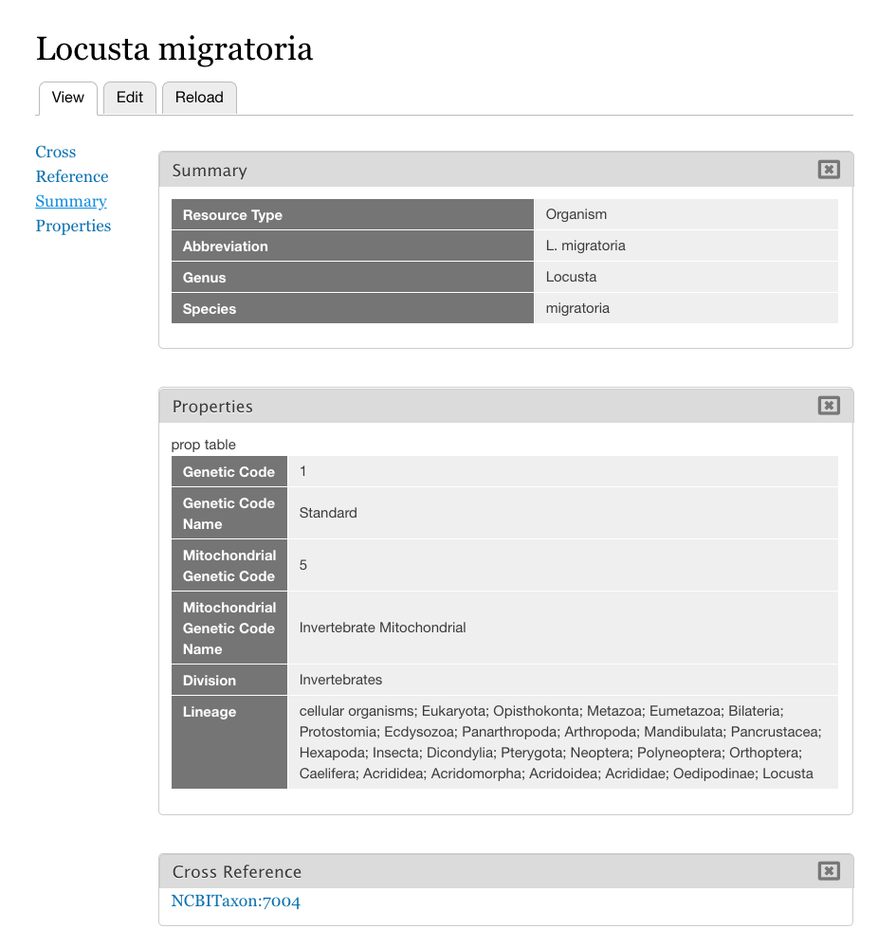
Figure S1. Imported NCBI Taxon 7004 (Locusta migratoria).
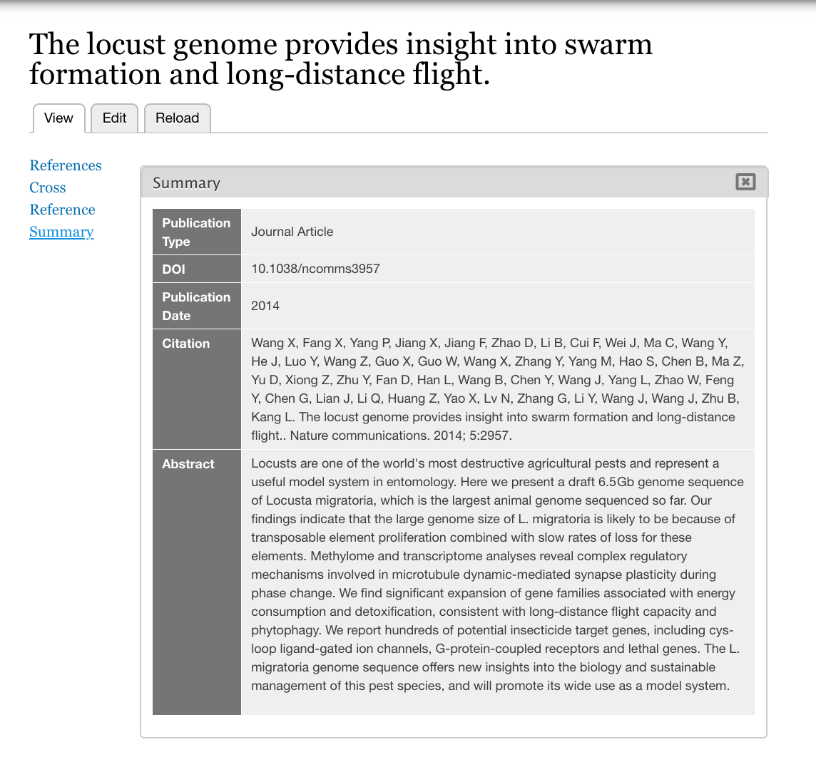
Figure S2. Imported Pubmed ID 24423660.

