**APPENDIX / SUPPLEMENT**

**TABLE A1: Systematic Review and Meta-analysis Search Strategy**

|  |
| --- |
| Search Strategy |
| (fecal transplantation) OR (faecal transplantation) OR (stool transplantation) OR (microbiota transplantation) OR (microflora transplantation) OR (feces transplantation) OR (faeces transplantation) OR (fecal flora transplantation) OR (faecal flora transplantation) OR (fecal microbiota transplantation) OR (faecal microbiota transplantation) OR (fecal transplant) OR (faecal transplant) OR (stool transplant) OR (microbiota transplant) OR (microflora transplant) OR (feces transplant) OR (faeces transplant) OR (fecal flora transplant) OR (faecal flora transplant) OR (fecal microbiota transplant) OR (faecal microbiota transplant) OR (fecal transfusion) OR (faecal transfusion) OR (stool transfusion) OR (microbiota transfusion) OR (microflora transfusion) OR (feces transfusion) OR (faeces transfusion) OR (fecal flora transfusion) OR (faecal flora transfusion) OR (fecal microbiota transfusion) OR (faecal microbiota transfusion) OR (fecal implantation) OR (faecal implantation) OR (stool implantation) OR (microbiota implantation) OR (microflora implantation) OR (feces implantation) OR (faeces implantation) OR (fecal flora implantation) OR (faecal flora implantation) OR (fecal microbiota implantation) OR (faecal microbiota implantation) OR (fecal implant) OR (faecal implant) OR (stool implant) OR (microbiota implant) OR (microflora implant) OR (feces implant) OR (faeces implant) OR (fecal flora implant) OR (faecal flora implant) OR (fecal microbiota implant) OR (faecal microbiota implant) OR (fecal instillation) OR (faecal instillation) OR (stool instillation) OR (microbiota instillation) OR (microflora instillation) OR (feces instillation) OR (faeces instillation) OR (fecal flora instillation) OR (faecal flora instillation) OR (fecal microbiota instillation) OR (faecal microbiota instillation) OR (fecal donor) OR (faecal donor) OR (stool donor) OR (microbiota donor) OR (microflora donor) OR (feces donor) OR (faeces donor) OR (fecal flora donor) OR (faecal flora donor) OR (fecal microbiota donor) OR (faecal microbiota donor) OR (fecal enema) OR (faecal enema) OR (stool enema) OR (microbiota enema) OR (microflora enema) OR (feces enema) OR (faeces enema) OR (fecal flora enema) OR (faecal flora enema) OR (fecal microbiota enema) OR (faecal microbiota enema) OR (fecal reconstitution) OR (faecal reconstitution) OR (stool reconstitution) OR (microbiota reconstitution) OR (microflora reconstitution) OR (feces reconstitution) OR (faeces reconstitution) OR (fecal flora reconstitution) OR (faecal flora reconstitution) OR (fecal microbiota reconstitution) OR (faecal microbiota reconstitution) OR (fecal infusion) OR (faecal infusion) OR (stool infusion) OR (microbiota infusion) OR (microflora infusion) OR (feces infusion) OR (faeces infusion) OR (fecal flora infusion) OR (faecal flora infusion) OR (fecal microbiota infusion) OR (faecal microbiota infusion) OR (fecal therapy) OR (faecal therapy) OR (stool therapy) OR (microbiota therapy) OR (microflora therapy) OR (feces therapy) OR (faeces therapy) OR (fecal flora therapy) OR (faecal flora therapy) OR (fecal microbiota therapy) OR (faecal microbiota therapy) OR (fecal bacteriotherapy) OR (faecal bacteriotherapy) OR (stool bacteriotherapy) OR (microbiota bacteriotherapy) OR (microflora bacteriotherapy) OR (feces bacteriotherapy) OR (faeces bacteriotherapy) OR (fecal flora bacteriotherapy) OR (faecal flora bacteriotherapy) OR (fecal microbiota bacteriotherapy) OR (faecal microbiota bacteriotherapy) OR (FMT)  AND  (Crohns disease) OR (Crohn's Disease) OR (Crohn Disease) OR (Ulcerative Colitis) OR (Inflammatory bowel disease) OR (UC) OR (IBD) OR (CD) OR (ileitis) OR (Colitis) OR (Pouchitis) |

**TABLE A2: Study Quality (Newcastle Ottawa Scale) - Cohort Studies**

|  |  |  |  |  |  |  |  |  |  |  |  |
| --- | --- | --- | --- | --- | --- | --- | --- | --- | --- | --- | --- |
|  | Author | NOS1 (Representativeness of exposed cohort to average active IBD patient) | NOS2 (Similarity of exposed and control cohort populations) | NOS3 (Confirmation of FMT exposure) | NOS4  (Evidence outcome of interest ie clinical remission / response was not present at start of study) | NOS5  (Study controls for disease severity) | NOS6  (Study controls for disease extent, duration or concomitant medications) | NOS7 (Outcome assessment) | NOS8 (Adequate follow up duration for outcome of interest - 1 month) | NOS9 (Adequacy of follow up of cohort) | **NOS**  **Total** |
| UC | Angelberger 201332 | 0 | 0 | 1 | 1 | 0 | 0 | 1 | 1 | 1 | **5** |
|  | Kump  201333 | 0 | 0 | 1 | 1 | 0 | 0 | 1 | 1 | 1 | **5** |
|  | Kunde  201334 | 1 | 0 | 1 | 1 | 0 | 0 | 1 | 1 | 1 | **6** |
|  | Cui  201535 | 0 | 0 | 1 | 1 | 0 | 0 | 1 | 1 | 1 | **5** |
|  | Damman  201536 | 1 | 0 | 1 | 1 | 0 | 0 | 1 | 1 | 1 | **6** |
|  | Karolewska Bochenek  201537 | 0 | 0 | 1 | 0 | 0 | 0 | 1 | 1 | 1 | **4** |
|  | Kellermayer 201538 | 0 | 0 | 1 | 0 | 0 | 0 | 1 | 1 | 0 | **3** |
|  | Kump  201539 | 1 | 1 | 1 | 0 | 0 | 0 | 1 | 1 | 1 | **6** |
|  | Scaldaferri  201540 | 1 | 1 | 1 | 1 | 0 | 1 | 1 | 1 | 0 | **7** |
|  | Suskind  201541 | 1 | 0 | 1 | 1 | 0 | 0 | 1 | 1 | 1 | **6** |
|  | Vermeire  201642 | 0 | 0 | 1 | 1 | 0 | 0 | 1 | 1 | 1 | **5** |
|  | Wei  201543 | 1 | 0 | 1 | 0 | 0 | 0 | 1 | 1 | 0 | **4** |
|  | Ren  201544 | 0 | 0 | 1 | 1 | 0 | 0 | 1 | 1 | 1 | **5** |
|  | Karakan  201645 | 0 | 0 | 1 | 0 | 0 | 0 | 1 | 1 | 1 | **4** |
|  | Goyal  201646 | 1 | 0 | 1 | 1 | 0 | 0 | 1 | 1 | 1 | **6** |
|  | Laszlo  201647 | 0 | 0 | 1 | 1 | 0 | 0 | 1 | 1 | 1 | **5** |
|  | Wei  201648 | 1 | 0 | 1 | 0 | 0 | 0 | 1 | 1 | 1 | **5** |
|  | Pai  201649 | 1 | 1 | 1 | 0 | 1 | 1 | 1 | 1 | 0 | **7** |
|  | Jacob  201650 | 1 | 0 | 1 | 1 | 0 | 0 | 1 | 1 | 1 | **6** |
|  | Nishida  201651 | 1 | 0 | 1 | 1 | 0 | 0 | 1 | 1 | 1 | **6** |
|  | Zhang  201652 | 0 | 0 | 1 | 1 | 0 | 0 | 1 | 1 | 1 | **5** |
|  | Grewal  201653 | 0 | 0 | 1 | 1 | 0 | 0 | 1 | 1 | 1 | **5** |
|  | Paramsothy 201711 | 1 | 0 | 1 | 0 | 0 | 0 | 1 | 1 | 1 | **5** |
|  | Ishikawa  201754 | 1 | 1 | 1 | 1 | 1 | 1 | 1 | 1 | 1 | **9** |
|  | | | | | | | | | | | |
| CD | Kahn  201458 | 1 | 0 | 1 | 0 | 0 | 0 | 1 | 0 | 1 | **4** |
|  | Cui  201559 | 0 | 0 | 1 | 1 | 0 | 0 | 1 | 1 | 0 | **4** |
|  | Suskind  201560 | 1 | 0 | 1 | 1 | 0 | 0 | 1 | 1 | 1 | **6** |
|  | Vermeire  201642 | 0 | 0 | 1 | 1 | 0 | 0 | 1 | 1 | 1 | **5** |
|  | Wei  201543 | 1 | 0 | 1 | 0 | 0 | 0 | 1 | 1 | 1 | **5** |
|  | Vaughn  201661 | 1 | 0 | 1 | 1 | 0 | 0 | 1 | 1 | 1 | **6** |
|  | Goyal  201646 | 0 | 0 | 1 | 1 | 0 | 0 | 1 | 1 | 0 | **4** |
|  | | | | | | | | | | | |
| Pouchitis | Landy  201563 | 1 | 0 | 1 | 1 | 0 | 0 | 1 | 1 | 1 | **6** |
|  | El-Nachef  201664 | 1 | 0 | 1 | 0 | 0 | 0 | 1 | 1 | 1 | **5** |
|  | Stallmach  201665 | 1 | 0 | 1 | 1 | 0 | 0 | 1 | 1 | 1 | **6** |

**TABLE A3: Study Quality (Cochrane Risk of Bias) – RCTs**

|  |  |  |  |  |  |  |
| --- | --- | --- | --- | --- | --- | --- |
|  | Random  Sequence  Generation | Allocation  Concealment | Blinding of  Participants  & Personnel | Blinding of  Outcome  Assessment | Incomplete  Outcome  Data | Selective Reporting |
| Moayeddi  20159 | Low | Low | Low | Low | Low | Low |
| Rossen  201510 | Unclear | Unclear | Low | Low | Low | Low |
| Paramsothy  201711 | Low | Low | Low | Low | Low | Low |
| Costello*  201712 | Unclear | Unclear | Low | Low | Low | Low |

* At the time of submission of this manuscript, Costello et al, 2017 had been presented in abstract form but had yet to undergo full publication peer review

**TABLE A4: Summary of Meta-Analyses – Main Results**

|  |  |  |  |  |  |  |  |  |
| --- | --- | --- | --- | --- | --- | --- | --- | --- |
| **Meta-analysis** | **Number of studies included** | **Model** | **Effect size** | **Lower limit** | **Upper limit** | **Heterogeneity** | | |
| **Cochran's Q** | **Q p-value** | **I2** |
| **Clinical Remission** |  |  |  |  |  |  |  |  |
| Cohorts UC - clinical remission | 24 | Random | 0.325 | 0.234 | 0.432 | 50.148 | 0.001 | 54.135 |
| Cohorts CD - clinical remission | 6 | Random | 0.518 | 0.311 | 0.719 | 10.467 | 0.063 | 52.230 |
| RCT UC - clinical remission | 4 | Random | 2.885 | 1.359 | 6.127 | 4.784 | 0.188 | 37.288 |
| RCT UC - clinical remission (without Rossen et al) | 3 | Both | 4.052 | 2.082 | 7.885 | 0.490 | 0.783 | 0.000 |
| **Clinical Response** |  |  |  |  |  |  |  |  |
| Cohorts UC - clinical response | 20 | Random | 0.521 | 0.398 | 0.641 | 45.389 | 0.001 | 58.140 |
| Cohorts CD - clinical response | 4 | Random | 0.632 | 0.297 | 0.875 | 10.378 | 0.016 | 71.093 |
| RCT UC - clinical response | 4 | Random | 2.481 | 1.182 | 5.209 | 6.205 | 0.102 | 51.654 |
| RCT UC - clinical response (without Rossen et al) | 3 | Both | 3.389 | 1.904 | 6.035 | 1.633 | 0.442 | 0.000 |

**Table A5. Publication bias**

|  |  |
| --- | --- |
| **Meta-analysis** | **Egger's testa** |
| UC - Cohort studies - Clinical remission | 0.055 |
| CD - Cohort studies - Clinical remission | 0.042 |
| UC- RCTs- Clinical remission | 0.960 |
| UC - Cohort studies - Clinical response | 0.481 |
| CD - Cohort studies - Clinical response | 0.562 |
| UC- RCTs- Clinical response | 0.333 |

**UC, ulcerative colitis; CD, Crohn’s Disease; RCTs, randomized controlled trials**

**a. Two tailed P-value**

**TABLE A6: Subgroup Analyses**

|  |  |  |  |  |  |  |  |  |  |  |  |
| --- | --- | --- | --- | --- | --- | --- | --- | --- | --- | --- | --- |
| **Meta-analysis** | **Subgroup analysis** | **Number of studies included** | **Model** | **Effect size** | **Lower limit** | **Upper limit** | **Heterogeneity** | | | | |
| **Cochran's Q** | | **Q p-value** | | **I2** |
| **Clinical Remission** |  |  |  |  |  |  |  |  | |  | |
| **Paediatric vs Adult** |  |  |  |  |  |  |  |  | |  | |
| Cohorts UC - clinical remission | Adult population | 18 | Random | 0.344 | 0.243 | 0.462 | 40.886 | | 0.001 | | 58.421 |
| Cohorts UC - clinical remission | Paediatric population | 6 | Random | 0.225 | 0.074 | 0.513 | 7.739 | | 0.171 | | 35.391 |
| Cohorts CD - clinical remission | Adult population | 4 | Random | 0.455 | 0.177 | 0.765 | 10.229 | | 0.017 | | 70.671 |
| Cohorts CD - clinical remission | Paediatric population | 2 | Both | 0.538 | 0.281 | 0.777 | 0.034 | | 0.853 | | 0.000 |
| **FMT methodology** |  |  |  |  |  |  |  |  | |  | |
| Cohorts UC - clinical remission | Upper GIT infusion | 4 | Both | 0.174 | 0.084 | 0.324 | 1.850 | | 0.604 | | 0.000 |
| Cohorts UC - clinical remission | Lower GIT infusion | 14 | Random | 0.357 | 0.237 | 0.499 | 30.385 | | 0.004 | | 57.216 |
| Cohorts CD - clinical remission | Upper GIT infusion | 3 | Random | 0.533 | 0.195 | 0.844 | 6.741 | | 0.034 | | 70.329 |
| Cohorts CD - clinical remission | Lower GIT infusion | 1 | NA | NA | NA | NA | NA | | NA | | NA |
| Cohorts UC - clinical remission | Fresh | 14 | Random | 0.280 | 0.153 | 0.457 | 35.207 | | 0.001 | | 63.076 |
| Cohorts UC - clinical remission | Frozen | 4 | Random | 0.360 | 0.134 | 0.671 | 8.039 | | 0.045 | | 62.680 |
| Cohorts CD - clinical remission | Fresh | 4 | Random | 0.360 | 0.140 | 0.660 | 4.242 | | 0.236 | | 29.278 |
| Cohorts CD - clinical remission | Frozen | 1 | NA | NA | NA | NA | NA | | NA | | NA |
| Cohorts UC - clinical remission | Number of infusions (1) | 11 | Random | 0.234 | 0.108 | 0.434 | 32.570 | | 0.000 | | 69.297 |
| Cohorts UC - clinical remission | Number of infusions (2-4) | 3 | Both | 0.276 | 0.123 | 0.509 | 1.355 | | 0.508 | | 0.000 |
| Cohorts UC - clinical remission | Number of infusions (5-10) | 4 | Random | 0.352 | 0.173 | 0.584 | 5.792 | | 0.122 | | 48.206 |
| Cohorts UC - clinical remission | Number of infusions (<10) | 18 | Random | 0.271 | 0.171 | 0.401 | 40.690 | | 0.001 | | 58.220 |
| Cohorts UC - clinical remission | Number of infusions (>10) | 3 | Random | 0.487 | 0.208 | 0.774 | 2.807 | | 0.246 | | 28.751 |
| Cohorts CD - clinical remission | Number of infusions (1) | 5 | Random | 0.588 | 0.408 | 0.748 | 6.318 | | 0.177 | | 36.692 |
| Cohorts CD - clinical remission | Number of infusions (2-4) | 1 | NA | NA | NA | NA | NA | | NA | | NA |
| Cohorts CD - clinical remission | Number of infusions (5-10) | 0 | NA | NA | NA | NA | NA | | NA | | NA |
| Cohorts CD - clinical remission | Number of infusions (<10) | 6 | Random | 0.518 | 0.311 | 0.719 | 10.467 | | 0.063 | | 52.230 |
| Cohorts CD - clinical remission | Number of infusions (>10) | 0 | NA | NA | NA | NA | NA | | NA | | NA |
| Cohorts UC - clinical remission | Bowel lavage - Yes | 16 | Random | 0.299 | 0.185 | 0.445 | 35.015 | | 0.002 | | 57.162 |
| Cohorts UC - clinical remission | Bowel lavage - No | 3 | Random | 0.471 | 0.324 | 0.623 | 2.207 | | 0.332 | | 9.400 |
| Cohorts CD - clinical remission | Bowel lavage - Yes | 6 | Random | 0.518 | 0.311 | 0.719 | 10.467 | | 0.063 | | 52.230 |
| Cohorts CD - clinical remission | Bowel lavage - No | 0 | NA | NA | NA | NA | NA | | NA | | NA |
| Cohorts UC - clinical remission | Pre-antibiotic-Yes | 7 | Random | 0.329 | 0.170 | 0.540 | 14.370 | | 0.026 | | 58.246 |
| Cohorts UC - clinical remission | Pre-antibiotic-No | 13 | Random | 0.278 | 0.156 | 0.444 | 30.598 | | 0.002 | | 60.781 |
| Cohorts CD - clinical remission | Pre-antibiotic-Yes | 3 | Both | 0.476 | 0.246 | 0.717 | 1.733 | | 0.420 | | 0.000 |
| Cohorts CD - clinical remission | Pre-antibiotic-No | 3 | Random | 0.535 | 0.224 | 0.822 | 7.635 | | 0.022 | | 73.806 |
| Cohorts UC - clinical remission | Related donor | 2 | Random | 0.245 | 0.000 | 0.995 | 10.308 | | 0.001 | | 90.299 |
| Cohorts UC - clinical remission | Unrelated donor | 8 | Random | 0.362 | 0.201 | 0.561 | 16.073 | | 0.024 | | 56.449 |
| Cohorts CD - clinical remission | Related donor | 1 | NA | NA | NA | NA | NA | | NA | | NA |
| Cohorts CD - clinical remission | Unrelated donor | 2 | Random | 0.398 | 0.103 | 0.792 | 1.685 | | 0.194 | | 40.661 |
| **Severity of disease** |  |  |  |  |  |  |  |  | |  | |
| Cohorts UC - clinical remission | Mild | 0 | NA | NA | NA | NA | NA | | NA | | NA |
| Cohorts UC - clinical remission | Moderate | 17 | Random | 0.330 | 0.218 | 0.465 | 37.419 | | 0.002 | | 57.241 |
| Cohorts UC - clinical remission | Severe | 3 | Random | 0.337 | 0.074 | 0.763 | 5.375 | | 0.068 | | 62.788 |
| Cohorts CD - clinical remission | Mild | 0 | NA | NA | NA | NA | NA | | NA | | NA |
| Cohorts CD - clinical remission | Moderate | 4 | Random | 0.629 | 0.478 | 0.758 | 3.672 | | 0.299 | | 18.291 |
| Cohorts CD - clinical remission | Severe | 1 | NA | NA | NA | NA | NA | | NA | | NA |

**I2, Higgin’s test; UC, ulcerative colitis; CD, Crohn’s disease; FMT, fecal microbiota transplant; NA, not available**

**TABLE A7: Microbial Findings in Clinical Studies of FMT in IBD**

|  |  |  |  |  |
| --- | --- | --- | --- | --- |
| Disease | Type of Trial | Year | Author | Microbial Findings |
| UC | Case Report | 2016 | Kumagai[24](#_ENREF_24" \o "Kumagai, 2016 #704) | Different microbiota composition of patient from donor post FMT, no stable engraftment of donor microbiota |
| UC | Case Report | 2016 | Shimzu[26](#_ENREF_26" \o "Shimizu, 2016 #681) | Dramatic change in microbiota towards donor with increased *Bacteroides*, *Acidaminococcus*, *Eubacterium* and *Faecalibacterium* (detected at week 3, maintained at week 32) |
| UC | Cohort | 2013 | Angelberger[32](#_ENREF_32" \o "Angelberger, 2013 #449) | Abundant bacteria from donors established in recipients, but the efficiency and stability of donor microbiota colonisation varied greatly. Transient increase in recipient phylotype richness and similarity to donor. In 1 patient with clinical response, microbiota augmented by FMT with successive colonisation of donor derived phylotypes. |
| UC | Cohort | 2013 | Kump[33](#_ENREF_33" \o "Kump, 2013 #429) | No significant difference in the relative abundance of phyla between mucosal and faecal samples. In 3 patients, colonic microbiota changed towards donor but didn't correlate with clinical response. Significant reduction in Proteobacteria and increase in Bacteroidetes post FMT. |
| UC | Cohort | 2015 | Cui35 | FMT altered the composition of the recipient microbiota significantly, and became highly similar to that of the donor in those with successful treatment |
| UC | Cohort | 2015 | Damman[36](#_ENREF_36" \o "Damman, 2015 #443) | No significant difference was found on Shannon diversity index between donor and recipient baselines or between pre- and post-FMT samples. Majority of post-transplant increases were in species already present in the recipient at baseline. 40% DSI achieved in 60% of patients. |
| UC | Cohort | 2015 | Kellermayer[38](#_ENREF_38" \o "Kellermayer, 2015 #468) | Recipient microbiomes remained distinct from that of donor though there was transient engraftment of donor microbiome, with increase in recipient microbiome richness and diversity. Of the OTUs that were increased in abundance 61.5% belonged to *Lachnospiraceae*. *Coprococcus* was the only genus that increased in abundance by more than two-fold. |
| UC | Cohort | 2015/16 | Kump39, 68 | 14 unique donors; Higher microbial diversity in donors associated with response; significantly higher *Akkermansia muciniphila* and *Ruminococcaceae* in donors associated with remission; engraftment of the donor microbiota was not associated with treatment success, since all recipient microbiota, regardless of response, shifted towards the respective donor microbiota; no specific differences in the microbiota structure of responder and non -responder prior to FMT. Conclusion: Taxonomic composition of donor microbiota, especially high abundance of *A. muciniphila* and unclassified *Ruminococcaceae* is a major factor for efficacy of FMT in chronic active UC. Selective focus on composition of donor microbiota might increase efficacy of FMT in chronic active UC. |
| UC | Cohort | 2016 | Vermeire[42](#_ENREF_42" \o "Vermeire, 2016 #737) | Species richness increased in all patients with FMT. At week 8, there was a trend towards higher bacterial richness in patients responding to FMT than non-responders. Donor microbiota richness and number of transferred phylotypes were associated with treatment success; significantly higher bacterial richness was found in donors whose stools resulted in successful FMT (p = 0.012). Non-significant trend of higher richness at baseline in patients who successfully responded to FMT. |
| UC | Cohort  (pectin RCT, FMT in both arms) | 2016 | Wei48 | Increase in microbial diversity with FMT (regardless of pectin intake); no difference in microbial diversity post treatment in FMT group vs FMT + pectin group, but greater similarity between FMT + pectin group to donor relative to FMT alone group |
| UC | Cohort (preliminary data from RCT) | 2016 | Pai[49](#_ENREF_49" \o "Pai, 2016 #642) | Variability in alpha diversity and taxonomic richness with treatment |
| UC | Cohort | 2016 | Jacob50 | Significantly increased recipient microbial diversity post FMT; community composition at week 2 and 4 more similar to the donor than recipient at baseline |
| UC | Cohort | 2016 | Nishida51 | Higher *Bifidobacterium* in donor faeces used for responders than non-responders; higher Lactobacillales and *Clostridium* cluster IV in donor faeces of non-responders; no significant difference in microbial diversity of donor faeces used in responders vs non-responders or in patients themselves post FMT between responders and non-responders |
| UC | Cohort | 2017 | Ishikawa54 | Antibiotic associated dysbiosis reversed with FMT with recovery of Bacteroidetes proportion in responders |
| UC | RCT | 2015 | Moayeddi[9](#_ENREF_9" \o "Moayyedi, 2015 #439) | Significant change in microbiota composition with greater diversity with FMT compared with placebo at week 6 vs baseline (P= .02). Increased similarity between recipients post-FMT and their respective donors. Distinct differences in donor microbial profiles: significant enrichment for *Lachnospiraceae* and *Ruminococcus*  in donor B, and donor A displayed enrichment for *Escherichia* and *Streptococcus*. Notably donor’s B and F had similar profiles and both were associated with  successful FMT. There was a trend for responders having microbiota that was more similar to donor B than non-responders, but this did not achieve statistical significance |
| UC | RCT | 2015/7 | Rossen[10](#_ENREF_10" \o "Rossen, 2015 #441)  Fuentes67 | At baseline, non-responders showed reduced taxa from the *Clostridium* cluster XIVa, and significantly higher levels of Bacteroidetes compared to donors, with differences retained at 12 weeks. Sustained remission was highly associated with a shift to a *Clostridium* IV and XIVa enriched signature, including many butyrate producers, while relapse was associated with Proteobacteria and Bacteroidetes. ButCoA genes and known butyrate producers were enriched in responders. No differences were observed in microbiota composition of mucosal biopsies between responders and non-responders. Conclusion: At 12 weeks, microbiota of responders was similar to that of their donors; remission was associated with *Clostridium* IV and XIVa |
| UC | RCT | 2016/7 | Paramsothy11, 66 | In both faecal and colonic samples α-diversity significantly increased with FMT relative to baseline (p<0.005); this persisted 8 weeks after FMT. FMT significantly influenced patient microbial profiles, with the shift towards healthy donor microbiota most notable at the genus and OTU levels. LEfSe analysis showed a decrease in patient Bacteroides and an increase in donor Prevotella with FMT, independent of clinical outcome. Patients receiving FMT who achieved remission had greater baseline faecal and colonic mucosal α-diversity than those who did not achieve remission, and also had greater resultant diversity with and after FMT treatment. Specific taxa were consistently significantly associated with FMT remission across both faecal and colonic samples: taxa within *Barnesiella* were associated with remission, while taxa within *Fusobacterium* and *Sutterella* were associated with lack of remission. Conclusion: Baseline patient microbial diversity in UC appears to be predictive of therapeutic response to FMT. Intensive FMT is associated with increased microbial diversity, with the greatest diversity noted in patients achieving remission. Increased diversity persists 8 weeks after cessation of therapy. Specific bacterial taxa are transplanted or displaced by FMT, some of which are associated with treatment outcome. |
| Disease | Type of Trial | Year | Author | Microbial Findings |
| CD | Case Report | 2014 | Kao57 | Patients microbial profile changed towards that of donor post FMT and remained stable 4 weeks’ post FMT |
| CD | Cohort | 2015 | Suskind[60](#_ENREF_60" \o "Suskind, 2015 #434) | Engraftment in 7/9 patients on metagenomic stool analysis. No or modest improvement was seen in patients who did not engraft or whose microbiome was most similar to their donor. |
| CD | Cohort | 2016 | Vermeire[42](#_ENREF_42" \o "Vermeire, 2016 #737) | Transfer of 4 microbial phylotypes in 1 CD patient with temporary improvement in symptoms |
| CD | Cohort | 2016 | Vaughn61 | Significant increase in microbial diversity of patients post FMT; greater in responders than non -responders. Shift in microbial profile of responders towards donor, particularly at species level. Multiple metabolic pathways increased in responders after FMT compared with non-responders, including serine and glutamine metabolic pathways, folic acid metabolic pathways, and lipid A biosynthetic pathways. Most pathways increased in responders were related to increased energy metabolism or components needed for bacterial cell surface or cell walls. An increase in regulatory T cells was also noted in recipients’ lamina propria following FMT. |
| Disease | Type of Trial | Year | Author | Microbial Findings |
| Pouchitis | Cohort | 2015 | Landy[63](#_ENREF_63" \o "Landy, 2015 #560) | No overall changes in bacterial richness or diversity of faecal or mucosal microbiota post FMT. Variable shifts in faecal and mucosal microbiota composition, with possible increased similarity to donor. Overall, decreased *E. coli/Shigella* and *Ruminococcus* and increased *Sutterella* post FMT, but not robust on adjusted threshold levels. 2 of 3 patients demonstrated a change from extended spectrum β-lactamase resistant to ciprofloxacin sensitive coliforms |
| Pouchitis | Cohort | 2016 | El-Nachef[64](#_ENREF_64" \o "El-Nachef, 2016 #504) | Post FMT depletion of *Clostridiaceae*, *Erysipelotrichaceae*, *Enterobacteriaceae*, and enrichment of *Streptococcus*, *Megamonas* and *Bacteroides* |
| Pouchitis | Cohort | 2016 | Stallmach[65](#_ENREF_65" \o "Stallmach, 2016 #558) | 3 patients analysed, 2 patients who had remission had shift in microbiota towards donor. 3rd patient who did not initially respond had a unique microbiome pattern, distinct from donor. |

**Figure A1: Forest Plot of FMT in Ulcerative Colitis Cohort Studies (Clinical Response)**

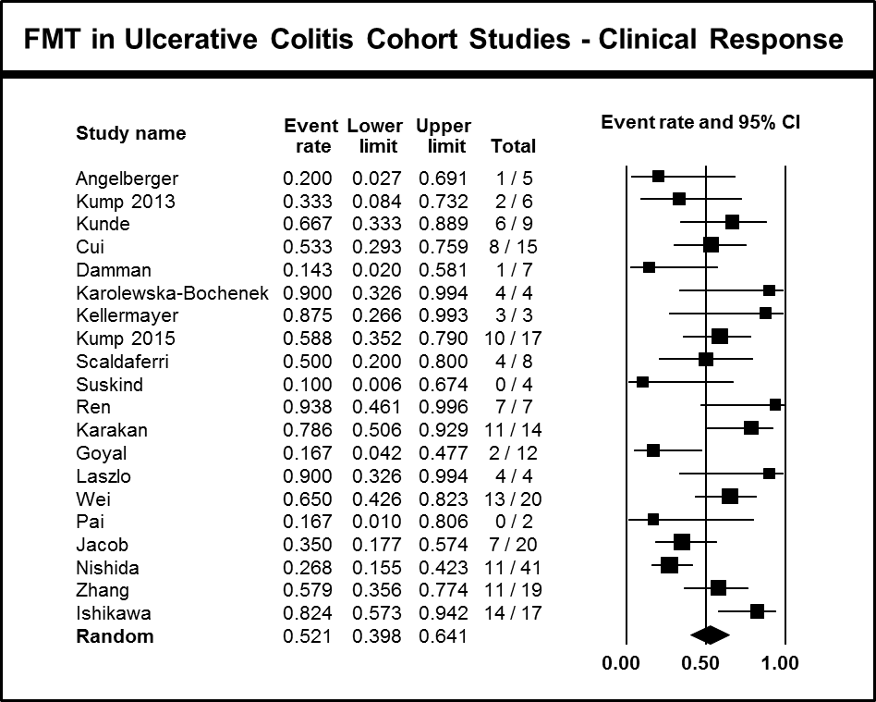

**Figure A1.** Forest plot of the meta-analysis of clinical response and FMT in ulcerative colitis including cohort studies available to date. The pooled proportion with 95% confidence intervals (CIs) were calculated using the random effects model (diamond). The filled squares represent the studies in relation to their weights. In this meta-analysis, four case-control studies (Kump et al 2015, Scaldaferri et al 2015, Pai et al 2016 and Ishikawa et al 2017) were included as cohorts (data from controls was removed) as the software did not allow the combination of one and two groups comparison analyses.

**Figure A2: Forest Plot of FMT in Ulcerative Colitis RCTs (Clinical Response)**

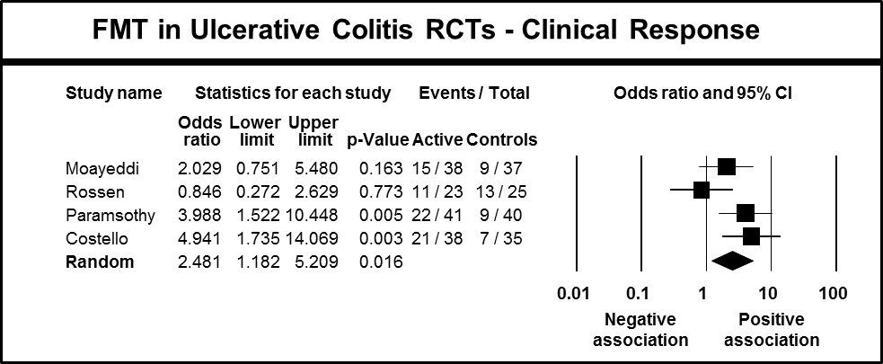

**Figure A2.** Forest plot of the meta-analysis of clinical response and FMT in ulcerative colitis including four RCTs available to date. The pooled ORs with 95% confidence intervals (CIs) were calculated using the random effects model (diamond). The filled squares represent the studies in relation to their weights.

**Figure A3: Forest Plot of FMT in Ulcerative Colitis RCTs (excluding Rossen et al)(Clinical Remission)**

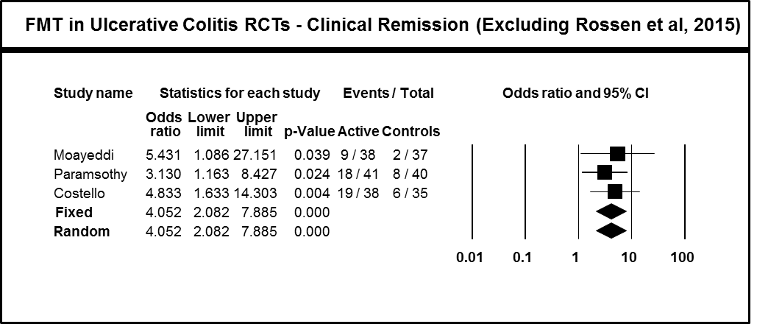

**Figure A3.** Forest plot of the meta-analysis of clinical remission and FMT in ulcerative colitis including RCTs by Moayeddi el al 2015, Paramsothy et al 2017 and Costello et al 2017. Given the low variability observed between these studies, the pooled proportion with 95% confidence intervals (CIs) were calculated using both fixed and random effects model (diamond). The filled squares represent the studies in relation to their weights.

**Figure A4: Forest Plot of FMT in Ulcerative Colitis RCTs (excluding Rossen et al)(Clinical Response)**

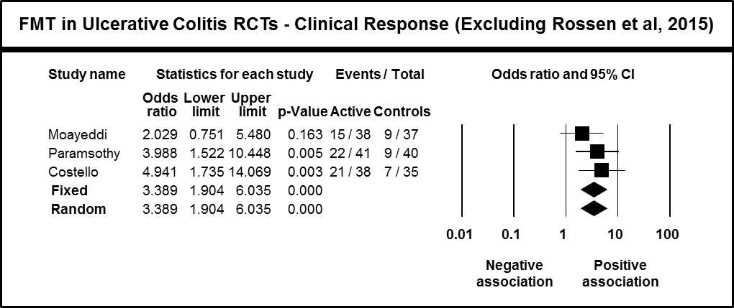

**Figure A4.** Forest plot of the meta-analysis of clinical response and FMT in ulcerative colitis including RCTs by Moayeddi el al 2015, Paramsothy et al 2017 and Costello et al 2017. Given the low variability observed between these studies, the pooled proportion with 95% confidence intervals (CIs) were calculated using both fixed and random effects model (diamond). The filled squares represent the studies in relation to their weights.

**Figure A5: Forest Plot of FMT in Crohn’s Disease Cohort Studies (Clinical Response)**

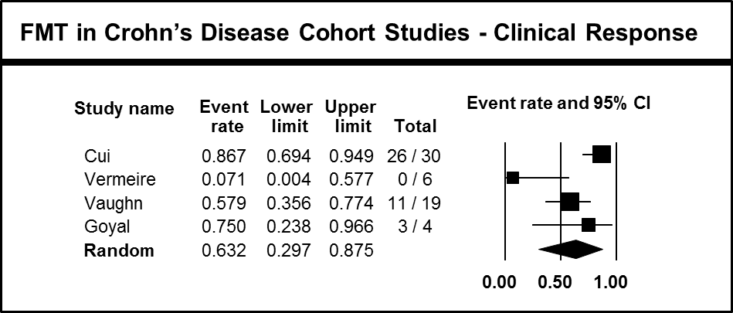

**Figure A5.** Forest plot of the meta-analysis of clinical response and FMT in Crohn’s Disease including cohort studies available to date. The pooled proportion with 95% confidence intervals (CIs) were calculated using the random effects model (diamond). The filled squares represent the studies in relation to their weights.